Appendix A

Regionalized PM2.5 Community Multiscale Air Quality model performance evaluation across a continuous spatiotemporal domain

Jeanette M. Reyes,ª Yadong Xu,ª William Vizuete,ª Marc L. Serreª*

a: Department of Environmental Sciences and Engineering, UNC, 135 Dauer Drive, Chapel Hill, NC 27599-7431

*Corresponding author: email: marc_serre@unc.edu; telephone: 919 966 7014

1. Model Performance Metrics
In the model performance literature typical definitions exist regarding nomenclature of certain metrics, namely, “bias” and “error”. In the Statistics realm, metrics such as “bias” and “error” are defined differently. This work utilizes naming schemes of metrics that is consistent with Statistical language. In Table A1 ${\tilde{x}}_{i}$ denotes a modeled value at space/time point $p_{i}$, ${ \hat{x}}_{i}$ is its paired observed value (i.e. observed at the same space/time location) and $e_{i}{=\tilde{x}}_{i}-{ \hat{x}}_{i}$ is the corresponding error. In Table A2 ${\hat{σ}}_{i}$ denotes an estimate of the error standard deviation, which in our work is obtained using $\sqrt{λ_{2}(p)}$.

Table A1. Table of commonly used model performance evaluation statistics used in the CMAQ literature. The left column displays the typical nomenclature used and the right column displays the nomenclature used in this work. The third column states whether the metrics quantifies systematic or random error. The second half of the table displays metrics less commonly used in the literature.
Metric name used in the CMAQ literature | Definition | Systematic / Random | Metric Name used in this Work
Regulatory Performance Metrics Used in Air Quality Modeling
# of data pairs | $$n$$ | NA | # of data pairs
Mean observation value | $$\frac{1}{n}\sum_{i=1}^{n}{\left({\hat{x}}_{i}\right)}=\overline{\hat{x}}$$ | NA | Mean observation value
Mean simulation value | $$\frac{1}{n}\sum_{i=1}^{n}{\left({\tilde{x}}_{i}\right)}=\overline{\tilde{x}}$$ | NA | Mean modeled value
Mean bias | $$\frac{1}{n}\sum_{i=1}^{n}{\left({\tilde{x}}_{i}-{\hat{x}}_{i}\right)}$$ | Systematic | Mean error
Normalized bias | $$100\%×\frac{1}{n}\sum_{i=1}^{n}{\left(\frac{{\tilde{x}}_{i}-{\hat{x}}_{i}}{{\hat{x}}_{i}}\right)}$$ | Systematic | Mean normalized Error
Normalized mean bias | $$100\%×\frac{\sum_{i=1}^{n}{\left({\tilde{x}}_{i}-{\hat{x}}_{i}\right)}}{\sum_{i=1}^{n}{{\hat{x}}_{i}}}$$ | Systematic | Normalized mean Error
Fractional bias | $$100\%×\frac{1}{n}\sum_{i=1}^{n}{\left(\frac{{\tilde{x}}_{i}-{\hat{x}}_{i}}{0.5×\left({\tilde{x}}_{i}+{\hat{x}}_{i}\right)}\right)}$$ | Systematic | Fractional error
Mean Error | $$\frac{1}{n}\sum_{i=1}^{n}{\left|{\tilde{x}}_{i}-{\hat{x}}_{i}\right|}$$ | Systematic / Random | Mean absolute error
Normalized Error | $$100\%×\frac{1}{n}\sum_{i=1}^{n}{\left(\frac{\left|{\tilde{x}}_{i}-{\hat{x}}_{i}\right|}{{\hat{x}}_{i}}\right)}$$ | Systematic / Random | Mean normalized absolute error
Normalized Mean Error | $$100\%×\frac{\sum_{i=1}^{n}{\left|{\tilde{x}}_{i}-{\hat{x}}_{i}\right|}}{\sum_{i=1}^{n}{{\hat{x}}_{i}}}$$ | Systematic / Random | Normalized mean absolute error
Fractional error | $$100\%×\frac{1}{n}\sum_{i=1}^{n}{\left(\frac{\left|{\tilde{x}}_{i}-{\hat{x}}_{i}\right|}{0.5×\left({\tilde{x}}_{i}+{\hat{x}}_{i}\right)}\right)}$$ | Systematic / Random | Fractional absolute error
Correlation | $$\frac{\sum_{i=1}^{N}{\left({\tilde{x}}_{i}-\overline{\tilde{x}}\right)\left({\hat{x}}_{i}-\overline{\hat{x}}\right)}}{\sqrt{\sum_{i=1}^{N}{{\left({\tilde{x}}_{i}-\overline{\tilde{x}}\right)}^{2}}}\sqrt{\sum_{i=1}^{N}{{\left({\hat{x}}_{i}-\overline{\hat{x}}\right)}^{2}}}}$$ | Random | Correlation
Less Commonly Used Regulatory Performance Metrics
Correlation squared | $$r^{2}$$ | Random | Correlation squared
Standard bias | $$\sqrt{V\left[{\tilde{x}}_{i}-{\hat{x}}_{i}\right]}$$ | Random | Standard error
Mean squared bias | $$\frac{1}{n}\sum_{i=1}^{n}{{\left({\tilde{x}}_{i}-{\hat{x}}_{i}\right)}^{2}}$$ | Systematic / Random | Mean squared error
Root mean squared bias | $$\sqrt{\frac{1}{n}\sum_{i=1}^{n}{{\left({\tilde{x}}_{i}-{\hat{x}}_{i}\right)}^{2}}}$$ | Systematic / Random | Root mean squared error
Normalized root mean squared bias | $$\frac{\sqrt{\frac{1}{n}\sum_{i=1}^{n}{{\left({\tilde{x}}_{i}-{\hat{x}}_{i}\right)}^{2}}}}{\frac{1}{n}\sum_{i=1}^{n}{{\hat{x}}_{i}}}$$ | Systematic / Random | Normalized root mean squared error
Mean bias/standard bias | $$\frac{1}{n}\sum_{i=1}^{n}{\left({\tilde{x}}_{i}-{\hat{x}}_{i}\right)}/\sqrt{V\left[{\tilde{x}}_{i}-{\hat{x}}_{i}\right]}$$ | Systematic | Mean error/standard error
Mean bias squared/mean squared bias | $$\frac{{\left(\sum_{i=1}^{n}{\left({\tilde{x}}_{i}-{\hat{x}}_{i}\right)}\right)}^{2}}{\sum_{i=1}^{n}{{\left({\tilde{x}}_{i}-{\hat{x}}_{i}\right)}^{2}}}={ME}^{2}/MSE$$ | Proportion of Systematic | Mean error squared/mean squared error
Variance of bias/mean squared bias | $$\frac{V\left[{\tilde{x}}_{i}-{\hat{x}}_{i}\right]}{\frac{1}{n}\sum_{i=1}^{n}{{\left({\tilde{x}}_{i}-{\hat{x}}_{i}\right)}^{2}}}$$ | Proportion of Random | Variance of errors/mean squared error

Table A2. Table of model performance evaluation statistics used when the estimate ${\tilde{x}}_{i}$ has a corresponding variance ${{\hat{σ}}_{i}}^{2}$. These metrics are used in the validation statistics.
BME Metric | Definition
Variance standardized error | $$V\left[\frac{{\tilde{x}}_{i}-{\hat{x}}_{i}}{{\hat{σ}}_{i}}\right]$$
Root mean squared standardized error | $$\sqrt{\frac{1}{n}\sum_{i=1}^{n}{{\left(\frac{{\tilde{x}}_{i}-{\hat{x}}_{i}}{{\hat{σ}}_{i}}\right)}^{2}}}$$
Mean root variance | $$\frac{1}{n}\sum_{i=1}^{n}{\left(\sqrt{{\hat{σ}}_{i}}\right)}$$

ME² , VE | ME² , VE | ME² , VE
(a) | (b) | (c)
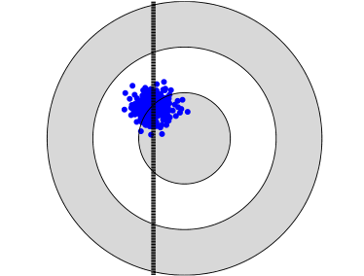 | 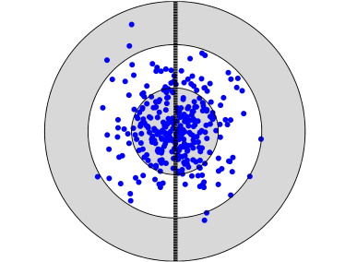 | 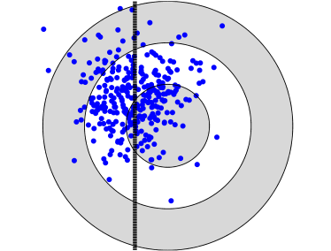
(d) | (e) | (f)
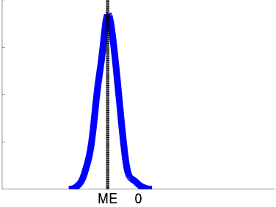 | 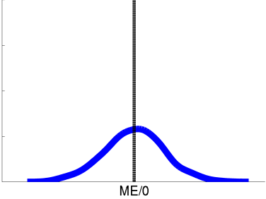 | 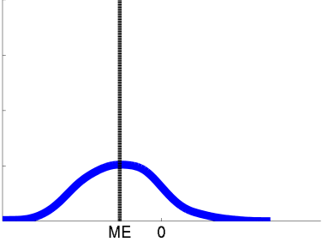
(g) | (h) | (i)
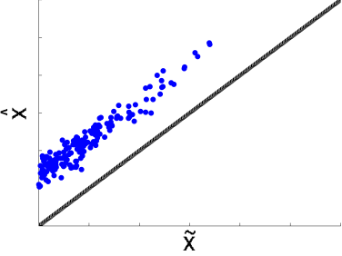 | 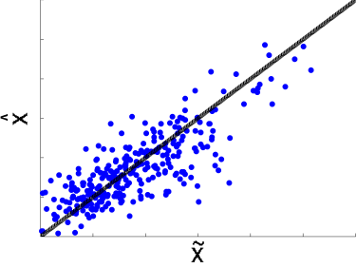 | 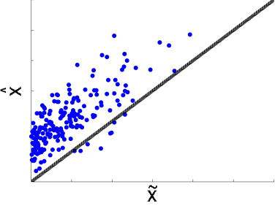
Figure A1. Visual representations of systematic and random error. Panels (a)-(i) show different scenarios of high and low systematic and random errors. The left column (plots (a), (d), (g)) displays three different visual representations of estimates with large systematic error (i.e. high ME²) and low random error (i.e. low VE). The middle column (plots (b), (e), (h)) displays representations of estimates with low systematic error and large random error. The right column (plots (c), (f), (i)) displays representations of estimates with large systematic error and large random error. The top row displays error using a target analogy, where estimates should ideally land on the target. The middle row displays the distribution of error via a PDF. The bottom row displays a group of paired modeled and observed concentrations within a space/time region $R(p)$. The modeled values are displayed on the independent axis as ${\tilde{x}}_{k}$ and the observed values are displayed on the dependent axis as $\hat{x}$. The solid line is the one-to-one line.

2. Data
2.1 Observed Data
The daily PM2.5 concentration for each monitoring site/day during 2000-2002 were constructed based on raw monitoring data from monitoring stations measuring either hourly or daily PM2.5 concentrations using the procedure described below.
PM2.5 monitoring data (raw data) sampled during the study period (2000-2002) were obtained from the Air Quality Systems (AQS) database maintained by the EPA, a repository of the monitoring data collected across various monitoring networks. PM2.5 data are available in a few data files on AQS depending on the source of data. These files are described in AQS as follows: 1) daily PM2.5 local conditions, 2) daily PM fine speciation from the Chemical Speciation Network (CSN) monitoring network and 3) daily PM fine speciation from the Interagency Monitoring of Protected Visual Environments (IMPROVE) monitoring network. Within each data file, the methodologies used to measure PM2.5 are defined using a parameter code which takes the following values: 1) 88101 for daily and hourly PM2.5 concentrations measured using a Federally Referenced Method (FRM) and 2) 88502 for PM2.5 Air Quality Index (AQI) values that provide acceptable measurements of PM2.5 concentrations in that they are comparable to FRM measurements. Data from the parameter 88502 are also known as Tapered Element Oscillating Microbalance (TEOM) data.
Hourly PM2.5 data were averaged into daily PM2.5 if at least 18 out of 24 hours were measured for a given day/monitor. Otherwise, a daily average was not constructed. More than 99.9% of hourly records were reported every hour on the hour. However, there were several records not reported on the hour. These hourly records were removed before constructing daily concentrations. All observations sampled at monitors whose measurement scale was “Microscale” were removed.
At each monitoring site with multiple monitors, the collocated daily concentrations recorded at any given day were combined using the following procedure to produce a constructed daily concentration for that site/day. First, priority rank scores were assigned to each collocated daily concentration based on its data source and type as follows:

Table A3. Ranking scores used for averaging collocated PM2.5 values for a given site/day
Rank 1 | FRM daily PM2.5
Rank 2 | TEOM daily PM2.5 from CSN
Rank 3 | TEOM daily PM2.5 from IMPROVE
Rank 4 | TEOM hourly PM2.5

If the collocated concentrations for a given site/day had varying priority ranks, then only the concentration with the highest rank (i.e. the smallest priority score) was retained. If there were more than one collocated daily concentrations with the highest priority rank, then these daily concentrations were averaged to produce a single daily concentration at that site/day.

2.2 Modeled Data
Daily concentrations for PM2.5 were also constructed from modeled CMAQ data. CMAQ inputs emissions and meteorological data which are then translated into complex chemical processes to estimate ambient air pollution over gridded geographical boundaries for different time steps. The modeled data used for this work were available at a 36km resolution every hour for the years 2001 and 2002 across the continental US. Data are projected using a Lambert Conic Conformal (LCC) projection.

Table A4. Description of available CMAQ modeling data
Year | Model | Domain | Resolution | Source | Received date
2001 | CMAQ v4.5 | The contiguous US | 36km | EPA | 08-26-2011
2002 | CMAQ  v4.5 | The contiguous US | 36km | CENRAP | 08-02-2011

The CMAQ data have full spatial and temporal coverage for the continental US (Table A4). All modeled runs were done using hindcasting. Daily modeled values were constructed by averaging the 24 hourly modeled values for a given grid location/day. Each modeled concentration over an area (i.e. the modeled concentration over a grid cell) is assigned the location defined by the centroid of that grid cell.

3. Choice of S-curve Parameters for the RAMP analysis
We conducted a visual analysis to select the parameters used to construct the $λ_{1}$ and $λ_{2}$ S-curves in the RAMP analysis. In the CAMP analysis $λ_{1}$ and $λ_{2}$ are calculated across the domain $D$. In the CAMP analysis the S-curves do not capture the variability of model performance at a fine spatial scale. To address this issue the RAMP analysis regionalizes the calculation to a space/time region $R(p)$ that consists of paired modeled/observed values at the $n$ closest stations within $T$ days of $p$. Our aim is to capture fine scale spatial variability in the S-curves. In order to achieve the finest spatial resolution possible we choose $n=3$. Using $3$ proximal stations define the smallest region $R(p)$ possible near any space/time location $p$ of interest, which provides a description of model performance at the finest spatial resolution possible for any given location of interest. The time window was thus increased to $±180$ days to allow approximately 150 paired values needed in the creation of the S-curve. To test whether $T=±180$ days and $n=3$ leads to a stable analysis we performed a validation and stochastic simulation analysis that demonstrates that RAMP produces $λ_{1}$ and $λ_{2}$ values that outperforms CAMP. We conducted a visual sensitivity analysis by increasing $n$ and inspecting whether the $λ_{1}$ and $λ_{2}$ maps change appreciatively as $n$ increases (Fig. A2). As seen in this figure, the $λ_{1}$ and $λ_{2}$ maps do not change appreciatively as $n$ increases from 3 to 6. The same result is obtained using other values of $n$ between 3 and 6 (results not shown). This demonstrates that the parameters chosen ($T=±$180 days and $n=3$) are as spatially specific as possible while still maintaining a stable estimation of $λ_{1}$ and $λ_{2}$.
Another choice for the number of station $n$ would be to use a fixed radius $r$, and select all stations within $r$ of the location $p$ of interest. We found that in order to achieve a stable estimate of $λ_{1}$ and $λ_{2}$, the radius has to be set to a long distance $r$ such that at least 3 stations are included in the most sparsely monitored area of the continental US. When moving to densely monitored areas, the number of station $n$ within the fixed $r$ radius becomes so large that essentially the RAMP method becomes equivalent to the CAMP method in these areas, and as a result this approach fails to assess model performance at a fine spatial resolution.

(a) | (b)
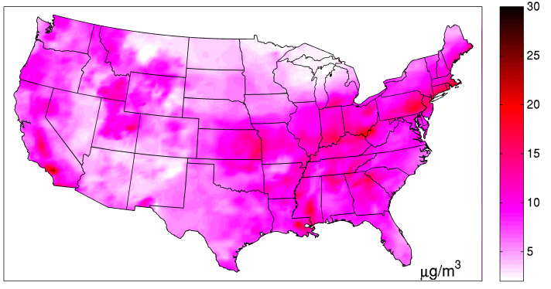 | 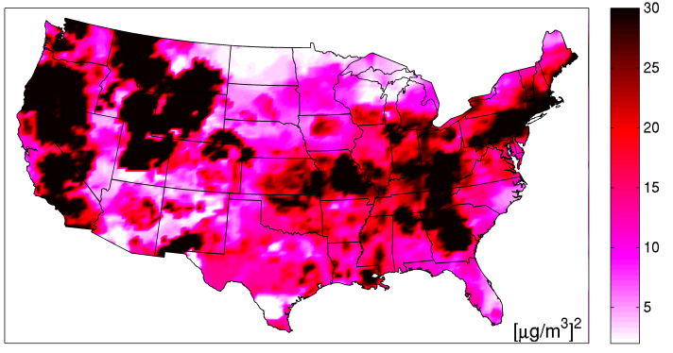
(c) | (d)
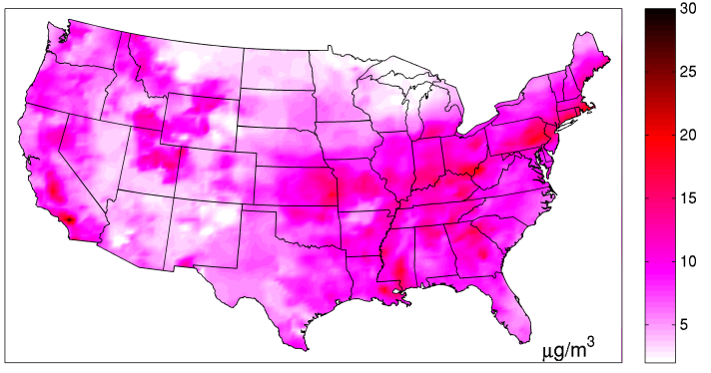 | 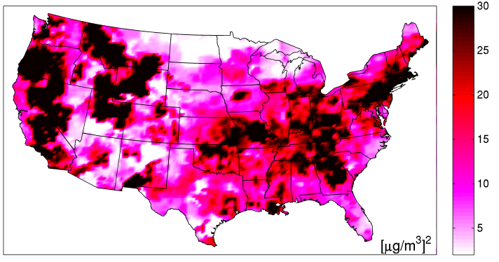
Figure A2. Maps of $λ_{1}(p)$ and $λ_{2}(p)$ across the US on July 1, 2001 calculated using the RAMP method with two sets of S-curve parameters. $λ_{1}(p)$ is displayed in (a) and (c). $λ_{2}(p)$ is displayed in (b) and (d). (a) and (b) are obtained using the $6$ closest stations within $180$ days of $p$, while (c) and (d) are obtained using the $3$ closest stations within $180$ days of $p$. No appreciable difference can be seen by comparing (a) and (b) against (c) and (d).

4. Model Performance Metrics for Different Fixed Modeled Values
The RAMP method allows for construction of model performance metrics as a function of both space/time region and arbitrary modeled values. Through the equation $ME\left({\tilde{x}}_{k};R(p)\right)={\tilde{x}}_{k}-λ_{1}({\tilde{x}}_{k};R(p))$ and an analogous equation for $VE\left({\tilde{x}}_{k};R(p)\right)$, one can visualize how mean error and variance of error changes across the United States for a given day for different increasing modeled values. Mean error for PM2.5 decreases consistently across the United States from $5 μg/m^{3}$ to $10 μg/m^{3}$. CMAQ has consistent problems estimating PM2.5 at smaller concentrations and high concentrations. CMAQ performs best at mid-range values of PM2.5 (Fig. A3). Standard error increases as a function of modeled value (Fig. A4). Change in the standard deviation of errors demonstrates that model performance is non-homoscedastic. The RAMP method allows the flexibility of allowing model performance to be both non-linear and non-homoscedastic. Non-homoscedastic behavior is most clearly observed in the Great Lakes region of the county.

(a) | (b)
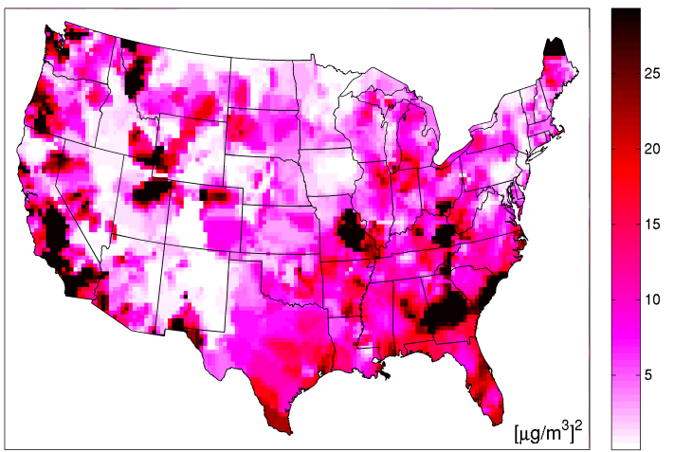 | 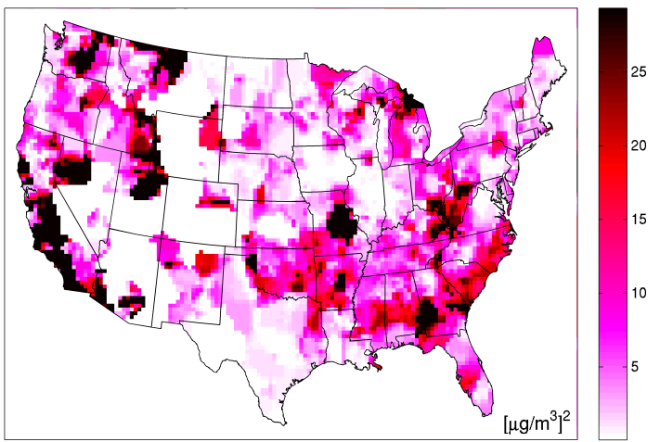
Figure A3. Systematic error (${ME}^{2}({\tilde{x}}_{k};R(p))$) for fixed modeled values for (a) $5 μg/m^{3}$ and (b) $10 μg/m^{3}$ across the US on July 1, 2001 using the RAMP method as interpolated by S-curves. Areas where ${ME}^{2}({\tilde{x}}_{k};R(p))$ are not displayed are outside the range of modeled values for the corresponding S-curve and are therefore not interpolated.

(a) | (b)
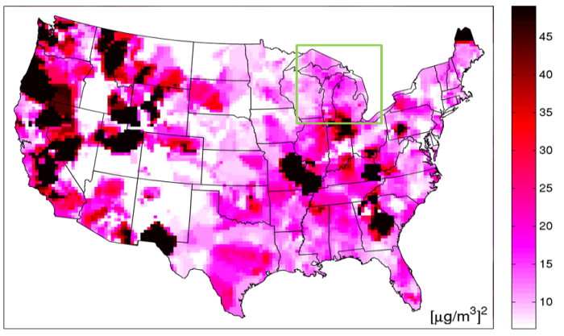 | 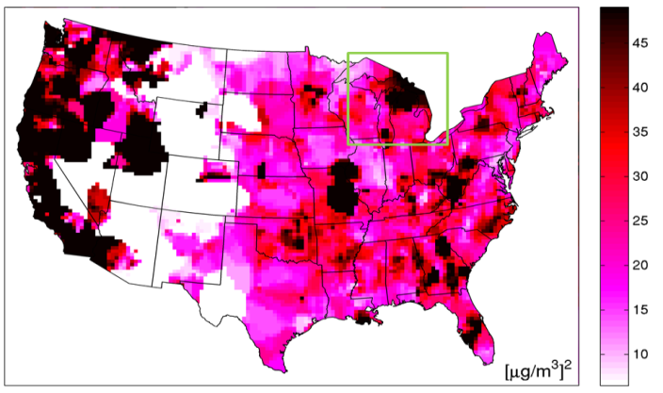
Figure A4. Random error ($VE({\tilde{x}}_{k};R(p))$) for fixed modeled values $5 μg/m^{3}$ (a) and $10 μg/m^{3}$ (b) across the US on July 1, 2001 using the RAMP method as interpolated by S-curves. Areas where $VE({\tilde{x}}_{k};R(p))$ are not displayed are outside the range of modeled values for the corresponding S-curve and are therefore not interpolated. The boxed area in green corresponds to the Great Lakes region.

5. Maps of Other Model Performance Metrics
All metrics can be visualized for each CMAQ grid cell. When looking at systematic error and random error as a proportion of total error, most error coming from CMAQ can be defined as random (Fig. A5a-b). Because such a large proportion of total error is coming from random error, visually, maps of random error and total error look similar (Fig. A5c). MNAE (Fig. A5e) is lowest in the Eastern part of the US where overall performance of CMAQ is known to be better. MNE has a large range illustrating the large potential normalized errors when observed values are small (Fig. A5d). Visually, the maps of MNE look similar to $VE(p)/MSE(p)$.

(a) | (b)
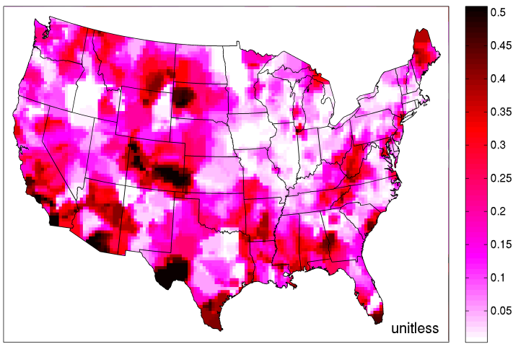 | 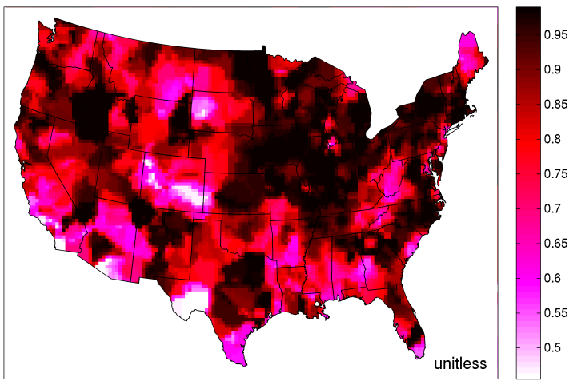
(c)
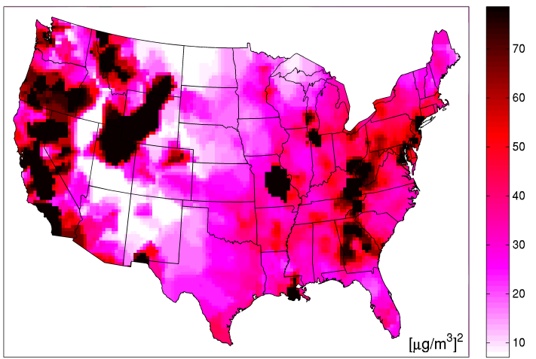
(d) | (e)
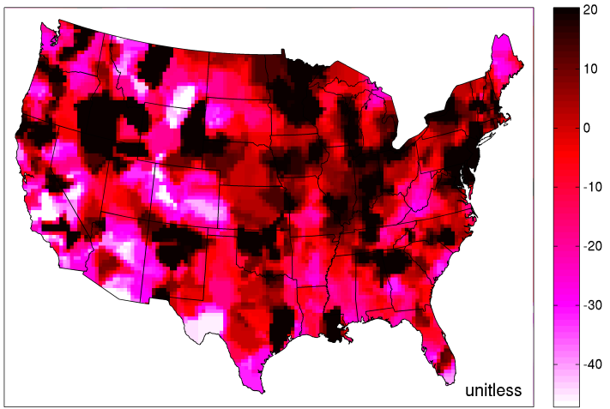 | 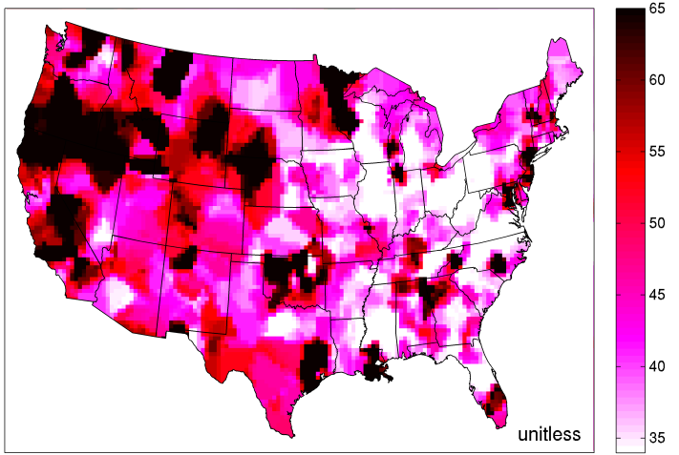
Figure A5. Maps of daily PM2.5 across the continental United States on July 1, 2001 displaying (a) ${ME}^{2}(p)/MSE(p)$, (b) $VE(p)/MSE(p)$, (c) $MSE(p)$, (d) $MNE(p)$ and (e) $MNAE(p)$.

6. $λ_{1}({\tilde{x}}_{k};R(p))$ and $λ_{2}({\tilde{x}}_{k};R(p))$ for Different Fixed Modeled Values
Patterns of $λ_{1}({\tilde{x}}_{k};R(p))$ for increasing modeled values follow along similar lines of $ME({\tilde{x}}_{k};R(p))$. That is, performance is most consistent with mid-levels of PM2.5. Most systematic error is seen with low and high concentrations. The corresponding error correction of $λ_{1}({\tilde{x}}_{k};R(p))$ shows the lowest levels of variation for $5 μg/m^{3}$, $10 μg/m^{3}$ and $15 μg/m^{3}$. Areas that show the highest levels of error correction in the US start in the Eastern US and move predominately to the Appalachian Mountain region of the country. Patterns of $λ_{2}({\tilde{x}}_{k};R(p))$ for increasing modeled values follow along similar lines of $VE({\tilde{x}}_{k};R(p))$. That is, performance is most homogenous for lower levels of PM2.5. Most random error is seen with mid to high level concentrations.

(a) | (b)
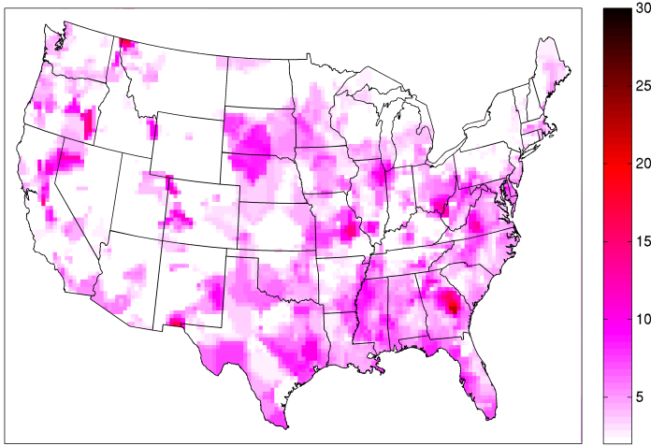 | 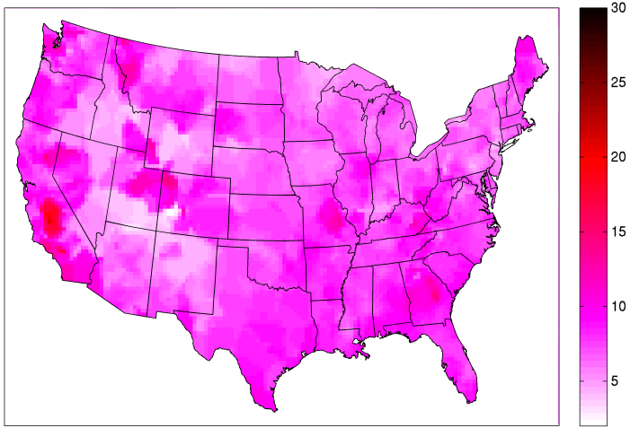
(c) | (d)
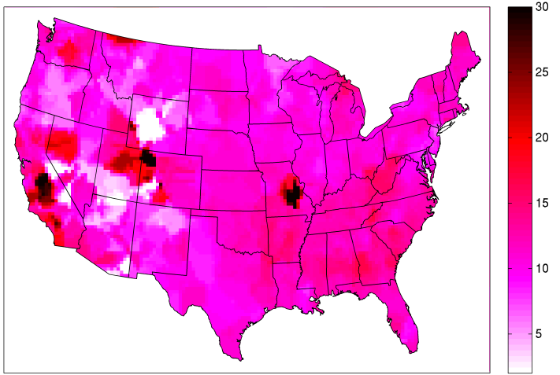 | 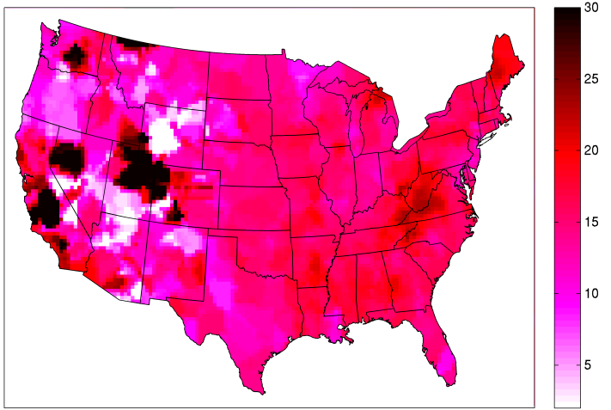
(e) | (f)
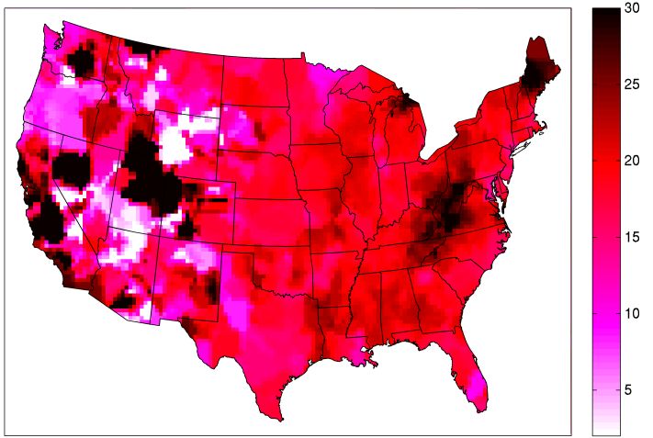 | 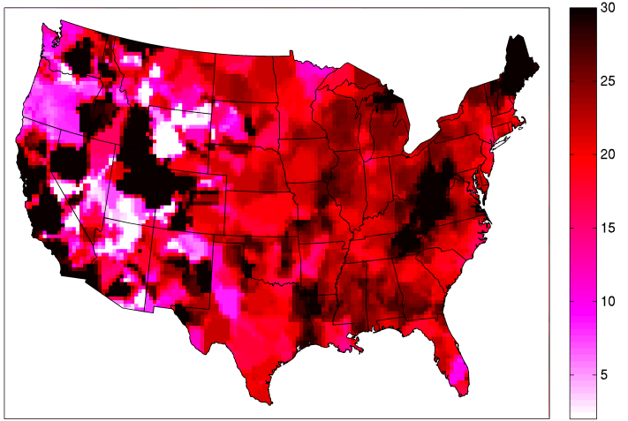
Figure A6. Maps of $λ_{1}({\tilde{x}}_{k};R(p))$ PM2.5 concentrations in increments of $5 μg/m^{3}$ across the continental United States on July 1, 2001 with (a) being $0 μg/m^{3}$ and (f) being $25 μg/m^{3}$. Units for all figures are $μg/m^{3}$.

(a) | (b)
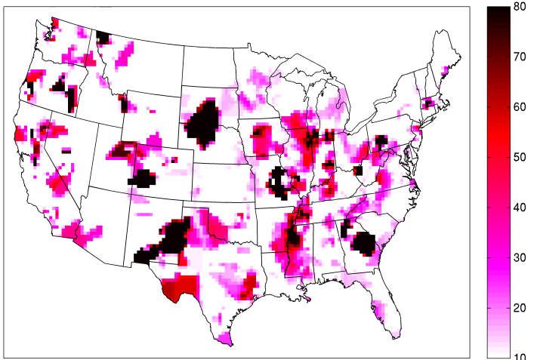 | 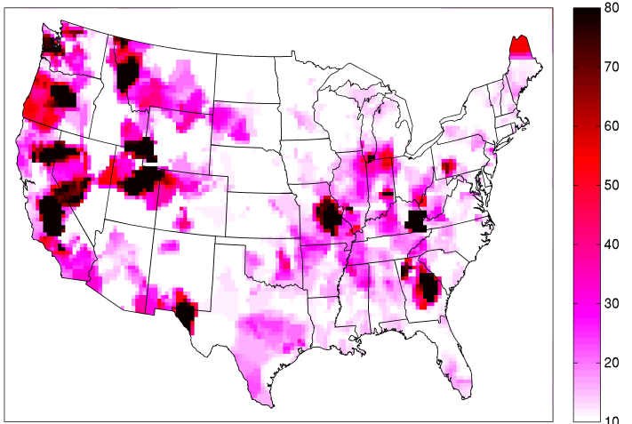
(c) | (d)
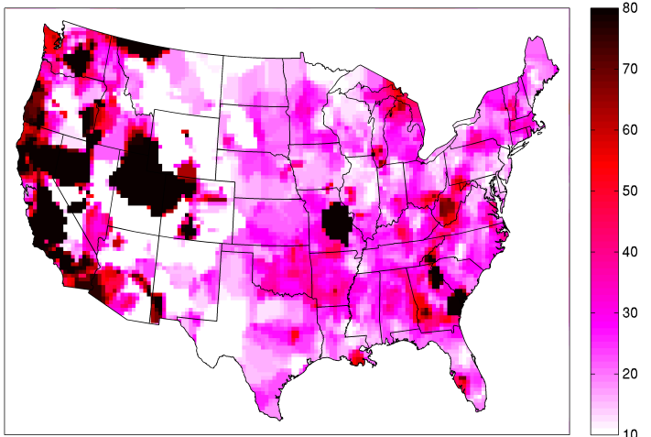 | 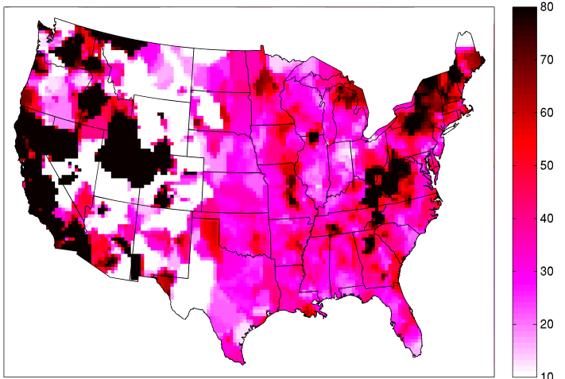
(e) | (f)
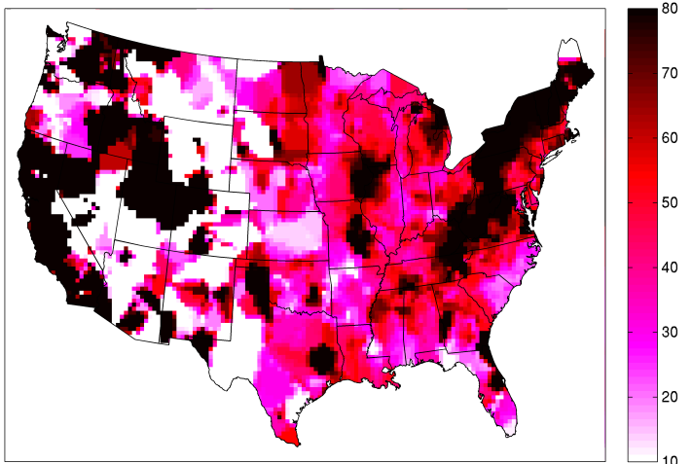 | 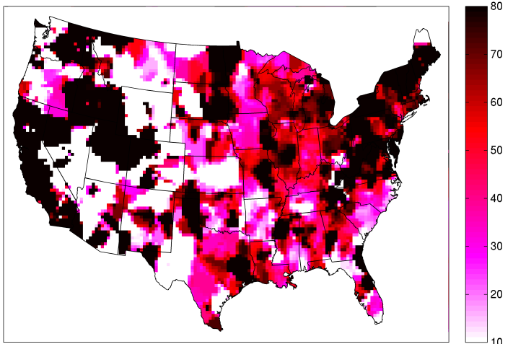
Figure A7. Maps of $λ_{2}({\tilde{x}}_{k};R\left(p\right))$ PM2.5 concentrations in increments of $5 μg/m^{3}$ across the continental United States on July 1, 2001 with (a) being $0 μg/m^{3}$ and (f) being $25 μg/m^{3}$. Units for all figures are ${\left(μg/m^{3}\right)}^{2}$.

7. RAMP Stochastic Simulation
We do not know the true values of $λ_{1}(p)$ and $λ_{2}(p)$ because they are not directly measured. As a result it is not possible to validate the RAMP method based on true or measured $λ_{1}(p)$ and $λ_{2}(p)$ values. However, we can use stochastic simulation to create a set of simulated values for $λ_{1}(p)$, $λ_{2}(p)$, $\tilde{x}(p)$ and $\hat{x}(p)$ that have the same statistical properties as the true values. These simulated values are taken as the simulated truth, which can then be used to validate the RAMP method.
To do this, $λ_{1}({\tilde{x}}_{k};R(p))$ and $λ_{2}({\tilde{x}}_{k};R(p))$ that were obtained in this work were selected as the “true” values. From the selected $λ_{1}({\tilde{x}}_{k};R(p))$ and $λ_{2}({\tilde{x}}_{k};R(p))$ and the CMAQ modeled values $\tilde{x}(p)$ used in this work, $λ_{1}(p)$ and $λ_{2}(p)$ were obtained by substituting ${\tilde{x}}_{k}$ with $\tilde{x}(p)$ in $λ_{1}({\tilde{x}}_{k};R(p))$ and $λ_{2}({\tilde{x}}_{k};R(p))$, respectively. Observed data were statistically simulated by randomly generating a stochastic realization ${\hat{x}}^{*}(p)\sim N(λ_{1}\left(p\right),λ_{2}(p))$. The set of $λ_{1}(p)$, $λ_{2}(p)$, $\tilde{x}(p)$ and ${\hat{x}}^{*}(p)$ values represent the simulated truth. The validation then consists of using the Constant, CAMP and RAMP methods to obtain ${λ_{1}}^{*}(p)$ and ${λ_{2}}^{*}(p)$ based on a re-estimation that uses only the $\tilde{x}(p)$ and ${\hat{x}}^{*}(p)$. The re-estimates ${λ_{1}}^{*}(p)$ and ${λ_{2}}^{*}(p)$ can be compared with the selected “true” $λ_{1}(p)$ and $λ_{2}(p)$ to evaluate the estimation accuracy of each method. Fig. A8a-b show $λ_{1}(p)$ and $λ_{2}(p)$, respectively. Fig. A8c-d show $\tilde{x}(p)$ and ${\hat{x}}^{*}(p)$, respectively, for the day of interest. The results of the re-estimation for the RAMP methods are shown in Fig. A8e-f. As can been seen in the figure, the maps of ${λ_{1}}^{*}(p)$ and ${λ_{2}}^{*}(p)$ are very similar to those of $λ_{1}(p)$ and $λ_{2}(p)$, respectively, which demonstrates that the RAMP method is able to correctly estimate $λ_{1}(p)$ and $λ_{2}(p)$ across the space/time study domain based only on paired $\tilde{x}(p)$ and ${\hat{x}}^{*}(p)$ values.

(a) | (b)
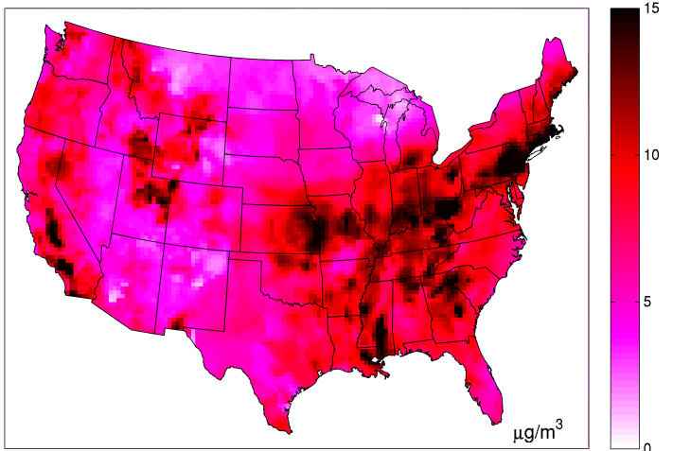 | 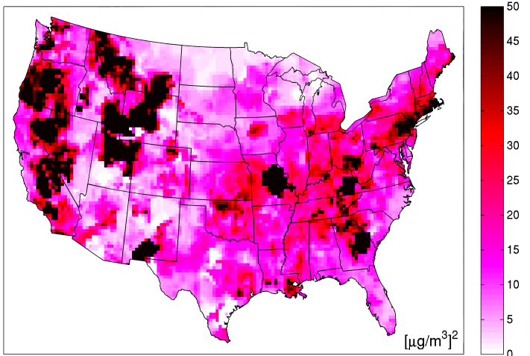
(c) | (d)
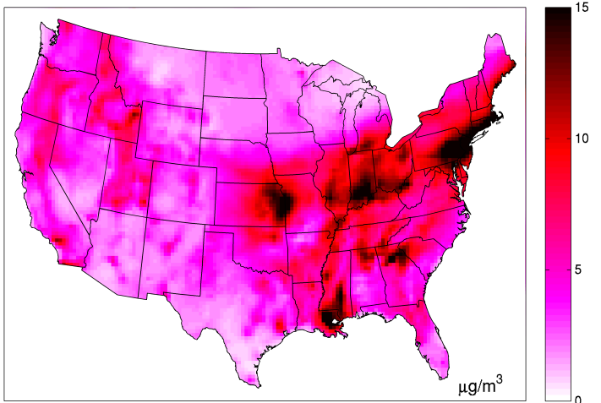 | 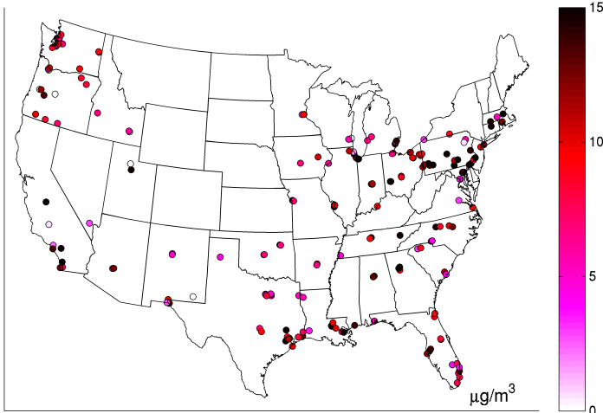
(e) | (f)
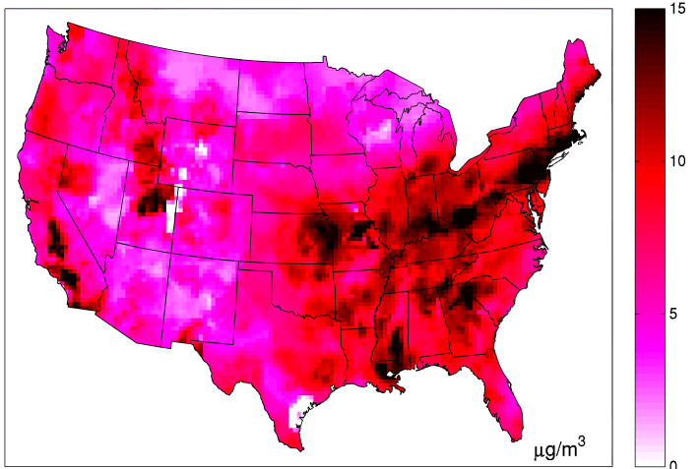 | 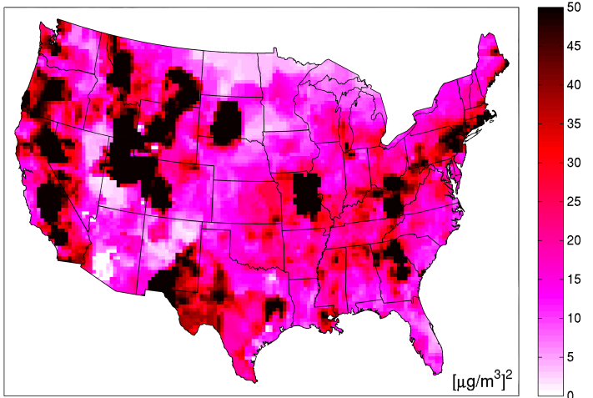
Figure A8. Maps of stochastic simulation of daily PM2.5 across the continental United States on July 1, 2001. (a) Selected true $λ_{1}(p)$, (b) selected true $λ_{2}(p)$, (c) CMAQ modeled values $\tilde{x}(p)$for that day, (d) stochastic realization ${\hat{x}}^{*}(p)\sim N(λ_{1}\left(p\right),λ_{2}(p))$, (e) ${λ^{*}}_{1}(p)$ and (f) ${λ^{*}}_{2}(p)$ re-estimated by the RAMP method based only on $\tilde{x}(p)$ and ${\hat{x}}^{*}(p)$.
In order to assess how well the RAMP method evaluates systematic errors compared to other methods, we show in Fig. A9a $ME\left(p\right)=\hat{x}\left(p\right)-λ_{1}(p)$ that was selected as the “truth” across the continental United States on July 1, 2001. We show in Fig. A9b-d ${ME}^{*}\left(p\right)=\hat{x}\left(p\right)-{λ_{1}}^{*}(p)$ values that were obtained using the Constant, CAMP and RAMP methods. The Pearson Correlation coefficient between $ME\left(p\right)$ and ${ME}^{*}\left(p\right)$ is $0.00\%$ for the Constant, $24.0\%$ for the CAMP and $76.1\%$ for the RAMP methods. These correlation values and the corresponding figures demonstrate that the Constant method is not able to capture any of the spatial variability in systematic errors and the CAMP method captures only some of the spatial variability of systematic errors. By comparison the RAMP method captures the spatial variability of systematic errors well.

(a) | (b)
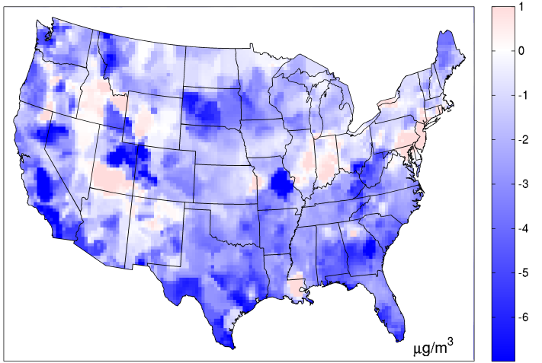 | 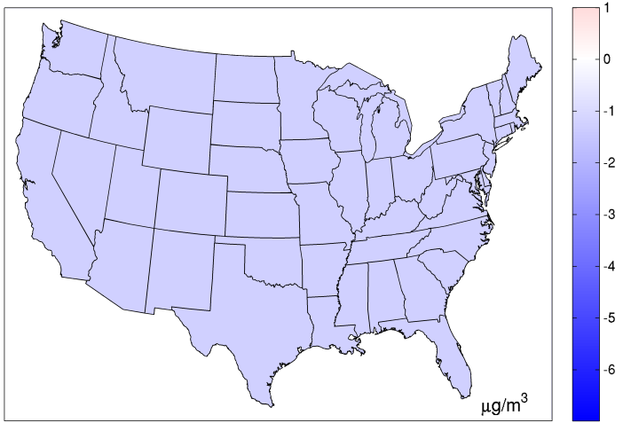
(c) | (d)
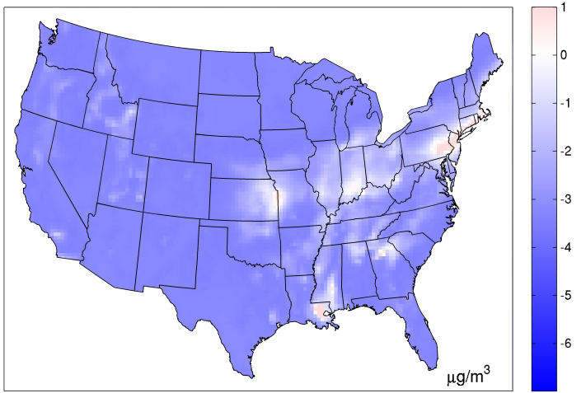 | 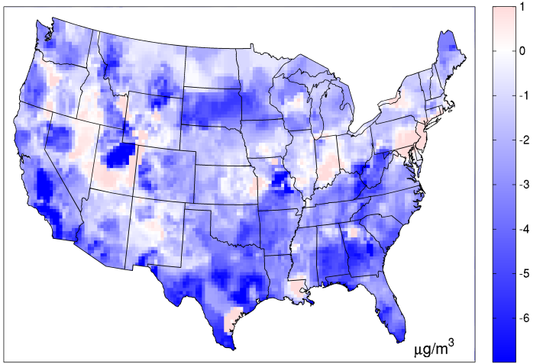
Figure A9. (a) Map of the selected true $ME\left(p\right)=\hat{x}\left(p\right)-λ_{1}(p)$ for daily PM2.5 across the continental United States on July 1, 2001, and maps of the corresponding re-estimated ${ME}^{*}\left(p\right)=\hat{x}\left(p\right)-{λ_{1}}^{*}(p)$ obtained using the (b) the Constant method, (c) the CAMP method and (d) the RAMP method.
In order to assess how well the RAMP method is able to assess systematic errors compared to other methods, we show in Fig. A10a $VE\left(p\right)=λ_{2}(p)$ that was selected as the “truth” across the continental United States on July 1, 2001, and we show in Fig. A10b-d ${VE}^{*}\left(p\right)={λ_{2}}^{*}(p)$ values that were obtained using the Constant, CAMP and RAMP methods. These maps indicates that the Constant method is unable to capture the spatial variability in random errors, the CAMP method captures only some of the spatial variability of random errors and, by comparison, the RAMP method is able to capture areas high and low random errors well.

(a) | (b)
 | 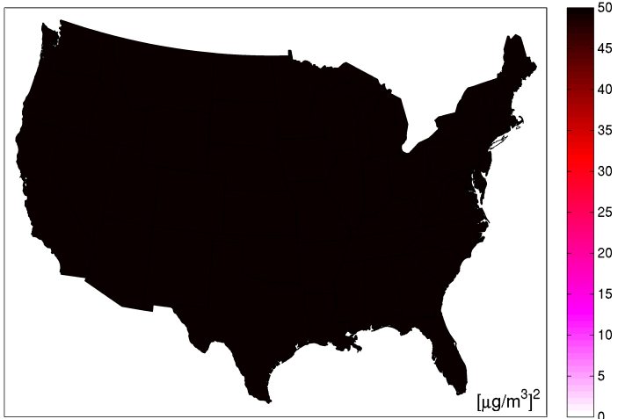
(c) | (d)
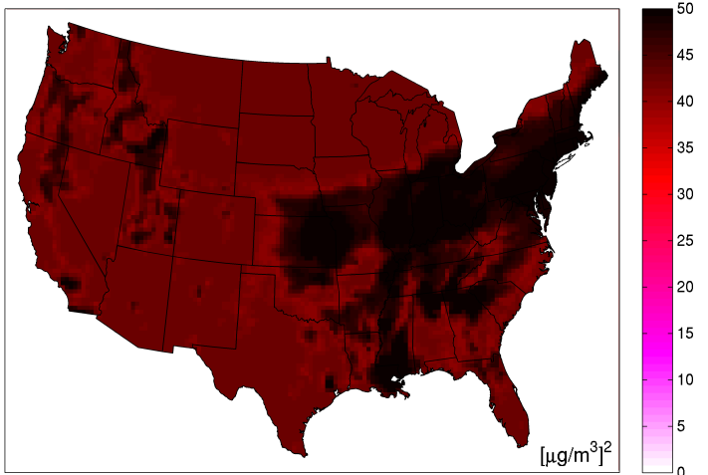
Figure A10. (a) Map of the selected true $VE\left(p\right)=λ_{2}(p)$ for daily PM2.5 across the continental United States on July 1, 2001, and maps of the corresponding re-estimated ${VE}^{*}\left(p\right)={λ_{2}}^{*}(p)$ obtained using the (b) the Constant method, (c) the CAMP method and (d) the RAMP method.
It should be noted that the ${ME}^{*}\left(p\right)$ and ${VE}^{*}\left(p\right)$ values were obtained using only the paired modeled and randomly generated observed values and yet the RAMP method is able to capture areas of high and low systematic and random errors across the continuous mapping domain. This demonstrates that the RAMP method is able to assess model performance at unsampled locations, i.e. at locations where observations are not available.

8. S-curves across the US

(a) | (b)
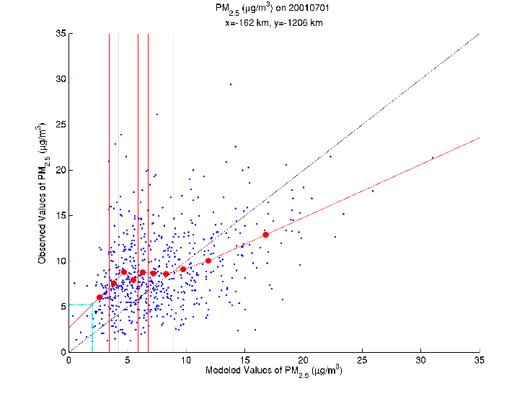 | 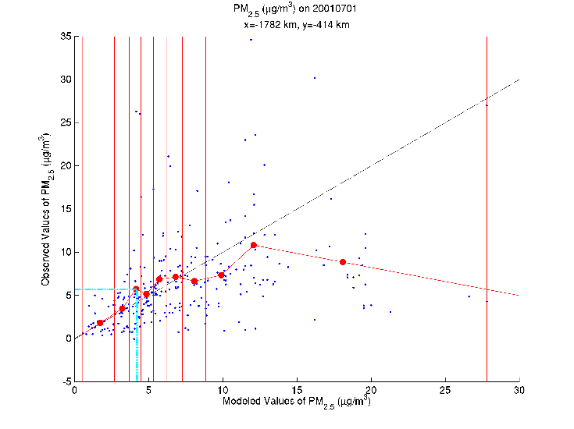
(c) | (d)
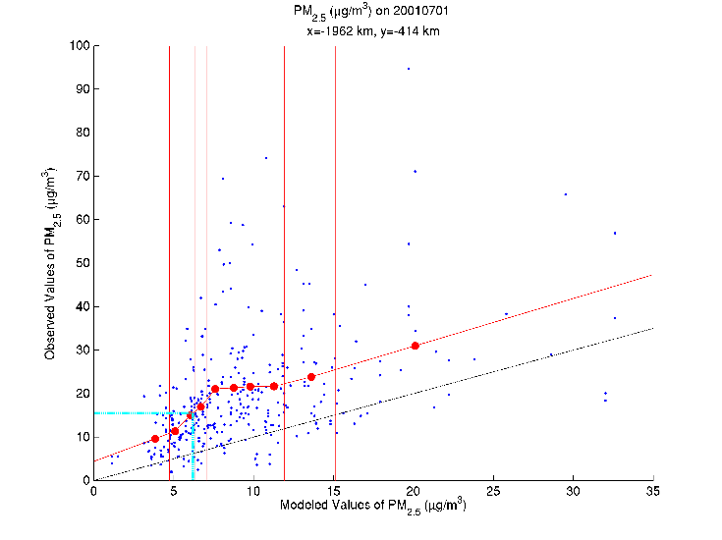 | 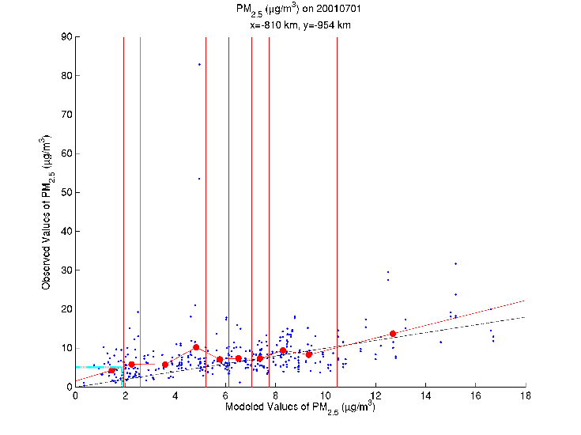
(e) | (f)
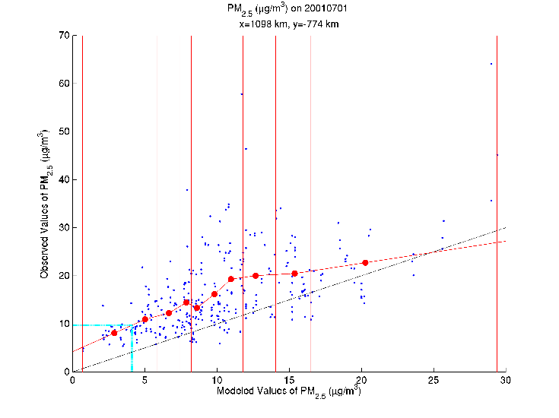 | 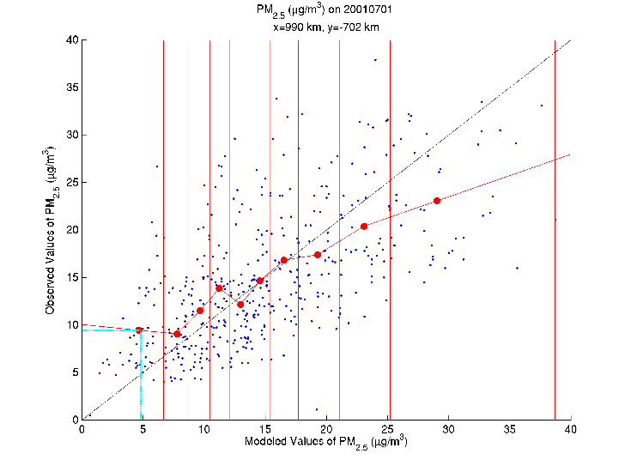
Figure A11. S-curves for selected CMAQ grids on July 1, 2001 across the continental US. Vertical cyan line marks $\tilde{x}(p)$ and the horizontal cyan line marks $λ_{1}\left(p\right)$.

