**SUPPLEMENTARY FOR**

**Porous Polyurethane Foam for use as a Particle Collection Substrate in a Nanoparticle Respiratory Deposition Sampler**

Levi W. D. Mines1, Jae Hong Park1, Imali A. Mudunkotuwa2, T. Renée Anthony1, Vicki H. Grassian2, and Thomas M. Peters1*

1Department of Occupational and Environmental Health, University of Iowa

2Department of Chemistry, University of Iowa

*Corresponding author

Thomas M. Peters, PhD

105 River St, S331 CPHB

University of Iowa, Iowa City, Iowa 52242

e-mail: Thomas-m-peters@uiowa.edu

**1. Collection Efficiency and Metal Fume Loading Size Distributions**

For the collection efficiency tests, the particle size distributions of test aerosols were log-normally distributed (Figure S1). The number median diameter for NaCl was 108 nm with a coefficient of variation (CV) of 3%, the geometric standard deviation was, 1.93 (CV 1%), and the number concentration on was 1.69 105 particles cm-3 (CV 13%). For metal fume, the number median diameter was 82 nm, the geometric standard deviation was 1.97, and the number concentration was 2.68 106 particles cm-3 (CV 1%). The airflow rate through the foam substrates was 2.54 ± 0.01 L min-1.

During particle loading of the foam substrate, the number median diameter was 79 nm (CV 3%), the geometric standard deviation was 1.76 (CV 0.5%), and the mean number concentration was 2.38 106 particles cm-3 (CV 5%). During particle loading of the nylon meshes, the number median diameter was 81 nm (CV 0.5%), the geometric standard deviation was 1.74 (CV 0.5%), and the number concentration was 2.53106 particles cm-3 (CV 3%).



Fig S1. Particle number concentration by particle mobility diameter normalized by total number concentration (N) measured in the bypass sampling line. Error bars represent one standard deviation of four measurements.

|  |  |
| --- | --- |
| M:\General Research Directory\102Peters\Research\Projects\2013-R01-NRDsampler\Imali\TEM\10-20-2014-samples from Jae\NaCl-10 min-0016.jpg | M:\General Research Directory\102Peters\Research\Projects\2013-R01-NRDsampler\Imali\TEM\10-20-2014-samples from Jae\Welding-10 min-0010.jpg |

Fig S2. Representative transmission electron microscope (TEM) images of salt particles (left) and metal fume particles (right). Particles appear as dark objects on the surface of a holey carbon TEM grid.

**2. Clark el al. (2009) Model for Particle Deposition in Porous Foam and Associated Equations**

The modeled collection efficiency $(η_{th})$ for the foam substrate was calculated as one minus the penetration from Clark et al. (2009) as:

$η_{th}=1-e^{-\frac{h}{d_{f}} \left\{40.7{St}^{1.9}+38.9{Ng}^{0.88}+84.4{Pe}^{-0.75}\right\}}$ (S1)

where substrate depth ($h$) is in mm, fiber diameter ($d_{f}$) is in µm, and *Pe,* *St,* and *Ng,* are Péclet, Stokes, and gravitational settling number respectively, calculated using SI units as:

$Pe=\frac{d_{f} U}{D}$ (S2)

$D=\frac{k T{ C}_{c}}{3 π μ{ d}_{ve}}$ (S3)

$Stk=\frac{ρ_{p} d_{ae}^{2} C_{c} U}{18 μ d_{f}}$ (S4)

$Ng=\frac{ρ_{p} d_{ae}^{2} C_{c} g}{18 μ U}$ (S5)

where $U$ is the face velocity, $D$ is the diffusion coefficient specific to the particle, $k$ is the Boltzmann constant, $T$ is temperature in kelvin, $μ$ is air viscosity, and $g$ is acceleration due to gravity (Raynor et al., 2011). For the Clark et al. (2009) model aerodynamic diameters (Eq. 6) and volume equivalent diameters (Eq. 7) were calculated using a shape factor of 1.08 and a density of 2160 kg m-3 to be comparable to the NaCl experimental data. The Clark et al. (2009) model was not compared to the metal fume data due to difficulties in adjusting the model for $χ$ of the metal fume.

**3. Calculation of Size-Dependent Shape Factors for Metal Fume particles 100-300 nm**

In Kim et al. (2009), the dynamic shape factor (χ) of agglomerates with different sintering temperatures was shown in Fig. 4 and reprinted here as Fig. S2. We fit a line to the data at room temperature using an empirical equation shown below, where $d_{m}$ is the mobility diameter in nm. The fitted line was added in red (thick, dotted line) to Fig. S3.

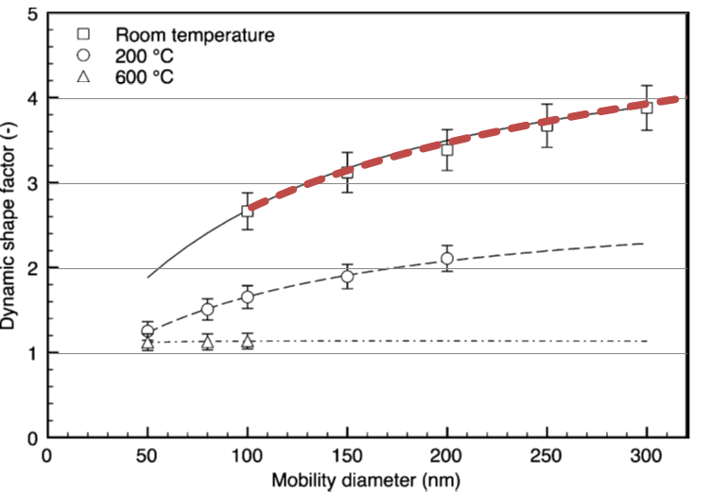

FIG. S3. Dynamic shape factor of agglomerates with different sintering temperatures (Kim et al., 2009)

$χ=1.13×\ln\left(d_{m}\right)-2.5,d_{m}>100 nm$ (S6)

where dm is mobility diameter in nanometers.

**4. Pressure Drops across the NRD Sampler and Individual Components**

Table S. Pressure drop at the flow rate of 2.5 L min-1 (Values represent average and standard deviation of three measurements).

|  |  |
| --- | --- |
| Parts | Pressure drop, Pa  avg. ± st. dev. |
| Housing and fittings | 30 ± 0 |
| 8 Meshes | 356 ± 15 |
| Foam | 23 ± 4 |
| Impactor | 3492 ± 117 |
| Cyclone | 61 ± 2 |
| NRD sampler (mesh) | 3911 ± 90 |
| NRD sampler (foam) | 3587 ± 25 |



FIG. S4. Nylon mesh openings were completely clogged with metal chain-agglomerate particles. The high pressure drop from the clogged openings caused a leak of air around the meshes.