Supporting Information
Methods
Device Fabrication and Data Analysis
The devices were fabricated with Whatman filter paper grade 4 [GE Healthcare Life Sciences], using a simple design of black circles on a 7 by 12 grid designed with CorelDraw X4. Whatman 4 was selected based on separate enzyme kinetics experiments. It was determined in this separate project that Whatman 4, due to its larger pores, therefore less surface area, has less nonspecific adsorption, resulting in a higher colorimetric signal. Each device circle was designed with a 4 pt line and measured 8 x 8 mm. To define the device’s hydrophobic barriers, a ColorQube 8870 [Xerox] wax printer was used to dispense wax on the surface. An IsoTemp [Fisher Scientific] hot plate was set to 150 °C with two metal plates and wax-printed paper was placed between the hot plate and a metal plate for 1 min to allow wax to melt through the pores. Scotch Shipping Heavy Duty packing tape was then taped on the back of the paper to prevent sample leakage (Figure S1A).
To make devices with nitrocefin dried into the paper before reaction, 5 µL of nitrocefin solution was dried into the chromatography paper before taping the back with packing tape. Devices were dried at 4 °C because it was determined that drying at lower temperatures away from light resulted in more efficient reactions with samples.
For quantifying colorimetric products, a “light box” and the camera of an iPhone 5C or 5S were used to capture images and send to computer for image analysis (Figure S1B). The resolution on an iPhone 5C and 5S are reported to be 8 megapixels with a resolution of 3264 x 2448. Using this method, we could obtain kinetic results as opposed to simply endpoint results that would be obtained using an office scanner. Pictures were taken within the box (measured 16 x 16 x 16 cm) designed to encompass the entire paper analytic device and to limit any outside light. In order to capture the image, a slit measured 2 x 5 cm was cut out of the top to allow a view inside the box for the camera phone and flash. The box interior was lined with standard white copy paper to best disperse light from the camera’s flash. For each experiment, three samples of each reaction were placed in every other column of circles. Water was placed in the columns on each side of the samples to act as a “light control.” Due to the imperfect flash intensity across the paper, the light controls were used to normalize the intensity of each sample spot to give more precise results.
Images were sent to a computer and analyzed using NIH ImageJ software. The image was split into its color channels and the green color channel was selected and inverted. The green channel was selected because it is the complimentary color of red, the reaction’s endpoint color. The color intensity of each sample spot was quantified, then normalized by subtracting the mean intensity of the water spots on each side of the sample spot. Normalized values were input into Microsoft Excel where the mean and standard deviation of samples were obtained. Standard deviation was represented in statistical graphs as error bars.

Characterization of β-lactamase and nitrocefin reaction
Nitrocefin [VWR International], a chromogenic cephalosporin, was used for detection of β-lactamase because of the distinct color change from yellow to red in the presence of the enzyme, making it a user-friendly platform. 5 mg of nitrocefin was initially dissolved in 1 mL dimethylsulfoxide (DMSO), because the substrate is insoluble in water. Aliquots of 9.68 mM nitrocefin was frozen at -20 °C in amber microcentrifuge tubes [VWR International]. These tubes were used to minimize degradation from UV exposure. Aliquots were taken out and allowed to thaw and warm to room temperature. Nitrocefin was further diluted with pH 7.4 phosphate buffered saline (PBS) [1.37 M NaCl, 0.027 M of KCl, 0.1 M Na₂HPO₄, and 0.018 M KH₂PO₄] to a concentration of 0.5 mM for each experiment (except for nitrocefin concentration optimization where 0.5 mM was selected). During pH optimization experiments, nitrocefin was diluted in pH buffers ranging from pH 6 to pH 9. Recombinant β-lactamase was purchased at a concentration of 1,500 U/mg [Abcam] and was initially dissolved in dH₂O and aliquoted and frozen. It was diluted with PBS before optimization experiments. For each reaction, 20 µL of nitrocefin would react with 20 µL of β-lactamase. Images were obtained at 2 hr, to ensure reaction completion. For determining the limit of detection of β-lactamase, the image was taken at 4 hr.

β-lactamase kinetics
In order to quantify the concentration of nitrocefin that was hydrolyzed every minute, a calibration curve was generated by quantifying the red product after the reaction had completed, and plotting green light intensity vs. product concentration. The linear regression equation of this line was used to calculate the product concentration in the solution at each time point. The slope of the line of red intensity between 3 and 5 min was used to calculate the reaction rate. Eight different concentrations of nitrocefin was used to obtain a kinetic curve (0.1, 0.2, 0.3, 0.4, 0.5, 0.6, and 0.7 mM). To obtain V_{max} and K_{m}, a Lineweaver-Burk plot was generated by plotting 1/[S] vs. 1/v and the inverse x- and y-intercepts were obtained. The calculated V_{max} and K_{m} values were carried out in the Michaelis-Menten equation to obtain a theoretical kinetic curve to compare to data points.

Live Bacteria Detection
DH5α E. coli cells [New England Biolabs] were used for both control and experimental bacteria in initial laboratory bacterial analysis. The control E. coli did not express β-lactamase, while the experimental bacteria expressed a previously published plasmid, pBG143, which encodes β-lactamase.^{[1]} The pBG143 plasmid was transformed into DH5α cells and the bacteria were incubated in Luria broth (LB) media containing 50 μg/mL ampicillin to select bacteria exclusively expressing β-lactamase. For subsequent experiments, bacteria were cultured in LB media overnight (~12-16 hr) before each experiment. To determine our limit of detection, bacteria concentration was calculated using serial dilution and plating 50 µL of 10⁻⁶ and 10⁻⁷ dilutions on LB Agar plates containing no antibiotics and allowed to grow for 24 hr. The colonies were counted on each plate, calculated back to the original concentration, and the average was taken to obtain an estimate of the original bacteria concentration. To determine whether cell lysis was necessary for β-lactamase detection, the cells were sonicated for 20 sec using a XL-2000 Series probe sonicator set at 5 W, 22 kHz. The sonication settings and time was selected due to previously published data on sonicating E. coli cells.^{[2]} Similar to optimizing the reaction with pure enzyme, 20 µL of bacterial culture was reacted with 20 µL of 0.5 mM nitrocefin and images were obtained after 2 hr of reaction. For all experiments involving bacteria, devices were placed in a petri dish to help prevent outside contamination and evaporation during the reaction time.
To detect bacteria using UV-vis spectrophotometry, a PerkinElmer Victor X5 multilabel plate reader was used to measure the change in absorbance in a microtiter plate. 100 µL of nitrocefin was mixed with 100 µL of bacteria sample and allowed to react for 2 hr when the absorbance was taken at 490 nm.^{[3]} The microtiter plate was covered with a plate lid to prevent evaporation during reaction.

Detecting β-lactamase in Sewage Samples
Waste water samples were collected from the Drake Water Reclamation Facility located in Fort Collins, Colorado, United States [Collected on 09/07/2016 at approximately 10 a.m.]. Influent samples were collected using a Hawk Composite Sampler, and effluent samples were collected as a grab sample post SO₂ treatment. After collection, influent and effluent samples were put directly on ice away from light for transportation back to the laboratory. 1 mL of sample was mixed with 3 mL of LB media and incubated in a 37 °C shaker. Three samples were taken of each the influent and effluent. Sample solution was taken out of the incubator every 2 hr to test for the presence of β-lactamase activity by reacting 20 µL of sample with 20 µL of 0.5 mM nitrocefin for 2 hr, when a picture would be obtained and analyzed. 0 hr samples were not mixed with media, but were reacted directly with nitrocefin.
Results were confirmed by membrane [0.45µm mixed cellulose esters millipore membrane, MilliporeSigma™] filtration techniques on Orientation plates and extended-spectrum-β-lactamase (ESBL) selecting plates [CHROMagar™]. Influent sewage samples were diluted through 10-fold dilutions, and the 10⁻⁶, 10⁻⁵, and 10⁻⁴ dilutions were plated on ESBL and Orientation plates and allowed to grow at 37 °C for 24 hr. The colony forming units were counted and calculated to CFUs/100 mL. Relative percentage of resistant bacteria was calculated with Orientation (non-selective) as the denominator and ESBL (selective) as the numerator from the same source.

Obtaining and Testing Bacterial Isolates from Sewage and Environmental Samples
Bacterial isolates were obtained from grab samples in the field, except for influent. Field samples include influent, effluent, surface water from a river and sewage samples from city sewers. All samples were plated by pipetting 50-100 µL on various clinical agars [CHROMagar™ Orientation, CHROMagar™ ESBL, and CHROMagar™ KPC]. Bacterial isolates were purified by selecting a single colony with an inoculating loop and spreading the colony on the same kind of agar the colony was selected from, or was spread onto a MacConkey agar plate [Difco]. To remove potential inhibitors before any testing, they were further subcultured onto non selective agar [Tryptic Soy Agar, Thermo Scientific™ Remel™] and then grown in a nutrient broth [Tryptic Soy Broth, Thermo Scientific™ Remel™, Soybean Casein Digest] at 37 °C and 2% CO₂. After replenishing the nutrient broth, all bacteria isolates were grown using a shaker for 12-18 hr depending on bacteria growth rate. They were also re-plated on ESBL plates to confirm resistance mechanisms. The isolates were given to the tester blind for accurate, unbiased results. Bacteria were not lysed before reacting 20 µL of bacteria solution with 20 µL of 0.5 mM nitrocefin. Images were obtained after 2 hr of reaction.
Matrix-assisted laser desorption ionization time of flight mass spectrophotometry (MALDI-TOF) was used for speciation of isolates. Isolated bacterial cultures purified from selective media were sent to the Colorado State University Veterinary Teaching Hospital-Diagnostic Medical Center (Vet-DMC) in Fort Collins, Colorado, US, to be analyzed. These samples were grown on blood agar plates and analyzed to identify species [VITEK-MS™ Biomerieux, USA]. Samples that could not be confidently identified at 99.9% or above by MALDI-TOF analysis were identified by 16-S-PCR of the variable 4 region.
To determine antibiotic susceptibility of Chromobacterium violaceum and the 32 E. coli isolates, each isolate was subjected to antibiotic susceptibility testing [VITEK 2™ Biomerieux, USA] using microdilution and photometric determination of growth at the Vet-DMC. Minimum Inhibitory Concentration’s (MICs) were reported in µg/mL, and results were interpreted per the Clinical Laboratory Standard Institute (CLSI). The antibiotics that were tested against C. violaceum included amikacin, amoxicillin-clavulanate, ampicillin, cefazolin, cefpodoxime, ceftazidime, cephalothin, imipenem, ticarcillin, and ticarcillin-clavulanate. Antibiotics tested against each E. coli isolate included amoxicillin, ampicillin, cefalexin, cefovecin, cefpodoxime, ceftiofur, piperacillin, ceftazidime, cefotaxime, and imipenem.
Polyermerase chain reaction (PCR) was also performed by the Vet-DMC. These diagnostic tests were used to determine whether the bacterial isolates’ genome contained ESBL genes blaTEM and/or blaCTX-M. PCR was performed using the diagnostic lab’s standard procedure as follows. The following are the primer sequences used for the amplification of the isolated DNA^{[4]}: CTX-M (F: ATG TGC AGY ACC AGT AAR GTK ATG GC, R: TGG GTR AAR TAR GTS ACC AGA AYC AGC GG, 593 bp) and TEM (F: CGC CGC ATA CAC TAT TCT CAG AAT GA, R: ACG CTC ACC GGC TCC AGA TTT AT, 445 bp). 32 E. coli isolates from ChromAgar™ ESBL and ChromAgar™ Orientation were lysed in 100 µL of water per sample at 100 °C for 1 hr using BIO-RAD T100™ Thermocycler [Bio-Rad Laboratories, Inc, California]. Amplification was carried out by 2 µL DNA, 10 pmol of each primer, and 12.5 µl Emerald Amp® GT PCR Master Mix [Takara Bio Inc., Clontech, Japan] under conditions described by Amaya 2011.^{[5]} The PCR conditions were as followed: 15 minutes of denaturation at 95 °C (1 cycle), 30 seconds of denaturation at 94°C, 90 seconds of annealing at 62 °C, and 1 minute of polymeration at 72 °C (34 cycles), with a final extension at 72 °C for 10 minutes. PCR products were analyzed on a 1.5% agarose gel [BioRad] and visualized using Ethidium Bromide (item). Single reaction PCR confirmed the presence or absence of each gene.

Results
Optimization of the β-lactamase and Nitrocefin Reaction
Reaction optimization was performed using arrays of 8-mm-diameter paper wells fabricated with Whatman #4 chromatography paper. In all studies, assays were kept at room temperature (~22 °C) to best mimic field conditions. The devices were photographed, then analyzed with NIH ImageJ software. To determine the optimal assay pH, β-lactamase and nitrocefin were reacted in phosphate buffered saline (PBS) solutions between pH 6 and pH 9 (Figure S2A). PBS pH 6.0 and 7.5 displayed the highest reaction efficiency. Why there was a dip in reaction efficiency between pH 6 and 7.5 is unknown. Future trials were performed at pH 7.4 (pH 7.0 for enzyme limit-of-detection) to best mimic blood pH for possible point-of-care diagnostic applications.
Optimal substrate concentration was determined using a constant concentration of β-lactamase (100 U/mL for prompt results) incubated with varying concentrations of nitrocefin. 1 mM nitrocefin provided the highest final color intensity, whereas 0.25 to 0.5 mM nitrocefin produced the largest color intensity change of 85-83% compared to a 64% intensity change observed with 1 mM nitrocefin (Figure S2B). Using nitrocefin at a concentration above 1 mM results in a very dark starting sample solution, making changes in the reaction color difficult to measure. Hence, lower concentrations of nitrocefin are optimal for generating the widest dynamic range for detection of β-lactamase.
To find the limit of β-lactamase enzyme detection, the minimum concentration of β-lactamase present that could react with nitrocefin to give a measurable color change was established. 0.5 mM nitrocefin was reacted with decreasing concentrations of recombinant β-lactamase for 4 hr and imaged. The enzyme showed little difference in light intensity at lower concentrations (Figure S2C). Any concentration of β-lactamase lower than 10 mU/mL, does not show enough color intensity to be detected accurately.
The optimal nitrocefin concentration to dry into the paper was determined by drying 5 µL of different concentrations of nitrocefin on chromatography paper and observing the change in color intensity before and after adding 1 U/mL of β-lactamase for 30 min. Similar to nitrocefin in solution, too high of concentrations of nitrocefin resulted in too dark of a starting spot, thus 1 mM was determined to be the optimal concentration to dry on paper with a color intensity change of 71% (Figure S2D).
Figure S2E displays the Michaelis-Menten curve for the reaction between β-lactamase and nitrocefin, which was described in the main text.

A
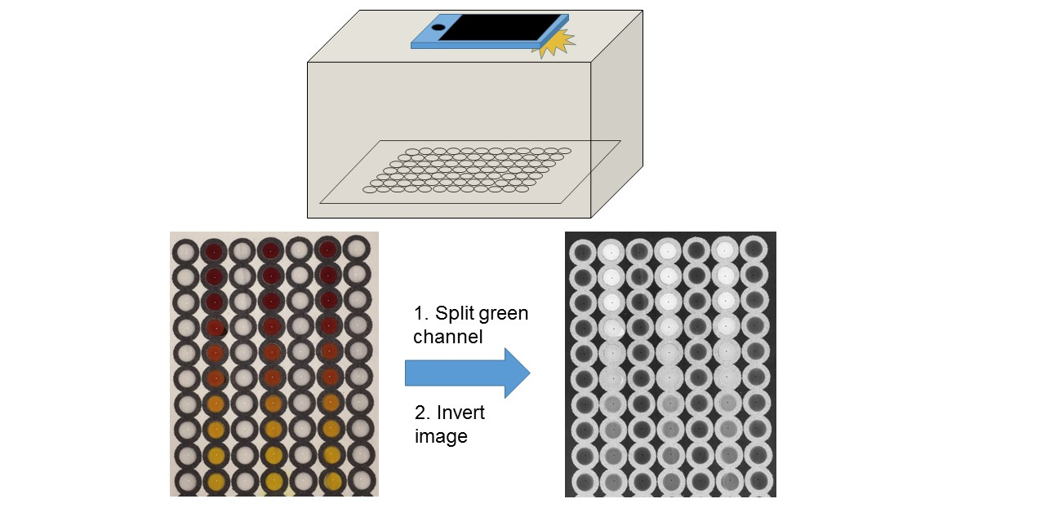
B
Figure S1 │ Device fabrication and Data Analysis. (A) Devices were developed by printing wax on Whatman grade 4 filter paper, then heated on a hot plate to melt the wax through the pores, creating a defined hydrophobic barrier. The back of the device sheet was then covered in packing tape to prevent sample leakage. (B) Devices were imaged using a cardboard box lined with copy paper and a hole on the top that allows for a camera to view and image the devices. These images were then wirelessly sent to a computer to analyze using ImageJ software.

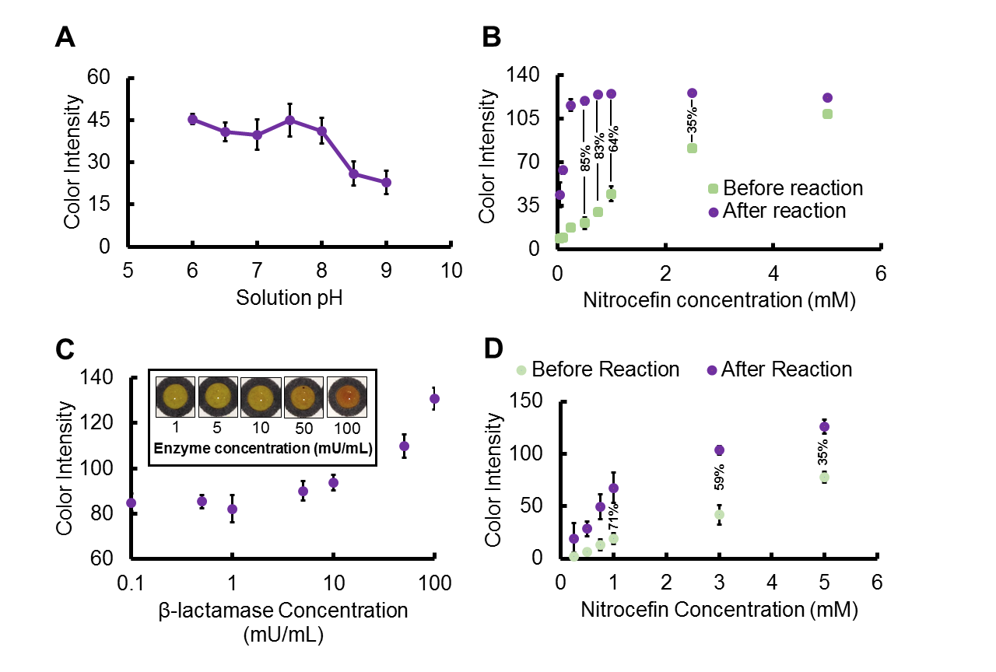
Figure S2 │ Nitrocefin and β-lactamase reaction optimization on paper. (A) β-lactamase enzyme was reacted with nitrocefin using different pH buffers to determine the optimal reaction pH where pH 7.5 was selected. (B) Optimal nitrocefin concentration was determined using change in signal from starting color intensity of nitrocefin alone (before reaction) and increase in color intensity (after reaction). Nitrocefin concentrations above 1 mM would be too dark before adding sample to distinguish between positive and negative samples, therefore a lower concentration of 0.5 mM was selected. (C) Different concentrations of β-lactamase enzyme were reacted with 0.5 mM nitrocefin to determine the lowest concentration of β-lactamase that could be detected before moving onto live bacteria. The enzyme limit-of-detection was determined to be around 10 mU/mL. (D) Optimal nitrocefin concentration to dry in paper was determined using change in signal similar to nitrocefin in solution. (E) The paper-based devices were used to determine kinetic values by reacting 1 U/mL of β-lactamase with nitrocefin between 0.1 and 0.7 mM. Error bars denote s.d. where n = 3 for all graphs.
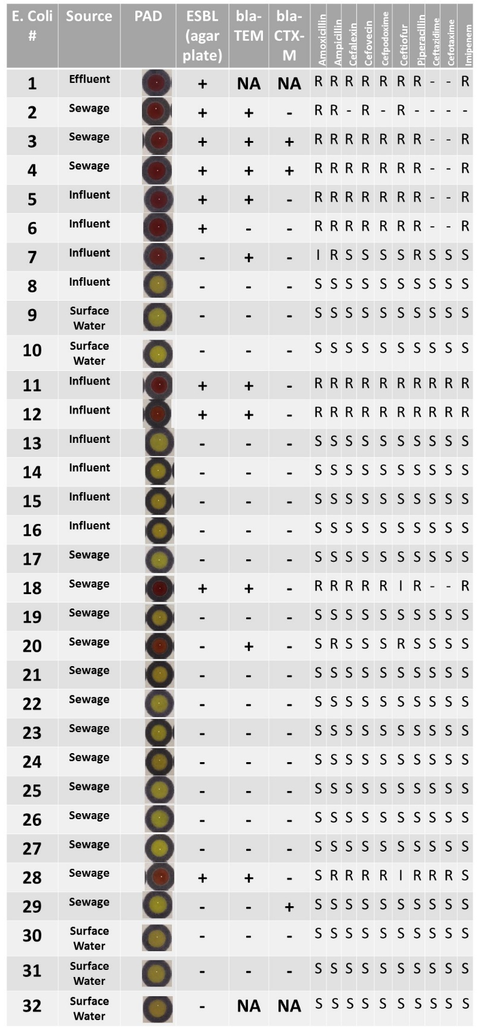
Figure S3 │ Comparing the PAD test to an ESBL-selecting plate, antibiotic susceptibility testing, and PCR gene analysis. According to ESBL-selecting plates, there were two false positives (#7 and #20). However, when compared to antibiotic susceptibility testing and PCR, these bacterial isolates were resistant to at least two penicillin antibiotics and had an ESBL gene in their genome.

References

[1] B. J. Geiss, A. A. Thompson, A. J. Andrews, R. L. Sons, H. H. Gari, S. M. Keenan, O. B. Peerson, J. Mol. Biol. 2009, 385, 1643-1654.
[2] J. C. Jokerst, J. A. Adkins, B. Bisha, M. M. Mentele, L. D. Goodridge, C. S. Henry, Anal. Chem. 2012, 84, 2900-2907.
[3] C. H. O'Callaghan, A. Morris, S. M. Kirby, A. H. Chingler, Antimicrob. Agents Chemother. 1972, 1, 283-288.
[4] H. Fang, F. Ataker, G. Hedin, K. Dornbusch, J. Clin. Microbiol. 2008, 46, 707-712.
[5] E. Amaya, D. Reyes, S. Vilchez, M. Paniagua, R. Mollby, C. E. Nord, A. Weintraub, J. Med. Microbiol. 2011, 60, 216-222.

