Appendix A. Survey and study populations

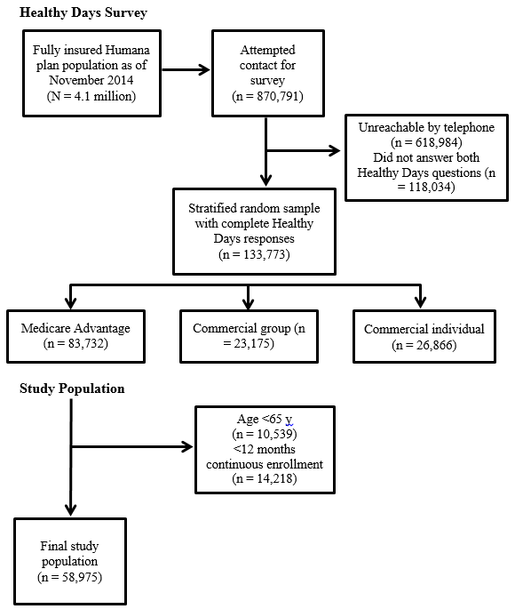
Appendix B. Diagnosis codes used to identify chronic conditions of interest
Chronic Condition | ICD-9 Codes
Chronic obstructive pulmonary disease | 491.0-491.22, 491.8, 491.9, 492.0, 492.8, 496, 518.1, 518.2
Coronary artery disease | 410.0-414.9, 429.5, 429.6, V4581-V4582
Congestive heart failure | 398.91, 402.01, 402.11, 402.91, 404.01, 404.11, 404.91, 415.0, 428.0-428.43, 428.9
Diabetes | V5867, 249.0-250.9
Hypertension | 401.0, 401.1, 401.9, 997.91
ICD-9, International Classification of Diseases, 9th Revision

