**Supplementary tables and figures**

**Table S1. List of SNPs validated by Sanger sequencing**.

|  |  |  |  |  |  |  |  |
| --- | --- | --- | --- | --- | --- | --- | --- |
| **Contig** | **SNP position** | **Gene identifier** | **Forward sequence (5'-3')** | **Reverse sequence (5'-3')** | **SNP reference / alternative** | **N\*** | **N\*\*** |
| DS113449 | 27735 | TVAG_197160 | TTGAATTGATGCGGGAAGAT | TTCAAACGCTGGCATCAATA | C/T | 16 out of 24 | 66.67 |
| DS113585 | 8390 | TVAG_168400 | TTGTTCGCAATCTCTGCTTG | CTAGCATTGACGAGGTCGATT | C/T | 21 out of 24 | 87.5 |
| DS113333 | 105154 | TVAG_364540 | TCCATCTGAATGAGTTGGTCA | TTCCGACTTTTCTTGTTGGT | C/T | 15 out of 24 | 62.5 |
| DS113315 | 43390 | TVAG_158720 | GCGAGGGTCATAACGTGAGT | TGAACTGTTGTGAAGCGAAGA | C/T | 15 out of 21 | 71.4 |
| DS113315 | 43417 | TVAG_158720 | GCGAGGGTCATAACGTGAGT | TGAACTGTTGTGAAGCGAAGA | G/T | 15 out of 21 | 71.4 |
| DS113630 | 56868 | TVAG_091200 | AACAATTTCACGCTTGAGCA | AGAAAAAGTAATGCACCGCC | C/A | 15 out of 20 | 75.0 |
|  |  |  |  |  |  | Total % accuracy: | 72.42 |

N*-No. isolates with matched SNP out of no. isolates successfully sequenced

N**-% match to ddRAD SNP

**Figure S1. Summary of analyses undertaken in this study. A.** Data sets and data analysis undertaken for *T. vaginalis.* **B.** Datasets and data analysis undertaken for *T. foetus.* ddRAD-Seq: double digest restriction-site associated DNA sequencing; WGS: whole genome shotgun sequencing; RNA-Seq: whole transcriptome sequencing.

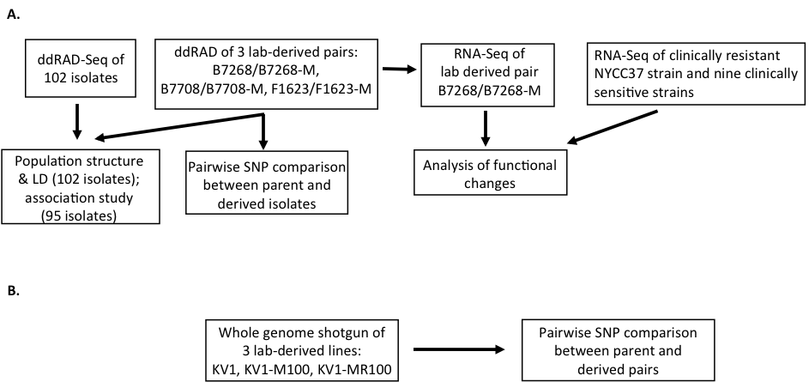

**Figure S2. Schematic representation of *in vitro*-induced Mz resistance in three *T. vaginalis* isolates, as described in [****1-3****].**



**Figure S3. Schematic representation of how the two *in vitro*-derived Mz resistant isolates KV1-M100 and KV1-1MR100 of *T. foetus* were generated from KV1, as described in reference [****4****].**



**Figure S4.** ***In silico* determination of ddRAD restriction enzyme sites, fragment sizes, and number of fragments**. A. Number of restriction sites in the G3 reference strain for five restriction enzymes. The x-axis represents the restriction enzyme, and the y-axis the log10 of number of the sites calculated as existing in either repetitive or unique regions of the genome. **B.** Fragment size and number for EcoRI and NlaIII ddRAD enzyme pairs. **C.** Fragment size distribution based on the G3 sequence.



**Figure S5.** **Flowchart describing processing of reads for SNP discovery.**

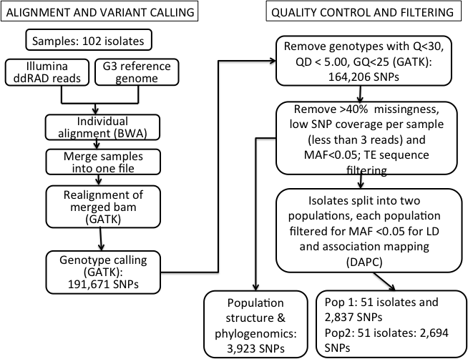

**References**

**1. Wright JM, Dunn LA, Kazimierczuk Z, Burgess AG, Krauer KG, Upcroft P, Upcroft JA: Susceptibility in vitro of clinically metronidazole-resistant Trichomonas vaginalis to nitazoxanide, toyocamycin, and 2-fluoro-2'-deoxyadenosine. *Parasitol Res* 2010, 107:847-853.**

**2. Brown DM, Upcroft JA, Dodd HN, Chen N, Upcroft P: Alternative 2-keto acid oxidoreductase activities in Trichomonas vaginalis. *Mol Biochem Parasitol* 1999, 98:203-214.**

**3. Voolmann T, Boreham P: Metronidazole resistant Trichomonas vaginalis in Brisbane. *Med J Aust* 1993, 159:490.**

**4. Kulda J, Cerkasov J, Demes P, Cerkasovova A: Tritrichomonas foetus: stable anaerobic resistance to metronidazole in vitro. *Exp Parasitol* 1984, 57:93-103.**