***Supplemental Information***

Rapid Elemental Analysis of Aerosols Using Atmospheric Glow Discharge Optical Emission Spectroscopy

Lina Zheng and Pramod Kulkarni*

Centers for Disease Control and Prevention, National Institute for Occupational Safety and Health, Cincinnati, OH, US

* Author to whom correspondence should be addressed to: Phone: (513) 841-4300; Fax: (513) 841-4545; Email: PSKulkarni@cdc.gov

**S.1 Voltage and current characteristics of the rf-GD system**

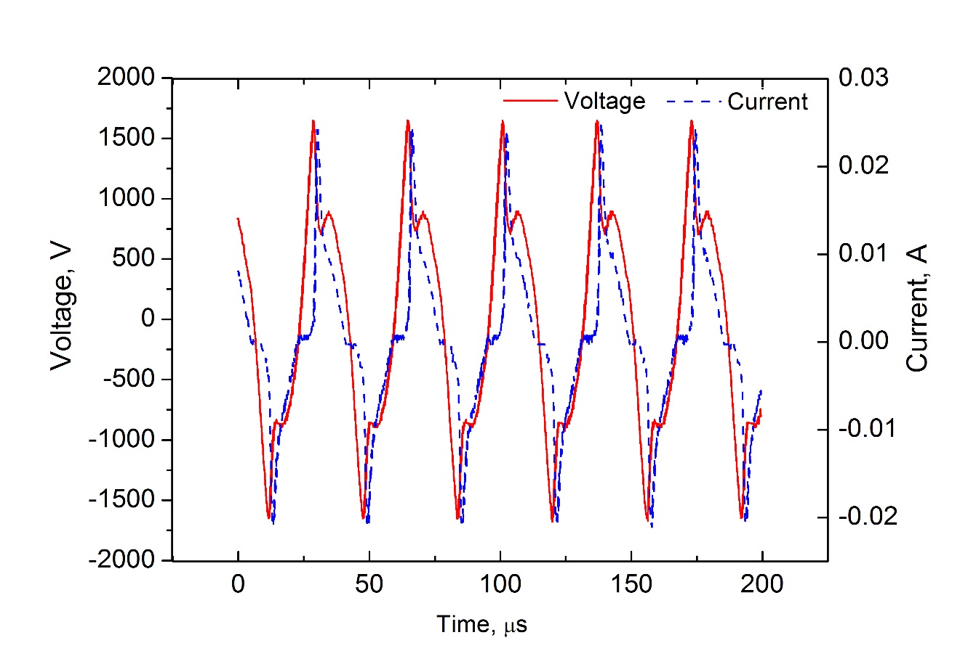

Fig. S-1 Voltage and current waveforms of the radio frequency glow discharge in argon gas at atmospheric pressure using a radio frequency power supply PVM500.

**S.2 Calculation of glow discharge gas temperature and electron density**

Gas temperature was determined from van der Waals broadening of the argon emission line at 603.2 nm.1-3 The profile of the spectral line Ar I 603.212 nm can be fitted to a Voigt function, which is the convolution of a Gaussian function and a Lorentzian function.1 Of various broadening mechanisms, instrumental broadening (${∆λ}_{I}$) and Doppler broadening (${∆λ}_{D}$) contribute to the Gaussian component (${∆λ}_{G}$), while Stark broadening (${ ∆λ}_{S}$) and Van der waals broadening (${∆λ}_{W}$) contribute to the Lorentzian component (${∆λ}_{L}$), as elucidated by the following equations: 2

= + (1)

(2)

Gaussian and Lorentzian components were separated from the deconvolution of fitted Voigt profile based on the Leverberg-Marquardt non-linear algorithm for least squares. Fixing the Gaussian component has been shown to increase the accuracy of deconvolution.4 In a glow discharge plasma with low temperature, Doppler broadening was estimated to be 0.003 nm by means of the following equation5 (assuming T=2000K), which is negligible.

${∆λ}_{D}=7.16 × {10}^{-7} λ{(\frac{T}{M})}^{1/2}$ (3)

where $λ$ is the wavelength (nm), $T$ is the temperature (K), and *M* isthe Ar atomic mass (a.m.u.). Therefore, Gaussian width was mainly caused by instrumental broadening, which was 0.05 nm for our instrument. Lorentzian width of the emission peak for Ar I 603.212 nm was obtained from the deconvolution of a fitted Voigt profile by fixing the Gaussian component at 0.05 nm. As the contribution of Stark broadening to Lorentzian width was negligible for 603.2 nm emission line,1 van der Waals broadening was determined as the Lorentzian width, which was in a range of 0.03 – 0.07 nm varying with interelectrode distance. A simplified equation between the gas temperature ($T_{g})$ and the van der Waals broadening of a given spectral line was given by6

(4)

where $C_{W}$ is a coefficient that depends on the transition and the nature of the interacting atoms considered; $C_{W}=4.217$ nm for Ar I (603.21 nm).7

Stark broadening of Hβ (486.133 nm) was used for electron density calculation. Stark broadening was obtained by subtracting van der Waals broadening from the Lorentzian width. The Lorentzian width of the emission peak for Hβ 486.133 nm was in a range of 0.08 – 0.18 nm varying with interelectrode distance. The van der Waals broadening of Hβ is given by8

(5)

where *P* is the gas pressure (Torr) and $T_{g}$ is the gas temperature (K). The calculated van der Waals broadening of Hβ was in a range of 0.03 – 0.08 nm. The Stark broadening was in a range of 0.05 – 0.10 nm. The Stark broadening is given by8

(6)

where is the electron density (cm-3) and is the reduced wavelength separation for the selected transition and is a function of both of the electron density and electron temperature. Generally, $α\left(n_{e},T_{e}\right)$ was assumed to be a constant (0.077) in a glow discharge plasma that has $T_{e}=$ 1–10 eV and 1013–1014 cm-3.8

**References**

(1) Munoz, J.; Dimitrijevic, M. S.; Yubero, C.; Calzada, M. D. *Spectrochimi. Acta B: At. Spectrosc.* **2009**, *64*, 167-172.

(2) Christova, M.; Castanos-Martinez, E.; Calzada, M. D.; Kabouzi, Y.; Luque, J. M.; Moisan, M. *Appl. Spectrosc.* **2004**, *58*, 1032-1037.

(3) Sismanoglu, B. N.; Amorim, J.; Souza-Correa, J. A.; Oliveira, C.; Gomes, M. P. *Spectrochimi. Acta B: At. Spectrosc.* **2009**, *64*, 1287-1293.

(4) Konjevic, N.; Ivkovic, M.; Sakan, N. *Spectrochimi. Acta B: At. Spectrosc.* **2012**, *76*, 16-26.

(5) Djurović, S.; Konjević, N. *Plasma Sources Science and Technology* **2009**, *18*, 035011(1-8).

(6) Hofmann, S.; van Gessel, A. F. H.; Verreycken, T.; Bruggeman, P. *Plasma Sources Sci. Technol.* **2012**, *21,* 065010(1-12).

(7) Yubero, C.; Dimitrijevic, M. S.; Garcia, M. C.; Calzada, M. D. *Spectrochimi. Acta B: At. Spectrosc.* **2007**, *62*, 169-176.

(8) Belostotskiy, S. G.; Ouk, T.; Donnelly, V. M.; Economou, D. J.; Sadeghi, N. *J. Appl. Phys.* **2010**, *107*, 053305(1-7).