**SUPPLEMENTARY MATERIALS**

**Title:** Defining the optimal dose of rifapentine for pulmonary tuberculosis: Exposure-response relations from two Phase 2 clinical trials

**Authors:** Radojka M. Savic, PhD,1 Marc Weiner, MD,2,3,\* William Mac Kenzie, MD,4 Melissa Engle,3 William C. Whitworth,4 John L. Johnson, MD,5,6 Pheona Nsubuga,6 Payam Nahid, MD,7,8 Nhung Viet Nguyen, MD,8 Charles A. Peloquin, PharmD,9 Kelly Dooley, MD,10 and Susan E. Dorman, MD,10 for the Tuberculosis Trials Consortium of the Centers for Disease Control and Prevention

Author Institutions:

1. University of California San Francisco School of Pharmacy, San Francisco, CA, USA
2. Veterans Administration Medical Center, San Antonio, TX, USA
3. University of Texas Health Science Center, San Antonio, TX, USA
4. Centers for Disease Control and Prevention, Atlanta, GA, USA
5. Case Western Reserve University School of Medicine and University Hospitals Case Medical Center, Cleveland, OH, USA
6. Uganda-Case Western Reserve University Research Collaboration, Kampala, Uganda
7. University of California San Francisco School of Medicine, San Francisco, CA, USA
8. National Tuberculosis Program, Hanoi, Vietnam
9. University of Florida, Gainesville, FL, USA
10. Johns Hopkins University School of Medicine, Baltimore, MD, USA

**Supplementary Methods**

**Microbiologic data**

Sputum samples were cultured by site laboratories on Löwenstein-Jensen solid medium and on liquid medium (Mycobacterial Growth Indicator Tube system, BACTEC MGIT 960, Becton Dickinson, Franklin Lakes, NJ, USA), as previously described.1,2

**Pharmacokinetic sampling**

We used 2 pharmacokinetic sampling protocols. Pharmacokinetic sampling was performed between 2 and 8 weeks of anti-TB treatment. With sparse sampling, 1 to 3 samples were obtained per participant (drawn at 2-4, 6-8, and 23-25 h after rifapentine doses); with intensive sampling, 7 samples were obtained (predose and 1, 2, 6, 9, 12, and 24 h after drug administration). Guidance in part for consumption of food before pharmacokinetic sampling was that food consumption be representative of how rifapentine was commonly taken at other study drug administrations. Site staff recorded detailed food histories and times with therapy and recorded food intake as high fat (> 27 g fat), lower fat (1 to 27 g fat), or fasting.

**Rifapentine and desacetyl rifapentine assays**

The plasma standard curves for rifapentine and its desacetyl rifapentine metabolite ranged from 0.50 to 100 μg/mL. The absolute recovery of rifapentine and desacetyl rifapentine from plasma was 95%. Within-sample precision was 2.85%, and validation precision across all standards ranged from 0.8% (0.50 μg/mL standard) to 3.1% (50 μg/mL standard) for rifapentine; precision for desacetyl rifapentine was similar to precision for rifapentine. All assays used prothionamide as internal standard. No interferences were observed with 90 drugs.

**Population pharmacokinetic and pharmacodynamic modeling**

Data were analyzed using a nonlinear mixed-effects approach with software (NONMEM, version 7, ICON, Dublin, Ireland). The first-order conditional estimation with interaction method was used. The pharmacokinetic parameters of rifapentine and desacetyl rifapentine were estimated for each phase 2 trial separately, and then data from both studies were analyzed jointly (**Figure S1**).3 The final population pharmacokinetic model contained covariates that met predefined statistical criteria and were clinically plausible (**Table S1**). Covariate effects were tested on the pharmacokinetic parameter clearance (CL), metabolite clearance, and bioavailability. Individual post hoc Bayesian estimates of pharmacokinetic parameters, including area under the concentration-time curve (AUC) and maximum concentration, were derived from the model. For subsequent pharmacokinetic modeling, individual AUC from participants in Study 29 were adjusted to account for drug administration on 5 of 7 days per week, compared with participants in Study 29X in which drugs were administered 7 days per week.

The pharmacokinetic model used 2203 rifapentine and metabolite (desacetyl rifapentine) concentrations from 405 tuberculosis participants. An initial base model structure was established using the full pharmacokinetic profile data from rifapentine. A compartmental model with first-order absorption and elimination was used to describe pharmacokinetics of rifapentine. A relative bioavailability parameter was estimated for each dose level relative to the lowest dose administered (450 mg). After the rifapentine model was established, the data for desacetyl rifapentine were added. The basic model structure for desacetyl rifapentine was a 1-compartment disposition model with linear formation and elimination rate (**Figure S1**). After the base model was built, all data were fitted simultaneously and model parameters were estimated using all pharmacokinetic data. Parameters were assumed to be log-normally distributed. Diagonal and full variance-covariance blocks of the parameter distributions were investigated. Additive, proportional, and combined error models were evaluated for residual variability.

**Development of the pharmacokinetic/pharmacodynamic models**

Covariates were identified by an automated procedure with Stepwise Covariate Model software (PsN, SourceForge, Slashdot Media, San Francisco, CA, USA), and linear and nonlinear relations were tested stepwise with forward inclusion (difference in objective function values [ΔOFV], 5.99; *P* ≤ .01 for 1 degree of freedom) and backward exclusion (ΔOFV, 10.83; *P* ≤ .001 for 1 degree of freedom). With categorical covariates, ΔOFV at the noted *P* values may have varied with the degrees of freedom. The final models contained covariates that met the predefined statistical criteria (as described above) and were retained because of clinical relevance, defined by impact of covariate on parameter > 10%. Demographic and clinical factors were tested in the models (**Table S1**), and covariate analyses of pharmacokinetic parameters were performed for clearance, bioavailability, and absorption rate constant (**Table S5**). Pharmacodynamic models for rifampin were constructed with methods similar to methods for rifapentine models (**Table S8**).

**Summary data analyses**

Analyses of data were performed with statistical software (SAS, version 9.3, SAS Institute Inc., Cary, NC, USA). Differences between groups were determined using the Wilcoxon rank sum test for continuous variables and chi-squared test for categorical data. Statistical significance was defined by *P* ≤ .05.

**Supplementary Results**

**Rifapentine pharmacokinetic sampling**

Sparse sampling was performed in 280 participants: 115 participants from Study 29 (rifapentine dose, 10 mg/kg) and 165 participants from Study 29X (57 participants at rifapentine 10 mg/kg, 55 participants at rifapentine 15 mg/kg, and 53 participants at rifapentine 20 mg/kg). Intensive sampling for rifapentine was performed in 103 participants: 43 participants from Study 29 (rifapentine dose, 10 mg/kg) and 60 participants from Study 29X (21 participants at rifapentine 10 mg/kg, 20 participants at rifapentine 15 mg/kg, and 19 participants at rifapentine 20 mg/kg).

**Rifapentine pharmacokinetic properties**

Rifapentine and metabolite pharmacokinetic parameters were well described with a 1-compartment model with first-order absorption, in which the metabolite was assumed to be formed by metabolism of the parent compound (**Figure S1**). The visual predictive check for both rifapentine and metabolite showed good agreement between observed data and data predicted by the model (**Figure S6**).

The estimated median rifapentine daily exposure for the 600-mg dose was 295 μg × h/L, 900 mg was 503 μg × h/L, and 1200 mg was 587 μg × h/L. Interindividual variability in rifapentine AUC0-24 was high (coefficient of variance [CV] of 21%), resulting in more than 4-fold variation in rifapentine exposures for a given dose. For rifapentine at 600 mg daily for 7 days, the area under the concentration-time curve from 0 to 168 hours (AUC0-168) was greater in Study 29X (2373 μg × h/mL; doses with food, 7 days per week) than in Study 29 (1545 μg × h/mL; doses without food, 5 days per week). Food increased rifapentine bioavailability by 40%, and estimated rifapentine AUC0-24 was greater when drug was taken with a higher fat meal (> 27 g fat) than with a lower fat meal or fasting (**Figure S7**).

**Rifapentine pharmacokinetic/pharmacodynamic modeling on solid media**

Significant rifapentine exposure-response relations were observed using time-to-event with maximum inhibitory effect models. On solid media, the rifapentine exposure (AUC0-24) needed for 95% of participants to achieve persistently negative sputum cultures (AUC95) was dependent on baseline mycobacterial burden, as characterized by baseline sputum acid-fast bacilli (AFB) smear grade and cavity size (**Table S7**). The mean target rifapentine AUC0-24 for participants who had baseline AFB smears of sputum classified 0 to 1+ was 203 μg × h/mL for participants without lung cavities or with cavities < 4 cm and 293 μg × h/mL for participants who had cavities ≥ 4 cm in aggregate size. The mean target rifapentine AUC0-24 for participants who had sputum AFB smear 3+ was 313 μg × h/mL (small or no cavities) versus 451 μg × h/mL (large cavities). The maximum mean percent culture conversion to negative on solid media was 64% in participants who had less than the target rifapentine AUC95, baseline cough, and baseline Karnofsky performance scale score < 100 (**Table S6**). For the same group of participants, treatment times were 83 to 98 days to achieve stable conversion to negative cultures for 95% of participants (**Table S6**). In contrast, maximum mean percent culture conversion to negative was 91% to 97% with ≥ target rifapentine AUC95, baseline cough, and Karnofsky score < 100, and treatment times were 52 to 62 days to achieve persistently negative cultures for 95% of participants (**Table S6**).

**Achieving rifapentine target exposures on solid media**

To assess whether potential rifapentine target exposures were achieved, participants were grouped by rifapentine dose and food category (**Figure S7**). In participants taking rifapentine 1200 mg daily, 5% of participants taking drug with a high-fat meal, 10% participants with a lower fat meal, and 26% participants fasting were below rifapentine AUC0-24 of 313 μg × h/mL. Estimates of target rifapentine exposures were grouped by participant grade of AFB smear and radiographic size of lung cavities at baseline (**Table S7**). Rifapentine AUC0-24 of 313 μg × h/mL was the mean target exposure on solid media for participants who had cavity size < 4 cm and 3+ sputum smears (**Table S7**). In contrast, for participants who had cavity size ≥ 4 cm and grade 3+ sputum smears and who were taking 1200 mg rifapentine, 27% of participants who had a high-fat meal, 39% participants who had a lower fat meal, and 64% participants who were fasting were below the target rifapentine exposure AUC0-24 of 451 μg × h/mL (**Figure S7**).

**Rifampin pharmacodynamics on solid media**

Responses to rifampin-based TB treatment were modeled with sequential cultures of sputum on solid media. Baseline cough and extent of disease on chest radiographs were independent predictors of sputum culture conversion on solid media. Most study participants (mean 83%; 95% confidence interval: 72%-93%) who had baseline productive cough and chest radiograph infiltrate extent < 25% of lung area had negative sputum cultures after completion of 8 weeks of treatment. With more extensive disease on baseline chest radiographs, conversion to negative was observed in 69% of participants (95% confidence interval: 60%-78%) when the infiltrate was between 25% and 50% of lung area and 57% of participants (95% confidence interval: 47%-67%) when the infiltrate was > 50% of lung area.

**Supplementary References**

1. [Dorman, S.E](http://ovidsp.tx.ovid.com.libproxy.uthscsa.edu/sp-3.8.1a/ovidweb.cgi?&S=JLBKFPIIJPDDDCAJNCOKLCGCPDOCAA00&Search+Link=%22Dorman+SE%22.au.)., *et al*. Substitution of rifapentine for rifampin during intensive phase treatment of pulmonary tuberculosis: study 29 of the tuberculosis trials consortium. *J. Infect. Dis.* **206,** 1030-1040 (2012).

2. [Dorman, S.E](http://www.ncbi.nlm.nih.gov/pubmed?term=Dorman%20SE%5BAuthor%5D&cauthor=true&cauthor_uid=22850121)., *et al*. Daily rifapentine for treatment of pulmonary tuberculosis. A randomized, dose-ranging trial. [*Am. J. Respir. Crit. Care Med*](http://www.ncbi.nlm.nih.gov/pubmed/25489785)*.* **191,** 333-343 (2015).

3. de Kanter, C.T., *et al*. Viral hepatitis C therapy: pharmacokinetic and pharmacodynamic considerations. *Clin. Pharmacokinet.* **53,**409-427 (2014).

**Table S1. Variables assessed in pharmacokinetic and pharmacodynamic analyses**

|  |  |
| --- | --- |
| **Variable** | **Definition** |
| AFB smear | AFB smear grade per Table 1 (main paper) |
| Age | Age (y) |
| Alcohol | Excess alcohol use within past year at entry |
| BMI | Body mass index (kg/m2) |
| Cavity (category) | Lung, cavitary appearance on radiograph (none/unilateral/bilateral) |
| Cavity (2 groups) | Lung, cavitary appearance on radiograph (aggregate size < 4 cm vs ≥ 4 cm) |
| Cavity (3 groups) | Lung, cavitary appearance on radiograph (none; aggregate size < 4 cm; size ≥ 4 cm) |
| Cough, productive | Cough at entry (productive/nonproductive/none) |
| Drug use | Any illicit intravenous or nonintravenous drug use |
| Education | Education level |
| Ethnicity | Ethnicity |
| Extent, bilateral | Bilateral lung infiltrate |
| Extent of infiltrate (3 groups) | Extent of lung infiltrate (< 25%; 25% to < 50%; > 50% area) |
| Extent of infiltrate (2 groups) | Extent of lung infiltrate (< 50%; > 50% area) |
| Fever | Fever at enrollment into Study 29 or 29X |
| Food | Rifapentine taken with no food, low fat food with meal, or food with > 27 g fat with meal |
| Sex | Sex |
| HIV | Status of human immunodeficiency virus infection |
| Homeless | History of being homeless within past year |
| Interfering drugs | Any drugs that interact with antituberculosis medicine |
| Karnofsky | Karnofsky score |
| Karnofsky, groups | Karnofsky at enrollment analyzed by individual scores; groups for modeling selected by analysis of data |
| Race | Race category (Asian, black, white, other) |
| Region | Enrollment from African vs non-African study site |
| Smoking | History of cigarette smoking at study enrollment |
| Study | Study 29 vs 29X |
| Study arm | Rifapentine vs rifampin treatment arm |
| Unemployed | Unemployed within past 24 mo at enrollment in Study 29 or 29X |
| Weight | Weight (kg) |
| Weight, IPT | Weight (kg) at end of intensive-phase therapy |

**Table S2**. **Covariate analyses of pharmacokinetic parameters for clearance, bioavailability, and absorption rate constant\***

|  |  |  |  |  |
| --- | --- | --- | --- | --- |
| **Parameter of Rifapentine and Metabolite** | **Covariate** | **Univariate**  ***P*** | **Multivariate**  ***P*** | **Backward Selection**  ***P*** |
| CL | Age | .0001 | .0005 | .0005 |
|  | HIV infection | .03 | .03 | .03 |
|  | Race | .0003 |  |  |
|  | Sex | 2 × 10-5 | 10-6 | 1.2 × 10-7 |
| CL metabolite | Race | .002 | .03 |  |
| F | Race | 10-12 | 10-12 | 1.8 × 10-12 |
|  | Sex | .003 |  |  |
| ka | Race | .04 | .01 |  |
|  | Sex | .01 |  |  |

\*Data reported as *P* values. ***Abbreviations***: CL, rifapentine clearance; CL metabolite, rifapentine metabolite clearance; F, rifapentine bioavailability; HIV, human immunodeficiency virus; ka, absorption rate constant.

**Table S3. Relation between time to achieve stable culture conversion and treatment arm, rifapentine dose, and pharmacokinetic-based predictors**

|  |  |  |  |  |  |  |  |  |
| --- | --- | --- | --- | --- | --- | --- | --- | --- |
| **Predictor** | **Function** | **Liquid Media Culture** | | | **Solid Media Culture** | | | |
| **-2 log Likelihood** | **Df** | ***P*** | **-2 log Likelihood** | **Df** | ***P*** |
| Base model |  | 33524 |  |  | 113487 |  |  |
| Arm (mg/kg) | - | 33523 | 2 | .62 | 113470 | 2 | .0003 |
| Dose (mg) | - | 33521 | 3 | .39 | 113468 | 3 | .0003 |
| AUC | Linear AUC |  | 1 | 4 × 10-5 | 113453 | 1 | 9 × 10-9 |
|  | Emax AUC | 33506 | 2 | .0002 | 113453 | 2 | 4 × 10-8 |
|  | Sigmoidal Emax AUC | 33496 | 3 | 1 × 10-6 | 113446 | 3 | 1 × 10-9 |
|  | Step function (AUC ≥ 350 μg × h/mL) | 33496 | 1 | 2 × 10-7 | 113448 | 1 | 5 × 10-10 |
| Cmax | Linear Cmax | 33512 |  | .0005 | 113471 |  | 7 × 10-5 |
|  | Emax Cmax | 33511 |  | .002 | 113469 |  | .0001 |
|  | Sigmoidal Emax Cmax | 33502 | 3 | 2 × 10-5 | 113464 | 3 | 1 × 10-5 |
|  | Step function (> 16 µg/mL) | 33500 | 1 | 1 × 10-6 | 113470 | 1 | 4 × 10-5 |

**Estimated parameters for the pharmacokinetic/pharmacodynamic model for rifapentine and rifampin in adults with tuberculosis**

|  |  |  |
| --- | --- | --- |
|  | **Rifapentine Value**  **(RSE, %)** | **Rifampin**  **Value**  **(RSE, %)** |
| Scale | 0.0137 (4) | 0.01472 (3) |
| Shape | 2.04 (5) | 2.115 (4.6) |
| AUC50 | 313 (3) |  |
| Emax | -0.346 (27) |  |

***Abbreviations***: AUC, area under concentration-time curve; Cmax, maximum concentration; Df, degrees of freedom; Emax, maximal achievable effect.

**Table S4**. **Rifapentine pharmacokinetic/pharmacodynamic outcomes in liquid media of participants with baseline Karnofsky score of 100**

|  |  |  |  |  |  |
| --- | --- | --- | --- | --- | --- |
| **Rifapentine AUC0-24 \* (μg × h/mL)** | **Aggregate Cavity Size on Chest Radiograph (cm)** | **Study Site** | **Percent of Participants with Negative Cultures in Liquid Media at Completion of Intensive-Phase Therapy,**  **Mean [95% CI]** | **Time (d) Calculated for 50% Participants to Develop Stable Conversion to Negative Cultures in Liquid Media While Receiving Antituberculosis Treatment**  **[range: 5%, 95% participants]** | **Sample Size** |
| > 350 | < 4 | Not Africa | 100 [83, 100] | 27 [8, 52] | 12 |
| 325 | < 4 | Not Africa | 100 [83, 100] | 29 [9, 56] | 12 |
| < 300 | < 4 | Not Africa | 89 [50, 93] | 40 [12, 78] | 14 |

\*AUC0-24 computed as rifapentine dose/CL, and the AUC0-24 targets refer to daily drug administration 7 days per week.

Data are not shown for 14 other participants with Karnofsky score of 100 in 9 other groups that differed by AUC0-24, radiograph cavity size, and geographic region (1 to 3 participants per grouping). Data for participants with Karnofsky score ≤ 90 are displayed in Table 4 (main paper). ***Abbreviations***: AUC0-24, AUC from 0 to 24 h needed to achieve 95% maximum inhibitory effect in liquid media by conversion of sputum culture to persistently negative cultures; CL, clearance.

**Table S5. Covariate analyses for rifapentine pharmacokinetic and pharmacodynamic parameters with culture results from liquid and solid media**

|  |  |  |  |  |
| --- | --- | --- | --- | --- |
| **Parameter** | **Covariate** | ***P* (Univariate Selection)** | ***P* (Multivariate Stepwise Forward Selection)\*** | ***P* (Multivariate Backward Exclusion)†** |
| Liquid Culture |  |  |  |  |
| AUC50 | Cavity (3 groups) | .002 |  |  |
|  | Karnofsky | .002 | .007 |  |
|  | AFB smear | .0001 |  |  |
| AUC95 | Region (Africa) | .007 |  |  |
|  | Cavity (2 groups) | < 10-6 | 3 × 10-7 | 8 × 10-5 |
|  | Cavity (3 groups) | .00002 |  |  |
|  | Food | .002 |  |  |
|  | Karnofsky | .003 |  |  |
|  | Race | .003 |  |  |
|  | Cough, productive | .01 | .006 |  |
| Scale | Region | 1 × 10-5 | .007 | .0002 |
|  | Cavity (2 groups) | 6 × 10-6 |  |  |
|  | Cavity (3 groups) | .00001 |  |  |
|  | Extent of infiltrate | .002 |  |  |
|  | Food | .006 |  |  |
|  | Karnofsky | 6 × 10-5 | .0001 | .0005 |
|  | Race | .005 |  |  |
|  | AFB smear | 6 × 10-5 | .006 |  |
| Shape | Cavity (size ≥ 4 cm vs < 4 cm or no cavity) (2 groups) | .002 |  |  |
|  | Cavity (3 groups) | .009 |  |  |
|  | Race | .007 |  |  |
|  | Smoking history | .007 |  |  |
|  | Extent of infiltrate | .03 | .0016 | .0007 |
| Solid Culture | | | | | |
| AUC50 | Cough, productive | .009 |  |  |
|  | Cavity (size ≥ 4 cm vs < 4 cm or no cavity) (2 groups) | .0007 |  |  |
|  | Cavity (3 groups) | .002 | .000332 | .001 |
|  | AFB Smear | 3.4 × 10-8 | 3.4 × 10-8 | 1.9 × 10-10 |
| AUC95 | Cough, productive | .004 |  |  |
|  | Cavity (2 groups) | .0007 |  |  |
|  | Cavity (3 groups) | .002 |  |  |
|  | AFB smear | .009 |  |  |
| Scale | Cough (3 groups) | .0001 |  |  |
|  | Cough, productive | 4 × 10-5 | .0009 | 2.7 × 10-7 |
|  | Cavity (2 groups) | .006 |  |  |
|  | AFB smear | .002 |  |  |
| Shape | Food | .00008 | .00006 | .00001 |
|  | Race | .002 |  |  |
|  | Smoking history | .001 |  |  |
|  | Study | .0004 |  |  |

Pharmacokinetic and pharmacodynamic model parameters included maximal achievable effect, rifapentine area under the concentration-time curve to achieve 50% (AUC50) and 95% (AUC95) maximal achievable effect and baseline hazard function defined by scale and shape parameter. Pharmacokinetic and pharmacodynamic covariates were identified first in univariate analyses and then by an automated procedure with Stepwise Covariate Model software, and relations were tested with stepwise forward inclusion (\*) and backward exclusion (†).

***Abbreviations****:* AFB smear, baseline sputum acid-fast bacilli smear grade; Cavity (2 groups), radiographic lung cavitary status (aggregate size < 4 cm vs ≥ 4 cm); Cavity (3 groups), radiographic lung cavitary status (none; aggregate size < 4 cm; or aggregate size ≥ 4 cm); Cough (3 groups), no cough, nonproductive cough, and productive cough at baseline; Cough, productive, group at baseline with productive cough vs others; Extent of infiltrate, extent of lung infiltrate by radiography (≤ 25%; 25% to ≤ 50%; or > 50% lung area); Karnofsky grade (100 vs ≤ 90); Race (4 groups): Asian, black, white, other; Region, African vs non-African participants; Study, Study 29 vs Study 29X. Scale is pharmacodynamic parameter that defines baseline hazard at time zero, and Shape is the pharmacodynamic parameter that describes the hazard constant change with time.

**Table S6**. **Rifapentine pharmacokinetic and pharmacodynamic outcomes in solid media\***

|  |  |  |  |
| --- | --- | --- | --- |
| **Rifapentine AUC95 With Cultures on Solid Media** | **Study Drug Coadministered With Meal**  **(> 27 g fat)** | **Percent of Participants with Negative Cultures on Solid Media at Completion of Intensive-Phase Therapy,**  **Mean [95% CI]†** | **Time (d) Calculated for 50% Participants to Develop Stable Conversion to Negative Cultures on Solid Media While Receiving Antituberculosis Treatment**  **[range: 5%, 95% participants]‡** |
| ≥ | Yes | 97 [94, 99] | 31[12, 52] |
| ≥ | No | 91 [88, 95] | 29 [8, 62] |
| < | Yes | 64 [71, 56] | 49 [19, 83] |
| < | No | 64 [70, 58] | 46 [12, 98] |

\*Data reported as mean percent [lower, upper 95% confidence interval] or median treatment time [range: 5%, 95%]. Data reported as (†) mean percent [95% confidence interval] of participants with negative cultures on solid media at completion of intensive-phase treatment and (‡) median time [range: 5%, 95%] estimated for participants to develop negative cultures while receiving antituberculosis treatment. Participants with baseline cough and a Karnofsky score < 100 were grouped by the significant covariates of (1) rifapentine exposure ≥ or < AUC95 (identified in Table S5) and (2) study antibiotics taken or not taken with high-fat meal.

***Abbreviations****:* AUC, area under concentration-time curve; AUC95, AUC0-24 to achieve 95% maximum inhibitory effect on solid media by conversion of sputum culture to persistently negative cultures; CI, confidence interval.

**Table S7. Rifapentine area under the concentration-time curve from 0 to 24 hours estimated to achieve 95% of maximum inhibitory effect by conversion of sputum culture to negative on solid media\***

|  |  |  |  |
| --- | --- | --- | --- |
| **Sputum AFB Smear** | **Aggregate Cavity Size of Lung on Chest Radiograph (cm)** | **Mean AUC0-24, (μg × h/mL)**  **[Lower, Upper**  **95% CI]** | **Proportion of Participants in Study 29X by Group** |
| 4+ | ≥ 4 | 811 [747, 876] | 0.17 |
|  | < 4 | 564 [498, 629] | 0.19 |
| 3+ | ≥ 4 | 451 [420, 481] | 0.09 |
|  | < 4 | 313 [277, 350] | 0.13 |
| 0-1+ | ≥ 4 | 293 [282, 303] | 0.11 |
|  | < 4 | 203 [180, 227] | 0.31 |

\*Data reported as mean AUC0-24 [lower, upper 95% confidence interval]. Rifapentine was taken daily (7 d/wk). Participant groups differed by baseline sputum AFB smear grade and aggregate cavity size on chest radiographs. ***Abbreviations:*** AFB, acid-fast bacilli; AUC, area under concentration-time curve; AUC0-24, AUC from 0 to 24 h needed to achieve 95% maximum inhibitory effect on solid media by conversion of sputum culture to persistently negative cultures; CI, confidence interval.

**Table S8. Covariate analyses for rifampin pharmacodynamic parameters with culture results from liquid and solid media**

|  |  |  |  |  |
| --- | --- | --- | --- | --- |
| **Parameter** | **Covariate** | ***P* (Univariate Selection)** | ***P* (Multivariate Stepwise Forward Selection)\*** | ***P* (Multivariate Backward Exclusion)†** |
| Liquid Culture |  |  |  |  |
| Scale | Region | .000001 | .002 |  |
|  | Cough, productive | 3.42 × 10-9 | 3.4 × 10-9 | 5.8 × 10-9 |
|  | Extent of infiltrate (2 groups) | .007 |  |  |
|  | Extent of infiltrate (3 groups) | 1.33 × 10-7 | 2.3 × 10-7 | 2.3 × 10-7 |
|  | Food | .00007 |  |  |
|  | Karnofsky | .003 |  |  |
|  | Race | .00005 |  |  |
|  | AFB smear | .00002 |  |  |
| Shape | Region | .0002 |  |  |
|  | Cough (3 groups) | .0002 |  |  |
|  | Cough, productive | .0004 |  |  |
|  | AFB Smear | .007 |  |  |
| Solid Culture |  |  |  |  |
| Scale | Cough, productive | .00001 | .00001 | .00007 |
|  | Extent of infiltrate (2 groups) | .00004 |  |  |
|  | Extent of infiltrate (3 groups) | .00001 | .00007 | .00007 |
|  | AFB Smear | .008 |  |  |

Pharmacodynamic model parameters included maximal achievable effect and baseline hazard function defined by scale and shape parameter. Pharmacodynamic covariates were identified first in univariate analyses and then by an automated procedure with Stepwise Covariate Model software, and relations tested with stepwise forward selection (\*) and backward exclusion (†).

***Abbreviations***: AFB smear, baseline sputum acid-fast bacilli smear grade; Cavity (2 groups), radiographic lung cavitary status (aggregate size < 4 cm vs ≥ 4 cm); Cavity (3 groups), radiographic lung cavitary status (none; aggregate size < 4 cm; or aggregate size ≥ 4 cm); Cough (3 groups), no cough, nonproductive cough, and productive cough at baseline; Cough, productive, group at baseline with productive cough vs others; Extent of infiltrate, extent of lung infiltrate by radiography (≤ 25%; 25% to ≤ 50%; or > 50% lung area); Karnofsky grade (100 vs ≤ 90); Race (4 groups): Asian, black, white, other.

**Figure S1**. Modeling strategy for rifapentine and desacetyl rifapentine (metabolite) in participants treated for tuberculosis in Tuberculosis Consortium Trials 29 and 29X. ***Abbreviations****:* CL, clearance; CLm, metabolite clearance; k, rate constant; ka, absorption rate constant; km, metabolite rate constant; V, rifapentine volume of distribution; Vm, metabolite volume of distribution.



**Figure S2**. Relation between rifapentine clearance and body weight. Individual difference is calculated as log (individual clearance) – log (population clearance).

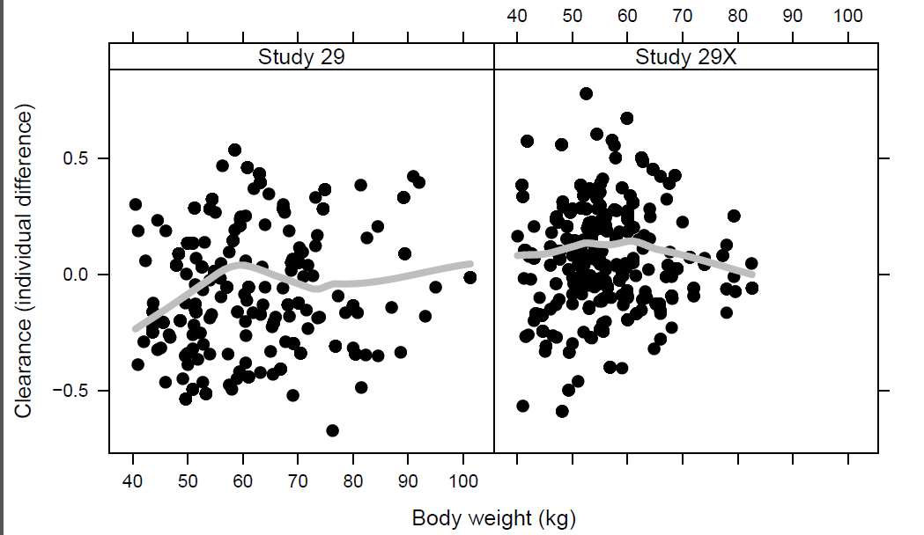

**Figure S3.** Forest Plot showing relative effects of demographic and clinical covariates on rifapentine area under the concentration-time curve from 0 to 24 h (AUC0-24). The median AUC0-24 [5%, 95% confidence interval] was estimated for a 31-year-old black male without human immunodeficiency virus (HIV) infection (bottom row).



Median rifapentine AUC0-24 [5%, 95% CI]

**Figure S4.** Relation between rifapentine area under the concentration-time curve from 0 to 24 h (AUC0-24) versus proportion of participants with no or small lung cavities **(A)** or Large Lung Cavities **(B)** with negative sputum cultures after completion of 8 weeks of multidrug therapy. Results are indicated for both liquid (orange) and solid (gray) media (mean, dark line; 95% confidence interval, shaded area). The proportions of all control participants treated for 8 weeks with rifampin who had negative cultures in liquid media (orange arrow) was 57% and on solid media (gray arrow) was 78%. Data for participants with large cavities on solid media were estimated for grade 4 acid-fast bacilli smear from baseline sputum.

**Figure S4A.**

C:\Users\weiner\AppData\Local\Microsoft\Windows\Temporary Internet Files\Content.Outlook\HGD3KM9U\2_month_positivity_expresp_05162016 small no.tiff

**Figure S4B.**

C:\Users\weiner\AppData\Local\Microsoft\Windows\Temporary Internet Files\Content.Outlook\HGD3KM9U\2_month_positivity_expresp_large_05162016.tiff

**Figure S5**. Simulations of the relation between target exposure, rifapentine dose, estimated area under the concentration-time curve from 0 to 24 h (AUC0-24) and coadministration of food with study drug (Fast, fasting; Lfat [low fat], 1 to 27 g fat; Hfat [high fat], > 27 g fat). A red line indicates a target rifapentine AUC0-24 (> 350 μg × h/mL) needed for 95% participants to achieve persistently negative cultures in liquid media. Estimated rifapentine AUC0-24 are illustrated for rifapentine dose of 1200 mg daily to all participants (Flat) versus adjusted doses of 1800 mg daily to participants of black race and 1200 mg daily in other participants (AdjDose).



**Figure S6**. Visual predictive check for concentrations of rifapentine (parent, left panel) and desacetyl rifapentine (metabolite, right panel). Solid lines represent median of observed data. Dotted lines are 5th and 95th percentile of the observed data. Middle gray shaded areas represent simulated median with uncertainty (for 500 repetitions of visual predictive check). Lower and upper tan shaded areas represent simulated 5th and 95th percentile with uncertainty.

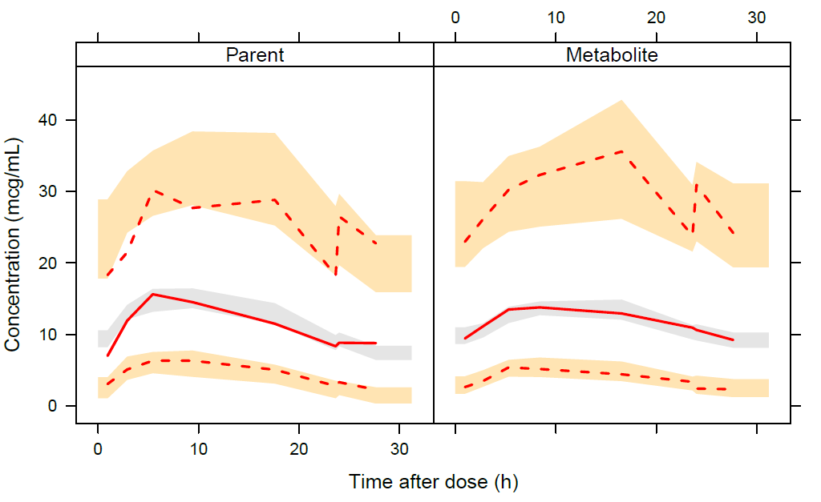

**Figure S7**. Rifapentine area under the concentration-time curve from 0 to 24 hours (auc0-24) estimated from rifapentine dose and food intake. Rifapentine doses were 900 or 1200 mg. Food intake was high fat (hf, > 27 g fat), lower fat (lf, 1 to 27 g fat), or fasting (fast). Target rifapentine AUC0-24 needed for 95% participants to achieve persistently negative cultures (AUC95) in solid media cultures are indicated by the 4 horizontal lines. The percent participants below target rifapentine AUC95 by rifapentine dose and food intake are indicated in the table at the bottom of the figure. AUC0-24 computed as rifapentine dose/CL, and the target AUC0-24 is for daily drug administration 7 days per week. ***Abbreviation***: CL, clearance.

