Supplemental tables, figures and figure captions
Beer, et al. Giardiasis diagnosis and treatment practices among commercially insured persons in the United States

Table S1. | MarketScan® claims used in analyses, by claim type
Claims |  |  | ICD-9-CM code(s)ª | CPT code(s)^{b}
Symptoms and diagnoses
 | Giardiasis |  | 007.1
 | Intestinal infectious diseases^{c} |  | 001–009
 | Digestive system disorders |  | 520–529
 | Symptoms, signs and ill-defined conditions involving digestive system |  | 787
 | Nonspecific abnormal findings in stool content |  | 792.1
GI-related diagnostic tests
 | Fecal occult blood |  |  | 82274
 | Acid-fast stain for Cryptosporidium, Cyclospora, and Cystoisospora |  |  | 87015
 | Salmonella and Shigella culture |  |  | 87045
 | Aerobic bacterial culture |  |  | 87046
 | Anaerobic bacterial culture |  |  | 87075
 | Acid-fast stain for any pathogen |  |  | 87206
 | Microsporidia stain direct smear |  |  | 87207
 | Cryptosporidum indirect fluorescent antibody test (IFA) |  |  | 87272
 | Clostridium difficile enzyme immunoassay (EIA) |  |  | 87324
 | Cryptosporidum EIA |  |  | 87328
 | Escherichia coli EIA |  |  | 87335, 87427
 | Fecal white blood cell count |  |  | 89055
 | Upper GI endoscopy |  |  | Multiple^{d}
 | Colonoscopy |  |  | Multiple^{e}
Giardia-specific diagnostic tests
 | Giardia IFA |  |  | 86674
 | Ova and parasites microscopy test |  |  | 87177
 | Ova and parasites microscopy test with trichrome stain |  |  | 87209
 | Giardia direct fluorescent antibody test (DFA) |  |  | 87269
 | Giardia enzyme immunoassay (EIA) |  |  | 87329
ªInternational Classification of Diseases, ninth revision, clinical modification
^{b}Current Procedural Terminology
^{c}Intestinal infectious diseases excluding giardiasis (007.1)
^{d}Upper GI endoscopy CPT codes used, in descending claim frequency order: 43239, 43235, 91110, 43259, 43249, 44361, 43248, 43251, 44382, 43200, 43242, 43258, 43250, 43226, 43236, 43244, 43246, 43202, 43247, 44380, 43237, 44350, 43201, 43232, 43234, 43238, 43245, 43256, 44372, 44376, 44377
^{d}Colonoscopy CPT codes used, in descending claim frequency order: 45380, 45378, 45385, 45384, G0121, 45383, 45381, G0105, 45386, 45382, 45391, 44389, 45355, 45379

Table S2. EventFlow analysis of giardiasis patient care event sequences
 |  | All outpatients (n=2,995) |  | Age <18 yrs (n=910) |  | Age 18-64 yrs (n=2,085)
 |  | n | % | n | % | n | % | P
First Eventª
 | GI symptom | 1836 | 61.3 | 523 | 57.5 | 1313 | 63.0 | <0.001
 | Giardiasis diagnosis | 1291 | 43.1 | 392 | 43.1 | 899 | 43.1 | 0.582
 | Antiparasitic prescription | 666 | 22.2 | 137 | 15.1 | 529 | 25.4 | <0.001
 | Giardia test | 589 | 19.7 | 259 | 28.5 | 330 | 15.8 | <0.001
 | GI-related test^{b} | 505 | 16.9 | 165 | 18.1 | 340 | 16.3 | 0.536
 | Antibiotic prescription | 251 | 8.4 | 51 | 5.6 | 200 | 9.6 | <0.001
 | Antiparasitic or antibiotic | 854 | 28.5 | 181 | 19.9 | 673 | 32.3 | <0.001
ªEvent(s) occuring on the first date of giardiasis-related care and treatment during the 180-day study window. Percentages add to >100 because multiple events can occur on the same day.
^{b}Excluding Giardia-specific tests.

Figure S1. Example dataset in EventFlow showing 12 giardiasis patient sequences
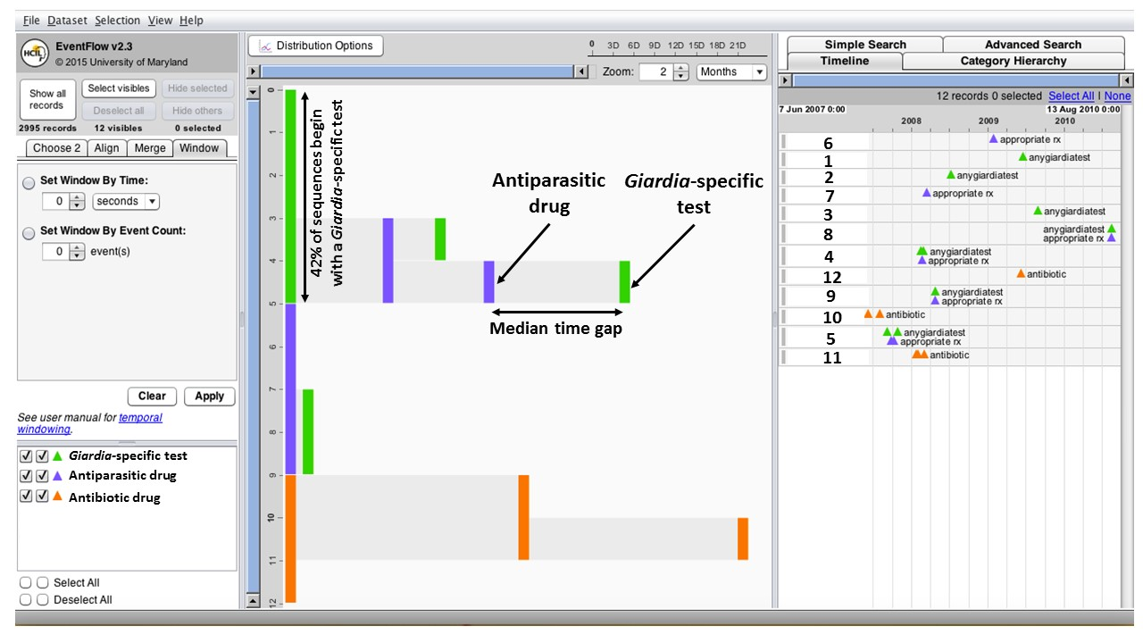

Figure S1. A screen shot of 12 giardiasis patients in EventFlow demonstrates how figures are constructed. A brief demonstration video also illustrates the process (http://go.umd.edu/eventflow-overview). On the far right, the timeline panel shows individual patient sequences with colored icons indicating each event. The center panel displays the EventFlow figure: all the patient sequences aggregated to a single window that enables visual pattern recognition, hypothesis generation and further analysis. The Y axis represents number of patients, and the X axis is time. Colored bars indicate individual events, and distance between bars is median time gap between events. Y axis values correspond with patient sequence numbers in the timeline panel (1–12), to aid understanding figure construction. The figure is created by aligning all sequences by the first event in each sequence (Time = 0) on the left side. The sequences are then sorted by the frequency of each event category. Here, the most common first event (n=5, 42%) is a giardia test, shown as a green vertical bar at the far left of the overview panel (patients 1–5 on the Y axis). Just below the green bar, a purple bar indicates that the next most common first event was an antiparasitic prescription (n=4, patients 6–9), and the orange bar at bottom left shows three patient sequences (patients 10–12) began with an antibiotic prescription. Sequences are then sorted again in the same way by frequency of their second event, then third event, and so on. In the figure, the top three patients (patients 1–3) have only one event (giardia test), and thus are shown as a single green bar. The next two patient sequences (patients 4 and 5) begin with a green bar (giardia test) followed by a purple bar (antiparasitic drug). However, patient 4 goes on to have another giardia test (3rd event, green bar) while patient 5 has another antiparasitic drug (3rd event, purple bar) followed by another giardia test (4th event, green bar). The far left panel enables users to customize the visual display and shows the color legend for each event.

Figure S2. EventFlow plot of event sequences for 2,995 giardiasis patients

Figure S2. EventFlow plot of giardiasis event sequences (N=2,995), showing all events for all cohort patients during the study window. Patient sequences (rows) are aggregated by sequence (event order), with each patient’s first event during the study window represented by a vertical bar at the far left, and subsequent events shown in order from left to right. For example, slightly less than 25% of patients had a GI symptom (light blue bar) followed by a diagnostic test (green bar) as their first two events. Distance between bars is equivalent to median time in days between events. Bar height represents the proportion of patients with a given sequence, and bar color represents event type. Bars with a pale blue background represent the interval between a patient’s first and last visit for a GI symptom, and patients may or may not have additional symptom visits during the interval. Only the initial giardiasis diagnosis used to center the study window is shown for each patient (magenta bars), and GI-related and Giardia-specific diagnostic tests are combined into a single category (green bars).

