**Supplemental Material**

**Acronyms and Abbreviations**

CO carbon monoxide

HAP household air pollution

ICS improved cookstove

PM2.5 fine particulate matter, particles with an aerodynamic diameter <2.5 micrometers

TCS traditional cookstove

UCB-PATS University of California Berkeley Particle and Temperature Sensor

**Quality Assurance**

*Instrument calibration*

Prior to deployment in the field, the UCB-PATS were calibrated against a DustTrak 8520 Aerosol Analyzer (TSI, Shoreview, MN, USA) in Berkeley Air’s laboratory and zeroed prior to each field deployment. The GasBadge was also calibrated in Berkeley Air’s lab with 20 ppm CO span gas and zeroed in the field prior to each deployment.

*Filter weighing*

At the beginning of each filter weighing session, a 100 mg calibration weight and three lab blanks were weighed.​​ ​Zeros were checked after every mass measurement. After every tenth sample, the balance’s reproducibility​ ​​was checked by reweighing the first filter in the previous batch of 10. All filters​ ​​were weighed twice.​ If​ ​​the first and second mass measurements differed by >​5 g (<1% of filters), filters​​ ​were weighed a third time.​ At the end of the session, the three lab blanks were re-weighed to assess drift.​ Field blanks (approximately 5% of the total number of samples) were collected and used for quality assurance.

**Kerosene lamp tests**

For the “near-field” test, two simple wick kerosene lamps and one large hurricane lamp were placed approximately 0.9 meters from two UCB and GasBadge monitor to measure PM2.5 concentrations continuously. All samplers were placed at the same level as the lamps and SUMS were placed on each of the lamps to monitor temperature. For the “far-field” test, the monitors were placed 1.0 m away from the lamps and 1.5 m above the ground. Continuous measurements were also conducted using two UCB and GasBadge monitors. For both tests, SUMs were also placed on the lamps. Eleven, 30-minute near- and far-field tests were conducted over a two day period. At the end of each day, a 30-minute water boil test was conducted on the open fire to serve as a comparison. In these tests, the UCB-PATS data did not undergo gravimetric adjustment.

Figure S1. Seven cookstoves assessed in study

3 stone fire (TCS) Eco Chula EcoZoom Envirofit Philips Pratki RTI TECA

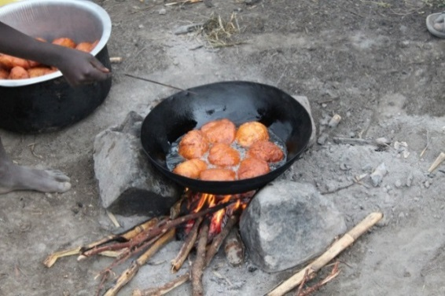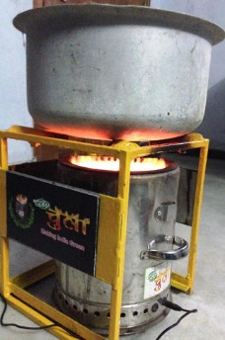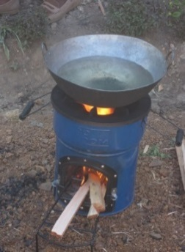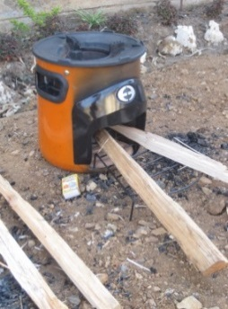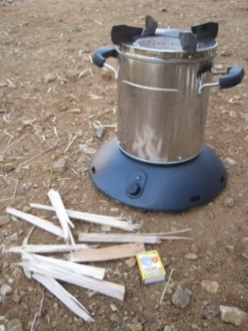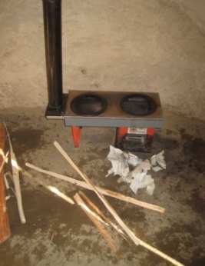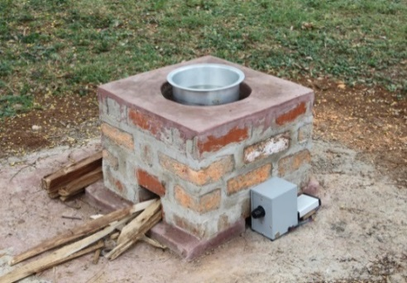

Table S1. Regression equations for instrument comparisons.

|  |  |  |  |
| --- | --- | --- | --- |
| **Stove** | **N** | **Regression equation** | **R2** |
| *PM2.5: UCB vs. gravimetric (kitchen)* | | | |
| All stoves | 256 | UCB=1.16*gravimetric + 177.4 | 0.86** |
| 3-stone Fire | 42 | UCB=1.32*gravimetric + 197.8 | 0.79** |
| Eco Chula | 35 | UCB=1.21*gravimetric + 164.2 | 0.90** |
| EcoZoom | 35 | UCB=1.11*gravimetric + 187.1 | 0.85** |
| Envirofit | 35 | UCB=0.71*gravimetric + 308.4 | 0.69** |
| Philips | 36 | UCB=1.31*gravimetric + 119.2 | 0.92** |
| Prakti | 38 | UCB=1.25*gravimetric + 96.0 | 0.94** |
| RTI TECA | 35 | UCB=1.05*gravimetric + 185.1 | 0.92** |
| *CO GasBadge and PM2.5 gravimetric (kitchen)* | | | |
| All stoves | 257 | Gravimetric=69.6*CO + 110.4 | 0.72** |
| 3-stone Fire | 44 | Gravimetric=146.8*CO + 70.9 | 0.76** |
| Eco Chula | 35 | Gravimetric=47.2*CO + 85.6 | 0.83** |
| EcoZoom | 37 | Gravimetric=43.0*CO + 300.2 | 0.48** |
| Envirofit | 34 | Gravimetric=95.4*CO – 29.8 | 0.90** |
| Philips | 35 | Gravimetric=43.0*CO + 300.2 | 0.79** |
| Prakti | 38 | Gravimetric=65.7*CO + 124.7 | 0.72** |
| RTI TECA | 34 | Gravimetric=110*CO – 111.5 | 0.88** |
| *CO: GasBadge and Draeger Color Diffusion Tube (mother)* | | | |
| All stoves | 238 | GasBadge=1.25*CO tube +0.66 | 0.71** |
| 3-stone Fire | 38 | GasBadge=1.05*CO tube +1.45 | 0.46** |
| Eco Chula | 35 | GasBadge=2.02*CO tube – 0.31 | 0.52** |
| EcoZoom | 33 | GasBadge=1.58*CO tube + 0.16 | 0.94** |
| Envirofit | 32 | GasBadge=4.39*CO tube -1.66 | 0.27* |
| Philips | 32 | GasBadge=1.13*CO tube +0.32 | 0.94** |
| Prakti | 34 | GasBadge=2.41*CO tube – 0.37 | 0.24* |
| RTI TECA | 34 | GasBadge=0.71*CO tube +1.43 | 0.06 |

Table S2. Distribution of 48-hour gravimetric PM2.5 (g/m3)and mean CO concentrations (ppm) in the kitchen.

|  |  |  |  |  |
| --- | --- | --- | --- | --- |
| **Stove Type** | **PM2.5 (g/m3)** | | **CO (ppm)** | |
| *N* | *Geometric mean*  *(95% CI)* | *N* | *Geometric mean*  *95% CI* |
| All stoves | 263 | 435 (391, 484) | 257 | 5.1 (4.6, 5.7) |
| 3 stone (TCS) | 45 | 586 (460, 747) | 44 | 6.5 (4.9, 8.5) |
| ICS only | 218 | 409 (363, 460) | 213 | 4.9 (4.3, 5.5) |
| Eco Chula | 36 | 518 (399, 674) | 35 | 5.4 (4.1, 7.2) |
| EcoZoom | 37 | 503 (368, 688) | 37 | 6.7 (4.9, 9.0) |
| Envirofit | 35 | 398 (307, 515) | 34 | 4.9 (3.9, 6.1) |
| Philips | 36 | 326 (246, 432) | 35 | 3.8 (2.8, 5.2) |
| Prakti | 39 | 374 (264, 539) | 38 | 4.5 (3.1, 6.6) |
| RTI TECA | 35 | 368 (278, 486) | 34 | 4.4 (3.4, 5.7) |

Table S3. Distribution of 48-hour personal exposures to CO (ppm), by stove type.

|  |  |  |  |  |
| --- | --- | --- | --- | --- |
| **Stove Type** | **Mother (GasBadge)** | | **Children (Draeger Tube)\*** | |
| *N* | *Geometric mean*  *(95% CI)* | *N* | *Geometric mean*  *95% CI* |
| All stoves | 237 | 1.3 (1.1, 1.4) | 239 | 0.8 (0.7, 0.8) |
| 3 stone (TCS) | 39 | 2.2 (1.7, 2.8) | 39 | 0.8 (0.7, 0.9) |
| ICS only | 198 | 1.1 (1.0, 1.3) | 200 | 0.8 (0.7, 0.8) |
| Eco Chula | 34 | 1.0 (0.7, 1.3) |  |  |
| EcoZoom | 34 | 1.3 (0.9, 1.8) |  |  |
| Envirofit | 34 | 1.1 (0.8, 1.6) |  |  |
| Philips | 30 | 1.1 (0.7, 1.5) |  |  |
| Prakti | 33 | 0.9 (0.6, 1.5) |  |  |
| RTI TECA | 33 | 1.4 (1.0, 2.1) |  |  |

*Concentrations by stove type not provided; >50% of samples at instrument limit of detection.

Table S4. Regression equations for personal and kitchen CO exposure comparisons.

|  |  |  |  |
| --- | --- | --- | --- |
| **Stove** | **N** | **Regression equation** | **R2** |
| *Mother vs. Kitchen (GasBadge)* | | | |
| All stoves | 242 | Mother CO=0.09*Kitchen CO + 1.34 | 0.07** |
| 3 stone (TCS) | 40 | Mother CO=0.50*Kitchen CO + 6.94 | 0.03 |
| Eco Chula | 35 | Mother CO=0.062*Kitchen CO + 0.84 | 0.17* |
| EcoZoom | 35 | Mother CO=0.05*Kitchen CO + 1.60 | 0.02 |
| Envirofit | 33 | Mother CO=-0.04*Kitchen CO + 1.88 | 0.23 |
| Philips | 31 | Mother CO=0.60*Kitchen CO - 1.11 | 0.65** |
| Prakti | 34 | Mother CO=0.06*Kitchen CO + 1.22 | 0.12* |
| RTI TECA | 34 | Mother CO=0.04*Kitchen CO + 1.89 | 0.01 |
|  | | | |
| *Child (Draeger Tube) vs. Kitchen (GasBadge)* | | | |
| All stoves | 233 | Child CO=0.01*Kitchen CO + 0.73 | 0.05** |

*p<0.05

**p<0.0001