eFigure. Sacramento County Trauma Triage Tool
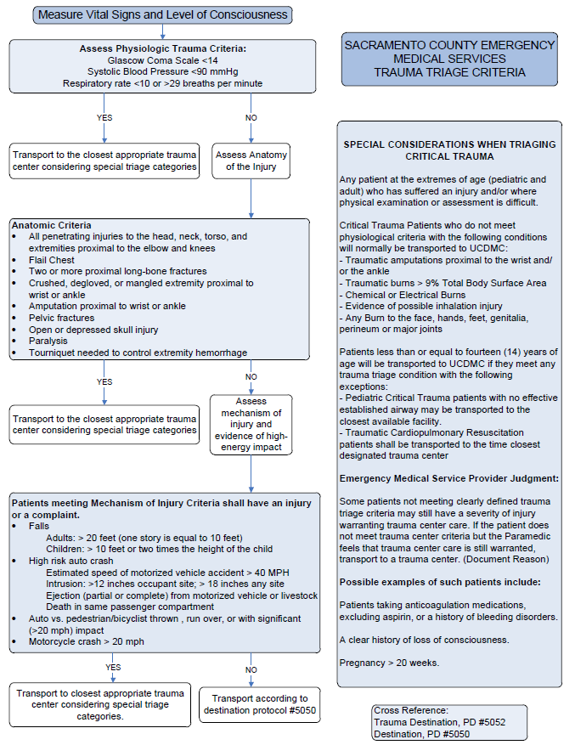

eTable 1. Interrater agreement for prehospital and ED/hospital variables, n=93
Characteristic | Percent agreement, n (%) | Kappa (95% CI)
Mechanism of injury | 87/93 (94) | 0.87 (0.78-0.94)
Prehospital documented warfarin use | 92/93 (99) | 0.96 (0.90-1.0)
Prehospital documented aspirin use | 91/93 (98) | 0.94 (0.93-1.0)
Prehospital initial GCS score | 92/93 (99) | 0.97 (0.92-1.0)
ED or hospital documented warfarin use | 92/93 (99) | 0.94 (0.83-1.0)
ED or hospital documented aspirin use | 91/93 (98) | 0.93 (0.83-1.0)
ED initial GCS score | 88/93 (95) | 0.78 (0.67-0.79)
Traumatic intracranial hemorrhage on cranial CT | 93/93 (100) | 1.0 (1.0-1.0)
In-hospital death or neurosurgery | 93/93 (100) | 1.0 (1.0-1.0)

Abbreviations: ED, emergency department, EMS, emergency medical services; GCS, Glasgow Coma Scale; CT, computed tomography; CI, confidence interval

eTable 2. Description of six patients who met Step 1-3 criteria and had a traumatic intracranial hemorrhage or the composite outcome measure but were not transported to a trauma center ª
Age, Sex | MOI | Anticoagulant/Antiplatelet agents | Initial EMS GCS score | Step 1-3 criteria met | EMS transport time | Cranial CT findings | ISS | Hospital Disposition | Composite outcome ^{b} | Death due to head trauma? | Transfer to Trauma Center? | Neuro-surgery?
89 M | Fall from standing | None | 15 | Physiological (SBP 80) | 17 | SDH | 17 | Discharged home, HD#3 | None | - | No | No
84 F | Fall from standing | None | 13 | Physiological (GCS 13) | 7 | IPH, SAH, herniation | 25 | Died, HD#3 | Death | Yes | No | No
82 F | Fall from standing | Warfarin, aspirin | 13 | Physiological (GCS 13) | 7 | SDH, IPH, SAH | 17 | Died, HD#3 | Death | Yes | No | No
66 F | Fall from standing | None | 12 | Physiological (GCS 12) | 8 | Normal | 0 | Died, HD#9 | Death | No | No | No
88 M | Fall from standing | None | 13 | Physiological (GCS 13) | 11 | Normal | 1 | Died, HD#1 | Death | No | No | No
80 M | Fall from standing | Clopidogrel | 10 | Physiological (GCS 10) | 23 | Normal | 2 | Died, HD#3 | Death | No | No | No
Abbreviations: tICH, traumatic intracranial hemorrhage; MOI, mechanism of injury; EMS, emergency medical services; GCS, Glasgow Coma Scale; CT, computed tomography; ISS, injury severity score; SBP, systolic blood pressure; SDH, subdural hematoma; IPH, intraparenchymal hemorrhage/contusion; SAH, subarachnoid hemorrhage; HD, hospital day
ª - Two patients had both tICH and composite outcome measure
^{b} – In-hospital death or neurosurgery

eTable 3. Trauma center triage in patients who did not meet Step 1-3 criteria and had anticoagulant or antiplatelet use, n=566
Medication | Triaged to trauma center, n (%) ª
Warfarin | 97/161 (60)
Direct oral anticoagulants ^{b} | 8/15 (53)
Aspirin | 186/350 (53)
Other antiplatelet agents ^{c} | 51/110 (46)
ª – includes concomitant medications
^{b} - Dabigatran, rivaroxaban, and apixaban
^{c} - Clopidogrel, ticlodipine, prasugrel, dipyridamole, cilostazol, and ticagrelor

eTable 4. Description of 24 patients who did not meet Step 1-3 criteria, had anticoagulant or antiplatelet use, had a traumatic intracranial hemorrhage or the composite outcome measure, and were not transported to a trauma center ª
Age, Sex | MOI | Anticoagulant/Antiplatelet agents | Initial EMS GCS score | EMS transport time | Cranial CT findings | ISS | Hospital Disposition | LOS (days) | Composite outcome ^{b} | Death due to head trauma? | Transfer to Trauma Center? | Neuro-surgery?
80 F | Fall from standing | Aspirin | 14 | 10 | SAH | 17 | Discharged SNF | 5 | None | - | No | No
84 F | Fall from standing | Warfarin | 14 | 17 | SAH | 21 | Discharged SNF | 9 | None | No | No | No
84 M | Fall from standing | Aspirin | 14 | 27 | IPH | 17 | Died | 3 | Death | Yes | No | No
69 M | Fall from standing | Aspirin | missing | 17 | SDH, IPH | 17 | Discharged home | 1 | None | - | No | No
82 M | Fall from standing | Clopidogrel | 15 | 18 | SDH | 17 | Discharged home | 3 | None | - | No | No
86 F | Unknown | Warfarin | missing | 15 | SDH, SAH | 17 | Discharged intermediate care facility | 3 | None | - | No | No
77 F | Fall from standing | Aspirin | 15 | 16 | IPH | 10 | Discharged home | 1 | None | - | No | No
91 F | Fall from standing | Aspirin | 14 | 19 | SAH | 10 | Discharged rehab facility | 9 | None | - | No | No
75 F | Fall from standing | Aspirin | 15 | 1 | SDH, IPH | 17 | Died | 1 | Death, neurosurgery | Yes | No | ICP monitor
84 M | Fall from standing | Clopidogrel, aspirin | 14 | 2 | SDH, IPH, SAH | 21 | Discharged home | 24 | None | - | No | No
84 M | Fall from standing | Aspirin | 15 | 15 | SDH | 17 | Discharged home | 1 | None | - | No | No
64 F | Fall from standing | Aspirin | 15 | 17 | SDH | 26 | Discharged home | 2 | None | - | No | No
72 M | Fall from standing | Clopidogrel | 15 | 13 | IPH | 16 | Died | 5 | Death | Yes | Yes | No
69 M | Fall from standing | Warfarin | 15 | 9 | SDH | 9 | Died | 11 | Death, neurosurgery | Yes | Yes | Subdural drain
94 F | Fall from standing | Clopidogrel, aspirin | 15 | 19 | SDH, SAH | 16 | Died | 6 | Death | Yes | No | No
81 M | Fall from standing | Aspirin | 15 | 13 | SDH | 17 | Discharged home | 2 | None | - | No | No
95 F | Fall from standing | Warfarin | 15 | 19 | SAH | 10 | Discharged SNF | 3 | None | - | No | No
86 F | Fall from standing | Aspirin | 15 | 3 | SDH | 17 | Discharged home | 1 | None | - | No | No
92 M | Fall from standing | Aspirin | 15 | 18 | Normal | 9 | Died | 2 | Death | No | No | No
82 M | Fall from standing | Clopidogrel, aspirin | 15 | 11 | SAH | 9 | Discharged home | 0 | None | - | No | No
56 M | Unknown | Warfarin | 15 | 5 | SDH | 21 | Discharged home | 3 | None | - | No | No
81 F | Fall from standing | Warfarin | 15 | 23 | IPH | 9 | Discharged home | 0 | None | - | No | No
71 F | Fall from standing | Aspirin | 15 | 20 | SDH, SAH | 17 | Discharged home | 3 | None | - | No | No
82 F | Fall from standing | Warfarin | 15 | 11 | SDH | 17 | Discharged SNF | 6 | None | - | No | No
Abbreviations: tICH, traumatic intracranial hemorrhage; MOI, mechanism of injury; EMS, emergency medical services; GCS, Glasgow Coma Scale; CT, computed tomography; ISS, injury severity score; SBP, systolic blood pressure; SDH, subdural hematoma; IPH, intraparenchymal hemorrhage/contusion; SAH, subarachnoid hemorrhage; LOS, length of stay; ICP, intracranial pressure
ª - Five patients had both tICH and composite outcome measure
^{b} - In-hospital death or neurosurgery

eTable 5. Description of 25 patients who did not meet Step 1-3 criteria, had no anticoagulant or antiplatelet use, had a traumatic intracranial hemorrhage or composite outcome measure, and were not transported to a trauma center ª
Age, Sex | MOI | Initial EMS GCS score | EMS transport time | Cranial CT findings | ISS | Hospital Disposition | LOS (days) | Composite outcome ^{b} | Death due to head trauma? | Transfer to Trauma Center? | Neuro-surgery?
55 M | Fall from standing | 15 | 12 | IPH | 10 | Discharged home | 3 | None | - | No | No
88 M | Fall from standing | 15 | 26 | EDH | 17 | Died | 3 | Death | Yes | No | No
95 M | Fall from height | 15 | 26 | Normal | 1 | Died | 0 | Death | No | No | No
89 F | Fall from standing | 15 | 3 | SDH | 21 | Discharged SNF | 3 | None | - | No | No
89 F | Fall from standing | 15 | 22 | IPH | 17 | Discharged SNF | 4 | None | - | No | No
94 M | Fall from standing | 15 | 12 | SDH | 17 | Discharged home | 1 | None | - | No | No
70 M | Unknown | 15 | 21 | SDH | 10 | Discharged home | 0 | None | - | No | No
55 F | Fall from standing | 15 | 14 | SAH | 20 | Discharged home | 6 | None | - | No | No
88 F | Fall from standing | 15 | 17 | SDH, IPH, SAH | 17 | Discharged SNF | 6 | None | - | No | No
78 F | Fall from standing | 15 | 18 | IPH | 9 | Discharged SNF | 2 | None | - | No | No
87 F | Fall from standing | 14 | 12 | IPH, SAH | 17 | Died | 3 | Death | Yes | No | No
87 F | Fall from standing | 15 | 6 | SDH, IPH, SAH | 26 | Died | 4 | Death | Yes | Yes | No
76 F | Fall from standing | 15 | 16 | SDH, IPH | 17 | Discharged home | 5 | None | - | Yes | No
85 M | Fall from standing | 14 | 16 | IPH, SAH | 10 | Discharged SNF | 5 | None | - | No | No
75 F | Fall from standing | 15 | 18 | SAH | 10 | Discharged SNF | 3 | None | - | No | No
104 F | Fall from standing | 15 | 23 | Normal | 0 | Died | 2 | Death | No | No | No
92 M | MVA > 35 mph | 15 | 14 | IPH, SAH | 21 | Discharged home | 1 | None | - | Yes | No
89 F | Fall from standing | 15 | 19 | SAH | 10 | Discharged home | 1 | None | - | No | No
88 F | Fall from standing | 15 | 14 | SAH | 17 | Discharged home | 2 | None | - | Yes | No
84 F | Fall from standing | 15 | 11 | Normal | 5 | Died | 2 | Death | No | No | No
63 F | Fall from standing | 15 | 13 | IVH | 17 | Discharged SNF | 3 | None | - | Yes | No
92 F | Fall from standing | 15 | 16 | SDH | 17 | Discharged SNF | 3 | None | - | No | No
91 M | Unknown | 15 | 11 | SDH, SAH | 18 | Discharged SNF | 30 | None | - | No | No
93 M | Unknown | 15 | 13 | SDH | 17 | Discharged home | 1 | None | - | No | No
77 M | Fall from standing | 14 | 14 | IVH | 17 | Discharged home | 1 | None | - | No | No
Abbreviations: tICH, traumatic intracranial hemorrhage; MOI, mechanism of injury; EMS, emergency medical services; GCS, Glasgow Coma Scale; CT, computed tomography; ISS, injury severity score; SBP, systolic blood pressure; SDH, subdural hematoma; IPH, intraparenchymal hemorrhage/contusion; SAH, subarachnoid hemorrhage; LOS, length of stay; ICP, intracranial pressure
ª - Three patients had both tICH and composite outcome measure
^{b} - In-hospital death or neurosurgery

eTable 6. Sensitivity analysis including only patients that received a cranial CT scan (n=1616); Test characteristics of a) Step 1-3 criteria, b) Step 1-3 criteria and anticoagulant or antiplatelet use, and c) actual transport to identify traumatic intracranial hemorrhage (n=131) or the composite outcome of death or neurosurgery during hospitalization (n=40)
 | Sensitivity |  | Specificity
 | n | % (95% CI) | n | % (95% CI)
Identification of traumatic intracranial hemorrhage
If only Step 1-3 criteria were used | 26/131 | 19.8% (13.9-27.5%) | 1349/1485 | 90.8% (89.3-92.2%)
If Step 1-3 + anticoagulant or antiplatelet criteria were used | 75/131 | 57.3% (48.7-65.4%) | 922/1485 | 62.1% (59.6-64.5%)
Actual transport | 83/131 | 63.4% (54.8-71.1%) | 676/1485 | 45.5% (44.4-48.1%)
Identification of death or neurosurgery
If only Step 1-3 criteria were used | 13/40 | 32.5% (20.1-48.0%) | 148/1576 | 90.6% (89.1-92.0%)
If Step 1-3 + anticoagulant or antiplatelet criteria were used | 28/40 | 70.0% (54.6-81.9%) | 966/1576 | 61.3% (58.9-63.7%)
Actual transport | 23/40 | 57.5% (42.2-71.5%) | 707/1576 | 44.9% (42.4-47.3%)

eTable 7. Sensitivity analysis including only patients with complete data (n=2047); Test characteristics of a) Step 1-3 criteria, b) Step 1-3 criteria and anticoagulant or antiplatelet use, and c) actual transport to identify traumatic intracranial hemorrhage (n=125) or the composite outcome of death or neurosurgery during hospitalization (n=40)
 | Sensitivity |  | Specificity
 | n | % (95% CI) | n | % (95% CI)
Identification of traumatic intracranial hemorrhage
If only Step 1-3 criteria were used | 26/125 | 20.8% (14.6-28.7%) | 1786/1922 | 92.9% (91.7-94.0%)
If Step 1-3 + anticoagulant or antiplatelet criteria were used | 75/125 | 60.0% (51.2-68.2%) | 1284/1922 | 66.8% (64.7-68.9%)
Actual transport | 79/125 | 63.4% (54.5-71.1%) | 939/1922 | 48.9% (46.6-51.1%)
Identification of death or neurosurgery
If only Step 1-3 criteria were used | 14/40 | 35.0% (22.1-50.5%) | 1859/2007 | 92.6% (91.4-93.7%)
If Step 1-3 + anticoagulant or antiplatelet criteria were used | 29/40 | 70.7% (55.5-82.4%) | 1323/2007 | 65.9% (63.8-67.9%)
Actual transport | 24/40 | 58.5% (43.4-72.2%) | 969/2007 | 48.2% (46.1-50.4%)

