Supplementary Table 1 Population characteristics of the NHANES III sample, stratified by AD case status as of 2011
 | All | Non-AD | AD | p-valueª
N | 4994 | 4892 | 102
Age (mean (SE)) (years) | 70.4 (0.25) | 70.3 (0.25) | 73.2 (0.85) | 0.003
Urinary cadmium (geometric mean (GSE)) (ng/mL) | 0.60 (1.03) | 0.60 (1.03) | 0.63 (1.11) | 0.58
Urinary creatinine (geometric mean (GSE)) (mg/dL) | 81.7 (1.01) | 81.6 (1.01) | 86.9 (1.11) | 0.55
Follow-up time (mean (SE)) (years) | 13 (0.22) | 13 (0.22) | 12.8 (0.66) | 0.70
Male | 43.5% | 43.6% | 39.3% | 0.46
Female | 56.5% | 56.4% | 60.7%
White | 84.7% | 84.6% | 86.1% | 0.62
Black | 8.1% | 8.2% | 5.6%
Others | 7.2% | 7.2% | 8.2%
Never smoker | 44.8% | 44.7% | 46.7% | 0.87
Past smoker | 40.1% | 40.1% | 40.4%
Current smoker | 15.1% | 15.2% | 12.8%
Less than high school ^{b} | 40.7% | 40.4% | 53.6% | 0.15
High school graduate or some college | 44.7% | 45.0% | 34.0%
College graduate or above | 14.5% | 14.6% | 12.4%

ª Comparisons were between AD cases and non-AD subjects. For categorical variables, p-values were obtained from Pearson's Chi-square test with Rao & Scott adjustment. For continuous variables, p-values were obtained from survey-weighted generalized linear models. Urinary cadmium and urinary creatinine were log-transformed in the models.
^{b} 29 missing in education level; all 29 were non-cases.

Supplementary Table 2 Urinary cadmium levels in population subgroups, NHANES III
 | N | Urinary Cadmium  (geometric mean (GSE)) (ng/mL) | P-valueª
Age (years)
60-64 | 1177 | 0.64 (1.05) | 0.006
65-69 | 1058 | 0.64 (1.04)
70-75 | 1166 | 0.57 (1.04)
76-90 | 1593 | 0.55 (1.04)
Male | 2467 | 0.62 (1.04) | ref
Female | 2527 | 0.58 (1.03) | 0.05
White | 2876 | 0.59 (1.03) | ref
Black | 995 | 0.69 (1.03) | 0.0003
Others | 1123 | 0.64 (1.10) | 0.35
Never smoker | 2332 | 0.45 (1.03) | ref
Past smoker | 1887 | 0.66 (1.03) | <0.0001
Current smoker | 775 | 1.10 (1.05) | <0.0001
Less than high school^{b} | 2780 | 0.65 (1.03) | ref
High school graduate or some college | 1677 | 0.61 (1.04) | 0.12
College graduate or above | 508 | 0.45 (1.06) | <0.0001

ª p-values were obtained through survey-weighted generalized linear regression. Urinary cadmium was log-transformed. The p-values for “Age” were from tests for linear trend over the four age categories.
^{b} 29 missing in education level. All 29 were non-cases.

Supplementary Table 3 Population characteristics of the NHANES III sample, stratified by AD case status within the first 12.7 years of follow-up
 | Non-AD | AD | p-valueª
N | 4950 | 44
Age (mean (SE)) (years) | 70.3 (0.25) | 75.6 (1.39) | .0008
Urinary cadmium (geometric mean (GSE)) (ng/mL) | 0.60 (1.03) | 0.72 (1.12) | .10
Urinary creatinine (geometric mean (GSE)) (mg/dL) | 81.5 (1.01) | 108.2 (1.10) | .005
Follow-up time (mean (SE)) (years) | 10 (0.10) | 8 (0.52) | .00003
Male | 43.5% | 49.0% | 0.53
Female | 56.5% | 51.0%
White | 84.6% | 93.9% | 0.13
Black | 8.2% | 1.8%
Others | 7.2% | 4.2%
Never smoker | 44.8% | 48.7% | 0.71
Past smoker | 40.2% | 41.8%
Current smoker | 15.2% | 9.5%
Less than high school ^{b} | 40.7% | 46.7% | 0.79
High school graduate or some college | 44.7% | 42.9%
College graduate or above | 14.5% | 10.3%

ª Comparisons were between AD cases and non-AD subjects. For categorical variables, p-values were obtained from Pearson's Chi-square test with Rao & Scott adjustment. For continuous variables, p-values were obtained from survey-weighted generalized linear models. Urinary cadmium and urinary creatinine were log-transformed in the models.
^{b} 29 missing in education level; all 29 were non-cases.

Supplementary Figure 1 Association between cadmium and AD mortality in men and women
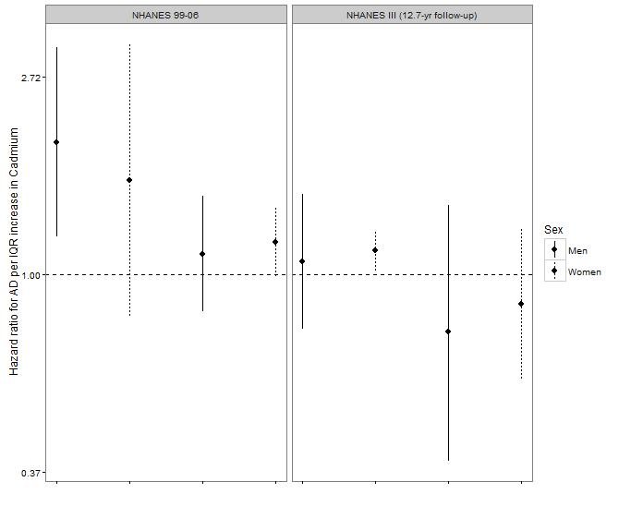
Urinary Cadmium
Blood Cadmium
Urinary Cadmium
(No creatinine in model)
Urinary Cadmium
(Creatinine in model)
Results came from analyses stratified by sex. Unless otherwise stated, all models were fully-adjusted. Note that a two-category race variable (“white” vs “non-white”) were used in all eight models presented here, and a two-category smoking variable (“ever” vs “never”) were used in the NHANES 99-06 models here because the number of cases in each sex stratum was small. It should be noted that among women in the NHANES 99-06 sample, when one AD case with extremely high urinary cadmium (2.37 ng/mL) and very short follow-up time (1.3 years) was removed, the HR in this stratum became much smaller (HR=1.35, 95% CI: 0.56, 3.21, p-value=0.49), instead of the HR=1.61 (95% CI: 0.81, 3.20, p-value=0.17) shown in the figure. Removing this observation from main analysis (i.e. regression models in Table 3) did not substantially alter results.

