Supplemental Information

Near-Real Time Measurement of Carbonaceous Aerosol Using Microplasma Spectroscopy: Application to Measurement of Carbon Nanomaterials

Lina Zheng^{a,b}, Pramod Kulkarni^{a*}, M. Eileen Birchª, Gregory Deyeª, Dionysios D. Dionysiou^{b}

ª Centers for Disease Control and Prevention,
National Institute for Occupational Safety and Health
4676 Columbia Parkway, MS R7
Cincinnati, OH, 45226

^{b} Environmental Engineering and Science Program, Department of Biomedical, Chemical and Environmental Engineering, University of Cincinnati,
Cincinnati, OH, 45221

¹Disclaimer—The findings and conclusions in this report are those of the authors and do not necessarily represent the views of the National Institute for Occupational Safety and Health. Mention of product or company name does not constitute endorsement by the Centers for Disease Control and Prevention.
* Author to whom correspondence should be addressed to: Phone: (513) 841-4300; Fax: (513) 841-4545; Email: PSKulkarni@cdc.gov

Table S-1: Description of carbon-containing materials used for calibration
Material | Manufacturer | Chemical composition | Density, g/cm³ | Carbon fraction by mass, %
Sucrose | Fisher Chemical | C₁₂H₂₂O₁₁ | 1.58 | 42
EDTA | Aldrich | C₁₀H₁₆N₂O₈ | 0.86 | 41
Caffeine | Aldrich | C₈H₁₀N₄O₂ | 1.23 | 49
Sodium Carbonate | Fisher Chemical | Na₂CO₃ | 2.54 | 11
Carbon black | Cabot | C | 1.8 | > 99
CNT (P7-SWNT) | Carbon Solutions | C | 2.1 | > 90

Table S-2 (a): Experimental parameters used in the SES systems
Spark energy | 200 mJ
Delay time | 5 µs
Integration time | 1 ms
Spectrometer wavelength range | 200–980 nm
Aerosol flow rate | 1.5 L min⁻¹
Operating voltage for corona | 5 kV
Distance between the electrodes | 5 mm
Diameter of corona electrode | 500 µm
Diameter of collection electrode | 1500 µm

Table S-2 (b): Experimental parameters used in the LIBS systems

Laser energy | 120 mJ
Laser wavelength | 532 nm
Delay time (LIBS) | 1.3 µs
Integration time | 1 ms
Spectrometer wavelength range | 200–980 nm
Aerosol flow rate | 1.5 L min⁻¹
Operating voltage for corona | 5 kV
Distance between the electrodes | 5 mm
Diameter of corona electrode | 500 µm
Diameter of collection electrode | 500 µm

The delay time for LIBS and SES systems was chosen for optimized signal-to-noise ratio. Our previous studies have demonstrated that the optimized signal-to-noise ratio could be obtained at the delay time of 1.3 us for LIBS method and 5 us for SES (Diwakar et al. 2012; Diwakar and Kulkarni 2012). The difference in delay times for the two systems is due to the difference in the spatial and temporal dynamics of the two microplasmas.

Table S-3: Comparison of different OC/EC thermal analysis methods
Method | OC Analysis |  |  | EC Analysis
 | Carrier gas | Temperature plateaus (°C) | Residence time (s) | Carrier gas | Temperature plateaus (°C) | Residence time (s)
Our method | N/A | N/A | N/A | Ambient air | 300 | 120
NIOSH Method 5040_TOT† (Birch 1998) | He | 250, 500, 600, 850 | 60,60,60, 90 | 2% O₂, 98% He | 650, 750, 850, 940 | 30, 30, 60, 120
IMPROVE_TOR (Chow et al. 2007) | He | 120, 250, 450, 550, | 150 – 580 | 2% O₂, 98% He | 550, 700, 800 | 150 – 580
STN_TOR/TOT (Chow et al. 2005) | He | 310, 480, 615, 900 | 60, 60, 60, 90 | 2% O₂, 98% He | 600, 675, 750, 815, 920 | 45, 45, 45, 45, 120
HKUST-3_TOT (Chow et al. 2005) | He | 250, 550, 650, 850 | 150, 150, 150, 110 | 1% O₂, 98% He | 650, 750, 850, 890 | 150, 150, 150, 150
TMO (Fung et al. 2002) | He | 120, 525 | 180, 300 | 2.5% O₂,  97.5% He | 750 | 180
TGA (Lapuerta et al. 2007) | N₂ | 450 | Heating rate: 3 °C per min | Ambient air | 500 | 1800
TGA (Iwatsuki et al. 1998) | Ambient air | 430 | 3600 | Ambient air | Continuous (430 to 800) | Heating rate: 10 °C per min
ACE-Asia_TOT (Schauer et al. 2003) | He | 340, 500, 615, 870, oven off | 60, 60, 60, 90, 45 | 2% O₂, 98% He | 550, 625, 700, 775, 850, 900 | 45, 45, 45, 45, 45, 120
EUSAAR_TOT (Cavalli et al. 2010) | He | 200, 300, 450, 650 | 120, 150, 180, 180 | 2% O₂, 98% He | 500, 550, 700, 850 | 120, 120, 70, 80
Coulometric method (ZH1/120.44 1995) | N₂ | 200, 400, 550 | 120, 120, 240 | O₂ | 800 | 270
R&P 5400 (continuous analyzer) (Rupprecht et al. 1995) | Ambient air | 340 | 600 | Ambient air | 600 | 750
†Temperature steps and times may vary but give comparable OC-EC results (as single fractions). Maximum in helium: $≥$ 650 °C, with 850 °C typical. Maximum in O₂/He: 920 °C, but samples can oxidize at higher or lower temperatures. A manual OC-EC split may be required with some applications (NIOSH 2016).

Table S-4: Composition and liquid concentration of solutions A, B, C, and D used to produce test aerosols.

Samples | Carbon concentration in the solutions, µg/mL |  |  |  | Total atomic carbon concentration, µg/mL | EC/OC
 | CNT | Sucrose | EDTA | Caffeine
A | 40 | 1 | 1 | 1 | 43 | 13.3
B | 80 | 5 | 5 | 5 | 95 | 5.3
C | 120 | 15 | 15 | 15 | 165 | 2.7
D | 160 | 50 | 50 | 50 | 310 | 1.1

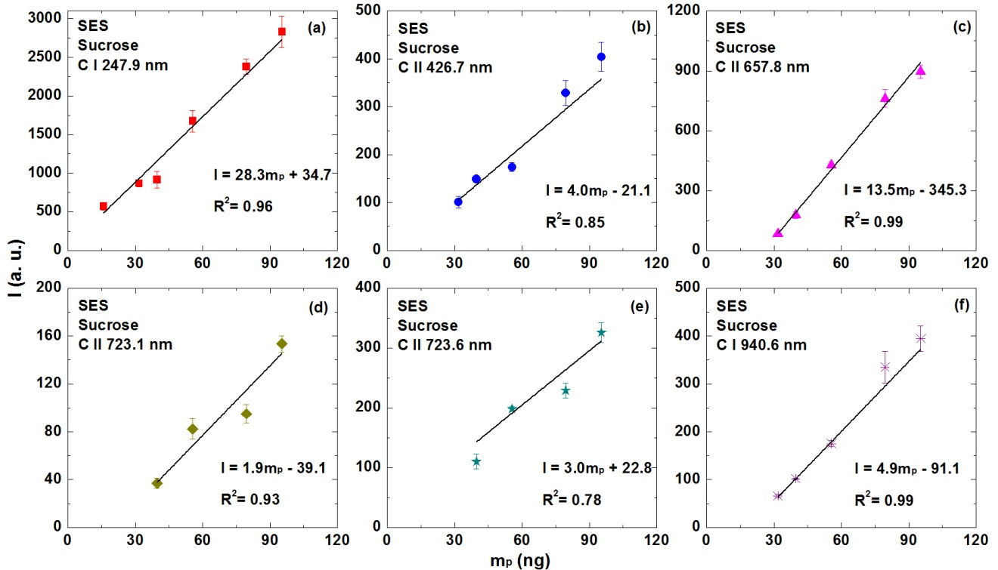
Figure S-1 (a-f). Changes in carbon signal intensity with carbon mass loading using sucrose as analyte, for different emission lines (x-axis represents carbon mass loaded on the collection electrode, ng; y-axis represents carbon signal intensity, arbitrary units [a. u.]).
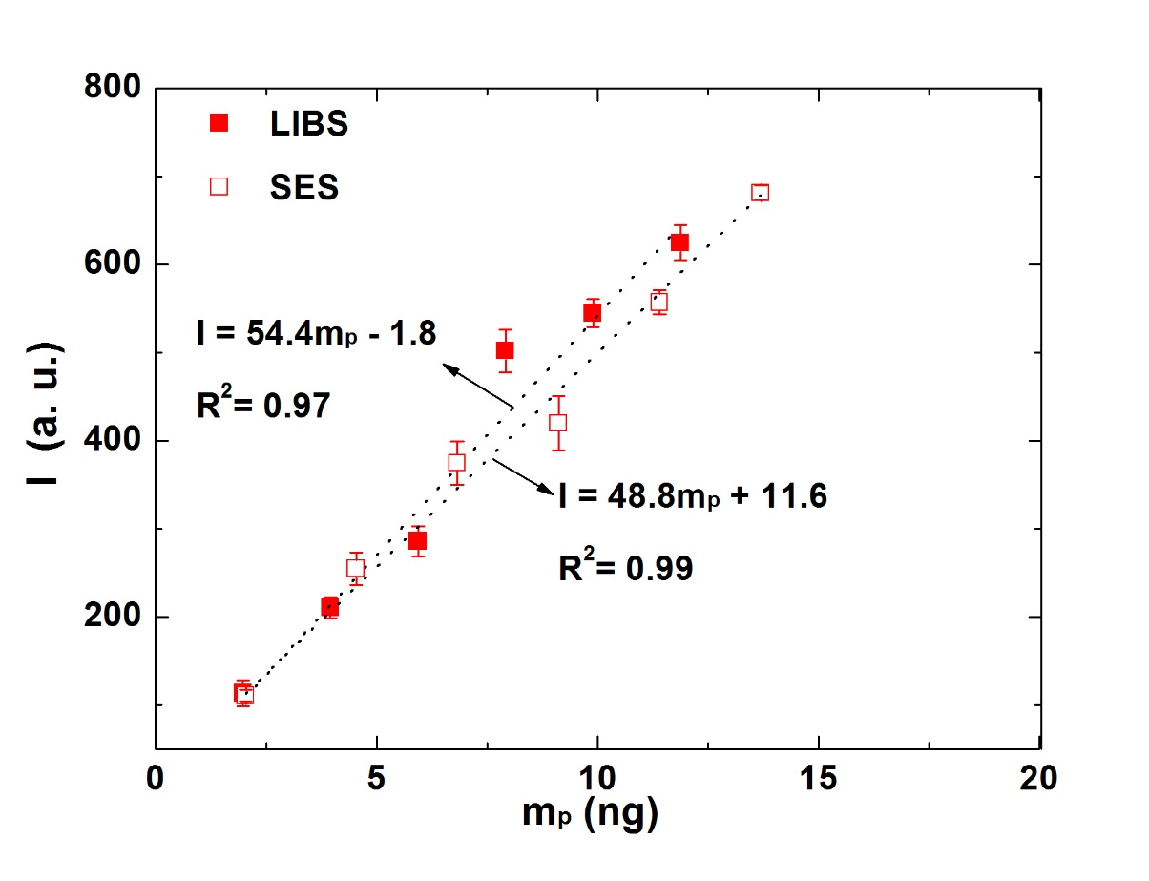
Figure S-2. Calibration curves for carbon black by LIBS and SES using the collection electrode with a diameter of 500 µm.
Figure S-2 shows calibration curves obtained from both microplasma systems, LIBS and SES, for carbon black particles using the 500 µm electrode. As mentioned earlier, the laser beam was oriented perpendicular to the longitudinal axis of the electrode. As discussed elsewhere (Diwakar et al., 2012), this orientation required a correction to account for mass loading in the shadow region. The correction factor was approximately 14% of the total mass collected on the tip (Diwakar et al. 2012) in our setup. In the SES system, no such correction was necessary due to the symmetrical nature of the ablation (about the longitudinal axis of the electrode). The sensitivity of LIBS measurements (for carbon black) is about 10% higher than that for SES measurements.

References
Birch, M. E. (1998). Analysis of Carbonaceous Aerosols: Interlaboratory Comparison. Analyst 123:851-857.
Cavalli, F., Viana, M., Yttri, K. E., Genberg, J., Putaud, J. P. (2010). Toward a Standardised Thermal-Optical Protocol for Measuring Atmospheric Organic and Elemental Carbon: the EUSAAR Protocol. Atmos. Meas. Tech. 3:79-89.
Chow, J., Watson, J., Chen, L.-W., Paredes-Miranda, G., Chang, M.-C., Trimble, D., Fung, K., Zhang, H., Zhen Yu, J. (2005). Refining Temperature Measures in Thermal/Optical Carbon Analysis. Atmos. Chem. Phys. 5:2961-2972.
Chow, J. C., Watson, J. G., Chen, L.-W. A., Chang, M. O., Robinson, N. F., Trimble, D., Kohl, S. (2007). The IMPROVE_A Temperature Protocol for Thermal/Optical Carbon Analysis: Maintaining Consistency with a Long-Term Database. J. Air Waste Manage. 57:1014-1023.
Diwakar, P., Kulkarni, P., Birch, M. E. (2012). New Approach for Near-Real-Time Measurement of Elemental Composition of Aerosol Using Laser-Induced Breakdown Spectroscopy. Aerosol. Sci. Tech. 46:316-332.
Fung, K., Chow, J. C., Watson, J. G. (2002). Evaluation of OC/EC Speciation by Thermal Manganese Dioxide Oxidation and the IMPROVE Method. J. Air Waste Manage. 52:1333-1341.
Iwatsuki, M., Kyotani, T., Matsubara, K. (1998). Fractional Determination of Elemental Carbon and Total Soluble and Insoluble Organic Compounds in Airborne Particulate Matter by Thermal Analysis Combined with Extraction and Heavy Liquid Separation. Anal. Sci. 14:321-326.

Lapuerta, M., Ballesteros, R., Rodríguez-Fernández, J. (2007). Thermogravimetric Analysis of Diesel Particulate Matter. Meas. Sci. Technol. 18:650.

Rupprecht, G., Patashnick, H., Beeson, D., Green, R., Meyer, M. (1995). A New Automated Monitor for the Measurement of Particulate Carbon in the Atmosphere. Proceedings, Particulate Matter: Health and Regulatory Issues:262-267.
Schauer, J. J., Mader, B., Deminter, J., Heidemann, G., Bae, M., Seinfeld, J. H., Flagan, R., Cary, R., Smith, D., Huebert, B. (2003). ACE-Asia Intercomparison of a Thermal-Optical Method for the Determination of Particle-Phase Organic and Elemental Carbon. Environ. Sci. Technol. 37:993-1001.

Smith, D., Huebert, B. (2003). ACE-Asia intercomparison of a thermal-optical method for the determination of particle-phase organic and elemental carbon. Environmental science & technology 37:993-1001.

ZH1/120.44 (1995). Von der Berufsgenossenschaften anerkannte Analysenverfahren zur Feststellung der Konzentrationen krebserzeugender Arbeitstoffe in der Luft in Arbeitsbereichen. Method No. 44: Diesel Engine Emission Carl Heymanns Verlag, Köln.

