Supplemental Materials
Seasonal and temperature modifications of the association between fine particulate air pollution and cardiovascular hospitalization in New York State
Wan-Hsiang Hsu, Syni-An Hwang, Patrick L. Kinney, Shao Lin

Table of Contents

Supplemental Material, Figure S1: Daily average temperature and PM_{2.5} concentrations for the 14 NYS weather regions, 1991-2006. 2
Supplemental Material, Table S1: Percent risk change (lag 0-lag 3) in cardiovascular morbidity per 10 µg/m³ increase in PM2.5 in NYS, 1991-2006 4
Supplemental Material, Table S2: Percent risk change in cardiovascular morbidity per 10 µg/m³ increase in PM_{2.5} in NYS, 1991-2006 using different DFs for the natural spline of the calendar time 5
Supplemental Material, Table S3: Percent change in cardiovascular morbidity per 10-µg/m³ increase in PM_{2.5} in NYS 6

Supplemental Material, Figure S1a: Daily average temperature for the 14 NYS weather regions, 1991-2006. Boxplots show the mean (marker), median (line), and IQR (box) with minimum to maximum range.
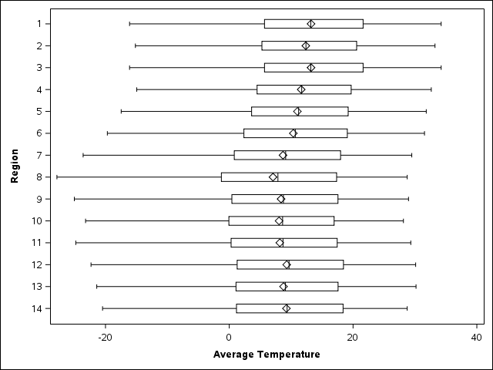

Supplemental Material, Figure S1b: Daily concentrations of PM_{2.5} for the 14 NYS weather regions, 1991-2006. Boxplots show the mean (marker), median (line), and IQR (box) with minimum to maximum range.
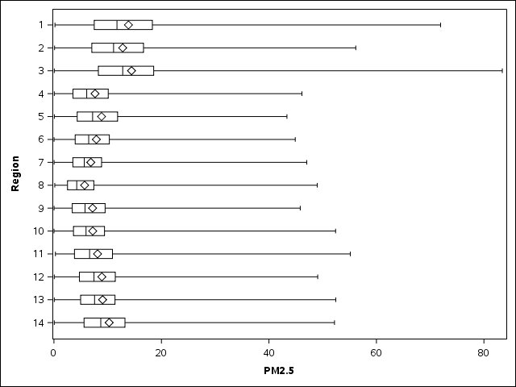

Supplemental Material, Table S1: Percent risk change (lag 0-lag 3) in cardiovascular morbidity per 10 µg/m³ increase in PM_{2.5} in NYS, 1991-2006
 | % Risk Changeª
Region | Lag 0 | Lag 1 | Lag 2 | Lag 3
NYC, Long Island & Hudson | 1.37 (0.90, 1.84)^{b} | 0.32 (-0.05, 0.69) | -0.18 (-0.53, 0.18) | -0.27 (-0.63, 0.09)
Adirondack & North | -0.43 (-2.33, 1.51) | -0.60 (-2.32, 1.16) | -1.50 (-3.27, 0.30) | -0.61 (-2.37, 1.17)
Mohawk Valley & Binghamton | 0.43 (-2.03, 2.95) | 0.66 (-0.82, 2.17) | 0.17 (-1.45, 1.81) | -0.72 (-2.33, 0.92)
Central & Western NY | 0.13 (-0.64, 0.91) | 0.56 (-0.30, 1.42) | 0.21 (-0.62, 1.05) | -0.15 (-0.91, 0.62)
a: Year-round
b: significant, p-value < 0.05

Supplemental Material, Table S2: Percent risk change in cardiovascular morbidity per 10 µg/m³ increase in PM_{2.5} in NYS, 1991-2006 using different DFs for the natural spline of the calendar time
 | % Risk Changeª
Region | DF=7/year | DF=5/year | DF=9/year
NYC, Long Island & Hudson | 1.37 (0.90, 1.84)^{b} | 1.45 (1.00, 1.91)^{b} | 1.40 (0.93, 1.87)^{b}
Adirondack & North | -0.43 (-2.33, 1.51) | -0.36 (-2.25, 1.56) | -0.21 (-2.13, 1.74)
Mohawk Valley & Binghamton | 0.43 (-2.03, 2.95) | 0.54 (-1.36, 2.47) | 0.38 (-1.51, 2.31)
Central & Western NY | 0.13 (-0.64, 0.91) | 0.18 (-0.64, 1.00) | 0.13 (-0.67, 0.94)
a: Year-round at lag 0; DF for the natural spline of calendar time
b: significant, p-value < 0.05

Supplemental Material, Table S3: Percent risk change in cardiovascular morbidity per 10 µg/m³ increase in PM_{2.5} in NYS
 | % Risk Changeª
Region | 1991-2006 | 1991-2004 | 1991-2004 (O₃)
NYC, Long Island & Hudson | 1.37 (0.90, 1.84)^{b} | 1.40 (0.94, 1.87)^{b} | 1.49 (1.00, 1.99)^{b}
Adirondack & North | -0.43 (-2.33, 1.51) | -0.77 (-2.79, 1.29) | -1.09 (-3.25, 1.12)
Mohawk Valley & Binghamton | 0.43 (-2.03, 2.95) | 0.24 (-1.89, 2.42) | 0.20 (-1.76, 2.20)
Central & Western NY | 0.13 (-0.64, 0.91) | 0.07 (-0.75, 0.90) | 0.28 (-0.65, 1.20)
a: Year-round at lag 0 during 1991-2006 and 1991-2004; 1991-2004 (O₃) controlled for 8-hr maximum ozone by season
b: significant, p-value < 0.05

