Supplemental Figure B – [Description]

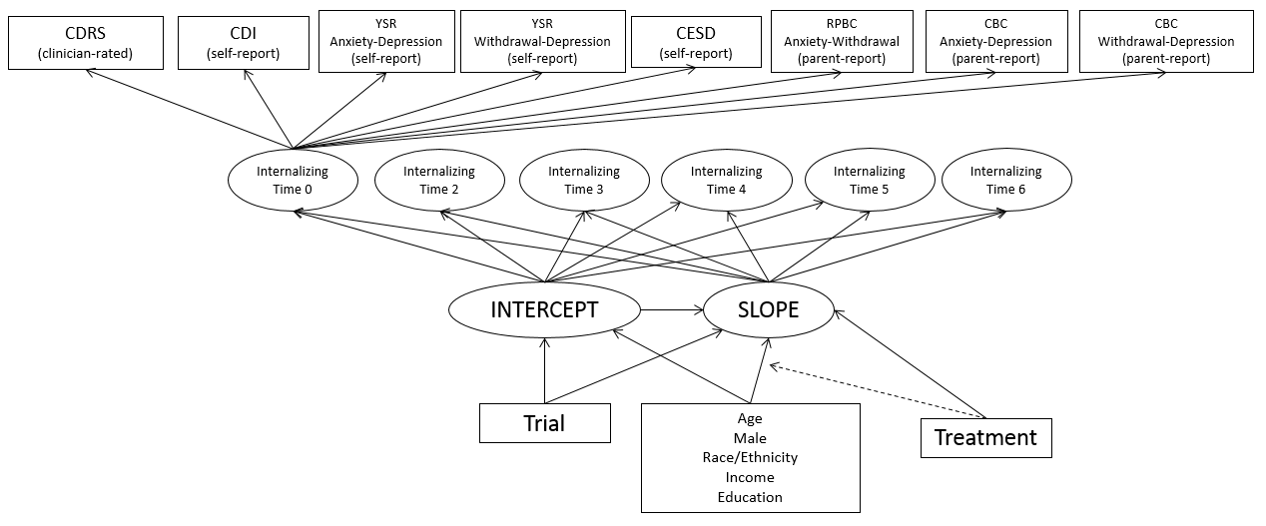
Second-order latent growth curve model. Though not pictured, the observed depression measures are indicators of the latent internalizing construct at each time point.

