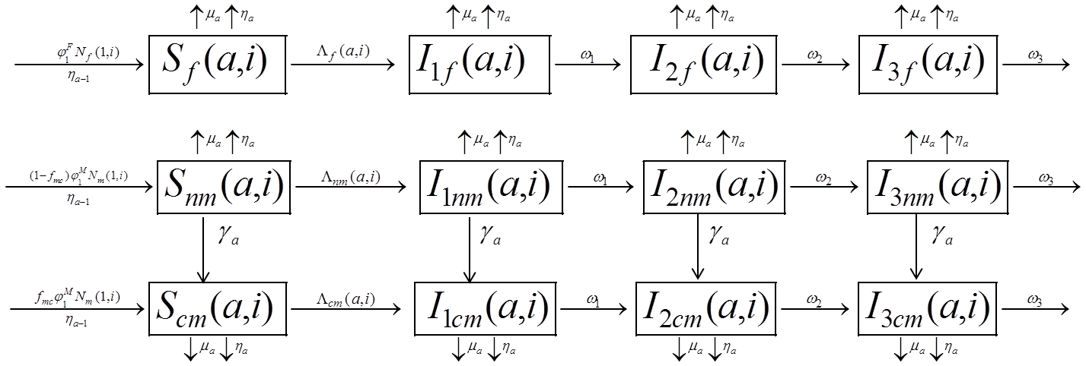
S1 Fig. Schematic illustration of HIV transmission dynamics with voluntary medical male circumcision as an HIV prevention intervention.

