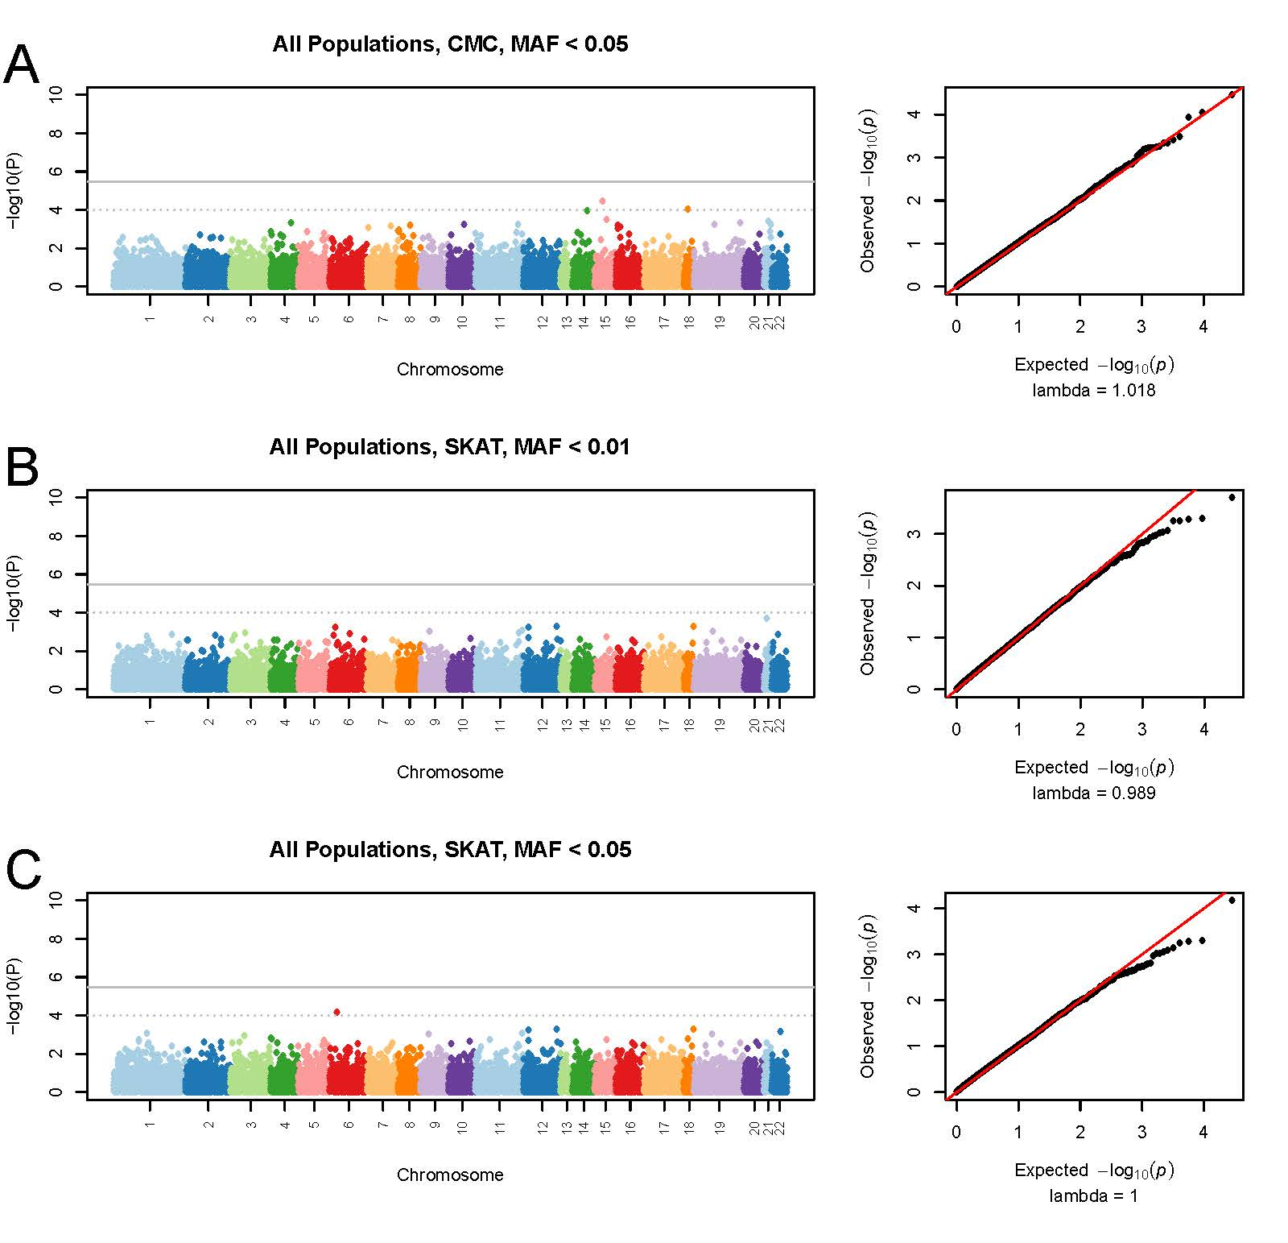
Supplementary Figure 1. Association results for gene-based tests of low-frequency coding variants in all populations. Manhattan plots and QQ plots are shown for the CMC test (A) and SKAT (B,C). The grey line shows Bonferroni-corrected genome-wide significance (i.e. p<3.4 x 10⁻⁶) and the dotted grey line shows the threshold for suggestive association (p<1.0 x 10⁻⁴).
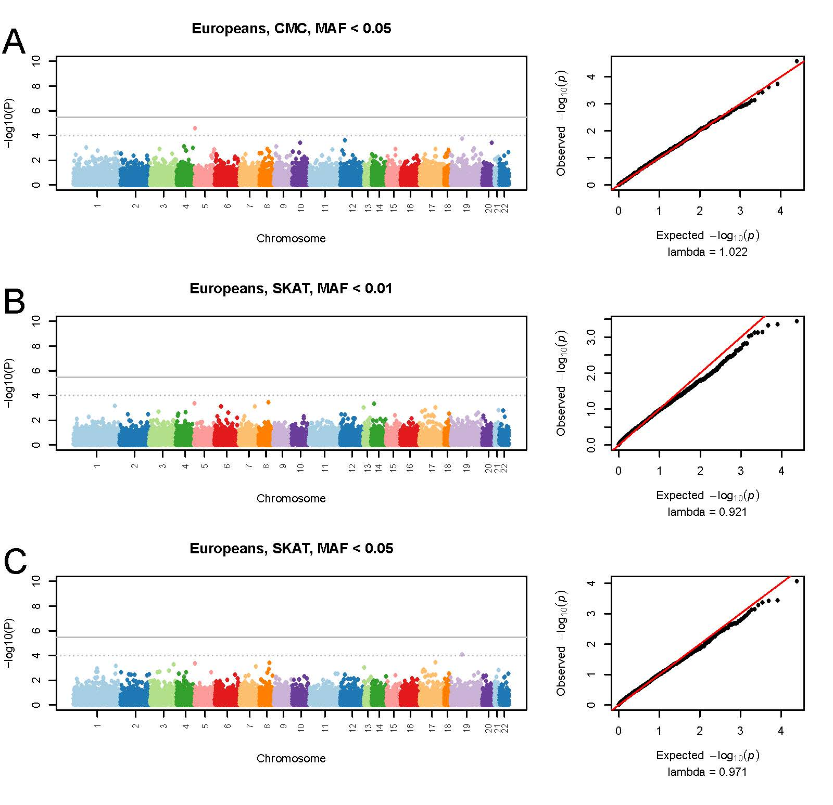

Supplementary Figure 2. Association results for gene-based tests of low-frequency coding variants in Europeans. Manhattan plots and QQ plots are shown for the CMC test (A) and SKAT (B,C). The grey line shows Bonferroni-corrected genome-wide significance (i.e. p<3.4 x 10⁻⁶) and the dotted grey line shows the threshold for suggestive association (p<1.0 x 10⁻⁴).

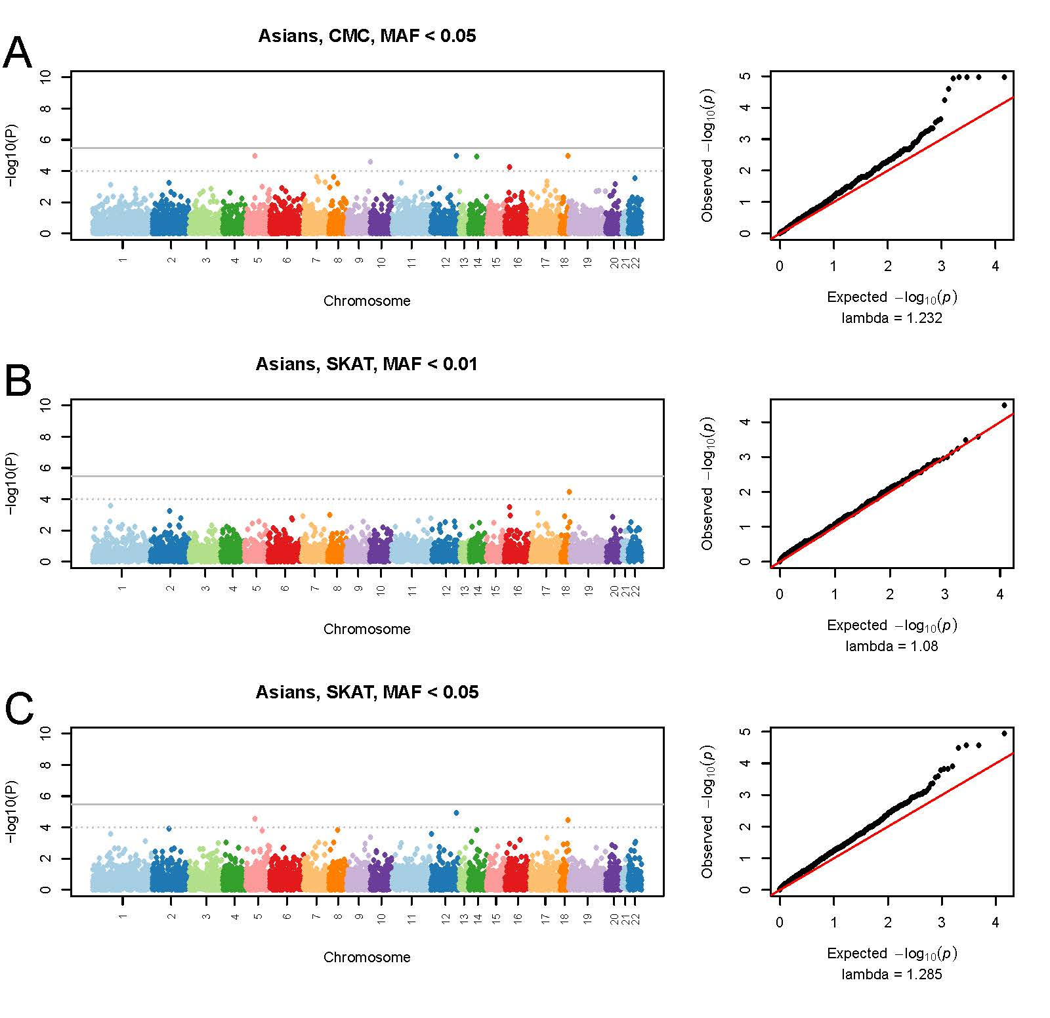

Supplementary Figure 3. Association results for gene-based tests of low-frequency coding variants in Asians. Manhattan plots and QQ plots are shown for the CMC test (A) and SKAT (B,C). The grey line shows Bonferroni-corrected genome-wide significance (i.e. p<3.4 x 10⁻⁶) and the dotted grey line shows the threshold for suggestive association (p<1.0 x 10⁻⁴).

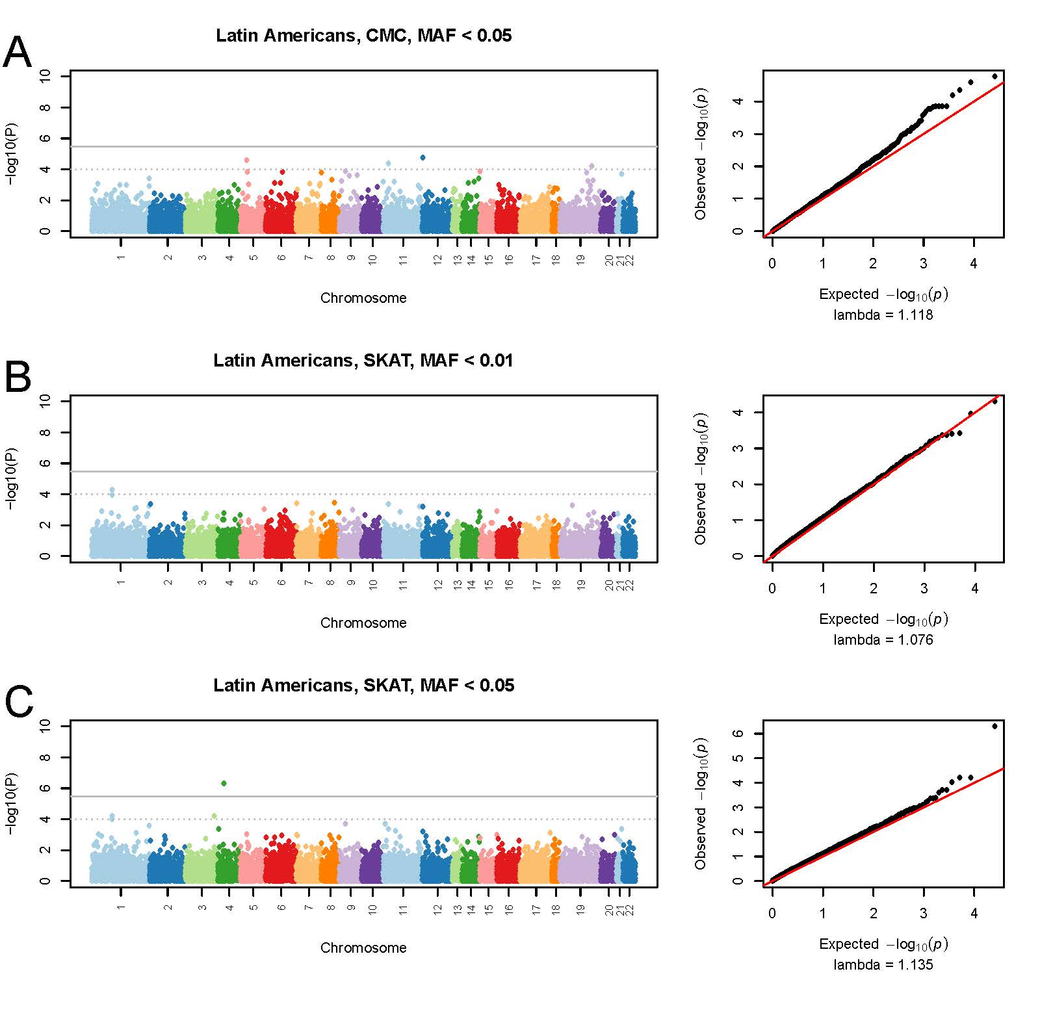

Supplementary Figure 4. Association results for gene-based tests of low-frequency coding variants in Latin Americans. Manhattan plots and QQ plots are shown for the CMC test (A) and SKAT (B,C). The grey line shows Bonferroni-corrected genome-wide significance (i.e. p<3.4 x 10⁻⁶) and the dotted grey line shows the threshold for suggestive association (p<1.0 x 10⁻⁴).

Supplementary Table 1. Low Frequency Variants in Associated Genes
GENE | CHR | BP | SNP | A1 | A2 | Cases |  | Controls |  | Population
 |  |  |  |  |  | MAF | N (Chrom.) | MAF | N (Chrom.)
AHRR | 5 | 306807 | rs111451538 | A | G | 0 | 1152 | 0.001796 | 1670 | Europeans
AHRR | 5 | 432995 | rs200229746 | A | G | 0.000868 | 1152 | 0 | 1670 | Europeans
AHRR | 5 | 434146 | rs111768223 | T | C | 0.01302 | 1152 | 0.00479 | 1670 | Europeans
AHRR | 5 | 434219 | rs35756515 | T | C | 0.000868 | 1152 | 0 | 1670 | Europeans
AHRR | 5 | 434546 | rs61757546 | T | C | 0.009549 | 1152 | 0.001198 | 1670 | Europeans
AHRR | 5 | 434581 | rs200762873 | G | C | 0.003472 | 1152 | 0.000599 | 1670 | Europeans
ALDH5A1 | 6 | 24495234 | rs200793796 | G | T | 0.002757 | 3990 | 0.00369 | 3252 | All Populations
ALDH5A1 | 6 | 24505099 | rs118203982 | A | G | 0 | 3990 | 0.000308 | 3252 | All Populations
ALDH5A1 | 6 | 24505165 | rs113591366 | C | G | 0.002506 | 3990 | 0.00246 | 3252 | All Populations
ALDH5A1 | 6 | 24505196 | rs62621664 | T | G | 0.01228 | 3990 | 0.01384 | 3252 | All Populations
ALDH5A1 | 6 | 24515432 | rs145087265 | G | A | 0.000501 | 3990 | 0 | 3252 | All Populations
ALDH5A1 | 6 | 24515462 | rs201146454 | C | A | 0.000251 | 3990 | 0.000308 | 3252 | All Populations
ALDH5A1 | 6 | 24520644 | rs149482918 | A | G | 0.01203 | 3990 | 0.00492 | 3252 | All Populations
ALDH5A1 | 6 | 24520719 | rs115784602 | A | G | 0.002005 | 3990 | 0.005228 | 3252 | All Populations
ALDH5A1 | 6 | 24528249 | rs147358733 | A | G | 0 | 3990 | 0.001538 | 3252 | All Populations
ALDH5A1 | 6 | 24528262 | rs139719918 | G | C | 0.000251 | 3990 | 0.000308 | 3252 | All Populations
ALDH5A1 | 6 | 24528331 | rs149793005 | G | A | 0.000501 | 3990 | 0 | 3252 | All Populations
ALDH5A1 | 6 | 24532351 | rs144177566 | A | G | 0.000251 | 3990 | 0 | 3252 | All Populations
ALDH5A1 | 6 | 24533753 | rs142482046 | C | A | 0.000251 | 3990 | 0.000923 | 3252 | All Populations
ALDH5A1 | 6 | 24533806 | rs151294087 | A | G | 0.000251 | 3990 | 0.000308 | 3252 | All Populations
ALDH5A1 | 6 | 24534412 | rs140376278 | T | C | 0.000251 | 3990 | 0.000308 | 3252 | All Populations
ALDH5A1 | 6 | 24534705 | rs11558625 | A | G | 0.01278 | 3990 | 0.00615 | 3252 | All Populations
ALDH5A1 | 6 | 24534724 | rs115442722 | T | C | 0.007268 | 3990 | 0.008918 | 3252 | All Populations
ALDH5A1 | 6 | 24534754 | rs9461036 | T | G | 0.001754 | 3990 | 0.002153 | 3252 | All Populations
ALDH5A1 | 6 | 24535161 | kgp26342350 | T | C | 0 | 3990 | 0.000308 | 3252 | All Populations
ALDH5A1 | 6 | 24535226 | rs9467217 | G | A | 0.001754 | 3990 | 0.002153 | 3252 | All Populations
ALDH5A1 | 6 | 24535234 | rs114422378 | T | C | 0.01053 | 3990 | 0.02306 | 3252 | All Populations
ALDH5A1 | 6 | 24535235 | rs143074829 | A | G | 0 | 3990 | 0.000615 | 3252 | All Populations
ALDH5A1 | 6 | 24535295 | rs138759652 | T | C | 0.000752 | 3990 | 0.000615 | 3252 | All Populations
ALDH5A1 | 6 | 24535332 | rs116311769 | A | C | 0.002256 | 3990 | 0.001538 | 3252 | All Populations
ALDH5A1 | 6 | 24535347 | rs73386199 | G | A | 0.005013 | 3990 | 0.003383 | 3252 | All Populations
ALDH5A1 | 6 | 24535413 | rs75854500 | A | G | 0.001253 | 3990 | 0.00123 | 3252 | All Populations
ALDH5A1 | 6 | 24535502 | rs142687378 | T | G | 0.000251 | 3990 | 0 | 3252 | All Populations
ALDH5A1 | 6 | 24536159 | rs150916849 | C | T | 0.005514 | 3990 | 0.003383 | 3252 | All Populations
ALDH5A1 | 6 | 24536925 | rs114960321 | T | C | 0.006516 | 3990 | 0.004305 | 3252 | All Populations
SMIM21 | 18 | 73139434 | rs142533881 | A | G | 0.001362 | 734 | 0.02795 | 322 | Asians
SMIM21 | 18 | 73139497 | rs146783544 | G | C | 0 | 734 | 0.003106 | 322 | Asians
CCDC62 | 12 | 123286287 | rs75175797 | A | G | 0 | 734 | 0.003106 | 322 | Asians
CCDC62 | 12 | 123297902 | rs55716280 | T | C | 0.001362 | 734 | 0.03106 | 322 | Asians
CCDC77 | 12 | 520944 | rs117439611 | A | G | 0.000476 | 2100 | 0.004792 | 1252 | Latin Americans
CCDC77 | 12 | 521010 | rs141242862 | A | G | 0.000476 | 2100 | 0.000799 | 1252 | Latin Americans
CCDC77 | 12 | 527682 | rs138940892 | G | A | 0.000476 | 2100 | 0 | 1252 | Latin Americans
CCDC77 | 12 | 527732 | rs112747420 | G | C | 0.000476 | 2100 | 0.000799 | 1252 | Latin Americans
CCDC77 | 12 | 542393 | rs150836970 | T | A | 0.000476 | 2100 | 0.005591 | 1252 | Latin Americans
CCDC77 | 12 | 542402 | rs76228130 | C | G | 0.001905 | 2100 | 0.007987 | 1252 | Latin Americans
CCDC77 | 12 | 549792 | rs143445221 | A | G | 0.000952 | 2100 | 0.000799 | 1252 | Latin Americans
CCDC77 | 12 | 549793 | rs150919241 | G | A | 0.000476 | 2100 | 0.001597 | 1252 | Latin Americans
CCDC77 | 12 | 549903 | rs114037221 | G | T | 0.001429 | 2100 | 0.007987 | 1252 | Latin Americans
CCDC77 | 12 | 550074 | rs149364540 | A | G | 0.000476 | 2100 | 0.000799 | 1252 | Latin Americans
CDSN | 6 | 31084090 | rs150846158 | T | G | 0.006076 | 1152 | 0 | 1670 | Europeans
CDSN | 6 | 31084244 | rs193021253 | T | C | 0.001736 | 1152 | 0 | 1670 | Europeans
CDSN | 6 | 31084936 | rs144038841 | C | G | 0.000868 | 1152 | 0 | 1670 | Europeans
CDSN | 6 | 31085136 | rs75843924 | T | C | 0.000868 | 1152 | 0 | 1670 | Europeans
CDSN | 6 | 31085286 | rs144847588 | T | C | 0.001736 | 1152 | 0 | 1670 | Europeans
DOPEY1 | 6 | 83831730 | rs76960445 | T | C | 0.000476 | 2100 | 0.004792 | 1252 | Latin Americans
DOPEY1 | 6 | 83835312 | rs144970641 | A | T | 0.000476 | 2100 | 0.001597 | 1252 | Latin Americans
DOPEY1 | 6 | 83838684 | rs61543280 | T | A | 0.000952 | 2100 | 0.003195 | 1252 | Latin Americans
DOPEY1 | 6 | 83838852 | rs147987838 | A | G | 0.002381 | 2100 | 0.002396 | 1252 | Latin Americans
DOPEY1 | 6 | 83841928 | rs148719618 | T | G | 0.000476 | 2100 | 0.000799 | 1252 | Latin Americans
DOPEY1 | 6 | 83847326 | rs41271565 | G | C | 0.000476 | 2100 | 0.000799 | 1252 | Latin Americans
DOPEY1 | 6 | 83847590 | rs147812480 | C | T | 0 | 2100 | 0.000799 | 1252 | Latin Americans
DOPEY1 | 6 | 83847699 | rs149855399 | G | C | 0 | 2100 | 0.001597 | 1252 | Latin Americans
DOPEY1 | 6 | 83848215 | rs139555117 | C | T | 0 | 2100 | 0.000799 | 1252 | Latin Americans
DOPEY1 | 6 | 83848222 | rs150951069 | A | G | 0 | 2100 | 0.001597 | 1252 | Latin Americans
DOPEY1 | 6 | 83848454 | rs140671585 | G | A | 0.000476 | 2100 | 0.001597 | 1252 | Latin Americans
DOPEY1 | 6 | 83851743 | rs115360882 | G | A | 0.002857 | 2100 | 0.009585 | 1252 | Latin Americans
DSC1 | 18 | 28711594 | rs146414667 | A | G | 0 | 3990 | 0.000308 | 3252 | All Populations
DSC1 | 18 | 28712532 | rs60591390 | A | G | 0.001253 | 3990 | 0.001538 | 3252 | All Populations
DSC1 | 18 | 28712551 | rs147041330 | G | C | 0.000752 | 3990 | 0.000615 | 3252 | All Populations
DSC1 | 18 | 28713955 | rs116112762 | C | T | 0.000251 | 3990 | 0 | 3252 | All Populations
DSC1 | 18 | 28713994 | rs28620831 | G | A | 0.02782 | 3990 | 0.04028 | 3252 | All Populations
DSC1 | 18 | 28714687 | rs200047736 | C | G | 0.000251 | 3990 | 0 | 3252 | All Populations
DSC1 | 18 | 28719812 | rs115338830 | G | T | 0.000251 | 3990 | 0.000308 | 3252 | All Populations
DSC1 | 18 | 28720032 | rs144984328 | A | G | 0.000251 | 3990 | 0.000308 | 3252 | All Populations
DSC1 | 18 | 28734765 | rs115175435 | G | A | 0.001253 | 3990 | 0.001845 | 3252 | All Populations
DSC1 | 18 | 28737407 | rs35338395 | A | G | 0.02732 | 3990 | 0.04766 | 3252 | All Populations
EHMT1 | 9 | 140638534 | rs11137198 | A | G | 0.001362 | 734 | 0.003106 | 322 | Asians
EHMT1 | 9 | 140648742 | rs45450992 | T | C | 0.004087 | 734 | 0.01863 | 322 | Asians
FLYWCH1 | 16 | 2988194 | rs199847169 | A | G | 0 | 734 | 0.009317 | 322 | Asians
FLYWCH1 | 16 | 2990062 | rs200567618 | T | A | 0 | 734 | 0.01242 | 322 | Asians
GTPBP3 | 19 | 17449524 | rs141865220 | T | C | 0 | 1152 | 0.000599 | 1670 | Europeans
GTPBP3 | 19 | 17451883 | rs138116759 | T | G | 0 | 1152 | 0.000599 | 1670 | Europeans
GTPBP3 | 19 | 17451962 | rs144775733 | T | C | 0 | 1152 | 0.000599 | 1670 | Europeans
GTPBP3 | 19 | 17451981 | rs3745193 | A | G | 0.05469 | 1152 | 0.02575 | 1670 | Europeans
HEATR8 | 1 | 55118790 | rs150191046 | G | C | 0.001429 | 2100 | 0.001597 | 1252 | Latin Americans
HEATR8 | 1 | 55119467 | rs12094920 | A | G | 0.001905 | 2100 | 0.01358 | 1252 | Latin Americans
HEATR8 | 1 | 55119546 | rs1655518 | A | G | 0.01762 | 2100 | 0.02077 | 1252 | Latin Americans
HEATR8 | 1 | 55119654 | rs12074499 | T | C | 0.004286 | 2100 | 0.01677 | 1252 | Latin Americans
HEATR8 | 1 | 55119702 | rs189525766 | C | T | 0.003333 | 2100 | 0.002396 | 1252 | Latin Americans
HEATR8 | 1 | 55134536 | rs74071881 | T | G | 0 | 2100 | 0.000799 | 1252 | Latin Americans
HEATR8 | 1 | 55134585 | rs2304314 | G | A | 0.02857 | 2100 | 0.02556 | 1252 | Latin Americans
HEATR8 | 1 | 55136188 | rs139403235 | T | C | 0.001429 | 2100 | 0.000799 | 1252 | Latin Americans
HEATR8 | 1 | 55139413 | rs200552161 | T | C | 0 | 2100 | 0.002396 | 1252 | Latin Americans
HEATR8 | 1 | 55139471 | rs138838053 | T | C | 0 | 2100 | 0.003195 | 1252 | Latin Americans
HEATR8 | 1 | 55144466 | rs75269200 | G | A | 0.006667 | 2100 | 0.02077 | 1252 | Latin Americans
HEATR8 | 1 | 55144525 | rs186975837 | A | G | 0.000952 | 2100 | 0.000799 | 1252 | Latin Americans
HEATR8 | 1 | 55145619 | rs148550771 | A | G | 0.000476 | 2100 | 0 | 1252 | Latin Americans
HEATR8 | 1 | 55151961 | rs201626732 | A | G | 0.000476 | 2100 | 0 | 1252 | Latin Americans
HEATR8 | 1 | 55151994 | rs201167904 | C | T | 0.000952 | 2100 | 0 | 1252 | Latin Americans
HEATR8 | 1 | 55166015 | rs139827199 | T | C | 0.000476 | 2100 | 0 | 1252 | Latin Americans
HEATR8 | 1 | 55166016 | rs145665162 | A | G | 0.001429 | 2100 | 0.000799 | 1252 | Latin Americans
HEATR8 | 1 | 55166079 | rs201020637 | C | T | 0.003333 | 2100 | 0.002396 | 1252 | Latin Americans
HEATR8 | 1 | 55167782 | rs181655955 | T | C | 0.001429 | 2100 | 0 | 1252 | Latin Americans
HEATR8 | 1 | 55168298 | rs3765018 | A | G | 0.0119 | 2100 | 0.008786 | 1252 | Latin Americans
HEATR8 | 1 | 55168357 | rs201261795 | T | C | 0.000952 | 2100 | 0.001597 | 1252 | Latin Americans
HEATR8 | 1 | 55168366 | rs201876492 | A | G | 0.000476 | 2100 | 0 | 1252 | Latin Americans
HEATR8 | 1 | 55172129 | rs11807983 | A | G | 0.008095 | 2100 | 0.007188 | 1252 | Latin Americans
HEATR8 | 1 | 55172201 | rs200035527 | G | A | 0.000476 | 2100 | 0.001597 | 1252 | Latin Americans
HEATR8 | 1 | 55174748 | rs145464693 | A | T | 0.001905 | 2100 | 0.000799 | 1252 | Latin Americans
HEATR8 | 1 | 55175664 | rs149350120 | G | A | 0.002381 | 2100 | 0.00639 | 1252 | Latin Americans
HEATR8 | 1 | 55175775 | rs187438824 | C | G | 0.000476 | 2100 | 0.000799 | 1252 | Latin Americans
HEATR8 | 1 | 55175807 | rs201511804 | T | C | 0.000952 | 2100 | 0 | 1252 | Latin Americans
KIAA0586 | 14 | 58896083 | rs147119902 | A | T | 0.009537 | 734 | 0.04348 | 322 | Asians
KIAA0586 | 14 | 58909435 | rs61735931 | C | T | 0.001362 | 734 | 0.003106 | 322 | Asians
KIAA0586 | 14 | 58920178 | rs147844088 | A | G | 0.001362 | 734 | 0.003106 | 322 | Asians
KIAA0586 | 14 | 58941425 | rs139493302 | T | C | 0.008174 | 734 | 0.03727 | 322 | Asians
KIAA0586 | 14 | 58949390 | rs77860620 | A | G | 0.002725 | 734 | 0.003106 | 322 | Asians
KIAA0586 | 14 | 58953746 | rs1617510 | C | G | 0 | 734 | 0.003106 | 322 | Asians
KIAA0586 | 14 | 58953863 | rs140565291 | C | A | 0 | 734 | 0.01242 | 322 | Asians
KIAA0586 | 14 | 58955530 | rs190271845 | C | T | 0.00545 | 734 | 0.003106 | 322 | Asians
KIAA0586 | 14 | 59014522 | rs140026883 | A | G | 0 | 734 | 0.003106 | 322 | Asians
N4BP2 | 4 | 40103817 | rs61748746 | A | G | 0.04524 | 2100 | 0.01518 | 1252 | Latin Americans
N4BP2 | 4 | 40104051 | rs10014170 | G | A | 0.0119 | 2100 | 0.01358 | 1252 | Latin Americans
N4BP2 | 4 | 40104294 | rs76438214 | C | G | 0.001905 | 2100 | 0.001597 | 1252 | Latin Americans
N4BP2 | 4 | 40104739 | rs62621880 | A | C | 0.000952 | 2100 | 0.001597 | 1252 | Latin Americans
N4BP2 | 4 | 40119617 | rs140402064 | T | C | 0.002381 | 2100 | 0.000799 | 1252 | Latin Americans
N4BP2 | 4 | 40121635 | rs142968103 | T | A | 0.02714 | 2100 | 0.04393 | 1252 | Latin Americans
N4BP2 | 4 | 40122313 | rs61748748 | T | A | 0.01429 | 2100 | 0.01518 | 1252 | Latin Americans
N4BP2 | 4 | 40122377 | rs78767806 | A | G | 0.00619 | 2100 | 0.01438 | 1252 | Latin Americans
N4BP2 | 4 | 40122453 | rs78417585 | T | C | 0.00381 | 2100 | 0.009585 | 1252 | Latin Americans
N4BP2 | 4 | 40122511 | rs150758210 | C | A | 0.004286 | 2100 | 0.000799 | 1252 | Latin Americans
N4BP2 | 4 | 40122771 | rs146409608 | C | T | 0.002381 | 2100 | 0 | 1252 | Latin Americans
N4BP2 | 4 | 40123399 | rs80192073 | T | G | 0.001429 | 2100 | 0.00639 | 1252 | Latin Americans
N4BP2 | 4 | 40123790 | rs61748749 | G | T | 0.04524 | 2100 | 0.01518 | 1252 | Latin Americans
N4BP2 | 4 | 40146415 | rs139228666 | G | C | 0.001905 | 2100 | 0.000799 | 1252 | Latin Americans
NLN | 5 | 65054587 | rs34339013 | A | G | 0.008095 | 2100 | 0.01278 | 1252 | Latin Americans
NLN | 5 | 65073287 | rs199806654 | T | G | 0 | 2100 | 0.000799 | 1252 | Latin Americans
NLN | 5 | 65081722 | rs151303282 | A | G | 0.000476 | 2100 | 0.003994 | 1252 | Latin Americans
NLN | 5 | 65084101 | rs6863012 | G | A | 0.02333 | 2100 | 0.03435 | 1252 | Latin Americans
NLN | 5 | 65118738 | rs6860508 | T | C | 0.03238 | 2100 | 0.05671 | 1252 | Latin Americans
OR2T6 | 1 | 248550916 | rs60632569 | A | G | 0.000952 | 2100 | 0.00639 | 1252 | Latin Americans
OR2T6 | 1 | 248550977 | rs114783918 | T | G | 0.001905 | 2100 | 0.005591 | 1252 | Latin Americans
OR2T6 | 1 | 248551009 | rs41308164 | A | G | 0.002857 | 2100 | 0.009585 | 1252 | Latin Americans
OR2T6 | 1 | 248551174 | rs61736246 | A | G | 0.000952 | 2100 | 0.00639 | 1252 | Latin Americans
OR2T6 | 1 | 248551195 | rs116441189 | A | G | 0.001905 | 2100 | 0.000799 | 1252 | Latin Americans
OR2T6 | 1 | 248551324 | rs140972140 | T | C | 0.000952 | 2100 | 0.004792 | 1252 | Latin Americans
OR2T6 | 1 | 248551346 | rs149801091 | T | C | 0.001429 | 2100 | 0.000799 | 1252 | Latin Americans
OR2T6 | 1 | 248551598 | rs61736247 | T | C | 0.000952 | 2100 | 0.002396 | 1252 | Latin Americans
OR2T6 | 1 | 248551727 | rs56967655 | A | T | 0.000952 | 2100 | 0.00639 | 1252 | Latin Americans
OR52E4 | 11 | 5905557 | rs140748846 | A | C | 0.000476 | 2100 | 0.000799 | 1252 | Latin Americans
OR52E4 | 11 | 5905639 | rs150480805 | G | T | 0.000476 | 2100 | 0.001597 | 1252 | Latin Americans
OR52E4 | 11 | 5905669 | rs16914094 | G | T | 0.001429 | 2100 | 0.009585 | 1252 | Latin Americans
OR52E4 | 11 | 5906117 | rs61876191 | G | A | 0 | 2100 | 0.002396 | 1252 | Latin Americans
OR52E4 | 11 | 5906193 | rs137865578 | A | G | 0.000476 | 2100 | 0.001597 | 1252 | Latin Americans
POLD1 | 19 | 50902164 | rs3218773 | A | G | 0.008095 | 2100 | 0.01278 | 1252 | Latin Americans
POLD1 | 19 | 50902188 | rs150066950 | T | A | 0.000952 | 2100 | 0.001597 | 1252 | Latin Americans
POLD1 | 19 | 50902196 | rs3218772 | T | C | 0.002857 | 2100 | 0.003195 | 1252 | Latin Americans
POLD1 | 19 | 50902633 | rs147911699 | T | G | 0.000476 | 2100 | 0.000799 | 1252 | Latin Americans
POLD1 | 19 | 50905151 | rs137953986 | A | G | 0 | 2100 | 0.001597 | 1252 | Latin Americans
POLD1 | 19 | 50905173 | rs41563714 | T | C | 0.000476 | 2100 | 0.001597 | 1252 | Latin Americans
POLD1 | 19 | 50905310 | rs1726803 | A | G | 0.01095 | 2100 | 0.01518 | 1252 | Latin Americans
POLD1 | 19 | 50905725 | rs76131127 | T | C | 0.000952 | 2100 | 0.002396 | 1252 | Latin Americans
POLD1 | 19 | 50905730 | rs8105725 | G | A | 0.000476 | 2100 | 0.001597 | 1252 | Latin Americans
POLD1 | 19 | 50905877 | rs113282414 | T | G | 0.002857 | 2100 | 0.005591 | 1252 | Latin Americans
POLD1 | 19 | 50905911 | rs199545019 | A | G | 0.000476 | 2100 | 0.000799 | 1252 | Latin Americans
POLD1 | 19 | 50912126 | rs1726790 | A | G | 0.01238 | 2100 | 0.01837 | 1252 | Latin Americans
POLD1 | 19 | 50916772 | rs1274607 | C | T | 0.03238 | 2100 | 0.05431 | 1252 | Latin Americans
POLD1 | 19 | 50918229 | rs3218775 | A | G | 0.01 | 2100 | 0.01278 | 1252 | Latin Americans
PRTG | 15 | 55912325 | rs184951996 | C | T | 0 | 3990 | 0.000308 | 3252 | All Populations
PRTG | 15 | 55912380 | rs202082038 | C | G | 0.001003 | 3990 | 0 | 3252 | All Populations
PRTG | 15 | 55912391 | rs79244725 | A | G | 0.000501 | 3990 | 0.000615 | 3252 | All Populations
PRTG | 15 | 55916656 | rs141129581 | A | G | 0.000752 | 3990 | 0.000615 | 3252 | All Populations
PRTG | 15 | 55916703 | rs148011047 | G | T | 0.002256 | 3990 | 0.000615 | 3252 | All Populations
PRTG | 15 | 55921043 | rs77440317 | T | C | 0.001504 | 3990 | 0.001538 | 3252 | All Populations
PRTG | 15 | 55921152 | exm2223537 | C | T | 0 | 3990 | 0.000308 | 3252 | All Populations
PRTG | 15 | 55929515 | rs10518816 | G | C | 0.007268 | 3990 | 0.00492 | 3252 | All Populations
PRTG | 15 | 55931949 | rs200168393 | G | A | 0.000251 | 3990 | 0.000308 | 3252 | All Populations
PRTG | 15 | 55933382 | rs140497034 | A | C | 0.005764 | 3990 | 0.00246 | 3252 | All Populations
PRTG | 15 | 55964644 | rs199658038 | C | T | 0.000501 | 3990 | 0 | 3252 | All Populations
PRTG | 15 | 55964778 | rs149494002 | G | C | 0.005514 | 3990 | 0.004305 | 3252 | All Populations
PRTG | 15 | 55965738 | rs200069819 | A | C | 0.001253 | 3990 | 0.000615 | 3252 | All Populations
PRTG | 15 | 55972815 | rs201799023 | C | T | 0.000251 | 3990 | 0 | 3252 | All Populations
PRTG | 15 | 55976015 | rs151321413 | C | T | 0.001504 | 3990 | 0.000308 | 3252 | All Populations
PRTG | 15 | 55976057 | rs116205356 | C | T | 0.001754 | 3990 | 0.000615 | 3252 | All Populations
PRTG | 15 | 56032665 | rs185716584 | G | C | 0.005263 | 3990 | 0.00369 | 3252 | All Populations
PRTG | 15 | 56032840 | rs190129010 | C | T | 0.000752 | 3990 | 0 | 3252 | All Populations
RAD23A | 19 | 13059006 | rs73505386 | C | G | 0 | 2100 | 0.002396 | 1252 | Latin Americans
RAD23A | 19 | 13059148 | rs148187629 | A | C | 0.000476 | 2100 | 0 | 1252 | Latin Americans
RAD23A | 19 | 13059563 | rs4987203 | A | G | 0.001905 | 2100 | 0.007987 | 1252 | Latin Americans
RAD23A | 19 | 13059626 | rs4987202 | T | C | 0.001429 | 2100 | 0.007188 | 1252 | Latin Americans
RNU5D | 5 | 80628399 | rs144410754 | C | T | 0 | 734 | 0.003106 | 322 | Asians
RNU5D | 5 | 80641789 | rs34607174 | T | C | 0.001362 | 734 | 0.006211 | 322 | Asians
THOC6 | 16 | 3076274 | rs116125644 | A | G | 0 | 734 | 0.009317 | 322 | Asians
THOC6 | 16 | 3077030 | rs116675970 | C | A | 0 | 734 | 0.006211 | 322 | Asians
THOC6 | 16 | 3077388 | rs149696424 | T | C | 0 | 734 | 0.006211 | 322 | Asians
YEATS2 | 3 | 183432967 | rs138709666 | A | G | 0.01286 | 2100 | 0.01198 | 1252 | Latin Americans
YEATS2 | 3 | 183442219 | rs16858033 | G | A | 0.03286 | 2100 | 0.05351 | 1252 | Latin Americans
YEATS2 | 3 | 183442258 | rs200719432 | T | C | 0.000952 | 2100 | 0 | 1252 | Latin Americans
YEATS2 | 3 | 183469912 | rs142872171 | T | C | 0 | 2100 | 0.001597 | 1252 | Latin Americans
YEATS2 | 3 | 183474410 | rs199904072 | G | T | 0.000476 | 2100 | 0.000799 | 1252 | Latin Americans
YEATS2 | 3 | 183474412 | rs35139586 | G | A | 0.000476 | 2100 | 0.002396 | 1252 | Latin Americans
YEATS2 | 3 | 183476697 | rs151134207 | G | A | 0.001429 | 2100 | 0.000799 | 1252 | Latin Americans
YEATS2 | 3 | 183476698 | rs34759333 | A | C | 0.00619 | 2100 | 0.001597 | 1252 | Latin Americans
YEATS2 | 3 | 183490222 | rs116616592 | T | G | 0.001429 | 2100 | 0.001597 | 1252 | Latin Americans
YEATS2 | 3 | 183491429 | rs201274382 | G | A | 0.000952 | 2100 | 0 | 1252 | Latin Americans
YEATS2 | 3 | 183508590 | rs79808533 | G | A | 0.01905 | 2100 | 0.03994 | 1252 | Latin Americans
YEATS2 | 3 | 183508669 | rs188928313 | A | G | 0.000952 | 2100 | 0 | 1252 | Latin Americans
YEATS2 | 3 | 183508714 | rs74496163 | A | G | 0.01524 | 2100 | 0.03754 | 1252 | Latin Americans
YEATS2 | 3 | 183516747 | rs201941589 | T | C | 0.003333 | 2100 | 0.008786 | 1252 | Latin Americans
YEATS2 | 3 | 183524803 | rs190474641 | A | G | 0.001429 | 2100 | 0.000799 | 1252 | Latin Americans

Supplemental Table 2. Control input genes for functional annotation enrichment analysis
ARHGAP29
BCOR
BMP4
CDH1
CHD7
CHRNG
COL2A1
COL8A1
CRISPLD2
DHODH
EPHA3
FGFR1
FGFR2
FLNA
FOXE1
GLI2
GLI3
GRHL3
IRF6
KDM6A
MAFB
MID1
MSX1
MTHFR
MYC
NIPBL
NOG
NTN1
OFD1
PAX7
PHF8
PTCH1
PVRL1
RIPK4
SATB2
SHH
SIX3
SOX9
SPRY2
TBX1
TBX22
TCOF1
TFAP2A
TGFA
TGFBR1
TGIF
TP63
TPM1
TWIST1
VAX1
WNT3

