ONLINE SUPPLEMENT

Title: Air pollution affects lung cancer survival
Authors: Sandrah P Eckel, PhD,¹ Myles Cockburn, PhD,¹ Yu-Hsiang Shu, PhD,^{1,2} Huiyu Deng, MA,¹ Frederick W. Lurmann, MS,³ Lihua Liu, PhD,¹ and Frank D Gilliland, MD PhD¹

Contents:eTable 1. Leave-one-out validation of inverse distance weighted squared interpolation of monthly California air quality monitoring site data, 1988-2012.

eFigure 1. Annual average ambient air pollutants at representative air monitoring sites from 1990-2010.

eTable 2. Reduction in 3-year average pollutant concentrations from 1990-1992 (1999-2001 for PM_{2.5}) to 2008-2010 at representative air monitoring sites.

eTable 3. Distances of residential addresses at diagnosis from highways and air quality monitors, by stage at diagnosis.

eTable 4. All-cause mortality hazard ratios for all predictor variables in the single pollutant models in Table 4 of the main text.

eTable 5a. Sensitivity analysis for NO₂ and O₃: adjusted all-cause mortality hazard ratios (and 95% confidence intervals) associated with a standard deviation (SD) increase in NO₂ or O₃ exposure, from models stratified by stage at diagnosis (like those in Table 4) but with additional stratification by factors of interest.

eTable 5b. Sensitivity analysis for PM₁₀ and PM_{2.5}: adjusted all-cause mortality hazard ratios (and 95% confidence intervals) associated with a standard deviation (SD) increase in PM₁₀ and PM_{2.5} exposure, from models stratified by stage at diagnosis (like those in Table 4) but with additional stratification by factors of interest.

eTable 1. Leave-one-out validation of inverse distance weighted squared interpolation of monthly California air quality monitoring site data, 1988-2012.
Summary statistic | Ozone | NO₂ | PM_{2.5} | PM₁₀
Mean observed (ppb or µg/m³) | 43.8 | 18.4 | 13.4 | 29.3
Mean estimated (ppb or µg/m³)^{1,2,3} | 43.9 | 17.7 | 13.1 | 28.7
Mean residual (ppb or µg/m³)⁴ | 0.1 | -0.7 | -0.4 | -0.5
Mean relative absolute value residual (ppb or µg/m³)^{4,5} | ±15% | ±34% | ±31% | ±35%
R² | 0.76 | 0.73 | 0.53 | 0.46
Sample size (number of monthly pairs) | 43,812 | 26,795 | 10,636 | 32,548
Mean Distance to Nearest Station (km) | 12.9 | 12.8 | 12.5 | 12.5
Mean Number of Stations Used | 3.8 | 3.9 | 3.4 | 3.5
- Statistics computed for observed concentrations above 5 ppb ozone, 2 ppb NO₂, 3 µg/m³ PM_{2.5}, and 6 µg/m³ PM₁₀ since the commonly deployed instruments are inaccurate below these levels.
- The ozone metric is the monthly average of the 8-hour daily maximum concentrations. The NO₂, PM_{2.5}, and PM₁₀ metrics are the monthly average of the 24-hour average concentrations.
- Based on ozone, NO₂, and PM₁₀ data for 1998-2012 and PM_{2.5} data for 1999-2012 in California.
- Residual defined as: estimated-observed
- Relative absolute value residual defined as: |estimated-observed|/observed

The performance of the inverse distance weighted squared (IDW2) spatial interpolation method was evaluated using leave one out validation for monthly monitoring site data. Results, shown in eTable 1, indicate the IDW2 method estimates monthly ozone, NO₂, PM_{2.5} and PM₁₀ with less than 1 ppb or 1 µg/m³ biases on average and with ±15%, ±34%, ±31%, and ±34% relative error on average, respectively. The coefficients of determination (r²) are 0.76, 0.73, 0.53, and 0.46 for ozone, NO₂, PM_{2.5} and PM₁₀, respectively. We expect that the lower R² values for PM is due to the local (primary emission) dust component that is not regional.

Temporal trends in ambient pollutant concentrations were substantial for NO₂, PM_{2.5} and PM₁₀ over the course of this study. eFigure 1 shows the trends in annual average concentrations at representative air monitoring sites in Fresno, Los Angeles, Sacramento, and San Francisco. Despite year-to-year fluctuations, a downward trend was observed for all eFigure 1 locations and pollutants except for ozone in Redwood City (south of San Francisco), where reductions in NOx emissions were believed to be responsible for increased ozone levels. eTable 2 shows the percent reduction in the 3-year average pollutant concentration of NO₂, PM₁₀, and ozone from 1991 to 2009 (and for PM_{2.5}, from 2000-2009) at these sites. On average, the concentrations of NO₂, PM_{2.5}, and PM₁₀ declined at 2 to 2.5% per year in this period, whereas ozone concentrations declined at a much slower rate (<0.3% per year).
eFigure 1. Annual average ambient air pollutants at representative air monitoring sites from 1990-2010.
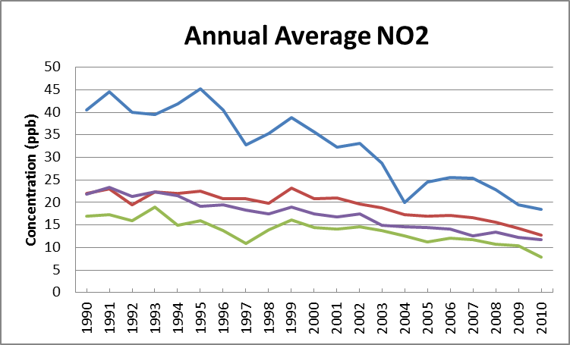
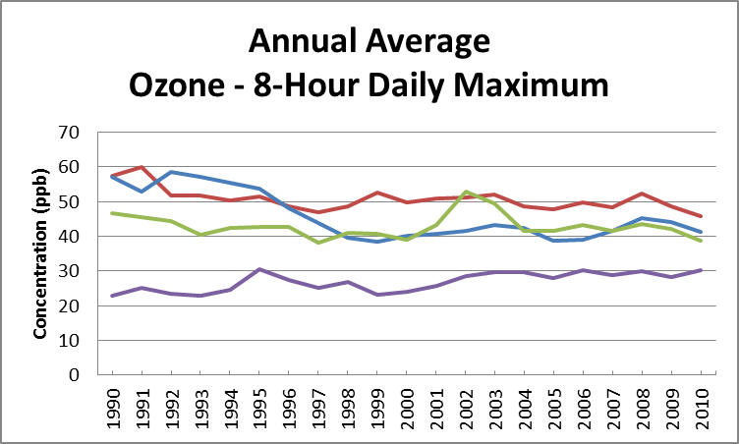
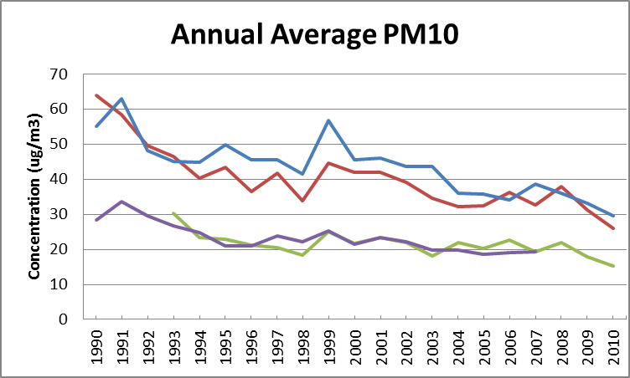
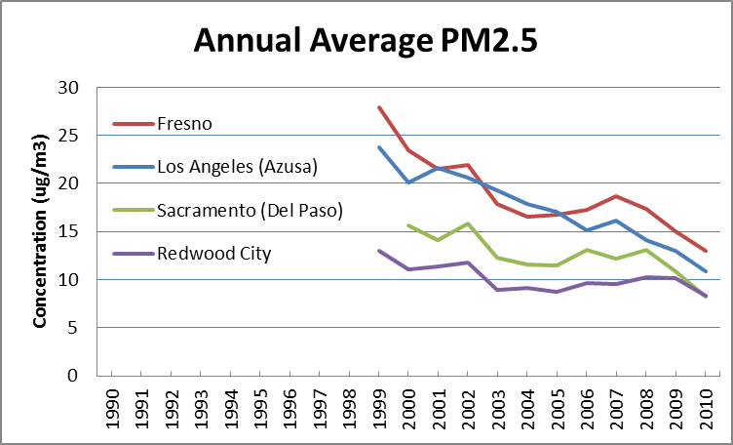
eTable 2. Percent reduction in 3-year average pollutant concentrations from 1990-1992 (1999-2001 for PM_{2.5}) to 2008-2010 at representative air monitoring sites.
Region (Monitoring site) | NO₂ | Ozone | PM₁₀ | PM_{2.5}
 | 1991-2009 | 1991-2009 | 1991-2009 | 2000-2009
Fresno (First St.) | 34% | 13% | 45% | 27%
Los Angeles (Azusa) | 51% | 22% | 40% | 42%
Sacramento (Del Paso) | 42% | 9% | 28%¹ | 16%²
San Francisco (Redwood City) | 44% | -24% | 38%³ | 17%
Average (%) | 43% | 5% | 38% | 26%
Average (%/year) | 2.3 | 0.26 | 2.0 | 2.5
¹⁻³ Time intervals differ due to monitor data availability: (1) 1994-2009, (2) 2001-2009, (3) 1991-2005.

eTable 3. Distances of residential addresses at diagnosis from highways and air quality monitors, by stage at diagnosis.
Measure (%) | Localized Only  (n=59,609) | Regional  (n=73,513) | Distant Site(s)  (n=186,496) | Unknown  (n=32,435) | Total  (n=352,053)
Distance to primary interstate highway
< 300 m | 8.4 | 8.6 | 8.8 | 8.4 | 8.7
300 – 1500 m | 35.3 | 35.9 | 36.6 | 34.9 | 36.1
> 1500 m | 46.7 | 45.8 | 44.9 | 44.9 | 45.4
% missingª | 9.6 | 9.6 | 9.6 | 11.8 | 9.8
Distance to primary US and State highways
< 300 m | 4.3 | 4.3 | 4.2 | 4.9 | 4.3
300 – 1500 m | 13.5 | 13.4 | 13.7 | 13.9 | 13.6
> 1500 m | 72.6 | 72.7 | 72.6 | 69.4 | 72.3
% missingª | 9.6 | 9.6 | 9.6 | 11.8 | 9.8
Distance to the closest air quality monitor
NO₂
< 5 km | 22.5 | 23.0 | 24.3 | 22.5 | 23.6
5-25 km | 65.1 | 63.8 | 63.0 | 60.4 | 63.3
> 25 km | 6.5 | 7.0 | 6.6 | 8.3 | 6.8
% missing^{b} | 5.9 | 6.2 | 6.1 | 8.8 | 6.3
O₃
< 5 km | 26.6 | 28.1 | 29.8 | 29,2 | 28.8
5-25 km | 67.0 | 65.1 | 63.5 | 60.7 | 64.2
> 25 km | 3.0 | 3.4 | 3.4 | 5.1 | 3.5
% missing^{b} | 3.3 | 3.4 | 3.3 | 5.0 | 3.5
PM₁₀
< 5 km | 21.1 | 22.4 | 23.7 | 21.8 | 22.8
5-25 km | 70.6 | 68.9 | 67.7 | 66.9 | 68.4
> 25 km | 5.3 | 5.8 | 5.7 | 6.8 | 5.7
% missing^{b} | 3.0 | 3.0 | 3.0 | 4.6 | 3.1
PM_{2.5}^{c}
< 5 km | 20.0 | 20.5 | 21.1 | 19.1 | 20.4
5-25 km | 66.5 | 63.8 | 61.5 | 57.7 | 62.6
> 25 km | 7.8 | 8.5 | 8.4 | 10.0 | 8.4
% missing^{b} | 5.7 | 7.3 | 9.0 | 13.2 | 8.3
ª Distance values are missing for participants with poor geocode matches (worse than street address match)
^{b} Air pollution exposures assignments are missing for participants with missing geocodes and for participants with no monitors for that pollutant ≤25 km from their residence
^{c} PM_{2.5} data are reported only for the subset of patients whose cancer was diagnosed in 1998 or later.

eTable 4. All-cause mortality hazard ratios for all predictor variables in the single pollutant models in Table 4 of the main text.
Model | NO₂ |  | O₃ |  | PM₁₀ |  | PM_{2.5}ª
Sample size (% censored) | 305,721 (8.0) |  | 327,513 (8.0) |  | 320,940 (7.9) |  | 160,707 (13.2)
 | HR | p-value | HR | p-value | HR | p-value | HR | p-value
Air pollution exposureª | 1.13 | <.001 | 1.02 | <.001 | 1.11 | <.001 | 1.16 | <.001
Age | 1.01 | <.001 | 1.01 | <.001 | 1.01 | <.001 | 1.01 | <.001
Sex
Male | 1.00 |  | 1.00 |  | 1.00 |  | 1.00
Female | 0.84 | <.001 | 0.84 | <.001 | 0.84 | <.001 | 0.82 | <.001
Race/ethnicity
Non-Hispanic white | 1.00 |  | 1.00 |  | 1.00 |  | 1.00
Hispanic | 0.90 | <.001 | 0.93 | <.001 | 0.91 | <.001 | 0.90 | <.001
Non-Hispanic black | 0.92 | <.001 | 0.95 | <.001 | 0.95 | <.001 | 0.93 | <.001
Other/Unknown | 0.78 | <.001 | 0.80 | <.001 | 0.80 | <.001 | 0.80 | <.001
Marital Status
Single | 1.00 |  | 1.00 |  | 1.00 |  | 1.00
Married | 0.92 | <.001 | 0.90 | <.001 | 0.90 | <.001 | 0.88 | <.001
Formerly married | 0.99 | 0.14 | 0.98 | 0.002 | 0.98 | 0.001 | 0.97 | <.001
Unknown | 0.90 | <.001 | 0.89 | <.001 | 0.89 | <.001 | 0.88 | <.001
Year of diagnosis
1988-1992 | 1.00 |  | 1.00 |  | 1.00 |  | NAª
1993-1997 | 1.02 | <.001 | 0.98 | <.001 | 1.04 | <.001 | NAª
1998-2002 | 1.00 | 0.66 | 0.92 | <.001 | 0.99 | 0.31 | 1.00
2003-2009 | 0.97 | <.001 | 0.85 | <.001 | 0.94 | <.001 | 1.09 | <.001
Socioeconomic Status
Lowest | 1.00 |  | 1.00 |  | 1.00 |  | 1.00
Low-middle | 0.98 | 0.02 | 0.99 | 0.03 | 1.00 | 0.80 | 1.01 | 0.48
Middle | 0.95 | <.001 | 0.97 | <.001 | 0.98 | 0.05 | 1.00 | 0.98
Higher-middle | 0.92 | <.001 | 0.96 | <.001 | 0.97 | <.001 | 0.99 | 0.58
Highest | 0.90 | <.001 | 0.94 | <.001 | 0.96 | <.001 | 0.97 | 0.04
Unknown | 0.88 | <.001 | 0.91 | <.001 | 0.92 | <.001 | 0.94 | 0.004
Education index
Low | 1.00 |  | 1.00 |  | 1.00 |  | 1.00
Low-medium | 1.03 | <.001 | 0.98 | 0.01 | 1.01 | 0.22 | 1.02 | 0.07
Medium-high | 1.03 | 0.002 | 0.96 | <.001 | 1.00 | 0.86 | 1.00 | 0.69
High | 1.01 | 0.31 | 0.94 | <.001 | 0.98 | 0.01 | 0.97 | 0.04
Rural-urban commuting area
Metropolitan core | 1.00 |  | 1.00 |  | 1.00 |  | 1.00
Non-metropolitan core | 0.93 | <.001 | 1.03 | <.001 | 0.96 | <.001 | 0.94 | <.001
Unknown | 1.30 | 0.65 | 0.82 | 0.74 | 1.27 | 0.68 | 1.28 | 0.67
Stage at diagnosis
Localized only | 1.00 |  | 1.00 |  | 1.00 |  | 1.00
Regional | 1.64 | <.001 | 1.65 | <.001 | 1.64 | <.001 | 1.70 | <.001
Distant site(s) | 3.06 | <.001 | 3.09 | <.001 | 3.06 | <.001 | 3.20 | <.001
Unknown | 1.44 | <.001 | 1.45 | <.001 | 1.43 | <.001 | 1.46 | <.001
Histology at diagnosis
Squamous cell | 1.00 |  | 1.00 |  | 1.00 |  | 1.00
Adenocarcinoma | 0.94 | <.001 | 0.94 | <.001 | 0.94 | <.001 | 0.90 | <.001
Small cell | 1.13 | <.001 | 1.12 | <.001 | 1.13 | <.001 | 1.16 | <.001
Large cell | 1.09 | <.001 | 1.09 | <.001 | 1.10 | <.001 | 1.13 | <.001
Others | 0.92 | <.001 | 0.91 | <.001 | 0.92 | <.001 | 0.97 | 0.001
Surgery
No | 1.00 |  | 1.00 |  | 1.00 |  | 1.00
Yes | 0.33 | <.001 | 0.33 | <.001 | 0.33 | <.001 | 0.31 | <.001
Unknown | 0.80 | <.001 | 0.80 | <.001 | 0.78 | <.001 | 1.11 | 0.27
Radiation
No | 1.00 |  | 1.00 |  | 1.000 |  | 1.00
Yes | 0.83 | <.001 | 0.82 | <.001 | 0.83 | <.001 | 0.86 | <.001
Unknown | 1.41 | <.001 | 1.44 | <.001 | 1.37 | <.001 | 0.94 | 0.54
Chemotherapy
No | 1.00 |  | 1.00 |  | 1.00 |  | 1.00
Yes | 0.62 | <.001 | 0.62 | <.001 | 0.62 | <.001 | 0.60 | <.001
Unknown | 1.07 | <.001 | 1.07 | <.001 | 1.07 | <.001 | 1.14 | <.001
Distance to primary interstate highway
< 300 m | 1.00 |  | 1.00 |  | 1.00 |  | 1.00
300 – 1500 m | 0.99 | 0.08 | 0.99 | 0.14 | 0.99 | 0.05 | 0.98 | 0.03
> 1500 m | 1.00 | 0.69 | 0.99 | 0.03 | 0.98 | 0.01 | 0.99 | 0.30
Missing | 1.00 | 0.91 | 0.98 | 0.04 | 0.97 | 0.04 | 0.99 | 0.42
Distance to primary US and State highways
< 300m | 1.00 |  | 1.00 |  | 1.00 |  | 1.00
300 – 1500 m | 0.97 | 0.01 | 0.97 | 0.002 | 0.97 | 0.003 | 0.97 | 0.05
> 1500 m | 1.00 | 0.66 | 0.98 | 0.07 | 0.98 | 0.04 | 0.98 | 0.13
Missing^{b} | NA | NA | NA | NA | NA | NA | NA | NA
Month of diagnosis
January | 1.00 |  | 1.00 |  | 1.00 |  | 1.00
February | 1.05 | <.001 | 1.04 | <.001 | 1.04 | <.001 | 1.07 | <.001
March | 1.06 | <.001 | 1.04 | <.001 | 1.05 | <.001 | 1.06 | <.001
April | 1.06 | <.001 | 1.05 | <.001 | 1.04 | <.001 | 1.06 | <.001
May | 1.06 | <.001 | 1.04 | <.001 | 1.04 | <.001 | 1.04 | <.001
June | 1.05 | <.001 | 1.05 | <.001 | 1.04 | <.001 | 1.04 | 0.01
July | 1.05 | <.001 | 1.05 | <.001 | 1.04 | <.001 | 1.05 | <.001
August | 1.05 | <.001 | 1.06 | <.001 | 1.04 | <.001 | 1.04 | <.001
September | 1.06 | <.001 | 1.08 | <.001 | 1.06 | <.001 | 1.04 | 0.003
October | 1.04 | <.001 | 1.06 | <.001 | 1.04 | <.001 | 1.03 | 0.002
November | 1.06 | <.001 | 1.08 | <.001 | 1.07 | <.001 | 1.06 | 0.01
December | 1.08 | <.001 | 1.08 | <.001 | 1.08 | <.001 | 1.08 | <.001
ª PM_{2.5} data are reported only for the subset of patients whose cancer was diagnosed in 1998 or later.
^{b} Only one of the identical “missing” categories for the two distance metrics can be estimated.

eTable 5a. Sensitivity analysis for NO₂ and O₃: adjustedª all-cause mortality hazard ratios (and 95% confidence intervals) associated with a standard deviation (SD) increase in NO₂ or O₃ exposure,^{b} from models stratified by stage at diagnosis (like those in Table 4) but with additional stratification by factors of interest.
 | NO₂ |  |  | O₃
Stratifying factor | Local | Regional | Distant | Local | Regional | Distant
None (Table 4 value) | 1.30 (1.28, 1.32) | 1.18 (1.17, 1.20) | 1.07 (1.07, 1.08) | 1.04 (1.02, 1.05) | 1.03 (1.02, 1.04) | 1.01 (1.01, 1.02)
Sex
Male | 1.29 (1.27, 1.32) | 1.18 (1.16, 1.19) | 1.07 (1.06, 1.08) | 1.04 (1.02, 1.06) | 1.03 (1.02, 1.05) | 1.01 (1.01, 1.02)
Female | 1.31 (1.28, 1.33) | 1.20 (1.18, 1.21) | 1.07 (1.06, 1.08) | 1.03 (1.01, 1.05) | 1.03 (1.01, 1.04) | 1.01 (1.01, 1.02)
Race
Non-Hispanic white | 1.30 (1.28, 1.32) | 1.18 (1.17, 1.19) | 1.07 (1.06, 1.08) | 1.04 (1.02, 1.05) | 1.03 (1.02, 1.04) | 1.01 (1.00, 1.02)
Hispanic | 1.28 (1.21, 1.34) | 1.21(1.17, 1.26) | 1.09 (1.07, 1.11) | 1.04 (0.98, 1.10) | 1.10 (1.05, 1.14) | 1.02 (1.00, 1.04)
Non-Hispanic black | 1.31 (1.25, 1.38) | 1.21(1.16, 1.26) | 1.06 (1.04, 1.08) | 1.02 (0.96, 1.07) | 1.01 (0.97, 1.05) | 1.04 (1.02, 1.06)
Other/Unknown | 1.37 (1.29, 1.46) | 1.18 (1.13, 1.23) | 1.08 (1.06, 1.11) | 1.05 (0.98, 1.13) | 0.96 (0.92, 1.01) | 1.03 (1.01, 1.06)
Year of diagnosis
1988-1992 | 1.29 (1.26, 1.31) | 1.16 (1.14, 1.18) | 1.06 (1.05, 1.08) | 1.15 (1.12, 1.17) | 1.10 (1.08, 1.12) | 1.03 (1.02, 1.04)
1993-1997 | 1.24 (1.21, 1.27) | 1.14 (1.12, 1.16) | 1.05 (1.04, 1.06) | 1.01 (0.98, 1.04) | 1.03 (1.01, 1.05) | 1.02 (1.01, 1.03)
1998-2002 | 1.41 (1.37, 1.45) | 1.26 (1.23, 1.29) | 1.09 (1.07, 1.10) | 0.91 (0.88, 0.93) | 0.93 (0.91, 0.96) | 0.99 (0.98, 1.01)
2003-2009 | 1.36 (1.30, 1.42) | 1.24 (1.21, 1.28) | 1.10 (1.08, 1.12) | 1.03 (0.99, 1.06) | 1.00 (0.98, 1.03) | 1.00 (0.99, 1.01)
Distance to closest air quality monitor
<5 km | 1.27 (1.24, 1.30) | 1.15 (1.13, 1.17) | 1.06 (1.05, 1.07) | 1.05 (1.03, 1.08) | 1.05 (1.03, 1.07) | 1.03 (1.02, 1.04)
5-25 km | 1.32 (1.30, 1.34) | 1.20 (1.18, 1.21) | 1.08 (1.07, 1.09) | 1.03 (1.01, 1.05) | 1.02 (1.01, 1.04) | 1.01 (1.00, 1.01)
Highest quality geocode match (street-address) | 1.30 (1.29, 1.32) | 1.19 (1.17, 1.20) | 1.07 (1.06, 1.08) | 1.03 (1.02, 1.05) | 1.03 (1.02, 1.04) | 1.01 (1.01, 1.02)
Rural-urban commuting area metropolitan core
No | 1.44 (1.34, 1.55) | 1.32 (1.24, 1.41) | 1.15 (1.11, 1.20) | 1.09 (1.05, 1.15) | 1.08 (1.05, 1.12) | 1.03 (1.01, 1.04)
Yes | 1.30 (1.28, 1.31) | 1.18 (1.17, 1.19) | 1.07 (1.06, 1.08) | 1.03 (1.01, 1.05) | 1.03 (1.01, 1.04) | 1.01 (1.01, 1.02)
Specific urban areas^{c}
Los Angeles county | 2.23 (2.15, 2.31) | 1.73 (1.68, 1.79) | 1.24 (1.23, 1.26) | 1.11 (1.08, 1.16) | 1.08 (1.05, 1.11) | 1.02 (1.00, 1.03)
Bay area counties^{c} | 3.24 (3.01, 3.49) | 2.25 (2.13, 2.39) | 1.32 (1.28, 1.36) | 0.73 (0.67, 0.78) | 0.86 (0.81, 0.91) | 1.02 (0.99, 1.04)
San Diego county | 4.87 (4.34, 5.46) | 2.73 (2.50, 2.98) | 1.39 (1.33, 1.45) | 2.13 (1.85, 2.44) | 1.54 (1.38, 1.72) | 1.10 (1.04, 1.15)
All other counties | 1.32 (1.29, 1.35) | 1.19 (1.17, 1.22) | 1.08 (1.07, 1.10) | 1.08 (1.05, 1.10) | 1.05 (1.03, 1.07) | 1.01 (1.00, 1.02)
ª Adjusted for age, sex, race/ethnicity, marital status, education index, SES, RUCA, distance to primary interstate highway, distance to primary US and State highways, month of diagnosis, year of diagnosis, and initial treatment
^{b} SD values: 10.2 ppb for NO₂, 11.9 ppb for O₃, 12.1 μg/m³ for PM₁₀, and 5.3 μg/m³ for PM_{2.5}
^{c} % of cases located in specific urban areas: 24.0% in Los Angeles county, 21.0% in Bay area counties, 8.6% in San Diego County.
^{d} San Francisco Bay area counties: Alameda, Contra Costa, Marin, Napa, San Francisco, San Mateo, Santa Clara, Solano, and Sonoma

eTable 5b. Sensitivity analysis for PM₁₀ and PM_{2.5}: adjustedª all-cause mortality hazard ratios (and 95% confidence intervals) associated with a standard deviation (SD) increase in PM₁₀ and PM_{2.5} exposure,^{b} from models stratified by stage at diagnosis (like those in Table 4) but with additional stratification by factors of interest.
 | PM₁₀ |  |  | PM_{2.5}^{c}
Stratifying factor | Local | Regional | Distant | Local | Regional | Distant
None (Table 4 value) | 1.26 (1.25, 1.28) | 1.16 (1.15, 1.17) | 1.07 (1.06, 1.07) | 1.38 (1.35, 1.41) | 1.26 (1.24, 1.28) | 1.10 (1.09, 1.11)
Sex
Male | 1.26 (1.24, 1.28) | 1.15 (1.14, 1.17) | 1.06 (1.05, 1.07) | 1.36 (1.33, 1.40) | 1.24 (1.21, 1.26) | 1.10 (1.08, 1.11)
Female | 1.26 (1.24, 1.28) | 1.17 (1.16, 1.19) | 1.07 (1.06, 1.08) | 1.40 (1.36, 1.45) | 1.28 (1.25, 1.31) | 1.11 (1.10, 1.13)
Race
Non-Hispanic white | 1.25 (1.24, 1.27) | 1.15 (1.14, 1.17) | 1.06 (1.05, 1.07) | 1.38 (1.35, 1.41) | 1.24 (1.22, 1.26) | 1.10 (1.09, 1.11)
Hispanic | 1.28 (1.22, 1.34) | 1.21 (1.17, 1.25) | 1.09 (1.07, 1.12) | 1.39 (1.29, 1.51) | 1.31 (1.24, 1.38) | 1.11 (1.08, 1.14)
Non-Hispanic black | 1.32 (1.26, 1.39) | 1.22 (1.18, 1.27) | 1.09 (1.07, 1.12) | 1.47 (1.36, 1.59) | 1.33 (1.26, 1.40) | 1.12 (1.09, 1.15)
Other/Unknown | 1.35 (1.27, 1.43) | 1.16 (1.11, 1.22) | 1.09 (1.07, 1.12) | 1.39 (1.27, 1.51) | 1.32 (1.24, 1.40) | 1.11 (1.08, 1.14)
Year of diagnosis
1988-1992 | 1.38 (1.35, 1.41) | 1.20 (1.18, 1.22) | 1.08 (1.07, 1.09) | NA^{c} | NA^{c} | NA^{c}
1993-1997 | 1.12 (1.10, 1.15) | 1.09 (1.07,1.11) | 1.05 (1.04, 1.06) | NA^{c} | NA^{c} | NA^{c}
1998-2002 | 1.24 (1.20, 1.27) | 1.16 (1.14, 1.19) | 1.06 (1.04, 1.07) | 1.39 (1.35, 1.42) | 1.27 (1.24, 1.30) | 1.10 (1.09, 1.11)
2003-2009 | 1.27 (1.23, 1.31) | 1.16 (1.13, 1.18) | 1.08 (1.06, 1.09) | 1.39 (1.34, 1.44) | 1.24 (1.21, 1.27) | 1.11 (1.09, 1.12)
Distance to closest air quality monitor
<5 km | 1.17 (1.14, 1.20) | 1.09 (1.07, 1.11) | 1.04 (1.03, 1.06) | 1.38 (1.33, 1.44) | 1.23 (1.20, 1.27) | 1.09 (1.08, 1.11)
5-25 km | 1.31 (1.29, 1.33) | 1.20 (1.18, 1.21) | 1.08 (1.07, 1.09) | 1.39 (1.36, 1.42) | 1.26 (1.24, 1.29) | 1.11 (1.10, 1.12)
Highest quality geocode match (street-address) | 1.26 (1.24, 1.28) | 1.16 (1.15, 1.17) | 1.07 (1.06, 1.07) | 1.38 (1.35, 1.41) | 1.26 (1.24, 1.28) | 1.10 (1.09, 1.11)
Rural-urban commuting area metropolitan core
No | 1.19 (1.15, 1.24) | 1.11 (1.08, 1.14) | 1.04 (1.03, 1.06) | 1.25 (1.16, 1.34) | 1.16 (1.10, 1.24) | 1.08 (1.05, 1.12)
Yes | 1.27 (1.26, 1.29) | 1.17 (1.16, 1.18) | 1.07 (1.06, 1.08) | 1.40 (1.37, 1.43) | 1.27 (1.25, 1.29) | 1.10 (1.10, 1.11)
Specific urban areas ^{d}
Los Angeles county | 2.62 (2.51, 2.74) | 1.92 (1.86, 1.99) | 1.28 (1.26, 1.31) | 2.96 (2.77, 3.15) | 2.32 (2.21, 2.44) | 1.38 (1.35, 1.41)
Bay area counties^{e} | 3.86 (3.59, 4.15) | 2.52 (2.38, 2.67) | 1.31 (1.28, 1.35) | 4.12 (3.64, 4.66) | 2.94 (2.67, 3.24) | 1.35 (1.29, 1.41)
San Diego county | 2.33 (2.11, 2.58) | 1.71 (1.57, 1.85) | 1.25 (1.20, 1.30) | 3.49 (2.99, 4.07) | 2.32 (2.04, 2.63) | 1.47 (1.38, 1.56)
All other counties | 1.21 (1.19, 1.23) | 1.12 (1.11, 1.13) | 1.05 (1.04, 1.06) | 1.33 (1.29, 1.36) | 1.22 (1.19, 1.25) | 1.10 (1.09, 1.11)
ª Adjusted for age, sex, race/ethnicity, marital status, education index, SES, RUCA, distance to primary interstate highway, distance to primary US and State highways, month of diagnosis, year of diagnosis, and initial treatment. In models stratifying by one of these factors, there is no adjustment for the factor.
^{b} SD values: 10.2 ppb for NO₂, 11.9 ppb for O₃, 12.1 μg/m³ for PM₁₀, and 5.3 μg/m³ for PM_{2.5}
^{c} PM_{2.5} results are only for the subset of patients whose cancer was diagnosed in 1998 or later
^{d} % of cases located in specific urban areas: 24.0% in Los Angeles county, 21.0% in Bay area counties, 8.6% in San Diego County.
^{e} San Francisco Bay area counties: Alameda, Contra Costa, Marin, Napa, San Francisco, San Mateo, Santa Clara, Solano, and Sonoma

