**Supplementary Figure S1.**

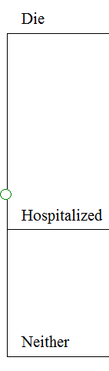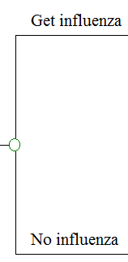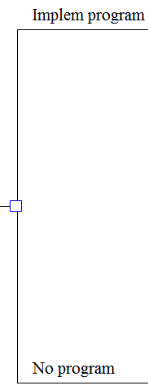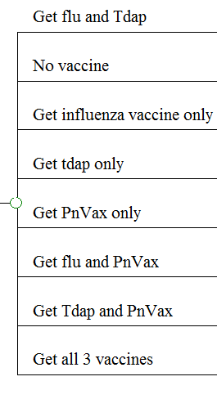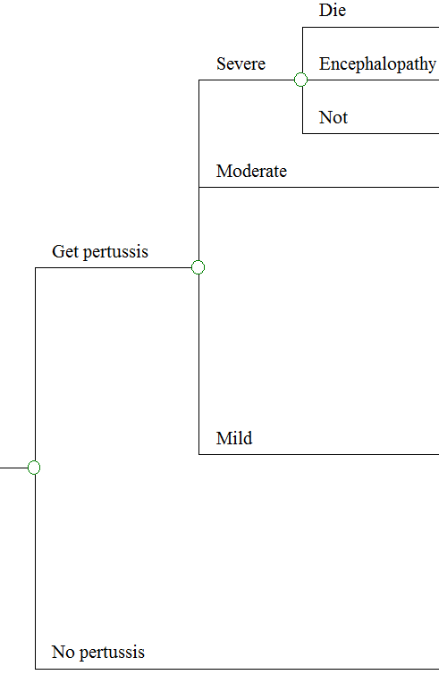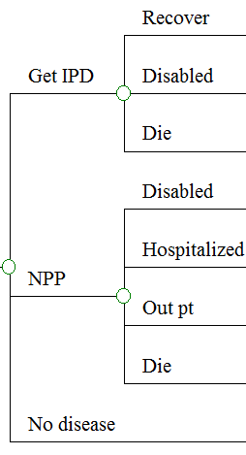

**Supplementary Figure S2.**

Tdap effectiveness (0.95 to 0)

Administration cost, per vaccine ($30 to $20)

Flu risk, per year (0.114 to 0.066)

Flu vaccine cost ($6.64 to $32.75)

Increase in PN vaccine uptake (0.182 to 0)

Increase in Tdap uptake (0.26 to 0.02)

Implementation cost, per person ($2.26 to $0.70)

Effectiveness vs. PN pneumonia (0.48 to 0)

PCV13 serotype coverage (0.5 to 0)

PN pneumonia risk (0.121 to 0.0054)

Increase in flu vaccine uptake (0.15 to 0)

Flu vaccine effectiveness (0.67 to 0.2)

Total cost of flu ($3706 to $432)

