Additional file
Figure S1: Hypothetical screening and diagnostic algorithms for pregnant and lactating women

- For all pregnant and lactating women, HIV+ and HIV-

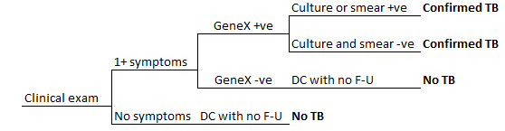

- For all pregnant and lactating women, HIV+ and HIV-
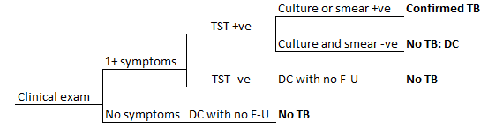

- For all pregnant and lactating women, HIV+ and HIV-
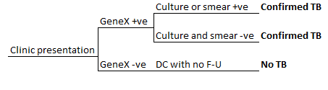

- For all pregnant and lactating women, HIV+ and HIV-

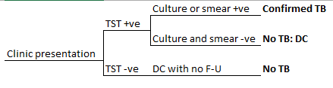

e. For all pregnant and lactating women, HIV+ and HIV-
