SUPPORTING INFORMATION

Enhanced HER2 Degradation in Breast Cancer Cells by Lysosomal Targeting Gold Nanoconstructs
Hyojin Lee^{1,+}, Duncan Hieu M. Dam^{1,2}, Ji Won Ha¹, and Teri W. Odom^{1,3}
¹ Department of Chemistry, Northwestern University, 2145 Sheridan Road, Evanston IL, 60208
⁺ Current address: Center for Biomaterials, Biomedical Research Institute, Korea Institute of Science and Technology (KIST), 5 Hwarangno 14-gil, Seongbuk-gu, Seoul 136-791, Republic of Korea
² Department of Dermatology, Northwestern University, 676 N St Clair Street, Chicago IL, 60611
³ Department of Materials Science and Engineering, Northwestern University, 2145 Sheridan Road, Evanston IL, 60208

*Corresponding Author: todom@northwestern.edu

Size and Surface Charge Characterization of AuNS and HApt-AuNS ……………..S2
Optical Properties of HApt and HApt-AuNS and Standard Curve of Cy3-HApt …S2
Characterization of HApt-AuNS Nanoconstruct after Incubation with FBS ………S3
Comparison on the effect of HApt-AuNS on cancer cell with normal cell ………….S4
Cell Viability Test at Different Concentration of Nanoconstruct …………………...S5
The Viability of Free HApt and HApt-AuNS-Treated MCF 10A …....……………..S5
Competition Assay of SK-BR-3 ………………………………………………………..S6
The Viability of SK-BR-3 after Treatment of Cells with Free HApt for 7 days ……S7
Cell Viability Test and Cell Cycle Analysis …………………………………………...S8
Fluorescence and DIC Imaging of Cells ……………………………………………….S9
TEM Images of SK-BR-3 ……………………………………………………………...S10
Measurement of Cluster Size of MCF-10A and SK-BR-3 …………………………..S11
References ……………………………………………………………………………...S12
Size and Surface Charge Characterization of AuNS and HApt-AuNS

Using dynamic light scattering (DLS), we determined that the hydrodynamic size and charge of HApt-AuNS was 90 nm (compared to 40 nm for bare AuNS) and that the surface charge was reduced to -8.05 mV in PBS solution compared to -30 mV of as-synthesized AuNS.

Table S1. Size, zeta-potential, and number of HApt on AuNS. The zeta-potential of AuNS was measured in deionized water condition and HApt-AuNS was in 1x PBS solution. We estimated the number of HApt on AuNS by measurement of fluorescence signal of Cy3-HApt.

The localized surface plasmon (LSP) resonance of HApt-AuNS was at longer wavelengths (~820) compared to as-synthesized AuNS (~791 nm) (Figure S1a). Total number of HApt on each AuNS were estimated using a fluorescence calibration curve (Figure S1b).
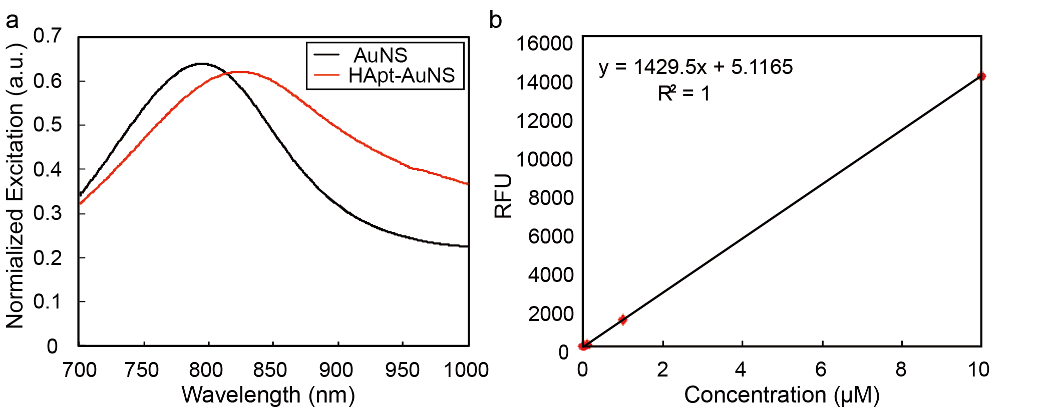
Figure S1. Optical properties of HApt and HApt-AuNS and Standard Curve of Cy3-HApt. (a) Extinction of AuNS shows a localized surface plasmon (LSP) resonance centered at 780 nm. The LSP wavelength shifted to 820 nm after functionalization of HApt. (b) Calibration curve to quantify amount of HApt on the surface of AuNS. For standard curve, we measured the fluorescence signals of 0, 10 nM, 100 nM, 1 μM and 10 μM of Cy3-HApt.
To check the stability of nanoconstructs in cell culture media, we incubated HApt-AuNS with FBS-containing media for 24 h. HApt-AuNS incubated with FBS showed the same LSP resonance compared to HApt-AuNS in water (Figure S2). In addition, changes in the size and surface charge of HApt-AuNS in FBS-containing media were negligible.
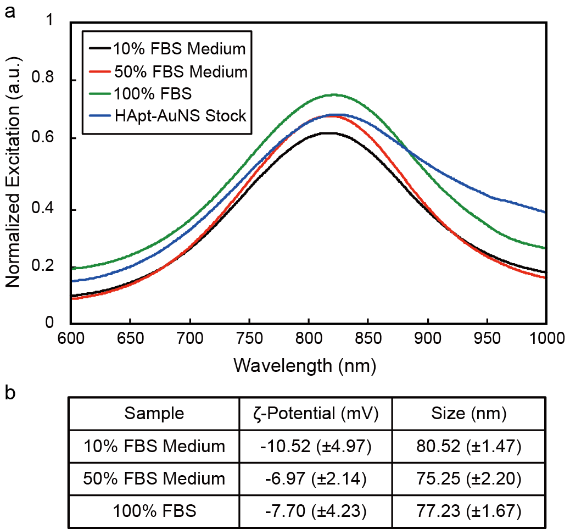

Figure S2. Stability characterization of HApt-AuNS nanoconstructs. (a) UV-vis spectra of HApt-AuNS shows that nanoconstructs do not aggregate after 24 h in FBS-containing media. (b) Zeta potential and dynamic light scattering sizes indicate HApt-AuNS has weak negative charge and uniformed size distribution after incubation with FBS.

Comparison on the Effect of HApt-AuNS on Cancer Cells and Normal Cells
SK-BR-3 cells are designated a 3+ level of HER2 (HER2 positive), corresponding to ca. 2 × 10⁶ receptors per cell while normal cells express 100-times fewer receptors (20,000).¹ To establish that HApt-AuNS uptake was mediated primarily through RME, we quantified how nanoconstruct uptake depended on the HER2 level. Both SK-BR-3 and MCF-10A were seeded in 12-well plates (50,000 cells/mL) and incubated with 2.5 nM HApt-AuNS for 24 h. After being counted, the cells were digested in acid and then analyzed by inductively coupled plasma-mass spectrometry (ICP-MS) to determine Au content. Using a two-dimensional (2D) projection of AuNS from TEM images to estimate overall volumes of AuNS, we converted the Au content to number of AuNS per cell.² Figure S3a indicates that a 2.2-times higher amount of AuNS nanoconstructs was found in SK-BR-3 cells compared to MCF-10A cells (2.7 × 10⁶ AuNS/cell) which suggests that internalization of nanoconstructs depends on the expression level of HER2. To determine whether the nanoconstruct concentration (2.5 nM) and treatment time (24 h) were harmful to normal cells, we treated MCF-10A cells with HApt-AuNS for 24 h; however, no cell death was observed (Figure S3b). Although the HER2 level in MCF-10A is 100-times lower than that in SK-BR-3, the amount of AuNS in MCF-10A is 2.2 times lower. Because the nanoconstruct consists of nucleic acid and AuNS can be internalized in cell through scavenger receptor-mediated uptake. ^{3, 4} The anti-cancer effect of HApt, however, relates to ability to HER2 cross-linking and induced HER2 degradation in lysosome, therefore nonspecific cellular uptake in MCF-10A caused no cell death.
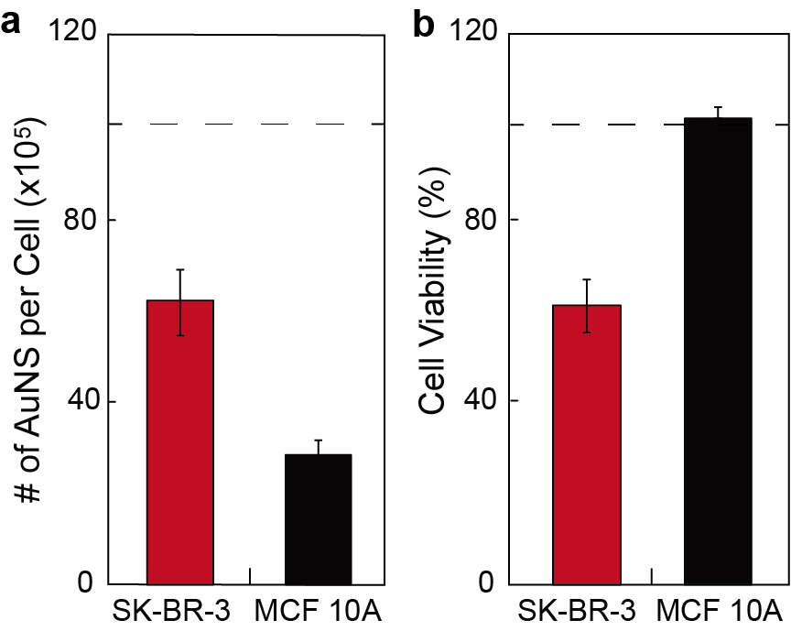
Figure S3. (a) Comparison of cellular uptake by ICP-MS analysis. The error bars were calculated from three independent experiments. (b) Cell viability of SK-BR-3 and MCF-10A after 24-h incubation of HApt-AuNS. The average value of viability was obtained from twelve independent experiments.
We adjusted the concentration of HApt-AuNS to find the lethal dose 50 (LD₅₀) in cancer cells. 50% of SK-BR-3 cell death was found for 2.5 nM HApt-AuNS (HApt concentration: 1 μM) (Figure S4).
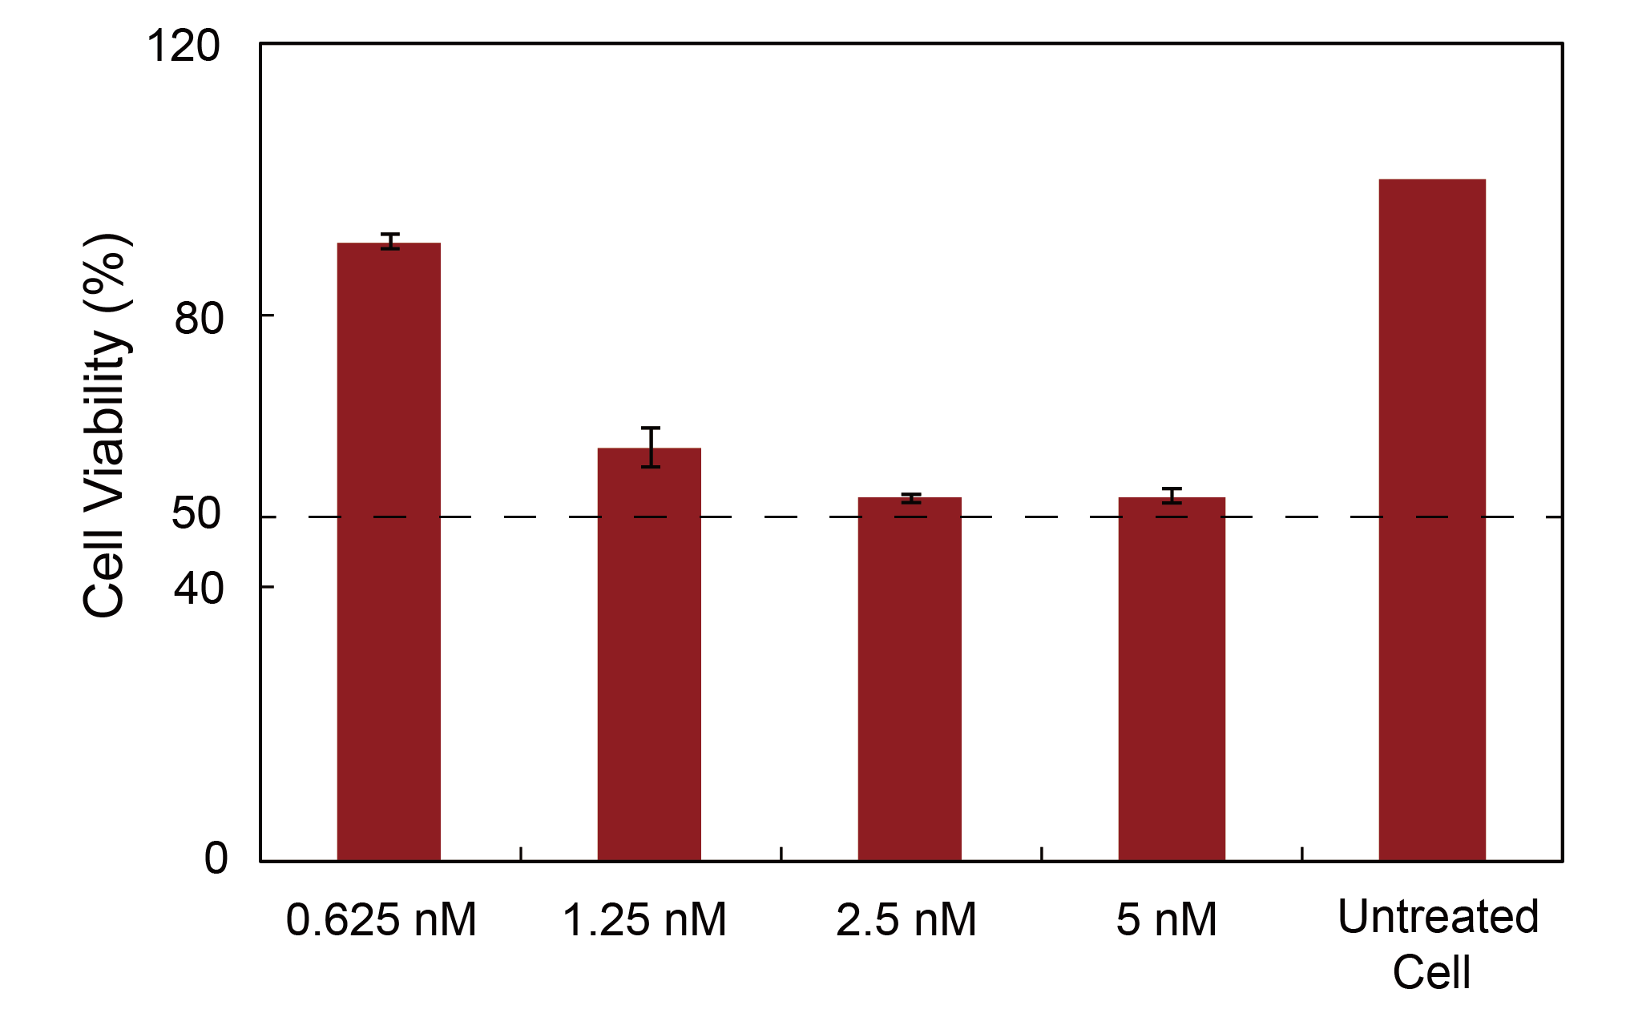
Figure S4. Cell viability test at different concentration of nanoconstruct. SK-BR-3 (10⁴ cells/ml) was incubated with HApt-AuNS at different concentration of nanoconstruct for 24h. The viability was studied by MTS assay.
To determine whether this nanoconstruct concentration and treatment time were harmful to normal cells, we treated MCF-10A cells with HApt-AuNS for 24 h; however, no cell death was shown (Figure S5). The viability of MCF-10A was maintained at over 90% even after 72-h treatment with HApt-AuNS, which suggests minimal adverse effects of nanoconstructs even after multiple cell-division cycles.⁵
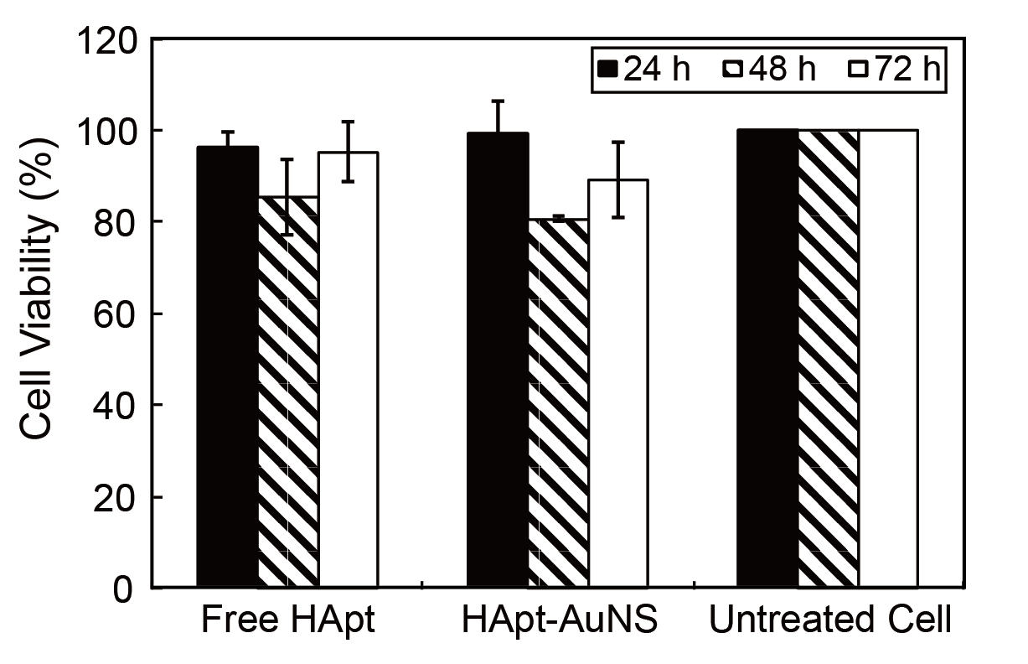
Figure S5. The viability of MCF 10A for 3 days. The concentration of HApt is 1μM (AuNS concentration: 2.5 nM). The error bars were calculated from 6 experiments.

Competition Assay of HApt-AuNS with Free HApt in SK-BR-3
After 24-h incubation of cells with free HApt (1 μM) to block HER2 binding, SK-BR-3 cells were treated with HApt-AuNS (2.5 nM). We then tested cell viability with the MTS assay. The results showed that the viability of pre-incubated cells with free HApt increased about 20% (from 56.6% to 74.2%), which suggests that the uptake and anti-cancer effect of HApt-AuNS in SK-BR-3 is primarily mediated by HER2.
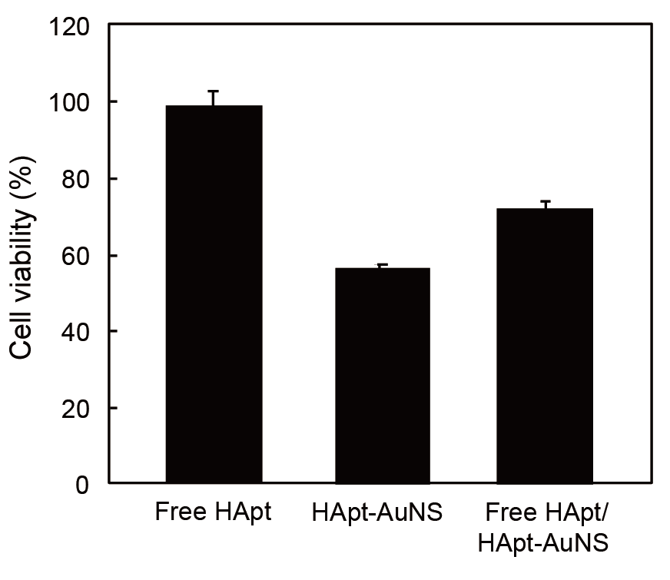
Figure S6. Competition assay. SK-BR-3 showed increase of cell viability about 20% when cells were pre-incubated with 1-µM free HApt.

Cell Viability Test with Free HApt at Different Time Points
SK-BR-3 cells were incubated with culture media containing free HApt (1 μM and 100 nM) for seven days. Cells showed a decreased viability of only 25% even after six days of incubation while the same concentration of HApt (1 μM) in HApt-AuNS showed 50% cell death after 24 h.
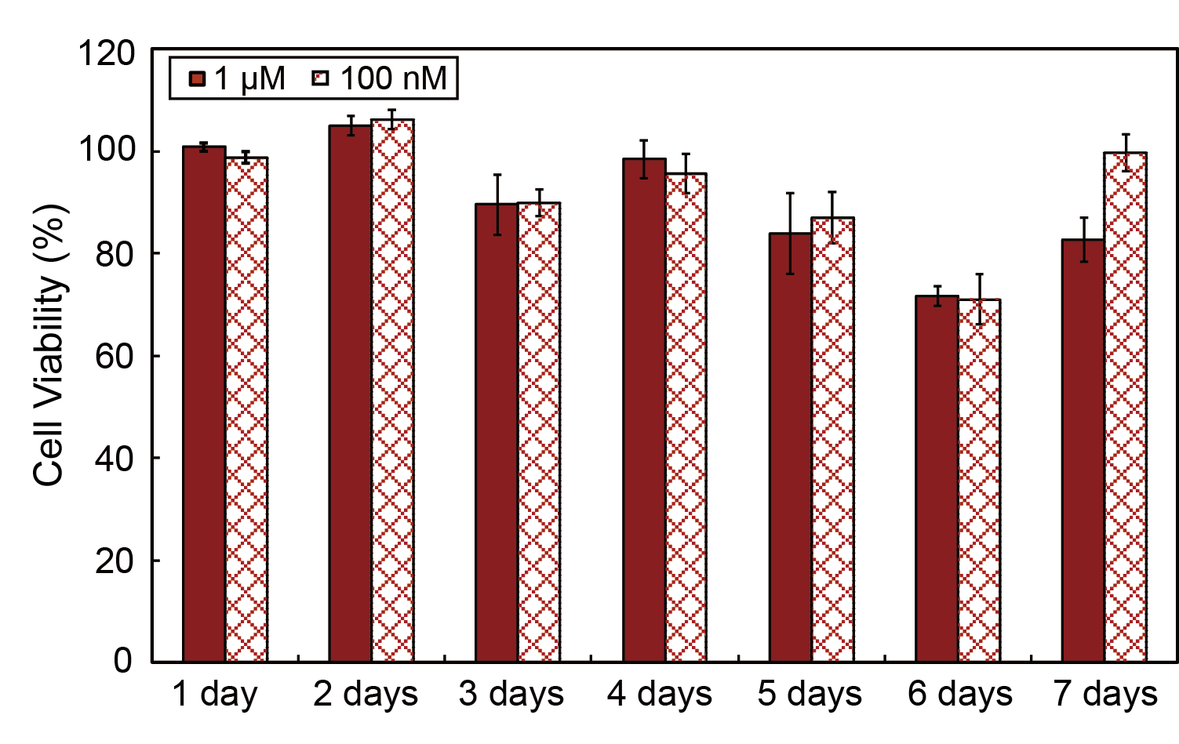
Figure S7. Cell viability of SK-BR-3 after treatment of cells with free HApt for 7 days. The concentrations of HApt are 1μM and 100 nM. Free HApt did not show anti-cancer effects on SK-BR-3 cells even at day 7 treatment time.

Cell Viability Test and Cell Cycle Analysis
SK-BR-3 (10⁴ cells/mL) was seed into 96 well and incubated for 8, 16 and 24 h with HApt-AuNS. Cell viability was studied by MTS assay. The result showed that the cell death occurred at 16 h. To analyze cell cycle, we seeded 10⁷ cells/mL. We investigated whether cell cycle arrest happened by staining the nucleus of the cells with 4',6-diamidino-2-phenylindole (DAPI) and using flow cytometer (BD LSRII, BD Bioscience). To synchronize the cell, we used serum starvation method (Figure S8).
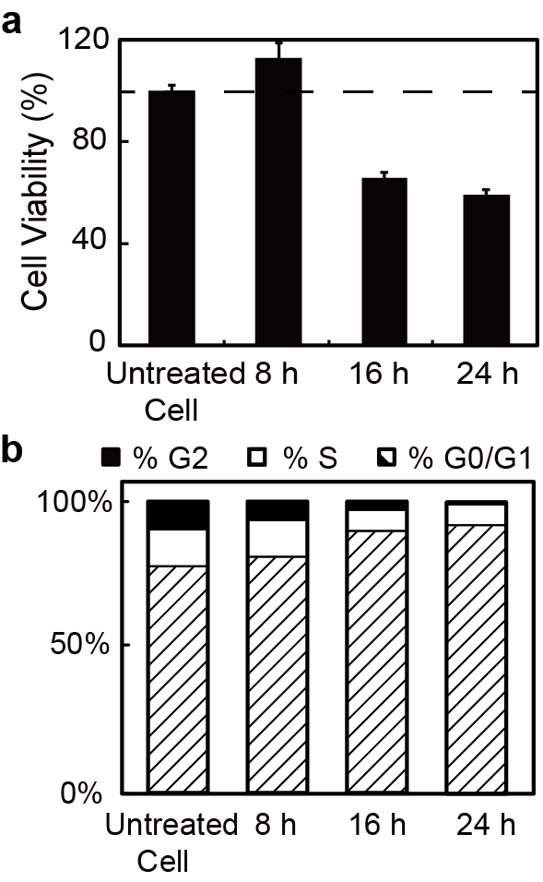
Figure S8. Effect of HApt-AuNS treatment on cell viability and cell cycle progression. (a) Cell viability after treatment of SK-BR-3 cells with HApt-AuNS for 8, 16 and 24 h. (b) Cell cycle analysis after incubation of cells with nanoconstructs for 8, 16 and 24 h. The concentration of cell was 1x 10⁷ cells/ml. The cell showed the transition to G0/G1 phase as a function of time.

Fluorescence and DIC imaging of Cells
We stained lysosomes with LysoTracker Green DND-26 which has excitation/emission at 504/511 nm. We labeled HApt with Cy5, which has excitation/emission at 650/670 nm to reduce the possibility of interference in signals. Figure S9 showed that as incubation time increased, the HER2-HApt-AuNS complexes were farther inside cells. At later times, such as 16 h and 24 h, lysosomal signal overlapped with the Cy5 label on HApt-AuNS. DIC images indicated that HER2-HApt-AuNS were also at similar intra-cellular locations.
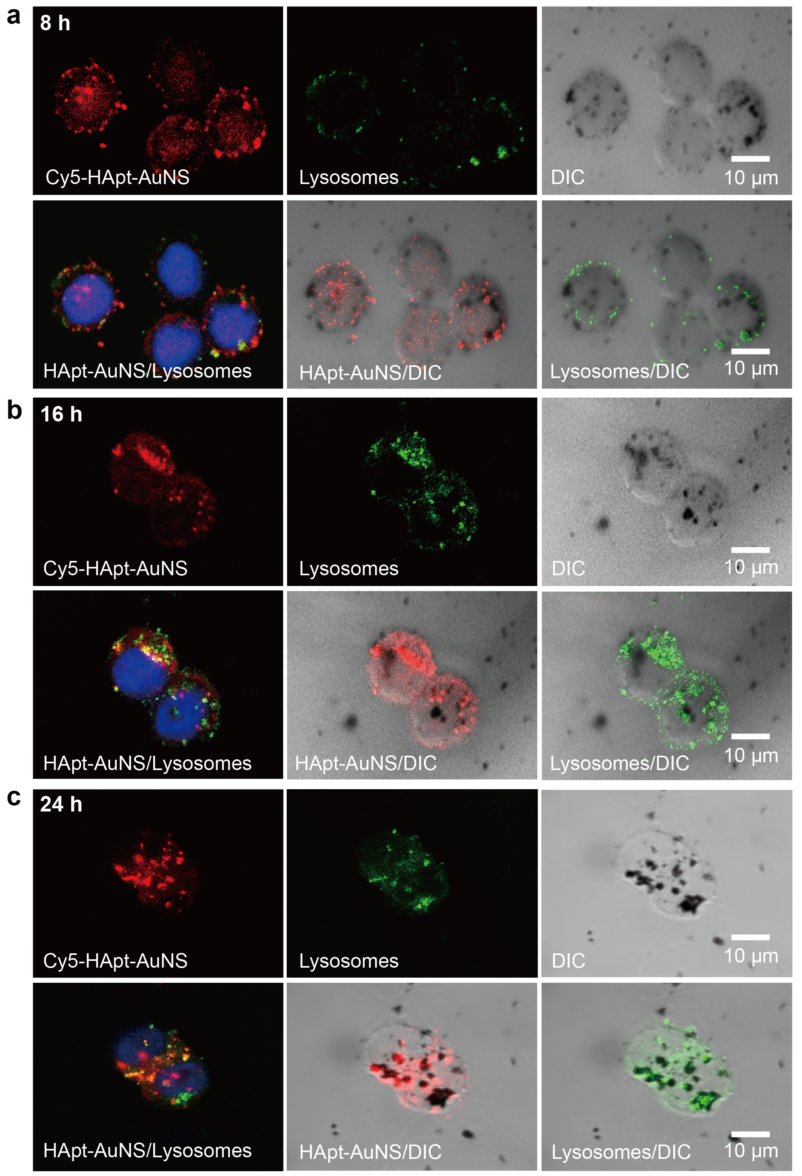
Figure S9. Optical Imaging of SK-BR-3 as a Function of HApt-AuNS Incubation Time. (a)-(c) The nanoconstructs appear as dark spots in the DIC images.
TEM Images of HApt-AuNS in SK-BR-3 Cells.
TEM results of pelleted and sliced cells (90-nm thickness) showed that the clusters located in vesicular structures of cells. The TEM images showed that the size and structure of AuNS could preserve even inside vesicular structure as a function of incubation time. (Figure S10).
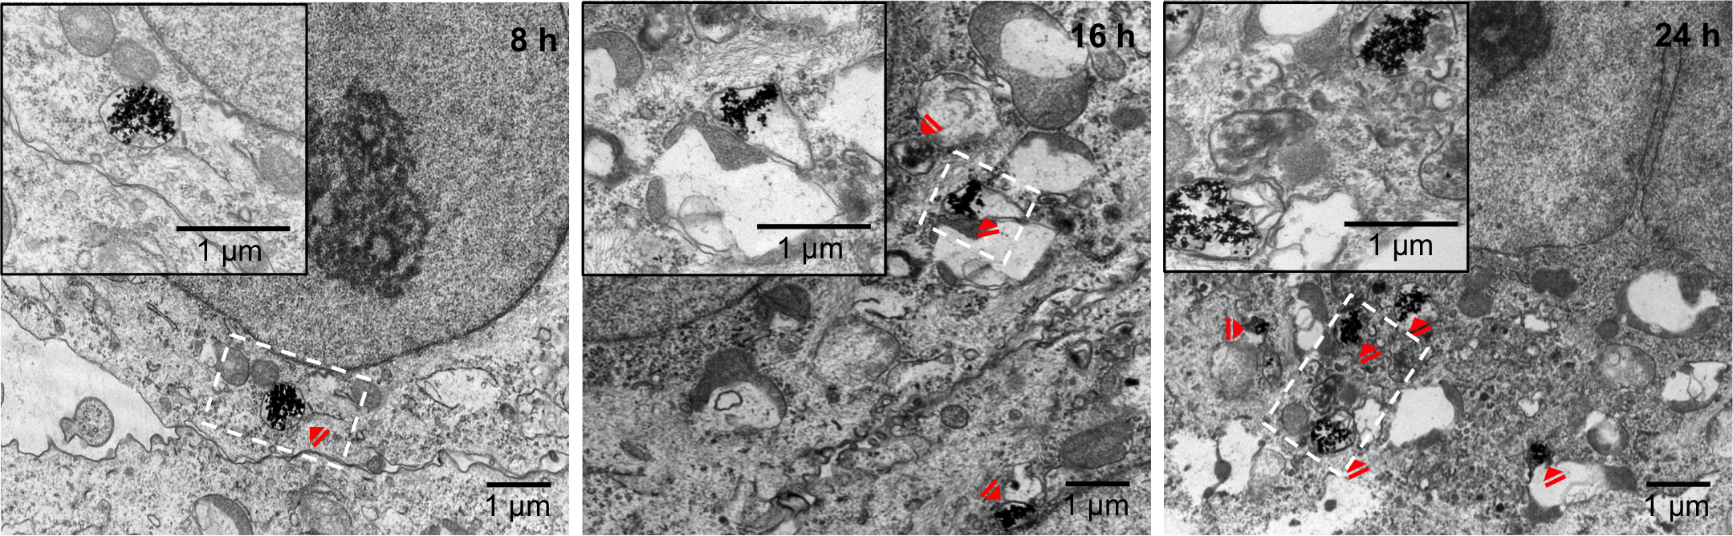

Figure S10. TEM images of SK-BR-3 cells after treatment of cells for 8, 16 and 24 h. The size of AuNS was still about 40 nm inside vesicular structure even after 24-h incubation.

Measurement of Cluster Sizes in MCF-10A and SK-BR-3 by DIC
MCF-10A (normal cells) and SK-BR-3 were incubated with HApt-AuNS for 8, 16 and 24 h. After fixing cells with 4% paraformaldehyde, images were obtained by DIC microscopy. Cluster sizes of HApt-AuNS in cells were measured by Image J. The sizes of AuNS clusters in SK-BR-3 cancer cells was larger (about 2.2 times) than that of MCF-10A after 24-h incubation of cells with nanoconstructs.
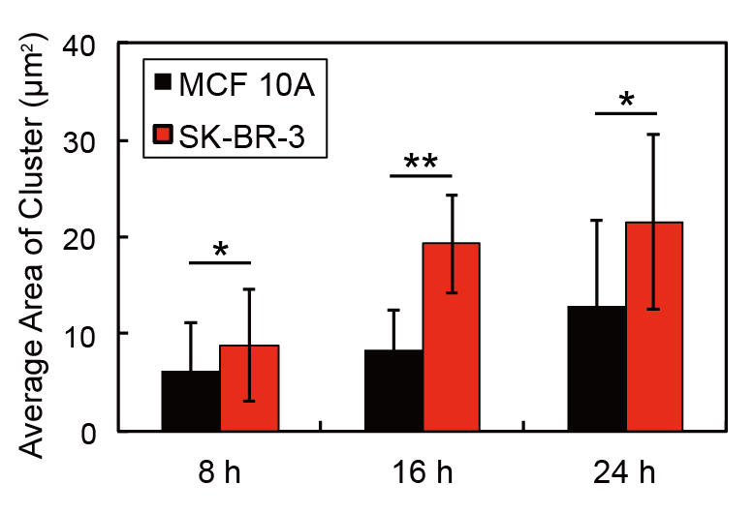
Figure S11. Average HApt-AuNS cluster area in MCF 10A and SK-BR-3. The error bars were obtained from six individual DIC images.

Supporting Information References

1. Brown, R. E. HER-2/neu-Positive Breast Carcinoma: Molecular Concomitants by Proteomic Analysis and their Therapeutic Implications. Annals of Clinical & Laboratory Science 2002, 32, 12-21.
2. Dam, D. H. M.; Lee, R. C.; Odom, T. W. Improved in Vitro Efficacy of Gold Nanoconstructs by Increased Loading of G-quadruplex Aptamer. Nano Letters 2014.
3. Patel, P. C.; Giljohann, D. A.; Daniel, W. L.; Zheng, D.; Prigodich, A. E.; Mirkin, C. A. Scavenger Receptors Mediate Cellular Uptake of Polyvalent Oligonucleotide-Functionalized Gold Nanoparticles. Bioconjugate Chemistry 2010, 21, 2250-2256.
4. Saha, K.; Kim, S. T.; Yan, B.; Miranda, O. R.; Alfonso, F. S.; Shlosman, D.; Rotello, V. M. Surface Functionality of Nanoparticles Determines Cellular Uptake Mechanisms in Mammalian Cells. Small 2013, 9, 300-305.
5. Ramljak, D.; Romanczyk, L. J.; Metheny-Barlow, L. J.; Thompson, N.; Knezevic, V.; Galperin, M.; Ramesh, A.; Dickson, R. B. Pentameric procyanidin from Theobroma cacao selectively inhibits growth of human breast cancer cells. Molecular Cancer Therapeutics 2005, 4, 537-546.

