Additional file 1: Figure S1. Baby-boomers graphical trend compared to other birth cohorts
in the United States, 1975-2014 ª
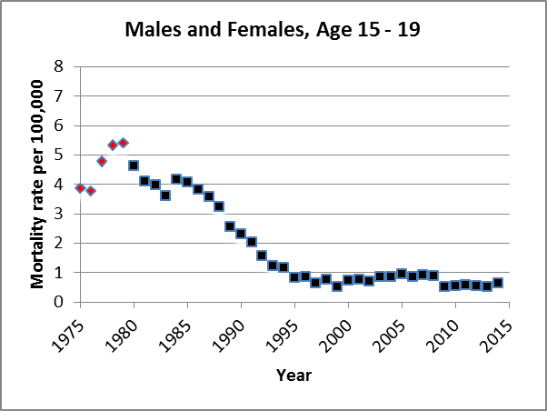 | 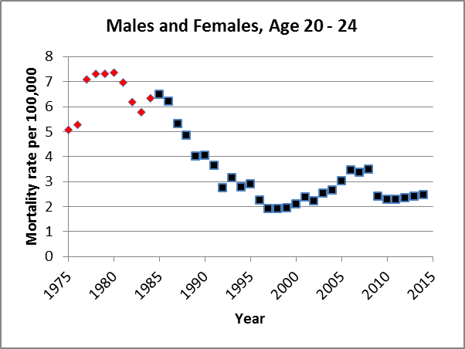 | 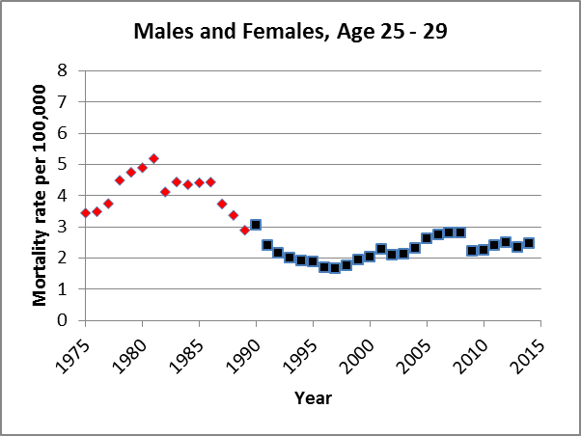
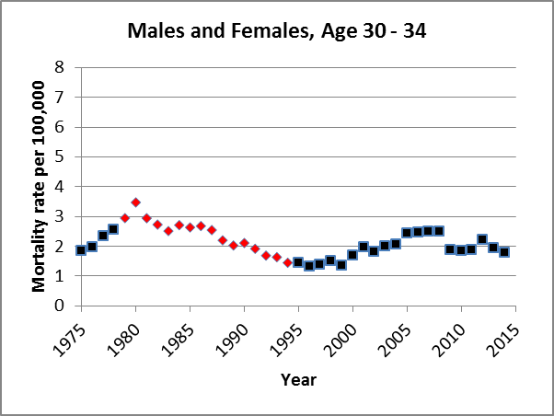 | 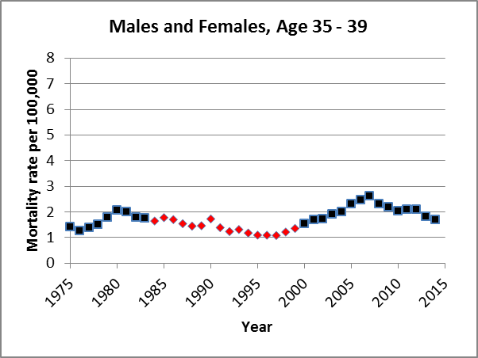 | 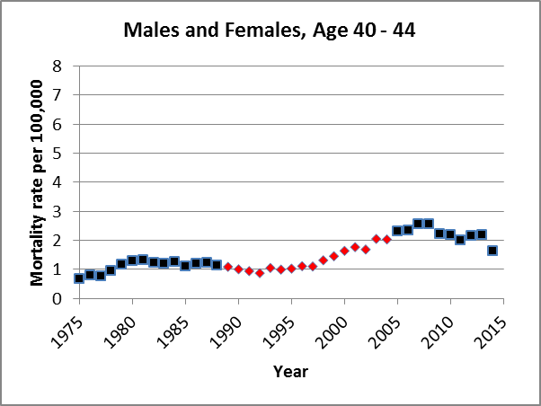
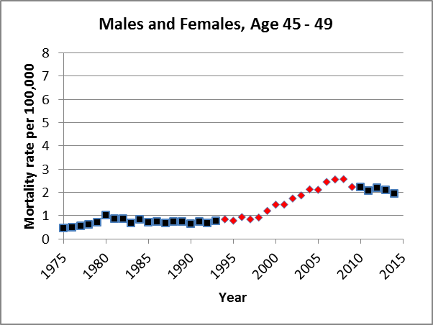 | 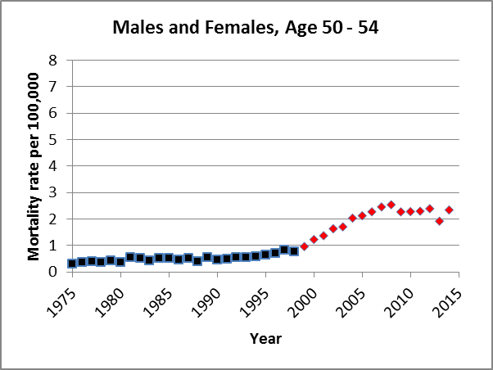 | 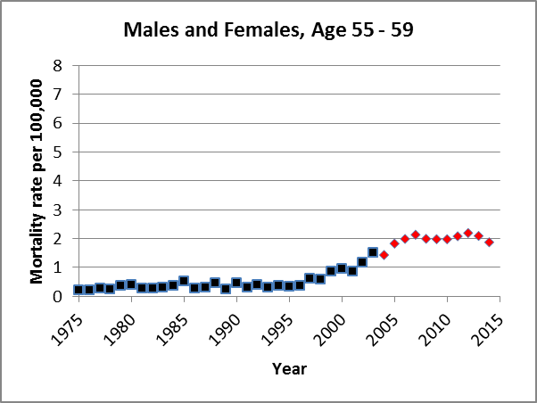
ª Red solid diamonds represent mortality rates for baby-boomers as the aged from 1975 to 2014; blue solid squares represent other birth cohorts

