Supplemental Material

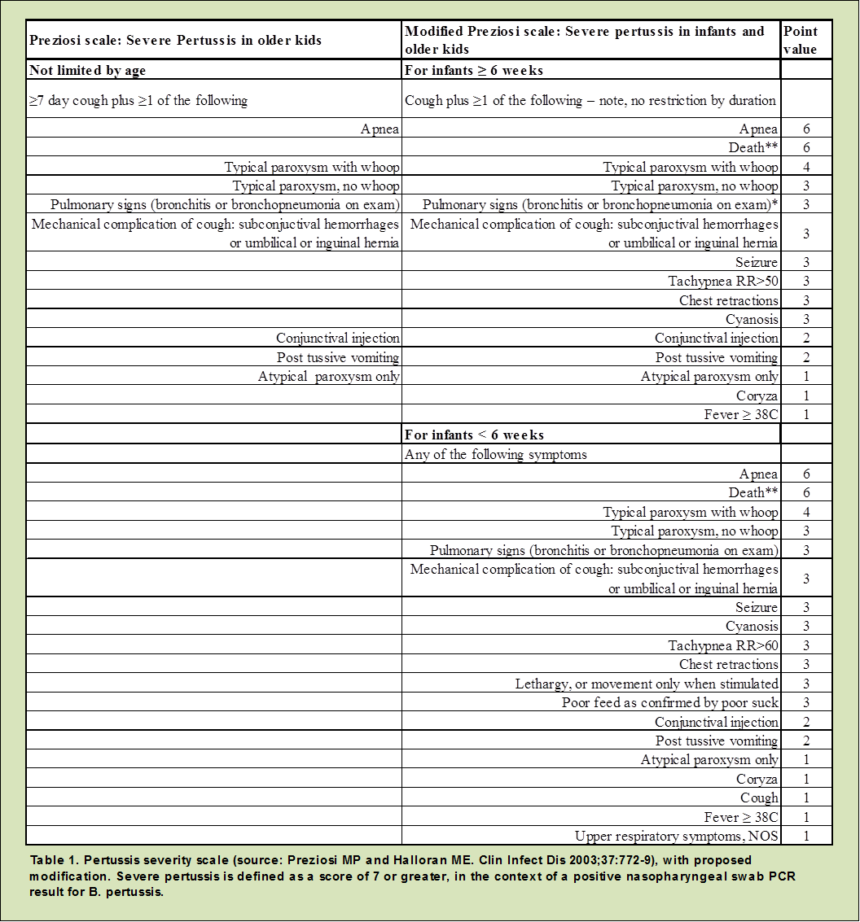
Figure S1. Pertussis severity scale (source: Preziosi MP and Halloran ME. Clin Infect Dis 2003;37:772-9), with proposed modification. Severe pertussis is defined as a score of 7 or greater in the context of a positive nasopharyngeal swab PCR results for B. pertussis.

Table S1. Baseline characteristics of mothers
Maternal Demographic Information
Median age in years (IQR)* (N = 197) | 22 (26 – 30)
Median gestational age in months (IQR)* (N = 197) | 34 (32 – 37)
Enrolled at time of birth (N (%))* | 65 (29.4%)
Highest level of maternal education (N = 2021) | N (%)
0 years | 1,078 (54.0)
1 to 5 years | 414 (20.7)
6 to 9 years | 222 (11.2)
10 years or more | 283 (14.2)
Missing | 24
Highest level of paternal education (N = 2021)
0 years | 939 (47.0)
1 to 5 years | 377 (18.9)
6 to 9 years | 279 (14.0)
10 years or more | 402 (20.1)
Missing | 24
Vaccines During Pregnancy*(N = 197)
Ever received TT vaccination? (N (%)) | 113 (57.4)
Median number of doses of tetanus toxoid (IQR) | 2 (1 – 2)
* Specific to mothers enrolled in the closed cohort (N = 221) only.

Table S2. Descriptive Summary of Symptoms for Eight Infants Meeting the Syndromic Case Definition with PCR Confirmation.
Subject identification number: | 32311 | 30361 | 18111 | 42201 | 53401 | 50701 | 42291 | 53321
Case classification* | Conf. | Conf. | Conf. | Conf. | Conf. | Prob. | Prob. | Synd.
Age (weeks) at diagnosis | 3 | 6 | 9 | 13 | 5 | 18 | 15 | 5
Modified Preziosi Score | 14 | 10 | 9 | 5 | 6 | 6 | 0 | 4 | Totals
Cough/paroxysms | Yes | Yes | Yes | Yes | Yes | Yes | Yes | No | 87.5% (7/8)
Cough at least 2 weeks | Yes | Yes | Yes | Yes | Yes | No | No | No | 62.5% (5/8)
Coryza | Yes | Yes | Yes | No | Yes | No | No | Yes | 50.0% (4/8)
Whoop | Yes | Yes | No | No | No | No | No | No | 25.0% (2/8)
Apnea | No | No | No | No | No | No | No | No | 0.0% (0/8)
Post-tussive emesis | No | No | Yes | Yes | No | No | No | No | 25.0% (2/8)
Cyanosis | No | No | No | No | No | No | No | No | 0.0% (0/8)
Seizure | No | No | No | No | No | No | No | No | 0.0% (0/8)
Tachypnea | No | Yes | Yes | Yes | No | Yes | No | No | 50.0% (4/8)
Severe chest indrawing | Yes | Yes | Yes | No | Yes | Yes | No | Yes | 75.0% (6/8)
Movement only when stimulated | No | No | No | No | No | No | No | No | 0.0% (0/8)
Poor feeding confirmed by poor suck | Yes | No | No | No | No | No | No | No | 0.0% (0/8)
Close exposure to a family members with prolonged afebrile cough illness | No | No | No | No | Yes | No | No | No | 12.5% (1/8)
Fever | No | No | No | No | No | No | No | No | 0.0% (0/8)
Wheeze | No | Yes | No | No | No | Yes | No | No | 25.0% (2/8)
Mechanical complications of cough | No | No | No | No | No | No | No | No | 0.0% (0/8)
Conjunctivial injection | No | No | No | No | No | No | No | No | 0.0% (0/8)
Atypical paroxysms only | Yes | No | No | No | Yes | No | No | No | 25.0% (2/8)
Upper respiratory symptoms NOS | Yes | Yes | Yes | Yes | No | No | Yes | No | 62.5% (5/8)
Other | No | No | No | No | No | No | No | Yes | 12.5% (1/8)
* Conf. represents cases meeting the CDC confirmed case classification; Prob. represents cases meeting the CDC probably case classification; Synd. represents cases meeting the syndromic case definition plus PCR confirmation.

Outcome definitions.
- Infant meets the syndromic definition and has a positive PCR test for B. pertussis. (PrePY definition)
- Infant meets the US Centers for Disease Control and Prevention case definition of
  - Probable case
    - Acute cough illness of any duration, with at least one of the following symptoms:
      - Paroxysms of coughing
      - Inspiratory whoop
      - Posttussive vomiting
      - Apnea (with or without cyanosis)
    - Meets one of the following criteria
      - PCR positive test for pertussis
      - Contact with a laboratory-confirmed case of pertussis
  - Confirmed case
    - Meets the clinical case definition of cough illness of 2 or more weeks with at least one of the following symptoms, accompanied by positive PCR test for pertussis or contact with a laboratory-confirmed case of pertussis:
      - Paroxysms of coughing
      - Inspiratory whoop
      - Posttussive vomiting
      - Apnea (with or without cyanosis)
    - Acute cough of any duration with isolation of B. pertussis from a clinical specimen

