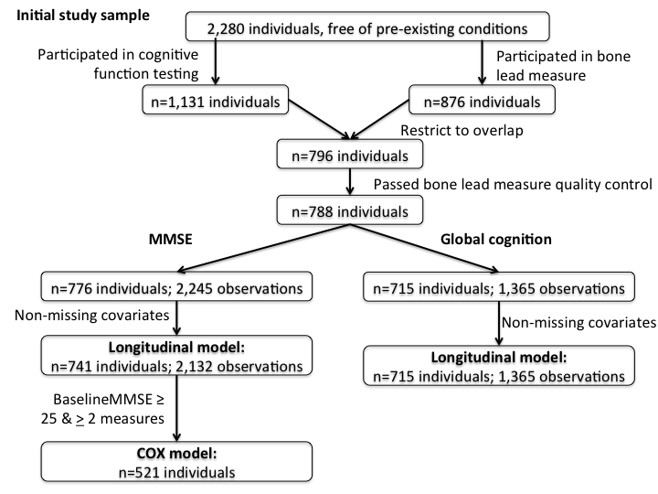

Supplementary Figure S1. Study sample selection procedures.

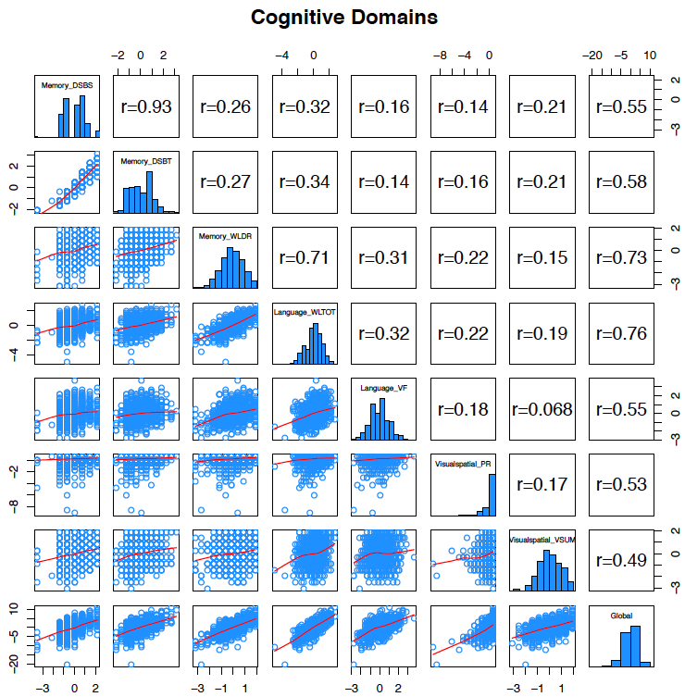
Supplementary Figure S2. Correlation coefficients for the pairwise cognitive scores: DSBT = digit-span backwards total, WLDR = word list delayed recall, WLTOT = word list total recall, VF = verbal fluency, PR = pattern recognition, VSUM = visual drawings, sum.

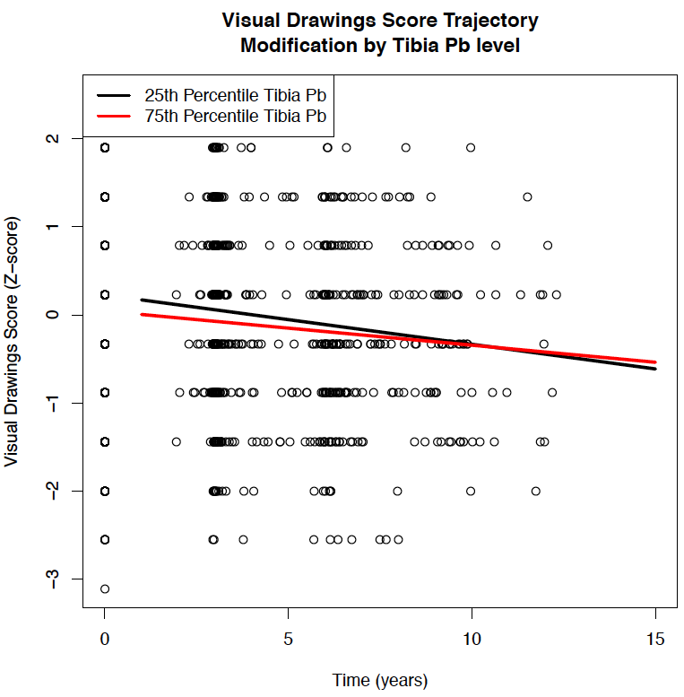

Supplementary Figure S3. The longitudinal changes in visual drawings Z-score over time in relation to tibia Pb. The model included baseline tibia Pb, time from first visit, the interaction of tibia Pb and time, and was adjusted for baseline age, smoking status, education level, and alcohol consumption, and random intercepts and random slopes for time. The visual drawings trajectory lines were obtained as a function of time by incorporating the 25th percentile (12.0 μg/g, black line) and the 75th percentile (27.0 μg/g, red line) of tibia Pb levels.
Supplementary Table S1
Table S1 - Number of subjects at MMSE < 25 for each visit
Visit | N Subjects
1 | 80
2 | 40
3 | 45
4 | 31
5 | 12
6 | 1
7 | 1

