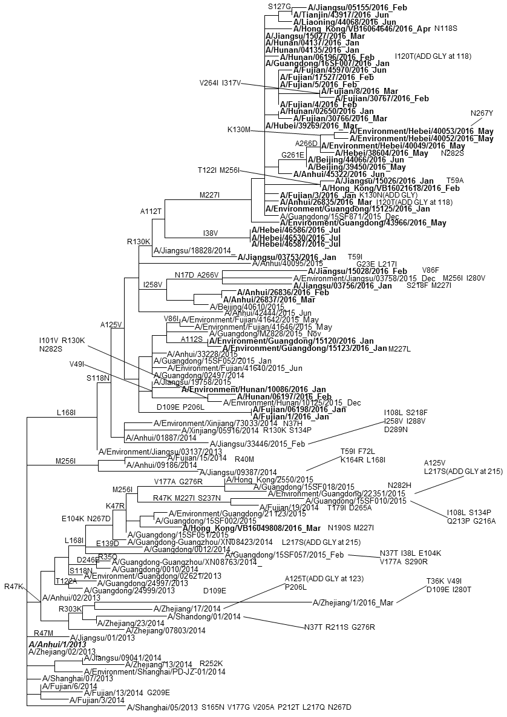
Figure 2 Evolutionary Relationships Among Influenza A(H7N9) virus hemagglutinin (HA) genes.
Amino acid differences shown on the branches and tips of the phylogenetic tree indicate changes compared with Anhui/1/2013, a candidate vaccine virus. Mature H7 HA numbering (numbering not including the HA signal peptide) was used. Sequences in bold represent fourth epidemic viruses and remaining sequences represent viruses circulating in the first, second and third epidemics.

