**Serum from obstructive sleep apnea patients induces inflammatory responses in coronary artery endothelial cells**

Katherine E. Zychowski1¶, Bethany Sanchez1¶, Rodrigo P. Pedrosa2, Geraldo Lorenzi-Filho2, Luciano F. Drager2, Vsevolod Y. Polotsky3, Matthew J. Campen1*

1Department of Pharmaceutical Sciences, University of New Mexico College of Pharmacy, Albuquerque, NM, USA

2 University of São Paulo Medical School, São Paulo, Brazil

3 Department of Medicine, Division of Pulmonary and Critical Care Medicine, Johns Hopkins University, Baltimore, MD, USA

¶These authors contributed equally to this work.

*Corresponding author: MSC09 5360,1 University of New Mexico, Albuquerque, NM 87131.

Tel: 505-925-7728.E-mail address: mcampen@salud.unm.edu (M. J. Campen)

ABSTRACT

*Background and aims:* Obstructive sleep apnea (OSA) is characterized by intermittent airway obstruction and systemic hypoxia during sleep, which can contribute to an increase in reactive oxygen species, vascular remodeling, vasoconstriction and ultimately cardiovascular disease. Continuous positive airway pressure (CPAP) is a clinical therapy that maintains airway patency and mitigates several symptoms of OSA. However, it is currently unknown whether CPAP therapy also reduces the overall inflammatory potential in the circulation; to address this in an unbiased manner, we applied a novel endothelial biosensor approach, the serum cumulative inflammatory potential (SCIP) assay.

*Methods:* We studied healthy controls (n=7), OSA subjects receiving no treatment, (OSA controls) (n=7) and OSA subjects receiving CPAP for 3 months (n=8). Serum was obtained from OSA subjects before and after CPAP or no treatment. A battery of quantitative and functional assays was performed to assess the serum inflammatory potential, in terms of endothelial responses. For the SCIP assay, human coronary artery endothelial cells (hCAECs) were incubated with 5% serum in media from individual subjects for 4 h. qPCR was performed to assess endothelial inflammatory transcript (ICAM-1, VCAM-1, IL-8, P-selectin, CCL5, and CXCL12) responses to serum. Additionally, transendothelial resistance was measured in serum-incubated hCAECs following leukocyte challenge.

*Results:* hCAECs exhibited significant increases in *VCAM-1, ICAM-1, IL-8* and *P-selectin* mRNA when incubated with serum from OSA patients compared to serum from healthy control subjects. Furthermore, compared to no treatment, serum from CPAP-treated individuals was less potent at inducing inflammatory gene expression in the SCIP assay. Similarly, in a leukocyte adhesion assay, naïve cells treated with serum from patients who received CPAP exhibited improved endothelial barrier function than cells treated with OSA control serum.

*Conclusions:* OSA results in greater serum inflammatory potential, thereby driving endothelial activation and dysfunction.

Keywords: Obstructive Sleep Apnea, inflammation, hypoxia, serum, bioassay.

*Abbreviations:* AHI, apnea-hypopnea index; BMI, body mass index; CCL5, chemokine ligand 5; CPAP, continuous positive air pressure; CRP, C-reactive protein; CVD, cardiovascular disease; CXCL12, stromal cell-derived factor 1; SCIP, serum cumulative inflammatory potential assay; hCAEC: human coronary artery endothelial cell; ICAM-1, intercellular adhesion molecule 1; IL-8, interleukin 8; LDL, low density lipoprotein; LFA-1, lymphocyte function-associated antigen-1; NF-kB, nuclear factor-kappa light chain-enhancer of activated B cells; OSA, obstructive sleep apnea; P-SEL, P-selectin; ROS, reactive oxygen species; SAA, serum amyloid A; sICAM-1, soluble ICAM-1; sVCAM-1, soluble VCAM-1; VCAM-1, vascular cell adhesion molecule 1; VLA-4, very late antigen-4.

INTRODUCTION

Obstructive sleep apnea (OSA) is highly prevalent in North America and throughout the developed world, and is characterized by chronic intermittent hypoxia and arousal from sleep caused by disruption of normal breathing. Recent studies in western countries have shown a rising prevalence in men (ranging from 10-49%, depending on age and cohort) and women (ranging from 10-23%) of moderate-to-severe sleep disordered breathing [1-3]. OSA can be an indication of metabolic deregulation in addition to being a great risk of cardiovascular disease partly due to lifestyle habits (diet, exercise), as well as the systemic inflammation that follows chronic hypoxia. However, OSA often goes unnoticed by people who are at highest risk for developing the disease [4, 5]. OSA has been implicated as an independent contributing factor to numerous cardiovascular diseases including atrial fibrillation, myocardial infarction, stroke and heart disease [6].

While the cause of increased risk is not completely understood, intermittent hypoxia and arousal may induce a cluster of responses including sympathetic nervous system activation and transient tissue ischemia that may combine to promote vascular inflammation. Periodic oxygen desaturation following temporary obstruction of the pharyngeal airway leads to increased production of vascular reactive oxygen species (ROS), which in turn may induce proinflammatory cytokines via redox-dependent signaling pathways [7, 8]. Numerous studies have characterized the relationship between OSA and markers of cardiovascular disease risk. Factors such as C-reactive protein (CRP), a broad-spectrum marker of inflammation and serum amyloid A (SAA), a serum apolipoprotein marker are also elevated in OSA patients compared to healthy patients [9-13]. It remains unclear whether conventional therapy for OSA is also valuable for the reduction in cardiovascular risk.

Continuous positive airway pressure (CPAP) therapy is a long-standing treatment to mitigate symptoms of OSA. CPAP increases the air pressure in the upper airway, thereby preventing airway collapse and mitigating intermittent hypoxemia [14]. Primary goals of CPAP therapy include improving sleep continuity, reducing daytime sleepiness, and improving daytime performance [14-16]. Because epidemiological evidence suggests a link between OSA and hypertension, stroke and other cardiovascular sequelae [17, 18], there is also substantial clinical interest in utilizing CPAP to target downstream cardiometabolic pathophysiology [18, 19]. CPAP therapy has not been consistently shown to reduce inflammatory markers and, while CPAP alleviates daytime somnolence and improves quality of life, it is unclear the extent to which this therapy reverses cardiovascular disease risk [9, 20-22].

Our laboratory has developed a novel approach that utilizes complete serum from patients to address a cumulative inflammatory potential as a complement to traditional markers, such as CRP or TNFα. By applying serum to endothelial cells in culture and measuring the endothelial cell transcriptional and functional responses, we have shown this approach to be quite sensitive in demonstrating greater inflammatory burden in patients with a prior cardiac event on standard-of-care medication compared to healthy control subjects, relative to conventional circulating biomarkers [23]. Additionally, we have used this serum cumulative inflammatory potential (SCIP) assay to show that prolonged use of a grape seed extract (principally resveratrol) could significantly lower inflammatory potential relative to placebo, while no changes were noted in circulating chemokines or acute phase proteins [24]. These studies suggests that serum factors altered by diseased states may induce changes in naïve cell behavior, and animal studies have confirmed that changes in endothelial mRNA gene expression are consistent with endothelial dysfunction, including decreased barrier integrity, increased leukocyte extravasation through the endothelium and downstream foam cell formation [25, 26].

The present study was therefore designed to explore the potential value of endothelial biosensor assays in the context of OSA and in assessing the value of CPAP therapy, by comparing both OSA subjects with health controls, as well as by comparing baseline values with serum responses obtained after 3 months of CPAP therapy.

PATIENTS AND METHODS

*Patient demographics*

Previously collected serum from health and OSA cohorts was used in a blinded fashion for these studies. Participants with no OSA were recruited from a previous investigation [27]. Patient recruitment has been previously described [28] and all clinical studies were approved by the local Ethics Committee for Sao Paulo University. Serum samples were collected after 3 months of CPAP or no treatment, with up to 48 h of deviation of the end of the study due to weekends or holidays. No participants had diabetes or sustained hypertension, were non-smokers, and were not using any medications. Based on clinical presentation, patients were subdivided into three treatment groups: Healthy Controls, OSA control subjects receiving no therapy and OSA subjects receiving CPAP (Fig. 1). Patients were randomly assigned to groups, and then underwent either CPAP or no treatment for 3 months. Serum samples were collected before and after the treatments [28]. For the present study, serum volume limitations restricted the total number of subject samples to: Healthy Controls (n=7), OSA control subjects receiving no therapy (n=8) and OSA subjects receiving CPAP (n=8). Serum markers CRP, sVCAM, sICAM, SAA, IL-6 and TNFα were measured by electrochemiluminescence (Meso Scale Discovery, Rockville, MD), as previously described [23]. Baseline physiological parameters were recorded including apnea hypopnea index (AHI), low-density lipoprotein (LDL), baseline O2 saturation, and BMI.

*Circulating inflammatory potential endothelial bioassay*

Naïve human coronary artery endothelial cells (hCAECs; Lonza, Allendale, NJ) between passages 3-5 were seeded in 24-well plates and grown to confluence, as determined by a plateau in resistance over the course of approximately 48 h. Cells were exposed to 5% serum for 4h, harvested, and RNA was isolated using RNeasy Mini kits (QIAGEN, Valencia, CA). RNA was then reversed transcribed using High-Capacity cDNA Reverse Transcription Kits (Applied Biosystems, Foster City, CA), prior to qPCR. Target genes including *ICAM1* (Hs00164232_m1), *VCAM1* (Hs01003372_m1), *IL8* (Hs00174103_m1), *SELP* (P-selectin; Hs00174583), *CXCL12* (Hs00171022_m1) and *CCL5* (Hs00982282_m1) were probed using the TaqmanR Gene Expression protocol as per the manufacturer’s instructions (ThermoScientific, Waltham, MA). Relative gene expression of the selected endothelial target was analyzed using the 2-ΔΔC T method, as previously described [29]. mRNA levels were then normalized to TATA-box binding protein (*TBP*) (Hs00427620_m1).

*Leukocyte adhesion*

THP-1 monocyte cell lines (ATCC, Manassas, Virginia) were used to assess transendothelial resistance of hCAECs after monocyte challenge. Based on Ohm’s Law (V=IR), the Electric Cell Impedance Sensing (ECIS) system (Applied Biophysics, Troy, NY) was utilized to examine alterations in endothelial barrier integrity and subsequent changes in electrical resistance (R). Briefly, 5 x105 hCAECs were plated per well and grown to confluence, as monitored by a plateau in transendothelial resistance. HCAECs, THP-1 cells were then incubated separately with 5% patient serum in the appropriate culture media for 4h, prior to combining the cells. Transendothelial resistance was measured at 16 kHz for 20h after the addition of THP-1 cells to the plated hCAECs. All adhesion assays were performed in triplicate. A normalized adhesion index was calculated as the difference in area (resistance x time) for the resistance changes over the 20h period, and repeated measures comparisons for serum obtained before and after CPAP or no treatment were made for each subject. Serum volume limitations led to attrition of one subject in each OSA group, so all assays are based on paired comparisons of 7 subjects for untreated and CPAP treatments.

*Statistical analysis*

When comparing only healthy controls and OSA (combined), data were subject to a Mann-Whitney t-test. When comparing differences between CPAP and OSA controls, a repeated measures two-way ANOVA was performed on each data set with a Fisher’s LSD post-hoc test for multiple comparisons. All values are considered significant at p≤0.05.

RESULTS

*Demographic and physiological baseline data*

Compared to participants with no OSA, male OSA patients presented similar age (40 ± 8 years old in healthy controls vs 44 ± 7 years old in OSA, p=0.22) but a higher BMI (27.4 ± 2.5 in healthy controls *versus* 30.5 ± 2.6 in OSA subjects, p=0.015) than healthy control subjects (Table 1.) Following the CPAP treatment, no significant change in BMI was noted (30.4 ±1.0 before to 30.4 ±0.9 after); untreated OSA subjects demonstrated a similar consistency (30.6 ± 1.0 to 30.3 ±1.0). Circulating markers of inflammation (CRP, IL-6, TNFα sICAM-1, sVCAM-1 and SAA) were not statistically different between the healthy and OSA subjects.

Indices of OSA severity were acquired and revealed a clear delineation between the healthy subjects and OSA subjects (Table 1). Apnea hypopnea index was much higher in OSA subjects than healthy controls. Indices of oxygenation (baseline oxygen saturation, lowest overnight oxygen saturation and time less than 90% saturation) were all significantly different in OSA subjects compared to the control group.

*Serum cumulative inflammatory potential assay*

To test the overall circulating inflammatory potential in OSA subjects the novel SCIP assay was utilized, wherein endothelial cells were incubated with serum from OSA and healthy control subjects for 4h and transcriptional responses were measured. OSA serum induced significantly greater endothelial cell expression of *VCAM1*, *ICAM1*, *IL8, SELP* and *CCL5* mRNA, compared to serum from healthy control subjects (Fig. 2). Endothelial *CXCL12* expression did not significantly change between healthy control and OSA treatment groups. Thus, despite similar levels of circulating markers (Table 1), serum from OSA patients exhibited the potential to induce greater endothelial inflammatory responses compared to serum from healthy controls.

The efficacy of CPAP therapy was then considered by using serum from OSA patients obtained before and after CPAP for 3 months, compared to control OSA subjects receiving no intervention. Serum following CPAP treatment resulted in significantly reduced *ICAM1* and *CCL5* expression compared to trends for OSA controls (Fig. 3). Although not statistically significant, endothelial incubation with serum obtained post-CPAP resulted in similar downward trends for *VCAM1*, *IL8*, *ICAM1* and *SELP* mRNA levels compared to control subjects.

*Transendothelial resistance after leukocyte challenge*

To establish the functional relevance of alterations in adhesion molecule and cytokine mRNA, cellular adhesion between endothelial cells (hCAECs) and monocytes (THP-1) was assessed following incubation with serum from before and after the CPAP treatments, compared to OSA controls. HCAEC incubation with serum (5% vol: vol in media) did not result in changes in transendothelial resistance (data not shown). Additionally, no morphological changes were observed in THP-1 cells upon serum incubation. Addition of baseline OSA (before CPAP or no treatment) serum-incubated THP-1 cells to the OSA serum-incubated endothelial layer (THP-1 challenge) significantly reduced hCAEC transendothelial barrier integrity, indicating substantial intracellular adhesion (Fig. 4). However, post-CPAP serum significantly reduced this cellular interaction and resulted in consistently improved endothelial resistance compared to serum, which received no treatment. Serum obtained after 3 months of no treatment exhibited negligible changes in the cellular interactions compared to serum taken from the same patients at the start of the study. A two-way ANOVA analysis of the adhesion index indicated a significant interaction of treatment x time (*p*=0.019). Thus, the 3-month CPAP treatment appeared to alter serum composition in a manner that reduced functional adhesion responses and interactions between endothelial cells and monocytes.

DISCUSSION

OSA is an important contributor to chronic vascular diseases such as coronary artery disease and stroke [18, 30]. The present study utilized a cellular biosensor approach to measure the balance of pro- and anti-inflammatory factors in the complete serum from OSA subjects and revealed a substantial increase in inflammatory transcriptional responses compared to healthy subjects an potential anti-inflammatory benefits derived from CPAP therapy. Serum-borne factors such as CRP, sICAM, sVCAM, and SAA, on the other hand, did not differ statistically between OSA and healthy control subjects. In addition to observing significant differences between SCIP assay results for control and OSA patients, small but significant reductions in endothelial inflammatory transcriptional responses were observed with serum obtained post-CPAP compared to untreated controls in the endothelial biosensor assay. CPAP therapy has been shown to dramatically benefit OSA patient quality of life and OSA-specific symptoms, such as daytime somnolence and risk of motor vehicle accidents [15, 16]. However, whether CPAP also reduces systemic inflammation and ultimately the risk of cardiovascular sequelae is uncertain [31, 32]. The present study utilized a relatively unbiased approach to assess the cumulative inflammatory potential in the serum, rather than focusing on individual biomarkers, and suggests that while OSA induces significant circulating inflammatory potential, CPAP may act to reverse some of these effects.

Despite several promising CPAP clinical studies, there is conflicting evidence in terms of primary endpoints of cardiovascular risk. Chirinos and colleagues (2014) found that CPAP had no benefit on C-reactive protein levels in a population of 58 OSA patients after both 8 and 24 weeks of treatment [33]. While weight loss therapy did cause a reduction in C-reactive protein at 24 weeks of therapy, combining CPAP with weight loss induced no added benefit. A more recent report also found that CPAP failed to reduce CRP or other circulating biomarkers of inflammation and cardiovascular risk [34]. Soluble levels of ICAM-1 and VCAM-1 in OSA patients have also been found to be increased compared to control [35-37], and CPAP therapy has been reported to lower circulating levels of adhesion molecules [38]. However, while quality of life benefits are well established [11,18], the value of CPAP in alleviating absolute risk of cardiovascular events remains uncertain [21, 39]. The results of the present study, showing a clear increase in inflammatory potential by OSA with modest trend towards improvement after 3 months of CPAP may reflect a reality that OSA may be an independent driver of cardiovascular disease, but is typically part of a larger cluster of risk factors that cannot addressed by CPAP, alone.

Blood contains thousands of detectable factors [40] and many have been associated with various pathologies. Major inflammatory biomarkers such as CRP are clearly elevated by acute cardiovascular events and have some value in predicting risk or reclassification [41], but common therapies and medications may affect CRP levels and nullify the predictive power [42]. Moreover, elevations of one inflammatory factor my be offset by an anti-inflammatory factor, which motivated the development of the SCIP assay as an unbiased means of addressing how a pathology-relevant cell type, such as endothelial cells, interpret the gestalt balance of circulating pro- and anti-inflammatory factors [43]. This assay has proven valuable for both studies of therapeutic benefit [24] and environmental health outcomes [44], as well as highlighting inflammatory differences between coronary artery disease patients and controls even after months of standard of care pharmacotherapy [23]. Importantly, this assay has been responsive in otherwise healthy subjects when other cytokine measurements failed to reveal effects [24, 44]. In the present study, this approach reveals substantial inflammatory potential in the serum of OSA patients relative to healthy control subjects, while conventional markers such as CRP, SAA, sICAM, and sVCAM were statistically undifferentiated between the groups. Moreover, after only 3 months of CPAP, trends of reduced inflammatory response could be observed with the SCIP assay.

The components of the serum that drive endothelial cell activation in the present study are not definitively known. Serum proteomics has been conducted on only a limited basis, revealing potential increases in a number of known proteins, such as fibronectin and ApoB100 in OSA patients [45]. Another study utilizing 2D electrophoresis noted increased serum levels of haptoglobins and reduced levels of paraoxonase-1 in OSA patients [46]. However, both proteomics studies were unable to examine modified (fragmented or adducted) proteins, and were they unable to link findings to specific functional outcomes. Serum-borne advanced glycation end products (AGEs) were associated with insulin resistance in male OSA patients [47]. Intermittent hypoxia upregulates AGEs in macrophages, thereby contributing to foam cell and subsequent atherosclerotic plaque formation [48]. Circulating plasma-derived exosomes in children with OSA significantly disrupted endothelial integrity, as well as zona occludens-1 levels [49]. Exosomes may explain in part the outcomes of the present study, although serum collection/storage conditions were not optimized to preserve this component. Circulating factors may not be the only contributor to vascular inflammation *in vivo*, however, as intermittent hypoxemia has been shown to induce the NF-kB pathway *in vitro* without induction of hypoxia inducible factor-1α [50, 51]. Our findings are complementary to this mechanism, as our assay system measures inflammatory potential of serum in the absence of intermittent hypoxia influences.

Following activation from an inflammatory stimulus, leukocytes adhere to the endothelium using receptors such as LFA-1 and VLA-4 which bind to ligands such as ICAM-1 and VCAM-1 on the endothelium [52]. After leukocyte arrest and adherence, these cells then extravasate through the endothelium [53]. Coinciding with our model, hCAECs incubated with CPAP-serum exhibited greater recovery compared to OSA control serum incubated hCAECs after THP-1 challenge. Similar to our results, Dyugovskaya et al. 2002 isolated mononuclear cells from OSA and healthy patients and found increased monocyte adhesion to cultured endothelial cells [54]. Other studies examined monocyte migration following OSA serum incubation and found significant monocyte migration in patients with both moderate and severe AHI [55]. Apneic serum also demonstrated a significant increase in mesenchymal stem cell chemotaxis [56]. Our findings corroborate this concept that serum components may cause this effect, and further highlight potential anti-inflammatory benefits of CPAP therapy. Whether the inflammatory serum compositional changes are due to obstructive mechanisms or intermittent hypoxia or both remains unclear [50, 51].

The findings of the present study are limited by the small study size and by the relative novelty of the SCIP assay. Some of the patient sera originally obtained [28] was consumed in related studies, thus our patient sample size was limited relative to the original clinical trial. However, the SCIP assay is in many ways optimal for smaller samples sizes, such as in the present cohort, owing to the ability to run all samples concurrently on cells seeded from the same passage of hCAECs. Future studies will need to explore larger samples sizes to confirm the inflammatory outcomes in OSA and potential benefits of CPAP with this assay paradigm. Despite efforts to match the study participants, there was still a small difference in BMI between OSA and control subjects, although in our previous studies, this range of BMI had no measurable independent influence on SCIP assay outcomes [23, 24]. Recent studies highlighting an inflammatory role for obesity have typically studied a cohort with a much higher BMI. Chirinos et al., for example, noted mean BMIs from approximately 38 to 40, while in our study the BMI in OSA patients was only 30.5 [33]. Not surprisingly, our OSA population had a considerably lower CRP mean value (2.8 *versus* 4.7) that not statistically different from healthy controls. However, the impact of CPAP on SCIP assays reinforces the potential role of OSA on inflammatory bioactivity. Moreover, in our studies with coronary artery disease patients, we found that BMI was unrelated to any outcome using the SCIP assay and both groups (healthy and coronary artery disease) included subjects within the BMI range of the present study. Moreover, in the present study, BMI was not significantly correlated with SCIP assay outcomes. Lastly, the most important weakness of the SCIP approach is that while it has been used in a number of settings for various cohorts, it has yet to be studied in relation to absolute risk of a major adverse cardiovascular event. Future studies will need to address the predictive value of the SCIP assay in a much larger population study.

Intermittent hypoxia from sleep-apnea has been linked with cardiovascular disease and exacerbation of atherosclerotic-related pathology [57, 58]. The present study demonstrated inflammatory bioactivity in OSA patient serum following incubation with endothelial cells, and a partial reversal of this inflammation as a result of 3-month CPAP therapy. The findings are based on a well-controlled study design and utilize a novel, unbiased cellular biosensor assay, SCIP, but ultimately a small cohort of subjects and findings need to be confirmed in related populations. Future studies linked to more thorough analytical chemistry of the serum composition are needed to better understand the pathological factors circulating in patients with OSA.

CONFLICT OF INTEREST

The authors declared they do not have anything to disclose regarding conflict of interest with respect to this manuscript.

FINANCIAL SUPPORT

This research was sponsored by NIGMS (K12GM088021), NIEHS (ES014639), NIOSH (OH010828), and NHLBI (HL128970 and HL080105).

AUTHOR CONTRIBUTIONS

Katherine Zychowski and Bethany Sanchez were jointly responsible for the majority of experimental design, laboratory benchwork and writing the manuscript. Rodrigo P. Pedrosa, Geraldo Lorenzi-Filho, Luciano F. Drager, Vsevolod Y. Polotsky were responsible for clinical study design, patient recruitment and providing patient serum samples. Matthew J. Campen was involved in both intellectual and financial contribution, and data analysis. All authors were involved in editing and revisions to the manuscript.

ACKNOWLEDGEMENTS

The authors would like to thank Fredine Lauer and Scott Burchiel for use of research equipment.

REFERENCES

1. Calvin, A.D., et al., *Obstructive sleep apnea, inflammation, and the metabolic syndrome.* Metabolic syndrome and related disorders, 2009. 7(4): p. 271-277.

2. Peppard, P.E., et al., *Increased prevalence of sleep-disordered breathing in adults.* American journal of epidemiology, 2013. 177(9): p. 1006-1014.

3. Heinzer, R., et al., *Prevalence of sleep-disordered breathing in the general population: the HypnoLaus study.* The Lancet Respiratory Medicine, 2015. 3(4): p. 310-318.

4. Schmidt, F.M., et al., *Inflammatory Cytokines in General and Central Obesity and Modulating Effects of Physical Activity.* PloS one, 2015. 10(3): p. e0121971.

5. Drager, L.F., et al., *Obstructive sleep apnea: a cardiometabolic risk in obesity and the metabolic syndrome.* Journal of the American College of Cardiology, 2013. 62(7): p. 569-576.

6. Sánchez-de-la-Torre, M., F. Campos-Rodriguez, and F. Barbé, *Obstructive sleep apnoea and cardiovascular disease.* The Lancet Respiratory Medicine, 2013. 1(1): p. 61-72.

7. Jelic, S., et al., *Inflammation, oxidative stress, and repair capacity of the vascular endothelium in obstructive sleep apnea.* Circulation, 2008. 117(17): p. 2270-2278.

8. Lavie, L., *Obstructive sleep apnoea syndrome–an oxidative stress disorder.* Sleep medicine reviews, 2003. 7(1): p. 35-51.

9. Marin, J.M., et al., *Long-term cardiovascular outcomes in men with obstructive sleep apnoea-hypopnoea with or without treatment with continuous positive airway pressure: an observational study.* The Lancet, 2005. 365(9464): p. 1046-1053.

10. Bouloukaki, I., et al., *Obstructive sleep apnea syndrome and cardiovascular disease: The influence of C-reactive protein.* World J Exp Med, 2015. 5(2): p. 77-83.

11. Ryan, S., C.T. Taylor, and W.T. McNicholas, *Systemic inflammation: a key factor in the pathogenesis of cardiovascular complications in obstructive sleep apnoea syndrome?* Thorax, 2009. 64(7): p. 631-636.

12. Nadeem, R., et al., *Serum inflammatory markers in obstructive sleep apnea: a meta-analysis.* Journal of clinical sleep medicine: JCSM: official publication of the American Academy of Sleep Medicine, 2013. 9(10): p. 1003.

13. McNicholas, W.T., *Obstructive sleep apnea and inflammation.* Progress in cardiovascular diseases, 2009. 51(5): p. 392-399.

14. Weaver, T.E., et al., *Relationship between hours of CPAP use and achieving normal levels of sleepiness and daily functioning.* Sleep, 2007. 30(6): p. 711.

15. Munoz, A., et al., *Long-term effects of CPAP on daytime functioning in patients with sleep apnoea syndrome.* Eur Respir J, 2000. 15(4): p. 676-81.

16. Karimi, M., et al., *Sleep apnea-related risk of motor vehicle accidents is reduced by continuous positive airway pressure: Swedish Traffic Accident Registry data.* Sleep, 2015. 38(3): p. 341-9.

17. Peppard, P.E., et al., *Prospective study of the association between sleep-disordered breathing and hypertension.* New England Journal of Medicine, 2000. 342(19): p. 1378-1384.

18. Yaggi, H.K., et al., *Obstructive sleep apnea as a risk factor for stroke and death.* N Engl J Med, 2005. 353(19): p. 2034-41.

19. Comondore, V.R., et al., *The impact of CPAP on cardiovascular biomarkers in minimally symptomatic patients with obstructive sleep apnea: a pilot feasibility randomized crossover trial.* Lung, 2009. 187(1): p. 17-22.

20. Barbe, F., et al., *Long-term effect of continuous positive airway pressure in hypertensive patients with sleep apnea.* Am J Respir Crit Care Med, 2010. 181(7): p. 718-26.

21. Barbe, F., et al., *Effect of continuous positive airway pressure on the incidence of hypertension and cardiovascular events in nonsleepy patients with obstructive sleep apnea: a randomized controlled trial.* JAMA, 2012. 307(20): p. 2161-8.

22. Craig, S.E., et al., *Continuous positive airway pressure improves sleepiness but not calculated vascular risk in patients with minimally symptomatic obstructive sleep apnoea: the MOSAIC randomised controlled trial.* Thorax, 2012. 67(12): p. 1090-6.

23. Cung, H., et al., *Characterization of a novel endothelial biosensor assay reveals increased cumulative serum inflammatory potential in stabilized coronary artery disease patients.* Journal of translational medicine, 2015. 13(1): p. 99.

24. Agarwal, B., et al., *Resveratrol for primary prevention of atherosclerosis: clinical trial evidence for improved gene expression in vascular endothelium.* International journal of cardiology, 2013. 166(1): p. 246.

25. Aragon, M.J., et al., *Inflammatory and Vasoactive Effects of Serum Following Inhalation of Varied Complex Mixtures.* Cardiovasc Toxicol, 2015.

26. Paffett, M.L., et al., *Ozone Inhalation Impairs Coronary Artery Dilation via Intracellular Oxidative Stress: Evidence for Serum-Borne Factors as Drivers of Systemic Toxicity.* Toxicol Sci, 2015. 146(2): p. 244-53.

27. Drager, L.F., et al., *Obstructive sleep apnea, masked hypertension, and arterial stiffness in men.* American journal of hypertension, 2010. 23(3): p. 249-254.

28. Drager, L.F., et al., *The effects of continuous positive airway pressure on prehypertension and masked hypertension in men with severe obstructive sleep apnea.* Hypertension, 2011. 57(3): p. 549-55.

29. Livak, K.J. and T.D. Schmittgen, *Analysis of relative gene expression data using real-time quantitative PCR and the 2− ΔΔCT method.* methods, 2001. 25(4): p. 402-408.

30. Molnar, M.Z., et al., *Association of incident obstructive sleep apnoea with outcomes in a large cohort of US veterans.* Thorax, 2015. 70(9): p. 888-95.

31. Feres, M.C., et al., *An assessment of oxidized LDL in the lipid profiles of patients with obstructive sleep apnea and its association with both hypertension and dyslipidemia, and the impact of treatment with CPAP.* Atherosclerosis, 2015. 241(2): p. 342-9.

32. Xu, H., et al., *Effect of continuous positive airway pressure on lipid profile in patients with obstructive sleep apnea syndrome: a meta-analysis of randomized controlled trials.* Atherosclerosis, 2014. 234(2): p. 446-53.

33. Chirinos, J.A., et al., *CPAP, weight loss, or both for obstructive sleep apnea.* N Engl J Med, 2014. 370(24): p. 2265-75.

34. Stradling, J.R., et al., *Markers of inflammation: data from the MOSAIC randomised trial of CPAP for minimally symptomatic OSA.* Thorax, 2015. 70(2): p. 181-2.

35. Ohga, E., et al., *Increased levels of circulating ICAM-1, VCAM-1, and L-selectin in obstructive sleep apnea syndrome.* Journal of Applied Physiology, 1999. 87(1): p. 10-14.

36. Ursavas, A., et al., *Circulating ICAM-1 and VCAM-1 levels in patients with obstructive sleep apnea syndrome.* Respiration, 2007. 74(5): p. 525-32.

37. El-Solh, A.A., et al., *Adhesion molecules in patients with coronary artery disease and moderate-to-severe obstructive sleep apnea.* Chest, 2002. 121(5): p. 1541-7.

38. Ohga, E., et al., *Effects of obstructive sleep apnea on circulating ICAM-1, IL-8, and MCP-1.* J Appl Physiol (1985), 2003. 94(1): p. 179-84.

39. Lamberts, M., et al., *Cardiovascular risk in patients with sleep apnoea with or without continuous positive airway pressure therapy: follow-up of 4.5 million Danish adults.* J Intern Med, 2014. 276(6): p. 659-66.

40. Metz, T.O., et al., *Application of proteomics in the discovery of candidate protein biomarkers in a diabetes autoantibody standardization program sample subset.* J Proteome Res, 2008. 7(2): p. 698-707.

41. Wilson, P.W., et al., *C-reactive protein and risk of cardiovascular disease in men and women from the Framingham Heart Study.* Arch Intern Med, 2005. 165(21): p. 2473-8.

42. Sever, P.S., et al., *Evaluation of C-reactive protein before and on-treatment as a predictor of benefit of atorvastatin: a cohort analysis from the Anglo-Scandinavian Cardiac Outcomes Trial lipid-lowering arm.* J Am Coll Cardiol, 2013. 62(8): p. 717-29.

43. Smoliga, J.M., E.S. Colombo, and M.J. Campen, *A healthier approach to clinical trials evaluating resveratrol for primary prevention of age-related diseases in healthy populations.* Aging (Albany NY), 2013. 5(7): p. 495-506.

44. Channell, M.M., et al., *Circulating factors induce coronary endothelial cell activation following exposure to inhaled diesel exhaust and nitrogen dioxide in humans: evidence from a novel translational in vitro model.* Toxicological Sciences, 2012: p. kfs084.

45. Jurado‐Gamez, B., et al., *Serum proteomic changes in adults with obstructive sleep apnoea.* Journal of sleep research, 2012. 21(2): p. 139-146.

46. Kim, J., et al., *Increase in serum haptoglobin and apolipoprotein M in patients with obstructive sleep apnoea.* Journal of sleep research, 2009. 18(3): p. 313-320.

47. Xu, J.-x., et al., *Serum advanced glycation end products are associated with insulin resistance in male nondiabetic patients with obstructive sleep apnea.* Sleep and Breathing, 2015: p. 1-7.

48. Xu, Y., et al., *Advanced glycation end product (AGE)-receptor for AGE (RAGE) signaling and up-regulation of Egr-1 in hypoxic macrophages.* Journal of Biological Chemistry, 2010. 285(30): p. 23233-23240.

49. Kheirandish-Gozal, L., et al., *Plasma-Derived Exosomes Alter Endothelial Tight Junction In Obese Children With Obstructive Sleep Apnea: Effect Of Adenotonsillectomy (t&a).* Am J Respir Crit Care Med, 2015. 191: p. A2596.

50. Ryan, S., C.T. Taylor, and W.T. McNicholas, *Selective activation of inflammatory pathways by intermittent hypoxia in obstructive sleep apnea syndrome.* Circulation, 2005. 112(17): p. 2660-2667.

51. Polotsky, V.Y., et al., *Intermittent and sustained hypoxia induce a similar gene expression profile in human aortic endothelial cells.* Physiol Genomics, 2010. 41(3): p. 306-14.

52. Elices, M.J., et al., *VCAM-1 on activated endothelium interacts with the leukocyte integrin VLA-4 at a site distinct from the VLA-4/fibronectin binding site.* Cell, 1990. 60(4): p. 577-584.

53. Middleton, J., et al., *Leukocyte extravasation: chemokine transport and presentation by the endothelium.* Blood, 2002. 100(12): p. 3853-3860.

54. Dyugovskaya, L., P. Lavie, and L. Lavie, *Increased adhesion molecules expression and production of reactive oxygen species in leukocytes of sleep apnea patients.* American journal of respiratory and critical care medicine, 2002. 165(7): p. 934-939.

55. Briançon-Marjollet, A., et al., *Altered in vitro endothelial repair and monocyte migration in obstructive sleep apnea: implication of VEGF and CRP.* Sleep, 2014. 37(11): p. 1825.

56. Carreras, A., et al., *Obstructive apneas induce early activation of mesenchymal stem cells and enhancement of endothelial wound healing.* Respiratory research, 2010. 11(1): p. 91.

57. Drager, L.F., V.Y. Polotsky, and G. Lorenzi-Filho, *Obstructive sleep apnea: an emerging risk factor for atherosclerosis.* CHEST Journal, 2011. 140(2): p. 534-542.

58. Drager, L.F., et al., *Early signs of atherosclerosis in obstructive sleep apnea.* American journal of respiratory and critical care medicine, 2005. 172(5): p. 613-618.

|  |  |  |  |
| --- | --- | --- | --- |
|  | Healthy | OSA | *p* Value |
| Age | 40.1 ± 7.9 | 44.3 ± 6.8 | 0.222 |
| BMI | 27.4 ± 2.5 | 30.5 ± 2.6 | 0.015 |
| Circulating inflammatory markers | | | |
| CRP (mg/L) | 1.6 ± 2.5 | 2.8 ± 2.4 | 0.28 |
| IL-6 (pg/ml) | 2.15 ± 0.05 | 2.23 ± 0.04 | 0.31 |
| TNFα (pg/ml) | 0.69 ± 0.05 | 0.68 ± 0.07 | 0.81 |
| SAA (ng/ml) | 2.1 ± 2.0 | 2.4 ± 1.8 | 0.78 |
| Soluble ICAM (µg/ml) | 0.40 ± 0.09 | 0.52 ± 0.20 | 0.16 |
| Soluble VCAM (µg/ml) | 0.60 ± 0.24 | 0.65 ± 0.38 | 0.70 |
| OSA Characteristics | | | |
| AHI | 2.6 ± 1.8 | 60.1 ± 22.3 | <0.0001 |
| Baseline O2 | 96.4 ± 0.9 | 94.7 ± 1.9 | 0.046 |
| Lowest O2 | 90.4± 2.2 | 71.8 ± 10.7 | 0.0002 |
| Time saturation <90% | 0.03 ± 0.02 | 29.5 ± 24.1 | 0.0045 |

**Table 1. Demographic and diagnostic data for healthy control and OSA group.**

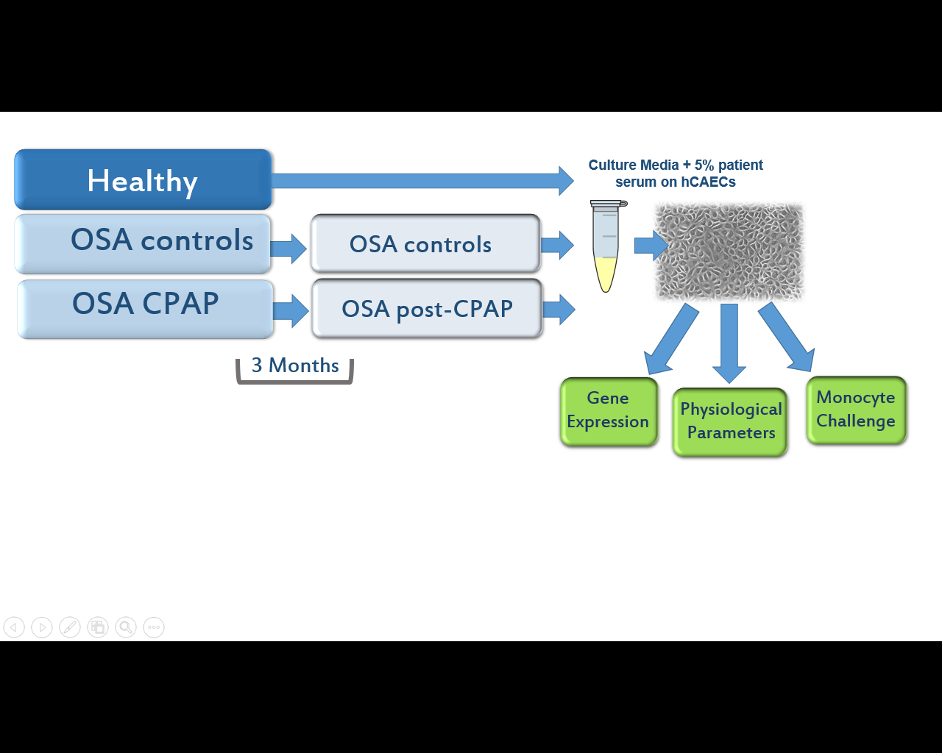

**Fig. 1. Experimental design.** Twenty-three patients were divided into three groups: Healthy controls (n=7), untreated (n=8), and CPAP-treated (n=8). OSA control or CPAP-treated patients were monitored before and after 3 months after treatment, and further subdivided into the following groups: pre-Untreated, post-Untreated, pre-CPAP, and post-CPAP.



**Fig. 2. Baseline differences in endothelial cell inflammatory responses to serum from healthy and OSA subjects.** Transcriptional responses of adhesion molecules (A-C: *VCAM1, ICAM1, SELP*) and cytokines (D-F: *IL8, CCL5, CXCL12*) are shown. Asterisks (*) indicate significant difference from control by an unpaired Mann-Whitney test (*p*<0.05).



**Fig, 3. Normalized endothelial cell transcriptional responses to serum from before and after 3 months of CPAP or OSA control.** Data were normalized by individual subject baseline data to examine trends over the 3-month period. Significant treatment-related effects were noted by a repeated measures two-way ANOVA for *ICAM1* and *CCL5* mRNA (\**p*<0.05). All other markers exhibited consistent, but non-significant trends.



**A**

**B**

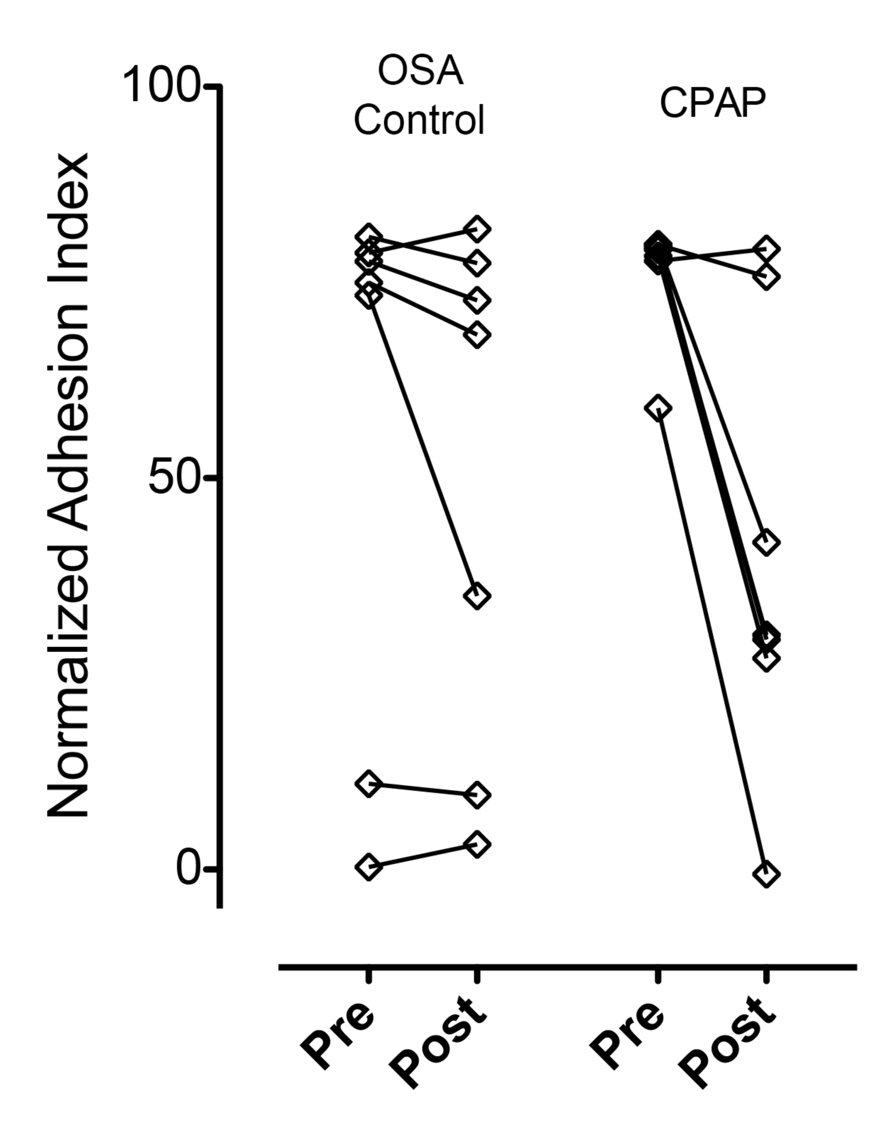

**Fig. 4. Leukocyte adhesion assay reveals significant loss in overall adhesion following CPAP compared to no therapy.** (A) Mean recordings of endothelial monolayer resistance upon addition of monocytic THP-1 cells for all OSA subjects before treatment (black), after observation without treatment(red) or after CPAP therapy (blue). (B) By examining the net adhesion index for each subject before and after no treatment or CPAP therapy, we see trends for a reduction in cellular adhesion associated with the CPAP therapy (in 5/7 subjects) with minimal change in untreated subjects (1/7). Analysis by two-way ANOVA reveals a significant interaction between treatment groups and time (*p*=0.019).

Supplemental Figure 1. Normalized resistance (y-axis) for endothelial cell monolayers challenged with THP-1 cells and serum from untreated (left) or CPAP-treated (right) OSA subjects. Baseline (pretreatment) serum responses (over a 20h period) are in blue, with responses to post-treatment serum in red. Greater adhesion is indicated by a greater loss of resistance.

