Figure. Change in potentially preventable deaths among the five leading causes of death, for persons aged <80 years — United States, 2010 and 2014

Diseases of the heart
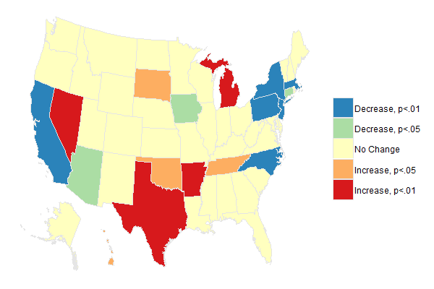

Malignant neoplasms (cancers)

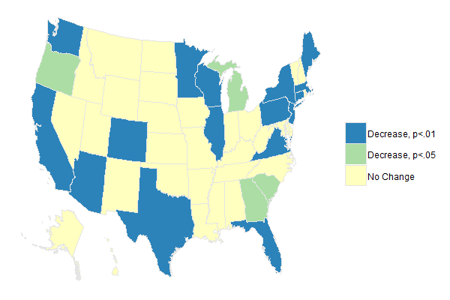

Cerebrovascular disease (stroke)

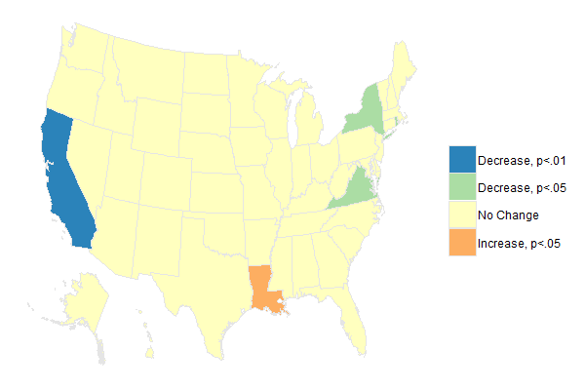

Chronic lower respiratory diseases (CLRD)

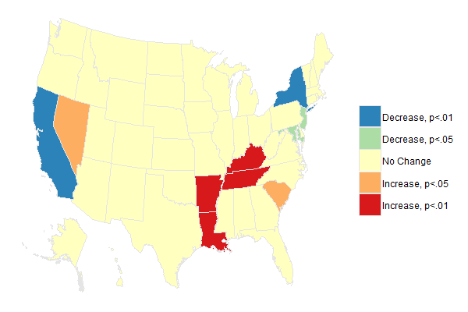
Unintentional injuries (accidents)
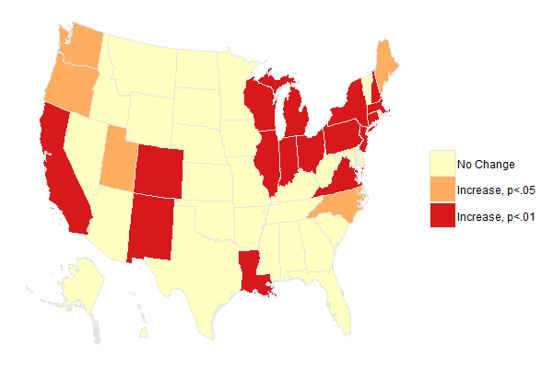

Z-score for change in potentially preventable deaths
United States, 2010-2014
State | Heart Disease | Cancer | Stroke | CLRD | Accidents
Alabama | 0.40 | -1.76 | 0.00 | 0.50 | 0.50
Alaska | -0.29 | -0.06 | -0.79 | -0.55 | 0.36
Arizona | -2.23 | -2.63 | -1.19 | 1.69 | 1.49
Arkansas | 2.72 | -0.71 | -0.28 | 3.26 | -1.11
California | -6.54 | -8.35 | -4.20 | -4.78 | 4.22
Colorado | -0.14 | -3.90 | -1.33 | 0.48 | 3.15
Connecticut | -2.07 | -3.79 | -1.45 | 0.42 | 3.76
Delaware | -0.20 | -1.01 | -0.62 | -0.65 | 1.36
District of Columbia | -0.50 | 0.88 | -1.34 | -0.40 | -0.12
Florida | -0.92 | -5.54 | -0.39 | 0.08 | -1.40
Georgia | 0.22 | -2.09 | -0.84 | 1.05 | 0.94
Hawaii | 2.00 | -0.14 | -1.01 | -0.62 | -0.03
Idaho | 0.28 | -0.10 | 0.13 | 0.89 | 0.98
Illinois | -1.19 | -3.60 | -0.08 | -0.45 | 4.60
Indiana | -0.03 | -1.21 | -0.44 | 1.56 | 3.84
Iowa | -2.43 | -1.08 | -0.65 | 1.24 | 0.73
Kansas | 0.27 | -0.95 | -0.59 | 1.38 | -0.36
Kentucky | 1.67 | -0.84 | -0.72 | 2.90 | -0.52
Louisiana | 0.86 | -1.50 | 2.09 | 2.88 | 3.63
Maine | -0.22 | -2.83 | -1.00 | 0.53 | 2.45
Maryland | -1.82 | -1.90 | 0.10 | -2.52 | 1.46
Massachusetts | -3.38 | -4.09 | -1.91 | -0.47 | 6.63
Michigan | 2.93 | -2.56 | -1.02 | 0.35 | 4.81
Minnesota | -1.21 | -4.34 | -0.66 | 1.37 | 0.82
Mississippi | 0.83 | 0.10 | -0.04 | 1.21 | 0.46
Missouri | 1.64 | -1.43 | 0.48 | -0.16 | 0.66
Montana | 0.02 | -0.10 | 0.04 | 0.40 | -0.20
Nebraska | -0.73 | -1.35 | -1.23 | -0.15 | 0.80
Nevada | 3.51 | -0.95 | -0.50 | 2.12 | 0.74
New Hampshire | -0.71 | -1.38 | -0.46 | 0.18 | 3.15
New Jersey | -2.65 | -4.06 | -1.35 | -2.41 | 4.23
New Mexico | 0.04 | -1.76 | -0.53 | 0.68 | 4.08
New York | -4.92 | -5.53 | -2.34 | -2.94 | 4.69
North Carolina | -3.30 | -1.25 | 0.66 | 1.61 | 2.05
North Dakota | -0.02 | 0.23 | -0.69 | -0.73 | 1.10
Ohio | 1.26 | -1.72 | -0.76 | 0.14 | 7.49
Oklahoma | 2.08 | -1.61 | -0.67 | -0.09 | 0.62
Oregon | -1.48 | -2.38 | -0.23 | -1.07 | 2.31
Pennsylvania | -2.83 | -4.50 | 0.73 | -0.14 | 5.22
Rhode Island | -0.33 | -1.10 | -2.02 | 0.04 | 1.89
South Carolina | -0.83 | -2.15 | -0.47 | 2.51 | 0.83
South Dakota | 2.08 | -0.52 | -1.34 | -1.44 | 0.93
Tennessee | 2.20 | -1.38 | 1.01 | 2.89 | 1.14
Texas | 2.85 | -5.07 | -0.11 | -0.93 | 0.92
Utah | -0.96 | -1.72 | 0.15 | 0.42 | 2.36
Vermont | 0.18 | -0.75 | -1.08 | 0.29 | 0.16
Virginia | -1.22 | -2.71 | -2.03 | -1.38 | 4.86
Washington | -1.21 | -4.49 | -1.60 | -0.31 | 2.07
West Virginia | -1.24 | 0.64 | 0.03 | 0.88 | 1.84
Wisconsin | -1.23 | -3.21 | -1.61 | 1.16 | 4.07
Wyoming | 0.22 | -1.55 | -0.54 | -0.55 | 0.49
Note: Z-scores <-2.58 correspond to a decrease (p<0.01); z<-1.96 corresponds to a decrease (p<0.05); z>1.96 corresponds to an increase (p<0.05); z>2.58 corresponds to an increase (p<0.01); z scores between -1.96 and 1.96 correspond to no significant change.

