SUPPLEMENTAL FIGURE. Global estimated coverage with 3 doses of diphtheria-tetanus-pertussis vaccine, by country† and gross national income (GNI) per capita*
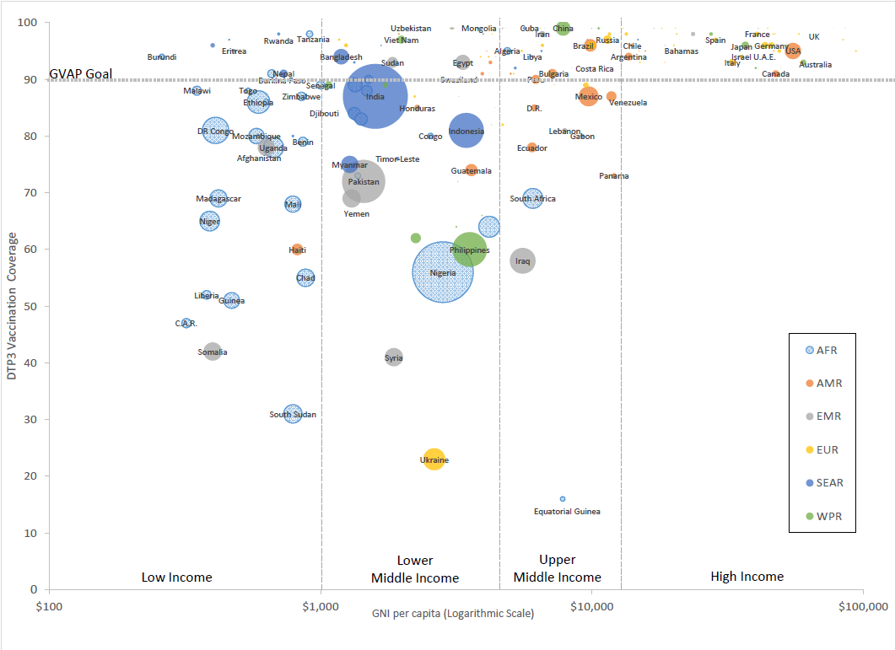
Abbreviations: AFR=African region; AMR = Americas region; CAR = Central African Republic; DR Congo = Democratic Republic of the Congo; DTP3= 3 doses of diphtheria-tetanus-pertussis vaccine; EMR=Eastern Mediterranean region; EUR=European region; GVAP = Global Vaccination Action Plan; SEAR=South-East Asia region; UAE = United Arab Emirates, USA = United States of America, WPR=Western Pacific region.
* Size of bubbles based on the number of children not vaccinated with DTP3 vaccine in respective country.
† GAVI-eligible countries in 2016: Burundi, Central African Republic, Malawi, Liberia, Niger, Democratic Republic of Congo, Madagascar, Gambia, Guinea, Eritrea, Togo, Mozambique, Ethiopia, Guinea-Bissau, Sierra Leone, Afghanistan, Burkina Faso, Uganda, Rwanda, Nepal, Mali, Comoros, South Sudan, Haiti, Zimbabwe, Benin, Chad, United Republic of Tanzania, Senegal, Djibouti, Cambodia, Kyrgyzstan, Bangladesh, Tajikistan, Myanmar, Yemen, Cameroon, Lesotho, Kenya, Mauritania, Côte d'Ivoire, Pakistan, Ghana, Zambia, India, Sao Tome and Principe, Laos, Sudan, Solomon Islands, Nicaragua, Papua New Guinea, Nigeria.

