Supplemental Digital Content 1: Figure
Person-time of observation in the HIV/AIDS Cancer Match Study by year and registry, 1996-2010

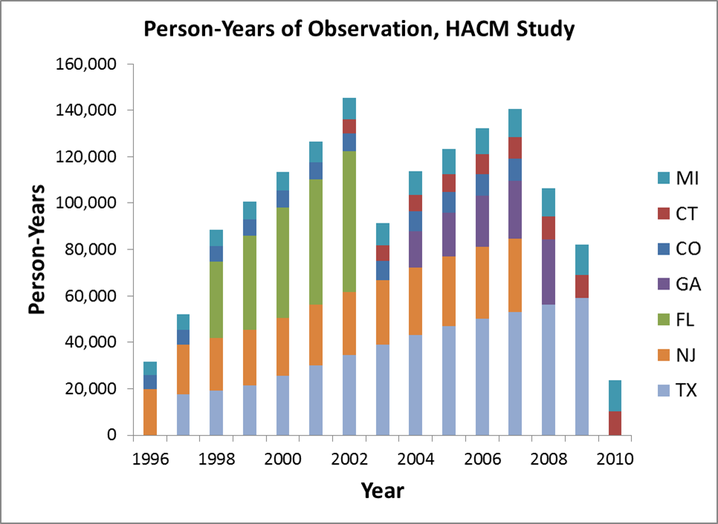

Person-time is based on 275,975 HIV-infected individuals from individual registries as follows: Colorado, 11,466; Connecticut, 12,645; Florida, 74,472; Georgia, 32,377; Michigan, 19,208; New Jersey, 46,786; Texas, 79,021.

Supplemental Digital Content 2: Table
Crude incidence rates and standardized incidence ratios among HIV-infected people in three calendar periods
Cancer | Incidence rate per 100,000 person-years |  |  |  | Standardized incidence ratio (95% confidence interval)
Cancer | 1996-2000 | 2001-2005 | 2006-2010 |  | 1996-2000 |  | 2001-2005 |  | 2006-2010
KS | 278 | 138 | 110 |  | 2895 | (2724, 3073) | 1214 | (1133, 1300) | 793 | (727, 863)
NHL | 449 | 243 | 194 |  | 26.8 | (25.6, 28.1) | 13.2 | (12.5, 13.9) | 10.0 | (9.4, 10.7)
Cervix | 127 | 88.1 | 47.0 |  | 8.1 | (6.7, 9.6) | 6.2 | (5.2, 7.3) | 3.7 | (2.8, 4.8)
Anus | 40.1 | 49.1 | 59.2 |  | 33.0 | (28.0, 38.7) | 32.5 | (28.9, 36.5) | 31.8 | (28.2, 35.6)
Female breast | 58.9 | 71.4 | 64.9 |  | 0.7 | (0.5, 0.9) | 0.7 | (0.6, 0.9) | 0.5 | (0.4, 0.7)
Colorectum | 24.1 | 27.8 | 29.7 |  | 1.0 | (0.8, 1.2) | 0.9 | (0.8, 1.1) | 0.8 | (0.7, 1.0)
HL | 40.1 | 38.2 | 32.6 |  | 11.6 | (9.8, 13.5) | 11.1 | (9.7, 12.7) | 10.0 | (8.5, 11.7)
Liver | 13.2 | 21.8 | 32.4 |  | 3.7 | (2.7, 4.9) | 3.6 | (3.0, 4.3) | 3.4 | (2.9, 4.0)
Lung | 104 | 83.5 | 77.5 |  | 3.4 | (3.1, 3.7) | 2.4 | (2.2, 2.6) | 1.9 | (1.7, 2.1)
Prostate | 30.2 | 42.8 | 55.6 |  | 0.5 | (0.4, 0.6) | 0.5 | (0.4, 0.6) | 0.5 | (0.4, 0.6)
Abbreviations: KS, Kaposi sarcoma; NHL, non-Hodgkin lymphoma; HL, Hodgkin lymphoma
Only females were evaluated for breast and cervical cancers, and only males for prostate cancer.

Supplemental Digital Content 3: Figure
Crude anal cancer incidence rates over time for individual HIV/AIDS Cancer Match Study registries, 1996-2010
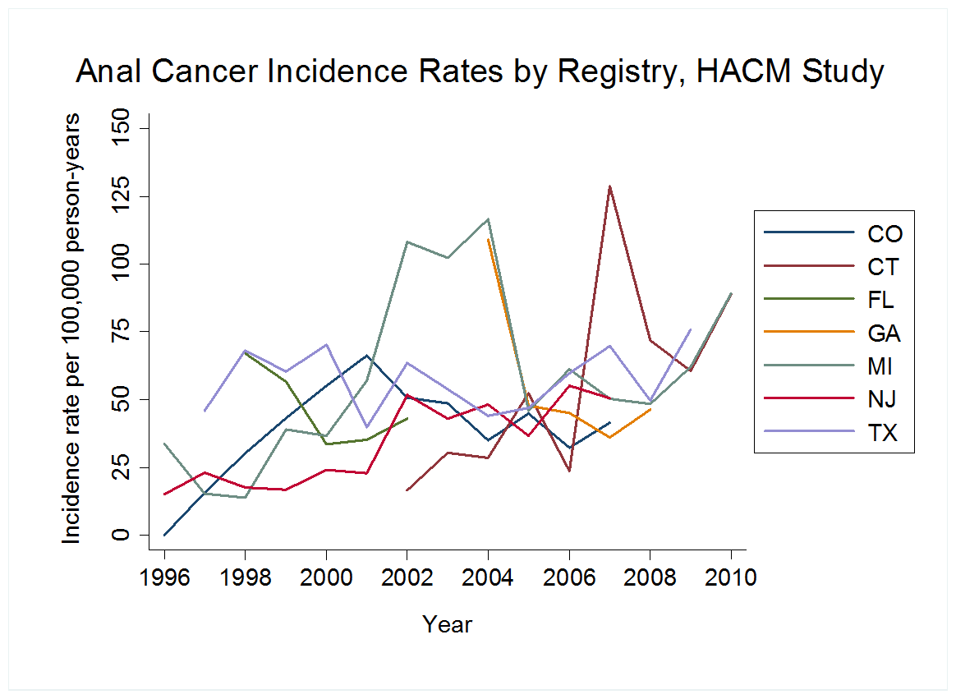
Heterogeneity among registry-specific trends was evaluated by adding an interaction term between calendar year and registry to models of crude incidence rates; this analysis indicated heterogeneity in anal cancer trends (p<0.001). With further adjustment for age, HIV risk group and sex, race/ethnicity, and HIV/AIDS-relative time, the significance of this interaction term was attenuated (p=0.017). Including all registries and adjusting for only registry, the annual percentage change (APC) in anal cancer incidence rates was 3.8% (95% CI 1.4%, 6.2%). This trend was no longer significant upon removal of the New Jersey registry, which showed a robust upward trend (APC without NJ 2.2%, 95% CI -0.3%, 4.9%).
Supplemental Digital Content 4: Table
Adjusted trends in cancer incidence among HIV-infected people for selected cancers*
Cancer | Annual percentage change (95% confidence interval)
Cancer | Crude trendª |  | Adjusted trend^{b} |  | Age^{c} |  | HIV/AIDS-relative time^{c} |  | HIV risk group and sex^{c} |  | Race/ethnicity^{c}
KS  1996-2000  2001-2010 | -29.3  -7.8 | (-32.9, -25.5)  (-9.6, -5.8) | -25.6  -5.7 | (-29.5, -21.6)  (-7.7, -3.7) | -29.2  -7.0 | (-32.8, -25.3)  (-8.9, -5.1) | -26.7  -5.9 | (-30.4, -22.7)  (-7.9, -4.0) | -28.7  -7.8 | (-32.3, -24.8)  (-9.7, -5.9) | -29.2  -7.8 | (-32.8, -25.4)  (-9.7, -5.9)
Breast | 1.1 | (-2.8, 5.1) | -1.6 | (-5.6, 2.6) | -2.5 | (-6.3, -1.5) | 1.8 | (-2.3, 6.0) | 1.2 | (-2.7, 5.3) | 1.1 | (-2.8, 5.2)
Colorectum | 2.2 | (-1.0, 5.5) | -0.9 | (-4.2, 2.5) | -1.6 | (-4.8, 1.7) | 2.4 | (-0.9, 5.9) | 2.4 | (-0.8, 5.8) | 2.3 | (-0.9, 5.7)
Liver | 8.5 | (4.6, 12.5) | 6.6 | (2.7, 10.7) | 4.3 | (0.5, 8.2) | 8.8 | (4.9, 13.0) | 10.1 | (6.2, 14.2) | 8.6 | (4.7, 12.6)
Lung | -2.8 | (-4.5, -1.1) | -6.8 | (-8.5, -5.0) | -7.8 | (-9.5, -6.2) | -2.6 | (-4.3, -0.8) | -2.4 | (-4.2, -0.7) | -2.7 | (-4.4, -1.0)
Prostate | 9.8 | (6.4, 13.3) | 2.9 | (-0.3, 6.3) | 2.2 | (-1.0, 5.4) | 9.9 | (6.5, 13.5) | 9.2 | (5.9, 12.7) | 9.9 | (6.6, 13.4)
*Results are shown for cancers where changes in HIV population demographics contributed significantly to time trends among HIV-infected people.
Abbreviations: KS, Kaposi sarcoma
ªAdjusted for registry only
^{b}Adjusted for registry, age, HIV/AIDS-relative time, HIV risk group and sex, and race/ethnicity
^{c}Adjusted for registry plus the variable noted

