Supplemental Material
Table S1. Pearson correlations of ZIP code characteristics, 8,200 ZIP codes, 1992-2006.
 | % Black | % Hispanic | % Poverty | % No HS | % Non-Green | % Built < 1940
% Black | 1.00 | 0.00 | 0.51 | 0.33 | 0.31 | 0.10
% Hispanic |  | 1.00 | 0.43 | 0.58 | 0.23 | -0.12
% Poverty |  |  | 1.00 | 0.72 | 0.32 | 0.22
% No HS |  |  |  | 1.00 | 0.18 | 0.16
% Non-Green |  |  |  |  | 1.00 | 0.19
% Built < 1940 |  |  |  |  |  | 1.00
See Table 1 for definitions of row and column names.
Table S2. Percent increases and 95% confidence intervals for admission to the hospital for renal, heat or respiratory causes among individuals aged 65 years and older for the six-day cumulative effects of extreme heat (EH, temperature > 97th percentile) vs. non-heat (temperature < 90th percentile) among individuals with (high) or without (low) the characteristic (individual level) or among individuals residing in ZIP codes in the 75th percentile (high) or 25th percentile (low) of the characteristic (ZIP-code level), holding the other characteristics at the study-wide median values, by quartiles of citywide air conditioning prevalence (ACP), May-September, 1992-2006.

Characteristic | Level | AC1 | AC2 | AC3 | AC4
Medianª |  | 18 (12, 24) | 13 (8, 18) | 10 (4, 17)# | 3 (-2, 9)###
Male | low | 17 (11, 23) | 10 (5, 15) | 10 (4, 17) | 4 (-2, 10)
Male | high | 20 (13, 28) | 15 (9, 22) | 10 (2, 19) | 3 (-4, 10)
Black | low | 17 (12, 23) | 11 (6, 15) | 8 (2, 13) | 2 (-3, 8)
Black | high | 24 (10, 40) | 23 (12, 36)** | 26 (10, 44)** | 8 (-5, 23)
Aged 78+ | low | 12 (6, 19) | 7 (2, 13) | 10 (3, 17) | 2 (-4, 8)
Aged 78+ | high | 25 (17, 32)*** | 18 (12, 25)*** | 10 (3, 18)## | 5 (-2, 12)#
% Non-Green | low | 19 (12, 26) | 13 (7, 19) | 10 (2, 18) | 3 (-4, 10)
% Non-Green | high | 18 (10, 26) | 12 (6, 19) | 11 (3, 20) | 4 (-2, 11)
% No HS | low | 15 (9, 21) | 8 (3, 13) | 9 (2, 16) | 2 (-4, 9)
% No HS | high | 24 (16, 32)*** | 20 (13, 27)*** | 12 (6, 19) | 5 (-1, 11)
% Black | low | 18 (12, 24) | 13 (7, 18) | 11 (4, 17) | 3 (-3, 9)
% Black | high | 20 (14, 26) | 12 (7, 17) | 10 (4, 16) | 6 (1, 12)**
% Built < 1940 | low | 18 (11, 25) | 9 (4, 15) | 10 (3, 17) | 0 (-5, 6)
% Built < 1940 | high | 19 (13, 26) | 19 (13, 25)***# | 11 (2, 22) | 10 (0, 20)*
ªMain effects.
p-value for EH x individual or ZIP-code level interaction term: * p < 0.1, ** p < 0.05, *** p < 0.01
p-value for EH x modifier x city AC interaction term (ACP1 is reference): # p < 0.1, ## p< 0.05, ### p < 0.01

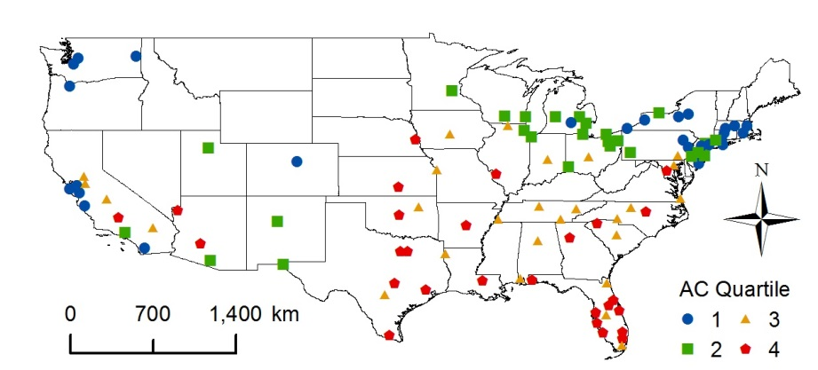
Figure S1. Study cities (n = 109) in the Continental United States and quartile of air conditioning prevalence (ACP) (1-4).

Akron, OH (2)
Albuquerque, NM (2) ª
Allentown-Bethlehem, PA (1)
Atlanta, GA (4)
Atlantic City, NJ (1)
Austin, TX (4)
Bakersfield, CA (4)
Baltimore, MD (3)
Baton Rouge, LA (4) ª
Bergen-Passaic, NJ (2)
Birmingham, AL (3)
Boston, MA (1)
Buffalo, NY (1)
Canton-Massillon, OH (2)
Charlotte, NC (3) ª
Chattanooga, TN (3)
Chicago, IL (2)
Cincinnati, OH (2)
Cleveland, OH (2)
Columbia, SC (3) ª
Columbus, OH (3)
Dallas, TX (4)
Daytona Beach, FL (4)
Denver, CO (1)
Des Moines, IA (3)
Detroit, MI (2)
El Paso, TX (2) ª
Erie, PA (1) ª
Flint, MI (2)
Fort Myers-Cape Coral, FL (4) ª
Fort Worth-Arlington, TX (4)
Fresno, CA (3)
Ft. Lauderdale, FL (4)
Gary, IN (2)
Grand Rapids, MI (2)
Greensboro, NC (3)
Greenville, SC (4)
Hartford, CT (1)
Houston, TX (4)
Indianapolis, IN (3)
Jacksonville, FL (3)
Jersey City, NJ (1)
Kansas City, MO-KS (3)
Knoxville, TN (3)
Lakeland-Winter Haven, FL (3)
Lancaster, PA (3) ª
Lansing, MI (1)
Las Vegas, NV-AZ (4)
Little Rock, AR (4)
Los Angeles, CA (2)
Madison, WI (2) ª
McAllen-Edinburg-Mission, TX (4) ª
Melbourne-Titusville-Palm Bay, FL (4)
Memphis, TN (3) ª
Miami, FL (3)
Middlesex, NJ (2)
Milwaukee, WI (2)
Minneapolis-St. Paul, MN (2)
Mobile, AL (3)
Monmouth-Ocean, NJ (2)
Nashville, TN (3)
Nassau-Suffolk, NY (1) ª
New Haven-Meriden, CT (1)
New York, NY (1)
Newark, NJ (1)
Oakland, CA (1)
Oklahoma City, OK (4)
Omaha, NE (4)
Orlando, FL (4)
Pensacola, FL (4) ª
Philadelphia, PA-NJ (2)
Phoenix, AZ (4)
Pittsburgh, PA (2)
Portland, OR (1)
Providence-Fall River, RI-MA (1)
Raleigh, NC (4)
Riverside-San Bernardino, CA (3)
Rochester, NY (2)
Rockford, IL (3)
Sacramento, CA (3)
Salinas, CA (1) ª
Salt Lake City, UT (2) ª
San Antonio, TX (3)
San Diego, CA (1)
San Francisco, CA (1)
San Jose, CA (1)
Sarasota-Bradenton, FL (4)
Scranton--Wilkes-Barre--Hazleton, PA (1) ª
Seattle, WA (1)
Shreveport, LA (3) ª
Spokane, WA (1) ª
Springfield, MA (1)
St. Louis, MO-IL (4)
Stamford-Norwalk, CT (2)
Stockton-Lodi, CA (3)
Syracuse, NY (1) ª
Tacoma, WA (1) ª
Tampa-St. Petersburg-Clearwater, FL (4)
Toledo, OH (2)
Trenton, NJ (2)
Tucson, AZ (2) ª
Tulsa, OK (3)
Utica-Rome, NY (1) ª
Virginia Beach, VA (3)
Washington, DC-MD-VA (4)
West Palm Beach-Boca Raton, FL (4)
Wichita, KS (4)
Worcester, MA (1)
Youngstown-Warren, OH (2)

ª The characteristics black race and percent of black residents in a ZIP code (% Black) were not analyzed in these cities due to an inadequate number of cases of black race on extreme heat days and/or multicollinearity of “% Black” with other characteristics.

Figure S2. Percent increases and 95% confidence intervals for admission to the hospital for renal/heat causes (A, B) or respiratory causes (C, D) among individuals aged 65 years and older for the two-day (A, C) or six-day (B, D) cumulative effects of extreme heat (EH, temperature > 97th percentile) vs. non-heat (temperature < 90th percentile) among individuals with (high) or without (low) the characteristic (individual level) or among individuals residing in ZIP codes in the 75th percentile (high) or 25th percentile (low) of the characteristic (ZIP-code level), holding the other characteristics at the study-wide median values, May-September, 1992-2006.

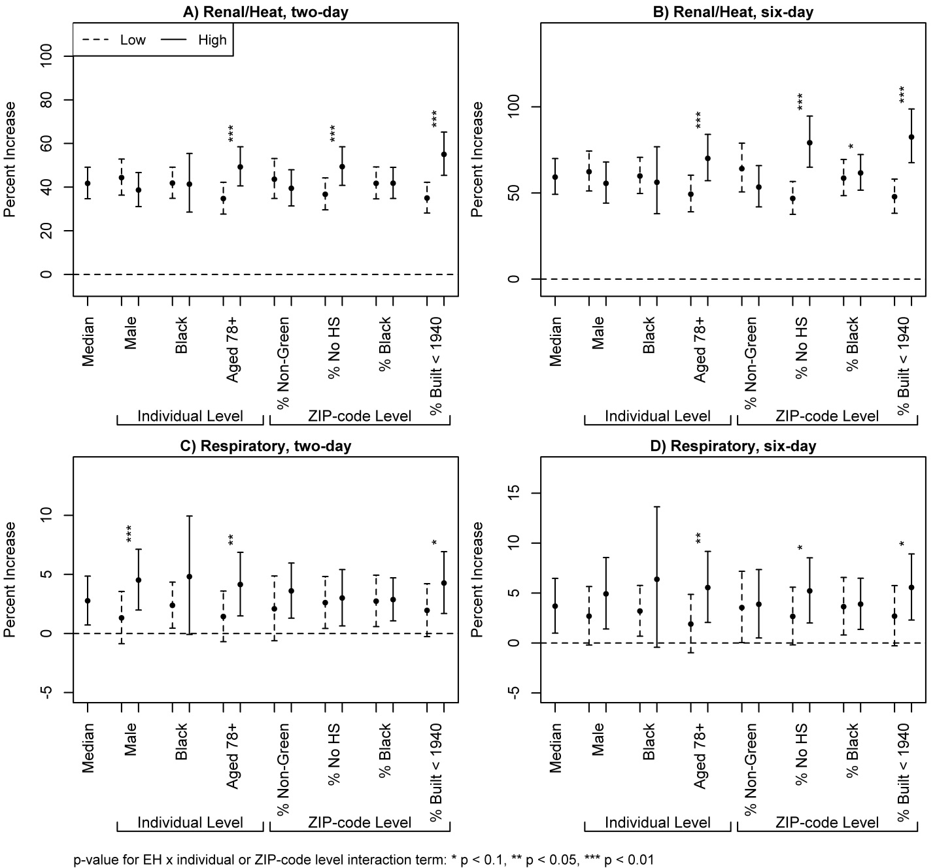

Figure S3. Percent increases and 95% confidence intervals for admission to the hospital for renal, heat or respiratory causes among individuals aged 65 years and older for the six-day cumulative effects of extreme heat (EH, temperature > 97th percentile) vs. non-heat (temperature < 90th percentile) among individuals with (high) or without (low) the characteristic (individual level) or among individuals residing in ZIP codes in the 75th percentile (high) or 25th percentile (low) of the characteristic (ZIP-code level), holding the other characteristics at the study-wide median values, May-September, 1992-2006. Percent poverty was used as the measure of socioeconomic status.
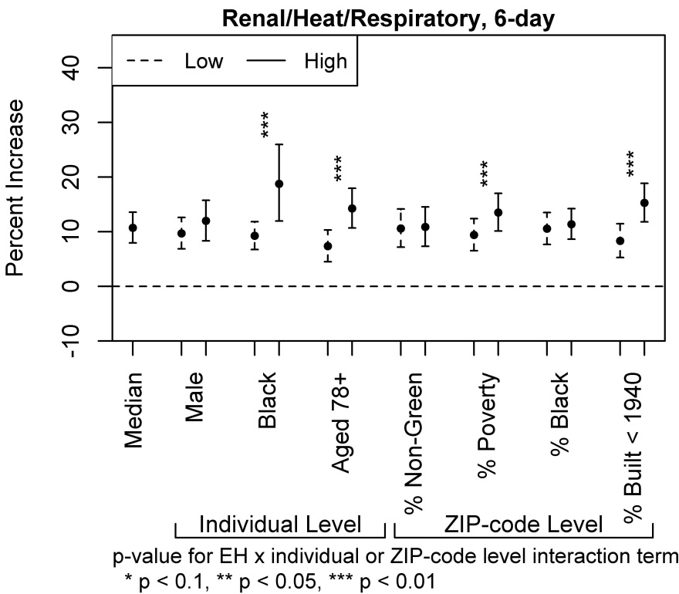

Figure S4. Percent increases and 95% confidence intervals for admission to the hospital for renal, heat or respiratory causes among individuals aged 65 years and older for the six-day cumulative effects of extreme heat (EH, temperature > 97th percentile) vs. non-heat (temperature < 90th percentile) among individuals with (high) or without (low) the characteristic (individual level) or among individuals residing in ZIP codes in the 75th percentile (high) or 25th percentile (low) of the characteristic (ZIP-code level), holding the other characteristics at the study-wide median values, by quartiles of citywide air conditioning prevalence (ACP), May-September, 1992-2006. Quartiles of ACP were defined based on the annual average ACP.

