**Supplementary Online Material**



*Figure S1*- Map of NH showing the 14 locations where air pollution measurements are taken. Outlines represent Town boundaries

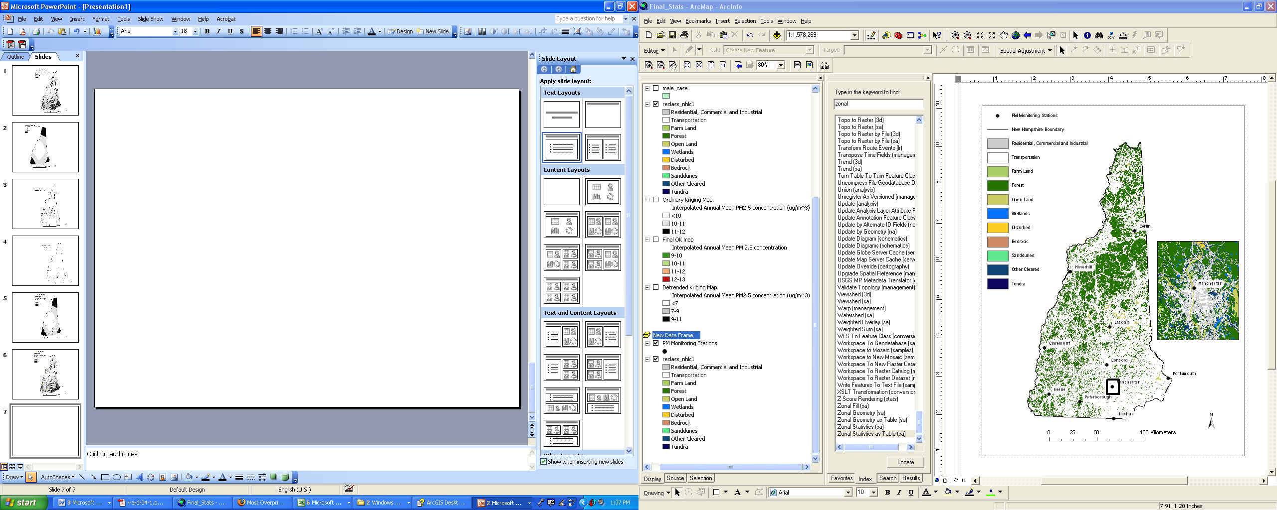

*Figure S2-* Map showing land use in NH in 2001 used in creation of the RIO map with a close-up of Manchester, NH to show the level of detail available.

*Figure S3*- Land use types by town using a 1km bandwidth, showing good separation between rural towns (e.g. Berlin) and urban centers (e.g. Nashua and Manchester).

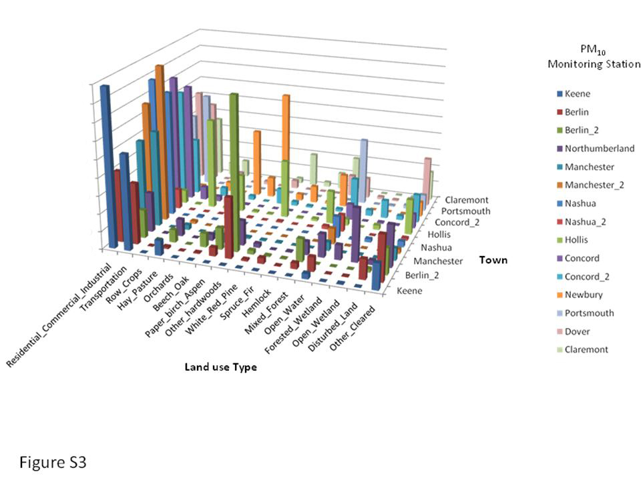

**Frequency (no. of million pixels)**

2

4

6

18

0

16

14

12

10

8

*Figure S4*- Land use types by town using a 2km bandwidth.

[Type a quote from the document or the summary of an interesting point. You can position the text box anywhere in the document. Use the Drawing Tools tab to change the formatting of the pull quote text box.]

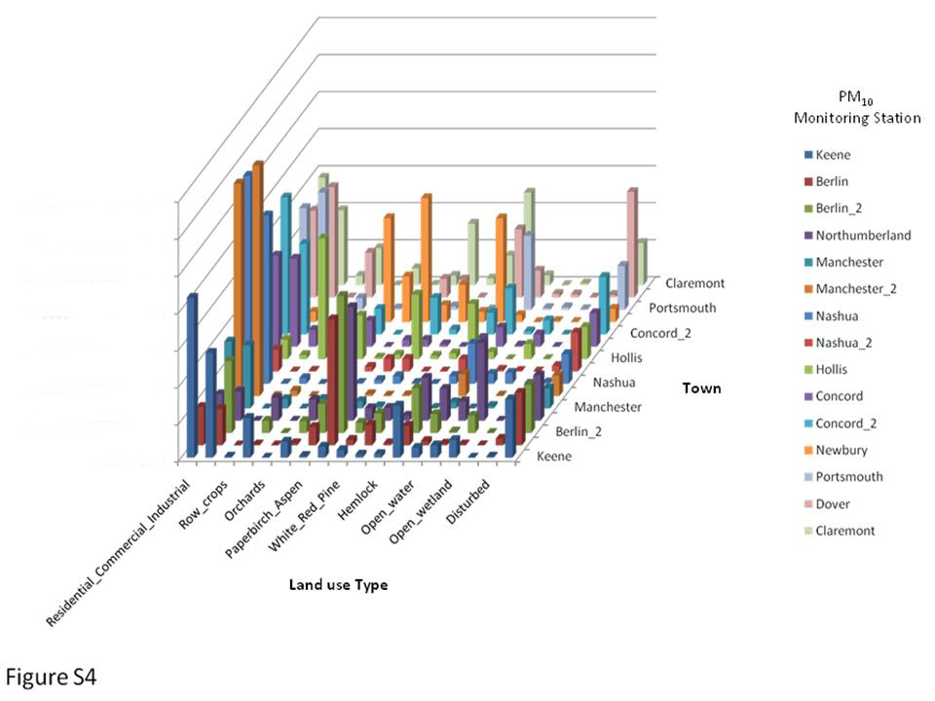

**Frequency (no. of million pixels)**

1

2

3

0

7

6

5

4

*Figure S5*- Land use types by town using a 3km bandwidth.

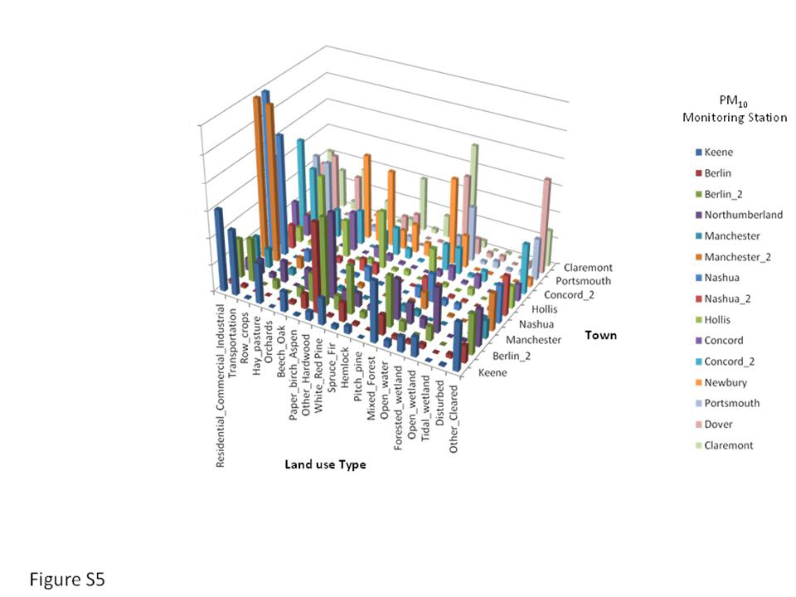

**Frequency (no. of million pixels)**

2

4

6

0

12

10

8

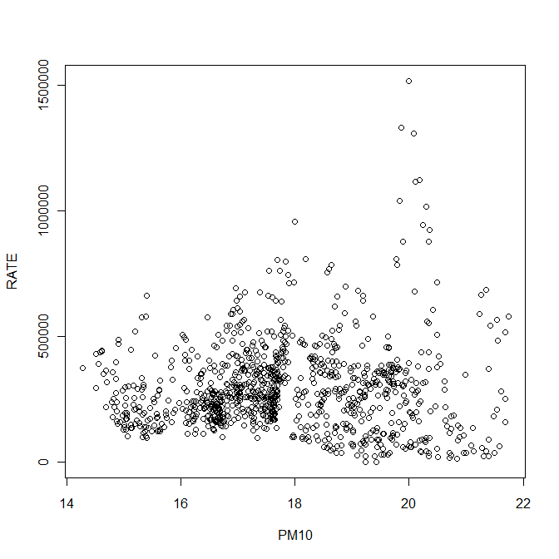

*Figure S6*- A plot of the relationship between PM10 from the RIO map at 1000 random points and cancer rates.

Table S1- Actual and estimated PM10 for each of the sampling sites using leave-one-out cross validation.

|  |  |  |
| --- | --- | --- |
|  | Actual PM (ug/m3) | Estimate (Mean)  (ug/m3) |
| Keene | 20 | 16.149 |
| Berlin | 32 | 19.536 |
| Berlin_2 | 15 | 16.406 |
| Northumberland | 17 | 14.434 |
| Manchester | 16 | 16.543 |
| Manchester_2 | 17 | 16.851 |
| Nashua | 17 | 16.851 |
| Nashua_2 | 16 | 19.984 |
| Hollis | 15 | 15.412 |
| Concord | 16 | 19.454 |
| Concord_2 | 23 | 16.757 |
| Newbury | 10 | 11.541 |
| Portsmouth | 19 | 19.508 |
| Dover | 17 | 18.470 |
| Claremont | 16 | 14.061 |