Appendix A: Data Abstraction and Quality Assessment

Each study that met inclusion criteria was abstracted by two reviewers independently. Abstraction was based on a standardized abstraction form (http://www.thecommunityguide.org/methods/abstractionform.pdf) that included information on study quality, intervention components, participant demographics, and outcomes. Disagreements between reviewers were resolved by team consensus.
Community Guide quality scoring methods^{26,27} were used for studies identified in the update. Threats to validity—such as poor descriptions of the intervention, population, sampling frame, and inclusion/exclusion criteria; poor measurement of exposure or outcome; poor reporting of analytic methods; incomplete data sets; loss to follow-up; or intervention and comparison groups not being comparable at baseline—were used to characterize studies as having good (0–1 limitations); fair (2–4 limitations); or limited (>4) quality of execution. Studies judged to be of limited quality of execution were excluded from analysis.
Conclusions on the strength of evidence on effectiveness were based on the total body of evidence by taking into account the number of studies included in the evidence, quality of available evidence, consistency of results, magnitude of effect estimates, and applicability considerations.²⁶

Appendix B: Methods Used to Estimate Intervention Effectiveness

Absolute Percentage Point Change
Absolute percentage point changes were calculated when studies presented the results as change in proportion of individuals with outcomes of interest (e.g., difference in UVR protective behaviors, UVR exposure, and sunburn incidence) attributable to the interventions. Effect estimates for each study were calculated separately using the last available data point. For studies with multiple intervention arms, the median of individual effect estimates from each intervention arm was used in the analysis.
Absolute percentage point change = (I_{post} - I_{pre}) - (C_{post} - C_{pre})
where I_{post} and I_{pre} were the posttest and pretest measures for the group receiving the intervention, and C_{post} and C_{pre} were the posttest and pretest measure for the comparison/control group.

In case of uncontrolled pre and post study designs, absolute percentage point change for these outcomes was calculated by comparing proportion of individuals before and after the implementation of the intervention.
Absolute percentage point change = I_{post} - I_{pre}
where I_{post} and I_{pre} were the posttest and pretest measures for the group receiving the intervention).

Difference-in-Differences of the Mean Change
In studies where the mean change in outcomes with continuous values were reported (e.g., mean change in combined UV protective behaviors, mean change in spectrophotometer scale for UVR exposure), the difference-in-differences of the mean change was calculated using the formula
Difference of difference = (I_{post} - I_{pre}) - (C_{post} - C_{pre})
where I_{post} and I_{pre} were the posttest and pretest measures for the group receiving the intervention, and C_{post} and C_{pre} were the posttest and pretest measure for the comparison/control group.

For outcomes where different measures were used to calculate the same outcome, the findings from the individual study were reported separately and overall effectiveness was summarized as favorable or unfavorable in terms of direction of desired intervention effects.

Appendix C. Tables and Figures
Appendix Table 1. Multicomponent Community-wide Interventions: Characteristics of Included Studies
Author/Year | Study design | Program/ Country | Components of Intervention | Intervention Duration | Scope | Setting | Target Population
ONS Report, 2010³³ | BA | Sun Smart campaign/ United Kingdom | Individually directed;  Media: Small media and mass media;  Policy | Ongoing since 2003 | Nation- wide | Schools, work-place, ORC, CW (social and mass media) | General population
Dobbinson, 2008³¹ | BA | SunSmart Program/ Australia | Media: Small media and mass media;  Policy;  Environmental | Ongoing since 1988 | Nation- wide | Day care centers, schools, ORC, workplace, HCC, CW(media) | General population
Olson, 2007³² | RCT | Sun Safe Program/ USA | Individually directed;  Policy;  Environmental | 1996–2004 | Local (10 Towns in New Hampshire) | Middle schools, HCC, ORC | Youth (grades 6-8)
Dietrich, 2000³⁴ | RCT | Sun Safe Program/ USA | Individually directed;  Policy;  Environmental | 1996–2004 | Local (10 Towns in New Hampshire) | Primary schools, maternity units, daycare centers, HCC, ORC | Children (2–11 yrs)
Miller, 1999³⁵ | BA | Falmouth Safe Skin Project/ USA | Individually directed;  Media: mass media and small media | 1994–1997 | Local (Falmouth, Town, MA) | HCC, daycare centers, schools, ORC, CW (media) | Children and parents
NSWCC Report, 1998³⁶ | BA | Seymour Snowman/  Australia | Individually directed;  Environmental;  Media: mass media and small media | 1997/98–1999/2000 | Statewide (NSW) | Child care centers, schools,  CW (media) | Children and parents
Rassaby,  1983³⁷ | BA | Slip! Slop! Slap!/ Australia | Media: Small media and mass media; Environmental | 1981/82–1986 | Statewide (Melbourne) | CW (media), ORC | General population

BA, before-and-after design; RCT, randomized control trial; CW, community-wide; HCC, healthcare center; NSWCC, New South Wales Cancer Council; ORC, outdoor recreation center; yrs, years
Appendix Table 2. Mass Media Interventions: Characteristics of Included Studies
Author, year | Study Design | Program/  Country | Target population | Intervention duration | Use of small media in addition to mass media
Koster, 2011³⁹ | BA | Anti-sunbed campaign /Denmark | General population  (15–59 yrs) | 2 yrs  (2007–2009) | —
Dobbinson, 2008³¹ | TS | SunSmart/Australia | Adults | Each summer for 14 yrs  (1987–2002) | —
Broadwater, 2004³⁸ | BA | Skin and Colon cancer media campaign/U.S. | Adults  (18–49 yrs) | 1 month  (April–May, 2003) | Yes
Smith, 2002²⁴ | BA | Sun protection mass media campaign/Australia | Adults (Parents) | 3 yrs, each summer  (1997–2000) | Yes
BA, before-and-after design; TS, time series design; yrs, years

Appendix Table 3. Effects of Changes in Intensity of Mass Media Exposure

 | Linear TARPs |  | Squared TARPs
 | ORs for TARPs x 100 (95% CI) | p-value | ORs for TARPs x 100 (95% CI) | p-value
Weekend behaviors (11 AM – 3 PM)
Hat used | 1.24 (1.15, 1.33) | <0.001 | 0.94 (0.85, 1.04) | 0.240
Sunscreen used ª | 1.16 (1.07, 1.25) | <0.001 | 1.02 (0.91, 1.14) | 0.731
3/4 or long-sleeved top worn | 1.08 (0.98, 1.18) | 0.109 | 1.07 (0.94, 1.22) | 0.329
3/4 or long leg cover worn | 1.05 (0.97, 1.12) | 0.225 | 1.05 (0.95, 1.17) | 0.325
 | Coeff for TARPs x 100 (95% CI) |  | Coeff for TARPs x 100 (95% CI)
Body exposure index ^{b} | –0.02 (–0.02, –0.01) | <0.001 | 0.01 (0.00, 0.01) | 0.035

ª Evidence for inadequate model fit (via the Hosmer–Lemeshow test, p<0.029).
^{b} Results from multiple regression.
Coeff, coefficient; TARP, target audience rating point.

Adapted and reprinted from American Journal of Preventive Medicine, 34(2):94–101; Dobbinson SJ, Wakefield MA, Jamsen KM, et al., Weekend Sun Protection and Sunburn in Australia: Trends (1987–2002) and Association with SunSmart Television Advertising, Copyright 2008, with permission from Elsevier.

Appendix Figure 1. Changes in sun protective behaviors other than sunscreen use: Multicomponent Community-wide interventions.
GP, general population

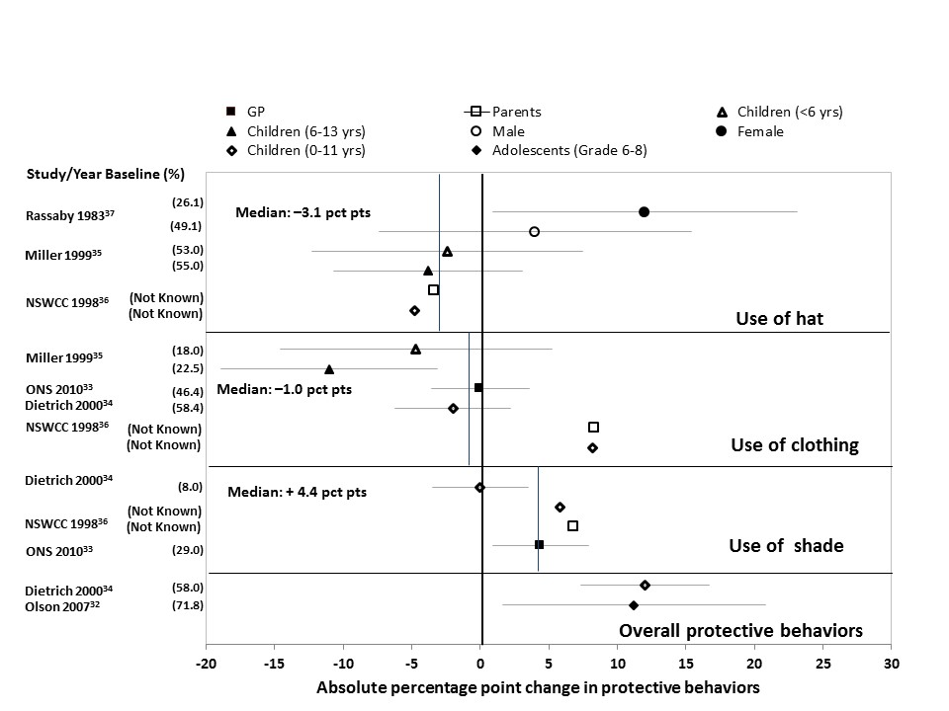

Appendix Figure 2. Changes in tanning bed use and spending time in sun during peak hours.

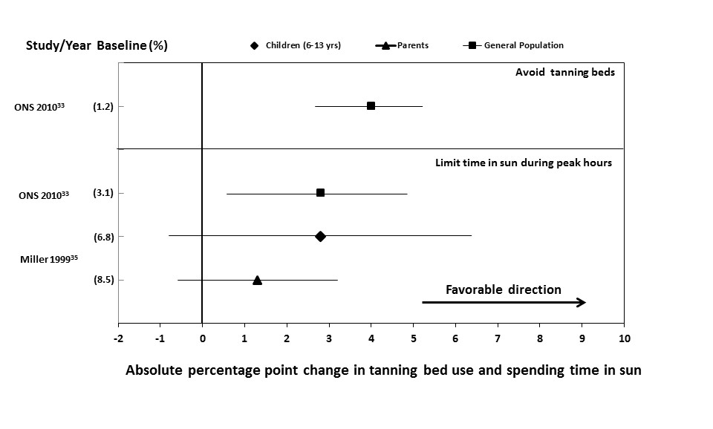

Appendix Figure 3. Changes in protective behaviors other than sunscreen use in adults: Mass Media interventions.

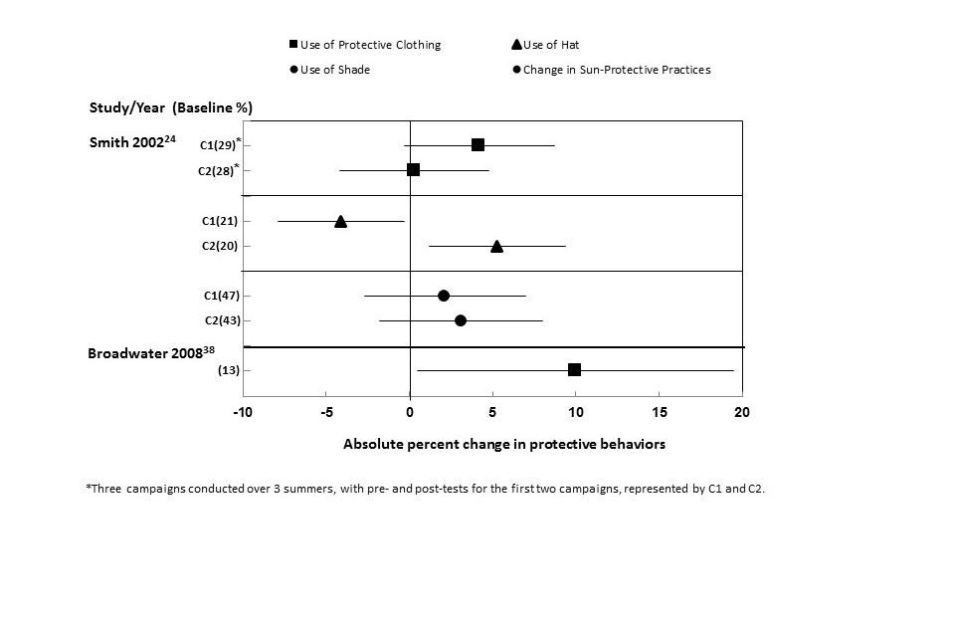

Appendix Figure 4. Changes in protective behaviors other than sunscreen use for children: Mass Media interventions.

