Appendix to Lugoga manuscript.docx

Contents
1. Non-HIV care variables available in HMIS data set for domains of interest 2
Table Appendix 1 2
2. PEPFAR investment and how it changes over time in the districts 2
Table Appendix 2, PEPFAR ART patient counts by year for the 56 original districts. 4
Table Appendix 3, Number of districts in each ART tertile by year 5
3. Cutpoints for tertile variables 5
Table Appendix 4, Cutpoints for factor variables 5
4. Regression model 5
Figure Appendix 1 Regression model. 5
Additional reference for quality evaluation of the Ugandan Health Management Information System. 5
5. Longitudinal analysis 6
Figure Appendix 2 OPD4 and ART plotted separately over time. 6
Figure Appendix 3 Graph set for OPD4 and ART plotted separately over time by district. 7
Figure Appendix 4 Deliveries and ART plotted separately over time. 9
Figure Appendix 5 TB tests and ART plotted separately over time. 10
Figure Appendix 6 Malaria tests and ART plotted separately over time. 10
Figure Appendix 7 DPT3 immunization and ART plotted separately over time. 11
Figure Appendix 8 Maternal deaths and ART plotted separately over time. 11

This web appendix supplements the manuscript by providing more detail on the variables in the regression model, followed by the regression model itself (focusing on control variables).
The U.S. Centers for Disease Control established the study approach and protocol well in advance of selecting variables. The protocol identified the types of non-HIV care we would measure as outcome variables. We examined the Uganda Health Management Information System variables available in each health care category, and describe in the manuscript why we selected the ones we did. Table A1 portrays all the variables we considered in each category.

1. Non-HIV care variables available in HMIS data set for domains of interest

Table Appendix 1
Health services outcomes | Variables to answer protocol aims | Modeling results in Table 5
Maternal health | New ANC attendance  ANC 4th visit  Post natal visits  Second dose IPT  Pregnant women Tetanus vaccine: Dose 1, Dose 2Stillbirths in unit  Deliveries in unit  Deliveries HIV positive in unit  Deliveries HIV positive who swallowed ARVs  Live births in unit  Babies born with low birth weight (< 2 . 5 kg)  Birth Asphyxia  Maternal deaths  Deliveries with TBA | Deliveries in unit  Maternal deaths
Family planning | Injectable  Total family planning users  Oral : Lo-Femenal  Oral: Microgynon  Oral: Ovrette  Oral: Others  Condoms  IUDs (Copper T)
Child health | BCG  polio 3  DPT-HepB+Hib 3  Measles immunization  Tetanus dose 1 and 2  Vit A supplement 1st Dose in the year  Dewormed 1st dose in the year | DPT-HepB+Hib 3
Overall service utilization | total attendance OPD  OPD age 4 and younger  OPD 5 and older  (above by gender)  Inpatient admissions  Deaths | OPD age 4 and younger
Operations | Caesarian sections  Total Number Major Operations  Total Number Minor Operations
Mental health | Anxiety disorders  Mania  Depression  Schizophrenia  Alcohol and Drug abuse  Childhood Mental Disorders
Lboratory services | Malaria blood smear  Syphilis screening  Pap smear  TB sputum | Malaria blood smear  TB sputum

2. PEPFAR investment and how it changes over time in the districts
There were 698,286 PEPFAR supported ART patients between July 2005 and December 2010 for all districts providing HMIS reports (Table R1). Table R1 shows ART counts for all districts for all years of the study. The number of districts with ART support increased over the first 3 years and the general pattern is that once ART services started they increase each year. Looking at all districts combined the number of ART services increased each year from 49,638 in 2005 (median 103, IQR 0, 612) to 207,872 in 2010 (median 1943, IQR 675, 4250). The distribution of ART was skewed with high numbers of services in a few large districts like Kampala and Mbarara while the majority of districts received much less ART support. Kampala had the highest number of ART patients with a total of 200,246 during the study period. There are three districts that did not receive PEPFAR ART support during the study period, Adjumani, Nakapiripirit, and Yumbe.

To show trends in ART and non-HIV services for individual districts we plot the counts for each year. Generally, the number of ART services increased with time. The number of ART services for all districts combined increased each year in the study period. Table R1 shows PEPFAR investment for each district for each year represented by the number of patients on ART.

THIS SPACE INTENTIONALLY LEFT BLANK

Table Appendix 2, PEPFAR ART patient counts by year for the 56 original districts.

| Year | Number of years by ART Tertile
dist56 | 2005 2006 2007 2008 2009 2010 Total | Low Medium High
--------------+--------------------------------------------------------- +-----------------------------
ADJUMANI | 0 0 0 0 0 0 0 | 6 0 0
APAC | 0 0 0 1225 1912 2942 6079 | 3 1 2
ARUA | 1566 0 102 135 223 298 2324 | 3 2 1
BUGIRI | 0 0 0 217 625 828 1670 | 3 3 0
BUNDIBUGYO | 0 0 0 122 566 0 688 | 5 1 0
BUSHENYI | 401 1546 2404 5338 5683 6987 22359 | 0 1 5
BUSIA | 0 0 0 230 823 837 1890 | 3 3 0
GULU | 1336 2389 4145 6473 7931 10367 32641 | 0 1 5
HOIMA | 405 483 1068 334 2326 2874 7490 | 0 4 2
IGANGA | 131 231 293 556 308 1332 2851 | 1 5 0
JINJA | 1255 2214 4133 5875 7154 7832 28463 | 0 1 5
KABALE | 940 938 1296 2110 2765 2884 10933 | 0 3 3
KABAROLE | 873 2412 3279 4825 7243 6373 25005 | 0 1 5
KABERAMAIDO | 0 0 392 500 778 809 2479 | 2 4 0
KALANGALA | 0 0 160 279 411 506 1356 | 3 3 0
KAMPALA | 24434 19179 26301 37058 43680 49594 200246 | 0 0 6
KAMULI | 91 131 200 687 537 903 2549 | 2 4 0
KAMWENGE | 0 0 0 554 566 781 1901 | 3 3 0
KANUNGU | 0 0 84 1271 920 853 3128 | 3 3 0
KAPCHORWA | 0 38 73 133 191 448 883 | 5 1 0
KASESE | 103 NA 1195 1547 2260 3354 8459 | 1 1 3
KATAKWI | 0 139 184 824 763 946 2856 | 3 3 0
KAYUNGA | 598 429 730 1207 1690 2111 6765 | 0 4 2
KIBAALE | 0 0 0 489 945 1599 3033 | 3 2 1
KIBOGA | 0 0 135 377 702 1181 2395 | 3 3 0
KISORO | 65 176 168 288 483 536 1716 | 3 3 0
KITGUM | 193 500 841 1878 2430 2562 8404 | 0 3 3
KOTIDO | 125 99 149 265 124 149 911 | 5 1 0
KUMI | 137 299 431 1562 1647 1966 6042 | 1 2 3
KYENJOJO | NA 0 73 744 1137 2309 4263 | 2 2 1
LIRA | 768 1274 1474 3884 6797 9505 23702 | 0 2 4
LUWEERO | 611 854 1762 2873 3952 4932 14984 | 0 2 4
MASAKA | 796 1609 2525 3097 5419 5676 19122 | 0 1 5
MASINDI | 0 0 788 1741 2250 1919 6698 | 2 1 3
MAYUGE | NA 0 172 332 531 614 1649 | 2 3 0
MBALE | 2141 2056 3354 4711 6039 6669 24970 | 0 0 6
MBARARA | 6588 4475 7205 9159 12251 14254 53932 | 0 0 6
MOROTO | 0 0 0 0 65 105 170 | 6 0 0
MOYO | 49 79 137 189 193 193 840 | 4 2 0
MPIGI | 141 348 1532 2333 3499 3684 11537 | 1 1 4
MUBENDE | 205 220 710 2567 4359 4054 12115 | 0 3 3
MUKONO | 736 1474 1005 2002 4397 5117 14731 | 0 2 4
NAKAPIRIPIRIT | NA NA NA 0 0 0 0 | 3 0 0
NAKASONGOLA | 0 55 222 340 941 440 1998 | 2 4 0
NEBBI | 0 80 305 764 1758 2062 4969 | 2 2 2
NTUNGAMO | 0 298 400 881 1119 1623 4321 | 1 4 1
PADER | 0 141 731 1436 1297 2019 5624 | 2 3 1
PALLISA | 0 0 0 268 565 822 1655 | 3 3 0
RAKAI | 385 802 1275 2067 2793 3275 10597 | 0 3 3
RUKUNGIRI | 356 783 1441 2623 2965 4446 12614 | 0 2 4
SIRONKO | 0 0 0 121 325 735 1181 | 4 2 0
SOROTI | 612 393 2138 590 3034 3926 10693 | 4 2 0
SSEMBABULE | 0 0 0 314 291 0 605 | 0 3 3
TORORO | 1445 1863 3066 3867 3599 5624 19464 | 0 0 6
WAKISO | 2152 3016 5471 7575 10105 12017 40336 | 0 0 6
YUMBE | 0 0 0 0 0 0 0 | 6 0 0
| -------------------------------------------------------- +-------------------------------
Total | 49638 51023 83549 130837 175367 207872 698286 | 105 113 112
-------------------------------------------------------------------------------------------------------
NA indicates that we do not have an HMIS report for this district for this year. Cells with 0 indicate that there was no PEPFAR ART support in the district for that year.

Table Appendix 3, Number of districts in each ART tertile by year
ART tertile | 2005 | 2006 | 2007 | 2008 | 2009 | 2010 | Total
Low | 31 | 29 | 23 | 9 | 6 | 7 | 105
Medium | 16 | 14 | 17 | 25 | 23 | 18 | 113
High | 6 | 11 | 15 | 22 | 27 | 31 | 112
TOTAL | 53 | 54 | 55 | 56 | 56 | 56 | 330

3. Cutpoints for tertile variables

Table Appendix 4, Cutpoints for factor variables
Tertile Cutpoints, minimum and maximum values for each level of the factor variable across all district months.

 | Low | Medium | High
ART patients | 0 – 191 | 192 – 1,436 | 1,437 – 49,594
HIV prevalence | 2.30 - 5.30 | 5.31 – 7.79 | 7.80 – 10.25
Sanitation, pit latrine coverage | .013 - .594 | .595 - .729 | .730 - .990
Education, elementary school enrollment | .150 - .618 | .619 – 1.045 | 1.046 – 1.578

4. Regression model

Figure Appendix 1 Regression model.

The Stata command used for our primary analysis is a random-effects negative binomial regression, xtnbreg. A separate model was run for each outcome.

$E\left(γ_{ij} | x_{ij},δ_{j}\right)=$ ${\{β}_{0}+ β_{1}A_{2_{ij}}+β_{2}A_{3_{ij}}+β_{3}{Y_{2006}}_{ij}+. . .β_{7}{Y_{2010}}_{ij}+β_{8}M_{2_{ij}}+. . .β_{19}M_{{12}_{ij}}+β_{20}S_{2_{ij}}+β_{21}S_{3_{ij}}+β_{22}E_{2_{ij}}+β_{23}E_{3_{ij}}+β_{24}H_{2_{ij}}+β_{25}H_{3_{ij}} +lnδ_{j} + P_{ij}$

Month within district – i
District - j
Where A is ART, Y is years, M is month, S is sanitation, E is education, H is HIV prevalence and subscripts indicate the factor levels included in the model. $lnδ_{j }$is the ovedispertion term and is equal to the district intercept. $P_{ij}$is the exposure term and is the district population.The exposure term for models with outcomes of maternal deaths and DPT3 replaces population with the number of deliveries.

Additional reference for quality evaluation of the Ugandan Health Management Information System.
Kalibala, Samuel. 2010. “Monitoring and Evaluation of the Emergency Plan Progress (MEEPP): End-of-Project Evaluation,” Final Report. New York: Population Council.

5. Longitudinal analysis
In the following analysis, we display raw data for all outcomes over time, in relation to raw ART enrolment data. For OPD4 (outpatient visits for children aged 4 and younger), we also portray the raw data by district by year. Figure Appendix 2 and Figures Appendix 4 through 8 illustrate raw data collapsed for all districts for the outcome variables of interest in relation to ART enrolment across the years. The collapsed data in all cases reflect the general pattern for the individual districts, as can be seen in Figure 3.

Figure Appendix 2 OPD4 and ART plotted separately over time.
All districts are plotted together for an overview of the association between ART and OPD4.

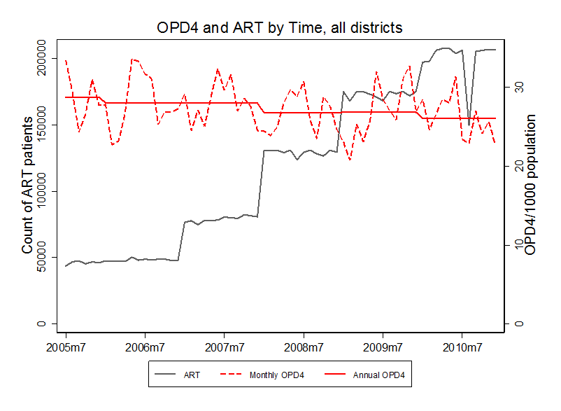

The grouped graphs have the same OPD4 scale (y-axis right) for all graphs. The ART scale (y-axis left) differs by groupings of ART. This grouping highlights the full ART range from 0 to 50,000 in a district month.

Figure Appendix 3 Graph set for OPD4 and ART plotted separately over time by district. 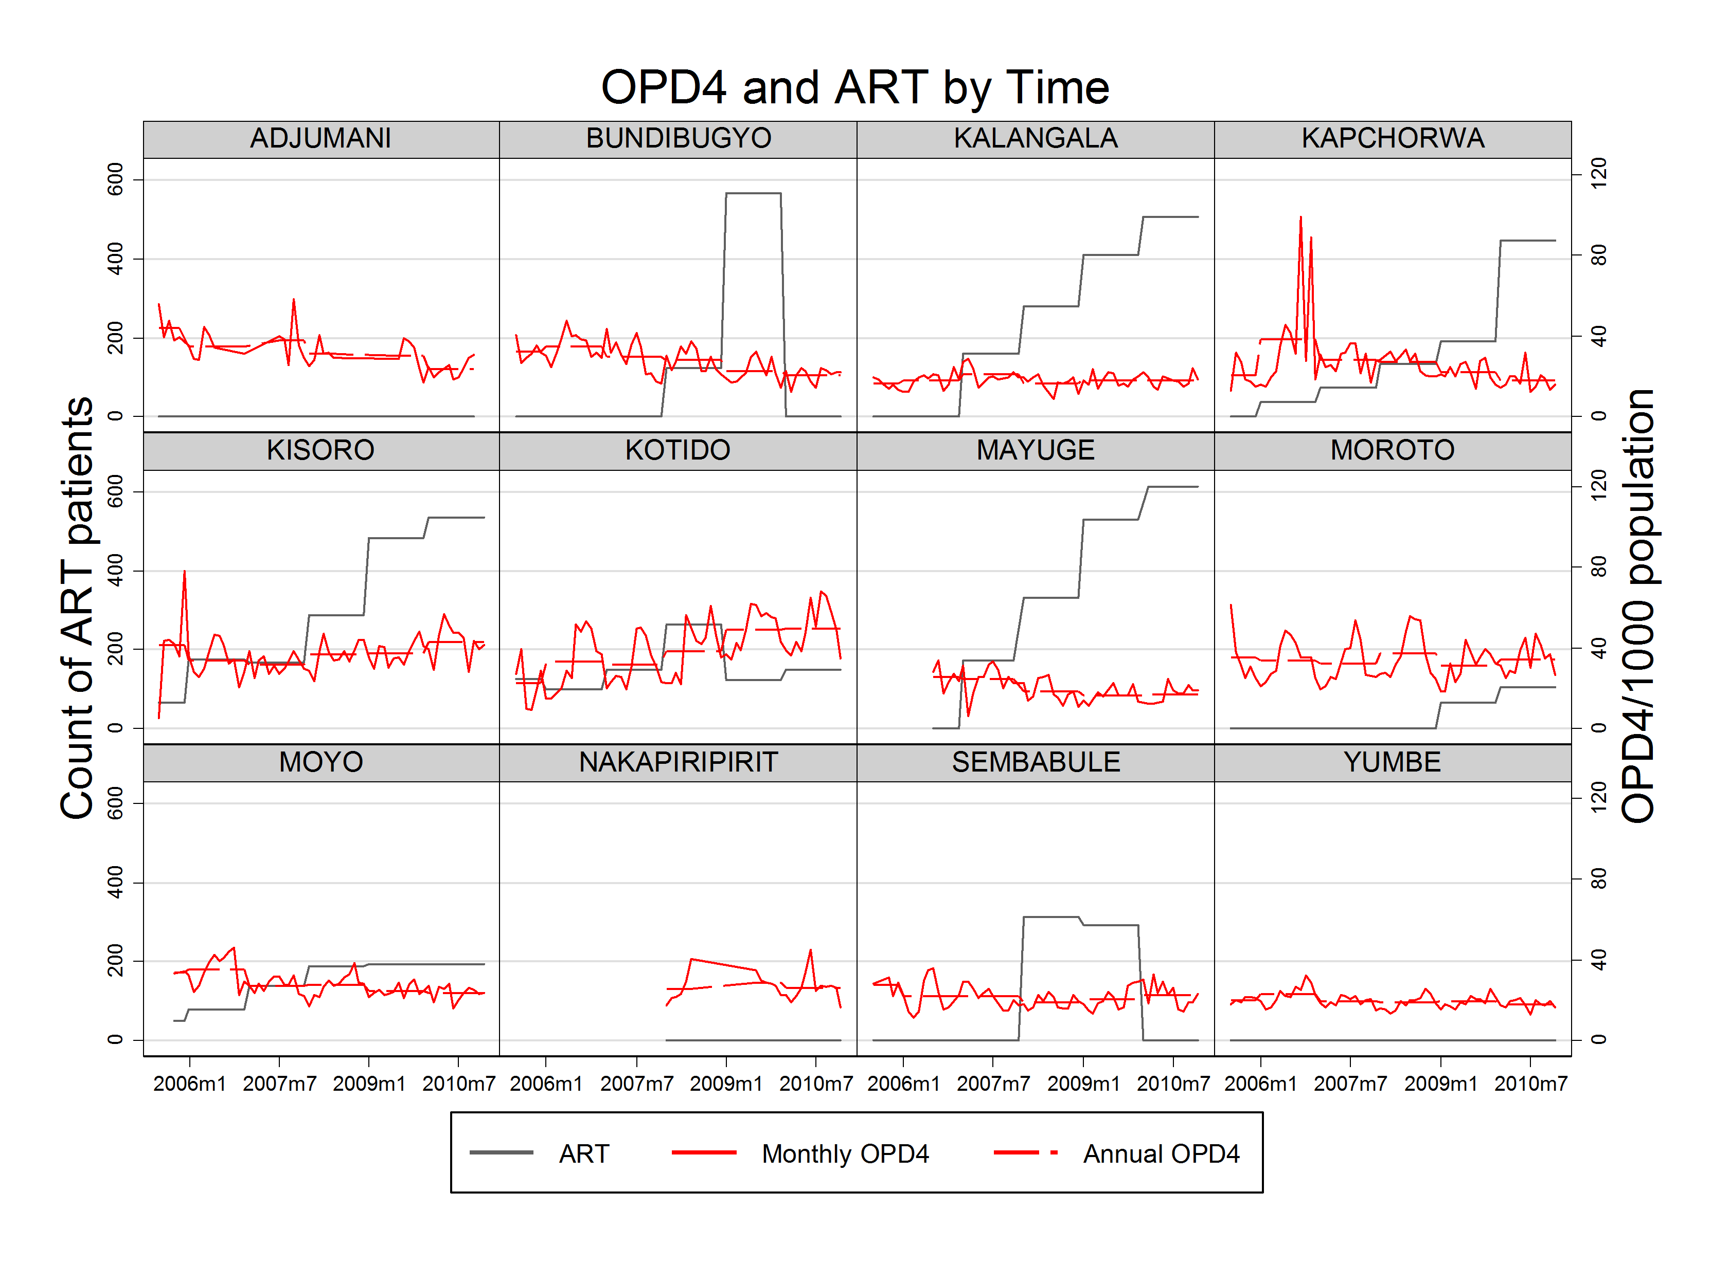
ART range 0 to 650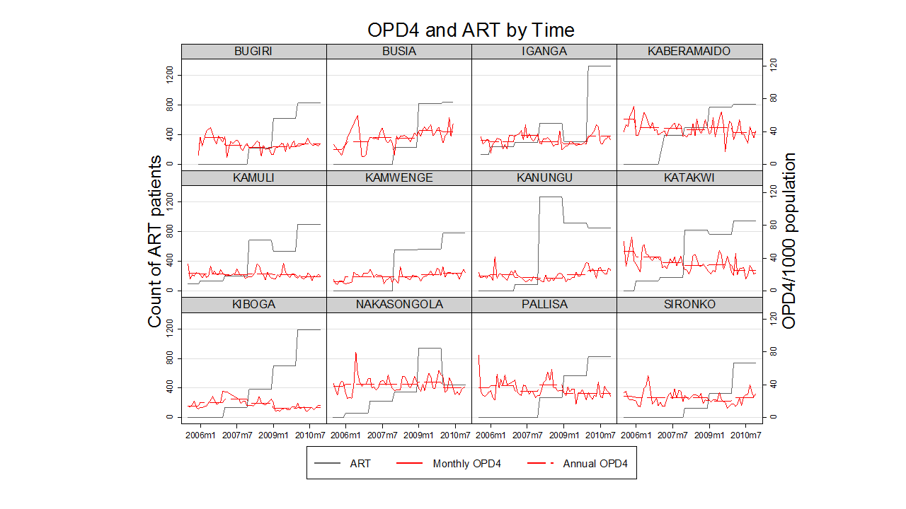

ART range 650 to 1,400
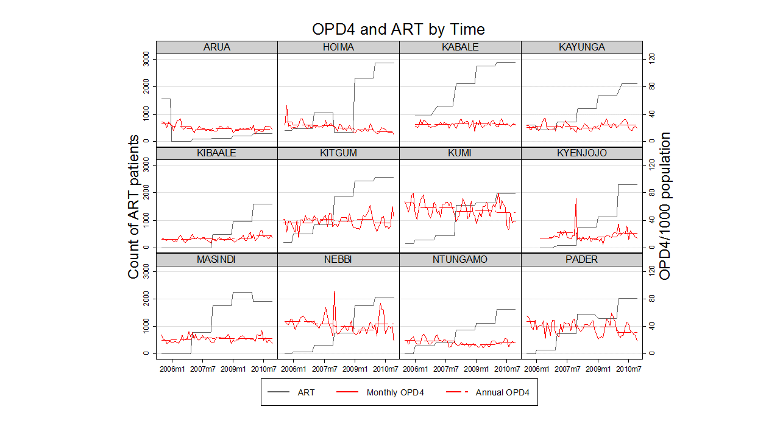

ART range 1,400 to 3,000

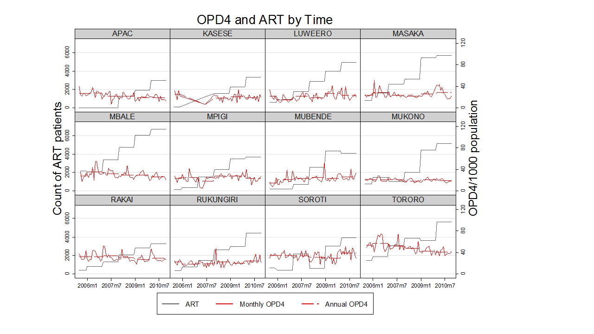
ART range 3,000 to 6,000

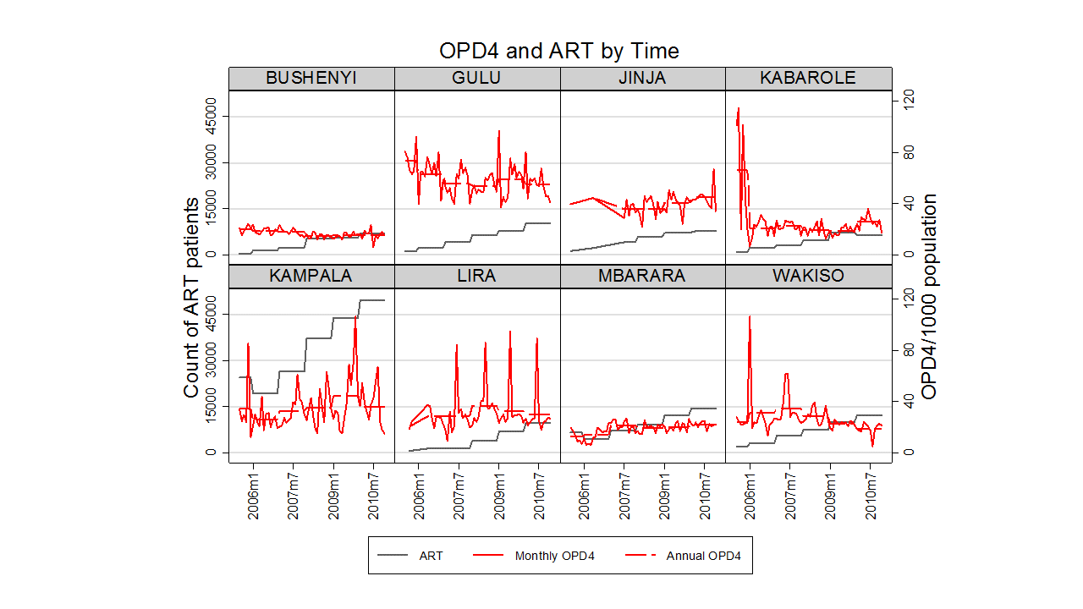
ART range 6,000 to 50,000

Figure Appendix 4 Deliveries and ART plotted separately over time.
All districts are plotted together for an overview of the association between ART and deliveries.
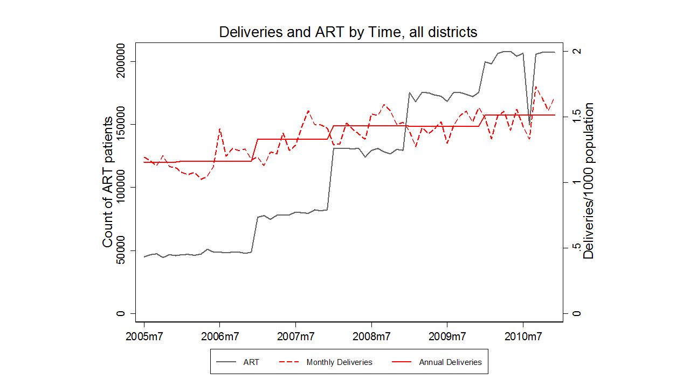

ART range 0 to 650

Figure Appendix 5 TB tests and ART plotted separately over time.
All districts are plotted together for an overview of the association between ART and TB.
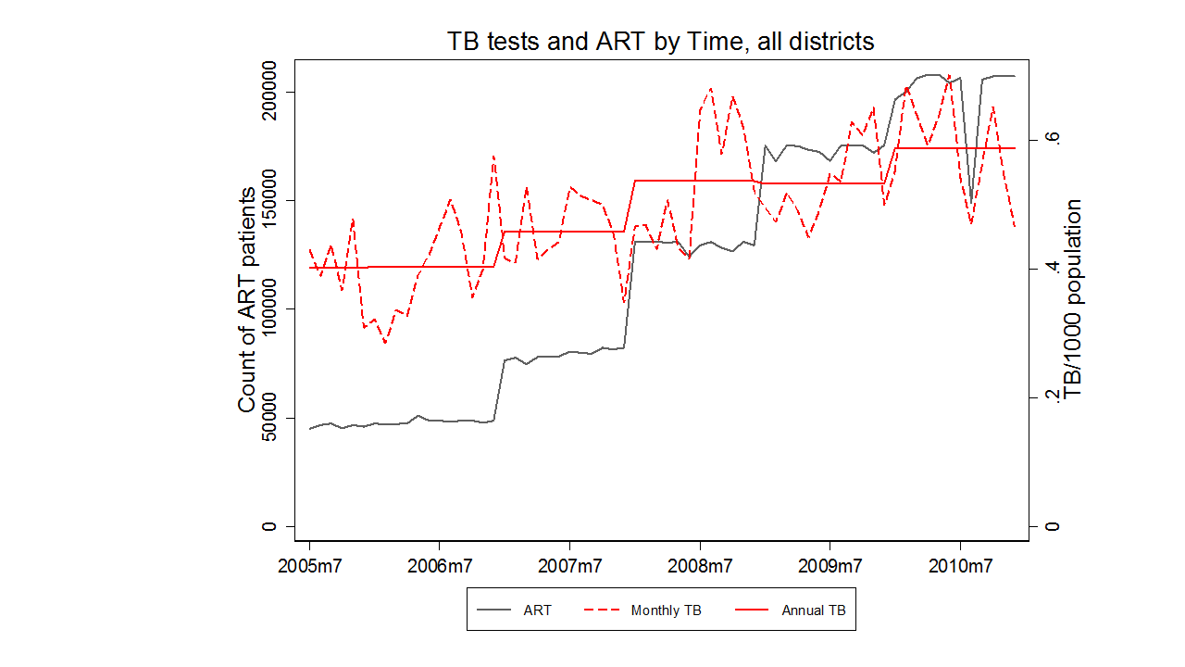
ART range 0 to 650

Figure Appendix 6 Malaria tests and ART plotted separately over time.
All districts are plotted together for an overview of the association between ART and Malaria. 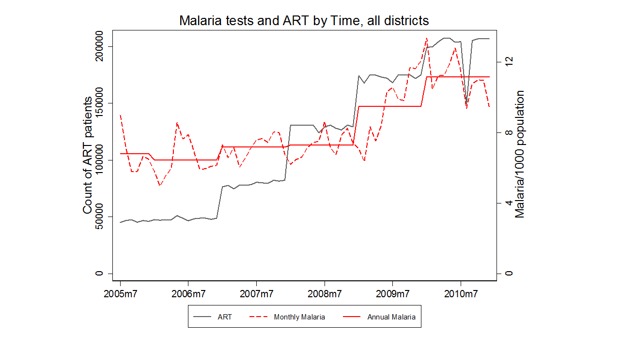

Figure Appendix 7 DPT3 immunization and ART plotted separately over time.
All districts are plotted together for an overview of the association between ART and DPT3.

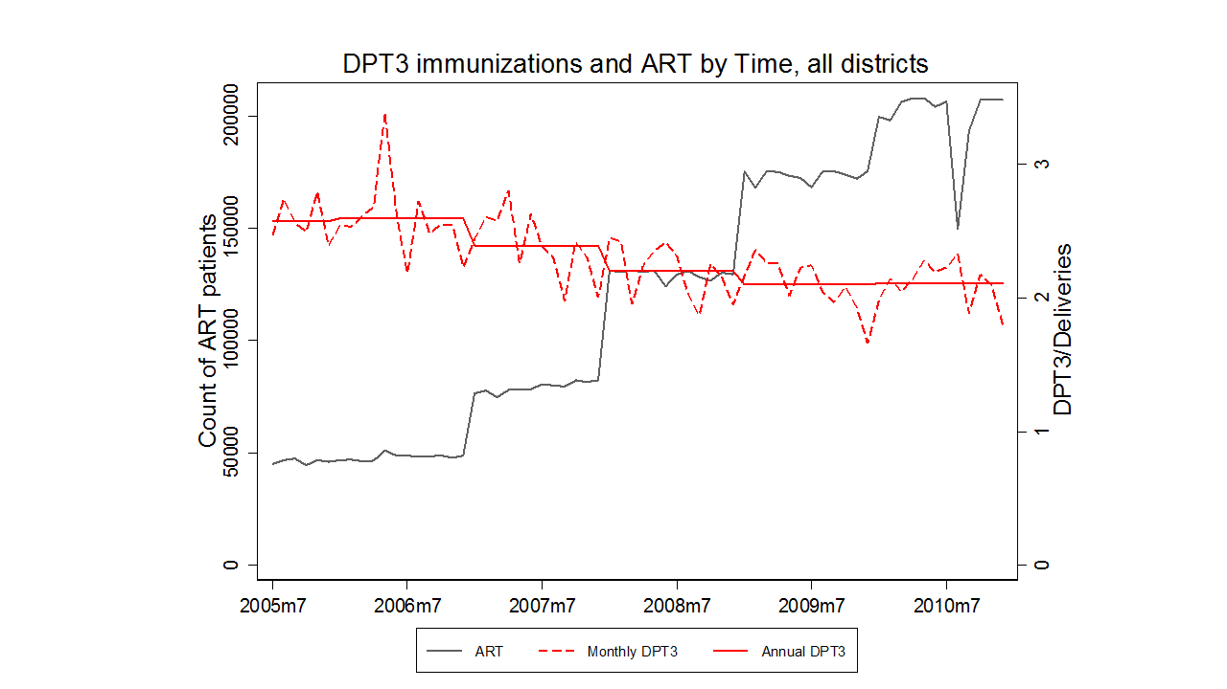

Figure Appendix 8 Maternal deaths and ART plotted separately over time.
All districts are plotted together for an overview of the association between ART and Maternal deaths. 