Appendix A
Species replacement details for cophylogeny analysis
Some host species in the bartonella dataset were only identified to the genus level, but these genera were important to include because their exclusion would have reduced the breadth of the analysis and some represented unique families. Thus, a representative species was chosen based on a) close relatedness with the original host (same genus), b) geographic range overlap with the study capture location, and c) the availability of cytb sequences on GenBank with similar length to others in the dataset (~1000 base pairs). For Micropteropus sp. and Epomophorus sp. from Nigeria, only Micropteropus pusillus and Epomophorus gambianus had ranges that overlapped with the capture location. Tylonycteris pachypus was the only species with a suitable cytb sequence for Tylonycteris sp. For other representative species, multiple options fulfilled the above criteria:
Miniopterus sp. (Kenya) – M. natalensis, M. fraterculus
Myotis sp. (Peru) – M. nigricans, M. keaysi, M. riparius, M. simus
Pipistrellus sp. (UK) – P. pipistrellus, P. nathusii, P. pygmaeus
Hipposideros sp. (Malaysia) – H. diadema, H. armiger, H. ater, H. bicolor, H. cervinus, H. cineraceus, H. larvatus, H. pomona
Rhinolophus sp. (Nigeria) – R. landeri, R. fumigatus
From these options, a random choice was drawn from the available set. Miniopterus natalensis was chosen to represent Miniopterus sp. from Kenya, Myotis nigricans for Myotis sp. from Peru, Pipistrellus pipistrellus for Pipistrellus sp. from the UK, Hipposideros diadema for Hipposideros sp. from Malaysia, and Rhinolophus landeri for Rhinolophus sp. from Nigeria. These replacements are marked with an asterisk (*) in Table S3.
For other bat species, no cytb sequences could be found or they were too short (much less than 1000 base pairs). Thus, a suitable replacement was found based on a) close relatedness with the original host (same genus), b) geographic range overlap with the study capture location, and c) the availability of cytb sequences on GenBank with similar length to others in the dataset (~1000 base pairs). Phyllostomus discolor is present in both Guatemala and Peru and only Phyllostomus hastatus is present in both locations. Megaderma lyra and Megaerops ecaudatus were the only other member of their genera in Vietnam to replace Megaderma spasma and Megaerops niphanae, respectively. For Hipposideros commersoni, this species has been split into three additional species previously recognized as subspecies – H. gigas, H. thomensis, and H. vittatus. Only H. gigas fulfilled both criteria for overlap with the capture location in Kenya and the availability of a suitable cytb sequence. For other replacement species, multiple options fulfilled the above criteria:
Rhinolophus borneensis subsp. chaseni and R. acuminatus (Vietnam) – R. affinis, R. malayanus, R. pearsonii, R. stheno
Hipposideros fulvus (Thailand) - H. armiger, H. ater, H. cineraceus, H. diadema, H. larvatus, H. lylei, H. pomona, H. pratti, H. turpis
From these options, a random selection was made. Rhinolophus acuminatus was replaced with Rhinolophus malayanus, Rhinolophus borneensis subsp. chaseni with Rhinolophus affinis, and Hipposideros fulvus with Hipposideros cineraceus. These replacements are marked with a dagger (†) in Table S3. Lei and Olival (2014) made similar replacements for species in their analysis, although without the stipulation that the geographic range of the substitute species should overlap with the capture location. The inclusion of this criterion is important in the present study because of the dual focus on bat phylogeny and sympatry. This stipulation was only modified for Chaerephon plicatus, which has no representative cytb sequence in GenBank and no other representatives of the genus present in Thailand.
It would be computationally infeasible to test how each choice of replacement affects our results, however we perform a single sensitivity analysis by using a second set of suitable replacement species in the global fit tests and correlation between bat phylogeny and sympatry. For the sensitivity analysis, we chose Miniopterus fraterculus (AJ841975) to represent Miniopterus sp. from Kenya, Chaerephon leucogaster (GQ489166) for Chaerephon plicatus from Thailand, Myotis riparius (JX130570) for Myotis sp. from Peru, Pipistrellus pygmaeus (AJ504442) for Pipistrellus sp. from the UK, Hipposideros pomona (DQ054810) for Hipposideros sp. from Malaysia, Hipposideros lylei (JN247043) for Hipposideros fulvus from Thailand, Rhinolophus stheno (FJ185213) for Rhinolophus acuminatus from Vietnam, Rhinolophus pearsonii (JX502551) for Rhinolophus borneensis subsp. chaseni from Vietnam, Rhinolophus fumigatus (FJ457614) for Rhinolophus sp. from Nigeria.
Using the maximum likelihood trees of bat species and Bartonella genotypes, global fit tests find a strongly significant cophylogenetic signal (ParaFitGlobal = 13.37, P = 1E-5; m² global value = 8.54, P = 1E-4). Using ParaFit, 159/186 of host-parasite links were significant at the P ≤ 0.05 level, 129/186 at the P ≤ 0.005 level, and 103/186 at the P ≤ 0.001 level. Using PACo, 93/186 of host-parasite links were below the median and 9 were above Q3+1.5(IQR). The correlation between bat phylogeny and sympatry remains strong with the substitute species (Pearson correlation coefficient = 0.31, P = 1E-5). Global fit tests were repeated using bat sympatry and the maximum likelihood tree of Bartonella genotypes, finding a significant trend (ParaFitGlobal = 106.3, P = 1E-5; m² global value = 57.5, P = 1E-4). Using ParaFit, 144/186 of host-parasite links were significant at the P ≤ 0.05 level, 133/186 at the P ≤ 0.005 level, and 126/186 at the P ≤ 0.001 level. Using PACo, 93/186 of host-parasite links were below the median and 5 were above Q3+1.5(IQR). The optimal linear combination of the bat phylogeny and bat sympatry matrices using ParaFit was ω_{phy} = 1and ω_{geo} = 0, ParaFitGlobal = 13.37; for PACo the optimal combination was ω_{phy} = 1and ω_{geo} = 0, m² global value = 8.54. Our sensitivity analysis indicated that the choice of substitute species does not greatly affect the results of the cophylogeny tests.
Appendix B
Analysis of sampling bias
We looked for the presence of bias in the dataset by testing the correlation between the number of host-parasite links and sampling effort. Specifically, we used two measures of sampling effort: the number of published articles on each bat species found on Web of Science and the total sample size of each bat species tested in the individual studies that contribute to the dataset. There was a significant log-log correlation between the number of host-parasite links and Web of Science articles (Fig. S10a; Pearson correlation coefficient, r = 0.27, P = 0.03). The correlation became only marginally significant when the bat with the highest number of host-parasite links (Eidolon helvum, 35 links) was removed (Fig. S10b; Pearson correlation coefficient, r = 0.24, P = 0.05). There was a significantly positive log-log correlation between the number of links and individual species’ sample sizes (Fig. S10c; Pearson correlation coefficient, r = 0.71, P = 4E-11). This correlation was still significant when the species with the highest number of host-parasite links (Eidolon helvum, 35 links) was removed (Fig. S10d; Pearson correlation coefficient, r = 0.66, P = 4E-09). This suggests that high levels of bartonella diversity found in several bat species are probably due in part to sampling bias, although this does not completely exclude the effects of ecological and evolutionary processes that may increase bartonella diversity in some bats.
Supplementary Material
Table S1. Bartonella citrate synthase (gltA) genotypes detected in bats included in the analysis dataset with GenBank accession numbers. Host bat genus and species were extracted from GenBank metadata or from published articles (Anh et al., 2015; Bai et al., 2015, 2012, 2011; Brook et al., 2015; Concannon et al., 2005; Judson et al., 2015; Kamani et al., 2014; Kosoy et al., 2010; Lin et al., 2012; Olival et al., 2015; Veikkolainen et al., 2014). Bats from Thailand were included from the CDC database (M. Kosoy, unpublished data).
Genotype | Host species | Location | gltA accession number
M406 | Myotis daubentonii | UK | AJ871613
M62 | Myotis mystacinus | UK | AJ871612
M207 | Pipistrellus sp. | UK | AJ871614
M451 | Nyctalus noctula | UK | AJ871615
M409 | Pipistrellus sp. | UK | AJ871611
Cul-9 | Lophostoma silvicolum | Peru | EF616479
R-191 | Rousettus aegyptiacus | Kenya | HM363764
T-837 | Triaenops persicus | Kenya | HM545138
H-556 | Hipposideros commersoni | Kenya | HM545137
C-583 | Coleura afra | Kenya | HM545136
M1-44 | Miniopterus sp. | Kenya | HM545139
M2-491 | Miniopterus sp. | Kenya | HM545140
M3-373 | Miniopterus sp. | Kenya | HM545141
B29042 | Desmodus rotundus | Guatemala | HM597187
B29043 | Desmodus rotundus | Guatemala | HM597188
B29044 | Desmodus rotundus | Guatemala | HM597189
B29107 | Desmodus rotundus | Guatemala | HM597190
B29108 | Desmodus rotundus, Carollia perspicillata | Guatemala | HM597191
B29114 | Desmodus rotundus, Carollia perspicillata | Guatemala | HM597192
B29102 | Pteronotus davyi | Guatemala | HM597193
B29109 | Pteronotus davyi | Guatemala | HM597194
B29119 | Desmodus rotundus | Guatemala | HM597195
B29122 | Desmodus rotundus | Guatemala | HM597196
B29116 | Phyllostomus discolor | Guatemala | HM597198
B29126 | Carollia perspicillata, Sturnira lilium | Guatemala, Costa Rica | HM597199, KJ816674
B29230 | Phyllostomus discolor | Guatemala | HM597200
B29115 | Phyllostomus discolor | Guatemala | HM597201
B29110 | Glossophaga soricina | Guatemala | HM597202
B29105 | Pteronotus davyi | Guatemala | HM597203
B29112 | Phyllostomus discolor | Guatemala | HM597204
B29134 | Pteronotus davyi | Guatemala | HM597205
B29137 | Sturnira lilium | Guatemala | HM597206
B29172 | Micronycteris microtis | Guatemala | HM597207
B29111 | Artibeus toltecus | Guatemala | HM597197
B32945 | Desmodus rotundus | Peru | JQ071379
B32947 | Phyllostomus discolor | Peru | JQ071387
B32954 | Artibeus planirostris | Peru | JQ071382
B32946 | Glossophaga soricina | Peru | JQ071383
B32943 | Carollia perspicillata | Peru | JQ071384
B32960 | Carollia perspicillata | Peru, Costa Rica | JQ071386, KJ816691
B32955 | Carollia perspicillata | Peru | JQ071385
B32854 | Phyllostomus hastatus | Peru | JQ071388
B32855 | Desmodus rotundus | Peru | JQ071378
B32856 | Vampyressa bidens | Peru | JQ071389
B32942 | Myotis sp. | Peru | JQ071390
B32851 | Artibeus obscurus | Peru | JQ071380
B32953 | Artibeus planirostris | Peru | JQ071381
No. 5 | Miniopterus schreibersii | Taiwan | JF500511
No. 7 | Miniopterus schreibersii | Taiwan | JF500513
AS050 | Myotis myotis | Poland | JQ695835
AS071 | Myotis myotis | Poland | JQ695834
2574/1 | Myotis daubentonii | Finland | KF003129
1160/1 | Myotis daubentonii | Finland | KF003122
1157/3 | Eptesicus nilssoni | Finland | KF003115
Mr37079 | Monophyllus redmani, Phyllonycteris poeyi | Puerto Rico, Dominican Republic | KJ530746, JX416249
Mr37078 | Monophyllus redmani | Puerto Rico | KJ530745
Mr37077 | Monophyllus redmani | Puerto Rico | KJ530744
Mr37075 | Monophyllus redmani | Puerto Rico | KJ530743
Bc37076 | Brachyphylla cavernarum | Puerto Rico | KJ530742
Aj37081 | Artibeus jamaicensis | Puerto Rico | KJ530741
B23976 | Eidolon helvum | Kenya | KM030507
B40005 | Eidolon helvum | Cameroon | KM030518
B23979 | Eidolon helvum | Kenya | KM030509
B24225 | Eidolon helvum | Kenya | KM030511
B40396 | Eidolon helvum | Tanzania | KM030522
B40400 | Eidolon helvum | Tanzania | KM030523
B23812 | Eidolon helvum, Rhinolophus landeri | Kenya, Nigeria | KM030504, KF418810
B24163 | Eidolon helvum | Kenya | KM030510
B32120 | Eidolon helvum | Nigeria | KM030512
B39301 | Eidolon helvum | Ghana | KM030516
B39325 | Eidolon helvum | Ghana | KM030517
B23975 | Eidolon helvum | Kenya | KM030506
B39286 | Eidolon helvum | Ghana | KM030514
B39296 | Eidolon helvum | Ghana | KM030515
B40908 | Eidolon helvum | Uganda | KM030526
B39249 | Eidolon helvum | Ghana | KM030513
B40391 | Eidolon helvum | Tanzania | KM030521
B40014 | Eidolon helvum | Tanzania | KM030520
B40406 | Eidolon helvum | Tanzania | KM030525
B23797 | Eidolon helvum, Micropteropus pusillus, Epomophorus gambianus | Kenya, Nigeria | KM030503, KF418812, KF418808
Mi-BA38 | Micropteropus sp. | Nigeria | KF418812
Eh-GB64 | Eidolon helvum | Nigeria | KF418811
Rh-GB31 | Rhinolophus sp. | Nigeria | KF418810
Ep-BA63 | Epomophorus sp. | Nigeria | KF418808
Rh-GB59 | Rhinolophus sp. | Nigeria | KF418809
Rh-GB1 | Rhinolophus sp. | Nigeria | KF418807
Ep-GB65 | Epomophorus sp. | Nigeria | KF418806
B110 | Hipposideros larvatus, Hipposideros armiger | Vietnam | KP100360, KP100357
B109 | Megaderma lyra | Vietnam | KP100359
B102 | Rhinolophus chaseni | Vietnam | KP100358
B096 | Hipposideros armiger | Vietnam | KP100357
B095 | Hipposideros armiger | Vietnam | KP100356
B087 | Hipposideros larvatus | Vietnam | KP100355
B081 | Hipposideros larvatus | Vietnam | KP100354
B079 | Rhinolophus chaseni | Vietnam | KP100353
B072 | Megaerops niphanae | Vietnam | KP100352
B068 | Rhinolophus acuminatus | Vietnam | KP100351
B064 | Rhinolophus acuminatus | Vietnam | KP100350
B063 | Rhinolophus acuminatus | Vietnam | KP100349
B056 | Rhinolophus acuminatus | Vietnam | KP100348
B055 | Rhinolophus acuminatus | Vietnam | KP100347
B052 | Rhinolophus acuminatus | Vietnam | KP100346
B050 | Rhinolophus acuminatus | Vietnam | KP100345
B049 | Rhinolophus sinicus | Vietnam | KP100344
B047 | Rhinolophus sinicus | Vietnam | KP100343
B006 | Rhinolophus acuminatus | Vietnam | KP100342
B005 | Megaderma spasma | Vietnam | KP100341
B003 | Rhinolophus acuminatus | Vietnam | KP100340
SK197 | Tadarida plicata | Thailand | -
SK170 | Tadarida plicata | Thailand | -
SK157 | Tadarida plicata | Thailand | -
CR224 | Hipposideros fulvus | Thailand | -
KP270 | Hipposideros larvatus | Thailand | -
KP182 | Hipposideros armiger, Hipposideros larvatus | Thailand | -
KP283b | Taphozous melanopogon | Thailand | -
SK163 | Tadarida plicata | Thailand | -
KP277 | Hipposideros larvatus | Thailand | -
KP293b | Hipposideros larvatus | Thailand | -
KEL08 | Eidolon dupreanum | Madagascar | KP010191
KEL16 | Eidolon dupreanum | Madagascar | KP010192
KEL17 | Eidolon dupreanum | Madagascar | KP010193
I | Anoura geoffroyi | Costa Rica | KJ816666
III | Artibeus lituratus, Anoura geoffroyi, Sturnira mordax, Sturnira lilium | Costa Rica | KJ816680
III | Vampyressa thyone | Costa Rica | KJ816672
III | Carollia castanea | Costa Rica | KJ816683
III | Artibeus lituratus | Costa Rica | KJ816675
III | Platyrrhinus vittatus | Costa Rica | KJ816684
VII | Carollia sowelli | Costa Rica | KJ816690
XII | Myotis keaysi | Costa Rica | KJ816676
2308 | Brucella melitensis | outgroup | AM040264
OV483 | Rhizobium leguminosarum | outgroup | NZ_JQJS01000011
OAB | Ochrobactrum anthropi | outgroup | NZ_CP008820

Table S2. Bartonella citrate synthase (gltA) genotypes detected in ectoparasites included in the analysis dataset with GenBank accession numbers. Ectoparasite and host bat genus and species were extracted from GenBank metadata or from published articles (Billeter et al., 2012; Brook et al., 2015; Judson et al., 2015; Morse et al., 2012; Veikkolainen et al., 2014).
Genotype | Ectoparasite | Host species | Location | gltA accession number
NB-1.2 | Siphonaptera sp. | Myotis brandtii | Finland | KF003137
AS025 | Spinturnix myoti | Myotis myotis | Poland | JQ695839
AS033 | Spinturnix myoti | Myotis myotis | Poland | JQ695838
AS036 | Spinturnix myoti | Myotis myotis | Poland | JQ695837
AS048 | Spinturnix myoti | Myotis myotis | Poland | JQ695836
AS067 | Spinturnix myoti | Myotis myotis | Poland | JQ695840
Cg 462 | Cyclopodia greefi | Eidolon helvum | Equatorial Guinea: Bioko | JN172074
Cg 401 | Cyclopodia greefi | Eidolon helvum | Equatorial Guinea: Bioko | JN172072
Cg 454 | Cyclopodia greefi | Eidolon helvum | Equatorial Guinea: Bioko | JN172071
Cg 414 | Cyclopodia greefi | Eidolon helvum | Equatorial Guinea: Bioko | JN172070
Cg 433 | Cyclopodia greefi | Eidolon helvum | Equatorial Guinea: Bioko | JN172069
Cg 443 | Cyclopodia greefi | Eidolon helvum | Equatorial Guinea: Bioko | JN172068
Cg 465-2 | Cyclopodia greefi | Eidolon helvum | Equatorial Guinea: Bioko | JN172067
Cg 713-2 | Cyclopodia greefi | Eidolon helvum | Equatorial Guinea: Bioko | JN172066
Cg 405 | Cyclopodia greefi | Eidolon helvum | Equatorial Guinea: Bioko | JN172065
Cg 424 | Cyclopodia greefi | Eidolon helvum | Equatorial Guinea: Bioko | JN172064
Cg 417-2 | Cyclopodia greefi | Eidolon helvum | Equatorial Guinea: Bioko | JN172063
Cg 426-1 | Cyclopodia greefi | Eidolon helvum | Equatorial Guinea: Bioko | JN172062
Cg 436-3 | Cyclopodia greefi | Eidolon helvum | Equatorial Guinea: Bioko | JN172061
Cg 418 | Cyclopodia greefi | Eidolon helvum | Equatorial Guinea: Bioko | JN172060
Cg 423-2 | Cyclopodia greefi | Eidolon helvum | Equatorial Guinea: Bioko | JN172059
Cg 423-1 | Cyclopodia greefi | Eidolon helvum | Equatorial Guinea: Bioko | JN172058
Cg 364 | Cyclopodia greefi | Eidolon helvum | Equatorial Guinea: Annobón | JN172049
Cg 374 | Cyclopodia greefi | Eidolon helvum | Equatorial Guinea: Annobón | JN172050
Cg 358-3 | Cyclopodia greefi | Eidolon helvum | Equatorial Guinea: Annobón | JN172051
Cg 366-1 | Cyclopodia greefi | Eidolon helvum | Equatorial Guinea: Annobón | JN172052
Cg 371 | Cyclopodia greefi | Eidolon helvum | Equatorial Guinea: Annobón | JN172053
Cg 315-1 | Cyclopodia greefi | Eidolon helvum | Equatorial Guinea: Annobón | JN172054
Cg 303-1 | Cyclopodia greefi | Eidolon helvum | Equatorial Guinea: Annobón | JN172055
Cg 303-2 | Cyclopodia greefi | Eidolon helvum | Equatorial Guinea: Annobón | JN172056
Cg 366 | Cyclopodia greefi | Eidolon helvum | Equatorial Guinea: Annobón | JN172057
Cg K1-2 | Cyclopodia greefi | Eidolon helvum | Ghana | JN172035
Cg K5-1 | Cyclopodia greefi | Eidolon helvum | Ghana | JN172036
Cg K8-1 | Cyclopodia greefi | Eidolon helvum | Ghana | JN172037
Cg Q22-1 | Cyclopodia greefi | Eidolon helvum | Ghana | JN172038
Cg Q98-1 | Cyclopodia greefi | Eidolon helvum | Ghana | JN172039
Cg Q100-2 | Cyclopodia greefi | Eidolon helvum | Ghana | JN172040
Cg Q130 | Cyclopodia greefi | Eidolon helvum | Ghana | JN172041
Cg G35-2 | Cyclopodia greefi | Eidolon helvum | Ghana | JN172042
Cg G31-1 | Cyclopodia greefi | Eidolon helvum | Ghana | JN172043
Cg G38-2 | Cyclopodia greefi | Eidolon helvum | Ghana | JN172044
Cg GG236 | Cyclopodia greefi | Eidolon helvum | Ghana | JN172045
Cg GG48 | Cyclopodia greefi | Eidolon helvum | Ghana | JN172046
Cg GG243-2 | Cyclopodia greefi | Eidolon helvum | Ghana | JN172047
Cg GG243-3 | Cyclopodia greefi | Eidolon helvum | Ghana | JN172048
E-124 | Cyclopodia greefi | Eidolon helvum | Ghana | JN190887
E7 | Cyclopodia horsfieldii | Pteropus hypomelanus | Malaysia | JX416257
E5 | Cyclopodia horsfieldii | Pteropus hypomelanus | Malaysia | JX416256
P2874 | Cyclopodia simulans | Ptenochirus jagori | Philippines | JX416255
27_3_4 | Paradyschiria lineata | Noctilio leporinus | Panama | JX416254
DR0583 | Trichobius adamsi | Macrotus waterhousii | Dominican Republic | JX416253
05_01_07 | Phthiridium sp. scissa group | Rhinolophus pearsoni | Laos | JX416252
23_03_04 | Strebla diaemi | Diaemus youngi | Panama | JX416251
CWD974 | Trichobius johnsonae | Pteronotus personatus | Mexico | JX416248
RCO934 | Pseudostrebla ribeiroi | Lophostoma silvicolum | Peru | JX416247
Mala11 | Basilia (Tripselia) coronata | Tylonycteris sp. | Malaysia | JX416246
ZAG03 | Basilia nattereri | Myotis nattererei | Slovenia | JX416241
JAE1033 | Leptocyclopodia sp. nov. | Harpionycteris whiteheadi | Philippines | JX416239
Mala15 | Phthiridium (Stylidia) fraterna | Hipposideros sp. | Malaysia | JX416238
DR05241 | Trichobius adamsi | Macrotus waterhousii | Dominican Republic | JX416237
ZAG01 | Trichobius corynorhinus | Corynorhinus townsendii | USA | JX416236
FG13 | Paratrichobius longicrus complex | Artibeus lituratus | French Guyana, Costa Rica | JX416232, KJ816687
FG10 | Paratrichobius longicrus complex | Artibeus lituratus | French Guyana | JX416231
KEL02-3 | Cyclopodia dubia | Eidolon dupreanum | Madagascar | KP010152
KEL02-4 | Cyclopodia dubia | Eidolon dupreanum | Madagascar | KP010153
KEL19-1 | Cyclopodia dubia | Eidolon dupreanum | Madagascar | KP010164
KEL09-1 | Cyclopodia dubia | Eidolon dupreanum | Madagascar | KP010159
KEL02-2 | Cyclopodia dubia | Eidolon dupreanum | Madagascar | KP010151
KEL11-1 | Cyclopodia dubia | Eidolon dupreanum | Madagascar | KP010160
KEL07-1 | Cyclopodia dubia | Eidolon dupreanum | Madagascar | KP010158
KEL17-2 | Cyclopodia dubia | Eidolon dupreanum | Madagascar | KP010163
KEL04-1 | Cyclopodia dubia | Eidolon dupreanum | Madagascar | KP010155
ANGB03-1 | Cyclopodia dubia | Eidolon dupreanum | Madagascar | KP010150
KEL04-2 | Cyclopodia dubia | Eidolon dupreanum | Madagascar | KP010156
KEL02-5 | Cyclopodia dubia | Eidolon dupreanum | Madagascar | KP010154
KEL17-1 | Cyclopodia dubia | Eidolon dupreanum | Madagascar | KP010162
II | Exastinion clovisi | Anoura geoffroyi | Costa Rica | KJ816688
III | Trichobius dugesii | Glossophaga soricina | Costa Rica | KJ816678
IV | Aspidoptera phyllostomatis | Artibeus jamaicensis | Costa Rica | KJ816682
V | Paratrichobius longicrus | Artibeus lituratus | Costa Rica | KJ816685
VIII | Trichobius joblingi | Carollia castanea | Costa Rica | KJ816686
X | Trichobius costalimai | Phyllostomus discolor | Costa Rica | KJ816665
XI | Trichobius keenani | Micronycteris microtis | Costa Rica | KJ816681
XII | Aspidoptera delatorrei | Sturnira lilium | Costa Rica | KJ816673
XIII | Anatrichobius scorzai | Myotis keaysi | Costa Rica | KJ816669
XIV | Anatrichobius scorzai | Myotis keaysi | Costa Rica | KJ816667
XV | Aspidoptera delatorrei | Sturnira lilium | Costa Rica | KJ816679
XVI | Paratrichobius dunni | Uroderma bilobatum | Costa Rica | KJ816692
XVII | Paratrichobius dunni | Uroderma bilobatum | Costa Rica | KJ816677
XIX | Megistopoda proxima | Sturnira lilium | Costa Rica | KJ816670
XX | Basilia sp. | Myotis keaysi | Costa Rica | KJ816689
2308 | Brucella melitensis | - | outgroup | AM040264
OV483 | Rhizobium leguminosarum | - | outgroup | NZ_JQJS01000011
OAB | Ochrobactrum anthropi | - | outgroup | NZ_CP008820

Table S3. Cytochrome b (cytb) sequences for bat species included in the analysis dataset with GenBank accession numbers. An asterisk (*) indicates that the species is a representative for sequences attributed only to the bat genus. A dagger (†) indicates that the original host species has no suitable cytb sequence in GenBank and was replaced by another species. A double dagger (‡) indicates that the host species name listed in the original article has been revised or reclassified. See Appendix A for details on species replacements. Host bat family and suborder were recorded based on the IUCN Red List of Threatened Species (IUCN, 2014), the Mammal Species of the World 3rd Edition (Wilson and Reeder, 2005), and published articles (Agnarsson et al., 2011; Teeling et al., 2002). Web of Science citations (as of August 2015) were recorded based on a search of the original host binomial species name. Study sample sizes for each species were quantified from original articles, using the original host species wherever a species-level replacement was made.
Host species | Family | Suborder | Region | cytb accession number | WoS citations | Study sample size | Number of links
Coleura afra | Emballonuridae | Yangochiroptera | Africa | JQ710752 | 6 | 9 | 1
Taphozous melanopogon | Emballonuridae | Yangochiroptera | Asia S/SE/SE | EF584221 | 28 | 2 | 1
Miniopterus natalensis* | Miniopteridae | Yangochiroptera | Africa | AJ841977 | 28 | 87 | 3
Miniopterus schreibersii | Miniopteridae | Yangochiroptera | Europe-Asia-Africa | EF530348 | 211 | 14 | 2
Chaerephon plicatus (Tadarida plicata)†‡ | Molossidae | Yangochiroptera | Asia S/SE/SE | GQ489157 | 5 | 45 | 4
Pteronotus davyi | Mormoopidae | Yangochiroptera | America C/S/Carib | AF338672 | 20 | 10 | 5
Pteronotus personatus | Mormoopidae | Yangochiroptera | America C/S/Carib | KC011599 | 13 | 1 | 1
Noctilio leporinus | Noctilionidae | Yangochiroptera | America C/S/Carib | JX257161 | 64 | 1 | 1
Anoura geoffroyi | Phyllostomidae | Yangochiroptera | America C/S/Carib | FJ155495 | 42 | 6 | 3
Artibeus toltecus | Phyllostomidae | Yangochiroptera | America C/S/Carib | FJ376728 | 3 | 1 | 1
Artibeus jamaicensis | Phyllostomidae | Yangochiroptera | America C/S/Carib | GQ861667 | 235 | 19 | 2
Artibeus lituratus | Phyllostomidae | Yangochiroptera | America C/S/Carib | KP134571 | 135 | 13 | 5
Artibeus obscurus | Phyllostomidae | Yangochiroptera | America C/S/Carib | KP134536 | 19 | 10 | 1
Artibeus planirostris | Phyllostomidae | Yangochiroptera | America C/S/Carib | KP134540 | 40 | 16 | 2
Brachyphylla cavernarum | Phyllostomidae | Yangochiroptera | America C/S/Carib | AY572383 | 14 | 2 | 1
Carollia castanea | Phyllostomidae | Yangochiroptera | America C/S/Carib | AF187022 | 27 | 20 | 2
Carollia perspicillata | Phyllostomidae | Yangochiroptera | America C/S/Carib | KF019723 | 354 | 49 | 6
Carollia sowelli | Phyllostomidae | Yangochiroptera | America C/S/Carib | AF511973 | 15 | 5 | 1
Desmodus rotundus | Phyllostomidae | Yangochiroptera | America C/S/Carib | FJ155477 | 376 | 50 | 10
Diaemus youngi | Phyllostomidae | Yangochiroptera | America C/S/Carib | FJ155475 | 22 | 1 | 1
Glossophaga soricina | Phyllostomidae | Yangochiroptera | America C/S/Carib | FJ392516 | 217 | 18 | 3
Lophostoma silvicolum  (Tonatia silvicola)‡ | Phyllostomidae | Yangochiroptera | America C/S/Carib | JF923862 | 15 | 2 | 2
Macrotus waterhousii | Phyllostomidae | Yangochiroptera | America C/S/Carib | AY380745 | 22 | 2 | 2
Micronycteris microtis | Phyllostomidae | Yangochiroptera | America C/S/Carib | AY380756 | 18 | 3 | 2
Monophyllus redmani | Phyllostomidae | Yangochiroptera | America C/S/Carib | AF382888 | 17 | 20 | 4
Phyllonycteris poeyi | Phyllostomidae | Yangochiroptera | America C/S/Carib | GU937240 | 7 | 1 | 1
Phyllostomus hastatus† | Phyllostomidae | Yangochiroptera | America C/S/Carib | FJ155479 | 94 | 17 | 7
Platyrrhinus vittatus | Phyllostomidae | Yangochiroptera | America C/S/Carib | FJ154178 | 1 | 2 | 1
Sturnira lilium | Phyllostomidae | Yangochiroptera | America C/S/Carib | KC753849 | 126 | 20 | 6
Sturnira mordax | Phyllostomidae | Yangochiroptera | America C/S/Carib | KC753824 | 6 | 11 | 1
Uroderma bilobatum | Phyllostomidae | Yangochiroptera | America C/S/Carib | AY169955 | 33 | 4 | 2
Vampyressa bidens | Phyllostomidae | Yangochiroptera | America C/S/Carib | FJ154181 | 5 | 3 | 1
Vampyressa thyone | Phyllostomidae | Yangochiroptera | America C/S/Carib | DQ312431 | 4 | 2 | 1
Corynorhinus townsendii | Vespertilionidae | Yangochiroptera | America N | KC747680 | 54 | 1 | 1
Eptesicus nilssonii | Vespertilionidae | Yangochiroptera | Europe-Asia C/E | GQ272582 | 46 | 1 | 1
Myotis brandtii | Vespertilionidae | Yangochiroptera | Europe-Asia C/E | AF376844 | 60 | 1 | 1
Myotis daubentonii | Vespertilionidae | Yangochiroptera | Europe-Asia C/E | AB106589 | 243 | 6 | 2
Myotis keaysi | Vespertilionidae | Yangochiroptera | America C/S/Carib | JX130526 | 5 | 9 | 4
Myotis myotis | Vespertilionidae | Yangochiroptera | Europe-Asia C/E | AM261883 | 2751 | 7 | 3
Myotis mystacinus | Vespertilionidae | Yangochiroptera | Europe-Asia C/E | AB106605 | 81 | 2 | 1
Myotis nattereri | Vespertilionidae | Yangochiroptera | Europe-Asia C/E | JF412413 | 143 | 2 | 1
Myotis nigricans* | Vespertilionidae | Yangochiroptera | America C/S/Carib | KP134584 | 58 | 6 | 1
Nyctalus noctula | Vespertilionidae | Yangochiroptera | Europe-Asia C/E | JX570902 | 195 | 1 | 1
Pipistrellus pipistrellus* | Vespertilionidae | Yangochiroptera | Europe-Asia C/E | KF874521 | 983 | 36 | 2
Tylonycteris pachypus* | Vespertilionidae | Yangochiroptera | Asia S/SE/SE | EF517315 | 15 | 1 | 1
Hipposideros armiger | Hipposideridae | Yinpterochiroptera | Asia S/SE/SE | JX849197 | 42 | 25 | 2
Hipposideros diadema* | Hipposideridae | Yinpterochiroptera | Asia S/SE/SE | DQ219421 | 13 | 1 | 1
Hipposideros fulvus† | Hipposideridae | Yinpterochiroptera | Asia S/SE/SE | DQ054809 | 12 | 1 | 1
Hipposideros commersoni‡ | Hipposideridae | Yinpterochiroptera | Africa | EU934469 | 3 | 4 | 1
Hipposideros larvatus | Hipposideridae | Yinpterochiroptera | Asia S/SE/SE | EU434949 | 19 | 32 | 7
Triaenops persicus | Hipposideridae | Yinpterochiroptera | Africa | EU798758 | 7 | 8 | 1
Megaderma lyra† | Megadermatidae | Yinpterochiroptera | Asia S/SE/SE | DQ888678 | 124 | 3 | 2
Eidolon dupreanum | Pteropodidae | Yinpterochiroptera | Africa | KM226003 | 10 | 94 | 8
Eidolon helvum | Pteropodidae | Yinpterochiroptera | Africa | JN398200 | 101 | 383 | 35
Epomophorus gambianus* | Pteropodidae | Yinpterochiroptera | Africa | JF728757 | 8 | 53 | 2
Harpyionycteris whiteheadi | Pteropodidae | Yinpterochiroptera | Asia S/SE/SE | DQ445708 | 1 | 1 | 1
Megaerops niphanae† | Pteropodidae | Yinpterochiroptera | Asia S/SE/SE | GQ410214 | 1 | 2 | 1
Micropteropus pusillus* | Pteropodidae | Yinpterochiroptera | Africa | JF728734 | 3 | 11 | 1
Ptenochirus jagori | Pteropodidae | Yinpterochiroptera | Asia S/SE/SE | AB046325 | 8 | 1 | 1
Pteropus hypomelanus | Pteropodidae | Yinpterochiroptera | Asia S/SE/SE | AB062472 | 44 | 2 | 2
Rousettus aegyptiacus | Pteropodidae | Yinpterochiroptera | Africa | JF728760 | 254 | 105 | 1
Rhinolophus acuminatus† | Rhinolophidae | Yinpterochiroptera | Asia S/SE/SE | FJ185205 | 2 | 17 | 2
Rhinolophus borneensis subsp. chaseni† | Rhinolophidae | Yinpterochiroptera | Asia S/SE/SE | DQ987605 | 2 | 5 | 7
Rhinolophus landeri* | Rhinolophidae | Yinpterochiroptera | Africa | EU436668 | 5 | 18 | 2
Rhinolophus pearsonii | Rhinolophidae | Yinpterochiroptera | Asia S/SE/SE | JX502551 | 2 | 1 | 1
Rhinolophus sinicus | Rhinolophidae | Yinpterochiroptera | Asia S/SE/SE | HM134917 | 18 | 7 | 2
Ornithorhynchus anatinus | - | - | outgroup | HQ379928 | - | - | -
Rattus rattus | - | - | outgroup | AB033702 | - | - | -
Equus caballus | - | - | outgroup | D82932 | - | - | -

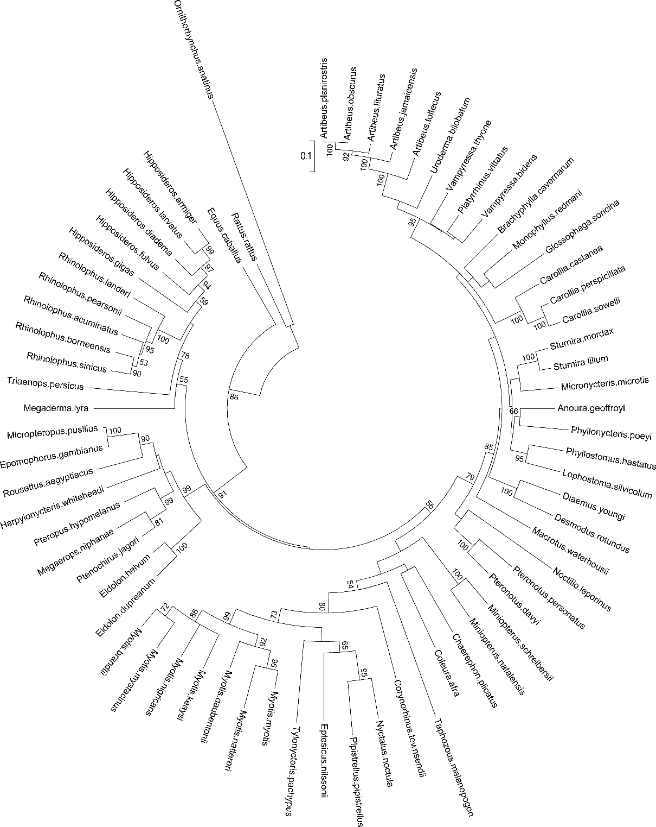
Fig. S1. Maximum likelihood (likelihood = -28954.11) phylogenetic tree of bat species using 1140 base pair sequences of the mitochondrial cytb gene aligned using MAFFT (Katoh and Standley, 2013). The tree was assembled in MEGA6 (Tamura et al., 2013) using the GTR+Γ+I substitution model with four gamma categories (Nei and Kumar, 2000). Node support values were estimated from 1000 bootstrap replicates; only support values ≥50% are shown.

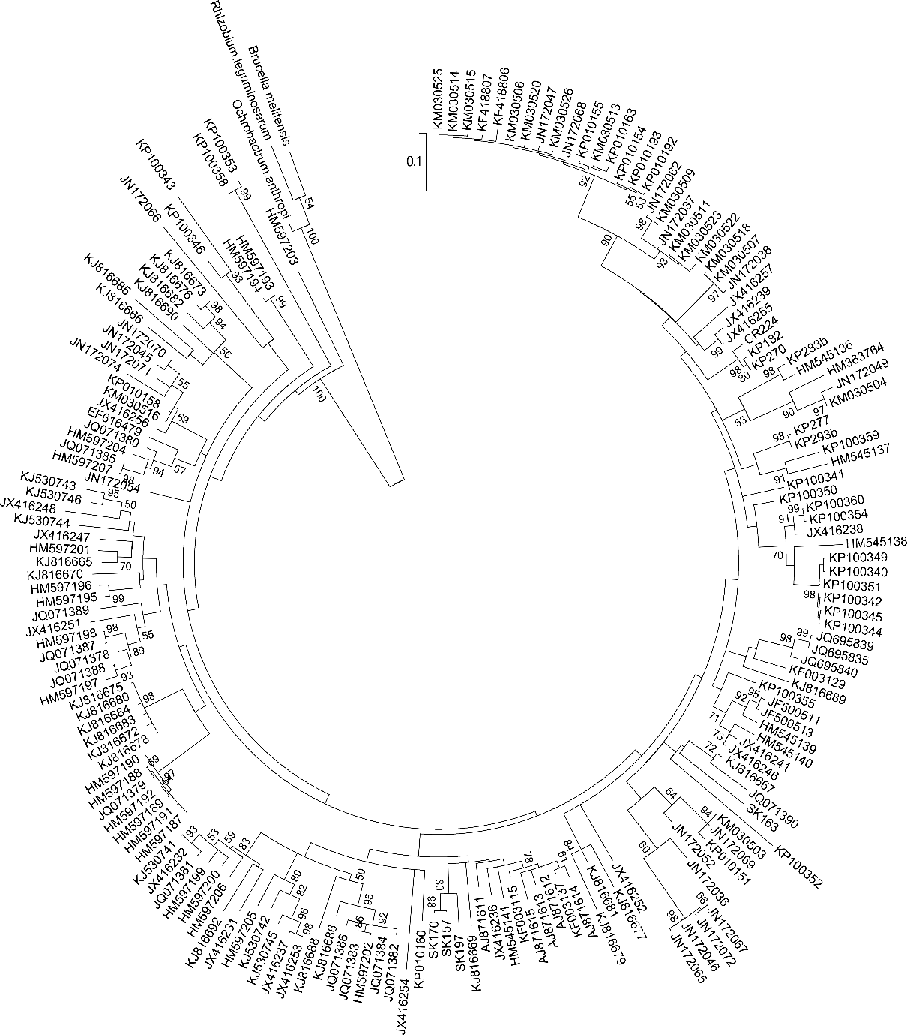
Fig. S2. Maximum likelihood (likelihood = -9839.48) phylogenetic tree of Bartonella genotypes using 333 base pair sequences of the genomic gltA gene aligned using MAFFT (Katoh and Standley, 2013). The tree was assembled in MEGA6 (Tamura et al., 2013) using the GTR+Γ+I substitution model with four gamma categories (Nei and Kumar, 2000). Node support values were estimated from 1000 bootstrap replicates; only support values ≥50% are shown.
Table S4. Global fit test results from ParaFit and PACo analyses. P-values were calculated from global fits (ParaFit and PACo) using 10000 permutations.
Test of cophylogeny (ML trees) |  |  | Test of sympatry (ML trees)
ParaFit |  |  | ParaFit
ParaFitGlobal | 12.07 |  | ParaFitGlobal | 70.42
p-value | 1E-05 |  | p-value | 1E-05
F1 statistics with p-value <0.05 | 157/186 |  | F1 statistics with p-value <0.05 | 146/186
F1 statistics with p-value <0.005 | 122/186 |  | F1 statistics with p-value <0.005 | 135/186
F1 statistics with p-value <0.001 | 96/186 |  | F1 statistics with p-value <0.001 | 125/186
PACo |  |  | PACo
m² global value | 8.11 |  | m² global value | 56.98
p-value | 1E-04 |  | p-value | 1E-04
Residuals below overall median | 93/186 |  | Residuals below overall median | 93/186
Number of outliers (>1.5xIQR) | 10 |  | Number of outliers (>1.5xIQR) | 5
Test of cophylogeny (Bayesian trees) |  |  | Test of sympatry (Bayesian trees)
ParaFit |  |  | ParaFit
ParaFitGlobal | 30.16 |  | ParaFitGlobal | 50.20
p-value | 1E-05 |  | p-value | 1E-05
F1 statistics with p-value <0.05 | 182/186 |  | F1 statistics with p-value <0.05 | 159/186
F1 statistics with p-value <0.005 | 180/186 |  | F1 statistics with p-value <0.005 | 152/186
F1 statistics with p-value <0.001 | 180/186 |  | F1 statistics with p-value <0.001 | 145/186
PACo |  |  | PACo
m² global value | 17.16 |  | m² global value | 53.13
p-value | 1E-04 |  | p-value | 1E-04
Residuals below overall median | 93/186 |  | Residuals below overall median | 93/186
Number of outliers (>1.5xIQR) | 8 |  | Number of outliers (>1.5xIQR) | 15
IQR – interquartile range.
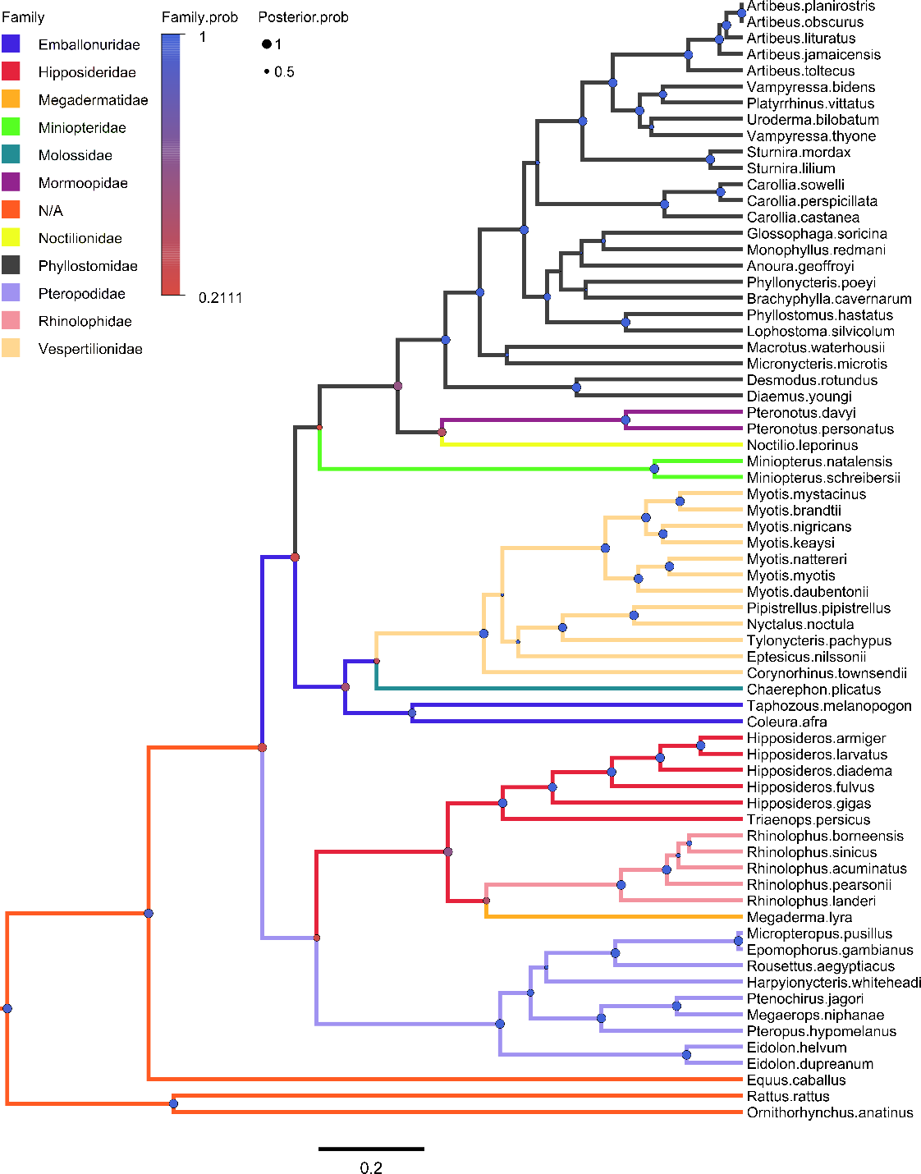
Fig. S3. Bayesian phylogeny of bat host species reconstructing bat families, shown by colored branches. Posterior probabilities for nodes are shown as circles (●) scaled by size from 0 to 1 (Posterior.prob) and colored by the support for the family at that node (Family.prob). Mean tree likelihood = -27928.95, ESS = 16066; mean family tree likelihood = -57.93, ESS = 15472.

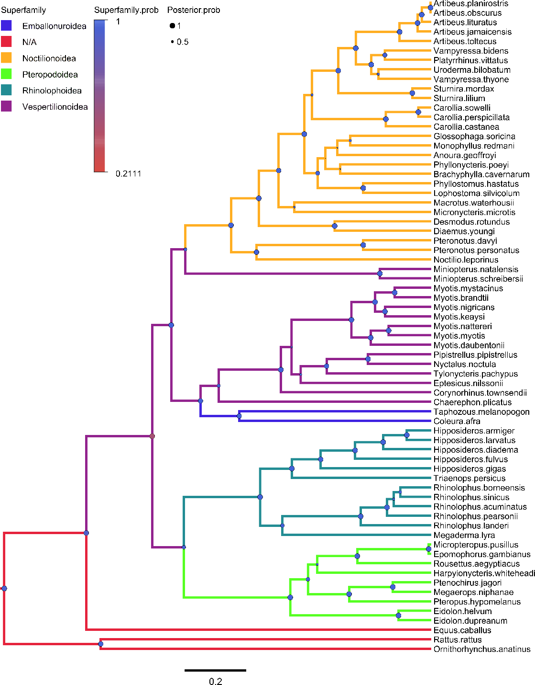
Fig. S4. Bayesian phylogeny of bat host species reconstructing bat superfamilies, shown by colored branches. Posterior probabilities for nodes are shown as circles (●) scaled by size from 0 to 1 (Posterior.prob) and colored by the support for the bat superfamily at that node (Superfamily.prob). Mean tree likelihood = -27928.95, ESS = 16066; mean superfamily tree likelihood = -30.75, ESS = 15199.

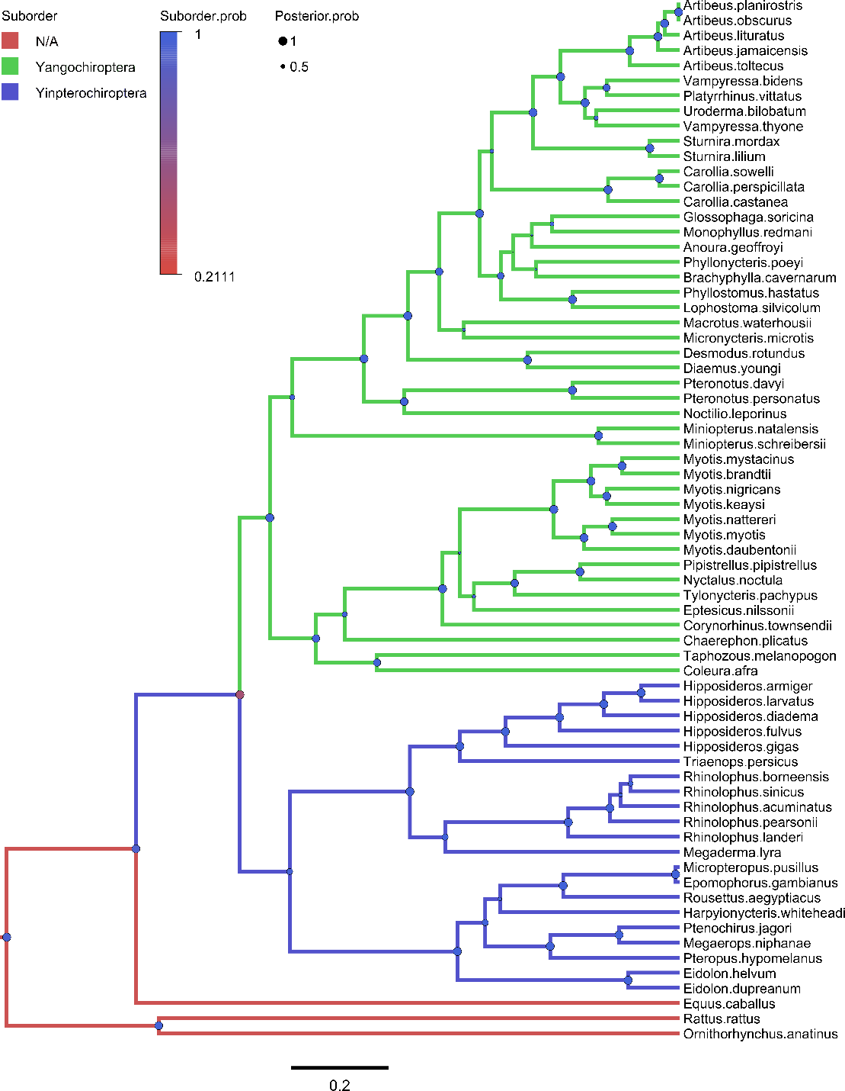
Fig. S5. Bayesian phylogeny of bat host species reconstructing bat suborders, shown by colored branches. Posterior probabilities for nodes are shown as circles (●) scaled by size from 0 to 1 (Posterior.prob) and colored by the support for the bat suborder at that node (Suborder.prob). Mean tree likelihood = -27928.95, ESS = 16066; mean suborder tree likelihood = -13.86, ESS = 15871.

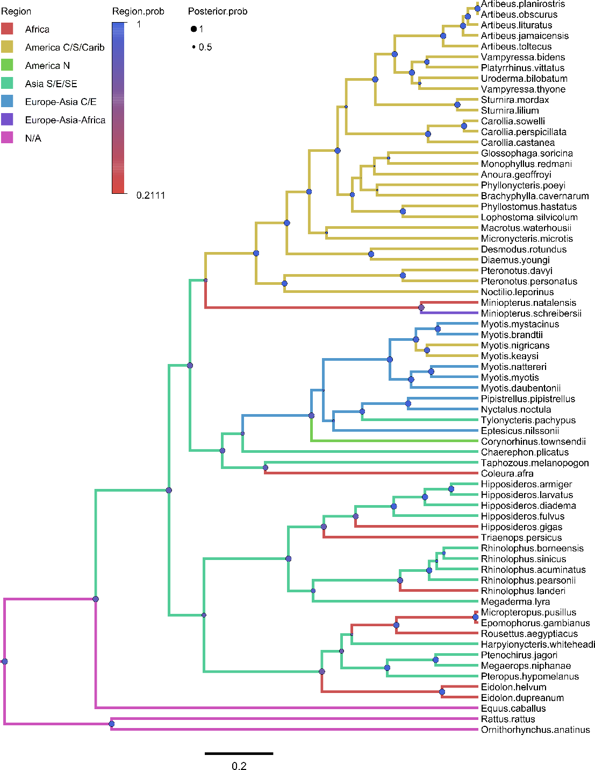
Fig. S6. Bayesian phylogeny of bat host species reconstructing bat geographic regions, shown by colored branches. Posterior probabilities for nodes are shown as circles (●) scaled by size from 0 to 1 (Posterior.prob) and colored by the support for the geographic region at that node (Region.prob). Note the geographic region represents where the bat host was captured, which may not reflect its total range. Mean tree likelihood = -27928.95, ESS = 16066; mean region tree likelihood = -60.51, ESS = 16166.
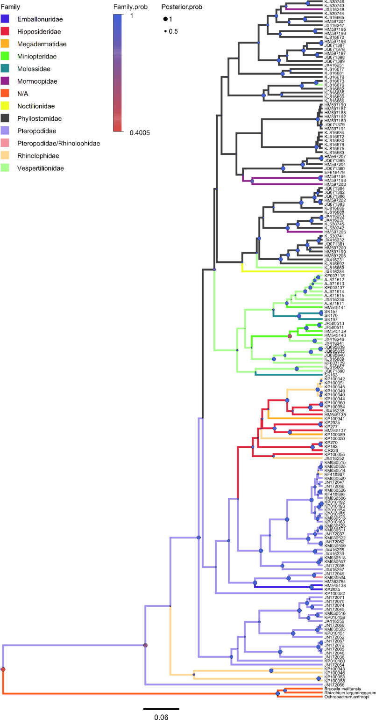
Fig. S7. Bayesian phylogeny of Bartonella genotypes reconstructing bat host families, shown by colored branches. Posterior probabilities for nodes are shown as circles (●) scaled by size from 0 to 1 (Posterior.prob) and colored by the support for the bat host family at that node (Family.prob). Mean tree likelihood = -9981.92, ESS = 2713; mean family tree likelihood = -125.52, ESS = 1028. Details on tip labels for Bartonella genotypes and associated host species are listed in Table S1 and S2.

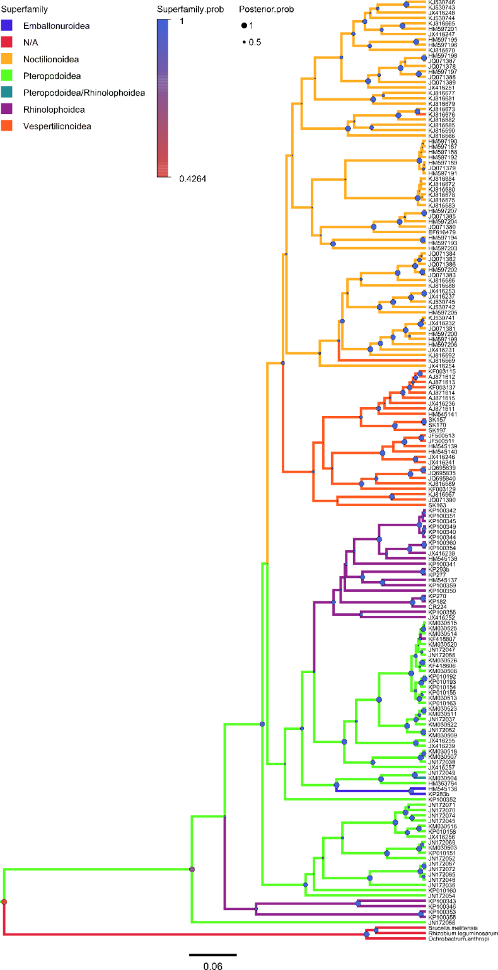
Fig. S8. Bayesian phylogeny of Bartonella genotypes reconstructing bat host superfamilies, shown by colored branches. Posterior probabilities for nodes are shown as circles (●) scaled by size from 0 to 1 (Posterior.prob) and colored by the support for the bat host suborder at that node (Superfamily.prob). Mean tree likelihood = -9981.92, ESS = 2713; mean superfamily tree likelihood = -60.36, ESS = 525. Details on tip labels for Bartonella genotypes and associated host species are listed in Table S1 and S2.

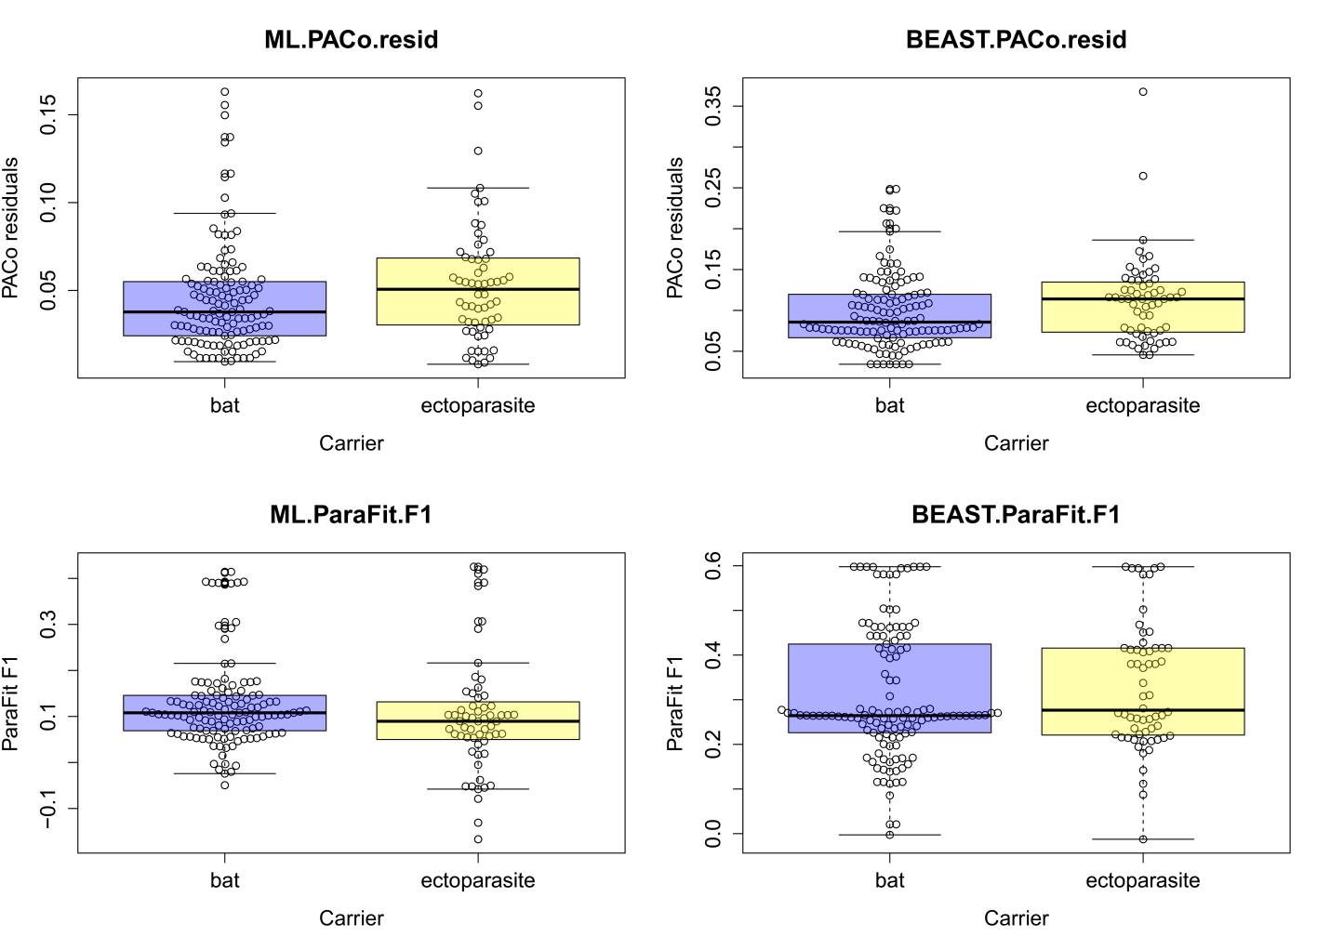
Fig. S9. Results of global fit comparisons based on analysis of host phylogeny and Bartonella genotypes, divided between genotypes found in bat hosts and ectoparasites. ML.PACo.resid – individual residuals from the PACo global fit using a maximum likelihood tree, BEAST.PACo.resid – individual residuals from the PACo global fit using a Bayesian tree, ML.ParaFit.F1 – F1 fit statistics from the ParaFit global fit using a maximum likelihood tree, BEAST.ParaFit.F1 – F1 fit statistics from the ParaFit global fit using a Bayesian tree.

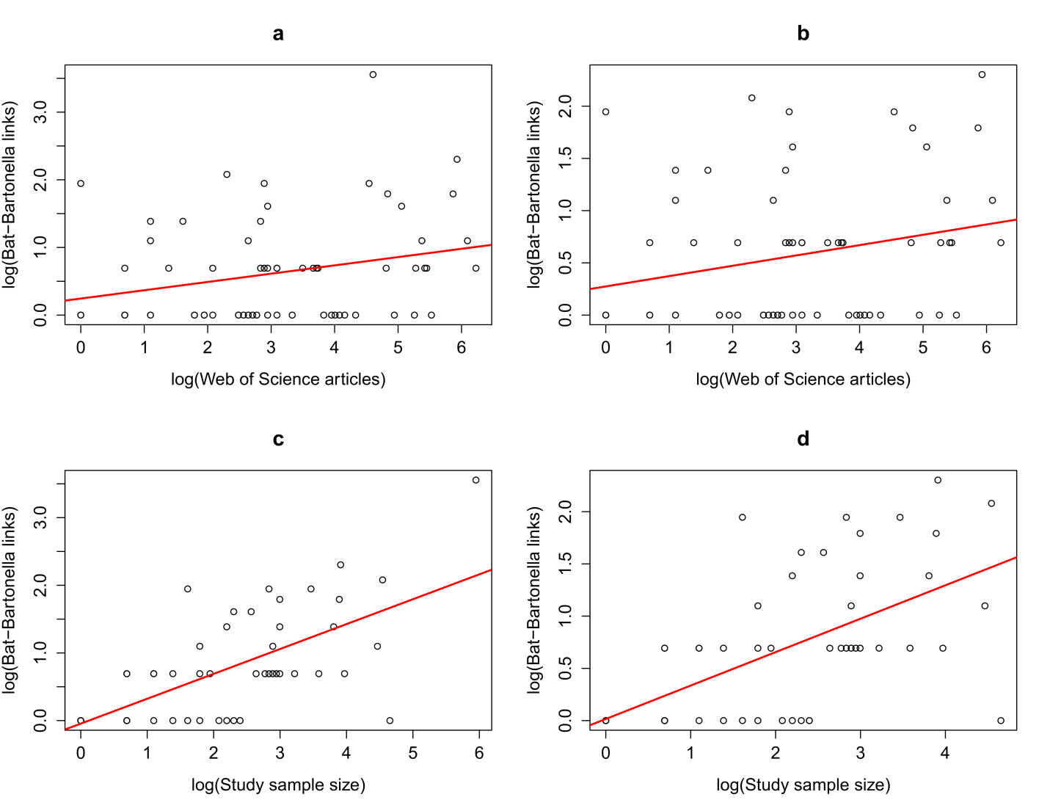
Fig. S10. Results of sampling bias tests for bat species and Bartonella genotypes. a) log-log correlation between the number of host-parasite links and Web of Science articles; b) log-log correlation between the number of host-parasite links and Web of Science articles, Eidolon helvum removed; c) log-log correlation between the number of links and individual species sample sizes; and d) log-log correlation between the number of links and individual species sample sizes, Eidolon helvum removed.
References
Agnarsson, I., Zambrana-Torrelio, C.M., Flores-Saldana, N.P., May-Collado, L.J., 2011. A time-calibrated species-level phylogeny of bats (Chiroptera, Mammalia). PLOS Curr. 3, RRN1212. doi:10.1371/currents.RRN1212
Anh, P.H., Van Cuong, N., Son, N.T., Tue, N.T., Kosoy, M.Y., Woolhouse, M.E., Baker, S., Bryant, J.E., Thwaites, G., Carrique-Mas, J.J., Rabaa, M.A., 2015. Diversity of Bartonella spp. in bats, southern Vietnam. Emerg. Infect. Dis. 21, 1266–1267. doi:10.3201/eid2107.141760
Bai, Y., Hayman, D.T., McKee, C.D., Kosoy, M.Y., 2015. Classification of Bartonella strains associated with straw-colored fruit bats (Eidolon helvum) across Africa using a multi-locus sequence typing platform. PLoS Negl. Trop. Dis. 9, e0003478. doi:10.1371/journal.pntd.0003478
Bai, Y., Kosoy, M.Y., Recuenco, S., Alvarez Castillo, D., Moran, D., Turmelle, A.S., Ellison, J., Garcia, D.L., Estevez, A., Lindblade, K., Rupprecht, C.E., 2011. Bartonella spp. in bats, Guatemala. Emerg. Infect. Dis. 17, 1269–1272. doi:10.3201/eid1707.101867
Bai, Y., Recuenco, S., Gilbert, A.T., Osikowicz, L.M., Gomez, J., Rupprecht, C.E., Kosoy, M.Y., 2012. Prevalence and diversity of Bartonella spp. in bats in Peru. Am. J. Trop. Med. Hyg. 87, 518–523. doi:10.4269/ajtmh.2012.12-0097
Billeter, S.A., Hayman, D.T., Peel, A.J., Baker, K.S., Wood, J.L., Cunningham, A.A., Suu-Ire, R.D., Dittmar, K., Kosoy, M.Y., 2012. Bartonella species in bat flies (Diptera: Nycteribiidae) from western Africa. Parasitology 139, 324–329. doi:10.1017/S0031182011002113
Brook, C.E., Bai, Y., Dobson, A.P., Osikowicz, L.M., Ranaivoson, H.C., Zhu, Q., Kosoy, M.Y., Dittmar, K., 2015. Bartonella spp. in fruit bats and blood-feeding ectoparasites in Madagascar. PLoS Negl. Trop. Dis. 9, e0003532. doi:10.1371/journal.pntd.0003532
Concannon, R., Wynn-Owen, K., Simpson, V., Birtles, R.J., 2005. Molecular characterization of haemoparasites infecting bats (Microchiroptera) in Cornwall, UK. Parasitology 131, 489–496. doi:10.1017/S0031182005008097
IUCN, 2014. The IUCN Red List of threatened species [WWW Document]. URL http://www.iucnredlist.org/
Judson, S., Frank, H., Hadly, E., 2015. Bartonellae are prevalent and diverse in Costa Rican bats and bat flies. Zoonoses Public Health 62, 609–617. doi:10.1111/zph.12188
Kamani, J., Baneth, G., Mitchell, M., Mumcuoglu, K.Y., Gutiérrez, R., Harrus, S., 2014. Bartonella species in bats (Chiroptera) and bat flies (Nycteribiidae) from Nigeria, West Africa. Vector-Borne Zoonotic Dis. 14, 625–632. doi:10.1089/vbz.2013.1541
Katoh, K., Standley, D.M., 2013. MAFFT multiple sequence alignment software version 7: improvements in performance and usability. Mol. Biol. Evol. 30, 772–780. doi:10.1093/molbev/mst010
Kosoy, M.Y., Bai, Y., Lynch, T., Kuzmin, I. V, Niezgoda, M., Franka, R., Agwanda, B., Breiman, R.F., Rupprecht, C.E., 2010. Bartonella spp. in bats, Kenya. Emerg. Infect. Dis. 16, 1875–1881. doi:10.3201/eid1612.100601
Lei, B.R., Olival, K.J., 2014. Contrasting patterns in mammal-bacteria coevolution: Bartonella and Leptospira in bats and rodents. PLoS Negl. Trop. Dis. 8, e2738. doi:10.1371/journal.pntd.0002738
Lin, J.-W., Hsu, Y.-M., Chomel, B.B., Lin, L.-K., Pei, J.-C., Wu, S.-H., Chang, C.-C., 2012. Identification of novel Bartonella spp. in bats and evidence of Asian gray shrew as a new potential reservoir of Bartonella. Vet. Microbiol. 156, 119–126. doi:10.1016/j.vetmic.2011.09.031
Morse, S.F., Olival, K.J., Kosoy, M.Y., Billeter, S.A., Patterson, B.D., Dick, C.W., Dittmar, K., 2012. Global distribution and genetic diversity of Bartonella in bat flies (Hippoboscoidea, Streblidae, Nycteribiidae). Infect. Genet. Evol. 12, 1717–23. doi:10.1016/j.meegid.2012.06.009
Nei, M., Kumar, S., 2000. Molecular evolution and phylogenetics. Oxford University Press, New York.
Olival, K.J., Dittmar, K., Bai, Y., Rostal, M.K., Lei, B.R., Daszak, P., Kosoy, M.Y., 2015. Bartonella spp. in a Puerto Rican bat community. J. Wildl. Dis. 51. doi:10.7589/2014-04-113
Tamura, K., Stecher, G., Peterson, D., Filipski, A., Kumar, S., 2013. MEGA6: molecular evolutionary genetics analysis version 6.0. Mol. Biol. Evol. 30, 2725–2729. doi:10.1093/molbev/mst197
Teeling, E.C., Madsen, O., Van den Bussche, R.A., de Jong, W.W., Stanhope, M.J., Springer, M.S., 2002. Microbat paraphyly and the convergent evolution of a key innovation in Old World rhinolophoid microbats. Proc. Natl. Acad. Sci. 99, 1431–1436. doi:10.1073/pnas.022477199
Veikkolainen, V., Vesterinen, E.J., Lilley, T.M., Pulliainen, A.T., 2014. Bats as reservoir hosts of human bacterial pathogen, Bartonella mayotimonensis. Emerg. Infect. Dis. 20, 960–967. doi:10.3201/eid2006.130956
Wilson, D., Reeder, D.M., 2005. Mammal species of the world: a taxonomic and geographic reference. Smithsonian Institution Press, Washington, D.C.

