Supplementary Materials for:

NIOSH Field Studies Team Assessment: Worker Exposure to Aerosolized Metal Oxide Nanoparticles in a Semiconductor Fabrication Facility

Authors
Sara A. Brenner, MD, MPH;¹* Nicole M. Neu-Baker, MPH;¹ Adrienne C. Eastlake, MS, REHS/RS;² Catherine C. Beaucham, MPH, CIH;² and Charles L. Geraci, PhD, CIH.²

*Corresponding author: Sara A. Brenner, MD, MPH; sbrenner@sunypoly.edu; p: (518) 956-7224; f: (518) 437-8687. State University of New York (SUNY) Polytechnic Institute, College of Nanoscale Science, Nanobioscience Constellation, 257 Fuller Road, Albany, New York 12203, United States.

Affiliations
¹State University of New York (SUNY) Polytechnic Institute, College of Nanoscale Science, Nanobioscience Constellation, 257 Fuller Road, Albany, New York, 12203, United States.

²National Institute for Occupational Safety and Health, 1090 Tusculum Avenue, Cincinnati, Ohio, 45226, United States.

Detailed DRI information:

Three real-time, field-portable, direct-reading instruments (DRIs) were used to characterize process emissions by determining the number or mass concentration and approximate size ranges of airborne particles. The first instrument used was a TSI model 3007 (TSI, Inc, Shoreview, MN) handheld condensation particle counter (CPC). The CPC operates by drawing air through a size-selective inlet, passing it through a heated saturator filled with isopropyl alcohol, and then cooling the air stream via a condenser chamber. In the condenser, the alcohol vapor condenses on the particles that serve as condensations nuclei and adsorb vapor until each particle is approximately 10µm in diameter. These larger particles then pass through an optical detector where they are counted. This process allows the CPC unit to count particles in the size range of 10nm-1,000nm. The data output is expressed as total number of particles per cubic centimeter (cc) of sampled air with an upper dynamic range limit of approximately 100,000 particles per cc of air (p/cc).
The second instrument, an optical particle counter (OPC; Model HHPC-6, ART Instruments, Grants Pass, Oregon), was used to determine the number concentration of particles and the size distribution at six specific size cutpoints: 300nm; 500nm; 1,000nm; 3,000nm; 5,000nm, and 10,000nm. The OPC is based on optical counting principles using laser light scattering. A light source illuminates a sample volume of aerosol and a photodetector measures the amount of light refracted by individual particles. The OPC was designed for classifying cleanrooms in accordance with specific cleanroom standards, which require counting efficiency for the 300nm bin to be at least 50%. Other potential real-world interferences include background particle interference, particle shape or refractive index (OPCs are calibrated with ideal particles having a refractive index between 1.5 and 1.6), and contamination from elements, such as aluminum.⁽²⁶⁾
The DustTrak DRX™ Aerosol Monitor (Model 8533; TSI, Inc., Shoreview, MN) was used to simultaneously measure mass and size fraction of airborne particulate using laser light scattering. The sampled air passes through a chamber illuminated by a laser light. Light scattered by particles is measured at 90º using a solid-state silicon photodetector. The intensity of the scattered light is a function of the particle mass concentration, the size distribution of the aerosol, and the composition of the aerosol drawn. This instrument was used to estimate the aerosol mass concentration of particulate less than 15,000nm in aerodynamic diameter. It should be noted that aerosol photometers provide estimates based upon assumed density and particle size distributions. According to the manufacturer, this instrument will respond to particles in the size range of 100nm to approximately 15,000nm and aerosol mass concentrations ranging from 1 to 150,000µg/m³. However, detector sensitivity is lower for particles smaller than 250nm diameter and the instrument efficiency in measuring fiber-like aerosols is less than that obtained when sampling an aerosol composed of spherical particulate.

The impact of a DRI encountering an ENM particle released in a liquid phase aerosol versus a free solid airborne ENM particle is not known. Based on this, NFST investigators assumed all the DRIs would respond to a slurry aerosol as airborne particles. All areas evaluated with DRIs had very low particle counts. Peaks that occurred during the tasks evaluated were no more than one order of magnitude greater than the average background concentration. DRIs cannot specifically identify the ENM of interest, but instead count all particles within each instrument’s specific range.

FIGURE 1S. TEM images of nanoparticles used in CMP slurries
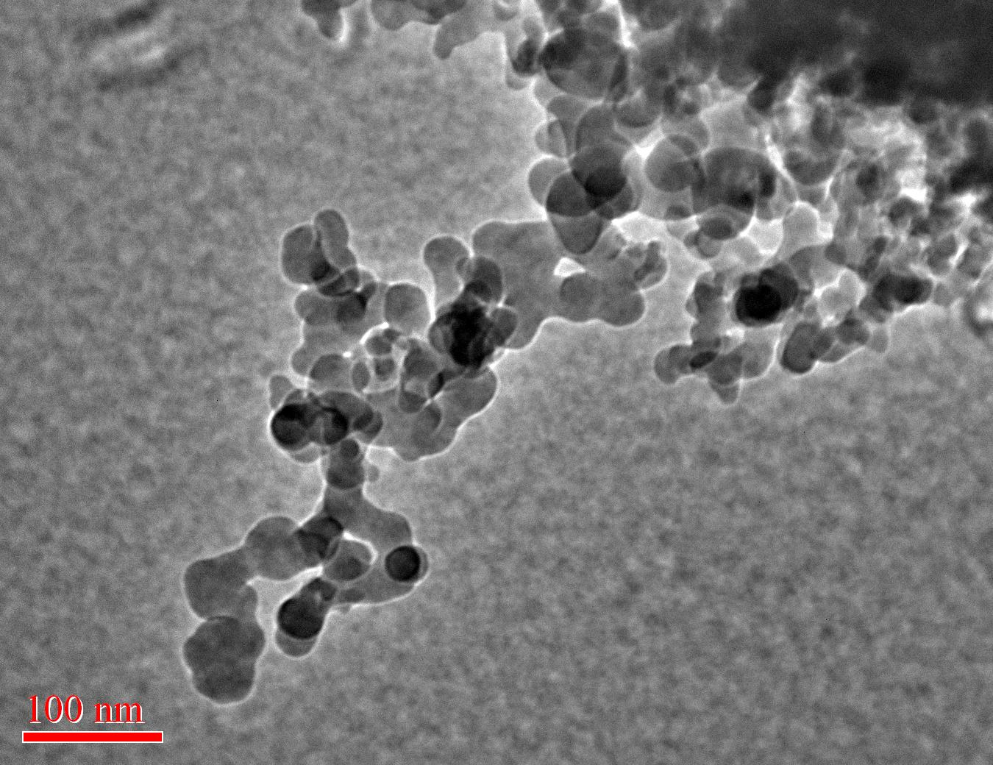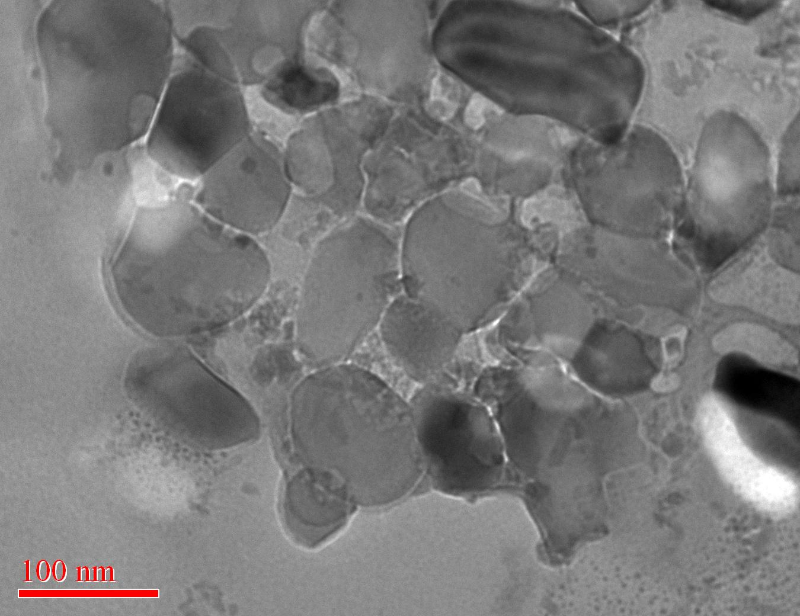
a
b
a) Amorphous silica nanoparticles found in slurry. b) Alumina nanoparticles found in slurry. Scale bars = 100nm.

FIGURE 2S. Particle concentration in wastewater treatment during pre-filter change on acid and base system as indicated by condensation particle counter on April 19, 2011.

FIGURE 3S. Particle concentration in wastewater treatment during filter bag change-out as indicated by condensation particle counter on April 20, 2011.

FIGURE 4S. Particle concentration in the subfab as indicated by condensation particle counter on April 20, 2011.

Note peak in background concentration that occurred after completion of evaluated task.

FIGURE 5S. Particle concentration in the subfab as indicated by condensation particle counter on April 21, 2011.

Vertical black lines indicate when the cabinet was opened and closed during the slurry purging and replenishing task.

FIGURE 6S. Respirable fraction of particulate in the subfab as indicated by DustTrak™ on April 21, 2011.

FIGURE 7S. Particle concentration in the cleanroom as indicated by condensation particle counter on April 20, 2011.

