SUPPLEMENTAL FIGURE 1. Antihypertensive medication (AHM) nonadherence* among Medicare Part D beneficiaries aged ≥65 years, by state and territory — United States, 2014
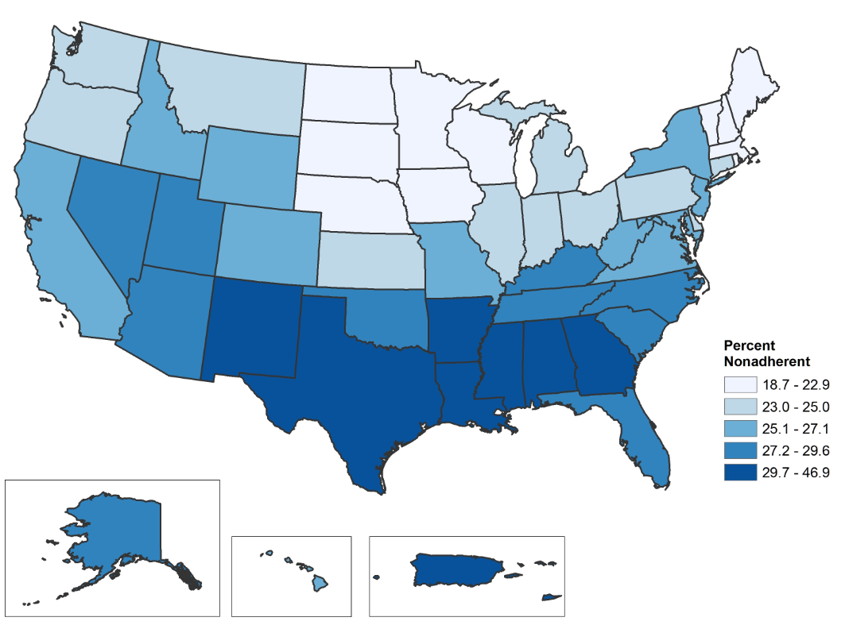
* Nonadherence is defined as patients not following their health care professional’s instructions concerning taking their prescribed medication. Using the proportion of days covered methodology, beneficiaries were considered nonadherent if they had access to AHM for <80% of the days from the date of their first AHM fill through the end of 2014 or until their death in 2014.
Source: Centers for Medicare and Medicaid Services Chronic Conditions Data Warehouse

