Electronic Supplementary Information for

Cell-free compartmentalized protein synthesis inside double emulsion templated liposomes with in vitro synthesized and assembled ribosomes

Filippo Caschera^{1*}, Jin Woo Lee^{2*}, Kenneth K. Y. Ho², Allen P. Liu², Michael C. Jewett¹
*These authors contributed equally to this work

1) Department of Chemical and Biochemical Engineering, Chemistry of Life Processes Institute, Simpson Querrey Institute, Northwestern University, Evanston, 60208, Illinois, United States of America.

2) Department of Mechanical Engineering, University of Michigan, Ann Arbor, 48109, Michigan, United States of America.

Corresponding authors: allenliu@umich.edu; m-jewett@northwestern.edu

Supplementary Information

1. Materials and Methods: Materials, S150 extract preparation, reaction buffer component final concentrations in iSAT, feeding outer solution component composition and concentrations, iSAT reaction preparation for well-plate reader, single emulsion preparation and iSAT encapsulation, doubled emulsion templated liposome preparation and iSAT reaction encapsulation, microscope set-up and image analysis method.

2. Figure S1. Time course of iSAT system in test tube.

3. Figure S2. Time course of iSAT system in emulsion.

4. Figure S3. Yield of liposomes over time

5. Figure S4. Additional images of liposomes expressing sfGFP

1. Materials and Methods

Materials: All chemicals used to prepare the iSAT system extracts and ribosomal parts (NH₄Cl, MgCl₂, EDTA, DTT, sucrose, Tris-OAc, Tris-HCl, Mg(OAc)₂, NH4(OAc), K-OAc, K-Glu, spermidine putrescine, HEPES, urea, acetone, and glacial acetic acid) were purchased from Sigma-Aldrich USA. The chemicals used to prepare the reaction buffer and the outer feeding solution to energize the iSAT system (ATP, GTP, UTP, CTP, folinic acid, tRNA, NAD, CoA, amino acids, K-oxalate, phosphoenolpyruvate (PEP), PEG6000, and dithiobutylamine (DTBA)) were purchased from Sigma-Aldrich USA. The plasmids used in this work: pJL1-sfGFP and pT7Op WT (1,2) were amplified in E. coli using standard mini and midi-prep procedures (Qiagen). The T7 RNA polymerase (0.8 mg/mL) to enable in vitro transcription was overexpressed in E. coli BL21, purified using affinity chromatography, and stored at -80°C in glycerol (1,2). The following material was used to prepare emulsions and liposomes: Poly(vinyl alcohol) MW 13,000-23,000, 87-89% hydrolyzed (PVA) (Sigma-Aldrich), UltraPure DNAse/RNase free water (Life Technologies), 1,2-dioleoyl-sn-glycero-3-phosphocholine (DOPC) (Avanti), 1-palmitoyl-2-oleoyl-sn-glycero-3-phosphocholine (POPC) (Avanti), Cholesterol (Chol) (Avanti), 1,2-dipalmitoyl-sn-glycero-3-phosphoethanolamine-N-(lissamine rhodamine B sulfonyl) (Rho-PE) (Avanti).

S150 extract preparation: The crude extract deprived of native E. coli ribosomes (termed S150 extract), and the purified total proteins of the 70S ribosomal particle (TP70) were prepared as previously described (1,2) with only a minor modification. Specifically, MRE600 cells were grown in 2xYTP medium (no glucose). The total protein concentration of the crude extract used in this work was ≈ 4 mg/mL determined through Bradford assay. The S150 extract and TP70 were stored in small aliquots at -80°C.

Reaction buffer component final concentrations in iSAT: 1.2 mM ATP, 0.85 mM GTP, 0.85 mM UTP, 0.85 mM CTP, 34 µg/µL folinic acid, E. coli tRNA 171 µg/mL, 10 mM Mg-Glu, 200 mM K-Glu, 10 mM NH₄-Glu, 3 mM of each amino acid, 0.33 mM NAD, 0.27 mM CoA, 4 mM K-oxalate, 1.5 mM spermidine, 1 mM putrescine, 42 mM PEP, 2% (v/v) PEG6000, 2 mM DTBA, 26 mM HEPES buffer pH 8. For each component, stock solutions were prepared and stored separately at -80°C.

Feeding outer solution component composition and concentrations: 2.4 mM ATP, 1.7 mM GTP, 1.7 mM UTP, 1.7 mM CTP, 6 mM of ach amino acid, 0.66 mM NAD, 0.54 CoA, 8 mM K-oxalate, 4 mM spermidine, 3 mM putrescine, 84 mM PEP, 4 mM DTBA, 20 mM Mg(OAc)₂, 40 mM NH₄OAc, 60 mM KOAc, 400 mM K-Glu, 2 mM DTT and 20 mM TrisOAc, pH 7.5. All the chemicals were mixed together making the outer feeding solution, and small aliquots were stored at -80°C.

iSAT reaction preparation for well-plate reader: Three 15 µL of iSAT reactions were prepared, which consist of 1.2 mM ATP, 0.85 mM GTP, 0.85 mM UTP, 0.85 mM CTP, 34 µg/µL folinic acid, E. coli tRNA 171 µg/mL, 10 mM Mg-Glu, 200 mM K-Glu, 10 mM NH₄-Glu, 3 mM of each amino acid, 0.33 mM NAD, 0.27 mM CoA, 4 mM K-oxalate, 1.5 mM spermidine, 1 mM putrescine, 42 mM PEP, 2 mM DTBA, 26 mM HEPES pH 8, 2% Poly(vinyl alcohol) Mw 13,000-23,000, 87-89% hydrolyzed (PVA) (Sigma-Aldrich), 4nM pJL1-sfGFP, 4nM pT7Op WT, 6μL S150 extract, 300 nM TP70, 0.6 μL T7 RNAP. Expression of sfGFP signal at 37°C was measured using a Biotek Synergy H1 plate reader (λ_{ex} = 482 nm, λ_{em} = 512 nm).

Single emulsion preparation and iSAT encapsulation: 15 µL of iSAT reaction was prepared in the same manner as in the well-plate reader experiment and 2 µL of iSAT reaction was mixed into 100 µL of an oil solution that consists of mineral oil and 2% Span80 (Sigma-Aldrich). Single emulsions were generated by vortexing the solution at medium power for approximately 3 seconds using a bench-top mini-vortexer.

Doubled emulsion templated liposome preparation and iSAT reaction encapsulation: The iSAT reaction was prepared similarly as in the well-plate reader experiment. We dissolved PVA into UltraPure water to a concentration of 10 % (w/v) by stirring the solution at 70 degrees Celsius overnight. The PVA solution was filtered (0.45 µm) to remove any debris. We prepared 12 mM lipid solution by mixing 69.5 % DOPC or POPC, 30 % Chol, 0.5 % Rho-PE in a glass tube, drying lipids by evaporating chloroform using Argon gas followed by desiccating under vacuum, and rehydrating the lipids in 1mL of volatile solvent (36 % chloroform and 64 % hexane). The ultra-thin double emulsion device was prepared as previously described (3). Borosilicate glass capillaries (B100-58-10 from Sutter Instrument) were pulled using Model P-87 flaming/brown micropipette puller from Sutter with settings pull = 0, velocity = 10 and ramp = +5 to generate tapered capillaries. The tapered ends of the glass capillaries were then sanded down to diameters of 120μm and 160μm for injection and the collection capillaries, respectively. The injection capillary was treated with silane (Sigma) for 1 hour to create hydrophobic surface. The excess silane was removed with compressed air after the treatment. The injection and collection capillaries were inserted into a square capillary from each side with the tapered ends facing each other. The two tips were aligned under an optical microscope at 10X magnification with 70μm space in between the tips and glued using 5 minutes epoxy. We prepared inner phase round capillary above a fire to form long and thin pipette. The outer diameter of the inner phase capillary should be about 200 μm. It was then inserted to the back of the injection capillary and glued with 5 minute epoxy. The inner phase flowed through the inner phase round capillary, the middle phase flowed in to the injection capillary and the outer phase was inserted through the square capillary. The inner phase composed of the iSAT mixture with 2% PVA, middle phase of phospholipid dissolved in volatile solvent, and outer phase of 10% PVA. Flow rates of 200μL/h inner phase, 200 μL/h middle phase, and 2400μL/h outer phase were used. Once the ultra-thin double emulsions were generated, the solution was mixed with either the feeding solution with 100 mM sucrose or buffer solution that includes iSAT dialysis solution (10 mM Tris-OAc pH 7.5, 10 mM Mg(OAc)₂, 20 mM NH4(OAc), 30 mM K-OAc, 200 mM K-Glu, 1 mM spermidine, 1 mM putrescine, 1 mM DTT) and 200 mM sucrose. The mixed solution was placed in 37 ˚C for solvent evaporation and protein expression. The osmolarities of the final inner phase and outer phase were measured using 5600 Vapro Vapor Pressure Osmometer (ELITechGroup).

Microscope set-up and image analysis method: Spinning disc confocal (CSU-X1) microscope (Olympus IX81) with 20X objective lens was used to image the liposomes with excitation at 488 nm and 561 nm wavelength lasers every 30 minutes. After capturing the images, ImageJ was used to analyze the average intensity of the GFP inside the liposome with background subtraction to calculate the fluorescence intensity.
Supplementary Figures
Figure S1: Time course of iSAT system in test tube

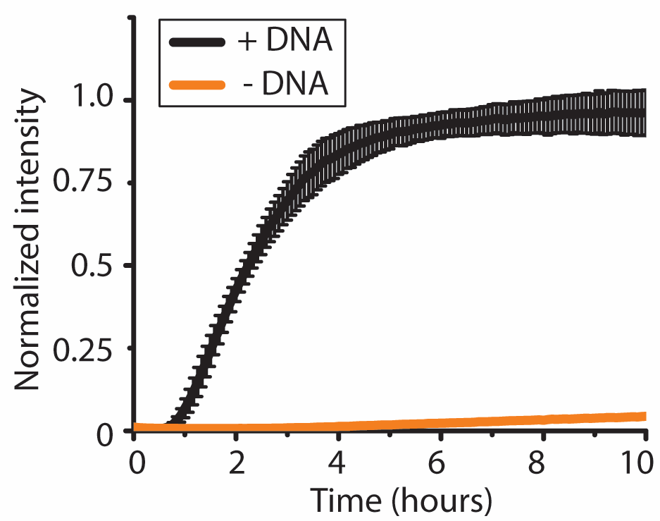

Supplementary Figure 1. sfGFP expression of bulk iSAT solution over 10 hours at 37˚C measured by a plate reader using λ_{ex} = 482 nm and λ_{em} = 512 nm (n=3). The final sfGFP expression titer was 3.3+/- 0.26μΜ.

Figure S2: Time course of iSAT system in emulsion.

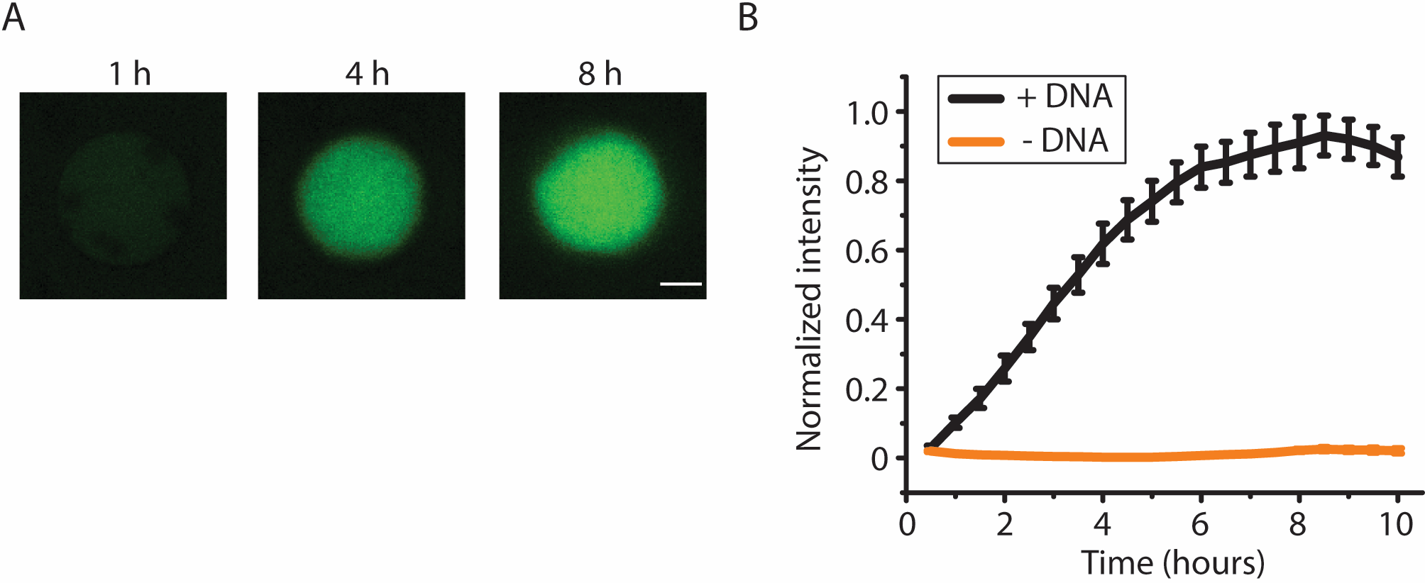

Supplementary Figure 2. (A) Confocal images of iSAT expressing sfGFP in single emulsions at 37˚C (scale = 20 µm). (B) Kinetics of iSAT expressing sfGFP in single emulsions over 10 hours. Average size is 67.3 µm with standard error 3.4 µm (n=3). The yield of sfGFP is 510 nM +/- 60nM. The time course of protein synthesis was determined using spinning disk confocal microscopy. The micrographs were analyzed using image analysis software ImageJ. The final sfGFP expression titer was 0.51 +/- 0.06 μΜ.

Figure S3: Yield of liposomes over time

Supplementary Figure 3. Percent of liposomes that do not burst over 15 hours of incubation at 37˚C. Approximately 30% of liposomes are left after 15 hours. (n = 128). Combinations of DOPC, +DNA, with and without feeding solution as well as POPC, +DNA, with and without feeding solution were used to calculate the yield.

Figure S4: Additional images of liposomes expressing GFP

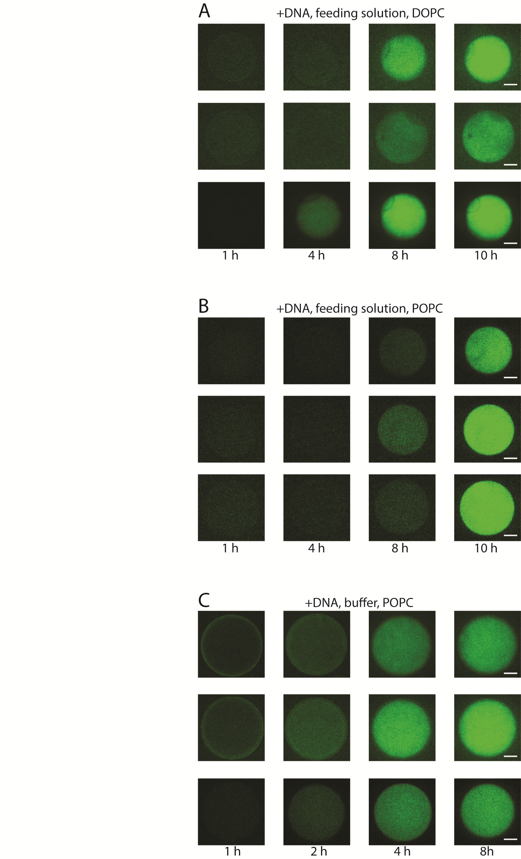
Supplementary Figure 4. (A) Confocal images of iSAT with sfGFP encapsulated in liposomes using 12 mM lipid consisting DOPC/cholesterol/Rhod-PE (referred to as DOPC liposomes) at 69.5/30/0.5 ratio with feeding solution on the outside (scale = 20 µm) (B) Confocal images of iSAT with sfGFP encapsulated in liposomes using 12 mM lipid consisting POPC/cholesterol/Rhod-PE (referred to as POPC liposomes) at 69.5/30/0.5 ratio lipids with feeding solution on the outside (scale = 20 µm). (C) buffer on the outside (scale = 20 µm).

References

1.Fritz, B.R., O.K. Jamil, and M.C. Jewett. 2015. Implications of macromolecular crowding and reducing conditions for in vitro ribosome construction. Nucleic acids research 43:4774-4784.
2.Fritz, B.R. and M.C. Jewett. 2014. The impact of transcriptional tuning on in vitro integrated rRNA transcription and ribosome construction. Nucleic acids research 42:6774-6785.
3. Ho, K.K.Y.*, V.L. Murray*, and A.P. Liu. 2015. Engineering artificial cells by combining HeLa-based cell free expression and ultrathin double emulsion template. Methods in Cell Biology volume 128, Chapter 16, 303-318.

