**SUPPLEMENTARY MATERIALS AND METHODS**

*Construction of standard curve for ST nested qPCR*

 The 249-bp ST nested qPCR target amplicon was cloned into the pCR®2.1-TOPO vector using a TOPO®TA Cloning® Kit. Plasmids were sequenced, linearized with HindIII, and used to construct standard curves. Copy number or grams/molecule (g/molecule) was calculated by:

Serial dilutions were made so that copies/tube of the standards ranged from 6.8 x 105 to 6.8 x 100.

*Sanger sequencing*

Amplified ST nested qPCR products were treated with ExoSAP-IT (Affymetrix) to remove unconsumed dNTPs and primers/probes. Sequencing reactions were performed with a BigDye Terminator v3.0 Ready Reaction Cycle Sequencing Kit (Applied Biosystems). The electrophoretic profiles of sequences were analyzed using BioEdit Sequence Alignment Editor version 7.2.5.

**SUPPLEMENTARY FIGURES AND FIGURE LEGENDS**

**Supplementary Figure 1**

**A**



**B**



**Supplementary Figure 1.** Construction of standard curve for ST nested qPCR. A standard curve of reactions ranging 6.8 x 105 to 6.8 x 100 copies/tube was generated using a plasmid containing the amplicon from the ST nested qPCR assay. (A) Amplification curves are shown. NTC was undetected. (B) Standard curve shown with the number of copies of plasmid DNA per reaction on the x-axis and corresponding Ct value on the y-axis. Pearson’s correlation coefficient (R), coefficient of determination (R2), efficiency, slope and y-intercept of the linear regression line are shown.

**Supplementary Figure 2**

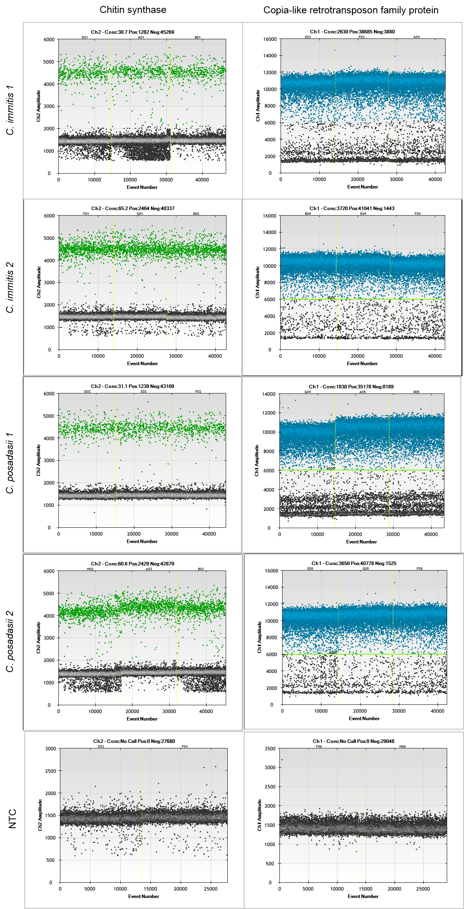

**Supplementary Figure 2.** Copy number estimation of gene used for detection by ddPCR. Copy number concentration (averaged from triplicates) of both a single-copy gene (chitin synthase; left panels, positive droplets in green and negative droplets in black) and the target gene (copia-like retrotransposon family protein; right panels, positive droplets in blue and negative droplets in black) was calculated. ddPCR plots for two *C. immitis* isolates (*C. immitis* 1 and *C. immitis* 2) and two *C. posadasii* isolates (*C. posadasii* 1 and *C. posadasii* 2) are shown. Non-template control (NTC) is shown bottom row.

**Supplementary Figure 3**



**Supplementary Figure 3.** Sequence of amplification product from air/dust samples positive for *Coccidioides*. Samples High 5 and High 6 were sequenced using Sanger sequencing. Sequences are aligned and compared with a part of the amplicon from the target gene used for *Coccidioides* detection. (.) indicates a nucleotide match and (-) indicates a missing or uncalled nucleotide.

**SUPPLEMENTARY TABLE AND TABLE LEGEND**

|  |  |
| --- | --- |
| Primer | Sequence |
| Outer  Forward 1 (OF 1) |  | |
| GGC GAA ACG GAG CTA AGC CTA AA | |
| Reverse 1 (OR 1) | GGA ATG ATG GAG GAC TTG TAT GCT TGT | |
| Reverse 2 (OR 2) | GGA ATG ATG GAG GAC TCG TAT GCT TGT | |
| Reverse 3 (OR 3) | GGA ATG ATG GAG GAC TTG TAC ACT TGT | |
| Reverse 4 (OR 4) | GGA ATG ATG GAG GAA TTG TAT GCT TGT | |
| Inner  Forward 1 (IF 1) |  | |
| AGG TAA TCC AAC TAG CA | |
| Forward 2 (IF 2) | AGG TAG TCC AAC TAG CA | |
| Forward 3 (IF 3) | AGG TAA TCC AAC CAG CA | |
| Reverse 1 (IR 1)  Probe | GTC ATT CAC TAA GCT ACC  6FAM-ACCCACATAGATTAGC-MGB-NFQ | |
|  |  | |
| Forward (Chi. Syn.) | GCTCTCGGACAAACAGTAAG | |
| Reverse (Chi. Syn.) | GCGTCCGTGGATTGATTT | |
| Probe (Chi. Syn.) | 6VIC-AGGAAGCGTGGAAGAAGATTGTCG-MGB-NFQ | |

**Supplementary Table.** Primer/probe sequences for ST nested qPCR assay and for the chitin synthase ddPCR assay.