Supplementary Information

**LIMONENE OZONOLYSIS IN THE PRESENCE OF NITRIC OXIDE: GAS-PHASE REACTION PRODUCTS AND YIELDS**

Jason E. Ham, Joel C. Harrison, Stephen R. Jackson, and J. R. Wells*

*Exposure Assessment Branch, Health Effects Laboratory Division,*

*National Institute for Occupational Safety and Health,*

*1095 Willowdale Road*

*Morgantown, WV 26505*

*Corresponding Author. Tel.: 1-304-285-6341; Fax: 1-304-285-6041

*E-mail address*: ozw0@cdc.gov

**Keywords:** ozone, reaction products, oxygenated organic compounds, derivatization

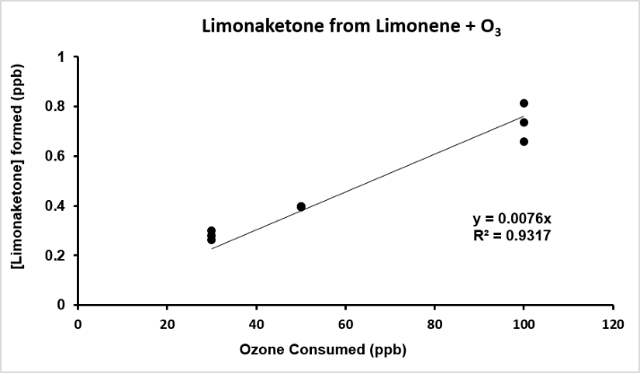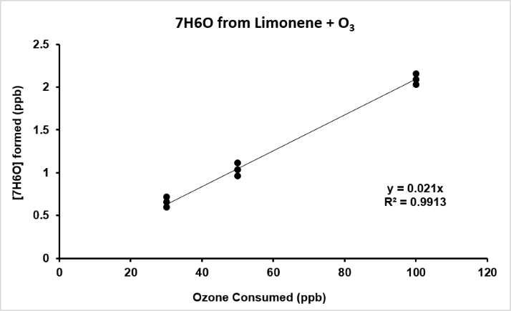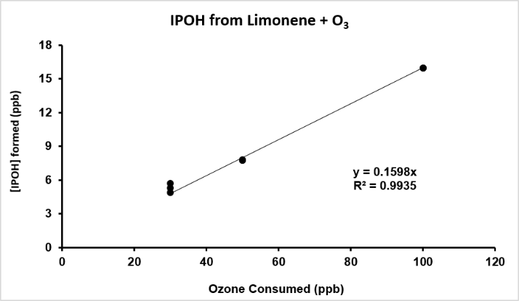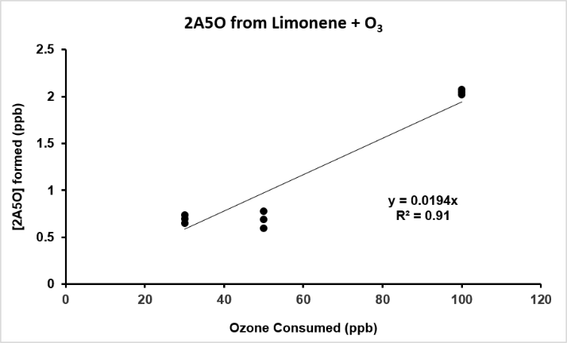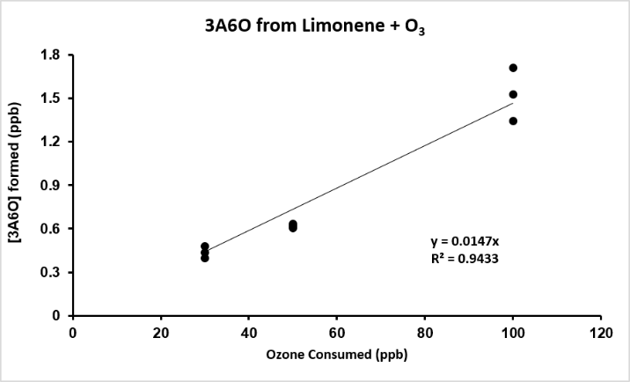

**A**

**C**

**B**

**D**

**E**

**Figure S1.** Yield plots from limonene + O3 experiments A) limonaketone, B) 7H6O, C) IPOH, D) 2A5O, and E) 3A6O.

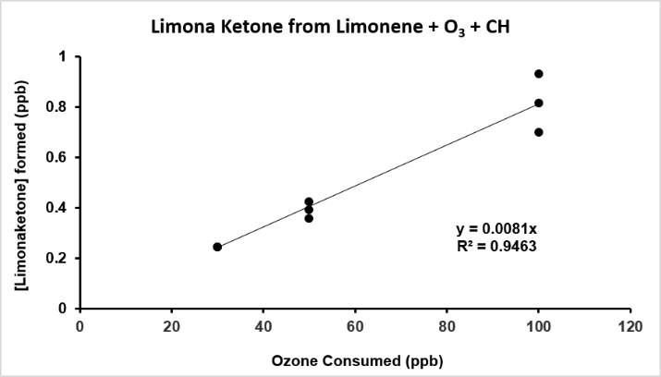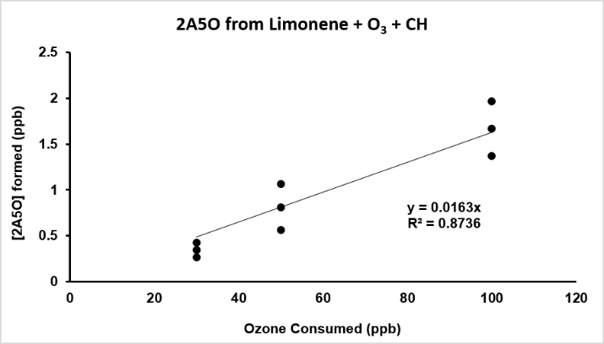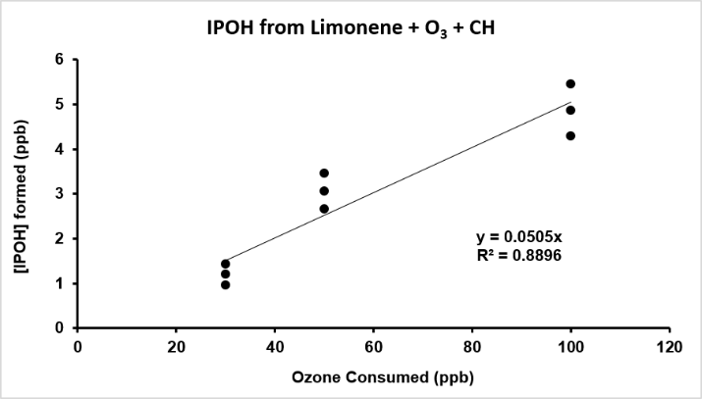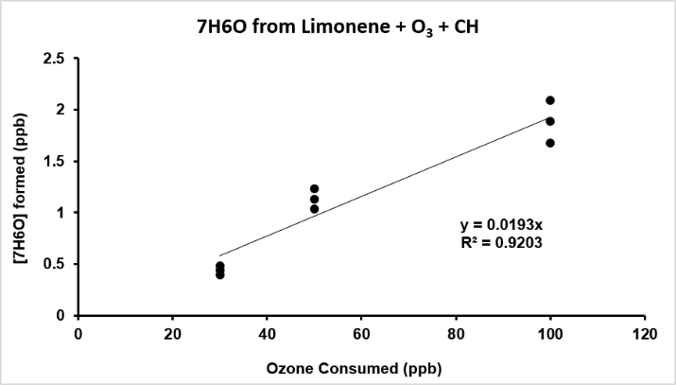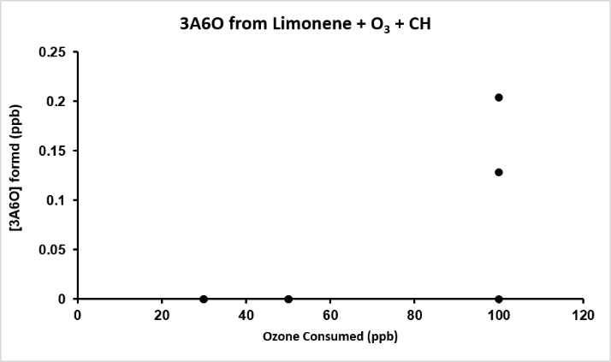

**A**

**C**

**B**

**D**

**E**

**Figure S2.** Yield plots from limonene + O3 + CH experiments A) limonaketone, B) 7H6O, C) IPOH, D) 2A5O, and E) 3A6O.

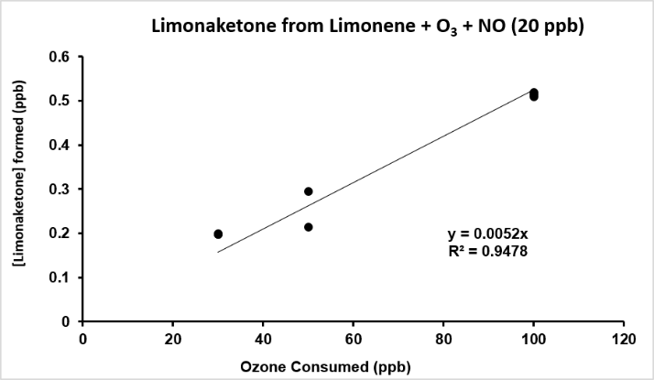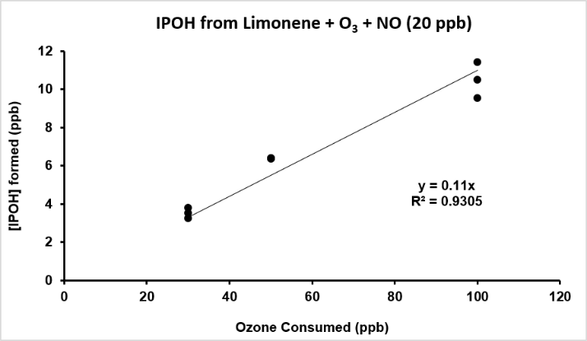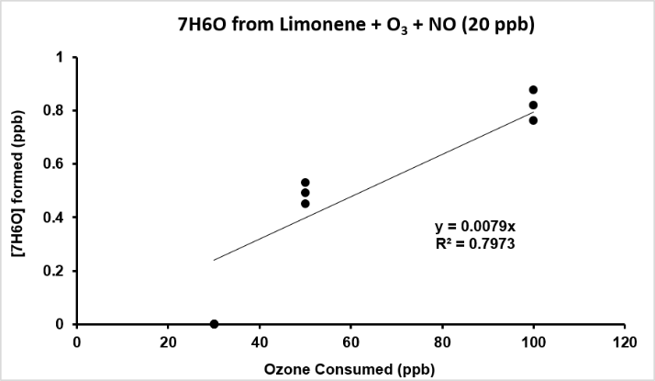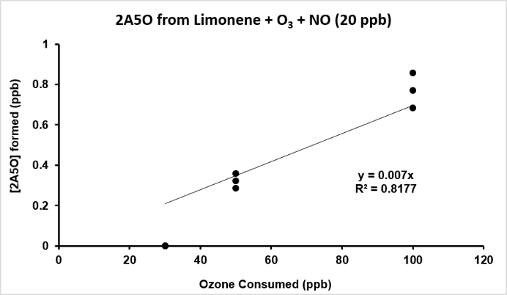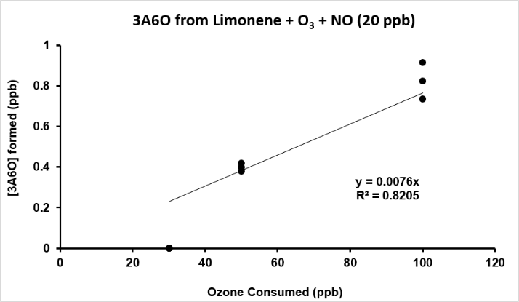

**A**

**C**

**B**

**D**

**E**

**Figure S3.** Yield plots from limonene + O3 + NO (20 ppb) experiments A) limonaketone, B) 7H6O, C) IPOH, D) 2A5O, and E) 3A6O.



**Figure S4.** Limonene ozonolysis mechanism based on observed data and MCM.