Supporting Information for
Identification and reconstitution of the polyketide synthases responsible for biosynthesis of the anti-malarial agent, cladosporin.

Rachel V. K. Cochrane,† Randy Sanichar,† Gareth R. Lambkin,† Béla Reiz,† Wei Xu,‡ Yi Tang,*‡ John C. Vederas*†
‡Department of Chemistry, University of Alberta, Edmonton, Alberta T6G 2G2, Canada
†Department of Chemical and Biomolecular Engineering, University of California, Los Angeles, CA 90095

Table of Contents
1. Genomic DNA Extraction and Sequencing…………………………………….……..S4
2. Media Recipes…….………………...…………................................………………...S5
3. Molecular Cloning of Cla2 and Cla3…………................................……….…..…......S5
4. Protein Purification………………………………………………….………………...S6
5. Cladosporin Isolation………………………………………………………….…..…..S6
6. Advanced Intermediate in vitro Assays...……...……………………………………...S7
7. Organic Synthesis…………………………………..………………………….……...S7
8. Supplementary Figures….……………………..………………………….…………S36
Figure S1. HPLC traces of cladosporin isolated from double transformants…..S36
Figure S2. Extracted ion chromatograms (EICs) and mass spectra showing in vivo heterologous production of cladosporin………………………………………..S37
Figure S3. ¹H NMR of cladosporin isolated from double transformants………S37
Figure S4. ¹³C NMR of cladosporin isolated from double transformants……...S38
Figure S5. THP ring formation during cladosporin biosynthesis....................... S38
Figure S6. EIC and mass spectrum of cladosporin in comparison to extract from in vitro assay with Cla3 and pentaketide……………………………………….S39
Figure S7. EIC and mass spectrum of decyl lactone in comparison to extract from in vitro assay conducted with Cla3 and decyl analogs…………………………S39
Figure S8. EIC and mass spectrum of synthetic octyl lactone in comparison to extract from in vitro assay conducted with Cla3 and octyl analog…………….S40
Figure S9. Crystal structure of P. falciparum KRS1 with cladosporin bound in the active site……………………………………………………………………….S40
Figure S10. Side view of the active site cavity of Cla4 and P. falciparum….....S40
Figure S11. Active site of Cla4 with ATP docked……………………………..S41
9. Supplementary References……………………..…………………………………....S41

General Information

Multiple online software servers were used to generate protein homology models, including I-TASSER, SWISS-MODEL,^{1,2} and HHpred.^{3,4,5} Root-mean-square deviation (RMSD) and C-scores (based on the significance of threading template alignments and the convergence parameters of the structure assembly simulations) values were used to assess reliability. The I-TASSER software consistently gave the most reliable predictions, with C-scores ranging from -1, 1 (typical range is -5, 2 where a higher value denotes a model with a higher confidence). I-TASSER was used for all subsequent protein homology modeling.

Polymerase chain reactions (PCR) were performed on an Eppendorf Mastercycler Nexus Gradient. Yeast cell cultures were pelleted on a Beckman Coulter Avanti J-26XPI High-Performance Centrifuge, using a J-Lite® JLA-9.1000 Fixed Angle Rotor. Protein samples were agitated at 4 °C on a Thermolyne BIGBill Orbital Shaker (Catalog no. M49125) at 50 rpm. HPLC grade acetonitrile (ACN) was purchased from Caledon Labs (Georgetown, ON, Canada). Cladosporin was purified on a Gildson preparative high-performance liquid chromatography (HPLC) system equipped with a model 322 HPLC pump, GX-271 liquid handler, 156 UV/vis detector and a 10 mL sample loop.

General Synthetic Procedures

Reactions involving either air or moisture sensitive reactants were conducted under a stream of dry argon. All solvents and chemicals were reagent grade and used as supplied from Sigma-Aldrich unless otherwise stated. Anhydrous solvents required were dried according to the procedures outlined in Perrin and Armarego.⁵ Removal of solvent was performed under reduced pressure, below 40 °C, using a Büchi rotary evaporator. All reactions and fractions from column chromatography were monitored by thin layer chromatography (TLC). Analytical TLC was done on glass plates (5 × 1.5 cm) pre-coated (0.25 mm) with silica gel (normal SiO₂, Merck 60 F254). Compounds were visualized by exposure to UV light and/ by dipping the plates in KMnO₄ solution, followed by heating. Flash chromatography was performed on silica gel (EM Science, 60Å, 230-400 mesh).

Spectroscopic Analyses

Nuclear magnetic resonance (NMR) spectra were obtained on Agilent VNMRS 700 MHz and Varian Inova 500 MHz spectrometer. ¹H NMR chemical shifts are reported in parts per million (ppm) using the residual proton resonance of solvents as reference: CDCl₃ δ 7.26 and CD₃OD δ 3.30. ¹³C NMR chemical shifts are reported relative to CDCl₃ δ 77.06 and CD₃OD δ 49.0. Infrared spectra (IR) were recorded on a Nicolet Magna 750 or a 20SX FT-IR spectrometer. Cast Film refers to the evaporation of a solution on a NaCl plate. Mass spectra were recorded on a Kratos IMS-50 (high resolution, electron impact ionization (EI)), and a ZabSpec IsoMass VG (high resolution electrospray (ES)). LC-MS analysis was performed on an Agilent Technologies 6220 orthogonal acceleration TOF instrument equipped with +ve and –ve ion ESI ionization, and full-scan MS (high-resolution analysis) with two-point lock mass correction operating mode. The instrument inlet was an Agilent Technologies 1200 SL HPLC system.

1. Genomic DNA Extraction and Sequencing
Genomic DNA (gDNA) was first isolated from a 7-day culture of Cladosporium cladosporioides UAMH 5063. The mycelia were flash frozen in liquid nitrogen and ground in a mortar and pestle. gDNA was then extracted with the DNeasy Plant Mini Kit (Catalog no. 69104, Qiagen) and sent to Ambry Genetics for sequencing using Illumina HiSeq 2000 technology.
Sample Preparation
DNA was fragmented and the ends repaired and phosphorylated using Klenow, T4 DNA polymerase and T4 polynucleotide kinase. An ‘A’ base was then added to the 3’ end of the blunted fragments, followed by ligation of Illumina adapters via T-A mediated ligation. The ligated products were size selected by gel purification and PCR amplified using Illumina paired-end primers. The library size and concentration were determined using an Agilent Bioanalyzer.
HiSeq 2000 Run Conditions
The libraries were seeded onto the flowcell at 9 pM per lane yielding approximately 759 K pass-filter clusters per mm⌃2 tile area. The libraries were sequenced using 101+7+101 cycles of chemistry and imaging.
HiSeq Pipeline Analysis
Initial data processing and base calling, including extraction of cluster intensities was done using RTA 1.13.48 (HiSeq Control Software 1.5.15). Sequence quality filtering script was executed in the Illumina CASAVA software (v 1.8.2, Illumina, Hayward, CA).
Number of Reads | 186235888
Average Read Length (bp) | 100.0
Contig N50 (bp) | 305326
Contig Minimum Length (bp) | 200
Contig Maximum Length (bp) | 1154434
Contig Average Length (bp) | 39655
Contig count | 764

Bioinformatic analysis was conducted using CLC Genomics Workbench, version 5.5.
2. Media Recipes

Yeast Nitrogen Base (YNB) stock - 6.7 g yeast nitrogen base without amino acids (Catalog no. 291940, BD Biosciences) dissolved in 100 mL Milli-Q water, filtered through a Millex-GV Syringe Filter Unit, 0.22μ, PVDF, 33 mm (Catalog no. SLGV033RS, Millex).

Adenine stock - 40 mg adenine hemisulfate salt (Catalog no. BP395-100, Fisher) dissolved in 20 mL Milli-Q water, filtered through a Millex-GV Syringe Filter Unit, 0.22μ, PVDF, 33 mm (Catalog no. SLGV033RS, Millex).

Tryptophan stock - 40 mg tryptophan (Catalog no. A9126, Sigma) dissolved in 20 mL Milli-Q water, filtered through a Millex-GV Syringe Filter Unit, 0.22μ, PVDF, 33 mm (Catalog no. SLGV033RS, Millex).

Uracil stock - 40 mg uracil (Catalog no. U0750, Sigma) dissolved in 20 mL Milli-Q water, filtered through a Millex-GV Syringe Filter Unit, 0.22μ, PVDF, 33 mm (Catalog no. SLGV033RS, Millex).

SDCt media

0.5 g Bacto Technical Grade Casamino Acids (Catalog no. 223120, BD Biosciences), 2 g dextrose, and 88 mL Milli-Q water (89 mL for SDCt (A)), autoclaved and then supplemented with 10 mL YNB stock, 1 mL adenine stock for SDCt (A), plus 1 mL tryptophan stock for SDCt (A, T) or 1 mL uracil stock for SDCt (A, U). For agar plates, 2 g agar (Catalog no. 214010, BD Biosciences) added before autoclaving.

Yeast Peptone Dextrose (YPD) media
10 g Bacto Yeast extract, 20 g Bacto Peptone and 950 mL Milli-Q water, autoclaved and then supplemented with dextrose to final concentration 1%.

3. Molecular Cloning of Cla2 and Cla3

Cla2 and Cla3 were cloned into two 2μ-based yeast-E. coli shuttle vectors, pKOS518-120A and pXK30. pKOS518-120A contains the TRP1 auxotrophic marker and an NdeI and EcoRI restriction site. pXK30 contains a URA3 auxotrophic marker and NdeI and PmLI restriction sites. Initially, total RNA was isolated from a 5-day culture of Cladosporium cladosporioides UAMH 5063 using the RNeasy Plant Mini Kit (Catalog no. 74903, Qiagen), and reverse transcribed into complementary DNA (cDNA) using AccuScript HighFidelity 1st Strand cDNA Synthesis Kit (Catalog no. 200820, Agilent). Primers containing a 35 bp overlap with the ADH2 promoter and terminator sequences present in the vectors were ordered from Integrated DNA Technologies and used in PCR reactions (standard conditions for PfuUltra II Fusion HS DNA polymerase Catalog no. 600670, Agilent) to amplify Cla2 and Cla3 from the cDNA library. A 6 × His sequence was also included in primer design so as to introduce a His tag to the C-terminus of the protein for purification purposes. Saccharomyces cerevisiae BJ5464-NpgA competent cells were prepared using the S. c. EasyComp™ Transformation Kit (Catalog no. K5050-01 Invitrogen), and transformed with the gene and linearized plasmid, where they underwent transformation-associated recombination (TAR). After 48 h growth on selective plates (SDCt (A, T) or SDCt (A, U)), the plasmids were isolated from the cells using Zymoprep™ Yeast Plasmid Miniprep II kit (Catalog no. D2004, Zymo research). The gene sequences were verified by primer walking and the plasmids harbouring either Cla2 or Cla3 were used for subsequent transformation reactions.

4. Protein Purification of Cla2 and Cla3

Plasmids containing either cla2 or cla3 genes were transformed separately into Saccharomyces cerevisiae strain BJ5464-NpgA. After 72 h growth on the appropriately selective plate, a single colony was used to inoculate a 3 mL selective seed culture, which was incubated at 28 °C and 250 rpm for 72 h. 1 mL of the seed culture was then used to inoculate a 1 L culture of YPD media and grown at 28 °C and 250 rpm for 72 h. The cells were harvested by centrifugation (5000 g, 15 minutes, 4 °C), resuspended in 25mL lysis buffer (50 mM NaH₂PO₄, pH = 8.0, 0.15 M NaCl, 10 mM imidazole) and the cells lysed by sonication (sonicate for 1 minute on ice, then let cool for 1 minute. Repeat 9 times). Cellular debris was removed by centrifugation (17000 g, 1 hour, 4 °C). Ni-NTA agarose resin (Catalog no. 30210, Qiagen) was added to the supernatant (typically 1 mL/L of culture) and the solution was agitated for at least 3 hours at 4 °C. The protein/resin slurry was loaded into a gravity flow column (Econo-Pac™ chromatography columns, Catalog no. 732-1010, BIO-RAD) and proteins were purified with increasing concentration of imidazole (10 mM – 250 mM) in Buffer A (50 mM Tris-HCl, pH = 7.9, 2 mM EDTA, 2 mM DTT). Purified proteins were concentrated (Vivaspin 20 100 kDa MWCO, Catalog no. 28-9323-63, GE Healthcare) and resuspended in Buffer A, then concentrated and flash frozen as 20% glycerol stocks.

5. Isolation of Cladosporin from Double Transformations
Plasmids containing either cla2 or cla3 were co-transformed into Saccharomyces cerevisiae strain BJ5464-NpgA. After 72 h growth on a selective (SDCt (A)) plate, a single colony was used to inoculate a 3 mL selective seed culture, which was incubated at 28 °C and 250 rpm for 72 h. 1 mL of the seed culture was then used to inoculate a 1 L culture of YPD media and grown at 28 °C and 250 rpm for 72 h. 2.5 mL of cyclopentanone was added after 24 h and again after 48 h to induce protein expression. Also, 25 mL of 20% NaOAc was added after 24 h and again after 48 h, to increase metabolite production. The cultures were extracted with 2 x 500 mL ethyl acetate, dried and concentrated in vacuo. The crude extract was dissolved in 1 mL of 1:1 ACN:H₂O and injected onto a Luna 5 C18(2) 100Å, AXIA, 250 x 21.2 mm reverse phase column, with detection at 214 nm. Mobile phase composition was as follows: samples were separated on a linear gradient of 40 to 95% ACN (vol/vol) in H₂O supplemented with 0.1% (vol/vol) formic acid at a flow rate of 10 mL/min by HPLC. Initially 40% ACN, ramping up to 75% ACN over 15 min. Eluent was then increased to 95% ACN over 1.5 min, and kept there for 1 min. Concentration of ACN was then decreased to 40% over 1 min and kept there for 2 min. 10 mg of cladosporin was isolated from a 1L culture. Presence of cladosporin in the sample was confirmed by NMR and LC-ESI-MS using combined retention time matching with accurate mass matching. LC-MS was performed using an Agilent 1200 SL HPLC System with a Kinetex 2.6 μ XB-C18 100Å, 100 x 2.1 mm reverse phase column with guard (Phenomenex, Torrance, USA), thermostated at 55 °C and an Agilent 6220 Accurate-Mass TOF HPLC/MS system (Santa Clara, CA, USA) with dual sprayer, the second sprayer delivering a calibrant solution. The buffer gradient system composed 0.1% formic acid in water as mobile phase A and 0.1% formic acid in acetonitrile as mobile phase B. The crude extracts were dissolved in methanol injected onto the column at an initial buffer composition of 20% ACN for 0.5 min, ramping up to 35% ACN over 15 min. Eluent then increased to 95% ACN over 2.5 min, and kept there for 1 min. Eluent ramped down to 20% ACN over 1 min. Mass spectra were acquired in both positive and negative mode of ionization. Mass spectrometric conditions in positive mode were drying gas 9 L/min at 300 °C, nebulizer 30 psi, mass range 100-1000 Da, acquisition rate of ~1.03 spectra/sec, fragmentor 150V, skimmer 63 V, capillary 3200 V, instrument state 4GHz High Resolution. Mass correction was performed for every individual spectrum using peaks at m/z 121.0508 and 922.0008 from the reference solution. Mass spectrometric conditions in negative mode were drying gas 9 L/min at 300 °C, nebulizer 30 psi, mass range 100-1100 Da, acquisition rate of ~1.03 spectra/sec, fragmentor 140 V, skimmer 63 V, capillary 3200 V, instrument state 4 GHz High Resolution. Mass correction was performed for every individual spectrum using peaks at m/z 112.98559 and 1033.98811 from the reference solution. Data acquisition was performed using the Mass Hunter software package (ver. B.04.00) Analysis of the HPLC-UV-MS data was done using the Find by Formula feature of the Agilent Mass Hunter Qualitative Analysis software (ver. B.07.00).

6. Advanced Intermediate in vitro Assays
For incorporation of cladosporin precursor assays, purified Cla3 was dissolved in Buffer A (50 mM Tris-HCl, pH = 7.9, 2 mM EDTA, 2 mM DTT, 10% glycerol) to a final concentration of 10 μM. To this (1 mL) solution was added 2 mM malonyl-CoA and 2 mM of each advanced intermediate, and the reaction was incubated overnight at room temperature. In parallel and under the same reaction conditions, two negative controls were performed in either the absence of Cla3, or the absence of pentaketide (2). The reactions were quenched and extracted with an equal volume of 99% ethyl acetate 1% acetic acid solution, concentrated, and analyzed by LC-MS using an Agilent 1200 SL HPLC System with a Kinetex 2.6 μ XB-C18 100Å, 100 x 2.1 mm reverse phase column with guard (Phenomenex, Torrance, USA), thermostated at 55°C and an Agilent 6220 Accurate-Mass TOF HPLC/MS system (Santa Clara, CA, USA) with dual sprayer. The buffer gradient system composed 0.1% formic acid in water and 0.1% formic acid in acetonitrile as mobile phase A and B, respectively. The crude extracts were dissolved in methanol injected onto the column at an initial buffer composition of 20% mobile phase B. After injection the column was washed at the initial condition for 0.5 minutes followed by elution of the analytes using a linear gradient from 20% to 98% mobile phase B over 15 minutes, kept at 98% for 4 minutes and to 20% mobile phase B over 0.5 minutes. Mass spectra were acquired in negative mode of ionization. Mass spectrometric conditions were drying gas 9 L/min at 300 °C, nebulizer 30 psi, mass range 100-1100 Da, acquisition rate of ~1.03 spectra/sec, fragmentor 140 V, skimmer 63 V, capillary 3200 V, instrument state 4 GHz High Resolution. Mass correction was performed for every individual spectrum using peaks at m/z 112.98559 and 1033.98811 from the reference solution. Data acquisition was performed using the Mass Hunter software package (ver. B.04.00.) Analysis of the HPLC-UV-MS data was done using the Find by Formula feature of the Agilent Mass Hunter Qualitative Analysis software (ver. B.07.00).

7. Organic Synthesis
Scheme S1: Synthesis of (S)-S-2-acetamidoethyl 3-hydroxy-4-((2R,6S)-6-methyltetrahydro-2H-pyran-2-yl)butanethioate (2).

Preparation of (S)-5-(1,3-dioxan-2-yl)pentan-2-ol (4). This known compound was synthesized via a literature preparation.⁶ To a 100 mL flame dried round bottom flask the commercially available Grignard reagent 3 (2.2 g, 10 mmol) was added along with 20 mL dry THF and cooled to −30 C using a Cryo Cooler. To this cold Grignard reagent solution, was added CuI (0.38 g, 2.0 mmol) stirred for 10 min, followed by the addition of (S)-propylene oxide (1.2 g, 20 mmol). This mixture was stirred at −30 °C overnight, then quenched by addition of saturated aqueous NH₄Cl solution (10 mL) and then stirred for 30 min. After stirring, the mixture was extracted with Et₂O (3 x 10 mL), and the combined organic layers were dried over Na₂SO₄, ﬁltered, and concentrated in vacuo. The resulting yellowish oil was puriﬁed by column chromatography using an eluent system of hexane/ethyl acetate (60/40) to afford alcohol 4 as a colorless oil (1.16 g, 67%): IR (CHCl₃, cast film) 3433, 2963, 2927, 1145 cm⁻¹; ¹H NMR (500 MHz, CDCl₃) δ 4.52 (t, J = 5.1 Hz, 1H), 4.09 (ddt, J = 10.4, 5.0, 1.4 Hz, 2H), 3.78 – 3.71 (m, 3H), 2.12 – 2.01 (m, 1H), 1.64 – 1.33 (m, 8H), 1.18 (d, J = 6.2 Hz, 2H); ¹³C NMR (126 MHz, CDCl₃) δ 102.2, 67.9, 66.9, 39.1, 35.0, 25.9, 23.5, 20.2; [α]²⁵_{D} = +6.40 (c = 1.0, CHCl₃); HRMS (EI) calcd for C₉H₁₇O₃ [M – H]+ 173.1178, found 173.1176.

Preparation of (2R,6S)-2-allyl-6-methyltetrahydro-2H-pyran (5). This known compound was synthesized via a literature preparation.⁶ To a cooled (−40 C) solution of 4 (1.1 g, 6.3 mmol) and allyltrimethylsilane (3.0 mL, 19 mmol) in CH₂Cl₂ (10 mL) was added TMSOTf (0.22 mL, 1.3 mmol). The reaction mixture was then warmed to −20 °C and allowed to stir for 1 h. After quenching by addition of saturated aqueous NaHCO₃ solution, the resulting mixture was diluted with Et₂O (20 mL). The layers were separated, and the aqueous layer was extracted with Et₂O (3 x 10 mL). The combined organic layers were dried over anhydrous Na₂SO₄ and concentrated in vacuo. The residue was puriﬁed by column chromatography using a hexane/ethyl acetate (90/10) eluent system to afford 5 as a colorless oil (0.192 g, 22%): IR (CHCl₃, cast film) 2954, 2871, 1724 cm⁻¹; ¹H NMR (500 MHz, CDCl₃) δ 5.80 (ddt, J = 17.1, 10.1, 7.0 Hz, 1H), 5.10 – 5.01 (m, 2H), 3.96 – 3.89 (m, 1H), 3.84 – 3.78 (m, 1H), 2.45 – 2.37 (m, 1H), 2.24 – 2.16 (m, 1H), 1.70 – 1.59 (m, 4H), 1.38 – 1.24 (m, 2H), 1.17 (d, J = 6.4 Hz, 3H); ¹³C NMR (126 MHz, CDCl₃) δ 135.5, 116.4, 70.7, 67.0, 38.0, 31.6, 29.3, 19.7, 18.3; [α]²⁵_{D} = –21.24 (c = 1.0, CHCl₃); HRMS m/z (relative intensity/%): 99.0810 (100), 81.0685 (59), 55.0560 (39); calcd for C₆H₁₁O [M – .C₃H₅]⁺ 99.0810, found 99.0809.

Preparation of 2-((2R,6S)-6-methyltetrahydro-2H-pyran-2-yl)acetaldehyde (6). This known compound was synthesized via a modified procedure.⁷ Compound 5 (0.18 g, 1.3 mmol) was dissolved in a mixture of 3:1 CH₂C1₂:MeOH (20 mL) and the solution was then cooled to –78C. Solid NaHCO₃ (1.0 g) was added then ozone in a stream of oxygen was bubbled through until the solution turned blue (5 min). Argon was bubbled through for 2 min, then dimethyl sulphide (1.5 mL) was added and the mixture allowed to warm to room temperature and stirred for 16 h. The solvent and excess Me₂S were removed in vacuo and the residue was taken up with CH₂C1₂ (3 x 10 mL). The solution was then filtered and concentrated in vacuo. The residue was puriﬁed by column chromatography using a diethyl ether/ethyl acetate (1/1) eluent system to afford 6 as a colorless oil (0.163 g, 89%): IR (CHCl₃, cast film) 2968, 2934, 1727 cm⁻¹; ¹H NMR (500 MHz, CDCl₃) δ 9.77 (dd, J = 3.2, 1.9 Hz, 1H), 4.41 – 4.35 (m, 1H), 3.92 (pd, J = 6.4, 3.4 Hz, 1H), 2.76 (ddd, J = 16.0, 8.5, 3.0 Hz, 1H), 2.44 (ddd, J = 16.0, 5.3, 2.0 Hz, 1H), 1.77 – 1.58 (m, 4H), 1.40 – 1.28 (m, 2H), 1.18 (d, J = 6.5 Hz, 3H); ¹³C NMR (126 MHz, CDCl₃) δ 201.6, 67.5, 66.4, 47.6, 31.1, 30.0, 19.4, 18.2; [α]²⁵_{D} = –22.54 (c = 1.0, CHCl₃); HRMS (EI) calcd for C₈H₁₄O₂ [M] ⁺ 142.0994, found 142.0991.

Preparation of (S)-1-((S)-4-Benzyl-2-thioxothiazolidin-3-yl)-3-hydroxy-4-((2R,6S)-6-methyltetrahydro-2H-pyran-2-yl)butan-1-one (8). This new compound was synthesized by a method adapted from the literature.⁸ To a stirred solution of 7 (0.34 g, 1.4 mmol) in dry CH₂Cl₂ (5 mL) was added TiCl₄ (1.0 M solution in CH₂Cl₂, 1.4 mL, 1.4 mmol) at 0 C under argon atmosphere. The reaction mixture was stirred for 5 min and then cooled to –78 °C. A solution of diisopropylethylamine (DIPEA) (0.19 g, 1.5 mmol) was added. The reaction mixture was stirred at –78 °C for 2 h. A solution of 6 (0.25 g, 1.2 mmol) was added to the reaction mixture, which was then stirred for 30 min at –78 °C. The reaction was quenched by the addition of 10 mL saturated ammonium chloride. The layers were separated, and the aqueous layer was extracted with ethyl acetate (3 x 10 mL). The combined organic layers were washed with brine (20 mL) and dried over Na₂SO₄. The solvent was removed in vacuo and the residue was purified using column chromatography (40/60, ethyl acetate/hexanes) to give 8 as a yellow oil (0.037 g, 76% yield). IR (CHCl₃, cast film) 3437, 2967, 2932, 1696 cm⁻¹; ¹H NMR (500 MHz, CDCl₃) δ 7.38 – 7.30 (m, 2H), 7.31 – 7.27 (m, 3H), 5.40 (ddd, J = 10.8, 7.1, 3.7 Hz, 1H, H-j), 4.42 (tdd, J = 11.5, 5.6, 3.2 Hz, 1H, H-h), 4.07 (ddq, J = 10.3, 7.0, 3.2 Hz, 1H, H-f), 4.02 – 3.94 (m, 1H, H-b), 3.52 (dd, J = 17.4, 2.9 Hz, 1H, H-i), 3.41 (ddd, J = 11.5, 7.2, 1.1 Hz, 1H, H-l), 3.34 (dd, J = 17.5, 9.2 Hz, 1H, H-i), 3.24 (dd, J = 15.4, 4.5 Hz, 1H, H-k), 3.05 (dd, J = 13.2, 10.5 Hz, 1H, H-k), 2.89 (d, J = 11.5 Hz, 1H, H-l), 1.91 (ddd, J = 14.4, 9.6, 3.4 Hz, 1H, H-g), 1.74 – 1.52 (m, 5H, H-c, d, e, g), 1.44 – 1.29 (m, 2H, H-c, e), 1.22 (d, J = 6.6 Hz, 3H, H-a); ¹³C NMR (126 MHz, CDCl₃) δ 201.4, 172.8, 136.6, 129.5, 129.0, 127.3, 68.5, 67.8, 67.6, 65.6, 46.1, 39.6, 36.9, 32.1, 31.1, 30.7, 19.1, 18.4; [α]²⁵_{D} = +74.43 (c = 1.0, CHCl₃); HRMS (ESI) calcd for C₂₀H₂₈NO₃S₂ [M+H] ⁺ 394.1505, found 394.1499.

Preparation of (S)-S-2-acetamidoethyl 3-hydroxy-4-((2R,6S)-6-methyltetrahydro-2H-pyran-2-yl)butanethioate (2). This new compound was synthesized by a method adapted from the literature.⁸ To a stirred solution of 8 (0.37 g, 0.093 mmol) in 5 mL ACN was added K₂CO₃ (0.054 g, 0.32 mmol) and N-acetylcysteamine (0.013 g, 0.11 mmol). The reaction mixture was stirred until the yellow color disappeared (5 min). The solvent was removed in vacuo and the residue was purified using flash column chromatography (100 % ethyl acetate) to give 2 as a clear oil (0.012 g, 44% yield). IR (CHCl₃, cast film) 3304, 3089, 2932, 1687, 1657 cm⁻¹; ¹H NMR (500 MHz, CDCl₃) δ 5.89 (s, 1H, N-H), 4.30 (dd, J = 8.2, 4.1 Hz, 1H, H-h), 4.10 – 3.94 (m, 2H, H-b, f), 3.49 – 3.37 (m, 3H, H-k, OH), 3.05 (td, J = 6.4, 4.6 Hz, 2H, H-j), 2.84 – 2.69 (m, 2H, H-i), 1.96 (s, 3H, H-l), 1.83 (ddd, J = 14.4, 9.3, 3.3 Hz, 1H, H-g), 1.73 – 1.57 (m, 4H, H-c, e), 1.51 (ddd, J = 14.4, 8.1, 3.2 Hz, 1H, H-g), 1.42 – 1.30 (m, 2H, d), 1.22 (d, J = 6.6 Hz, 3H, H-a); ¹³C NMR (126 MHz, CDCl₃) δ 198.8, 170.4, 67.9, 67.5, 66.5, 51.2, 39.7, 39.4, 30.7, 30.7, 28.8, 23.2, 18.7, 18.3; [α]²⁵_{D} = –6.82 (c = 1.0, CHCl₃); HRMS (ESI) calcd for C₁₄H₂₆NO₄S [M+H] ⁺ 304.1577, found 304.1575.

Scheme S2: Synthesis of (R/S)-S-2-acetamidoethyl 3-hydroxydecanethioate (11 and 12).

Preparation of (R/S)-1-((S)-4-benzyl-2-thioxothiazolidin-3-yl)-3-hydroxydecan-1-one (10a/b). These new compounds were synthesized by a method adapted from the literature.⁸ To a stirred solution of (7) (0.43 g, 1.7 mmol) in dry CH₂Cl₂ (10 mL) was added TiCl₄ (1.0 M solution in CH₂Cl₂, 1.7 mL, 1.7 mmol) at –78 C under argon atmosphere and stirred for 10 minutes. A solution of diisopropylethylamine (DIPEA) (0.24 g, 1.9 mmol) was added. The reaction mixture was stirred at –78 °C for 1 hour. Octanal (9) (0.20 g, 1.6 mmol) was added to the reaction mixture, which was then stirred for 30 min at –78 °C. The reaction was allowed to warm to room temperature and quenched by the addition of 10 mL saturated ammonium chloride. The layers were separated, and the aqueous layer was extracted with ethyl acetate (3 x 10 mL). The combined organic layers were washed with brine (20 mL) and dried over Na₂SO₄. The solvent was removed in vacuo and the residue was purified using column chromatography (15% ethyl acetate in hexanes) affording a two diastereomers; 10b (ANTI) and 10a (SYN) in a 1:2.2 ratio as yellow oils, R_{f} values of 0.2 and 0.1 (15% ethyl acetate in hexanes) respectively. ANTI (10b) (0.117 g, 24% yield): IR (CHCl₃, cast film) 3444, 2926, 1692 cm⁻¹; ¹H NMR (500 MHz, CDCl₃) δ 7.35 (dd, J = 8.0, 6.9 Hz, 2H), 7.31 – 7.25 (m, 3H), 5.42 (ddd, J = 10.8, 7.1, 4.0 Hz, 1H, H-m), 4.05 (td, J = 8.4, 7.5, 3.7 Hz, 1H, H-h), 3.50 (dd, J = 17.4, 3.2 Hz, 1H, H-i), 3.40 (ddd, J = 11.5, 7.2, 1.1 Hz, 1H, H-l ), 3.34 (dd, J = 17.5, 2.6 Hz, 1H, H-i), 3.23 (dd, J = 13.2, 4.0 Hz, 1H, H-n), 3.07 (s, 1H, OH), 3.05 (dd, J = 13.2, 10.5 Hz, 1H, H-n), 2.91 (d, J = 11.5 Hz, 1H, H-l), 1.65 – 1.23 (m, 12H, H-b,c,d,e,f,g), 0.88 (t, J = 7.0 3H, H-a); ¹³C NMR (126 MHz, CDCl₃) δ 201.5, 173.9, 136.4, 129.5, 129.0, 127.3, 68.6, 68.3, 45.6, 36.9, 36.7, 32.1, 31.9, 29.6, 29.3, 25.5, 22.7, 14.2; [α]²⁵_{D} = 137.15 (c = 1.0, CHCl₃); HRMS (ESI) calcd for C₂₀H₂₉NNaO₂S₂ [M+Na]⁺ 402.1532, found 402.1535. SYN (10a) (0.263 g, 52% yield): IR (CHCl₃, cast film) 3458, 2927, 1691 cm⁻¹; ¹H NMR (500 MHz, CDCl₃) δ 7.37 – 7.32 (m, 2H), 7.31 – 7.26 (m, 3H), 5.40 (m, 1H, H-m), 4.15 (dddd, J = 9.7, 7.3, 4.7, 2.4 Hz, 1H, H-h), 3.65 (dd, J = 17.8, 2.4 Hz, 1H, H-i), 3.41 (ddd, J = 11.6, 7.2, 1.0 Hz, 1H, H-l), 3.23 (dd, J = 13.2, 4.0 Hz, 1H, H-n), 3.13 (dd, J = 17.5, 9.5 Hz, 1H, H-i), 3.10 (dd, J = 13.5, 10.5 Hz, 1H, H-n), 2.90 (dd, J = 11.6, 0.7 Hz, 1H, H-l), 2.75 (bs, 1H, OH), 1.66 –1.21 (m, 12H, H-b,c,d,e,f,g), 0.88 (t, J = 7.0 Hz, 3H, H-a); ¹³C NMR (126 MHz, CDCl₃) δ 201.4, 173.4, 136.5, 129.5, 129.0, 127.3, 68.4, 67.9, 46.0, 36.9, 36.4, 32.1, 31.9, 29.6, 29.3, 25.6, 22.7, 14.2; [α]²⁵_{D} = 162.29 (c = 1.0, CHCl₃); HRMS (ESI) calcd for C₂₀H₂₉NNaO₂S₂ [M+Na]⁺ 402.1532, found 402.1535.

Preparation of (S)-S-2-acetamidoethyl 3-hydroxydecanethioate (11). This known compound was synthesized by a method adapted from the literature.⁸ To a stirred solution of (10a) (0.26 g, 0.80 mmol) in 5 mL ACN was added K₂CO₃ (0.47 g, 2.82 mmol) and N-acetylcysteamine (0.12 g, 0.97 mmol). The reaction mixture was stirred until the yellow color disappeared (10 min). The solvent was removed in vacuo and the residue was purified using flash column chromatography (50 % ethyl acetate in hexanes) to give (11) as a white solid (0.147 g, 63% yield), mp 64 – 66 ºC; IR (CHCl₃, cast film) 3408, 3315, 3087, 2918, 2853, 1685, 1662 cm⁻¹; ¹H NMR (500 MHz, CDCl₃) δ 5.93 (s, 1H), 4.09 – 4.00 (m, 1H), 3.49 – 3.40 (m, 2H), 3.08 – 3.00 (m, 2H), 2.78 – 2.63 (m, 2H), 1.96 (s, 3H), 1.55 – 1.20 (m, 12H), 0.87 (t, J = 7.5 Hz, 3H); ¹³C NMR (126 MHz, CDCl₃) δ 199.6, 170.5, 68.9, 51.1, 39.3, 36.8, 31.8, 29.5, 29.3, 28.9, 25.5, 23.2, 22.7, 14.1; [α]²⁵_{D} = 18.40 (c = 1.0, CHCl₃); HRMS (ESI) calcd for C₁₄H₂₇NNaO₃S [M+Na] ⁺ 312.1604, found 312.1606.

Preparation of (R)-S-2-acetamidoethyl 3-hydroxydecanethioate (12). This known compound was synthesized by a method adapted from the literature.⁸ To a stirred solution of (10b) (0.100 g, 0.32 mmol) in 5 mL ACN was added K₂CO₃ (0.18 g, 1.10 mmol) and N-acetylcysteamine (0.05 g, 0.38 mmol). The reaction mixture was stirred until the yellow color disappeared (10 min). The solvent was removed in vacuo and the residue was purified using flash column chromatography (50 % ethyl acetate in hexanes) to give (12) as a white solid (0.073 g, 81% yield), mp 64 – 66 ºC; IR (CHCl₃, cast film) 3407, 3313, 3087, 2918, 2853, 1685, 1662 cm⁻¹; ¹H NMR (500 MHz, CDCl₃) δ 6.03 (t, J = 5.8 Hz, 1H), 4.04 (dp, J = 8.1, 3.7 Hz, 1H), 3.43 (m, 2H), 3.02 (m, 2H), 2.82 (s, 1H), 2.70 (m, 2H), 1.95 (s, 3H), 1.49 – 1.23 (m, 12H), 0.86 (t, J = 6.7 Hz, 3H); ¹³C NMR (126 MHz, CDCl₃) δ 199.5, 170.6, , 68.8, 51.1, 39.3, 36.8, 31.8, 29.5, 29.2, 28.8, 25.5, 23.2, 22.6, 14.1; [α]²⁵_{D} = –17.64 (c = 1.0, CHCl₃); HRMS (ESI) calcd for C₁₄H₂₇NNaO₃S [M+Na] ⁺ 312.1604, found 312.1605.

Scheme S3: Synthesis of decyl-SNAC thioester (14).

Preparation of S-2-acetamidoethyl decanethioate (14). This known compound (14) was prepared by a modified method from literature.⁹ To a stirred solution of decanoic acid (0.500 g, 2.90 mmol) in 25mL dry DCM at 0 ºC, DCC (0.659 g, 3.19 mmol) was added, followed by DMAP (0.039 g, 0.32 mmol) and stirred for 10 mins. N-acetylcsyteamine (0.450 g, 3.77 mmol) was then added to the reaction mixture and allowed to stir for 1 h at 0°C, warmed up to room temperature then allowed to continue stirring for 2 hours. The reaction mixture was filtered to remove the precipitate, and the filtrate was washed twice with 1M HCl and then with saturated NaHCO₃ solution, and dried over MgSO₄. The solvent was removed in vacuo and the product was purified by flash chromatography (70/30 DCM:EtOAc) to yield a white solid of R_{f} 0.2 (50% ethyl acetate in hexanes) (0.555 g, 70% yield); mp 68 – 70 ºC; IR (CHCl₃, cast film) 3295, 3102, 2916, 2849, 1686, 1637 cm⁻¹; ¹H NMR (500 MHz, CDCl₃) δ 5.78 (s, 1H), 3.44 (q, J = 6.5, 2H), 3.03 (t, J = 6.5, Hz, 2H), 2.57 (t, J = 7.5 Hz, 2H), 1.96 (s, 3H), 1.66 (p, J = 7.5 Hz, 2H), 1.34 – 1.29 (m, 12H), 0.85 (t, J = 7.0, 3H); ¹³C NMR (126 MHz, CDCl₃) δ 200.3, 170.2, 44.2, 39.9, 31.9, 29.4, 29.3, 29.3, 29.0, 28.5, 25.7, 23.3, 22.7, 14.2; HRMS (ESI) calcd for C₁₄H₂₇NNaO₂S [M+Na] ⁺ 296.1655, found 296.1656.

Scheme S4: Synthesis of (S)-S-2-acetamidoethyl 3-hydroxyoctanethioate (17).

Preparation of (R/S)-1-((S)-4-benzyl-2-thioxothiazolidin-3-yl)-3-hydroxyoctan-1-one (16a/b). These known compounds¹⁰ were synthesized by a different method adapted from the literature.⁸ To a stirred solution of (7) (0.40 g, 1.6 mmol) in dry CH₂Cl₂ (10 mL) was added TiCl₄ (1.0 M solution in CH₂Cl₂, 1.8 mL, 1.8 mmol) at –78 C under argon atmosphere and stirred for 10 minutes. A solution of diisopropylethylamine (DIPEA) (0.25 g, 1.9 mmol) was added. The reaction mixture was stirred at –78 °C for 1 hour. Hexanal (15) (0.22 g, 2.2 mmol) was added to the reaction mixture, which was then stirred for 30 min at –78 °C. The reaction was allowed to warm to room temperature and quenched by the addition of 10 mL saturated ammonium chloride. The layers were separated, and the aqueous layer was extracted with ethyl acetate (3 x 10 mL). The combined organic layers were washed with brine (20 mL) and dried over Na₂SO₄. The solvent was removed in vacuo and the residue was purified using column chromatography (10% ethyl acetate in hexanes) affording a two diastereomers; 16b (ANTI) and 16a (SYN) in a 1:2.9 ratio as yellow oils, R_{f} values of 0.11 and 0.10 (10% ethyl acetate in hexanes) respectively. ANTI (16b) (0.109 g, 19% yield): IR (CHCl₃, cast film) 3440, 2928, 1692 cm⁻¹; ¹H NMR (500 MHz, CDCl₃) δ 7.39 – 7.33 (m, 2H), 7.30 – 7.24 (m, 3H), 5.42 (dddd, J = 10.3, 7.3, 4.0, 0.7 Hz, 1H), 4.06 (dddd, J = 9.1, 7.4, 4.6, 2.7 Hz, 1H), 3.46 (dd, J = 17.5, 10.5 Hz, 1H), 3.40 (ddd, J = 11.3, 8.0, 1.0 Hz, 1H), 3.31 (dd, J = 17.5, 2.5 Hz, 1H), 3.23 (dd, J = 13.3, 4.0 Hz, 1H), 3.08 (bs, 1H), 3.05 (dd, J = 13.5, 10.5 Hz, 1H), 2.91 (dd, J = 11.6, 0.7 Hz, 1H), 1.64 – 1.24 (m, 8H), 0.90 (t, J = 7.0 Hz, 3H); ¹³C NMR (126 MHz, CDCl₃) δ 201.5, 173.9, 136.4, 129.5, 129.0, 127.3, 68.5, 68.3, 45.6, 36.9, 36.7, 32.1, 31.8, 25.2, 22.7, 14.1; [α]²⁵_{D} = 126.21 (c = 1.0, CHCl₃); HRMS (ESI) calcd for C₁₈H₂₅NNaO₂S₂ [M+Na]⁺ 374.1219, found 374.1221. SYN (16a) (0.312 g, 56% yield): IR (CHCl₃, cast film) 3436, 2928, 1692 cm⁻¹; ¹H NMR (500 MHz, CDCl₃) δ 7.38 – 7.35 (m, 2H), 7.35 – 7.23 (m, 3H), 5.45 – 5.36 (m, 1H), 4.15 (dddd, J = 9.8, 7.3, 4.6, 2.4 Hz, 1H), 3.65 (dd, J = 17.7, 2.4 Hz, 1H), 3.41 (ddd, J = 11.5, 7.2, 1.0 Hz, 1H), 3.23 (dd, J = 13.2, 4.0 Hz, 1H), 3.13 (dd, J = 17.7, 9.4 Hz, 1H), 3.05 (dd, J = 13.2, 10.4 Hz, 1H), 2.90 (dd, J = 11.5, 0.7 Hz, 1H), 2.70 (s, 1H), 1.64 – 1.23 (m, 8H), 0.90 (t, J = 7.0 Hz, 3H); ¹³C NMR (126 MHz, CDCl₃) δ 201.4, 173.4, 136.5, 129.5, 129.0, 127.3, 68.4, 67.9, 46.0, 36.9, 36.4, 32.1, 31.8, 25.3, 22.6, 14.1; [α]²⁵_{D} = 165.31 (c = 1.0, CHCl₃); HRMS (ESI) calcd for C₁₈H₂₅NNaO₂S₂ [M+Na]⁺ 374.1219, found 374.1221.

Preparation of (S)-S-2-acetamidoethyl 3-hydroxyoctanethioate (17). This known compound was synthesized by a method adapted from the literature.⁸ To a stirred solution of (16a) (0.20 g, 0.57 mmol) in 5 mL ACN was added K₂CO₃ (0.33 g, 1.99 mmol) and N-acetylcysteamine (0.08 g, 0.68 mmol). The reaction mixture was stirred until the yellow color disappeared (10 min). The solvent was removed in vacuo and the residue was purified using flash column chromatography (70 % ethyl acetate in hexanes) to give (17) as an opaque oil that solidify upon refrigeration (0.110 g, 74% yield); IR (CHCl₃, cast film) 3297, 3089, 2930, 2858, 1689, 1658 cm⁻¹; ¹H NMR (500 MHz, CDCl₃) δ 5.89 (s, 1H), 4.05 (tq, J = 8.0, 4.1 Hz, 1H), 3.45 (m, 2H), 3.04 (m, 2H), 2.80 – 2.69 (m, 2H), 1.96 (s, 3H), 1.56 – 1.22 (m, 8H), 0.88 (t, J = 6.8 Hz, 3H); ¹³C NMR (126 MHz, CDCl₃) δ 199.6, 170.5, 68.9, 51.1, 39.3, 36.8, 31.7, 28.9, 25.1, 23.3, 22.6, 14.0; [α]²⁵_{D} = 12.16 (c = 1.0, CHCl₃); HRMS (ESI) calcd for C₁₂H₂₃NNaO₃S [M+Na] ⁺ 284.1291, found 284.1292.

Scheme S5: Synthesis of (S)-S-2-acetamidoethyl 3-hydroxydodecanethioate (20).

Preparation of (R/S)-1-((S)-4-benzyl-2-thioxothiazolidin-3-yl)-3-hydroxydodecan-1-one (19a/b). These known compounds were synthesized by a method adapted from the literature.⁸ To a stirred solution of (7) (0.40 g, 1.6 mmol) in dry CH₂Cl₂ (10 mL) was added TiCl₄ (1.0 M solution in CH₂Cl₂, 1.8 mL, 1.8 mmol) at –78 C under argon atmosphere and stirred for 10 minutes. A solution of diisopropylethylamine (DIPEA) (0.25 g, 1.9 mmol) was added. The reaction mixture was stirred at –78 °C for 1 hour. Decanal (18) (0.35 g, 2.2 mmol) was added to the reaction mixture, which was then stirred for 30 min at –78 °C. The reaction was allowed to warm to room temperature and quenched by the addition of 10 mL saturated ammonium chloride. The layers were separated, and the aqueous layer was extracted with ethyl acetate (3 x 10 mL). The combined organic layers were washed with brine (20 mL) and dried over Na₂SO₄. The solvent was removed in vacuo and the residue was purified using column chromatography (10% ethyl acetate in hexanes) affording a two diastereomers; 19b (ANTI) and 19a (SYN) in a 1:1.6 ratio as yellow oils, R_{f} values of 0.11 and 0.05 (10% ethyl acetate in hexanes) respectively. ANTI (19b) (0.203 g, 31% yield): IR (CHCl₃, cast film) 3439, 2925, 1689 cm⁻¹; ¹H NMR (500 MHz, CDCl₃) δ 7.39 – 7.32 (m, 2H), 7.30 – 7.24 (m, 3H), 5.42 (dddd, J = 10.4, 7.3, 4.1, 0.7 Hz, 1H), 4.05 (tdd, J = 9.1, 4.5, 2.8 Hz, 1H), 3.46 (dd, J = 17.8, 9.5 Hz, 1H), 3.40 (ddd, J = 11.5, 7.0, 1.0 Hz, 1H), 3.30 (dd, J = 17.0, 2.5 Hz, 1H), 3.23 (dd, J = 13.2, 4.0 Hz, 1H), 3.08 (s, 1H), 3.05 (dd, J = 13.0, 10.5 Hz, 1H), 2.91 (dd, J = 11.6, 0.7 Hz, 1H), 1.64 – 1.22 (m, 16H), 0.88 (t, J = 7.0 Hz, 3H); ¹³C NMR (126 MHz, CDCl₃) δ 201.5, 173.9, 136.4, 129.5, 129.0, 127.3, 68.6, 68.3, 45.6, 36.9, 36.7, 32.1, 31.9, 29.6, 29.6, 29.6, 29.4, 25.5, 22.7, 14.2; [α]²⁵_{D} = 102.48 (c = 1.0, CHCl₃); HRMS (ESI) calcd for C₂₂H₃₃NNaO₂S₂ [M+Na]⁺ 430.1845, found 430.1852. SYN (19a) (0.315 g, 49% yield): IR (CHCl₃, cast film) 3459, 2925, 1693 cm⁻¹; ¹H NMR (500 MHz, CDCl₃) δ 7.38 – 7.32 (m, 2H), 7.32 – 7.24 (m, 3H), 5.44 – 5.36 (m, 1H), 4.19 – 4.10 (m, 1H), 3.65 (dd, J = 17.7, 2.4 Hz, 1H), 3.41 (ddd, J = 11.5, 7.2, 1.0 Hz, 1H), 3.23 (dd, J = 13.2, 4.0 Hz, 1H), 3.13 (dd, J = 17.8, 9.5 Hz, 1H), 3.05 (dd, J = 13.2, 10.4 Hz, 1H), 2.90 (dd, J = 11.6, 0.6 Hz, 1H), 2.76 (bs, 1H), 1.66 – 1.22 (m, 16H), 0.88 (t, J = 7.0 Hz, 3H); ¹³C NMR (126 MHz, CDCl₃) δ 201.4, 173.4, 136.4, 129.5, 129.0, 127.3, 68.4, 67.9, 45.9, 36.9, 36.4, 32.1, 31.9, 29.6, 29.6, 29.6, 29.3, 25.6, 22.7, 14.1; [α]²⁵_{D} = 147.89 (c = 1.0, CHCl₃); HRMS (ESI) calcd for C₂₂H₃₃NNaO₂S₂ [M+Na]⁺ 430.1845, found 430.1854.

Preparation of (S)-S-2-acetamidoethyl 3-hydroxydodecanethioate (20). This known compound was synthesized by a method adapted from the literature.⁸ To a stirred solution of (19a) (0.29 g, 0.72 mmol) in 5 mL ACN was added K₂CO₃ (0.42 g, 2.53 mmol) and N-acetylcysteamine (0.87 g, 0.68 mmol). The reaction mixture was stirred until the yellow color disappeared (10 min). The solvent was removed in vacuo and the residue was purified using flash column chromatography (70 % ethyl acetate in hexanes) to give (20) as a white solid (0.189 g, 82% yield), mp 66 – 68 ºC: IR (CHCl₃, cast film) 3398, 3311, 2918, 2849, 1682, 1666 cm⁻¹; ¹H NMR (500 MHz, CDCl₃) δ 5.97 (s, 1H), 4.09 – 4.00 (m, 1H), 3.44 (m, 2H), 3.03 (m, 2H), 2.78 – 2.63 (m, 2H), 1.96 (s, 3H), 1.55 –1.24 (m, 16H), 0.87 (t, J = 6.9 Hz, 3H); ¹³C NMR (126 MHz, CDCl₃) δ 199.5, 170.5, 68.9, 51.1, 39.3, 36.8, 31.9, 29.6, 29.5, 29.5, 29.3, 28.9, 25.5, 23.2, 22.7, 14.1; [α]²⁵_{D} = 14.86 (c = 1.0, CHCl₃); HRMS (ESI) calcd for C₁₆H₃₁NNaO₃S [M+Na] ⁺ 340.1917, found 340.1920.

Scheme S6: Synthesis of acid and lactone standards 23, 24, 25, and 26.

Preparation of 2,4-dimethoxy-6-methylbenzoic acid (22). This known compound was prepared following literature preparation.^{11,12} To a solution of orsellinic acid (2.5 g, 14.88 mmol) in acetone (80 mL), K₂CO₃ (12.67 g, 89.29 mmol) was added. MeI (5.6 mL, 89.29 mmol) was added and the reaction mixture was refluxed overnight. After the reaction was complete, the solvent and excess MeI was removed in vacuo and 100 mL water was added, the resulting solution was extracted with Et₂O (4 × 40 mL). The combined organic layers were washed with NaHCO₃ (40 mL) and brine (40 mL), then dried over Na₂SO₄ and concentrated in vacuo to give the crude product as a pale yellow oil. This crude sample was analyzed by LCMS and was found to contain the desired product. No further purification was done; this crude product was used as is, for the next step. The crude product from the previous reaction was transferred to a 250 mL round bottom flask, containing 80 mL of 10% KOH in EtOH and refluxed overnight. The mixture was allowed to cool then concentrated in vacuo. The resultant residue was acidified to pH 1 with 6M HCl and extracted with ethyl acetate, washed with brine (40 mL), then dried over Na₂SO₄ and concentrated in vacuo. The crude mixture was purified by flash chromatography using 50% ethyl acetate, and 1% acetic acid in hexanes, to yield the product as a yellow-brown solid (2.72 g, 93 %), mp 142–144 °C; IR (CHCl₃, cast film) 2935, 2850, 2650, 1680, 1585 cm⁻¹; ¹H NMR (500 MHz, CDCl₃) δ 6.43 (d, J = 2.3 Hz, 1H), 6.38 (d, J = 2.3 Hz, 1H), 3.93 (s, 3H), 3.83 (s, 3H), 2.55 (s, 3H); ¹³C NMR (126 MHz, CDCl₃) δ 168.4, 162.3, 159.6, 144.1, 112.3, 109.1, 96.6, 56.5, 55.5, 22.6; HRMS (ESI) calcd for C₁₀H₁₁O₄ [M–H] – 196.0736, found 196.0736.

Preparation of 6,8-dihydroxy-3-pentylisochroman-1-one (23). This new compound was prepared by a method adapted from literature.¹³ In a flame dried 250 mL round bottom flask, 10 mL of dry THF was added and cooled to 0 ºC over an ice bath and kept under argon. To this cooled solvent, (i-Pr)₂NH (0.07 mL, 7.14 mmol) was added and stirred for 5 min, then 2.5 M n-BuLi (2.85 mL, 7.14 mmol) was added dropwise. After 10 min of stirring, the reaction mixture was further cooled to –78 ºC. After 10 min, a solution of (22) (0.35 g, 1.78 mmol) dissolved in 5 mL dry THF, was slowly added and stirred for 30 min. Hexanal (0.88 mL, 7.14 mmol) was then added and stirred for 90 min maintaining –78 ºC. The reaction was then allowed to warm to room temperature (15 min), and then quenched with 20 mL of water. The reaction mixture was acidified with 1M HCl to pH 1 and then extracted 4 times with EtOAc. The combined organic phases were dried in anhydrous Na₂SO₄, filtered and then concentrated in vacuo to provide the crude protected product. This crude sample was analyzed by LCMS and was found to contain the desired methoxy-protected product. No further purification was done; this crude product was used as is, for the next step. The deprotection of the hydroxyls was carried out following a modified literature protocol. The crude product from the previous step was dissolved in 10 mL DCM, cooled to –78 ºC; 1M BBr₃ (11.3 mL, 11.30 mmol) was added dropwise. The reaction mixture was stirred for 1 h and then heated to reflux overnight. The reaction was allowed to cool and 25 mL of water was added, and the layers were separated, and then extracted with 2 x 20 mL DCM. The combined organic layer was washed twice with 20 mL saturated sodium bicarbonate then washed with 20 mL brine and dried over MgSO₄. The DCM was removed in vacuo, and the crude product was purified by column chromatography (20% EtOAc/Hexanes) to yield the product as a white solid (0.223 g, 47 %), mp 86–88 ºC: IR (CHCl₃, cast film) 3246, 2951, 2925, 2851, 1626, 1584 cm⁻¹; ¹H NMR (500 MHz, CDCl₃) δ 6.32 (d, J = 2.2 Hz, 1H, H-b), 6.21 (d, J = 2.3 Hz, 1H, H-d), 5.97 (bs, 1H, OH), 4.57 – 4.47 (m, 1H, H-i), 2.92 – 2.81 (m, 2H, H-h), 1.86 (dddd, J = 13.8, 10.3, 7.4, 5.1 Hz, 1H, H-j), 1.70 (ddt, J = 13.9, 10.8, 5.5 Hz, 1H, H-j), 1.61 – 1.53 (m, 1H, H-k), 1.46 (m, 1H, H-k ), 1.33 (m, 4H, H-l,m), 0.91 (t, J = 7.1 Hz, 3H, H-n); ¹³C NMR (126 MHz, CDCl₃) δ 170.1, 164.4, 162.5, 141.9, 106.6, 102.1, 102.0, 79.3, 34.7, 33.2, 31.6, 24.6, 22.5, 14.0; HRMS (ESI) calcd for C₁₆H₂₁O₄ [M–H] – 249.1132, found 249.1131.

Preparation of 3-heptyl-6,8-dihydroxyisochroman-1-one (24). This new compound was prepared by a method adapted from literature.¹³ In a flame dried 250 mL round bottom flask, 10 mL of dry THF was added and cooled to 0 ºC over an ice bath and kept under argon. To this cooled solvent, (i-Pr)₂NH (0.14 mL, 10.19 mmol) was added and stirred for 5 min, then 2.5 M n-BuLi (4.08 mL, 10.19 mmol) was added dropwise. After 10 min of stirring, the reaction mixture was further cooled to –78 ºC. After 10 min, a solution of (22) (0.50 g, 2.55 mmol) dissolved in 5 mL dry THF, was slowly added and stirred for 30 min. Octanal (1.59 mL, 10.19 mmol) was then added and stirred for 90 min maintaining –78 ºC. The reaction was then allowed to warm to room temperature (15 min), then quenched with 20 mL of water. The reaction mixture was acidified with 1M HCl to pH 1 and then extracted 4 times with EtOAc. The combined organic phases were dried in anhydrous Na₂SO₄, filtered and then concentrated in vacuo to provide the crude protected product. This crude sample was analyzed by LCMS and was found to contain the desired methoxy-protected product. No further purification was done; this crude product was used as is, for the next step. The deprotection of the hydroxyls was carried out following a modified literature protocol.¹⁴ The crude product from the previous step was dissolved in 10 mL DCM, cooled to –78 ºC; 1M BBr₃ (15.3 mL, 15.30 mmol) was added dropwise. The reaction mixture was stirred for 1 h and then heated to reflux overnight. The reaction was allowed to cool and 25 mL of water was added, and the layers were separated, and then extracted with 2 x 20 mL DCM. The combined organic layer was washed twice with 20 mL saturated sodium bicarbonate then washed with 20 mL brine and dried over MgSO₄. The DCM was removed in vacuo, and the crude product was purified by column chromatography (15% EtOAc/Hexanes) to yield the product as a white solid (0.313 g, 44 %), mp 92–94 ºC: IR (CHCl₃, cast film) 3264, 2950, 2927, 2856, 1660, 1500 cm⁻¹; ¹H NMR (500 MHz, CDCl₃) δ 6.31 (d, J = 2.3 Hz, 1H, H-b), 6.20 (d, J = 2.3 Hz, 1H, H-d), 5.61 (s, 1H, OH), 4.51 (ddt, J = 11.1, 7.2, 4.7 Hz, 1H, H-i), 2.93 – 2.78 (m, 2H, H-h), 1.92 – 1.81 (m, 1H, H-j), 1.75 – 1.64 (m, 1H, H-j), 1.60 – 1.48 (m, 1H, H-k), 1.44 (m, 1H, H-k), 1.30 (m, 8H, H-l,m,n,o), 0.89 (t, J = 6.8 Hz, 3H, H-p); ¹³C NMR (126 MHz, CDCl₃) δ 170.0, 164.5, 162.2, 141.9, 106.5, 102.2, 102.0, 79.3, 34.8, 33.2, 31.8, 29.4, 29.2, 24.9, 22.7, 14.1; HRMS (ESI) calcd for C₁₆H₂₁O₄ [M–H] – 277.1445, found 277.4444.

Preparation of 6,8-dihydroxy-3-nonylisochroman-1-one (25). This new compound was prepared by a method adapted from literature.¹³ In a flame dried 250 mL round bottom flask, 10 mL of dry THF was added and cooled to 0 ºC over an ice bath and kept under argon. To this cooled solvent, (i-Pr)₂NH (0.07 mL, 7.14 mmol) was added and stirred for 5 min, then 2.5 M n-BuLi (2.85 mL, 7.14 mmol) was added dropwise. After 10 min of stirring, the reaction mixture was further cooled to –78 ºC. After 10 min, a solution of (22) (0.35 g, 1.78 mmol) dissolved in 5 mL dry THF, was slowly added and stirred for 30 min. Decanal (1.34 mL, 7.14 mmol) was then added and stirred for 90 min maintaining –78 ºC. The reaction was then allowed to warm to room temperature (15 min), and then quenched with 20 mL of water. The reaction mixture was acidified with 1M HCl to pH 1 and then extracted 4 times with EtOAc. The combined organic phases were dried in anhydrous Na₂SO₄, filtered and then concentrated in vacuo to provide the crude protected product. This crude sample was analyzed by LCMS and was found to contain the desired methoxy-protected product. No further purification was done; this crude product was used as is, for the next step. The deprotection of the hydroxyls was carried out following a modified literature protocol.¹⁴ The crude product from the previous step was dissolved in 10 mL DCM, cooled to –78 ºC; 1M BBr₃ (11.3 mL, 11.30 mmol) was added dropwise. The reaction mixture was stirred for 1 h and then heated to reflux overnight. The reaction was allowed to cool and 25 mL of water was added, and the layers were separated, and then extracted with 2 x 20 mL DCM. The combined organic layer was washed twice with 20 mL saturated sodium bicarbonate then washed with 20 mL brine and dried over MgSO₄. The DCM was removed in vacuo, and the crude product was purified by column chromatography (20% EtOAc/Hexanes) to yield the product as a white solid (0.246 g, 43 %), mp 98–100 ºC: IR (CHCl₃, cast film) 3254, 2955, 2931, 2861, 1628, 1498 cm⁻¹; ¹H NMR (500 MHz, CDCl₃) δ δ 6.31 (d, J = 2.3 Hz, 1H, H-b), 6.20 (d, J = 2.3 Hz, 1H, H-d), 5.65 (bs, 1H, OH), 4.56 – 4.47 (m, 1H, H-i), 2.92 – 2.81 (m, 2H, H-h), 1.86 (dddd, J = 13.6, 10.2, 7.3, 5.1 Hz, 1H, H-j), 1.75 – 1.64 (m, 1H, H-j), 1.52 (ddd, J = 10.3, 7.8, 5.0 Hz, 1H, H-k), 1.44 (tq, J = 13.3, 5.6, 4.5 Hz, 1H, H-k), 1.38 – 1.25 (m, 12H, H-l,m,n,o,p,q), 0.88 (t, J = 6.8 Hz, 3H, H-r); ¹³C NMR (126 MHz, CDCl₃) δ 170.0, 164.5, 162.2, 141.9, 106.5, 102.2, 102.0, 79.3, 34.8, 33.2, 31.9, 29.6, 29.5, 29.4, 29.3, 24.9, 22.7, 14.2; HRMS (ESI) calcd for C₁₆H₂₁O₄ [M–H] – 305.1758, found 305.1753.

Preparation of 2,4-dihydroxy-6-nonylbenzoic acid (26). This known compound ⁹ was prepared by a different method, adapted from literature.¹³ In a flame dried 250 mL round bottom flask, 10 mL of dry THF was added and cooled to 0 ºC over an ice bath and kept under argon. To this cooled solvent, (i-Pr)₂NH (0.07 mL, 7.14 mmol) was added and stirred for 5 min, then 2.5 M n-BuLi (2.85 mL, 7.14 mmol) was added dropwise. After 10 min of stirring, the reaction mixture was further cooled to –78 ºC. After 10 min, a solution of (22) (0.35 g, 1.78 mmol) dissolved in 5 mL dry THF, was slowly added and stirred for 30 min. Octyl iodide (1.34 mL, 7.14 mmol) was then added and stirred for 30 min maintaining –78 ºC, then for 90 min at room temperature after which it was quenched with 20 mL of water. The reaction mixture was acidified with 1M HCl to pH 1 and then extracted 4 times with EtOAc. The combined organic phases were dried in anhydrous Na₂SO₄, filtered and then concentrated in vacuo to provide the crude protected product. This crude sample was analyzed by LCMS and was found to contain the desired methoxy-protected product. No further purification was done; this crude product was used as is, for the next step. The deprotection of the hydroxyls was carried out following a modified literature protocol.¹⁴ The crude product from the previous step was dissolved in 10 mL DCM, cooled to –78 ºC; 1M BBr₃ (11.3 mL, 11.30 mmol) was added dropwise. The reaction mixture was stirred for 1 h, allowed to warm to room temperature and then heated to reflux overnight. The reaction was allowed to cool and 25 mL of water was added, and the layers were separated, and then extracted with 2 x 20 mL DCM. The combined organic layer was washed twice with 20 mL saturated sodium bicarbonate then washed with 20 mL brine and dried over MgSO₄. The DCM was removed in vacuo, and the crude product was purified by HPLC. Crude sample was dissolved in MeOH and injected on a Phenomenex Luna 5μ C18(2), 100A, AXIA, 250 x 21.2 mm; prep scale column, flow rate of 9 ml/min (A= H₂O, 1% TFA and B= ACN, 1 % TFA); 0-5 min, 5% B; 15-20 min, 70% B, 38-43 min, 98% B; 45-50 min, 5% B. Compound (26) eluted at 32 min as a single symmetrical peak to yield the product after removal of the solvent as a white solid (0.059 g, 55 %), mp 147 – 149 ºC: : IR (CHCl₃, cast film) 3383, 2954, 2922, 2852, 2541, 1623, 1466 cm⁻¹; ¹H NMR (500 MHz, CDCl₃) δ 6.29 (s, 1H, H-b), 6.27 (s, 1H, H-d), 5.28 (bs, 1H, OH), 2.91 (t, J = 7.5 Hz, 2H, H-h), 1.58 – 1.57 (m, 2H, H-i), 1.36 – 1.27 (m, 14H, H-j,k,l,m,n,o), 0.88 (t, J = 7.0 Hz, 3H, H-p); ¹³C NMR (126 MHz, CDCl₃) δ 174.5, 166.5, 161.2, 150.5, 111.1, 103.7, 101.5, 36.7, 32.0, 31.8, 29.8, 29.6, 29.5, 29.4, 22.7, 14.1; HRMS (ESI) calcd for C₁₆H₂₃O₄ [M–H] – 279.1602, found 279.1601.

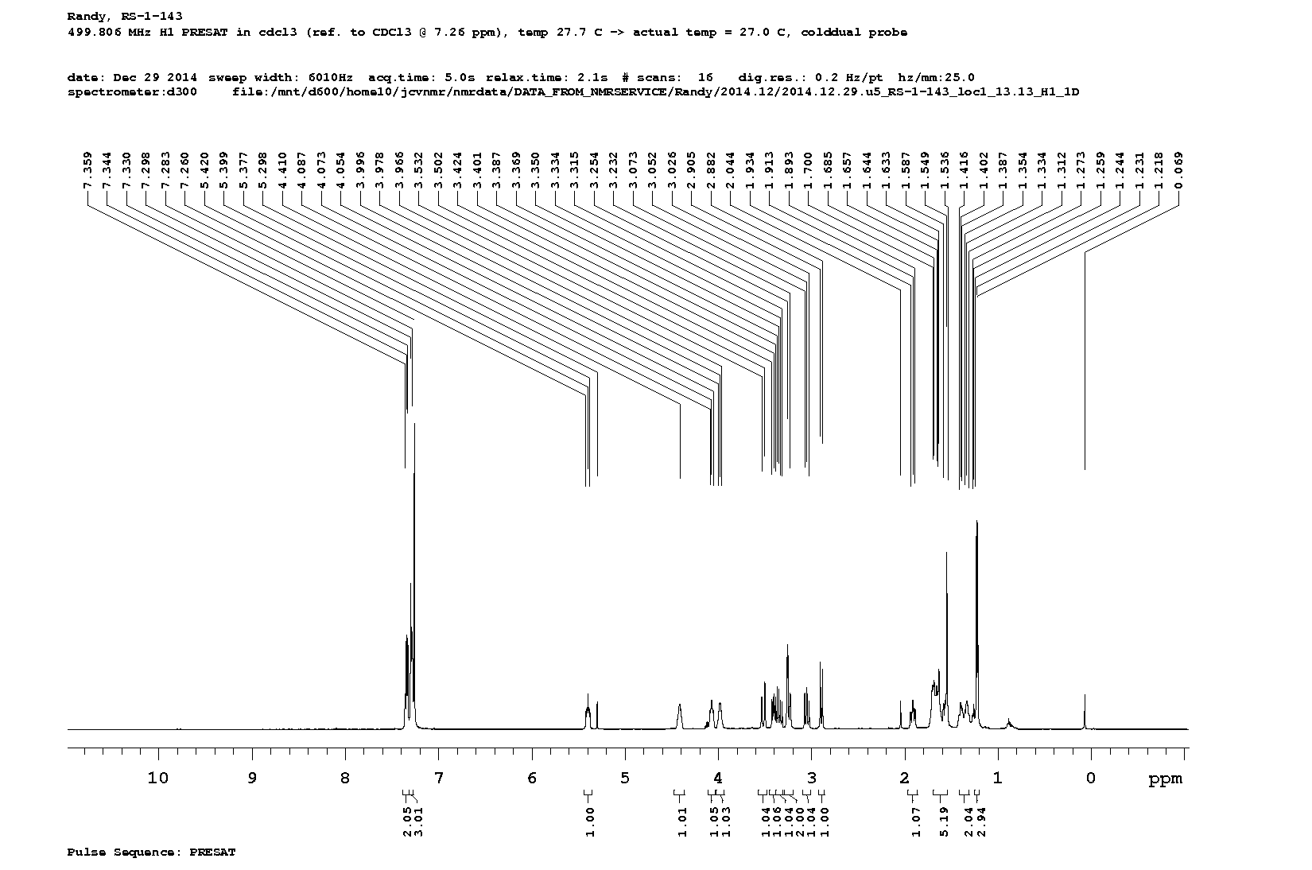
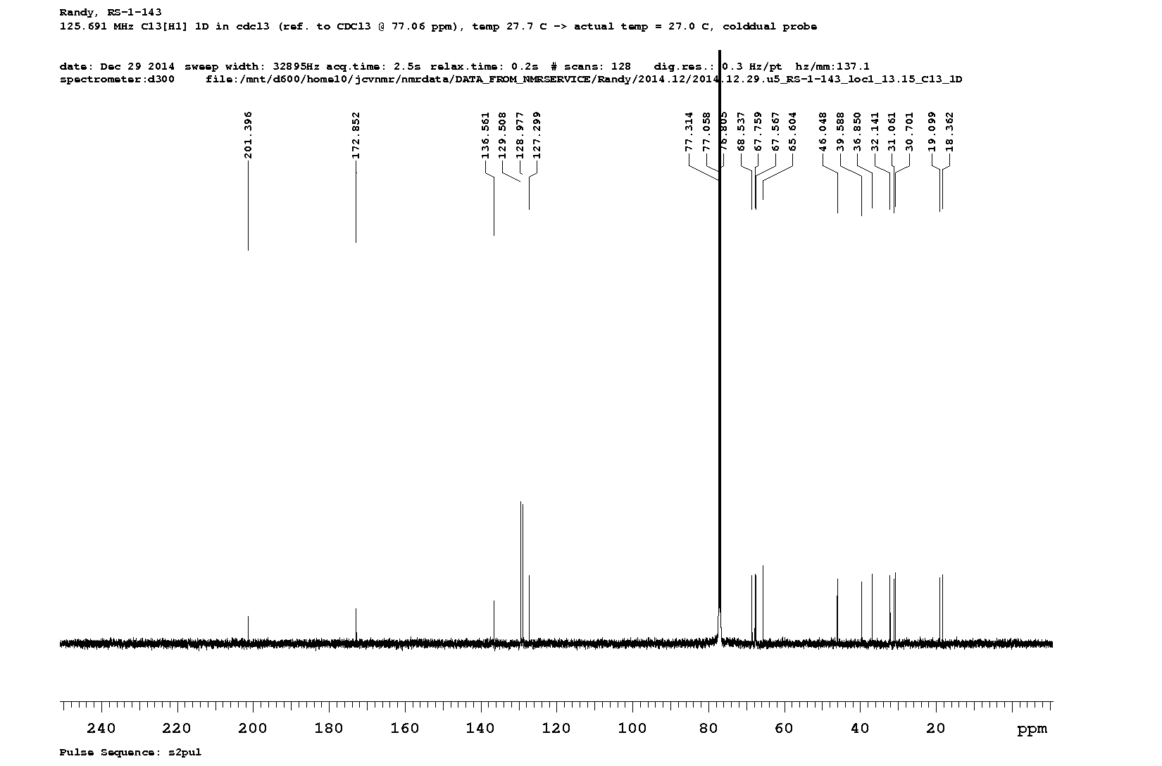
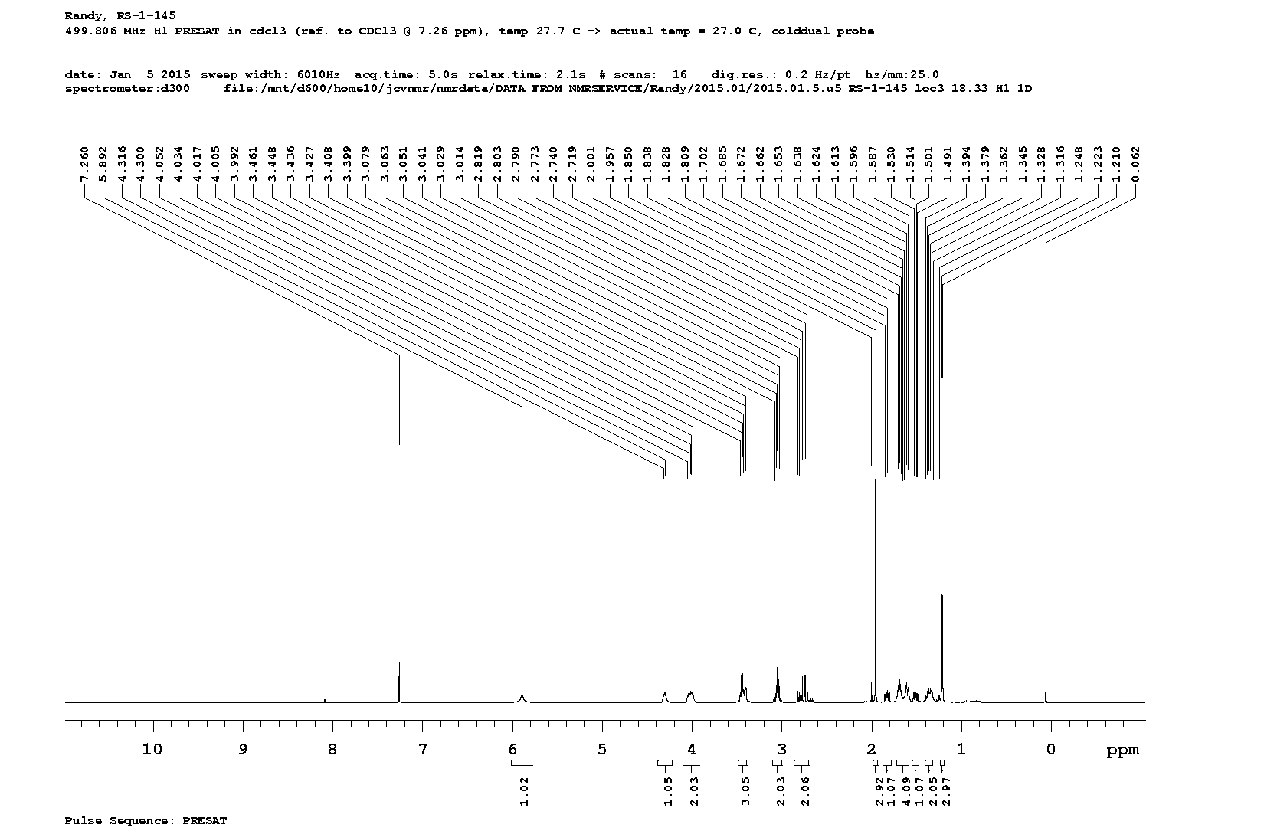
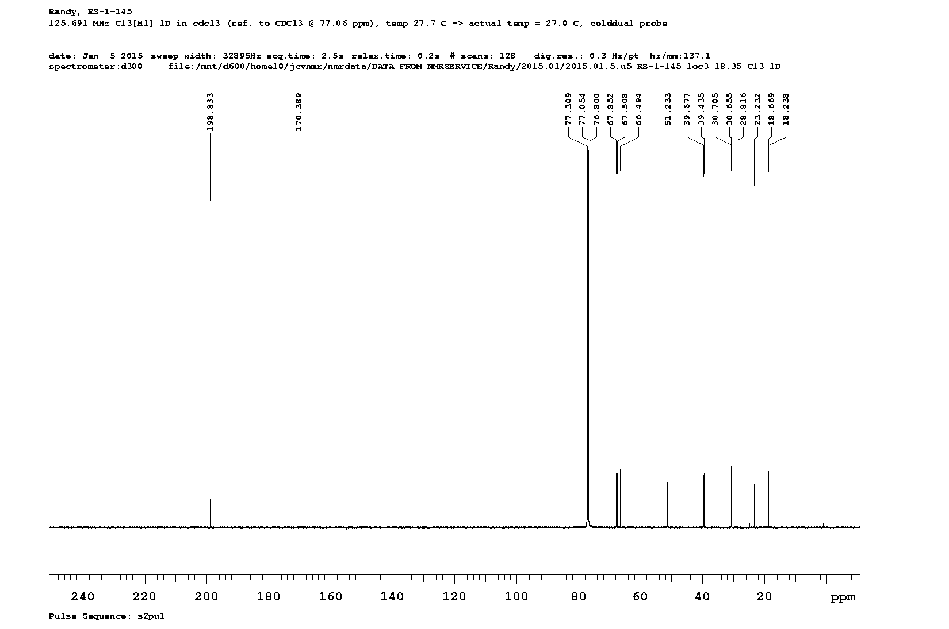
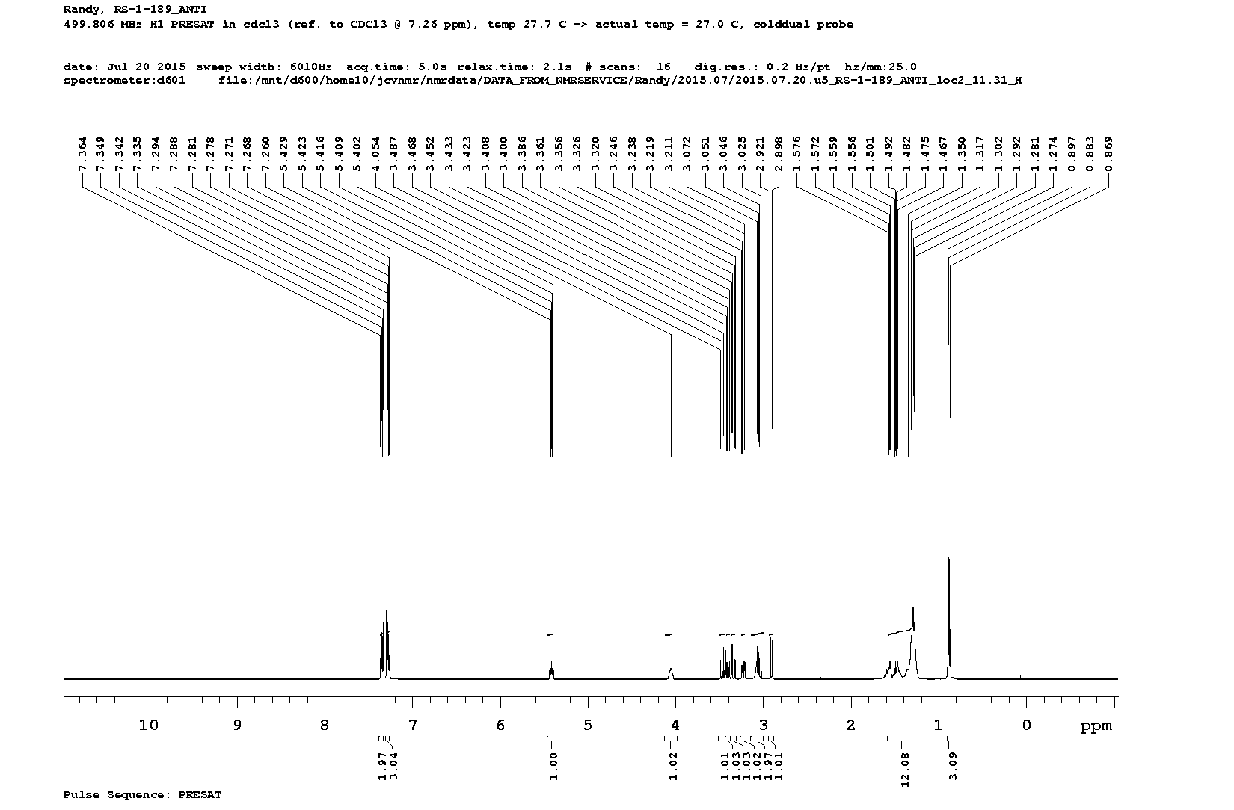
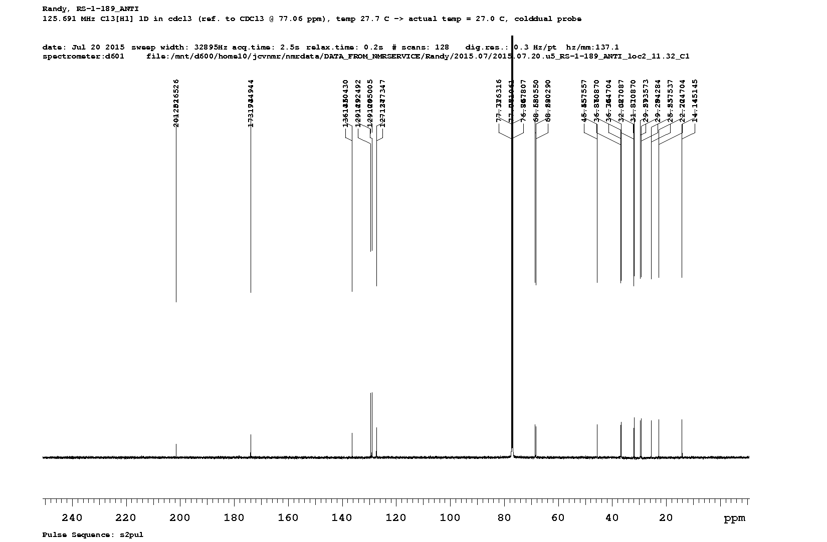
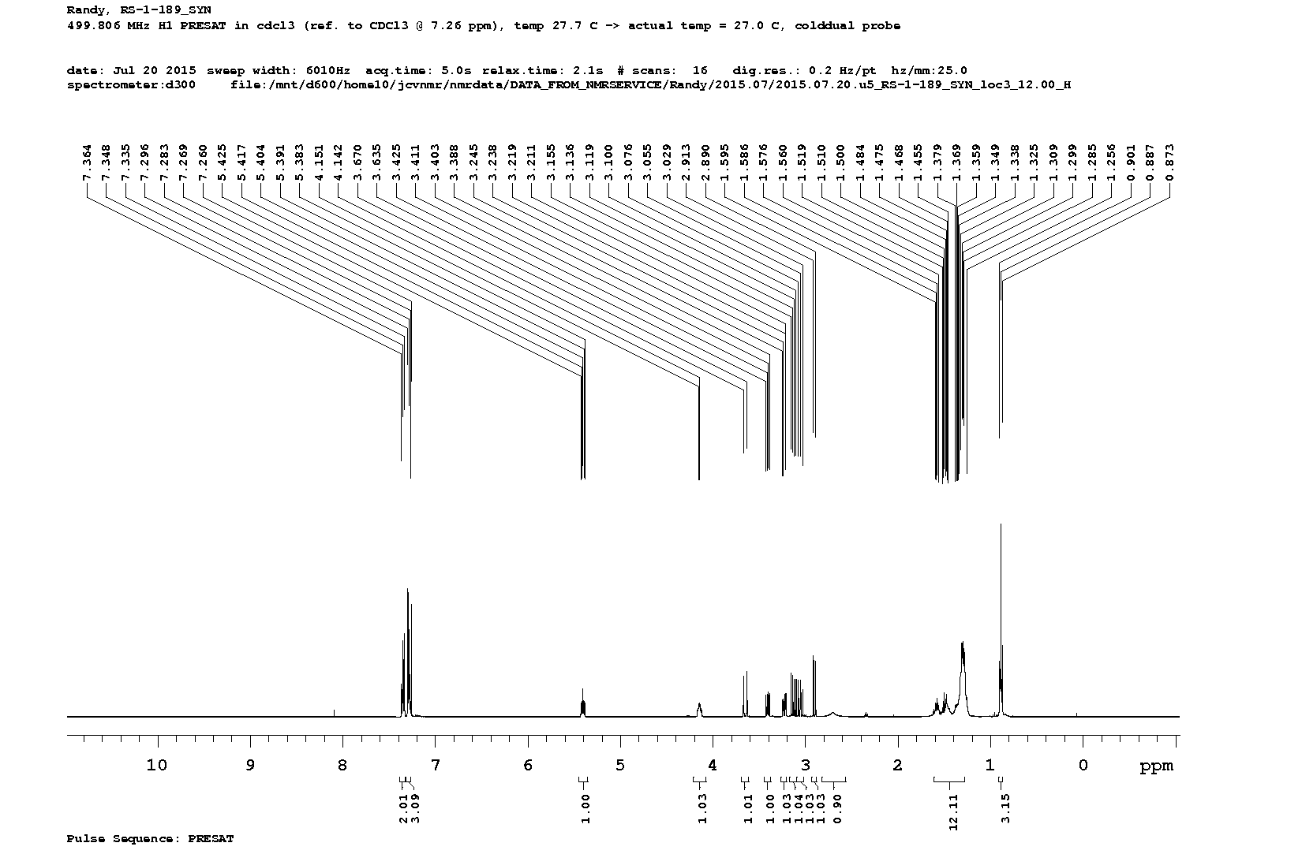
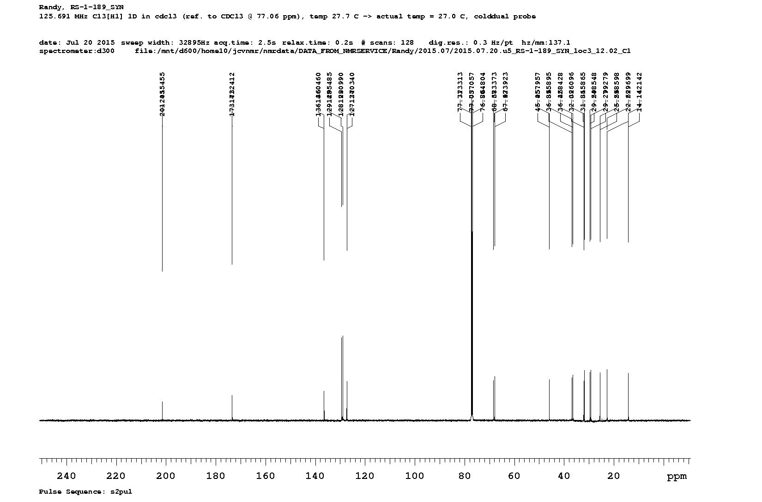
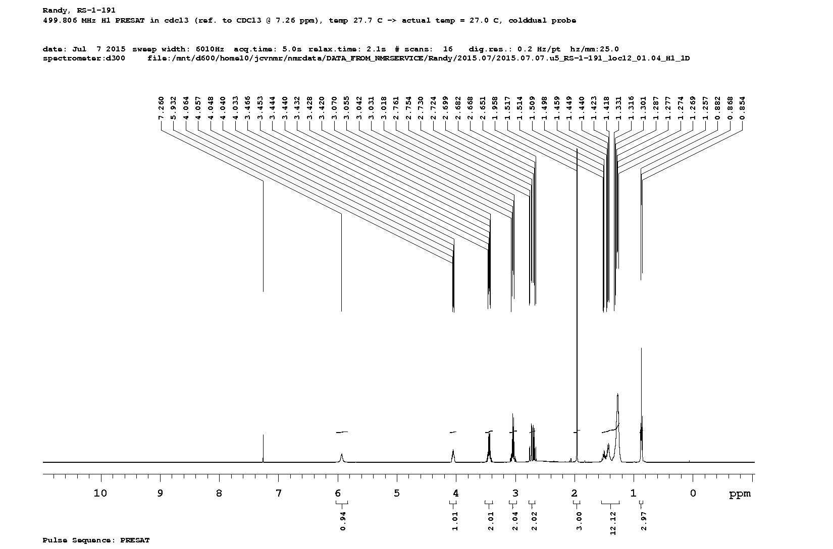
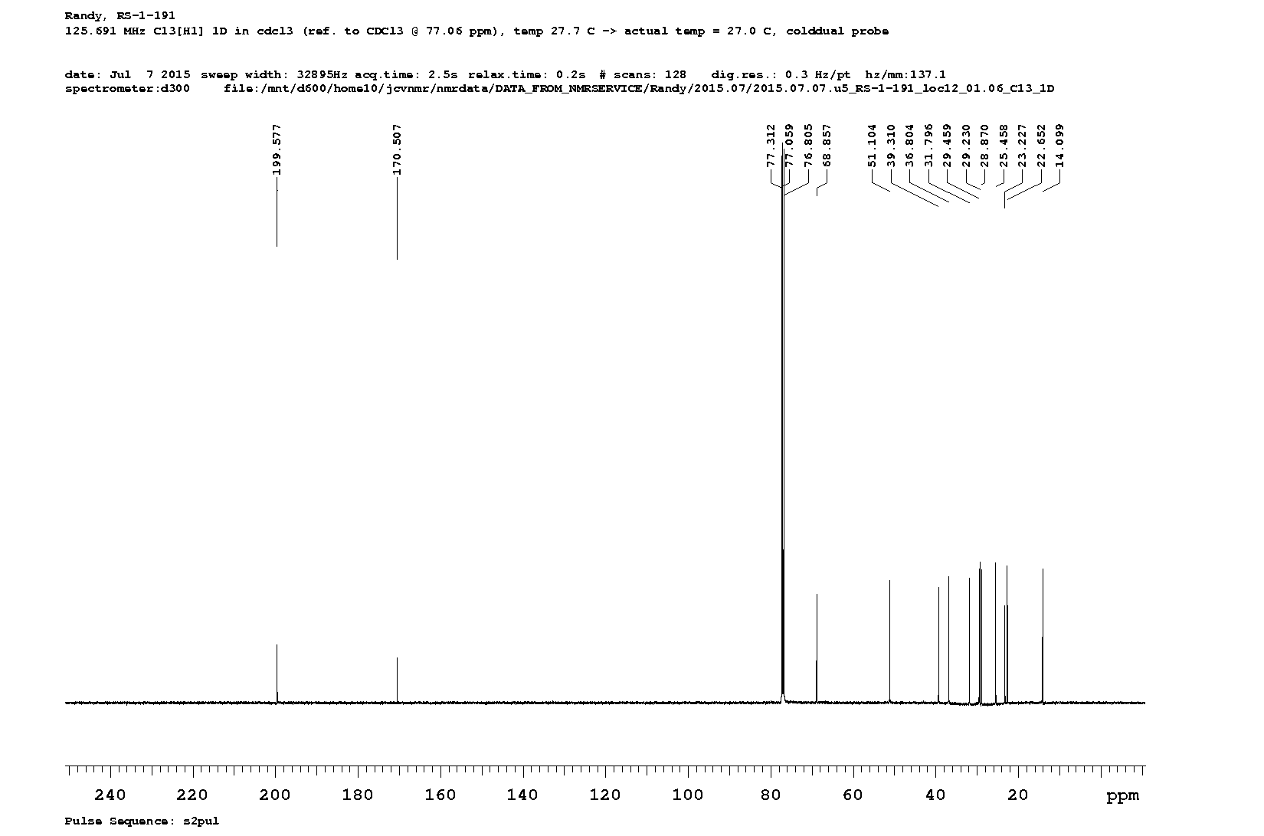
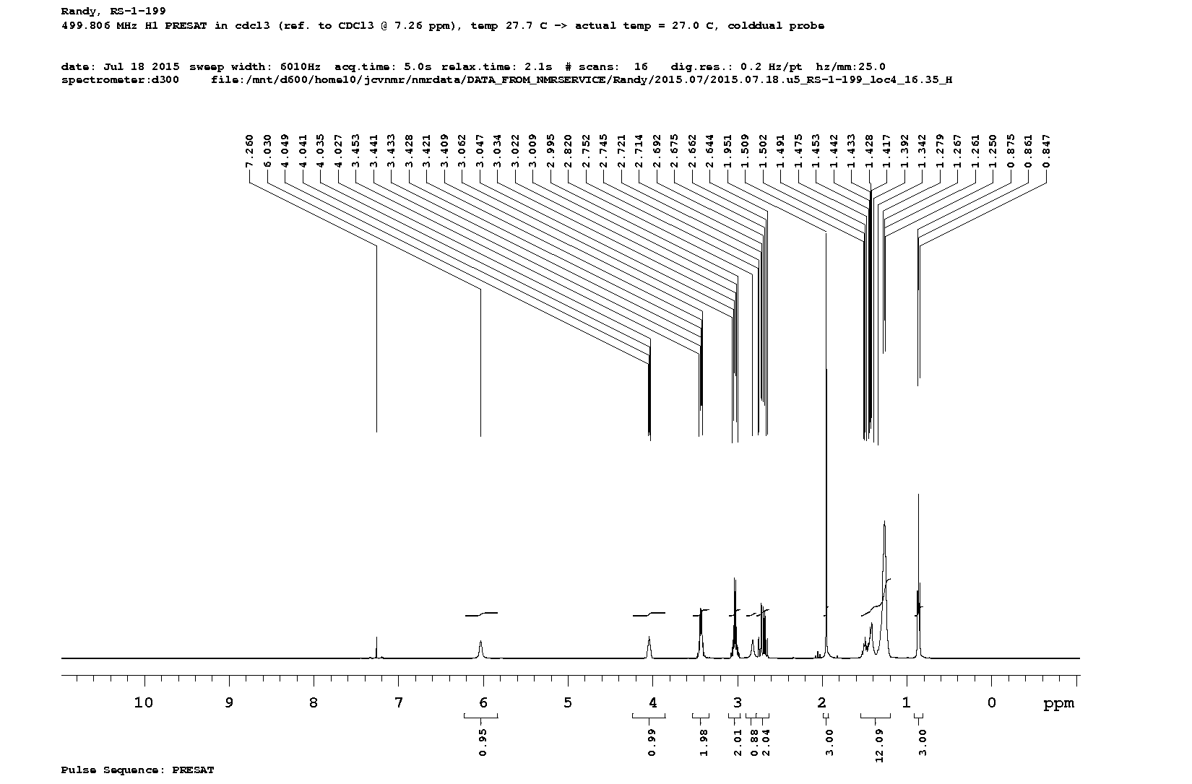
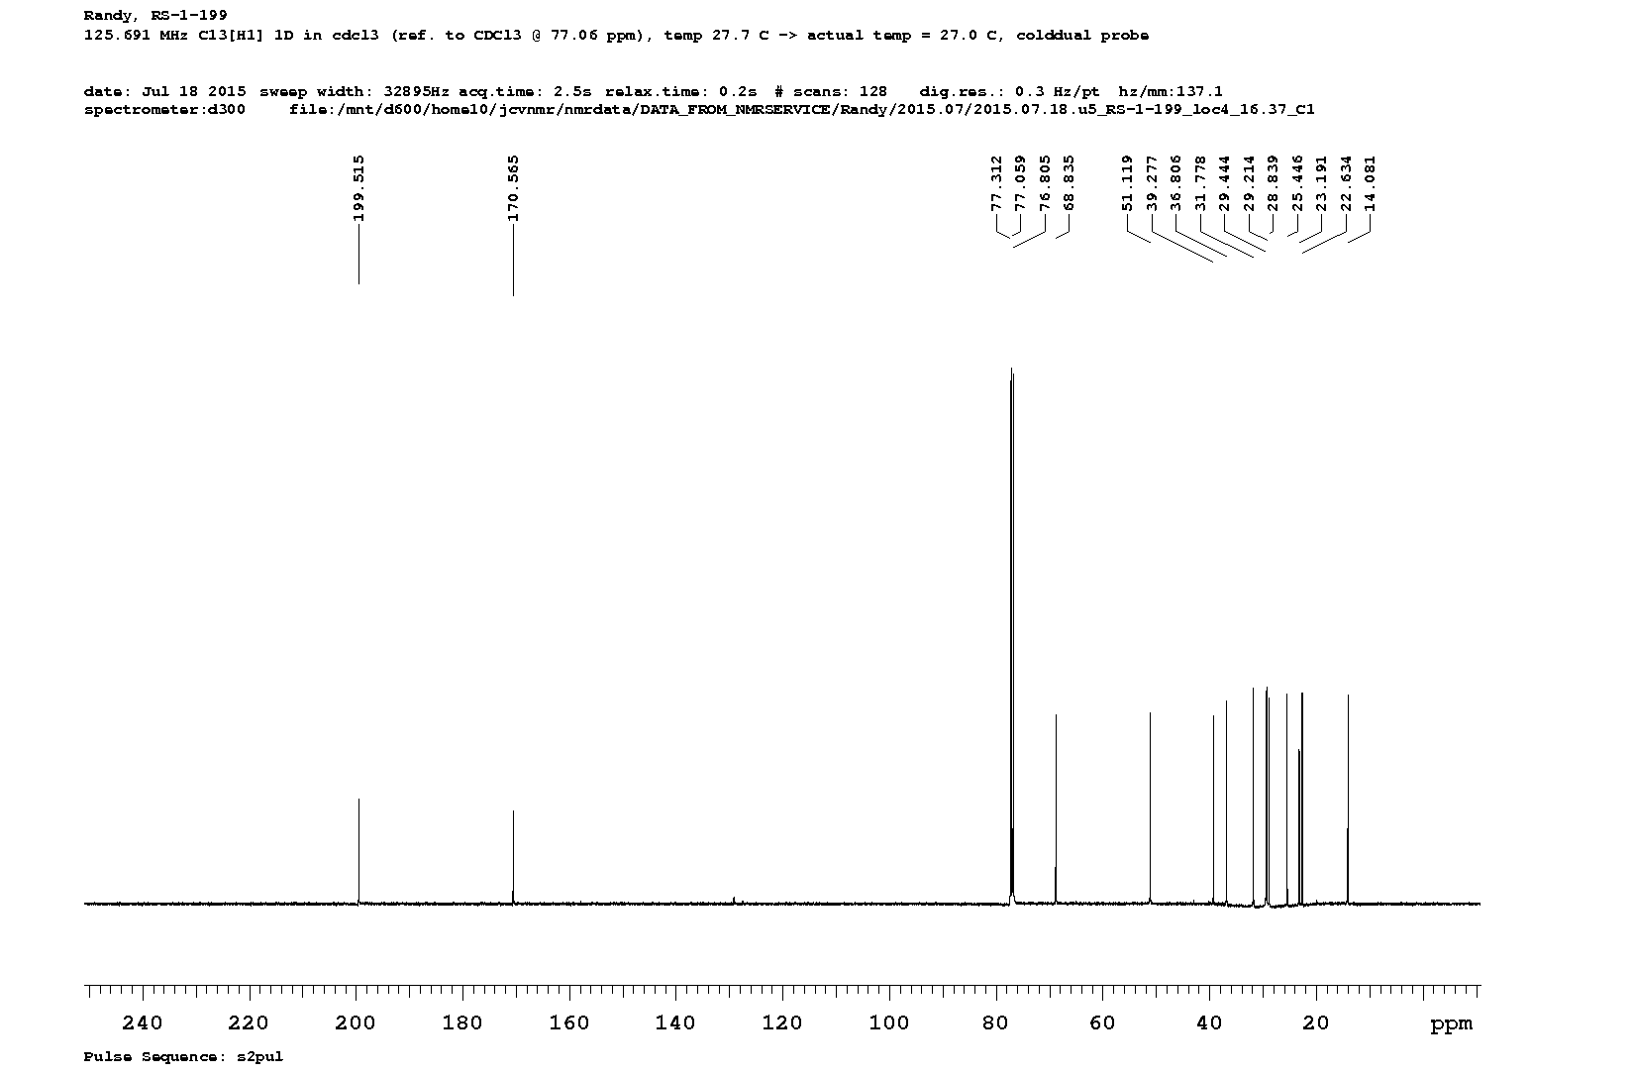

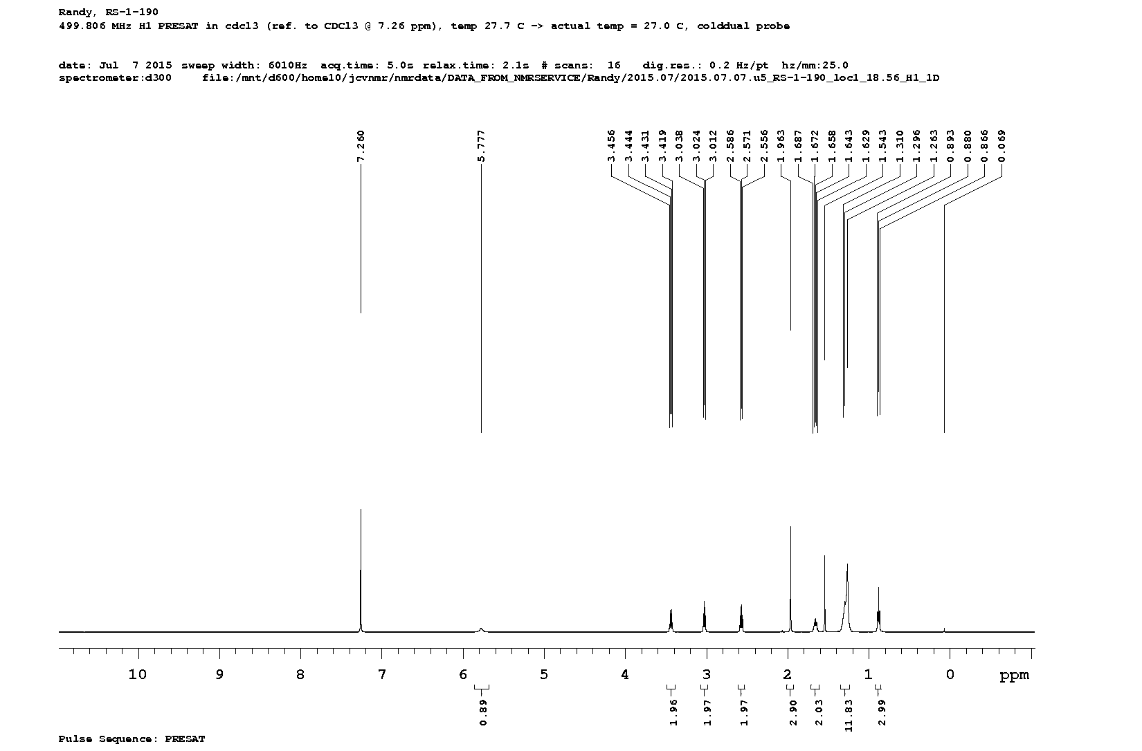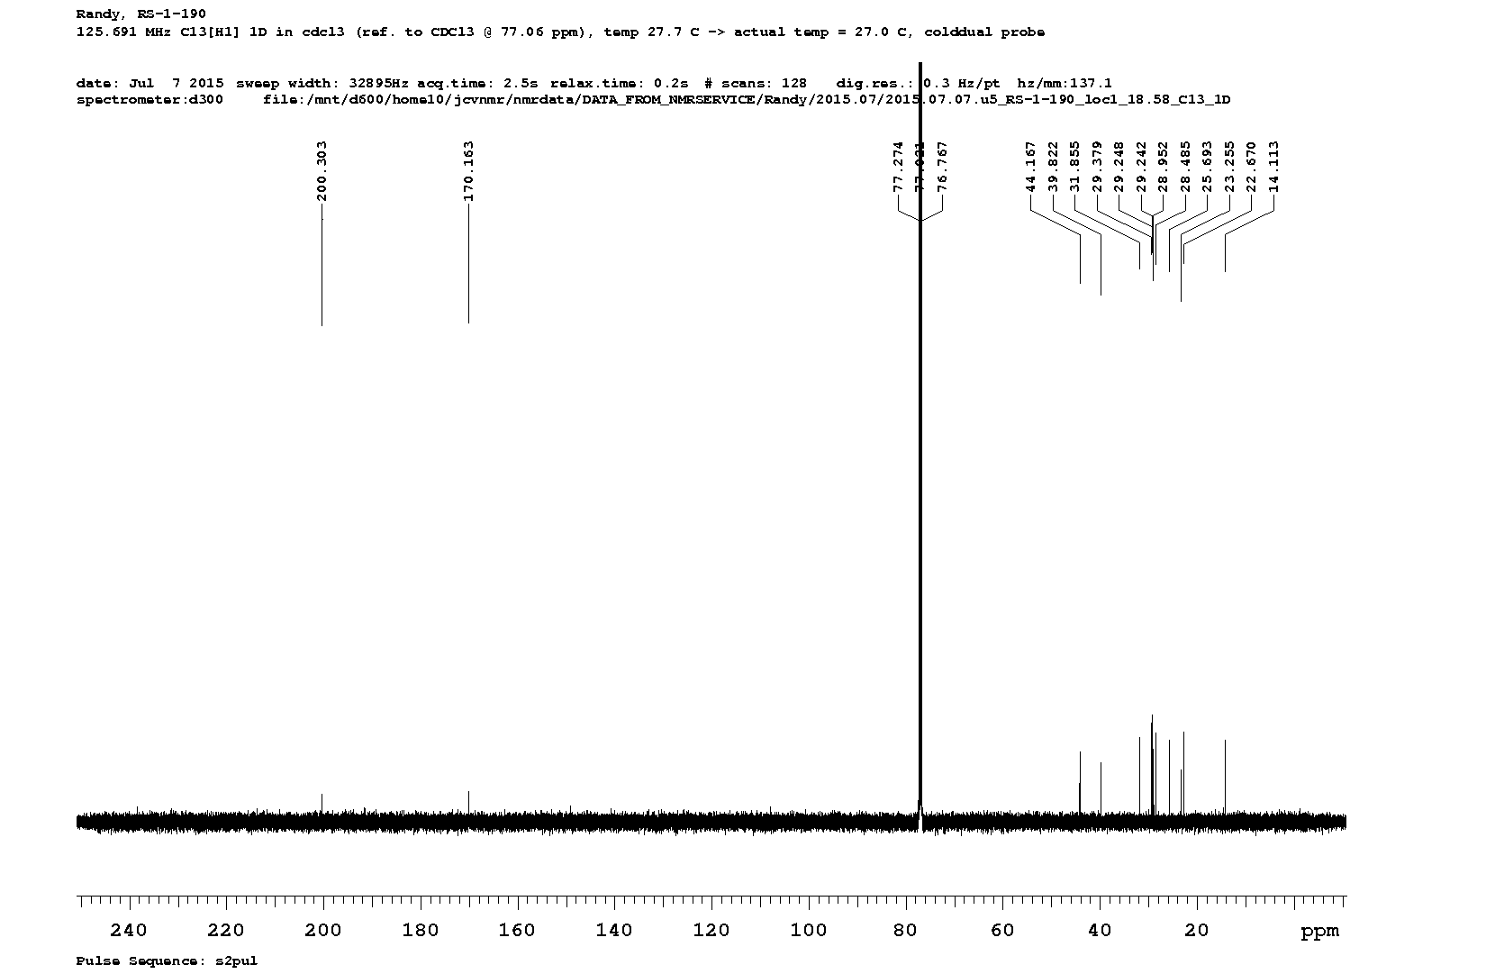
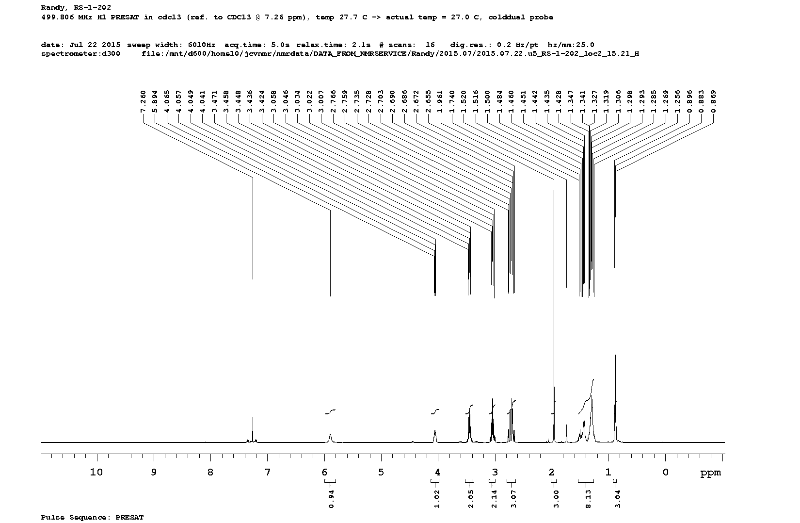
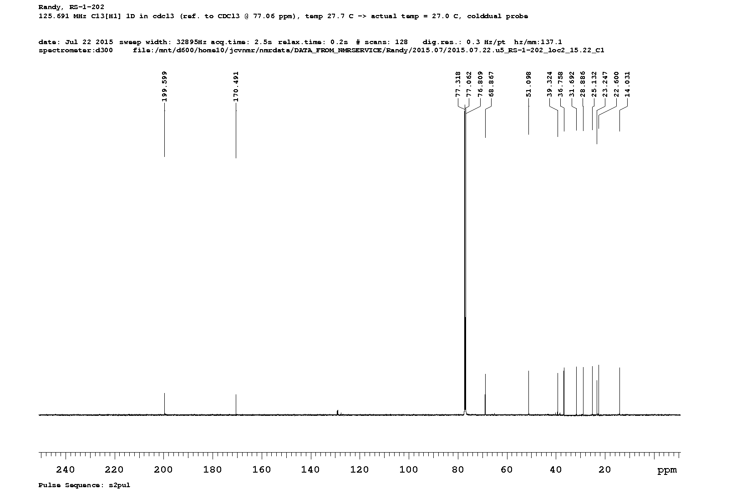

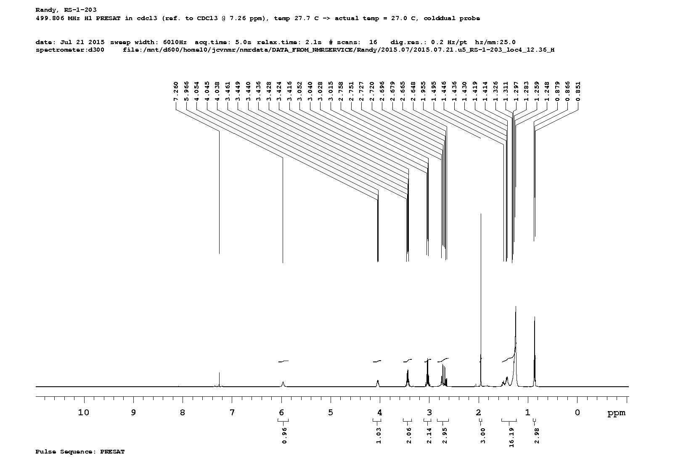
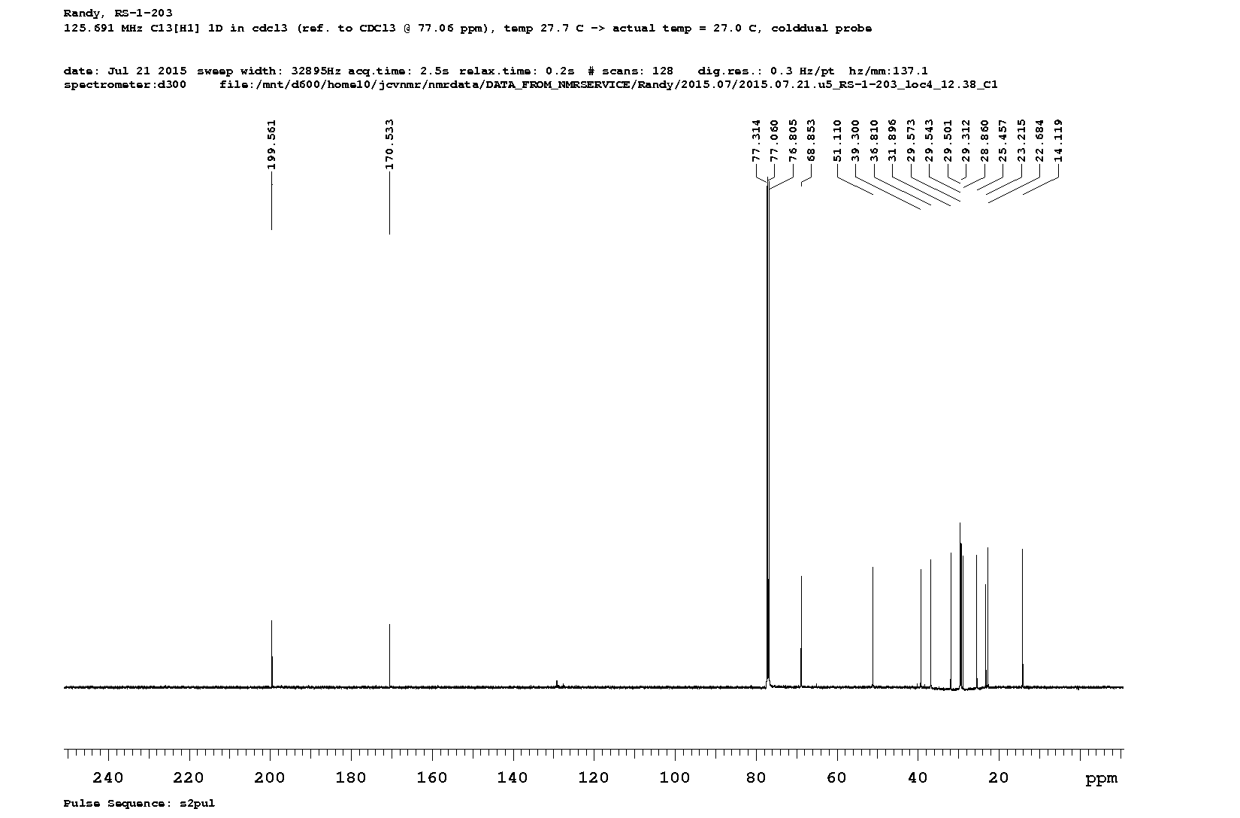
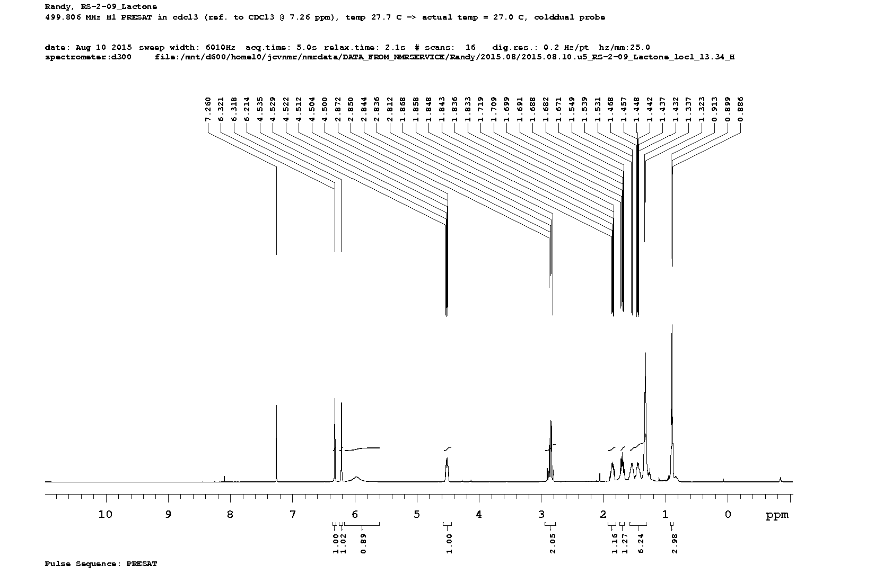
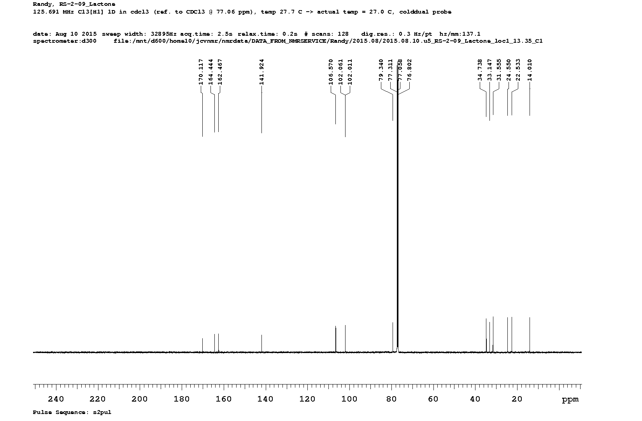

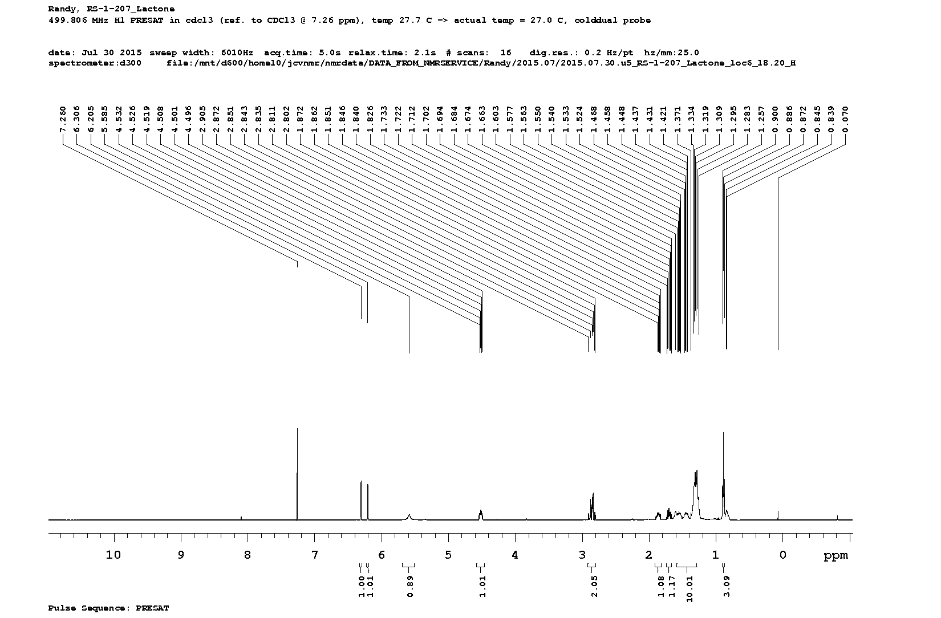
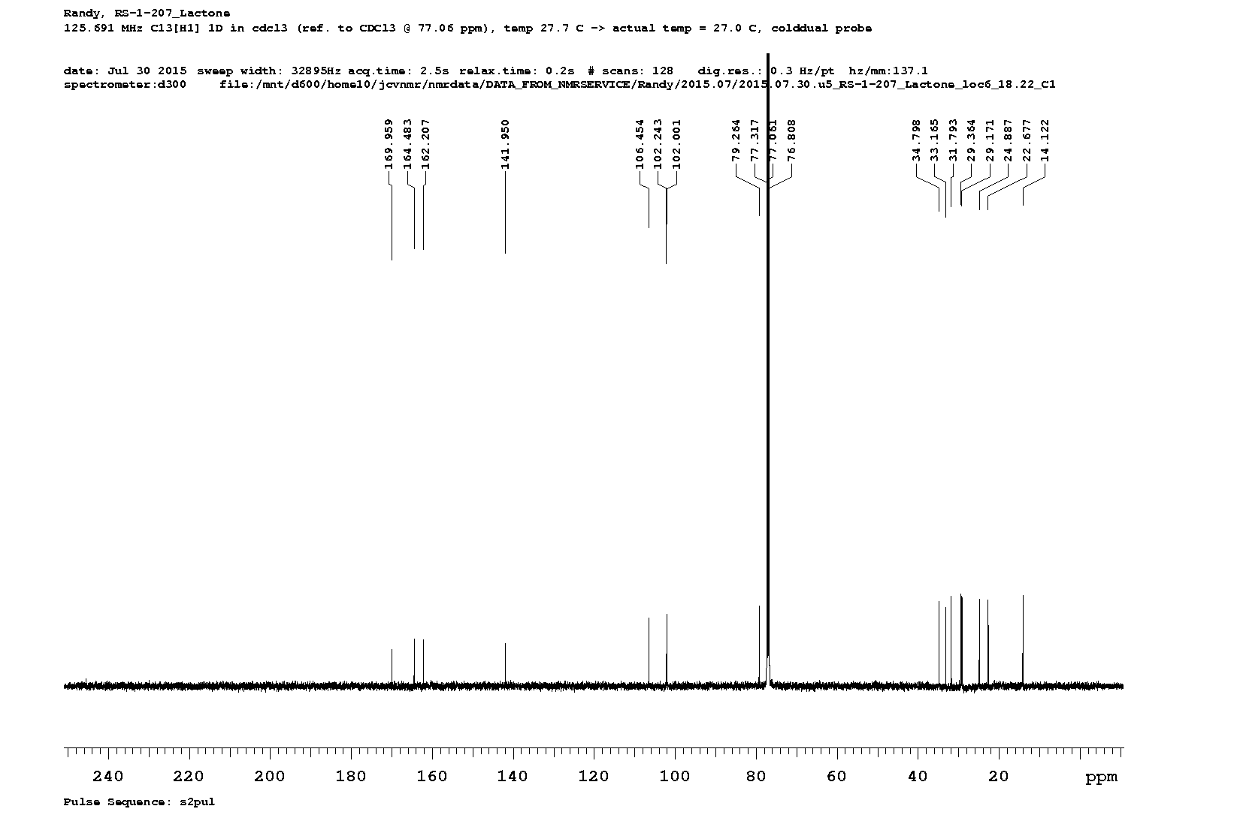
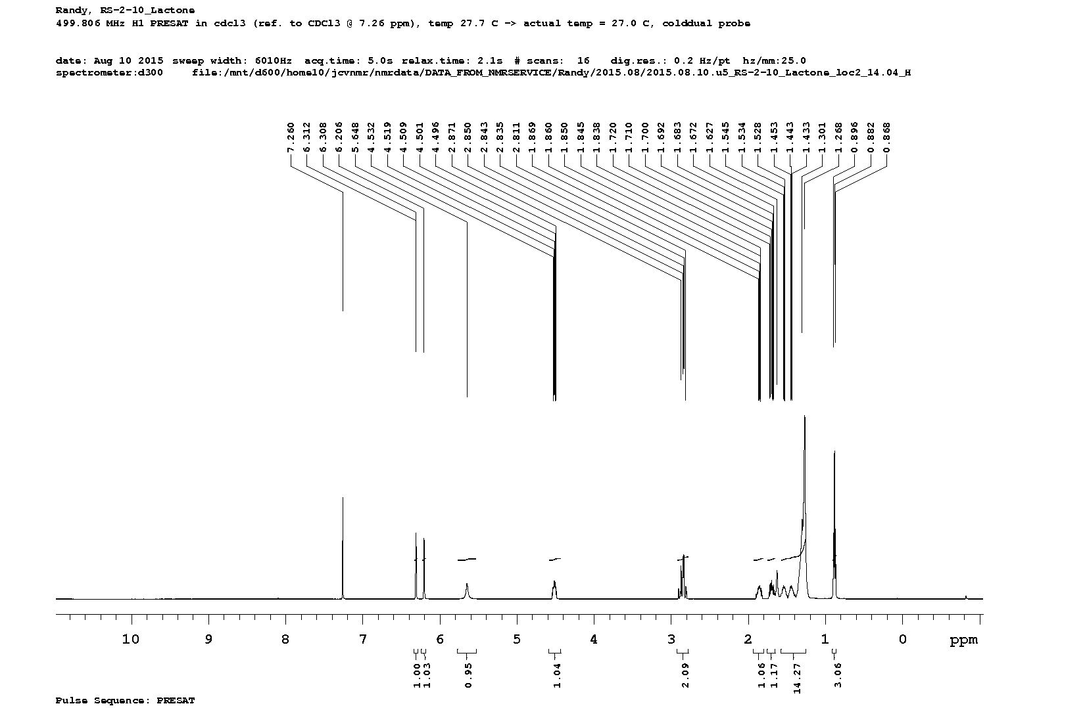
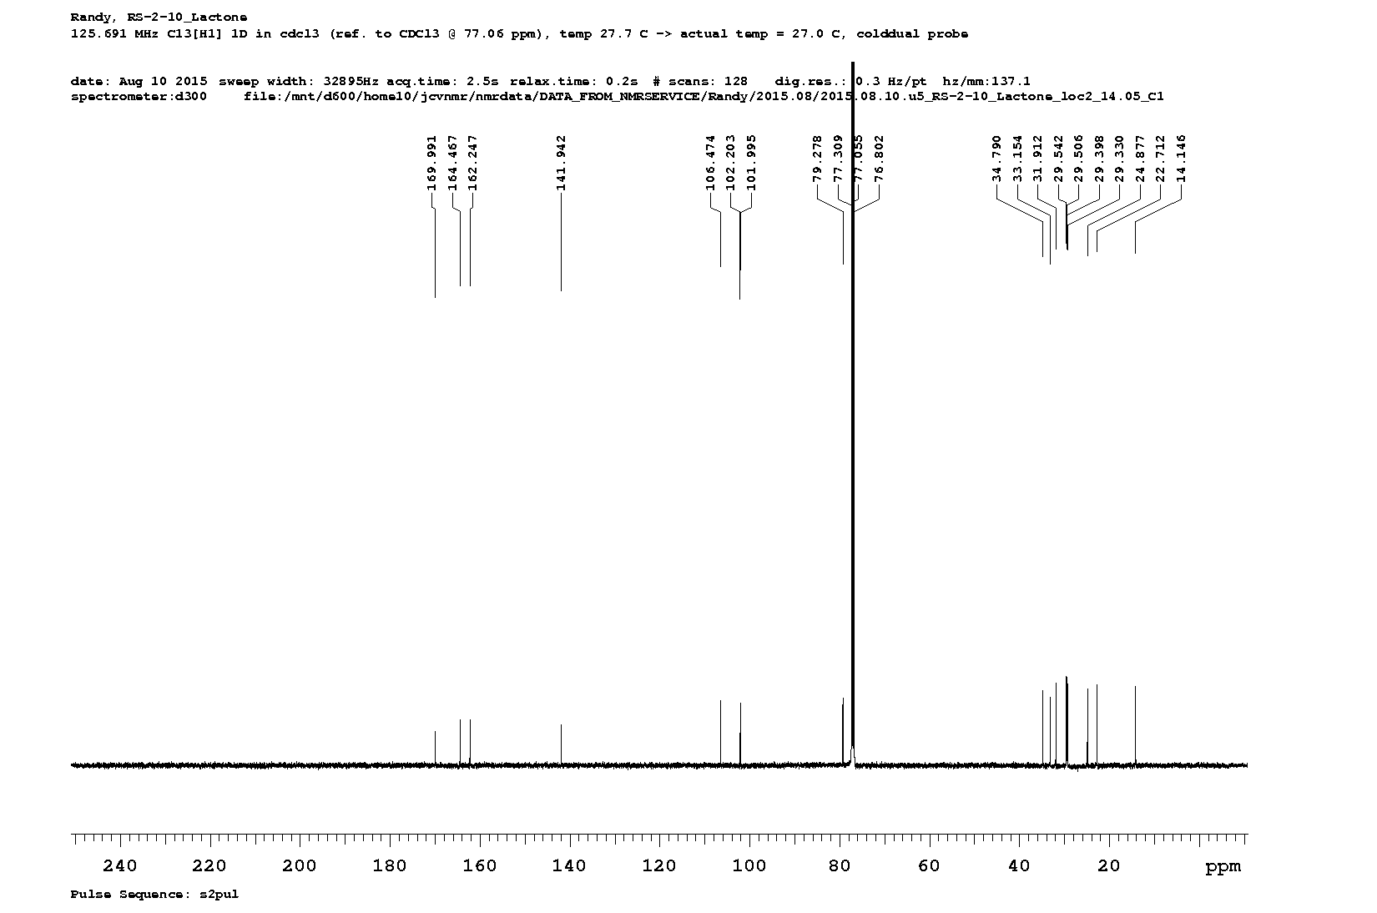
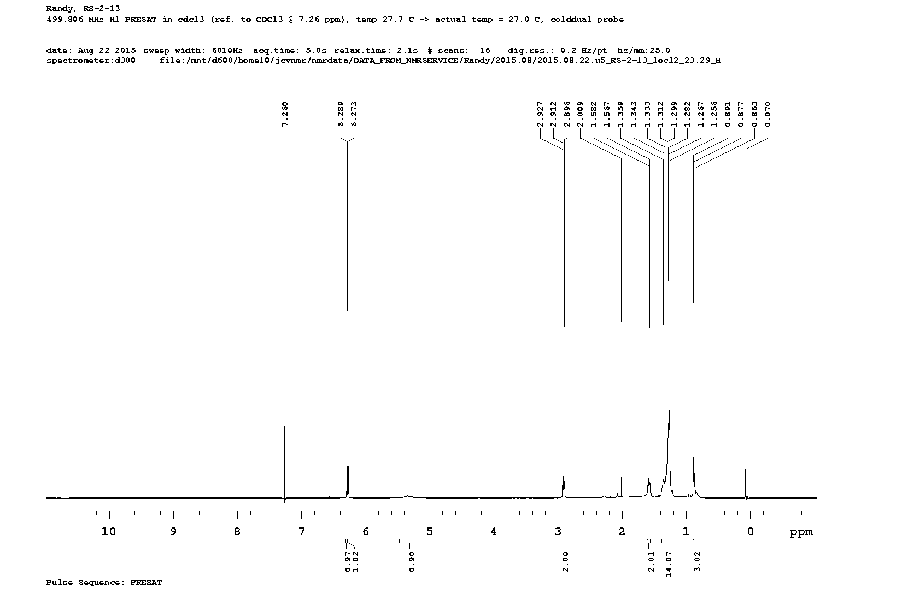
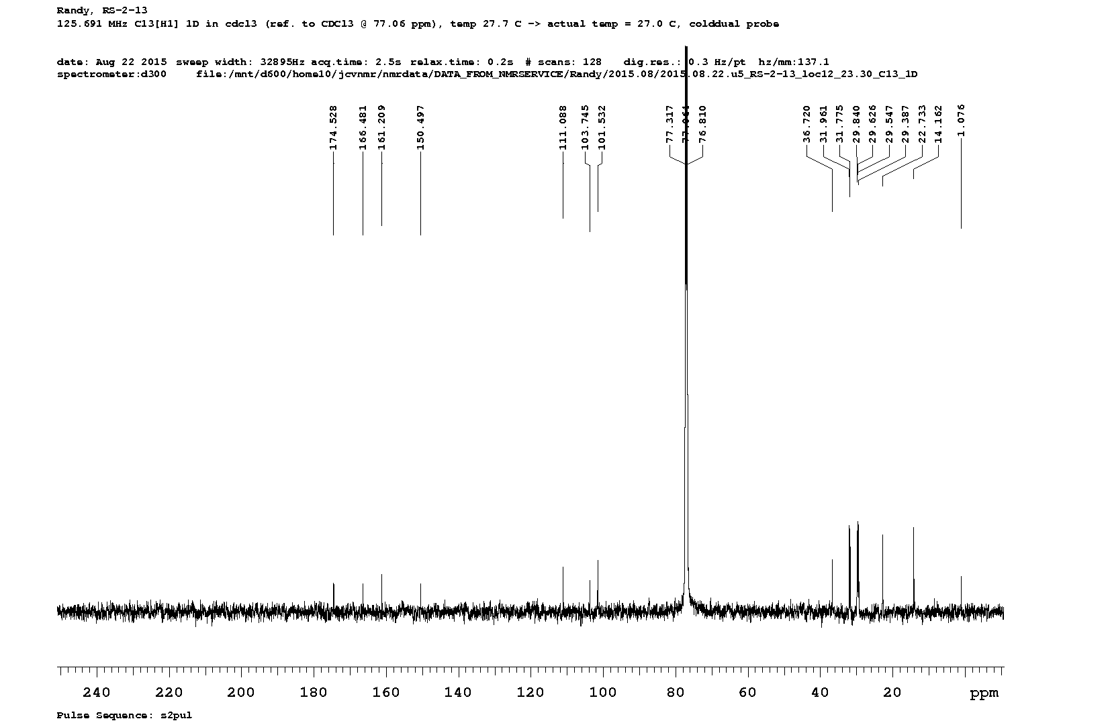

8. Supplementary Figures
cladosporin

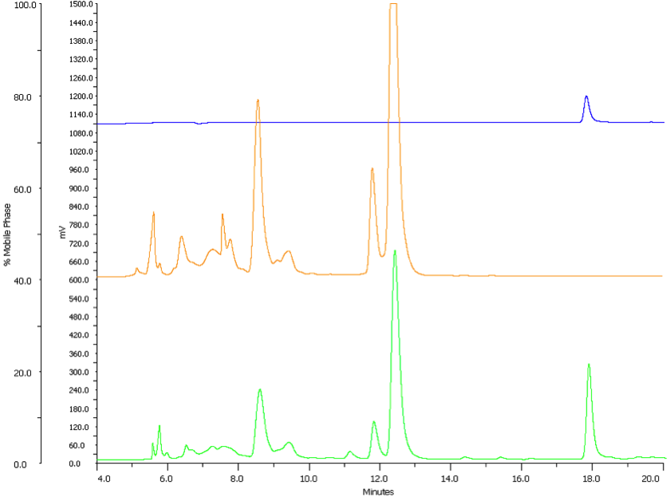
Figure S1. HPLC traces of cladosporin isolated from double transformants. The blue trace indicates 200 μ injection of cladosporin synthetic standard. The orange trace is from a 50 mL culture of Cla2 and Cla3 transformed cells grown in standard YPD (1% dextrose) media, roughly 0.3 mg/L of cladosporin was isolated from this reaction. When supplemented with 0.1% cyclopentanone and 1% NaOAc (green trace), the yield increased to 10 mg/L of cladosporin.
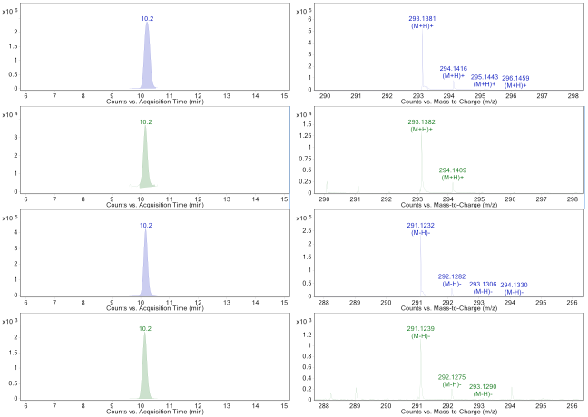
Figure S2. Extracted ion chromatograms (EICs) and mass spectra showing in vivo heterologous production of cladosporin. Cladosporin synthetic standard (blue) and cladosporin from extract (green) are shown in both positive and negative mode of ionizations. Results are representative of a technical duplicate.
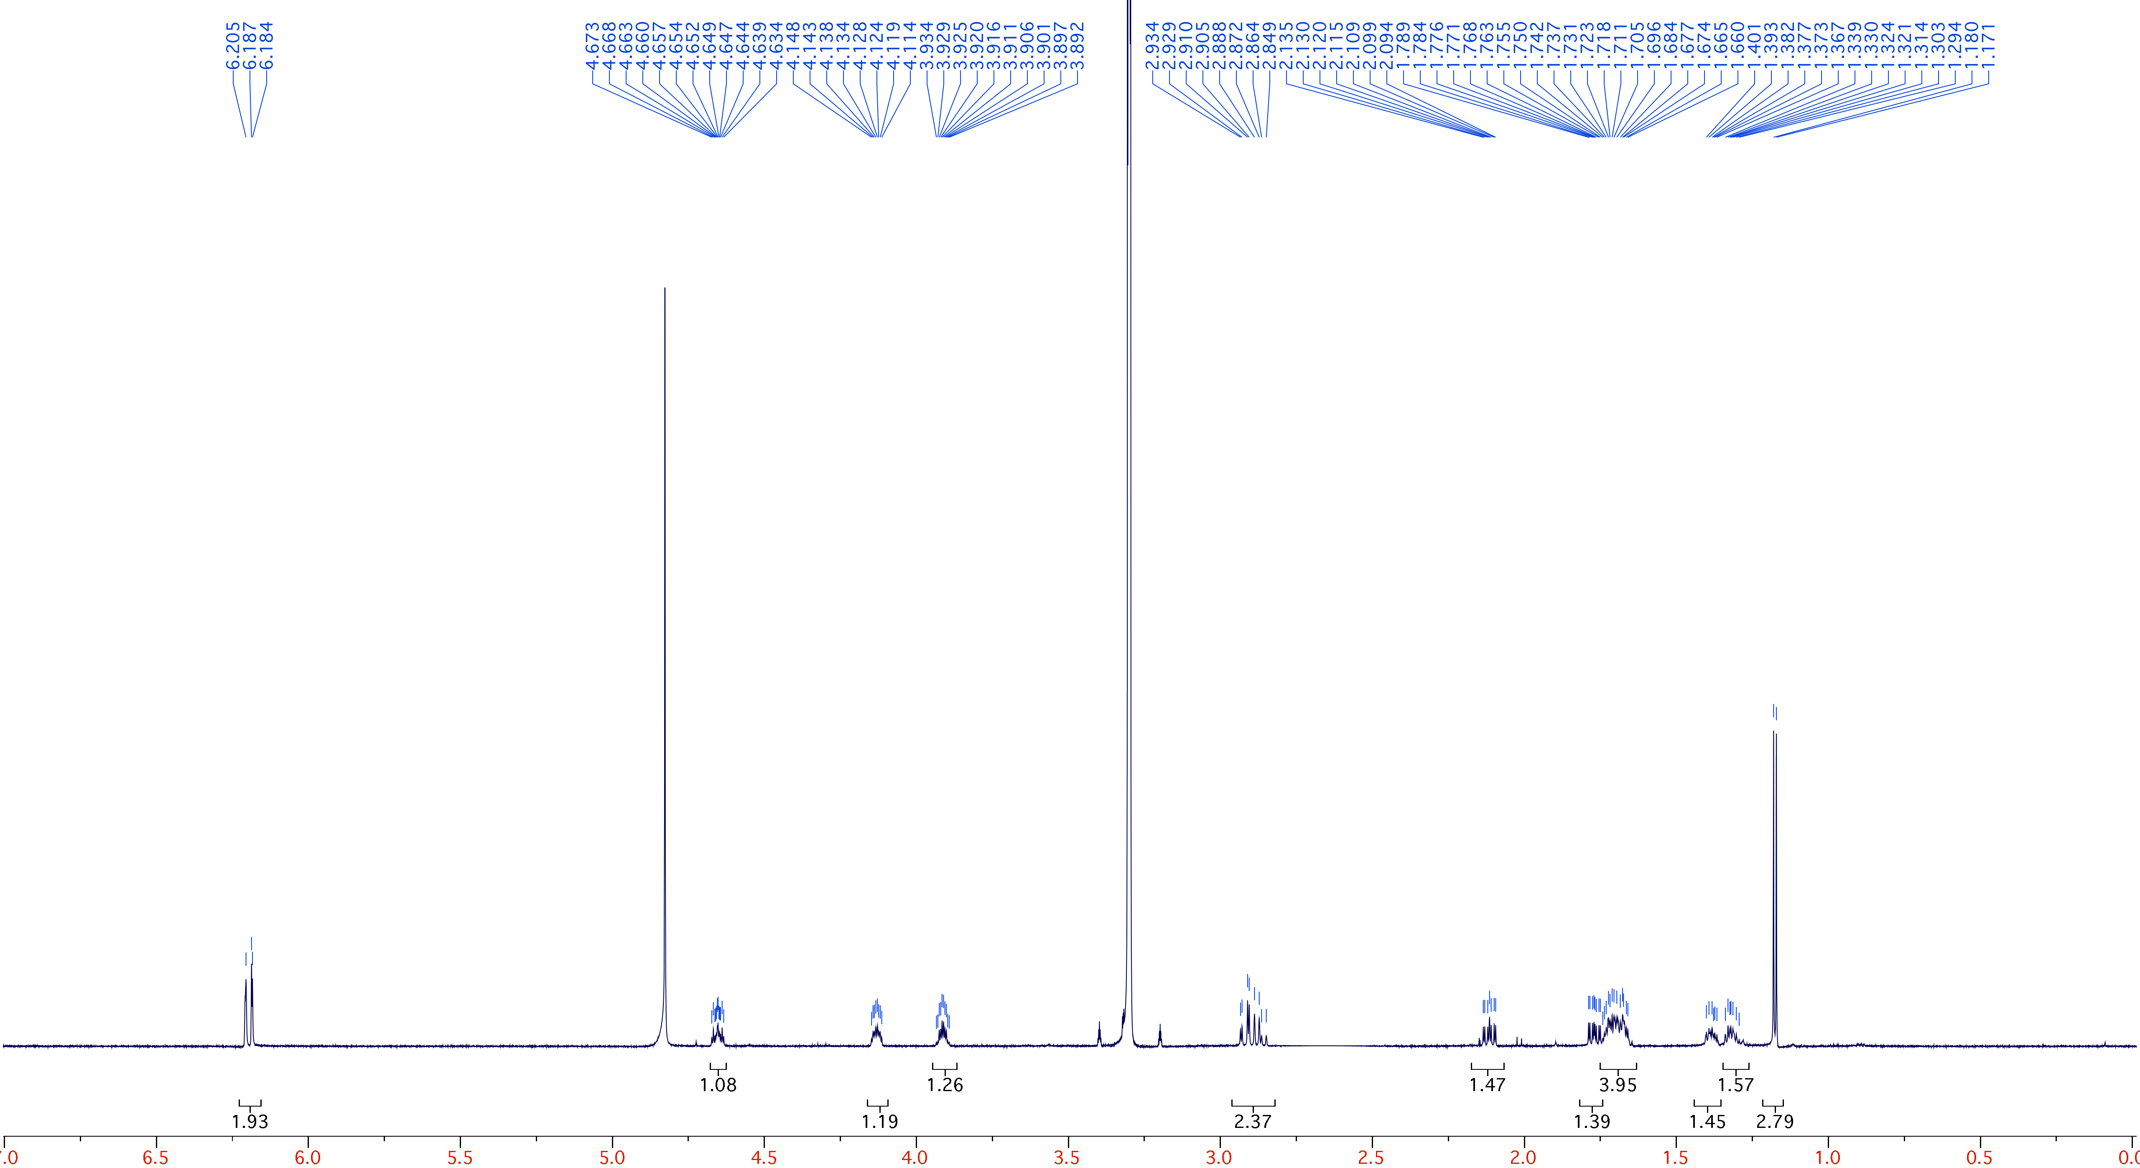
Figure S3. ¹H NMR of cladosporin isolated from double transformants.

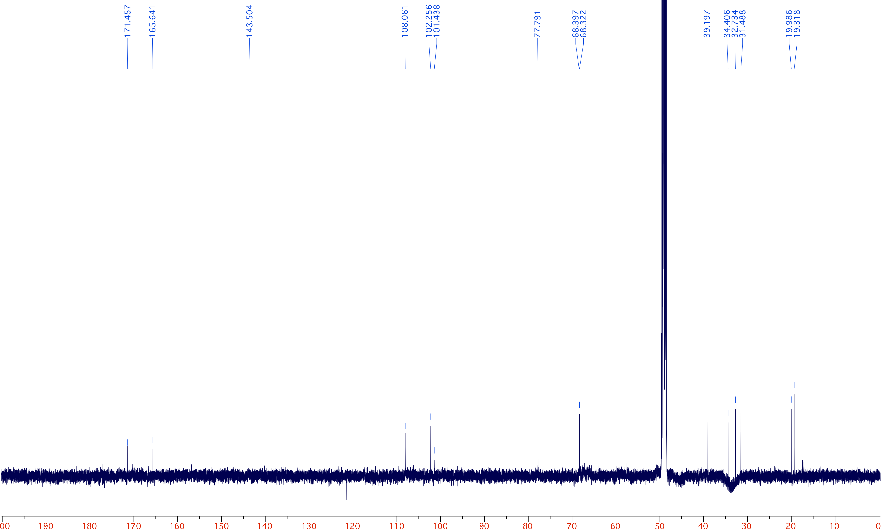
Figure S4. ¹³C NMR of cladosporin isolated from double transformants.
Cladosporin (1) [C₁₆H₂₀O₅] – ¹H NMR (700 MHz, CD₃OD)  6.21 – 6.18 (m, 2H, H-5, H-7), 4.67 – 4.63 (m, 1H, H-3), 4.15 – 4.11 (m, 1H, H-10), 3.93 – 3.89 (m, 1H, H-14), 2.93 – 2.85 (m, 2H, H-4), 2.14 – 2.09 (m, 1H, pro-S-H-9), 1.79 – 1.75 (m, 1H, pro-R-H-9), 1.74 – 1.66 (m, 4H, H-13, pro-R-H-11, H-12), 1.40 – 1.37 (m, 1H, pro-S-H-11), 1.34 – 1.29 (m, 1H, H-13), 1.18 (d, 3H, J = 6.3 Hz, H-15); ¹³C NMR (125 MHz, CD₃OD) 171.5, 165.6, 143.5, 108.1, 102.3, 101.4, 77.8, 68.4, 68.3, 39.2, 34.4, 32.7, 31.5, 20.0, 19.3.
Figure S5. Proposed formation of the tetrahydropyran (THP) ring during cladosporin biosynthesis.¹⁵ The THP ring can be formed by either a syn addition on a trans double bond, or an anti addition on a cis double bond, both of which are consistent with the stereochemistry observed at C9 (R) and C10 (R). This oxa-conjugate addition may be catalyzed by the DH domain of Cla2, based on recent observations my Hahn and co-workers.¹⁶

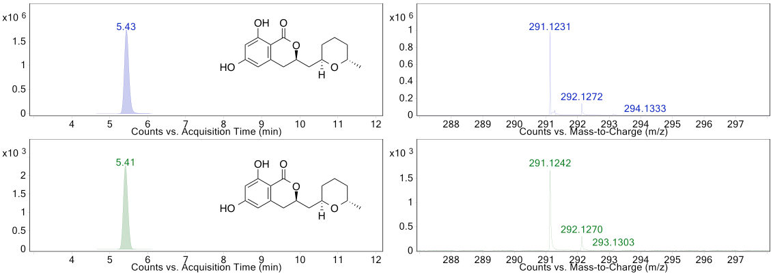
Figure S6. EIC and mass spectrum of cladosporin synthetic standard (blue) in comparison to extract from in vitro assay conducted with Cla3 and pentaketide (2) (green). Results are representative of a technical duplicate.

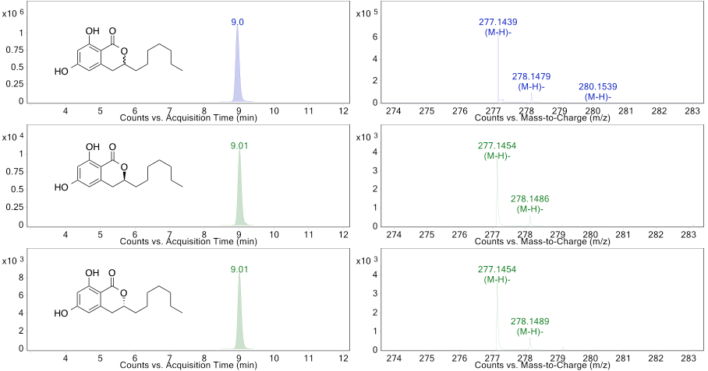
Figure S7. EIC and mass spectrum of synthetic decyl lactone standard 24 (blue) in comparison to extract from in vitro assay conducted with Cla3 and decyl analogs 16a and 16b (green). Results are representative of a technical duplicate.

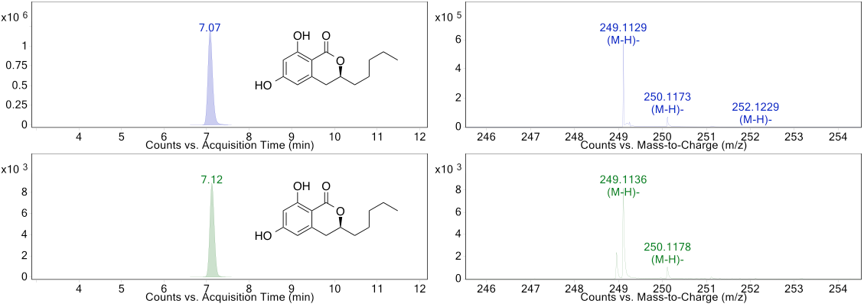
Figure S8. EIC and mass spectrum of synthetic octyl lactone standard 23 (blue) in comparison to extract from in vitro assay conducted with Cla3 and octyl analog 17 (green). Results are representative of a technical duplicate.

Figure S9. (A) Crystal structure of P. falciparum KRS1 with cladosporin (green) bound in the active site (PDB ID 4PG3).¹⁷ (B) Space filling model of Cla4 with cladosporin superimposed in the active site. The methyl group of Thr₃₃₄ has a steric clash with the methyl substituent of cladosporin. We prepared a homology model of Cla4 using I-TASSER wherein the software automatically selected human KRS1 (PDB ID 3BJU).¹⁸ Cla4 has a narrower active site cavity in comparison to P. falciparum KRS1, with Gln₃₁₈ and Thr₃₃₄ preventing binding of cladosporin in Cla4.

Figure S10. Side view of the active site cavity of Cla4 (pale blue) and P. falciparum KRS1 (pale yellow). The active site cavity of P. falciparum KRS1 is wider than that of Cla4, illustrated by the large amount of yellow surface area. The adenine ring of ATP binds in the green area shown, and the lysine-binding pocket is shown in red.
Figure S11. Active site of Cla4 with ATP docked. Gln₃₁₈ forms H-bonds with the phosphate groups of ATP. ATP also forms electrostatic interactions with the side chains of Arg₅₄₈ and Arg₃₂₀, as well as several backbone interactions.

9. Supplementary References

(1) Arnold, K.; Bordoli, L.; Kopp, J.; Schwede, T. Bioinformatics 2006, 22, 195.
(2) Bordoli, L.; Kiefer, F.; Arnold, K.; Benkert, P.; Battey, J.; Schwede, T. Nat. Protoc. 2009, 4, 1.
(3) Soding, J.; Biegert, A.; Lupas, A. N. Nucleic Acids Res. 2005, 33, W244.
(4) Soding, J. Bioinformatics 2005, 21, 951.
(5) Remmert, M.; Biegert, A.; Hauser, A.; Soding, J. Nat. Methods. 2012, 9, 173.
(6) Zheng, H.; Zhao, C.; Fang, B.; Jing, P.; Yang, J.; Xie, X.; She, X. J. Org. Chem. 2012, 77, 5656.
(7) Greenspoon, N.; Keinan, E. J. Org. Chem. 1988, 53, 3723.
(8) Zhou, H.; Gao, Z.; Qiao, K.; Wang, J.; Vederas, J. C.; Tang, Y. Nat. Chem. Biol. 2012, 8, 331-333.
(9) Zhou, H.; Zhan, J.; Watanabe, K.; Xie, X.; Tang, Y. Proc. Natl. Acad. Sci. U. S. A. 2008, 105, 6249.
(10) Kitir, B.; Baldry, M.; Ingmer, H.; Olsen, C. A. Tetrahedron 2014, 70, 7721.
(11) Arlt, A.; Koert, U. Synthesis 2010, 917.
(12) Gimbert, Y., Chevenier, E., Green, A.E., Massadier, C., Piettre, A. Process for preparing hypoxyxylerone derivatives and their therapeutic applications. Fr. EP1300403 A1, April 09, 2003.
(13) Tiouabi, M. Synthesis of the derivatives of natural isocoumarins, metabolites of the fungal pathogen Ceratocystis fimbriata sp. Ph.D. Dissertation, Institute of Chemistry University of Neuchatel, Neuchatel, Switzerland, 2005.
(14) Bode, S. E.; Drochner, D.; Muller, M. Angew. Chem. Int. Ed. Engl. 2007, 46, 5916.
(15) Rawlings, B. J.; Reese, P. B.; Ramer, S. E.; Vederas, J. C. J. Am. Chem. Soc. 1989, 111, 3382.
(16) Berkhan, G.; Hahn, F. Angew. Chem. Int. Ed. Engl. 2014, 53, 14240.
(17) Khan, S.; Sharma, A.; Belrhali, H.; Yogavel, M.; Sharma, A. J. Struct. Funct. Genomics 2014, 15, 63.
(18) Guo, M.; Ignatov, M.; Musier-Forsyth, K.; Schimmel, P.; Yang, X. L. Proc. Natl. Acad. Sci. U. S. A. 2008, 105, 2331.

