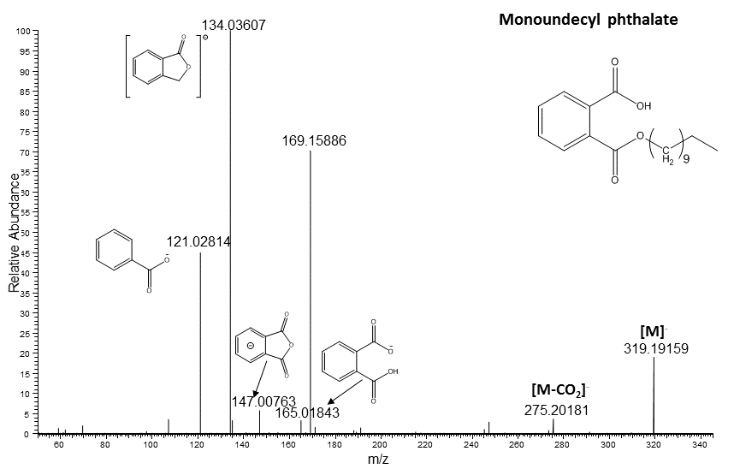

Figure 1S: High resolution mass spectrometric fragmentation of monoundecyl phthalate identified in human liver microsomes after *in vitro* metabolism of DUP.