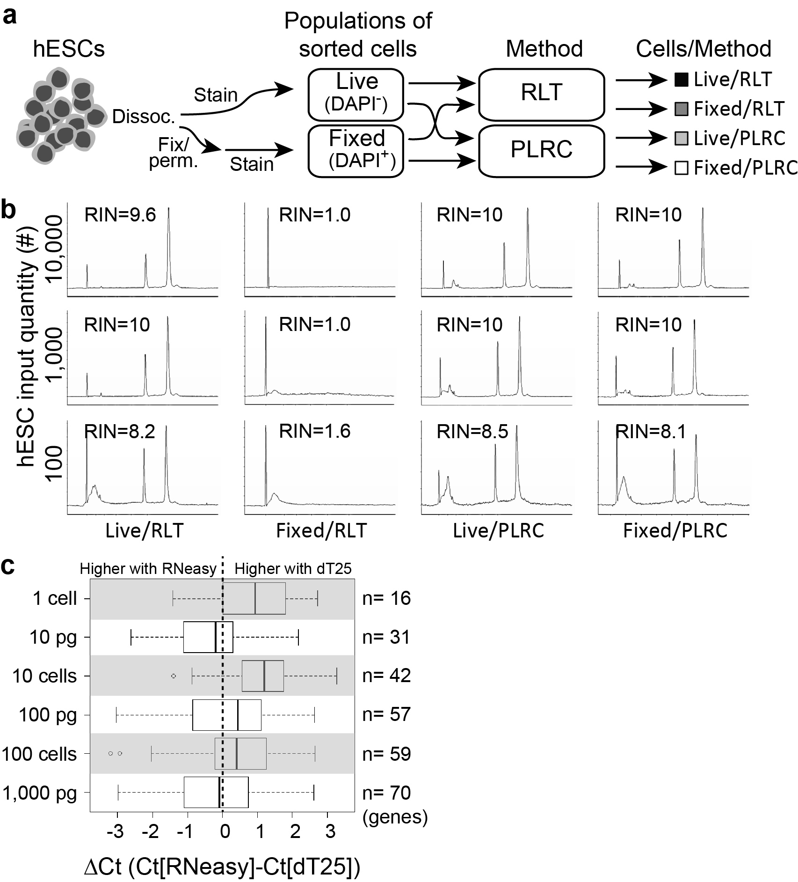
Supplementary Figure 1

Purification of RNA from populations of hESCs and bulk purified RNA.
(a) Schematic of the experiment comparing a modified RNA harvesting protocol to standard RNA purification protocol using live or fixed, stained and sorted H1 hES populations. Live or fixed and permeabilized cells were stained with DAPI, and RNA was harvested using either the Qiagen microRNeasy Kit (RLT), or using a modified fixed cell method with protease lysis and reverse crosslinking (PLRC). (b) Representative Bioanalyzer traces showing column purified total RNA from 10,000, 1,000, and 100 live or fixed, permeabilized and DAPI-stained H1 hESCs with or without reverse-crosslinking (Fixed and Live, respectively). Samples were diluted or concentrated so 66 cell equivalents were loaded per lane. (c) Comparison of gene expression between RNeasy columns and dT25 bead RNA purification techniques by qRT-PCR. Input samples were Human Brain Total RNA (white) and fixed H1 hESCs (gray). Data are from 5-6 biological replicates in at least 5 independent experiments, genes were only assessed if they we present in at least 3 samples.
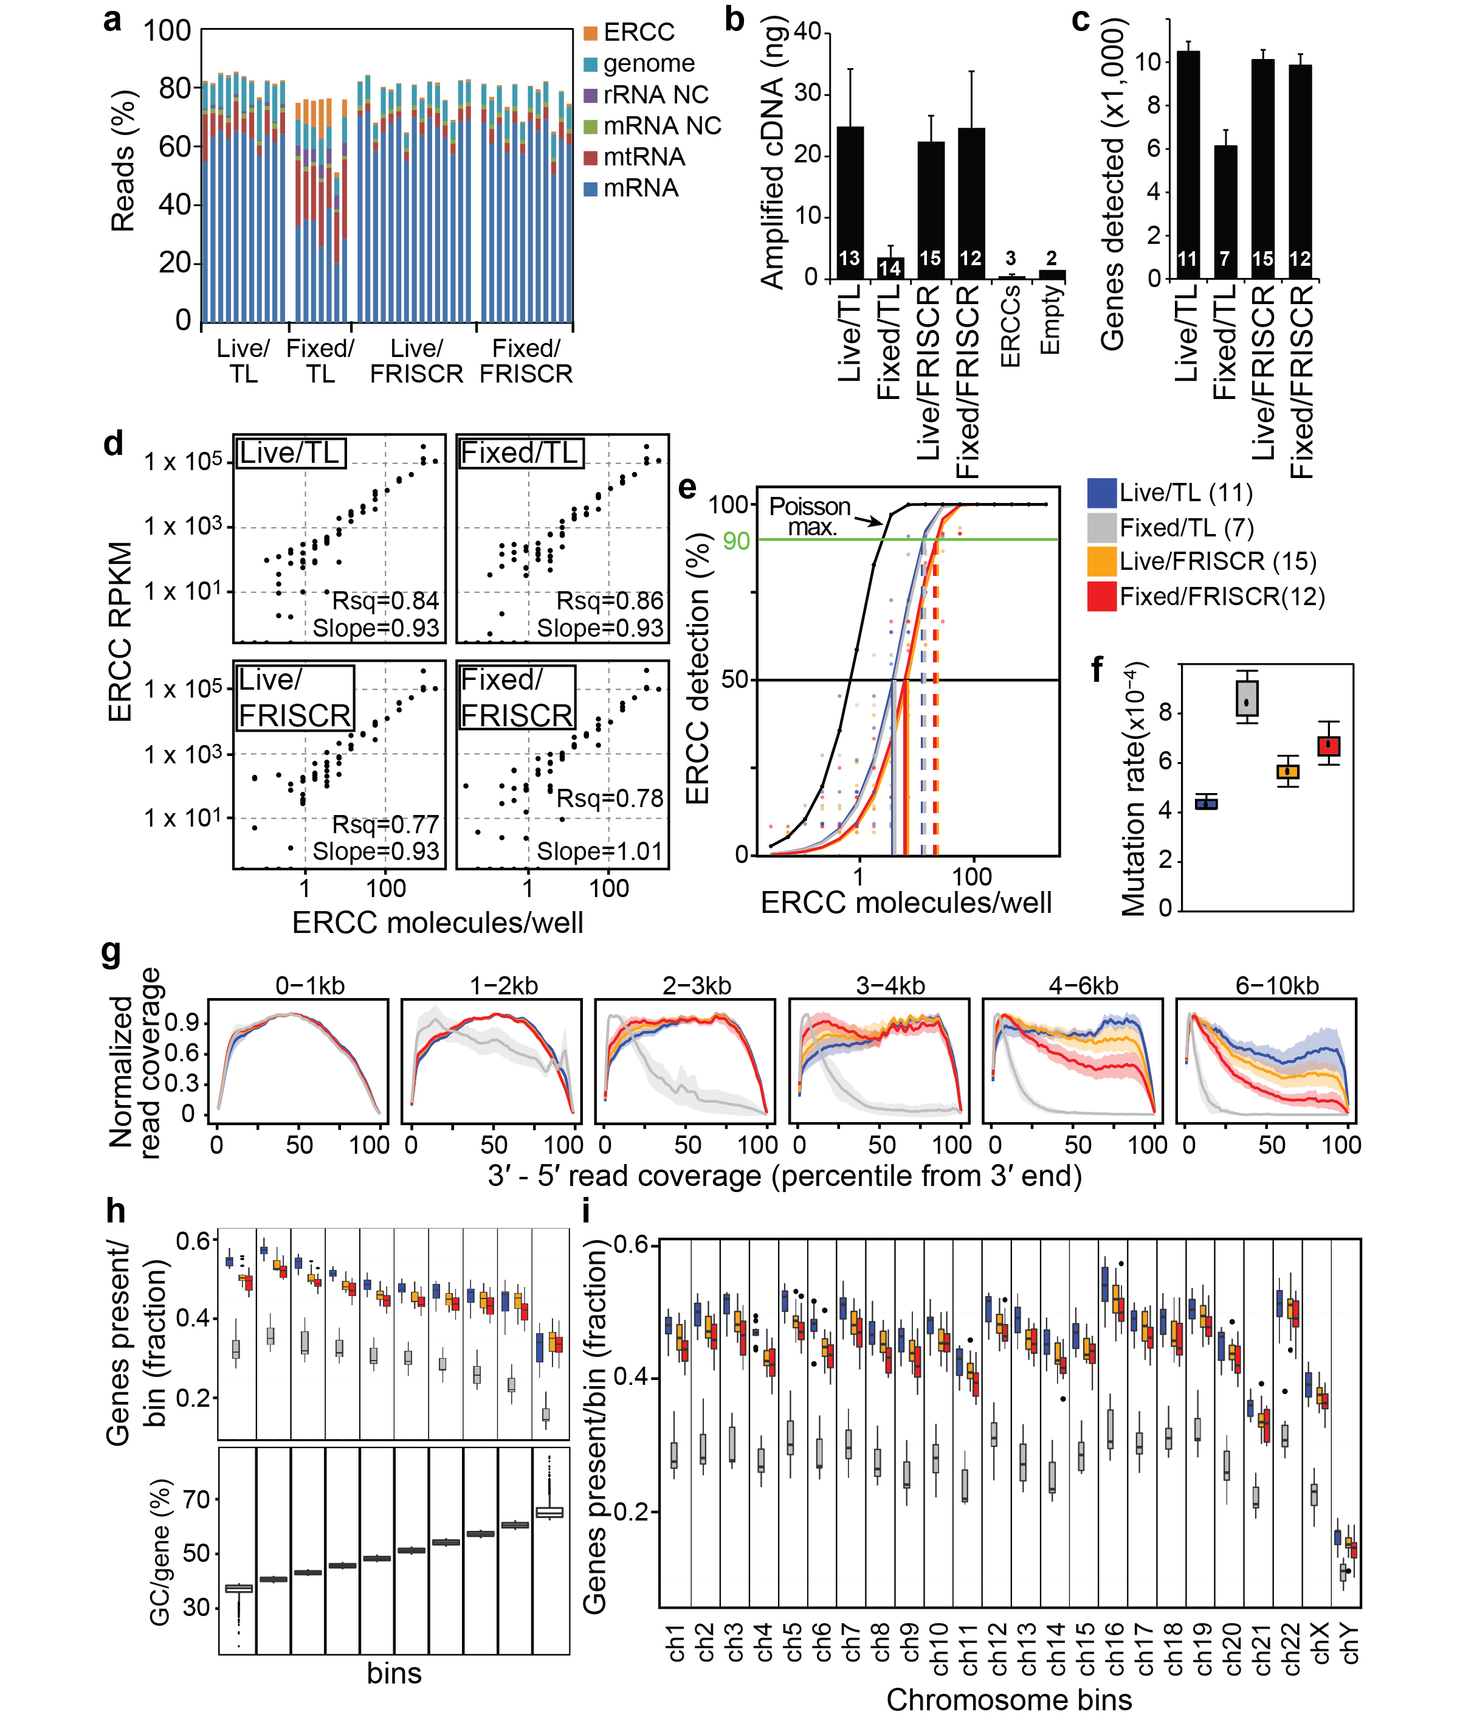
Supplementary Figure 2

Evaluation of FRISCR with single H1 hESCs.
Live or fixed single sorted H1 hESCs were prepared by standard Triton-X100 lysis (TL) or FRISCR, and sequenced after making SmartSeq2 cDNA libraries. (a) Bar plot shows read-mapping percentages for each cell. Single-cell libraries were sequenced to a moderate depth (7.0M reads +/- 0.9M). 100% is all barcoded reads independent of mapping. (b) Bar plot showing mean +/- SD of total cDNA yield amplified per cell using SmartSeq2. Numbers of single-cell samples are indicated on bars. Data is from two biological replicates except for Empty (water only) and ERCC only controls which are from one biological replicate. Analysis carried out in (c,e-i) is on libraries subsampled to 5 million reads. (c) Number of unique genes detected by RNA-Seq per cell with TPM > 0. (d) RPKM values of ERCC synthetic RNAs spiked-in at the time of cell collection. Data is the average value of each ERCC RNA for all single cells per experimental preparation. RPKM only takes into account ERCC mapped reads, and the mean slope and Rsq values are shown. All conditions show strong linearity. (e) Percentage of times an ERCC RNA molecule was detected in a sample. Each curve is fitted to the data points and assumes a Poisson distribution of ERCC molecules. The black line indicates the % detection if recovery is 100% and dilution follows Poisson statistics. To detect a species 50% of the time, RNA must be present at ~3.8, ~4.1, ~6.8, and ~6.1 copies for Live/TL, Fixed/TL, Live/FRISCR, and Fixed/FRISCR samples respectively. Color scheme and sample numbers apply to panels e-i. (f) Mutation rate in the single-cell gene expression data. (g) Normalized average read counts per experimental preparation are shown across the percentile predicted transcript length (3′ to 5′). Solid line represents the average and shading is the SD. Note Fixed/FRISCR prepared cells show more 3′ bias than Live/TL or Live/FRISCR cells with longer transcripts. (h) Boxplot showing the fraction of genes detected out of all annotated genes for the given GC bin (bottom plot) with TPM > 0. (i) Boxplot showing the fraction of genes expressed out of all annotated genes from the indicated chromosome with TPM > 0. All boxplots show the median as a central line, the second and third quartiles as boxes, the “whiskers” extend to the highest/lowest value within the 1.5 interquartile range, and data points outside the range are indicated as dots.
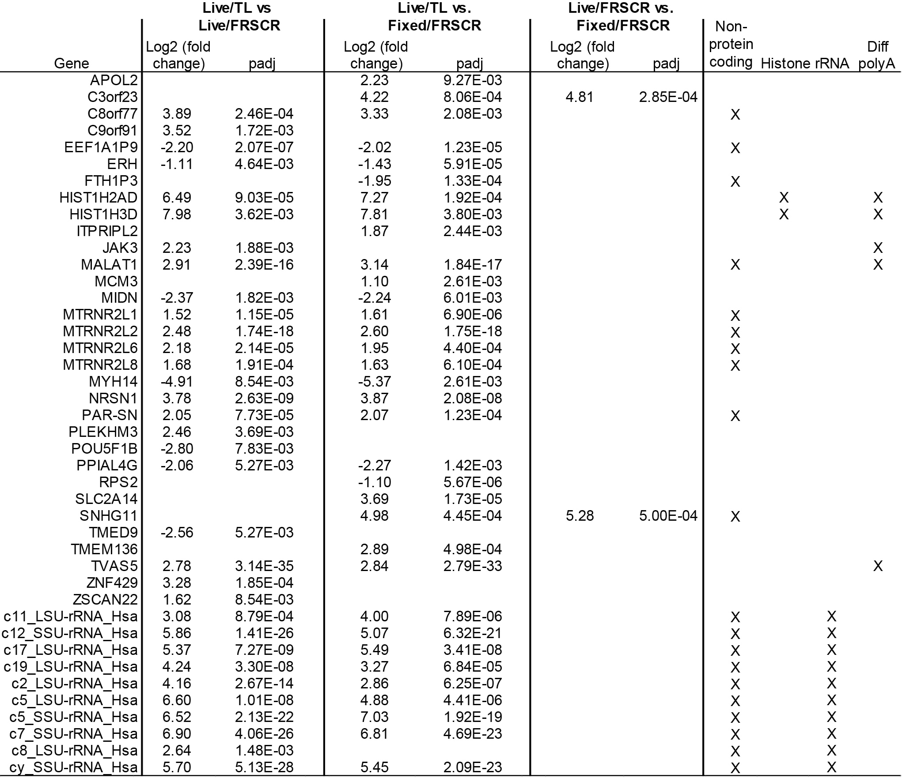
Supplementary Figure 3

Table of genes differentially expressed in hESCs between experimental conditions.
Differential expression is based on DESeq. Tables show significantly differentially expressed genes (Padj < 0.01) from single cell comparisons between Live/TL versus Live/FRISCR samples, Live/TL versus Fixed/FRISCR samples, and Live/FRISCR versus Fixed/FRISCR. Non protein-coding, Histone, rRNA genes are indicated, as well as genes previously shown to undergo differential polyadenylation²⁰. Fixed/TL comparisons are not show because the number of differentially expressed genes detected were too high to present in the summary table.
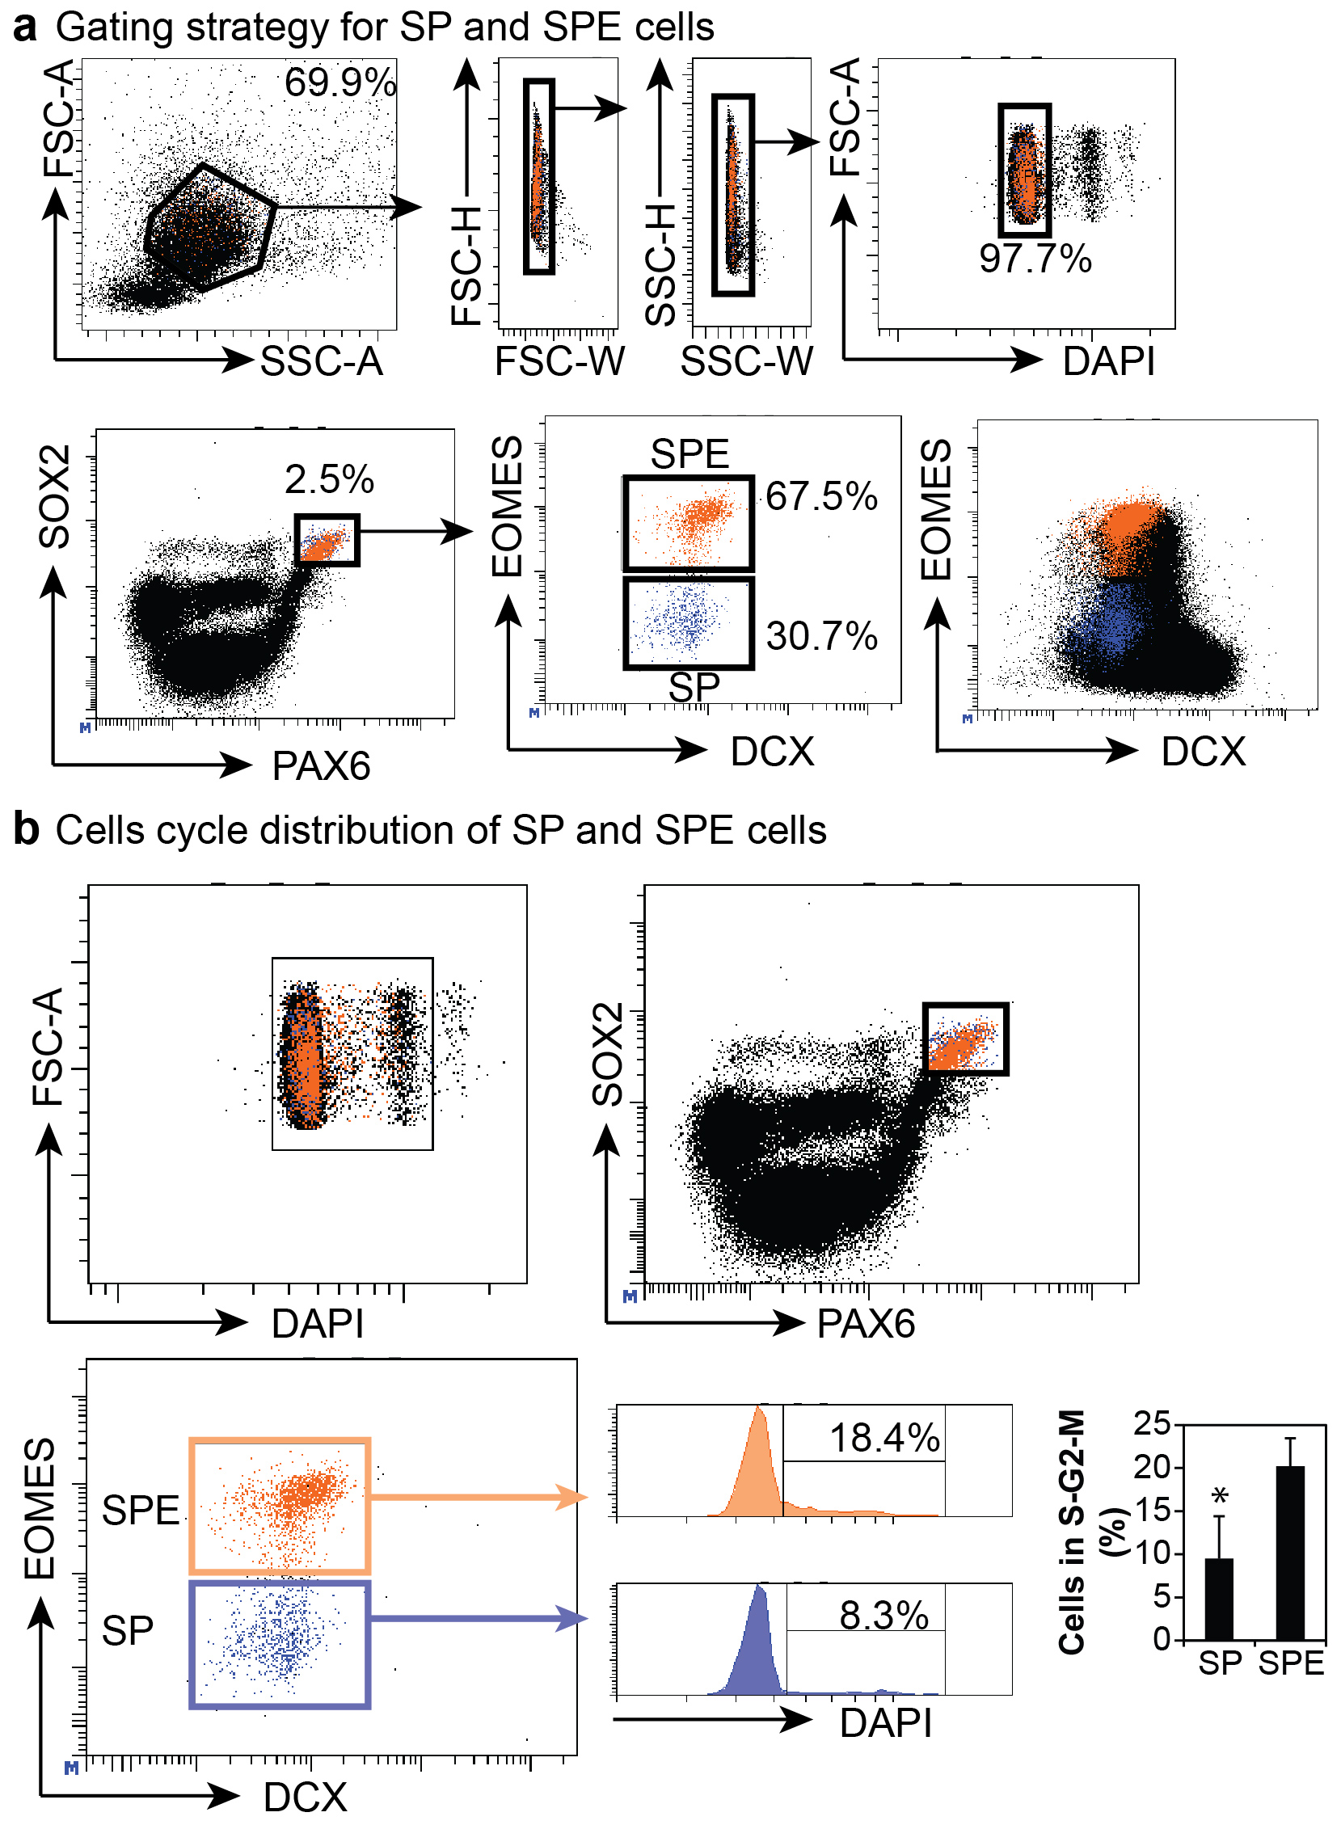
Supplementary Figure 4

Gating strategy for prospective isolation and profiling of human cortical progenitor cells.
(a) Representative images of the entire gating strategy for the isolation of the SP and SPE cells. Top row: cells are gated for morphology, then single cells, and lastly for the presence of DAPI. Note only cells in the G₀-G₁ phase of the cell cycle were sorted. Bottom row: Progenitors were first identified by high expression of SOX2 and PAX6, and then by the presence (orange) or absence (blue) of EOMES. Bottom right: Projection of progenitor populations on all cells gated by the strategy on the top row and stained for EOMES and DCX show that SP and SPE progenitors are negative for DCX. (b) Representative SP and SPE cells were irrespective of cell cycle phase. SP and SPE were subsequently evaluated for DAPI fluorescence. Quantitation of cells in S-G₂-M from three independent prenatal tissues (between 14 and 19 PCW) showed a significant 2-fold difference between SP and SPE cells.* = P < 0.05, homoscedastic t-test.
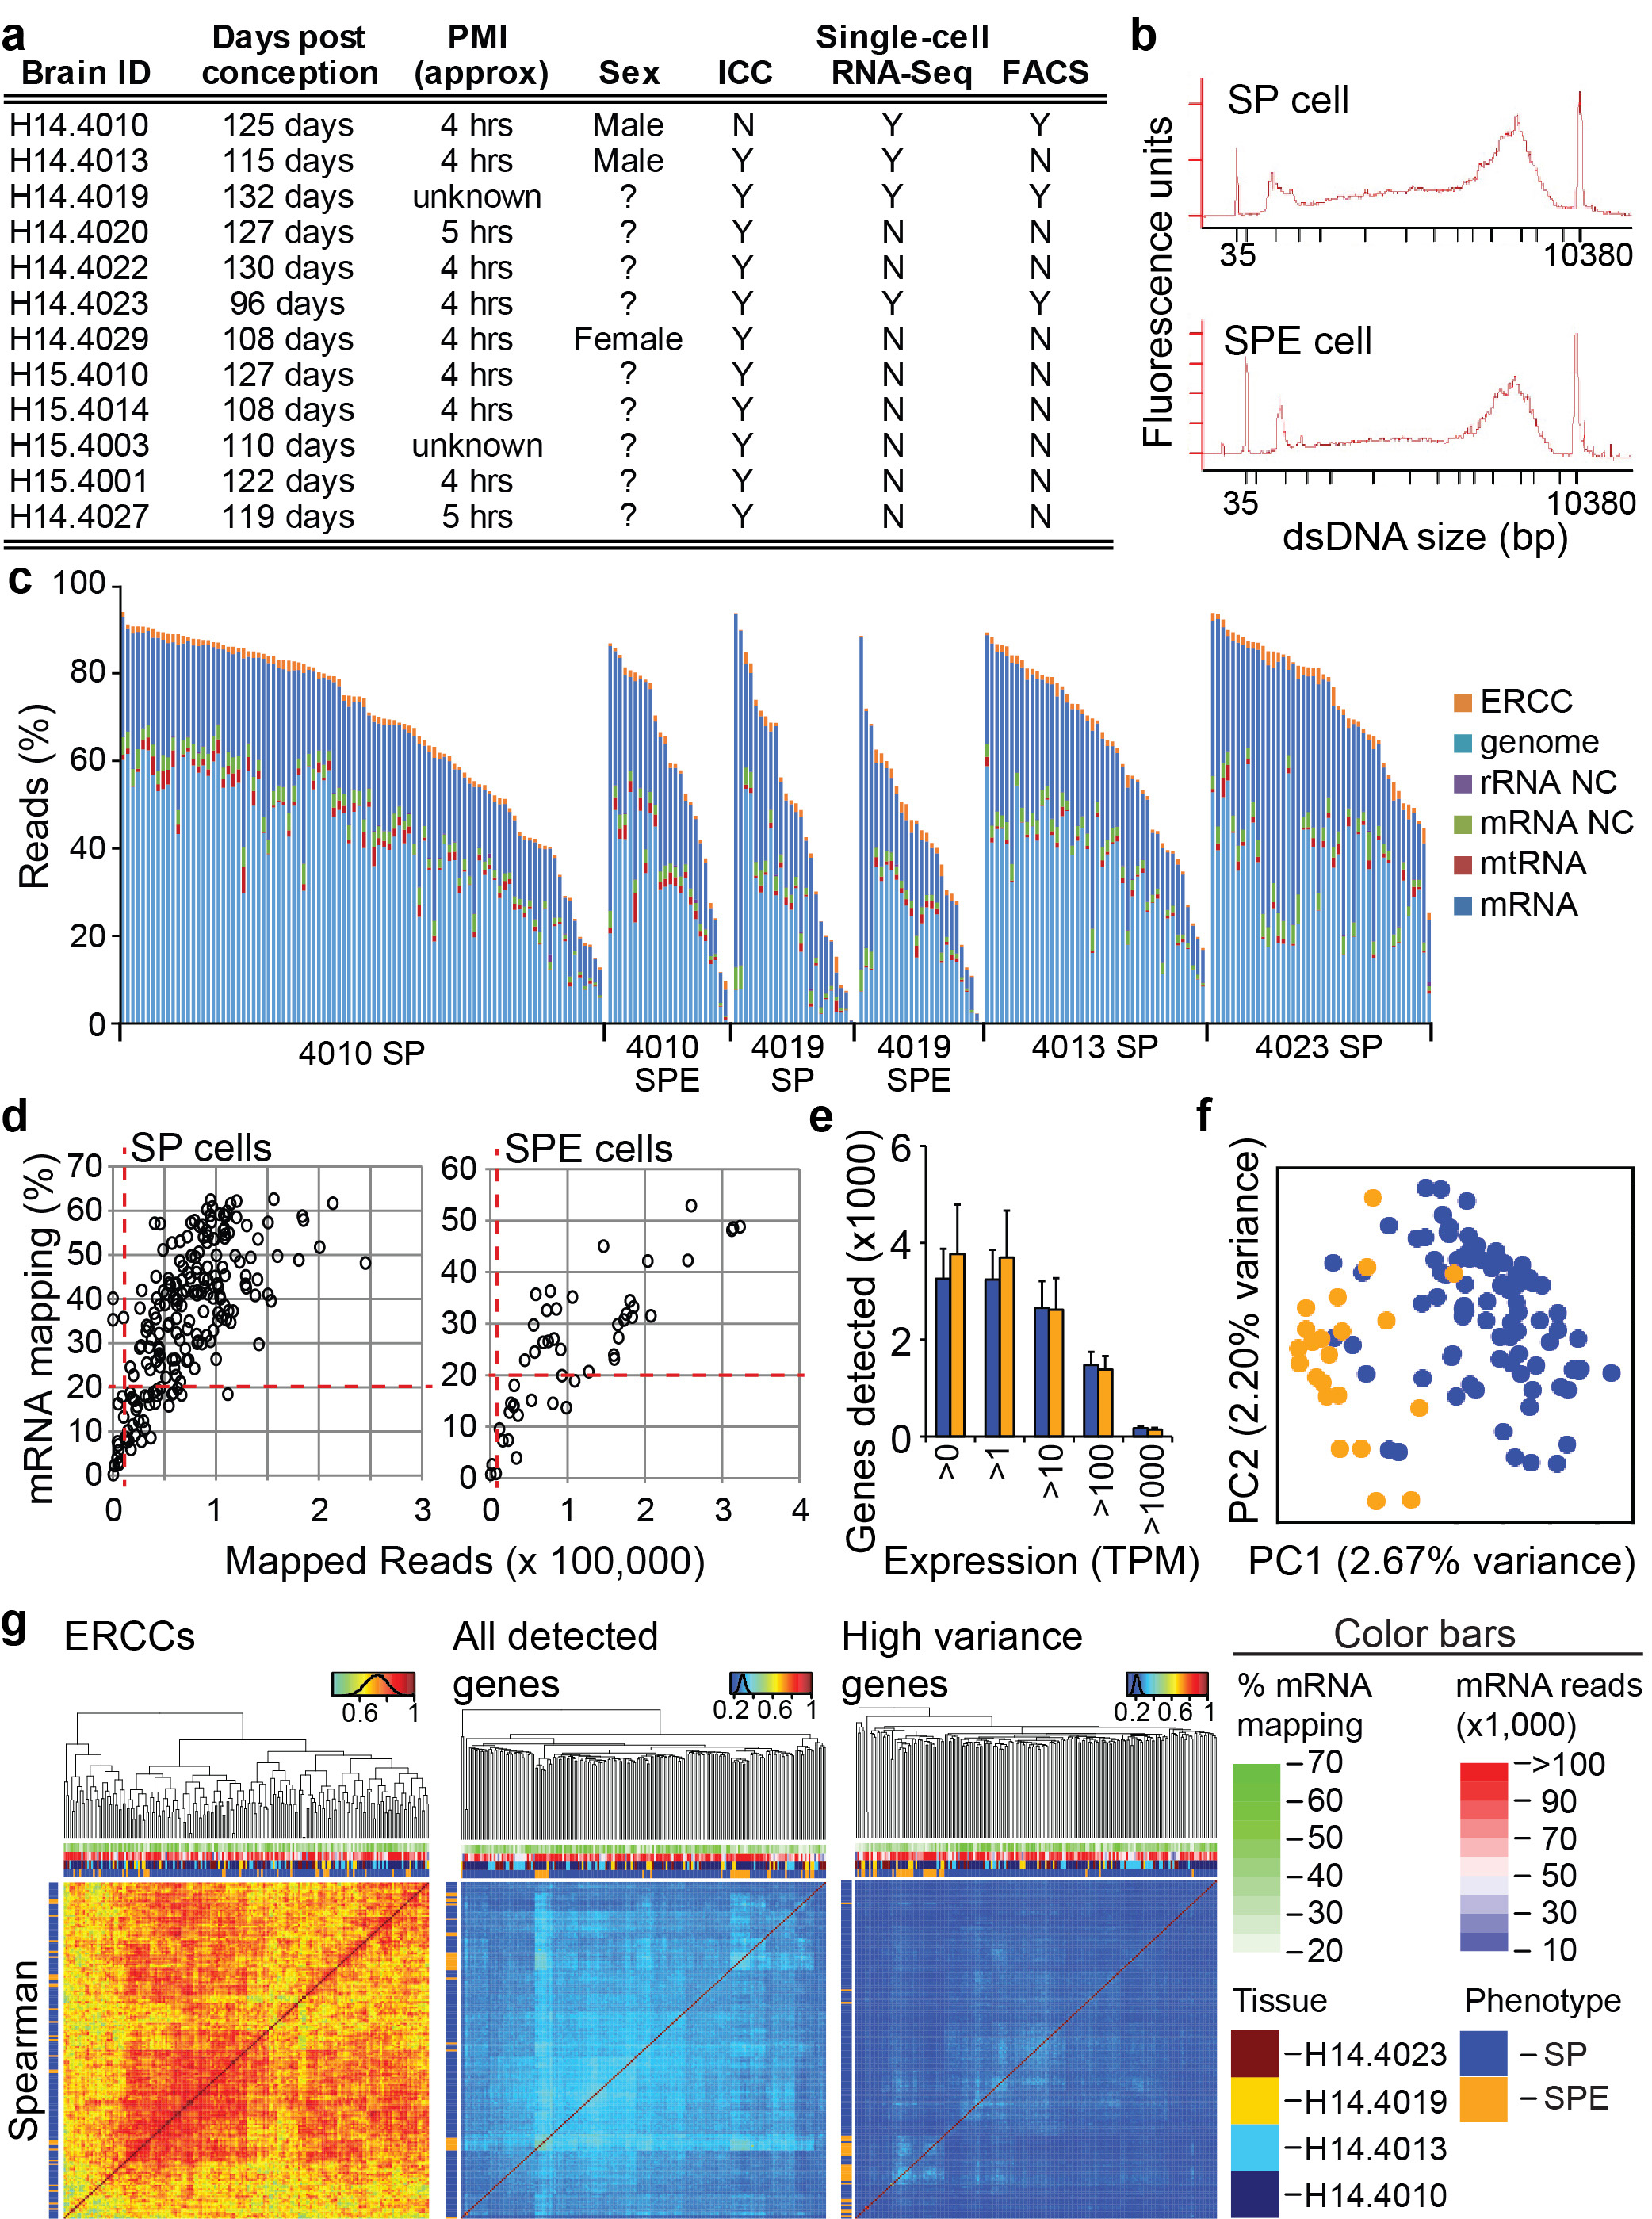
Supplementary Figure 5

Single-cell transcriptional analysis of human cortical progenitors.
(a) Table of primary human tissues used in this manuscript describing their use in specific experiments: ICC (immunocytochemistry), and FACS indicates flow cytometry for quantitation of population frequency and nuclear content. (b) Representative Bioanalyzer traces show cDNA amplification curves of SP and SPE single cells. (c) Bar plot shows read-mapping percentages for each primary cell prepared by FRISCR. Single-cell libraries were sequenced at low depth on a MiSeq. 100% is all barcoded reads independent of mapping. (d) Scatter plots of all SP and SPE cells sequenced on the MiSeq from four primary tissues showing number of mapped reads versus the % mapping to mRNA. Red dashed lines indicate the lower limits for secondary analysis steps. For (e-g) only cells with >10,000 mapped reads, >20% mRNA mapping, and presence of GAPDH are included (n = 157 SP and n = 29 SPE cells). (e) Barplot for SP and SPE cells show number of unique genes detected at each TPM threshold. Barplot is Mean±SD. (f) Principal component analysis of SP and SPE cells based on the genes with variance beyond technical noise. (g) Spearman correlation between cells based on ERCCs reads only (left), all genes (middle), and high variability genes (right). Color bars from heat maps are indicated below.
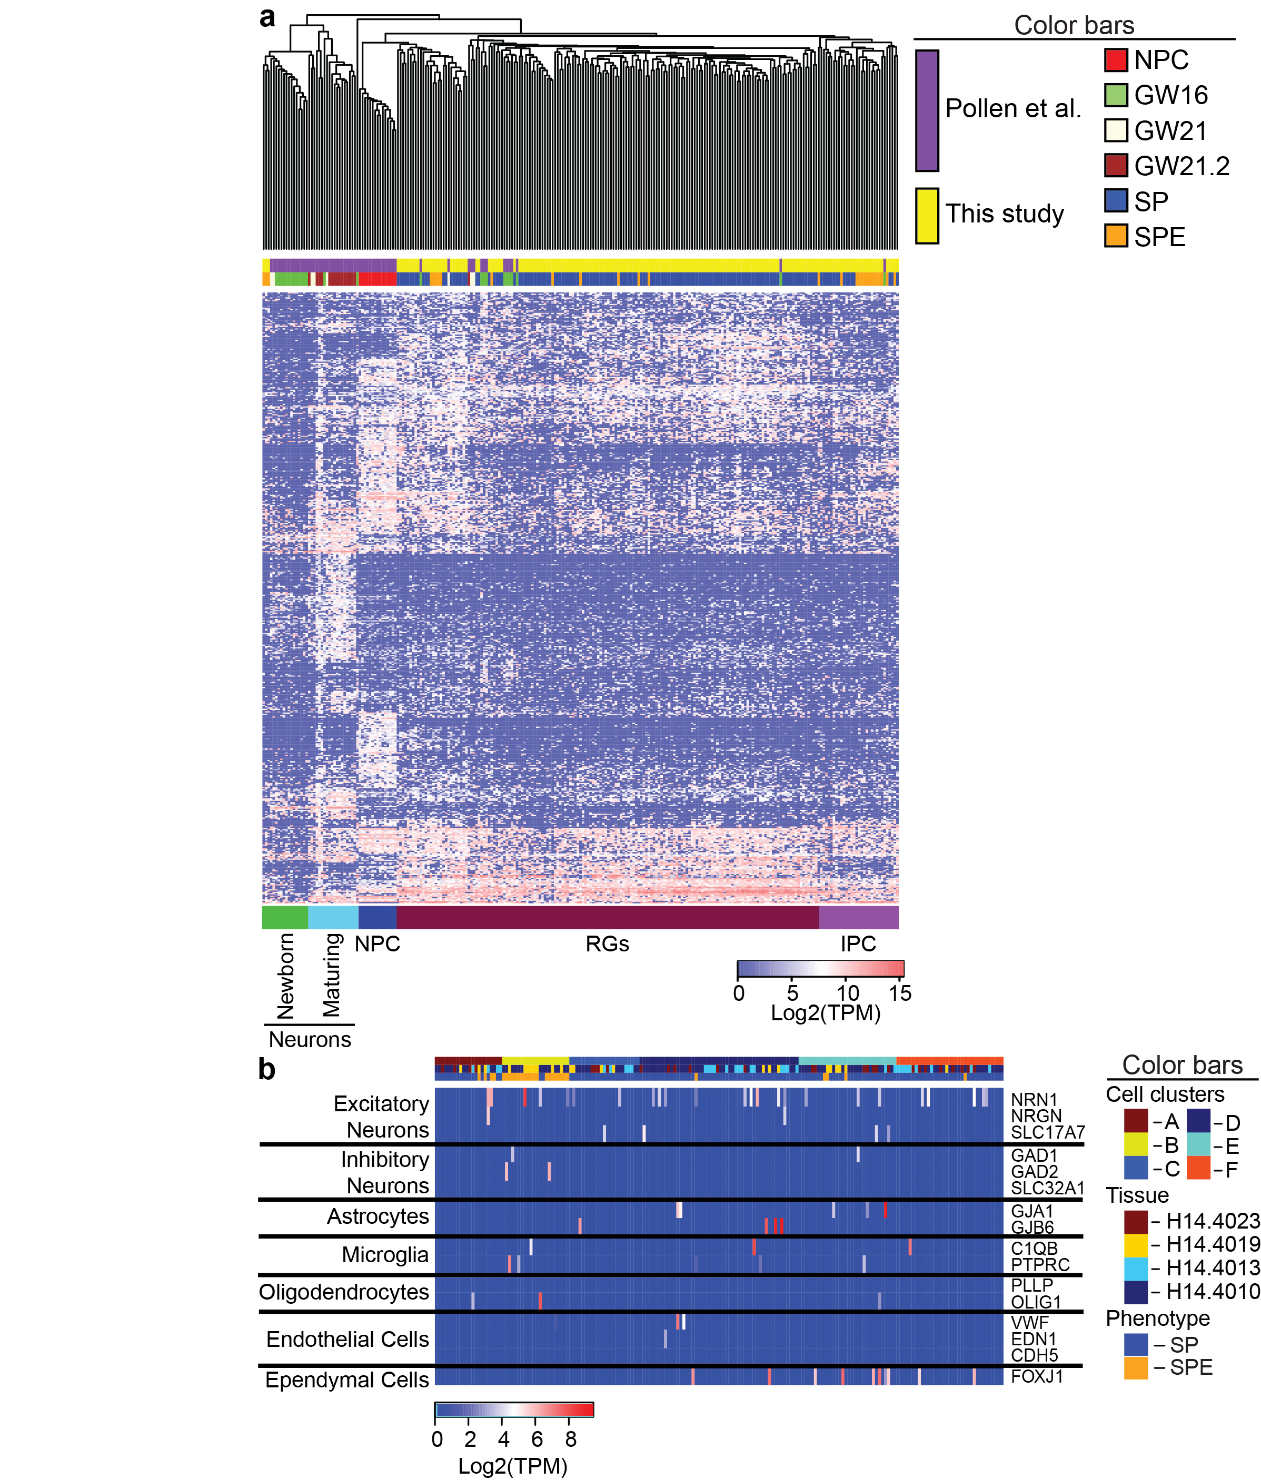
Supplementary Figure 6

Human cortical progenitors prepared by FRISCR show hallmarks of RGs and IPCs, but not other cell types.
(a) Data from fixed SP and SPE cells were compared to existing previously published data generated from live prenatal human neural cells by hierarchical clustering. Clustering was based on the common 482 of the top 500 genes contributing to the first principal component that was identified in a previous study²¹. This clustering robustly categorizes cells by cell type despite the two data sets differing by sample age, sample donor, dissociation, cell capture, cDNA amplification, and use of live or fixed cells. NPCs are neural precursor cells generated from hESCs²¹. Lower color bar annotations were based on annotation from the earlier study²¹. (b) Gene expression analysis of markers of other brain cell types. SP and SPE cells have only sparse expression of non-progenitor cell type markers.
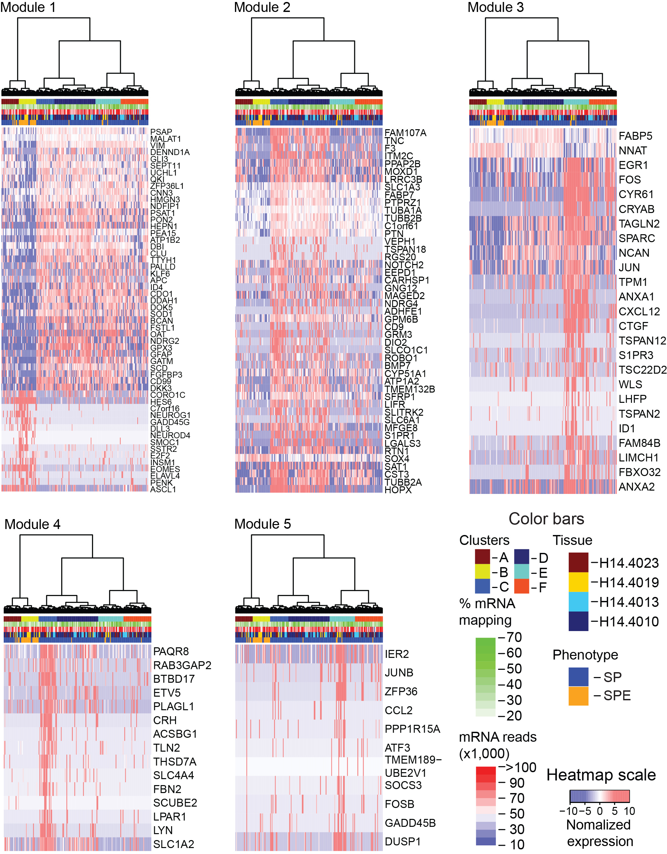
Supplementary Figure 7

Heatmaps of genes that comprise each of the five WGCNA modules.
Heatmap colors show expression of a given gene normalized between cells. Red indicates high expression, blue indicates low expression. Color bars are indicated, and clustering was derived from Fig. 5b.
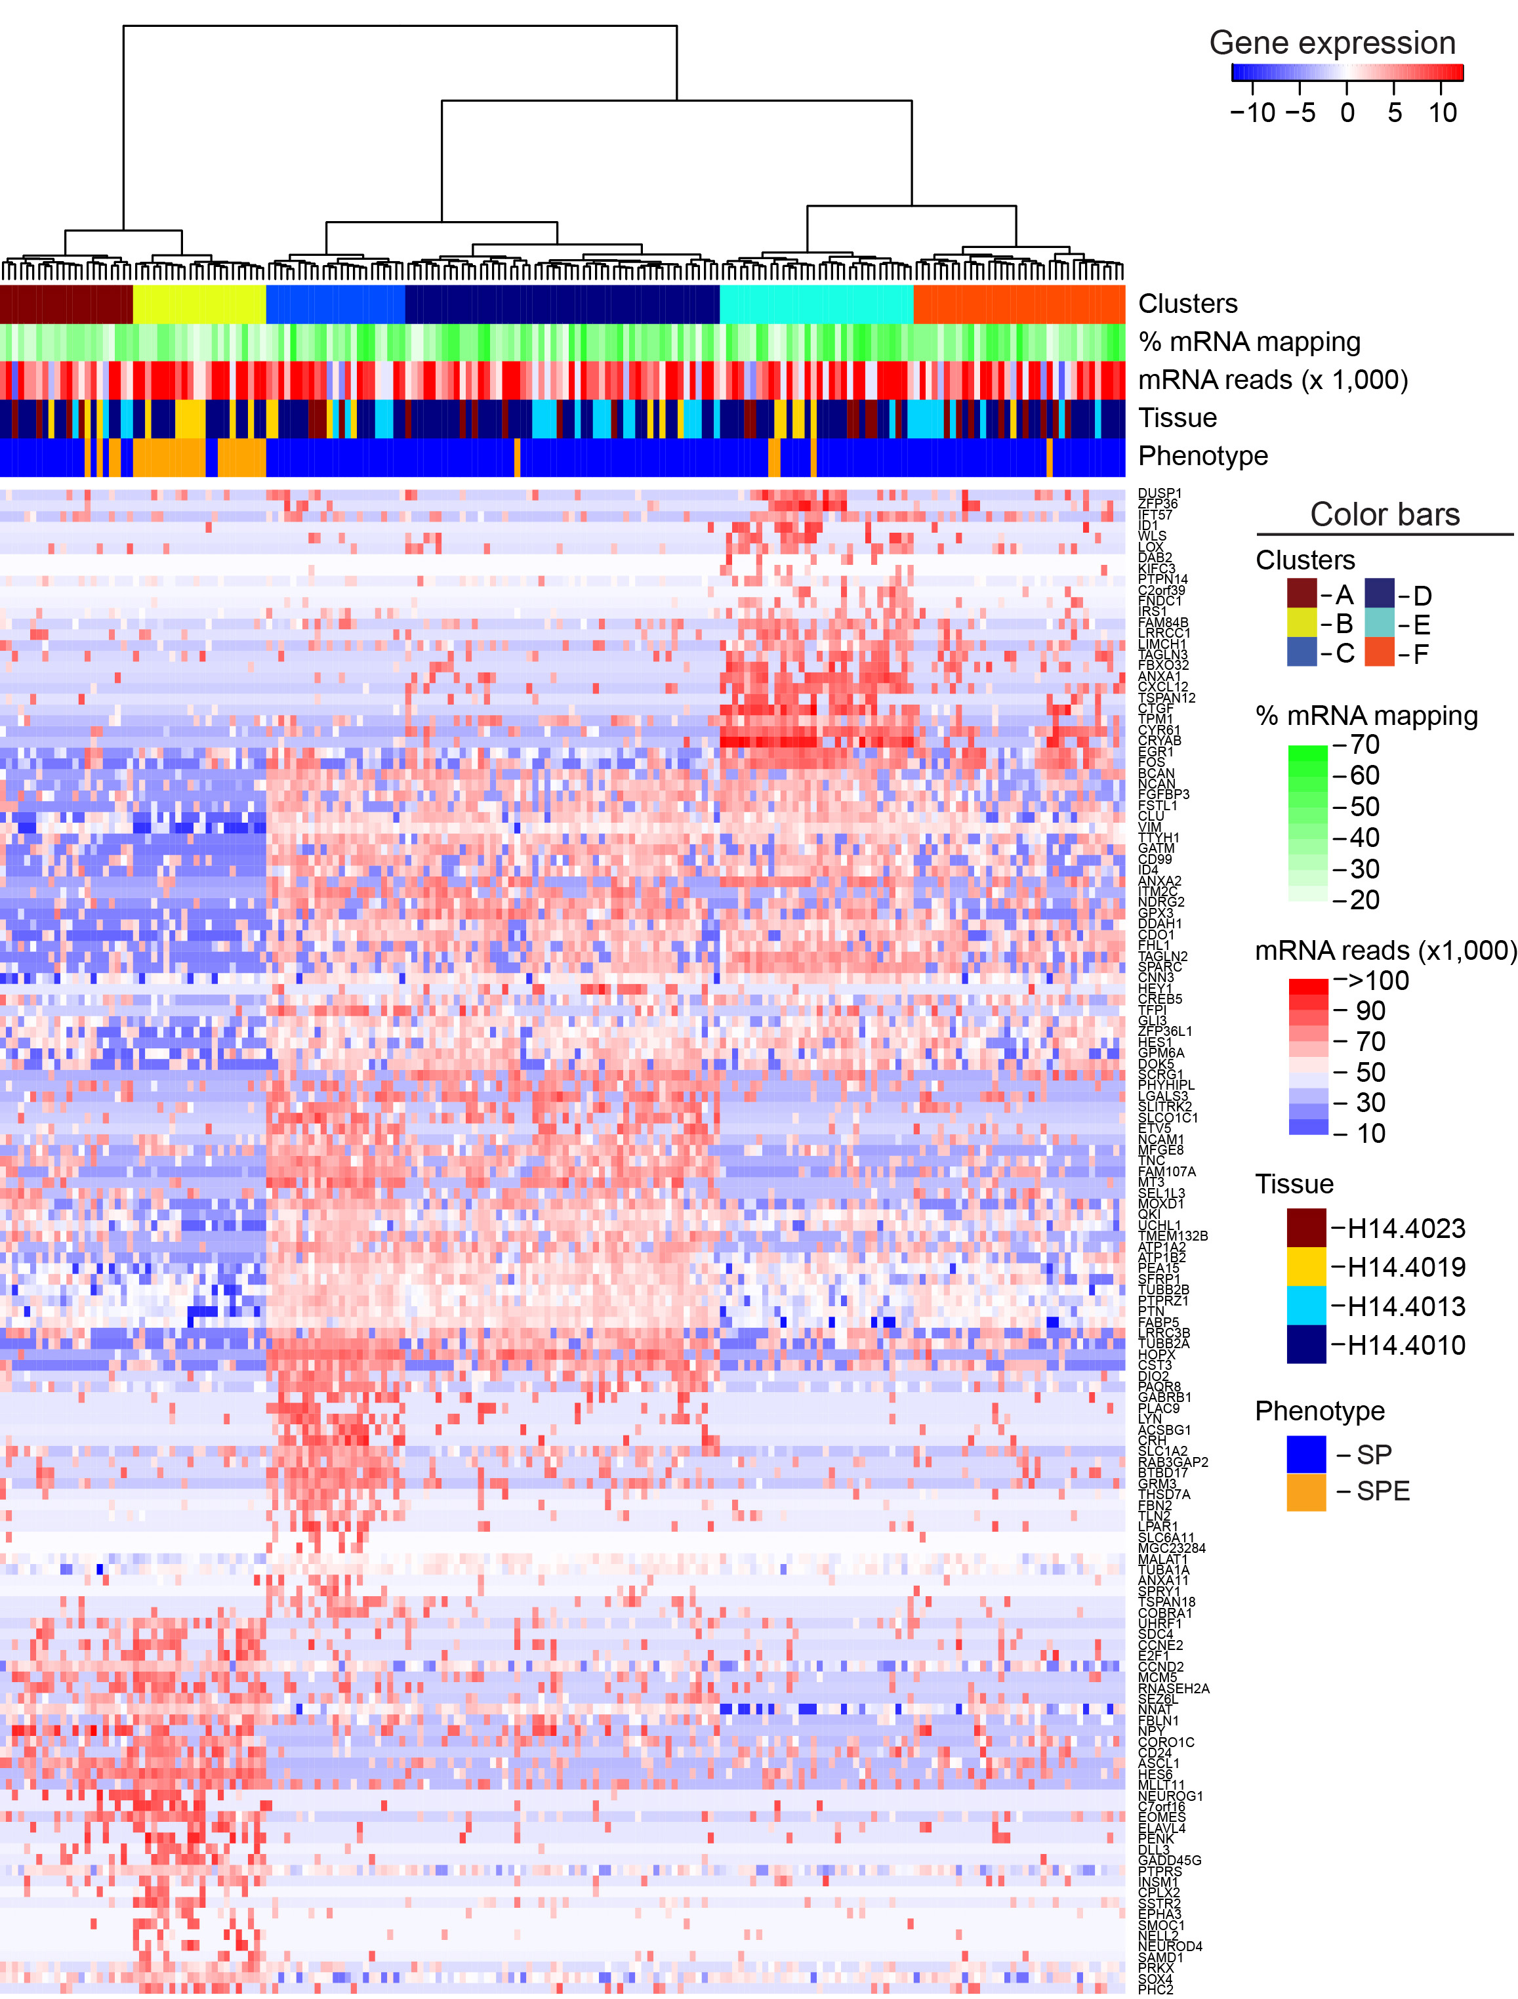
Supplementary Figure 8

Heatmap of genes from all five WGCNA modules and differential expression between cell clusters.
Cells are arranged by hierarchical clustering. Red indicates high expression, blue indicates low expression. Cell clustering was maintained as in Fig. 5b, and color bars are indicated. Nearly every cluster includes cells from each tissue (except B), and clusters are not driven by library read statistics.
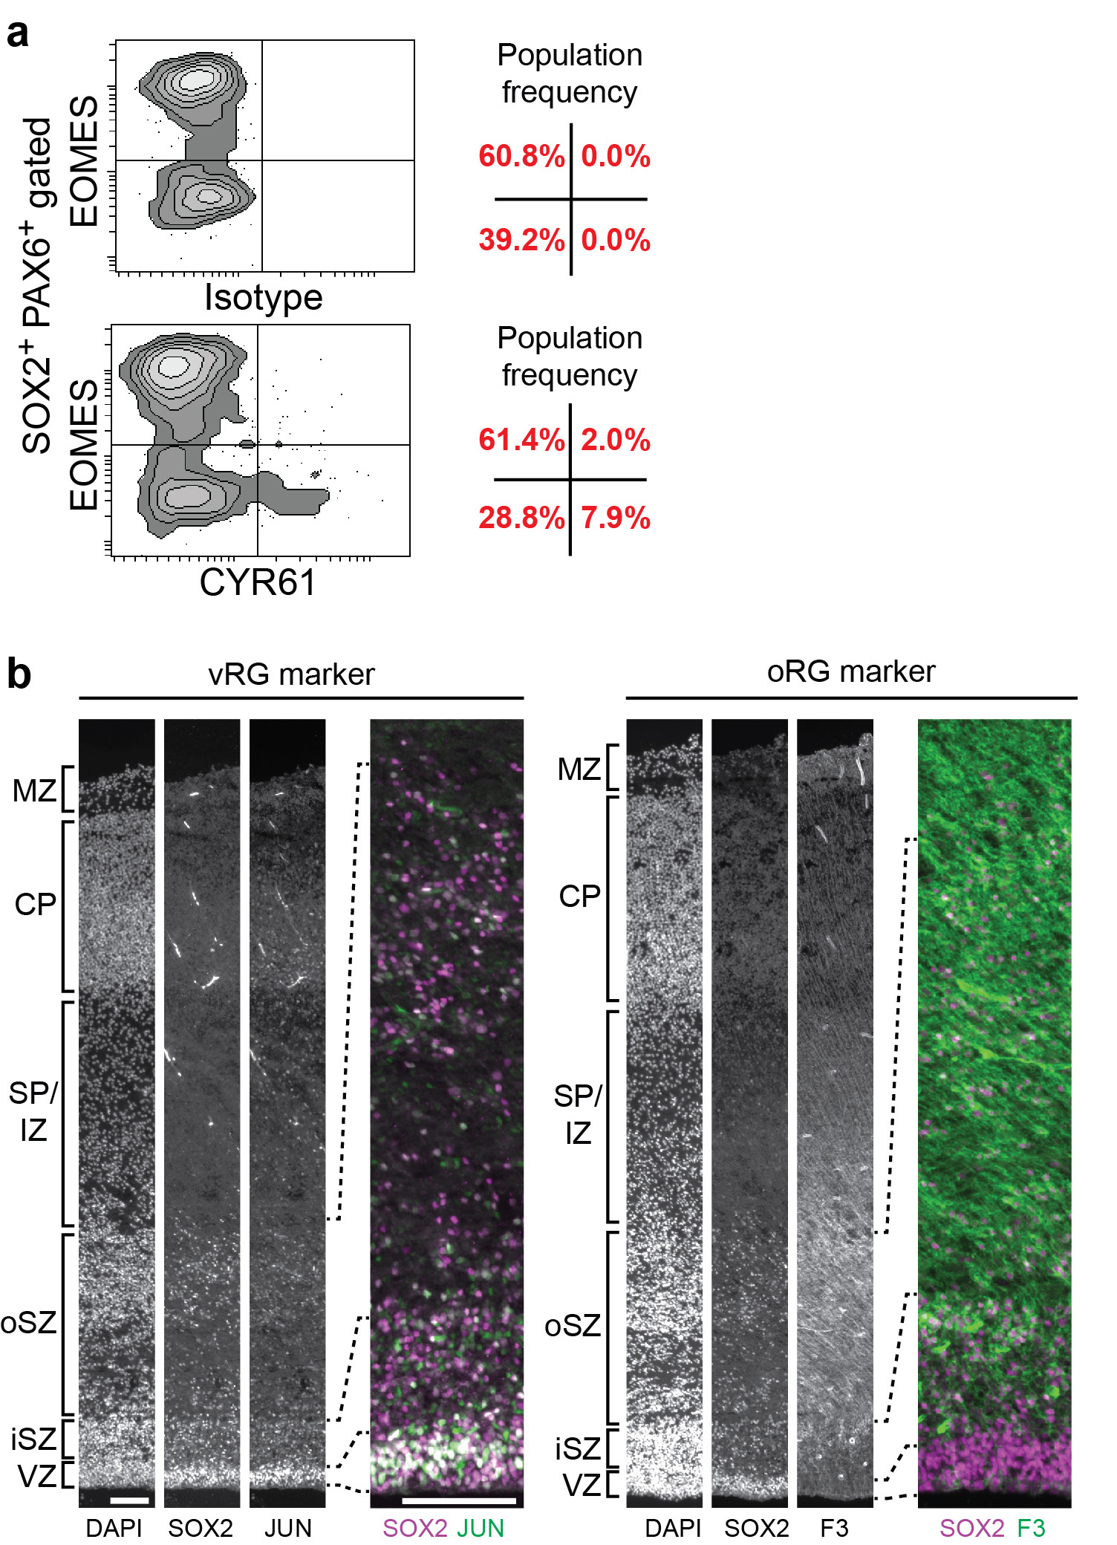
Supplementary Figure 9

Validation that modules 2 and 3 are enriched in non-overlapping sets of RG progenitors.
(a) FACS analysis of SP and SPE cells stained with EOMES and isotype (top) or CYR61 (bottom). Only cells staining for with a higher intensity than the isotype control (non-specific primary antibody) are considered positive for CYR61. Frequencies of events in quadrant gates are indicated (right). Data are from one brain representative of five brains analyzed in two independent experiments. (b) Grayscale (left) micrographs of entire cortical depth showing DAPI, SOX2, and the vRG-enriched protein JUN, or oRG-enriched protein F3, and (right) merged micrographs of only the germinal zone showing co-staining of SOX2 (magenta), with JUN or F3 (green). Tissue is 16 PCW cortex, scales are 100 µm, and images are stitched montages. Abbreviations are: marginal zone (MZ), cortical plate (CP), subplate/intermediate zone (SP/IZ), outer subventricular zone (oSZ), inner subventricular zone (iSZ), and ventricular zone (VZ).
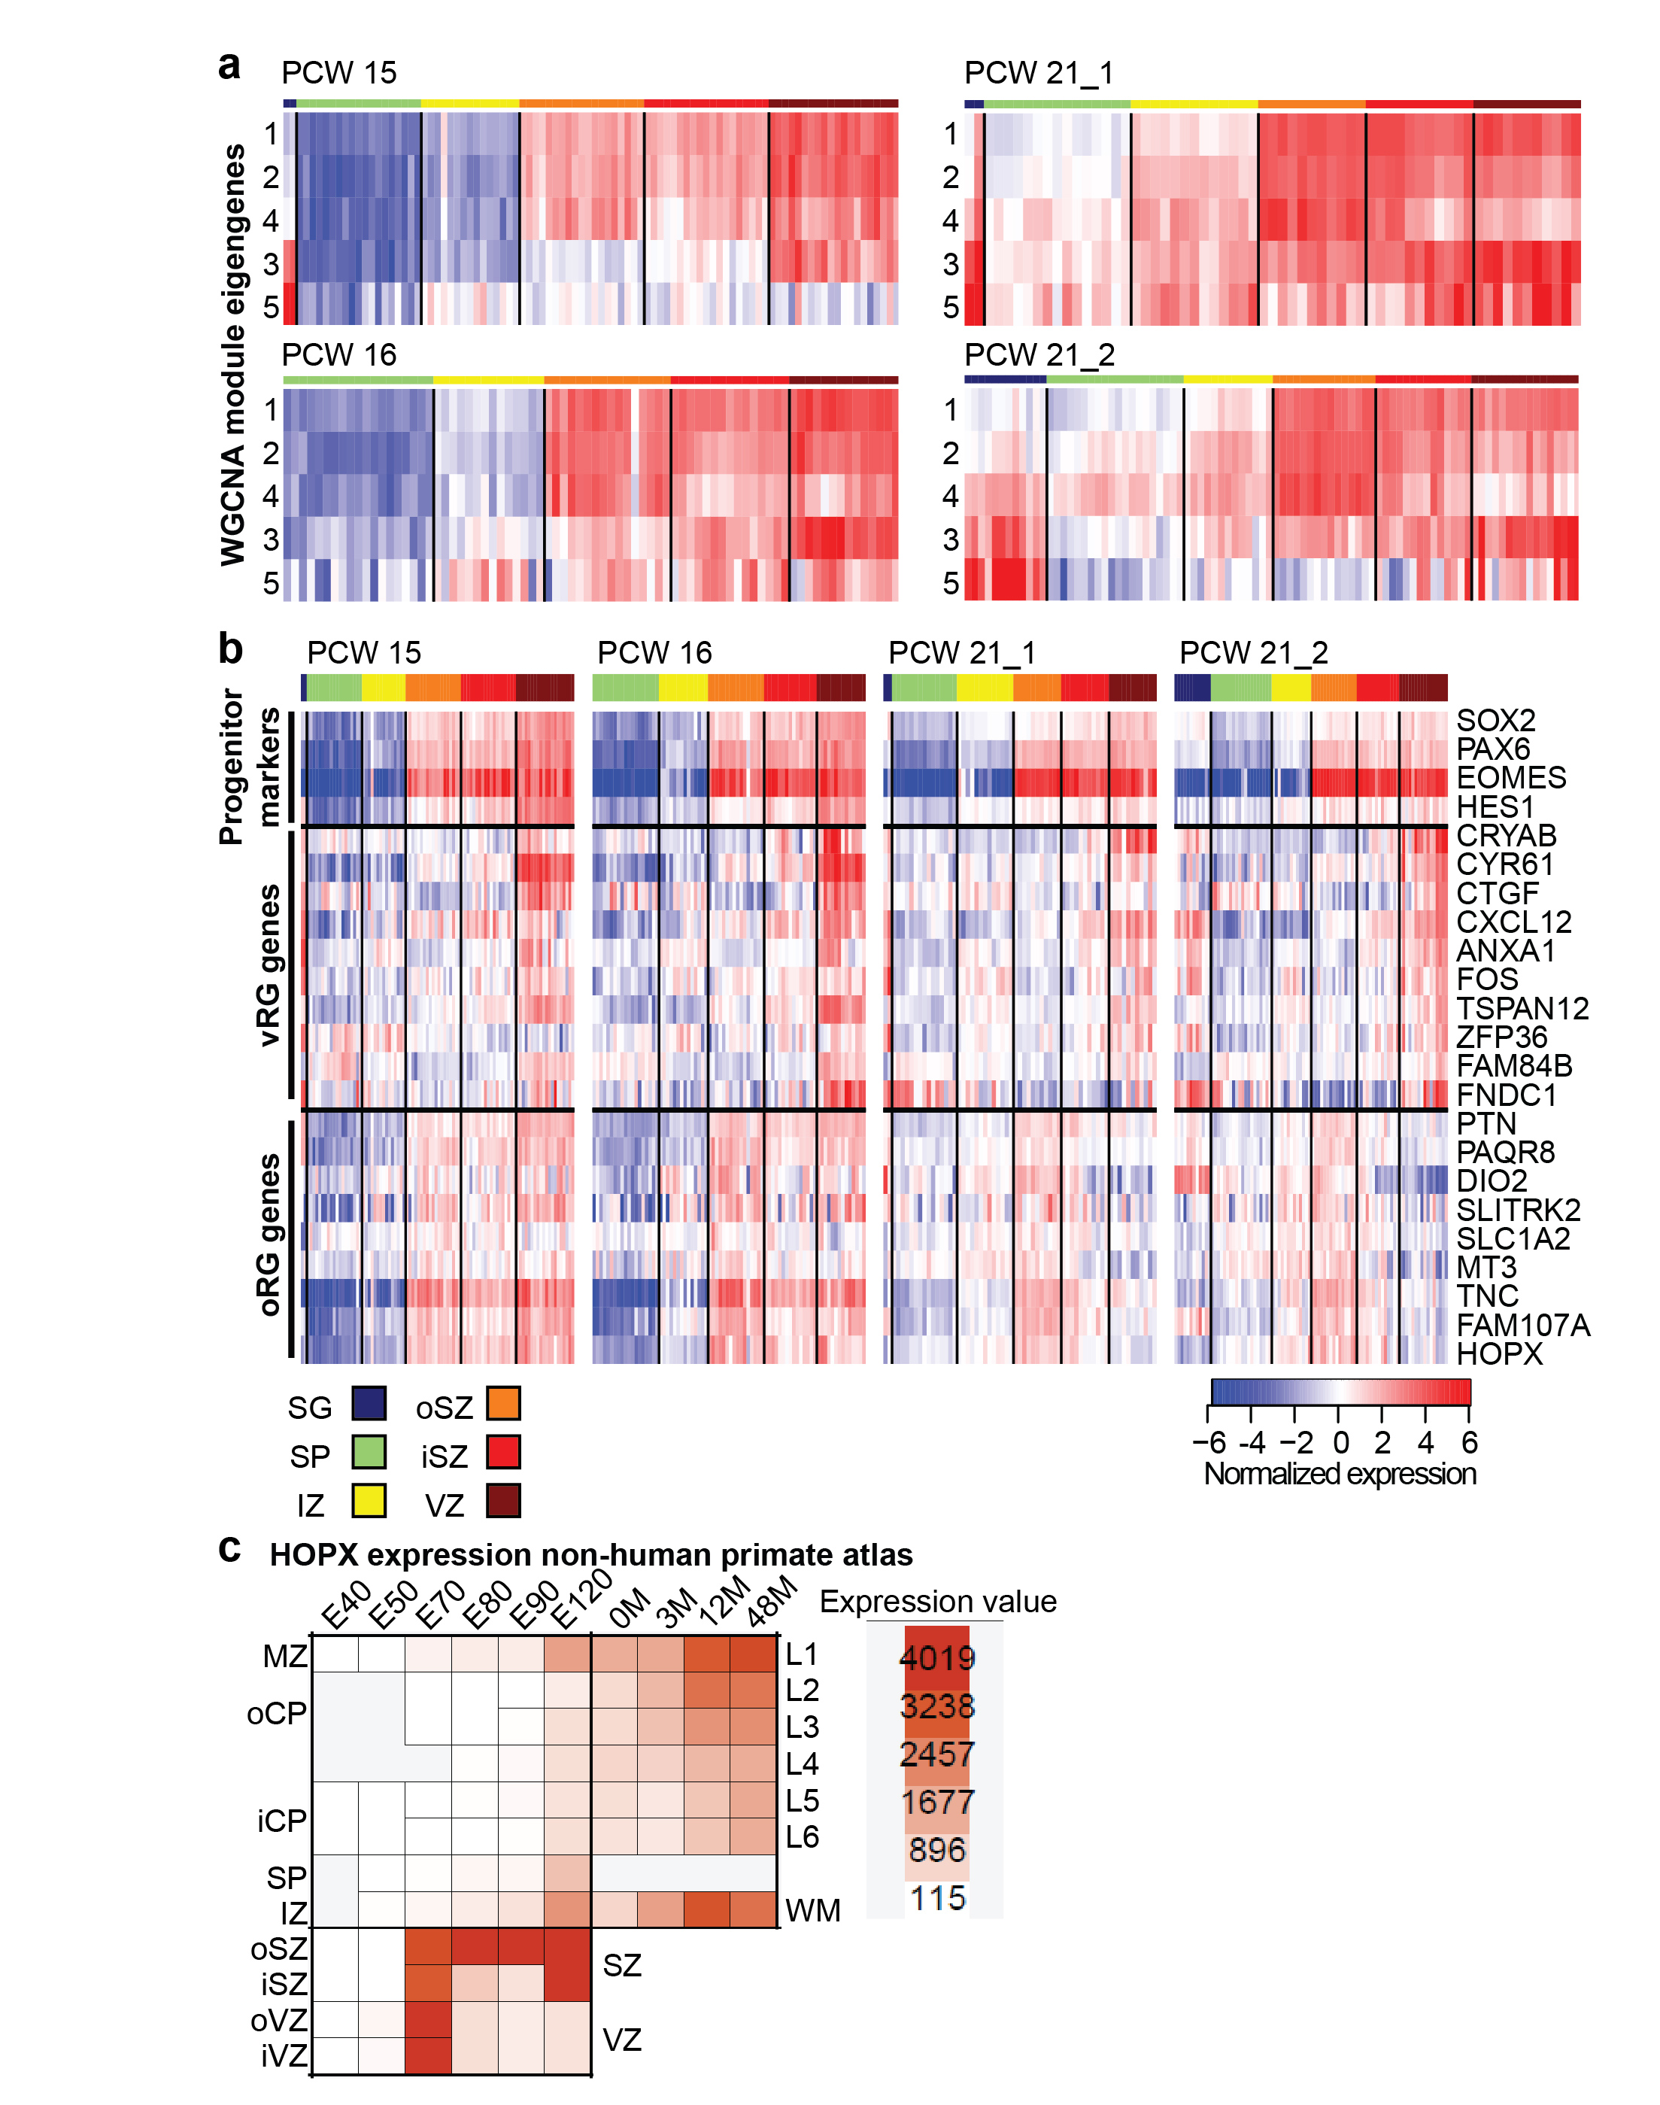
Supplementary Figure 10

Mapping RG modules to human and non-human primate atlas data.
(a) Heatmaps illustrating enrichment of module eigengene expression in each brain of the BrainSpan Atlas of the Developing Human Brain data. Regions with high correlation to a given eigengene are red, while poor correlation is blue. (b) Heatmaps showing expression of genes in each brain of the BrainSpan Atlas of the Developing Human Brain¹¹ identified because they were differentially expressed between cell clusters C and D (oRGs) verses cluster E (vRGs) from the FRISCR-prepared single cells (Fig. 5d), and were differentially expressed between oSZ and VZ regions of 21 PCW human tissues. Common progenitor markers are included at the top of the heatmap for reference. (c) Expression of HOPX in macaque though development. Plot shows expression of HOPX in the visual cortex (V1) of the NIH Blueprint Non-Human Primate Atlas. Each column shows different ages from embryonic day 40 (E40), through 48 months after birth (48M). Rows are micro-dissected regions. Red indicates high expression. Abbreviations for prenatal time points are: marginal zone (MZ), outer cortical plate (oCP), inner cortical plate (iCP), subplate (SP), intermediate zone (IZ), outer subventricular zone (iSZ), inner subventricular zone (iSZ), and VZ (ventricular zone). Abbreviations for postnatal time points are: Layer 1-6 (L1-L6), and white matter (WM). Expression of HOPX is initiated in V1 at E70, when the oSZ is formed, and while first detected in the entire germinal zone, is subsequently enriched in the oSZ.
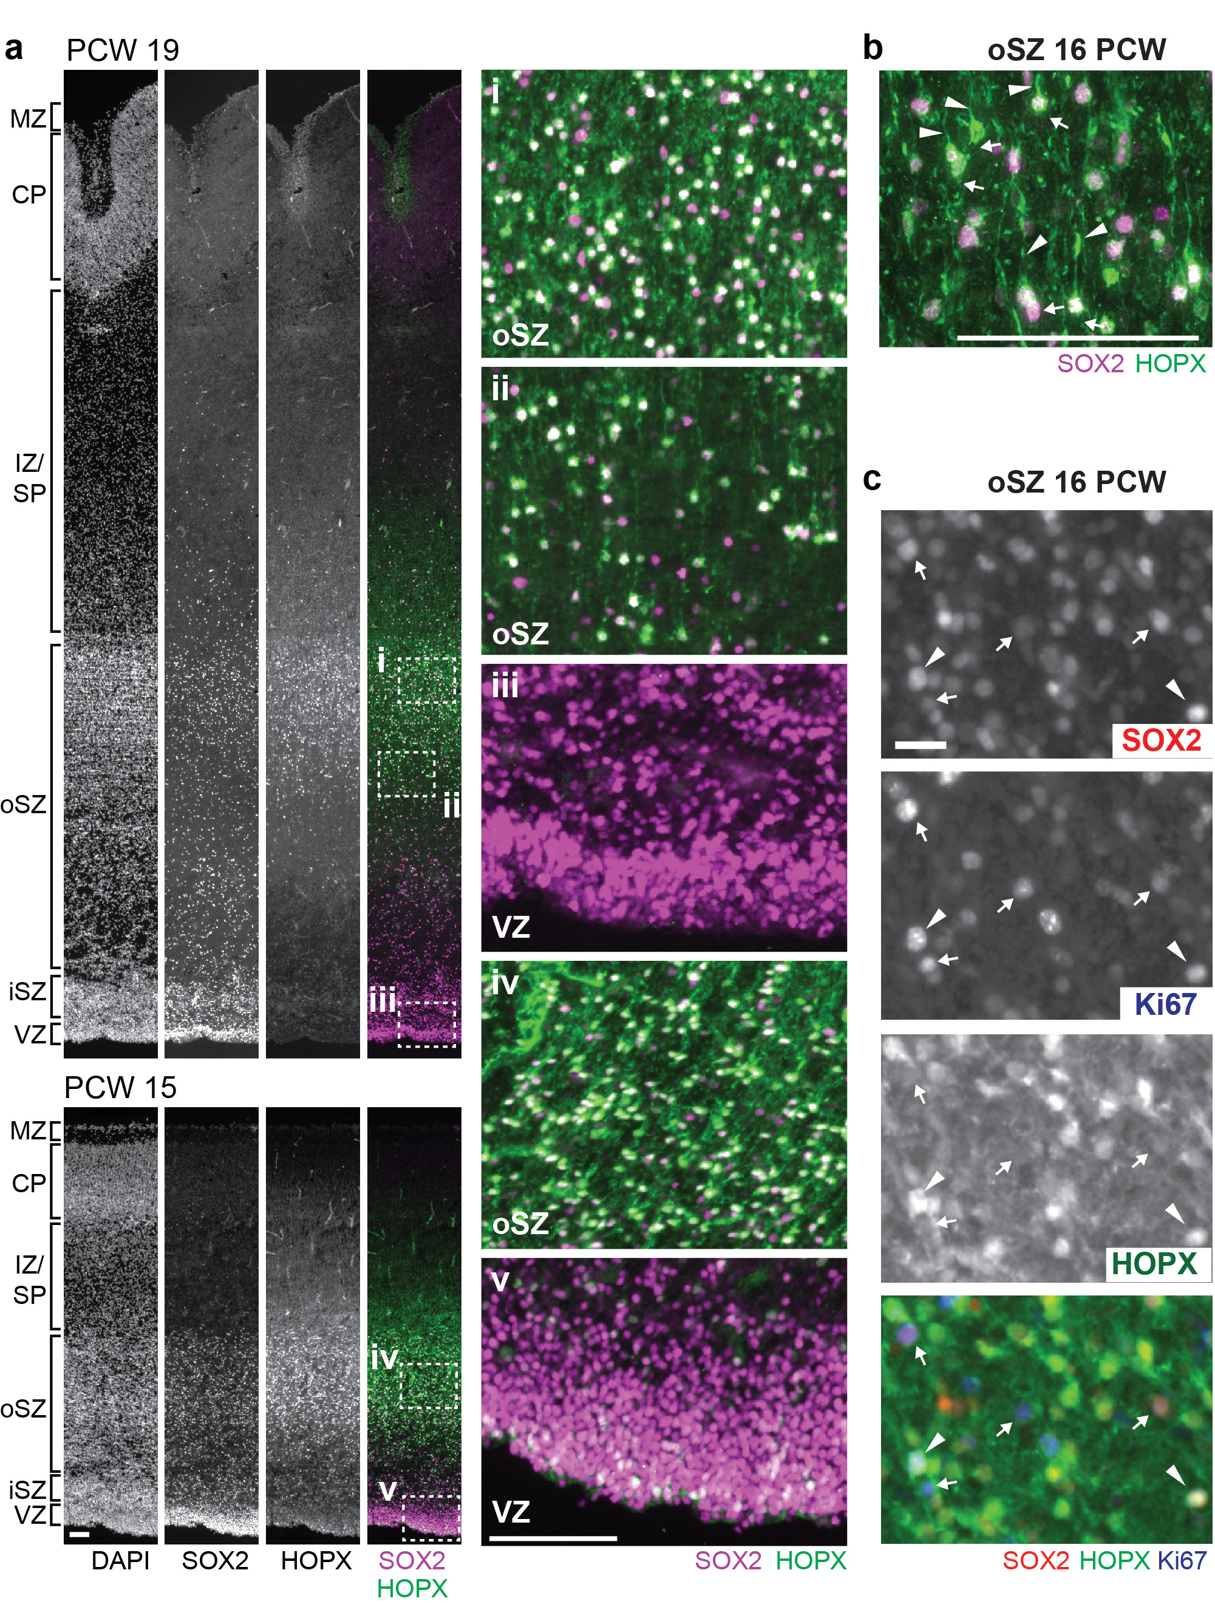
Supplementary Figure 11

Characterization of human HOPX+ cortical RG cells.
(a) Grayscale (left) micrographs of the entire cortical depth showing DAPI, SOX2, and HOPX, and merged (right) micrographs showing co-staining of SOX2 (magenta) and HOPX (green). Tissue is 19 (top), and 15 (bottom) PCW cortex, scales are 100 µm. 19 PCW tissue appears in Fig. 6d, and is shown here with single color images. Insets of the oSZ (i, ii, and iv) and the VZ (iii, v) are shown to right. Note substantial overlap of HOPX and SOX2 staining in the oSZ (i, ii, and iv), some overlap in the 15PCW VZ (v), and no overlap in the 19 PCW VZ (iii). Abbreviations are: marginal zone (MZ), cortical plate (CP), subplate/intermediate zone (SP/IZ), outer subventricular zone (oSZ), inner subventricular zone (iSZ), and VZ (ventricular zone). (b) oSZ region of 16 PCW cortex stained by HOPX (green) and SOX2 (magenta). Note multiple SOX2⁺, HOPX⁺ cells in this field exhibit basal processes (arrowhead), but not apical processes (arrow). Scale is 100 µm. (c) Grayscale and merged micrographs of a representative region of oSZ stained for SOX2, HOPX, and Ki67. White arrows are SOX2⁺, HOPX⁻, Ki67⁺ cells and arrowheads are SOX2⁺, HOPX⁺, Ki67⁺ cells. Scale is 20 µm.
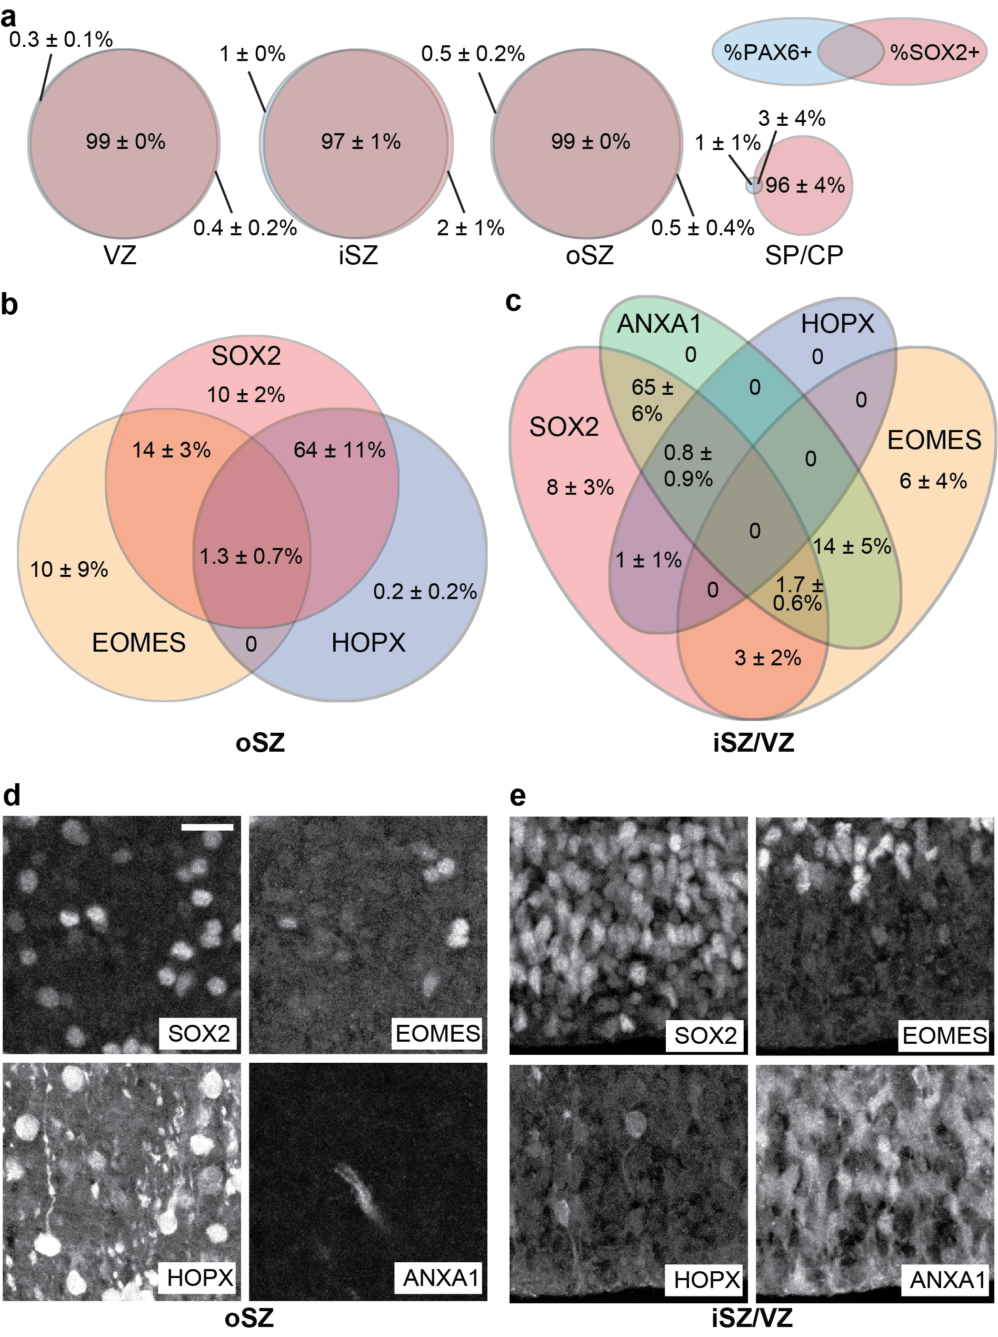
Supplementary Figure 12

Overlap of RG subtype markers.
(a) Venn diagram showing the percentage overlap of SOX2 and PAX6 antigen expression in the VZ, iSZ, oSZ, and Subplate/Cortical Plate (SP/CP). Data are mean percentages +/- SD. Note nearly all SOX2⁺PAX6⁻ cells reside outside of the germinal zone, and 99% of cells in the oSZ and VZ that express SOX2 also express PAX6. Data are from three brains between 15 and 18 PCW, at least three fields from each region of each brain were quantified by manual counting. (b) Venn diagram showing the percentage overlap of SOX2, HOPX, and EOMES in the oSZ; and (c) SOX2, HOPX, EOMES, and ANXA1 in the VZ/iSVZ. Data are mean +/- SD from four brains between 15 and 18 PCW, at least three fields from the indicated brain region of each brain were quantified by manual counting. (d-e) Representative confocal micrographs co-stained for SOX2, EOMES, HOPX, and ANXA1 of the oSZ (d) and VZ/iSVZ (e) from which quantitation in the above Venn diagrams were derived. Tissue is H15.4001 17 PCW and scale bar is 20 µm.

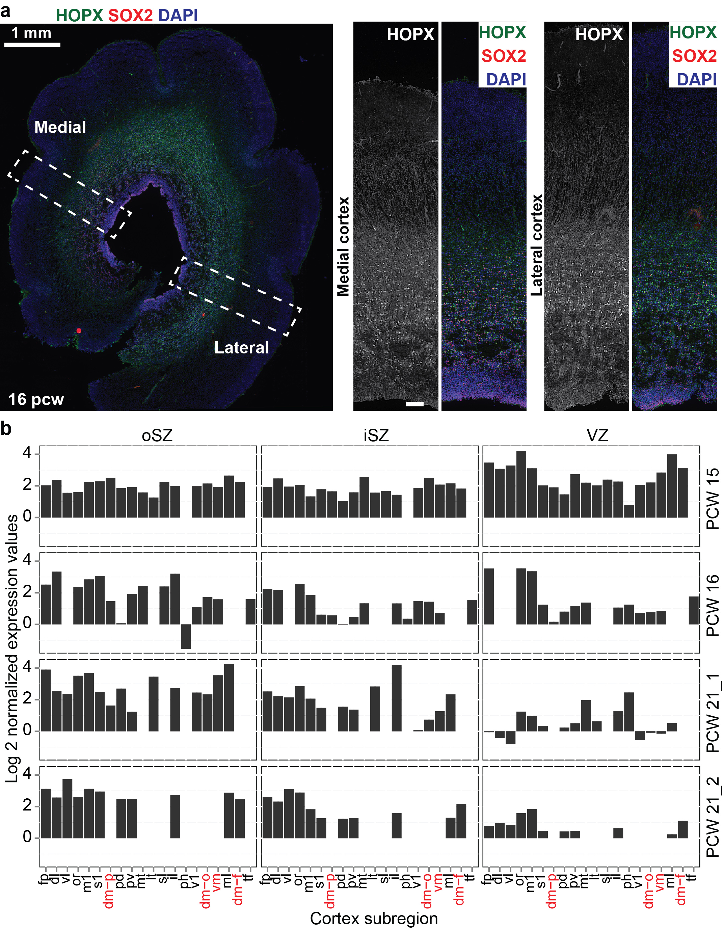
Supplementary Figure 13

HOPX is expressed in both lateral and medial cortical regions.
(a) Micrograph of a 16 PCW tissue section showing both medial and lateral regions of the cortex co- labeled by HOPX, SOX2, and DAPI. HOPX is notably enriched in the oSZ of both medial and lateral cortical regions. Medial cortex was assigned by the observation of the medial-derived hippocampus in serial sections. (b) Analysis of HOPX expression in each brain of the BrainSpan Atlas of the Developing Human Brain shows no enrichment in medial regions (red) of the cortex in any brain or germinal zone. The cortical regional abbreviations are: frontal polar (fp), dorsolateral (dl), ventrolateral (vl), orbital (or), motor cortex (m1), somatosensory cortex (s1), dorsomedial parietal cortex (dm-p), posterosuperior (dorsal) (pd), posteroinferior (ventral) (pv), medial temporal (mt), lateral temporal (lt), superolateral (sl), inferolateral (il), parahippocampal (ph), primary visual (v1), dorsomedial occipital (dm-o), ventromedial (vm), midlateral (ml), dorsomedial frontal (dm-f), and midinferior (tf).

