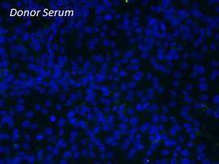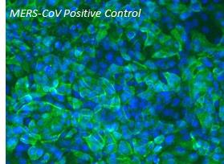
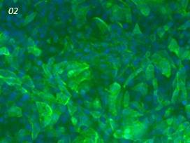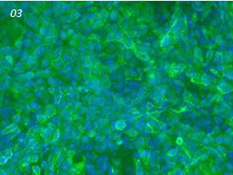
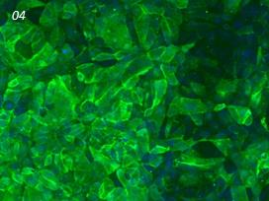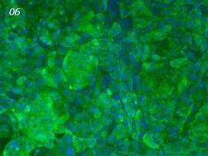
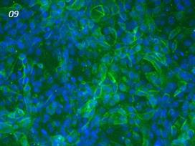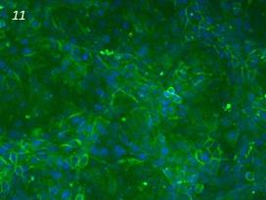
Legend: MERS-CoV infected Vero cells are shown reacting with the sera from the 6 outbreak members in an indirect immunofluorescence antibody assay (x20). DAPI counterstain (BLUE) was used to stain the nuclei. Serum from a confirmed MERS-CoV patient (provided by Public Health England) was used a positive control. All serum samples were diluted 1:100, except 09 (1:50).

