SUPPORTING MATERIALS
A quantification analysis of cargo-cargo interaction in axonal transport: cargos slow down at stationary obstacles in axons
Daphne L. Che, Praveen D. Chowdary, and Bianxiao Cui
Department of Chemistry, Stanford University, Stanford, CA 94305

Figure S1 Kymograph construction from the time-lapse TrkA transport movie. (A) Movie frames show TrkA cargos transporting inside an axon at various time point (yellow arrowheads). (B) Maximum intensity projection of the time-lapse image series over 1000 frames. The outline of the axon shape can be traced (red line). (C) The TrkA kymograph is generated by plotting the TrkA fluorescence intensity profile inside the axon along the time axis. Horizontal bar, 5s. Vertical bar, 5 μm.
Figure S2 Dual-color imaging of TrkA transport when crossing mitochondria in DRG neurons. (A) A movie frame shows mitochondria (Mito-YFP, yellow arrows) and TrkA cargos (TrkA-mCherry, red arrows) in the same axon. (B) Time projection of the time-lapse movie (500 frames), where the axonal shape can be seen on the right window of the camera. TrkA kymograph and mitochondrial kymograph can be constructed by tracing the fluorescence intensity along the axon shape over the duration of the time-lapse movie (see Figure 2A-B in main text). Scale bar, 5 μm.

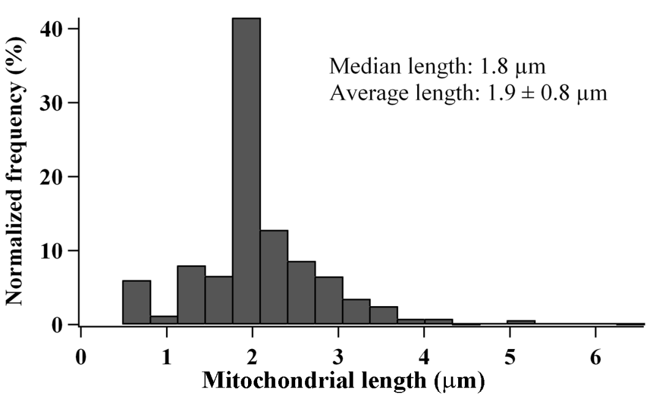
Figure S3 Mitochondrial length distribution in DRG neurons. The length of individual stationary mitochondrion is determined from Mito-YFP fluorescence signal in mitochondrial kymograph as shown in Figure 2A in the main text. Errors show standard deviation (n = 905). Data were cumulated from mitochondria measurements in 7 independent cultures.
Figure S4 TrkA transport behavior when crossing large vs. small mitochondria in DRG neurons. The measured median mitochondrial length in DRG neurons is 1.8 µm (see Figure S3). This value is chosen as the cut off length to split the mitochondria into two groups: large mitochondria are those with length > 1.8 µm (n = 332, average length 2.6 ± 0.7 µm), and small mitochondria are those with length ≤ 1.8 µm (n = 573, average length 1.5 ± 0.4 µm). Errors show standard deviation. We then separate the transport behavior data in Figure 2 C-D (main text) into two groups of small vs. large mitochondrial site. (A) TrkA retrograde transport behavior. (B) TrkA anterograde transport behavior. Error bars represents standard deviation. Bootstrapping (5 sets of 300 randomly selected events) was performed to calculate the standard deviation. Data were cumulated from 7 independent experiments. Statistical significant was conducted using Student’s t-test, p<0.001.

Figure S5 Linear segmentation of TrkA trajectory using linear regression in Matlab. (A) Original trajectory before fitting. (B) In the first cycle, the entire trace is fitted to one straight line. The algorithm determines the point along the trace that is furthest from the fitting line (black dot). This point is used to break the trace into two parts. (C) In the second cycle, the algorithm fit these two parts of the trace into two straight lines. The algorithm again finds the point with the largest residual value to break the trace into three parts. The same algorithm is repeated to subsequently break the trace into many segments. The fitting cycle is terminated when the total squared residuals (∑r²) becomes less than a cutoff value. This cutoff is determined empirically and is used for the fitting of all trajectories in the study. (D) The fitting result, where the trajectory (red dots) is separated into linear segments (blue lines). The slope of each segment is the instantaneous velocity of the cargo at that time. Inset shows an enlarged section of the trajectory, where the speed of each segment is shown in µm/s unit.

