Supplemental Information for “Efficacy of face shields against cough aerosol droplets from a cough simulator”

# Aerosol measurement instruments

## Spray droplet size analyzer

A Spraytec Analyzer with a 300-mm lens and an Inhalation Cell (Malvern Instruments Ltd., Worcestershire, UK) was attached behind the breathing head form to measure the concentration of aerosol particles inhaled during breathing. The advantage of this instrument is that it can acquire particle size distribution data at a high rate with a broad nominal size range of 0.1 to 900 µm. In addition, it can measure aerosol plumes that are passing through its measurement zone rather than drawing a sample for measurement, and it measures particle volume rather than number. However, a significant limitation of the instrument in our experiments was that its lower detection limit was about 5.8230 x 10-2 µl/l , which meant that it could read aerosol concentrations for only a few seconds after a cough before the aerosol concentration fell below the minimum level. In practice, this also meant that the inhaled aerosol concentration could be measured only when the simulators were 46 cm apart and no face shield was worn. In addition, during our experiments, the spray analyzer typically showed a cloud of particles from around 0.5 to 100 µm, and often it also reported particles between 250 and 900 µm. After a discussion with the manufacturer, we concluded that this second peak represented noise rather than actual droplets; therefore, during our analysis, we discarded data for particles larger than 215 µm. The aerosol size distribution data for each experiment were collected at 50 Hz.

## Optical particle counters

Two optical particle counters (OPCs; Model 1.108, Grimm Technologies, Inc., Douglasville, GA) were used because they can measure much lower aerosol particle concentrations than the spray analyzer (down to 50 particles per liter). However, they have a much lower measurement rate (1 Hz maximum) and they draw in a sample for measurement, which can lead to losses of larger particles. The OPCs also measure particle counts rather than volumes, and they have an upper measurement limit of 2 x 106 particles per liter. When the OPCs are set to measure particle concentrations every second, the OPC will report data for only the first or last 8 of its 15 size bins (the 2- to 3-µm middle bin is reported in either mode). Because of this, each test was conducted twice: once to collect data for smaller particles (0.3 to 3 µm) and once to collect them for larger particles (>2 µm). The smaller and larger size range results were then combined and the results from the two OPCs were averaged.

# Tables of experiments

Table S. Experiments performed with aerosol particle measurement instruments. Data were collected for 30 minutes in these experiments (PPE is personal protective equipment; OPC is optical particle counter).

|  |  |  |  |  |
| --- | --- | --- | --- | --- |
| *Shield on breathing head form* | *Mouth-to-mouth distance (cm)* | *Cough aerosol particle size* | *Grimm OPC data collection mode* | *Number of replicates* |
| None | 46 | Large | Small | 3 |
| Face shield | 46 | Large | Small | 3 |
| None | 46 | Large | Large | 3 |
| Face shield | 46 | Large | Large | 3 |
| None | 46 | Small | Small | 3 |
| Face shield | 46 | Small | Small | 3 |
| None | 46 | Small | Large | 3 |
| Face shield | 46 | Small | Large | 3 |
| None | 183 | Large | Small | 3 |
| Face shield | 183 | Large | Small | 3 |
| None | 183 | Large | Large | 3 |
| Face shield | 183 | Large | Large | 3 |
| None | 183 | Small | Small | 3 |
| Face shield | 183 | Small | Small | 3 |
| None | 183 | Small | Large | 3 |
| Face shield | 183 | Small | Large | 3 |
|  |  |  |  |  |
|  |  |  | TOTAL | 48 |

Table S. Experiments performed with influenza virus. During these experiments, an N95 respirator was sealed to the breathing head to act as a collection filter for particles that are inhaled by the breathing simulator. The amount of influenza virus in the samples was determined by quantitative real-time polymerase chain reaction (qPCR) and viral plaque assays (VPAs).

|  |  |  |  |  |  |
| --- | --- | --- | --- | --- | --- |
| *Shield on breathing head form* | *Mouth-to-mouth distance (cm)* | *Cough aerosol particle size* | *Collection time (minutes)* | *Sample assay method* | *Number of replicates* |
| None | 46 | Large | 5 | qPCR & VPA | 3 |
| Face shield | 46 | Large | 5 | qPCR & VPA | 3 |
| None | 46 | Large | 30 | qPCR | 3 |
| Face shield | 46 | Large | 30 | qPCR | 3 |
| None | 46 | Small | 5 | qPCR | 3 |
| Face shield | 46 | Small | 5 | qPCR | 3 |
| None | 183 | Large | 5 | qPCR | 3 |
| Face shield | 183 | Large | 5 | qPCR | 3 |
|  |  |  |  |  |  |
|  |  |  | TOTAL |  | 24 |

# Photos of experiments using aerosol measurement instruments



This photo shows the experimental setup for experiments using aerosol particle measurement devices. In this experiment, the mouths of the coughing and breathing simulators were 46 cm (18 inches) apart. The yellow arrows and particles show how the cough aerosol exits the coughing simulator and travels toward the breathing simulator. Particles that are inhaled into the mouth of the head form of the breathing simulator travel through the measurement zone of the spray droplet size analyzer and are measured.

|  |  |
| --- | --- |
| \\Cdc.gov\private\L502\wdl7\Photos scans & illustrations\Environmental chamber & cough simulator\EC Face shield MLP experiments\MLP exp set-up 026.jpg | Front view of breathing head form, spray droplet size analyzer, and OPCs. The OPCs draw aerosol samples at 1.2 liters per minute through the vertical stainless steel tubes on either side of the mouth of the head form. |

|  |  |
| --- | --- |
| \\Cdc.gov\private\L502\wdl7\Photos scans & illustrations\Environmental chamber & cough simulator\EC Face shield MLP experiments\MLP exp set-up 035.jpg | This photo shows a face shield on the breathing head form. The OPC sampling tubes are behind the face shield and on either side of the mouth. |

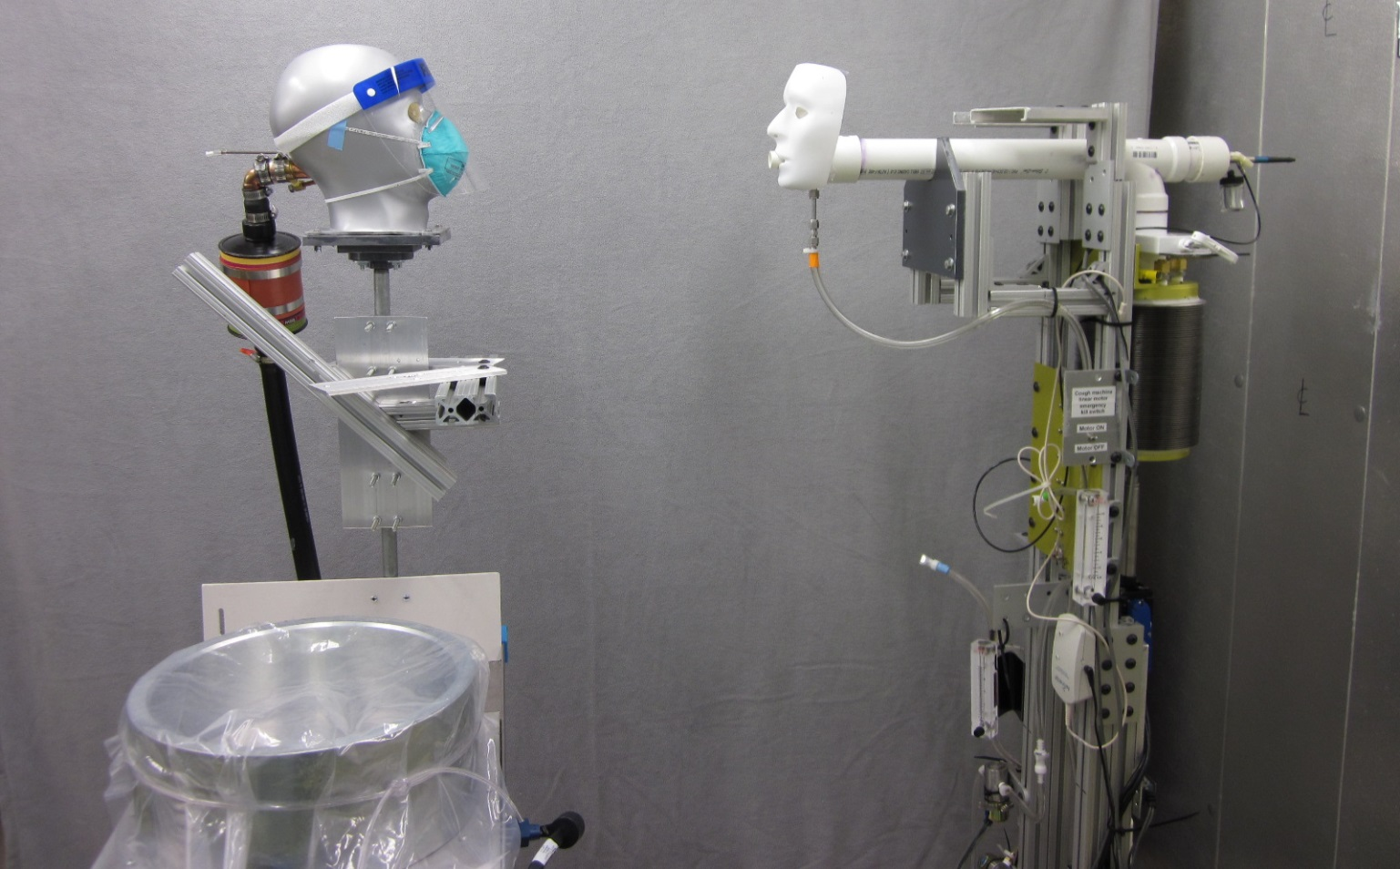

Experimental setup for experiments with influenza virus. The silver cylinder covered with plastic in the left foreground is the piston of the breathing simulator.

|  |  |
| --- | --- |
| \\Cdc.gov\private\L502\wdl7\Photos scans & illustrations\Environmental chamber & cough simulator\EC Face shield ILP experiments\ILP exp set-up 007.jpg | Close-up of face shield and respirator on breathing simulator. The green N95 respirator is sealed to the breathing head form and is used to collect the particles that would be inhaled by the breathing simulator. Previous experiments have shown that a sealed N95 respirator filters out virtually all of the particles. |

# Supplemental data files

These data summary files are included in the online supplemental material for this article. MLP refers to aerosol particle measurement experiments done with Complete Dulbecco’s Modified Eagle Medium (CDMEM) only. ILP refers to experiments done with CDMEM containing influenza virus. More detailed data files are available from the corresponding author upon request.

|  |  |
| --- | --- |
| *File* | *Description* |
| MLP Spraytec supplemental data.txt | This file contains the total volume measurements of particles that were inhaled during the first breathing cycle after a cough (1.4 seconds in duration). Volumes are in microliters. |
| MLP Grimm supplemental data.txt | This file shows the particle count reading from the Grimm optical particle counters (OPCs) during each experiment. The readings were averaged between the Grimms and also averaged over the time from 1 minute to 30 minutes after the cough. Readings are in counts per liter of air. |
| ILP experiments qPCR data.txt | This file shows the results of the quantitative real-time polymerase chain reaction (qPCR) qPCR analysis of the virus collected by the respirators and face shields. |
| ILP experiments VPA data.txt | This file shows the results of the viral plaque assay (VPA) analysis of the virus collected by the respirators and face shields. |

# Experimental parameters used in file headers

|  |  |
| --- | --- |
| *Parameter* | *Description* |
| Test ID | Unique code assigned to each experiment. |
| Shield | “None” means no face shield was used in the experiment. “Face shield” means that a face shield was worn by the breathing head form. |
| Distance | This is the distance in inches from the mouth of the coughing simulator to the mouth of the breathing simulator. |
| Generator | This refers to the aerosol generator used with the coughing simulator, which was either an air brush for larger particles or a nebulizer for smaller particles. |
| Grimm mode | When the Grimm optical particle counter (OPC) is operating at 1 Hz, it will report only the smallest or largest 8 size bins. Thus, each experiment had to be performed twice, once with the Grimm OPCs in small-particle mode and once in large-particle mode. The spray analyzer was able to collect data during both experiments. |
| Collection time | The length of time in minutes after the cough over which the breathing simulator was operated and influenza virus was collected on the respirator and face shield. |
| Replicate | Each experiment was performed three times in each condition, with the Grimm OPC in each size mode. |
| Size bin | The aerosol measurement instruments report the data with the particles grouped into a series of logarithmically spaced size ranges. |
| # of virus matrix gene copies detected | This is the number of copies of the influenza M1 matrix gene that were detected in the sample with quantitative real-time polymerase chain reaction (qPCR). This corresponds approximately to the number of influenza viruses in the sample, although qPCR does not distinguish between viable and nonviable viruses. |
| Plaque-forming units | This is the number of viral plaques that were detected in the viral plaque assay (VPA), which is proportional to the amount of viable influenza virus in each sample. |
| Adjusted for area | The respirator had a total outer surface area of 137 cm2, while the 4 coupons that were analyzed each had an area of 4.9 cm2. Thus, the amounts of virus found in the respirator coupons were multiplied by 6.98 to estimate the amount of virus collected on the entire respirator. Similarly, the face shield had an area of 548 cm2, and the amount of virus on 442 cm2 was determined, so the face shield results were multiplied by 1.24 to estimate the amount of virus on the entire face shield. |
| Outer mask layer and inner mask layer | The mask coupons were separated into their outermost layer and their middle and inner layers. The outer layer was analyzed separately from the middle and inner layers, which were analyzed together. |