Supplemental Table 1. Coefficient of Variance for Salmonella Serotypes Reported at Least 1,600 Times During 1996-2011 to CDC, by State, Month of Year, Age Group, and Sex, with Illustrative Figures (listed from most to least reported)

Serotype  No. of Isolates,^{d}  Rate,^{e}  % Change^{f} | CV,ª Distribution by State^{b}  (# Isolates/100,000 Persons by State)^{g} | CV,ª Distribution by Month  (% Isolates by Month) | CV,ª Distribution by Age^{c}  (# Isolates/100,000 Persons by Age group) | CV,ª Distribution by Sex  (% Isolates by Sex)
Typhimurium^{+ h} | 29.8 | 31.1 | 95 | 4.8
126,528  2.73  -16% | 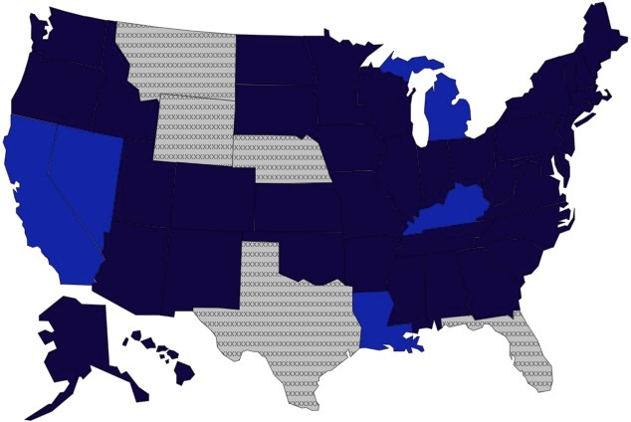 | 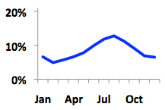 | 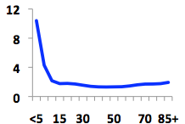 | 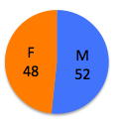
Enteritidis | 44.7 | 29.1 | 24.4 | 5.6
106,514  2.29  -1.1% | 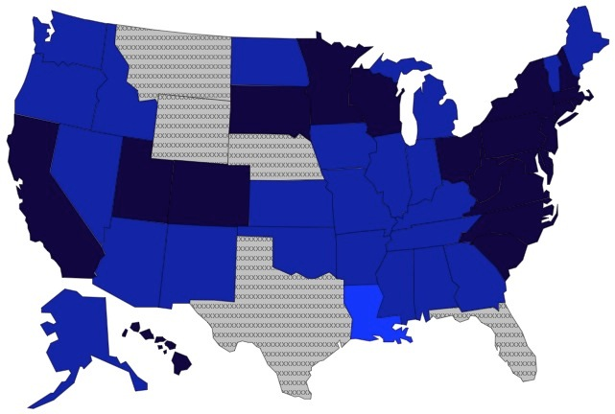 | 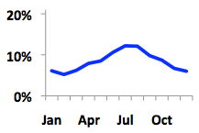 | 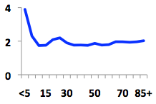 | 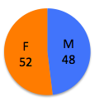
Newport | 78.3 | 68.1 | 80.8 | 9.6
54,487  1.17  +26.8% | 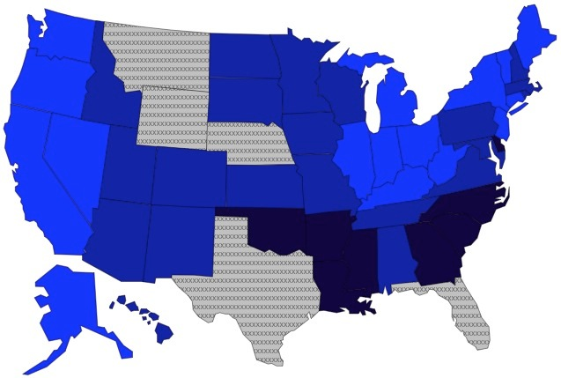 | 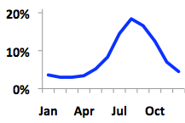 | 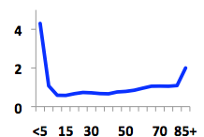 | 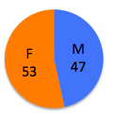
Heidelberg | 33.1 | 31.7 | 78.8 | 0.3
26,980  0.88  -30% | 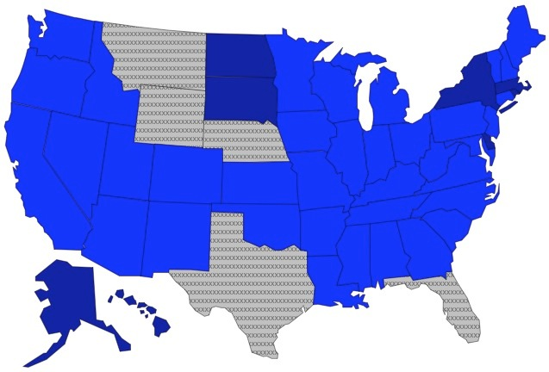 | 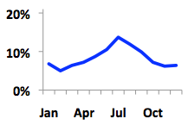 | 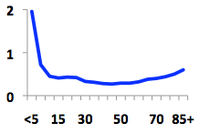 | 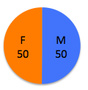
Javiana | 135.1 | 82.6 | 115.9 | 1.5
24,936  0.54  +63.1% | 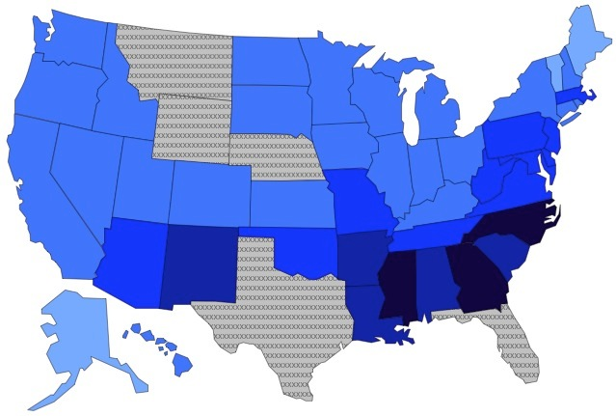 | 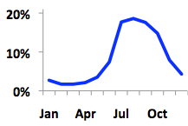 | 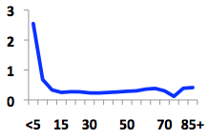 | 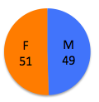

Serotype  No. of Isolates,^{d}  Rate,^{e}  % Change^{f} | CV,ª Distribution by State^{b}  (# Isolates/100,000 Persons by State)^{g} | CV,ª Distribution by Month  (% Isolates by Month) | CV,ª Distribution by Age^{c}  (# Isolates/100,000 Persons by Age group) | CV,ª Distribution by Sex  (% Isolates by Sex)
Montevideo | 57.8 | 38 | 80.5 | 10.1
15,080  0.43  +13.7% | 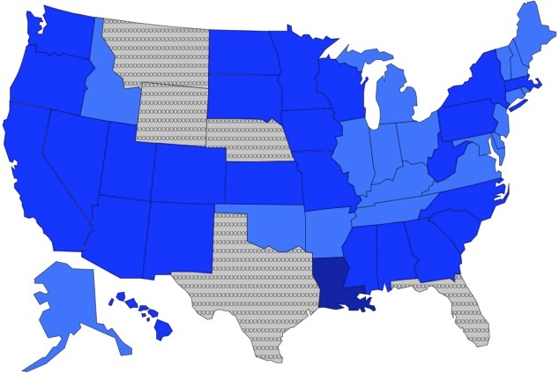 | 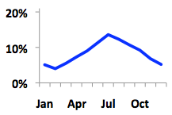 | 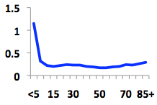 | 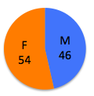
Muenchen | 95.8 | 61.3 | 93.6 | 12.3
12,465  0.32  +7.4% | 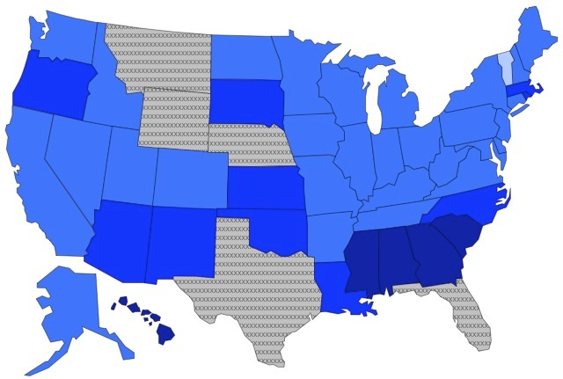 | 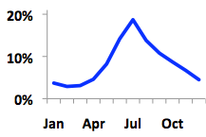 | 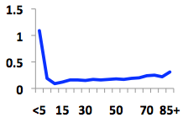 | 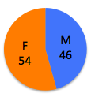
Saintpaul | 53.5 | 41.6 | 67.7 | 4.6
11,126  0.24  +42.8% | 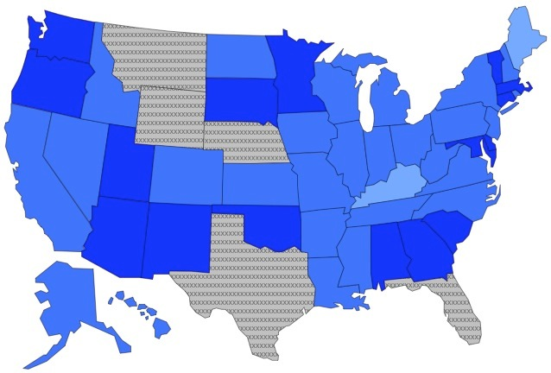 | 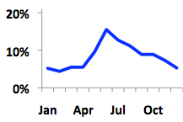 | 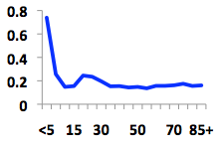 | 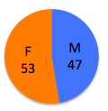
Oranienburg | 76.3 | 38 | 68.5 | 10.1
10,413  0.22  -0.3% | 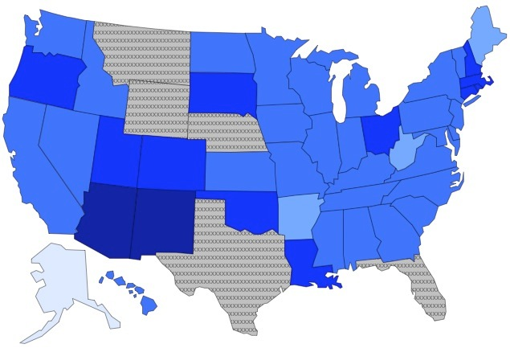 | 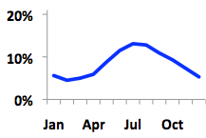 | 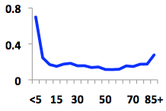 | 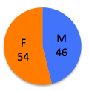
Infantis | 39.8 | 33.1 | 63.3 | 11.3
9,566  0.21  +5.0% | 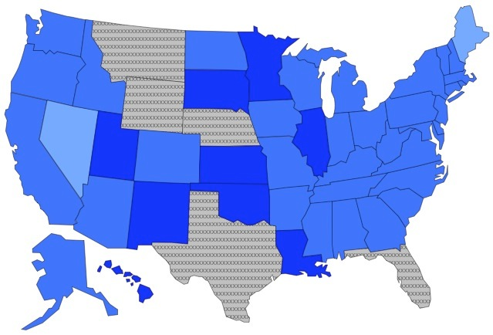 | 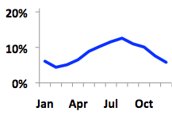 | 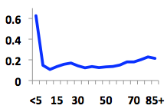 | 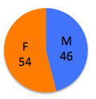
Braenderup | 40.8 | 38 | 41.3 | 16.1
9,270  0.20  +21.2% | 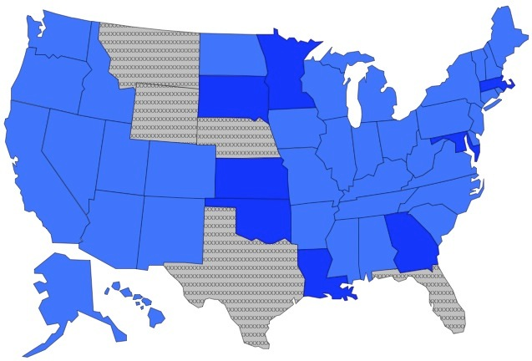 | 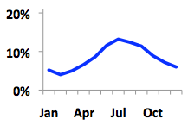 | 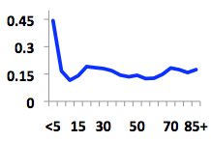 | 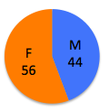

Serotype  No. of Isolates,^{d}  Rate,^{e}  % Change^{f} | CV,ª Distribution by State^{b}  (# Isolates/100,000 Persons by State)^{g} | CV,ª Distribution by Month  (% Isolates by Month) | CV,ª Distribution by Age^{c}  (# Isolates/100,000 Persons by Age group) | CV,ª Distribution by Sex  (% Isolates by Sex)
Paratyphi B. Var L(+) Tartrate+ ^{i} | 65.7 | 32.1 | 92.9 | 6.2
8,585  0.17  0% | 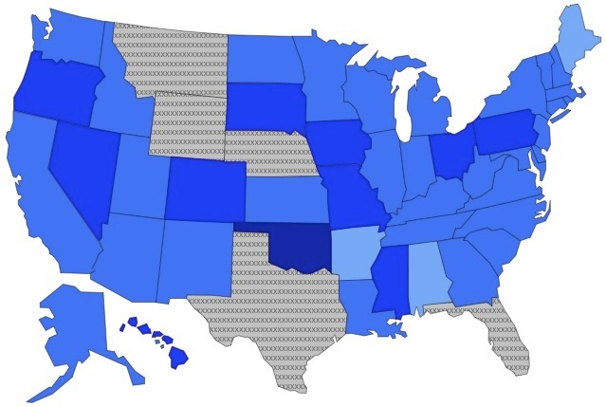 | 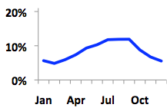 | 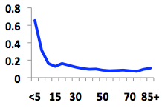 | 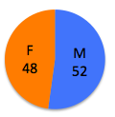
Agona | 46 | 32.3 | 72 | 4.5
8,348  0.18  -22.6% | 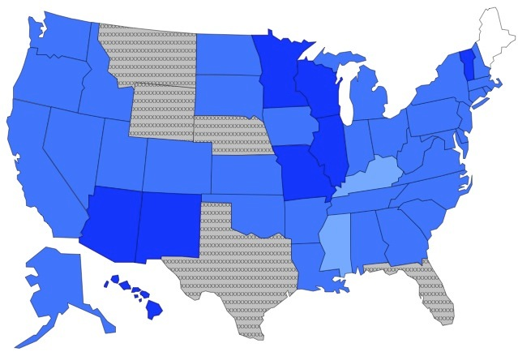 | 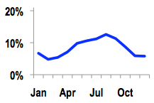 | 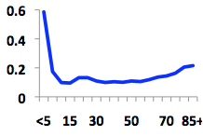 | 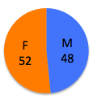
Thompson | 44.6 | 42.2 | 49.6 | 11.9
8,225  0.18  -25.7% | 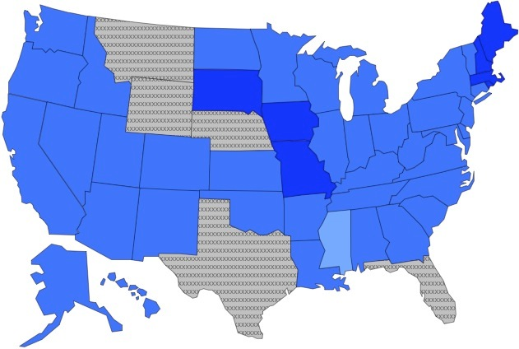 | 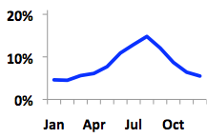 | 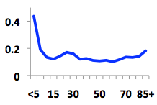 | 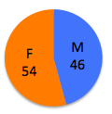
Mississippi | 255.8 | 69.3 | 160.1 | 7.7
6,438  0.14  +62.5% | 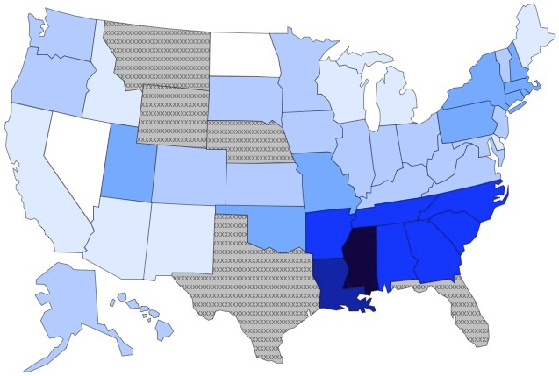 | 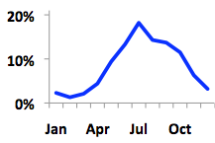 | 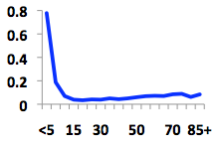 | 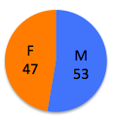
Typhi | 93.1 | 28.7 | 67.8 | 6
6,211  0.13  +2.9% | 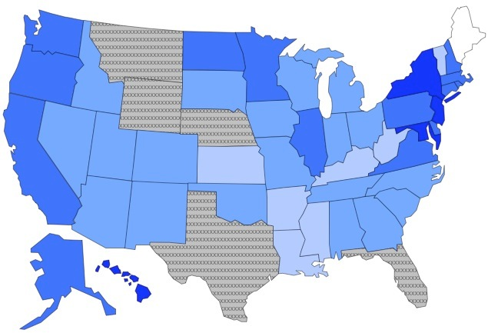 | 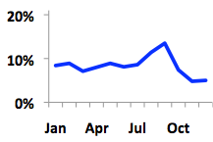 | 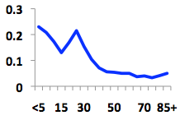 | 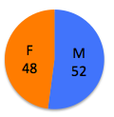
Hadar | 58.8 | 27.4 | 52 | 8.6
5,683  0.12  -48.8% | 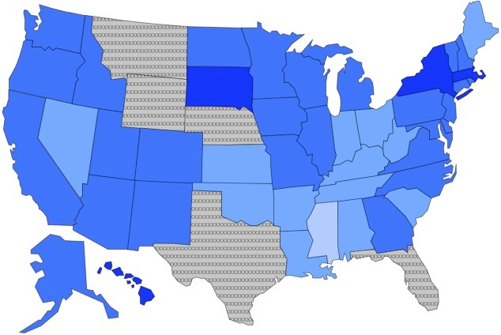 | 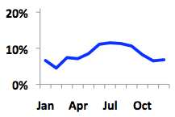 | 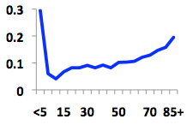 | 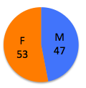
Serotype  No. of Isolates,^{d}  Rate,^{e}  % Change^{f} | CV,ª Distribution by State^{b}  (# Isolates/100,000 Persons by State)^{g} | CV,ª Distribution by Month  (% Isolates by Month) | CV,ª Distribution by Age^{c}  (# Isolates/100,000 Persons by Age group) | CV,ª Distribution by Sex  (% Isolates by Sex)
Poona | 107.2 | 28.7 | 151 | 3.5
4,645  0.10  -19.5% | 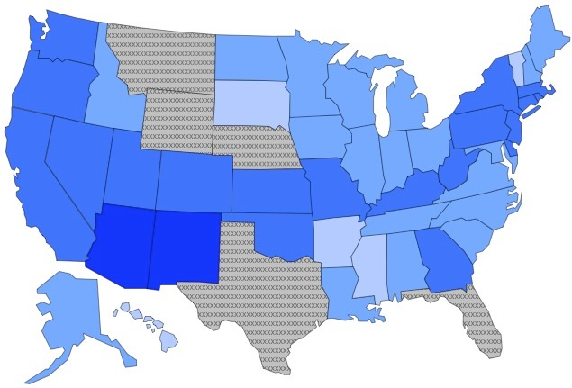 | 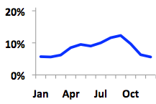 | 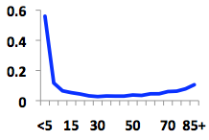 | 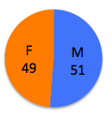
Berta | 60.1 | 56.7 | 40.3 | 10.3
3,635  0.08  +15.9% | 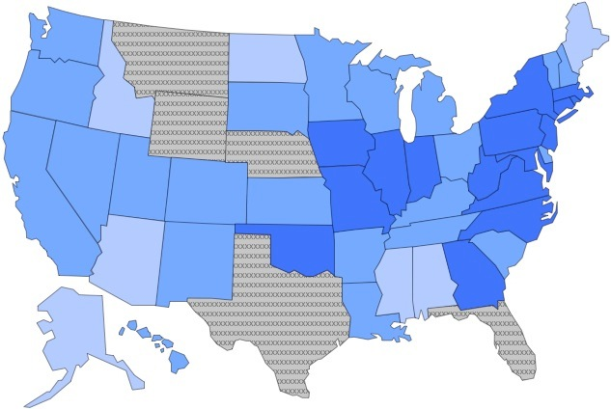 | 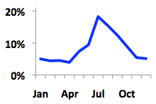 | 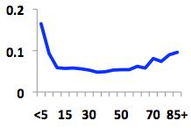 | 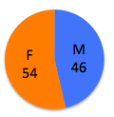
Bareilly | 127 | 63.3 | 100.1 | 1.3
3,576  0.08  +49.5% | 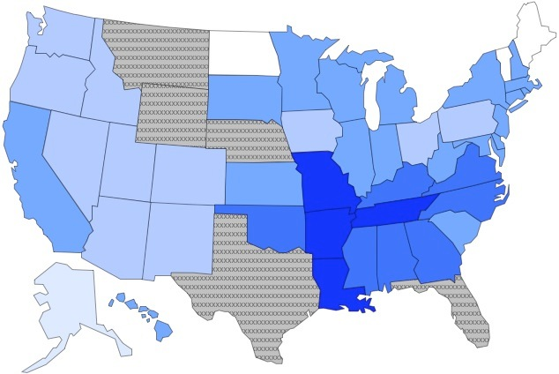 | 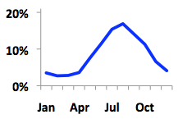 | 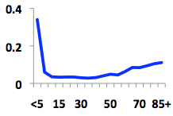 | 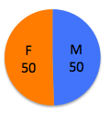
Stanley | 54.3 | 27 | 129 | 9.1
3,357  0.07  +7.8% | 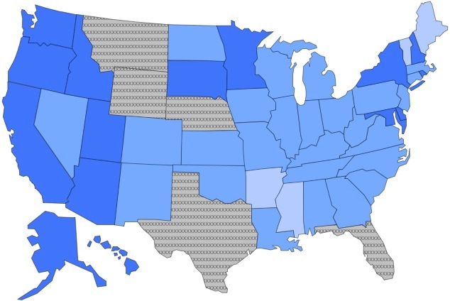 | 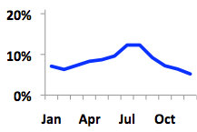 | 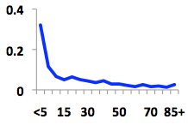 | 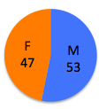
Anatum | 56.6 | 24 | 49 | 27.8
3,336  0.07  +7.6% | 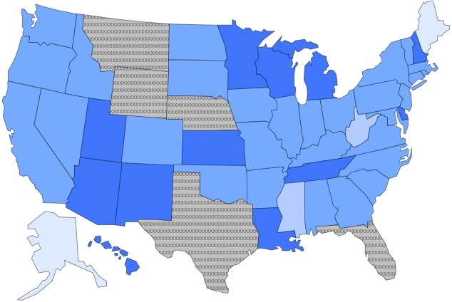 | 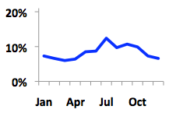 | 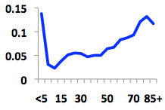 | 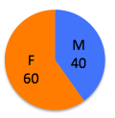
Schwarzengrund | 92.7 | 42.3 | 149.7 | 0.6
3,185  0.07  +78.1% | 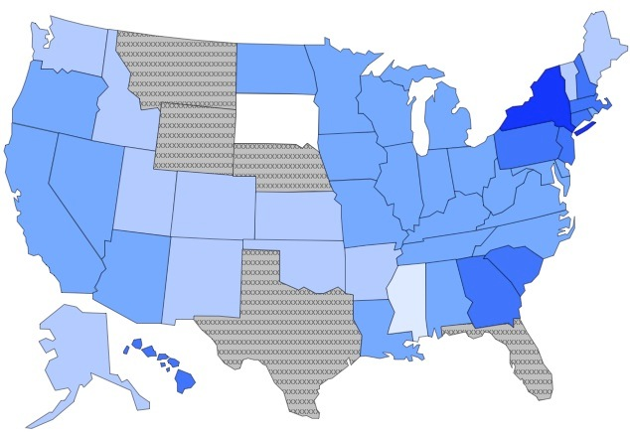 | 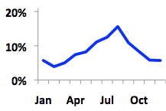 | 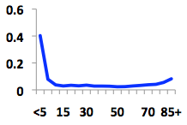 | 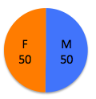
Serotype  No. of Isolates,^{d}  Rate,^{e}  % Change^{f} | CV,ª Distribution by State^{b}  (# Isolates/100,000 Persons by State)^{g} | CV,ª Distribution by Month  (% Isolates by Month) | CV,ª Distribution by Age^{c}  (# Isolates/100,000 Persons by Age group) | CV,ª Distribution by Sex  (% Isolates by Sex)
Mbandaka | 58.5 | 20.8 | 70.8 | 23.6
3,159  0.07  +7.1% | 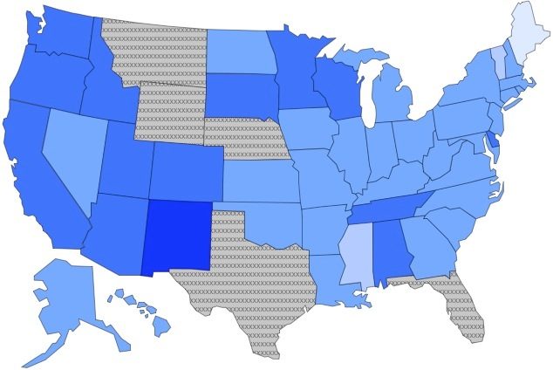 | 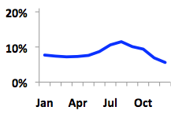 | 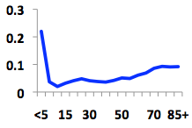 | 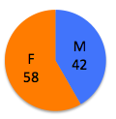
Hartford | 73.2 | 56.7 | 43.2 | 14.1
2,921  0.06  +30.7% | 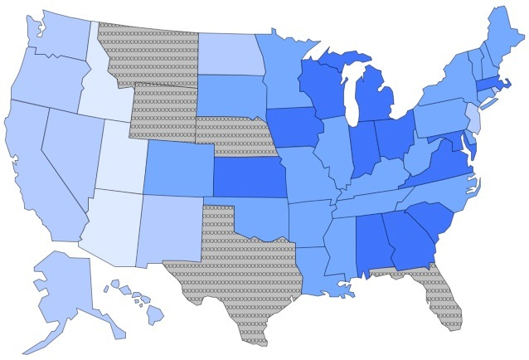 | 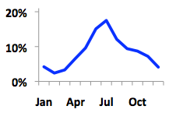 | 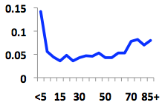 | 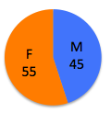
Litchfield | 78.3 | 39.1 | 70.6 | 14.3
2,839  0.06  +51.5% | 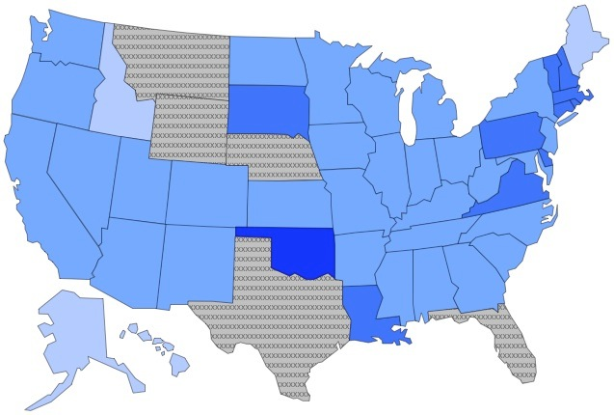 | 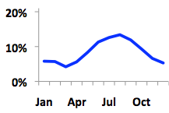 | 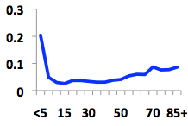 | 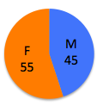
Panama | 101.2 | 34.5 | 67.6 | 7.4
2,584  0.06  +5.9% | 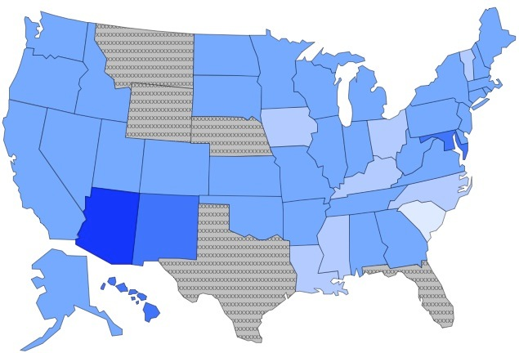 | 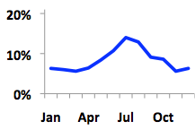 | 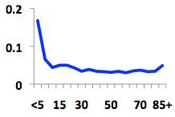
Derby | 105.9 | 24 | 88 | 5.7
2,312  0.05  -21.2% | 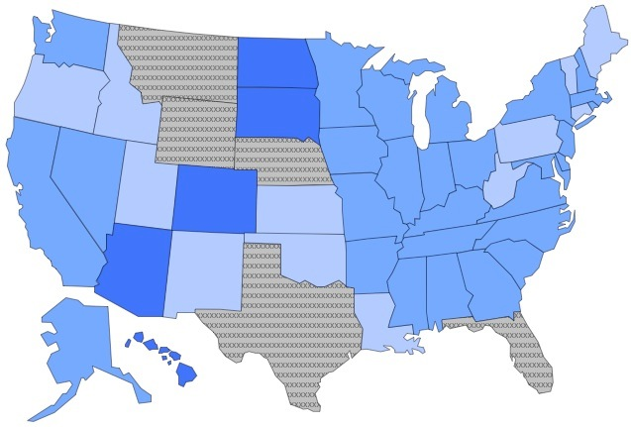 | 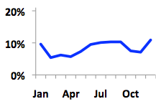 | 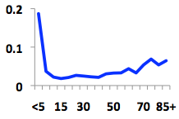 | 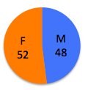
Senftenberg | 76.1 | 18.3 | 49.8 | 34.7
2,247  0.05  -9.6% | 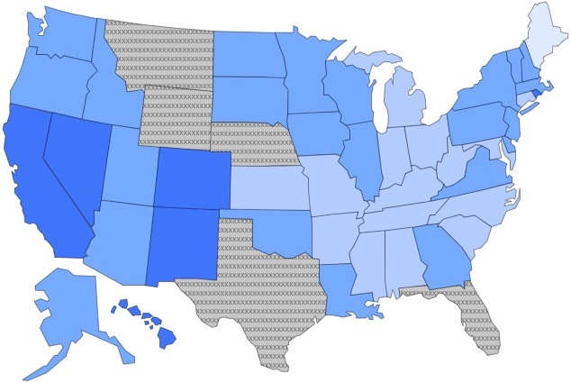 | 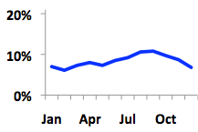 | 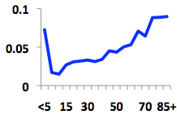 | 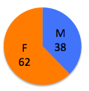
Serotype  No. of Isolates,^{d}  Rate,^{e}  % Change^{f} | CV,ª Distribution by State^{b}  (# Isolates/100,000 Persons by State)^{g} | CV,ª Distribution by Month  (% Isolates by Month) | CV,ª Distribution by Age^{c}  (# Isolates/100,000 Persons by Age group) | CV,ª Distribution by Sex  (% Isolates by Sex)
Sandiego | 64.1 | 29.5 | 91.8 | 0.5
2,050  0.04  +43.3% | 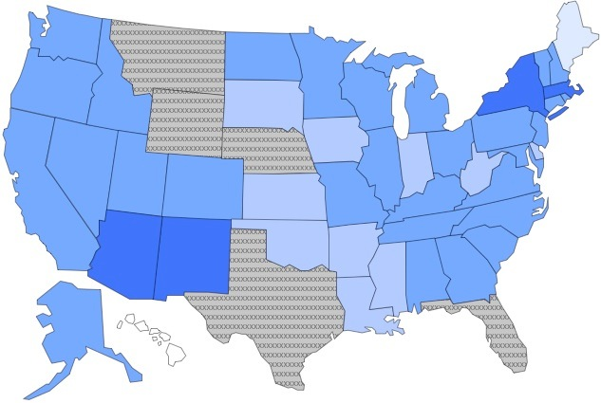 | 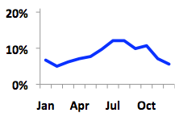 | 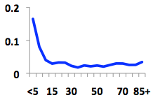 | 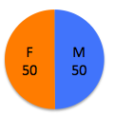
Paratyphi A | 80.6 | 34.6 | 62.5 | 13.7
2,043  0.04  +70.6% | 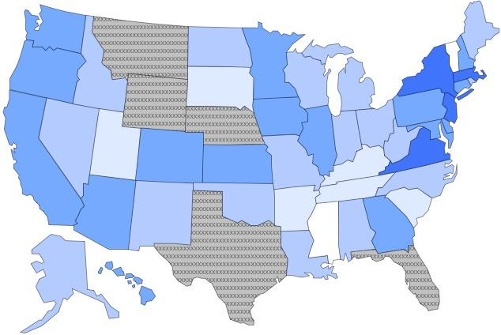 | 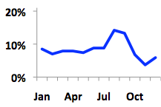 | 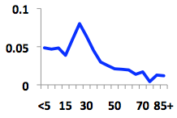 | 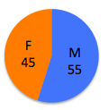
Brandenburg | 59 | 26.5 | 85.3 | 1.6
1,722  0.04  -40.6% | 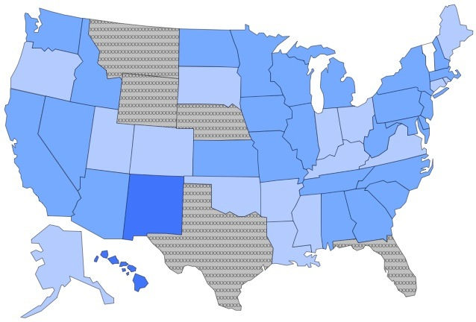 | 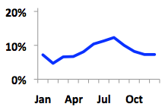 | 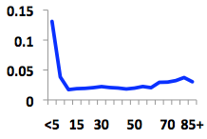 | 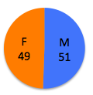
Tennessee | 48.7 | 32.6 | 73.2 | 53.5
1,721  0.04  +253% | 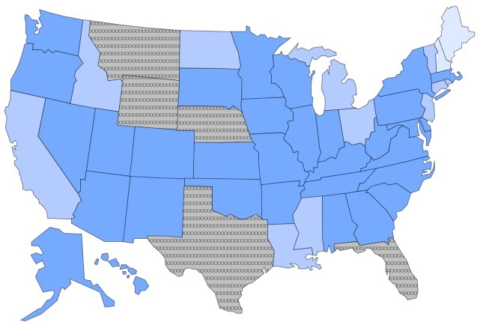 | 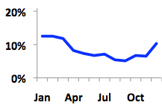 | 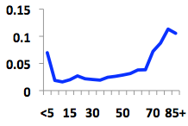 | 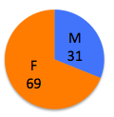
Norwich | 161.2 | 87 | 111.3 | 5.6
1,683  0.04  +49.7% | 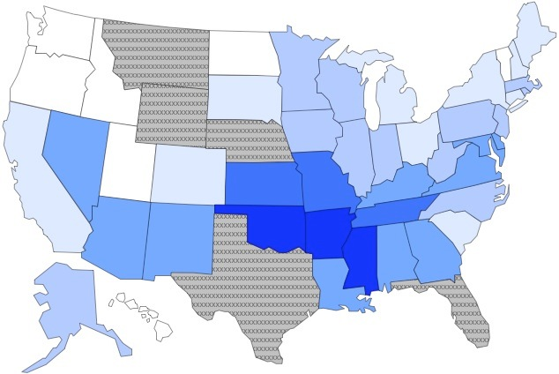 | 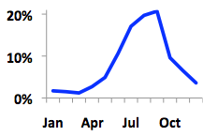 | 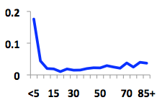 | 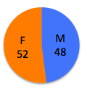
Rubislaw | 197.3 | 56.3 | 264.6 | 7.3
1,629  0.04  +32.2% | 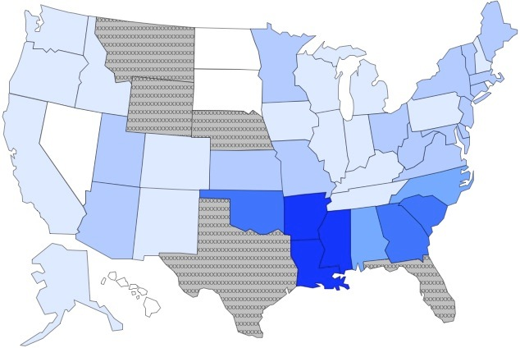 | 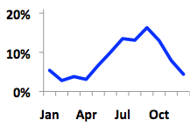 | 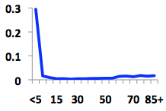 | 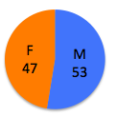
Serotype  No. of Isolates,^{d}  Rate,^{e}  % Change^{f} | CV,ª Distribution by State^{b}  (# Isolates/100,000 Persons by State)^{g} | CV,ª Distribution by Month  (% Isolates by Month) | CV,ª Distribution by Age^{c}  (# Isolates/100,000 Persons by Age group) | CV,ª Distribution by Sex  (% Isolates by Sex)
Give | 195.1 | 45.1 | 96.5 | 9.6
1,611  0.03  +9.7% | 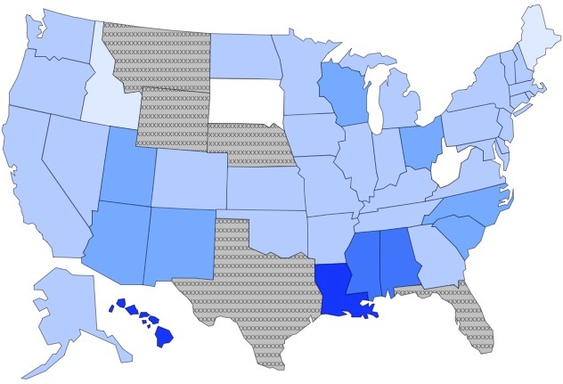 | 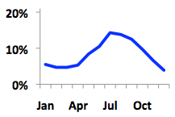 | 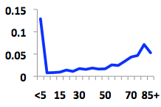 | 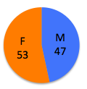
All Others | 59.4 | 28.1 | 89.2 | 5.9
50,455  1.09  +17.5% | 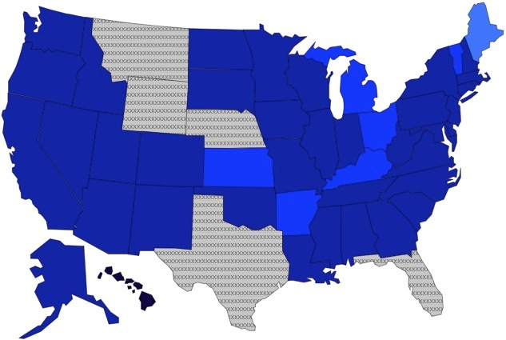 | 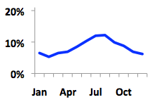 | 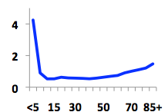 | 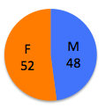
ª CV = Coefficient of variation.
^{b} Excludes 6 states reporting >10% of isolates with no serotype data or only partial serotype data for 8 or more of the 16 surveillance years (shown in gray on maps: Montana, Texas, Florida, Nebraska, Wyoming, Washington DC).
^{c} Age groups based on US census age groups of 18 groupings (6 of the 18 age groups shown on x-axis due to space).
^{d} Total isolates reported during 1996-2011 in the United States.
^{e} Rate of isolates (# per 100,000 persons) in the United States during 1996-2011.
^{f} Percentage change in isolation rate (per 100,000 persons) during 2004-2011 compared with 1996-2003.
^{g} Legend (no. of isolates per 100,000 population):

^{h} Includes serotype I, 4,[5],12:i:- and Typhimurium isolates reported as Typhimurium var. 5-.
^{i} Includes isolates reported as Paratyphi B.

