Supplement

Methods
HIV-Uninfected Laboratory Control Group:
80 HIV-uninfected men who have sex with men (MSM) were enrolled as a laboratory control group to characterize antibody responses among healthy ID vaccine recipients; 40 were randomly assigned to receive intramuscular vaccine and 40 to receive intradermal vaccine. At the first study visit, all HIV-uninfected participants received pre-HIV test counseling and a rapid HIV test; those positive on an initial rapid test underwent two additional HIV rapid tests to confirm the diagnosis. Rapid HIV testing was repeated 12 months post vaccination to determine whether HIV seroconversion occurred during the study period.

Exclusion Criteria
Exclusion criteria included females, men >60 years of age, non-Thai nationality, severe allergies to chicken eggs, prior severe reaction to influenza vaccine, history of Guillain-Barré syndrome, on steroid therapy or other immunosuppressant medications, receipt of influenza vaccine in the 12 months prior to enrollment, receipt of any vaccine in the 4 weeks prior to the first study visit or anticipated receipt of a vaccine (other than influenza vaccine provided through the study protocol) in the 4 weeks following the first study visit, receipt of any experimental agents within the 4 weeks prior to enrollment or anticipated receipt of an experimental agent during the 12 month study period, and any condition, in the opinion of the investigators, that would place them at unacceptable risk of injury or render them unable to meet requirements of the protocol.

Withdrawal Criteria
- Medical condition for which continued participation, in the opinion of the investigator, would pose a risk to the participant
- As deemed necessary by the principal investigator for noncompliance or other reasons
- Withdrawal of consent
- Lost to follow up

HIV Testing:
With the exception of HIV-infected BMCS cohort members, all study participants underwent HIV testing upon enrollment into the influenza vaccine study after receiving pre-HIV test counseling. HIV-infected BMCS members received HIV testing at the time of enrollment into the BMCS cohort, but were not re-tested at enrollment into the influenza study.
BMCS participants were screened for HIV in oral fluid using OraQuick® HIV-1/2 (Orasure Technologies, Inc., USA). If reactive, the result was confirmed with 3 rapid blood tests:
- 1st confirmation: Determine™ HIV-1/2 (Inverness Medical Japan, Japan)
- 2nd confirmation: DoubleCheck™ II HIV-1&2 (Orgenics Ltd., Israel)
- 3rd confirmation: Capillus™ HIV-1/HIV-2 (Trinity Biotech, USA). As of November 2008, this test was replaced by Core™ HIV-1&2 (Core Diagnostics, UK)
All other participants (including BMCS participants that were negative for HIV upon initial testing) underwent one initial HIV rapid test. If reactive, the result was confirmed using two additional HIV rapid tests.
- Initial HIV rapid test: Alere Determine™ HIV-1/2 (Alere Medical Co., Ltd., Japan)
- 1st Confirmation: SDBioline HIV-1/2 3.0 (Standard Diagnostics, Inc., Korea). As of January 10, 2012, test was replaced with DoubleCheck Gold Ultra HIV-1/2 (Orgenics Ltd., Israel)
- 2nd Confirmation: Core™ HIV-1&2 (Core Diagnostics, UK)

One participant was found to have an inconclusive HIV test result (initially reactive by Determine HIV-1/2 but non-reactive by the confirmation rapid test). This participant was later confirmed HIV-negative by HIV-EIA, Genetic System HIV-1/2 Plus O EIA (Bio-Rad, USA).Western blot was not used in this study. HIV-EIA was used for confirmatory testing for the inconclusive case only.

All HIV-infected participants also had blood collected for HIV viral load testing, COBAS® Taqman® HIV-1 Test (Roche Diagnosis, Switzerland).

Randomization Procedures
Randomization assignments were placed in sealed opaque envelopes, shuffled and put into boxes corresponding to stratification groups (CD4 ≥200 and <200 cells/mm³). Study nurses allocated newly enrolled participants by randomly selecting a sealed envelope from the appropriate box after confirming HIV infection status and CD4 cell count.

Vaccination
IM vaccine was administered in the deltoid muscle of the arm and ID vaccine via a micro-injection system into the skin over the deltoid region.

Post Vaccination Safety Monitoring
Prior to receiving the influenza vaccine, all study participants received an influenza vaccine fact sheet which outlined potential risks, side effects, and benefits of the vaccine. All participants were observed for 30 minutes post vaccination to monitor for any immediate adverse reactions to the vaccine. Participants were provided with adverse event diary cards with a symptom check-list on one side and important phone numbers on the other side. Participants also received a thermometer and ruler to measure temperature, diameter of local skin erythema and induration, and arm circumference at the site of vaccination. Participants were provided with a phone number for a study nurse to call in case they have any questions or experience any reactions to the vaccine. This phone number was available to call 24 hours per day, 7 days per week for the first 7 days after vaccination. Participants were contacted by phone 3 days post vaccination to gather data on whether or not they experienced any adverse reactions from the vaccine. During the call, a standardized adverse event questionnaire was administered to all participants and they were also reminded to return adverse event cards to the research coordinator at the end of 7 days (in person, by fax, by email, or by standard mail). The study coordinator contacted participants to clarify any missing values and to review all Grade 3 or greater adverse events. Participants were instructed to seek medical care immediately if they experience any severe or life-threatening reactions to the vaccine.

Adverse Event Monitoring and Study Halting Criteria
The Adverse Event Scales that follow have been established based upon the 2007 report on Guidance for Industry: Toxicity Grading Scale for Healthy Adult and Adolescent Volunteers Enrolled in Preventive Vaccine Clinical Trials. U.S. Department of Health and Human Services; Food and Drug Administration; Centers for Biological Evaluation and Research.

Grading of Solicited Adverse Vaccine Events
 | Mild  (Grade 1) |  | Moderate  (Grade 2) |  | Severe  (Grade 3) | Potentially Life-Threatening  (Grade 4)
Local Reactions
Pain | Does not interfere with activity |  | Repeated use of non-narcotic pain reliever > 24 hours or interferes with activity |  | Any use of narcotic pain reliever or prevents daily activity | Hospitalization
Tenderness | Mild discomfort to touch |  | Discomfort with movement |  | Significant discomfort at rest | Hospitalization
Redness/ Erythema | 2.5- 5 cm |  | 5.1- 10 cm |  | > 10 cm | Necrosis or exfoliative dermatitis
Swelling/ Induration | 2.5- 5 cm and does not interfere with activity |  | 5.1- 10 cm or interferes with activity |  | > 10 cm or prevents daily activity | Necrosis
Systemic Symptoms
Feverishness |  | >37.8 and <38° C  and no interference  with activity |  | ≥ 38 and < 38.5° C  and some interference with activity | ≥ 38.5 and < 39° C  and prevents daily activity | ≥ 39° C  and hospitalization
Fatigue/Malaise |  | No interference with activity |  | Some interference with activity | Prevents daily activity | Hospitalization
Myalgia/ Body Aches |  | No interference with activity |  | Some interference with activity | Prevents daily activity | Hospitalization
Headache |  | No interference with activity |  | Some interference with activity | Prevents daily activity | Hospitalization
Nausea |  | No interference with activity |  | Some interference with activity | Prevents daily activity | Hospitalization
Itching |  | No interference with activity |  | Some interference with activity | Prevents daily activity | Hospitalization
Potentially life threatening adverse event is an event that meets one of the following criteria:
- Death during the protocol period
- Life-threatening event
- Event requiring inpatient hospitalization
- Results in persistent or significant disability/ incapacity
- Any other important medical event based upon appropriate medical judgment

The study will be halted for Safety Monitor Review/ recommendation if:
- Any potentially life-threatening event occurs (Grade 4)
- Any participant experiences ulceration, abscess, or necrosis associated with vaccine
- Any participant experiences laryngospasm, bronchospasm, or anaphylaxis associated with vaccine administration
- 2 or more participants experience urticaria associated with vaccine administration

The study will be halted for Safety Monitor Review/ recommendation if during the 7 days after vaccine administration any of the following occur:
- 15% or more participants enrolled to date experience a severe (Grade 3 or higher) vaccine-related local reaction
- 15% or more participants enrolled to date experience a severe (Grade 3 or higher) vaccine-related quantitative systemic reaction
- 15% or more participants enrolled to date experience a severe (Grade 3 or higher) vaccine-related subjective systemic reaction that is corroborated by study personnel

Results
Interim safety analysis
An interim safety analysis was conducted after 10% of participants were enrolled in January 2012. The safety monitor concluded that 95% of adverse events were mild, 4% of adverse events were moderate and all adverse events resolved within 7 days of symptom onset.

Antibody Responses at 6 and 12 Months Post-Vaccination Among HIV-infected Participants
At 6 months, 3% (95% CI: 1–6) of ID and 6% (95% CI: 3–10%) of IM vaccine recipients had seroprotection to all 3 vaccine strains; at 12 months 2% (95% CI: 0–4%) of ID and 5% (95% CI: 2–8%) of IM vaccine recipients had seroprotection to all 3 vaccine strains (Figure 3a). At 6 months, 74% (95% CI: 67–80%) of ID and 77% (95% CI: 70–82%) of IM vaccine recipients had seroprotection to at least one of the 3 vaccine strains; at 12 months 51% (95% CI: 44–58%) of ID and 57% (95% CI: 49–64%) of IM vaccine recipients had seroprotection to at least one of the 3 vaccine strains (Figure 3b).

Supplemental Figure 1a. Percent and 95% confidence interval for HIV-infected participants who seroconverted to all three vaccine strains at 1, 6, and 12 months post-vaccination
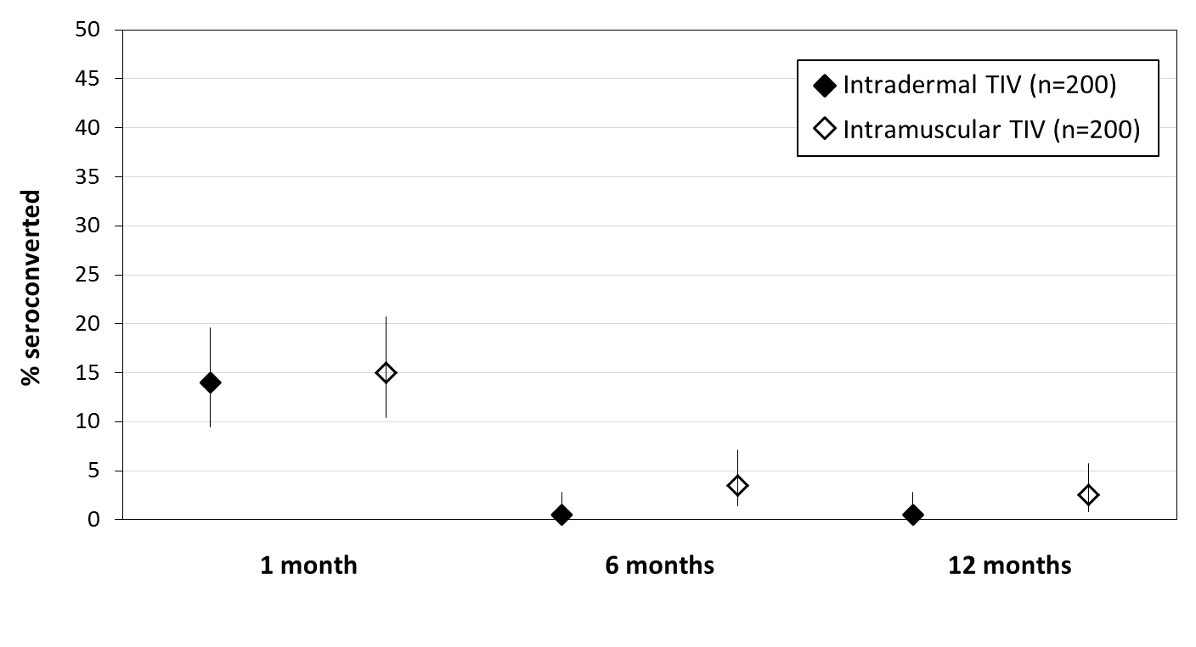

Supplemental Figure 1b. Percent and 95% confidence interval of HIV-infected participants who seroconverted to any of the three vaccine strains at 1, 6, and 12 months post-vaccination
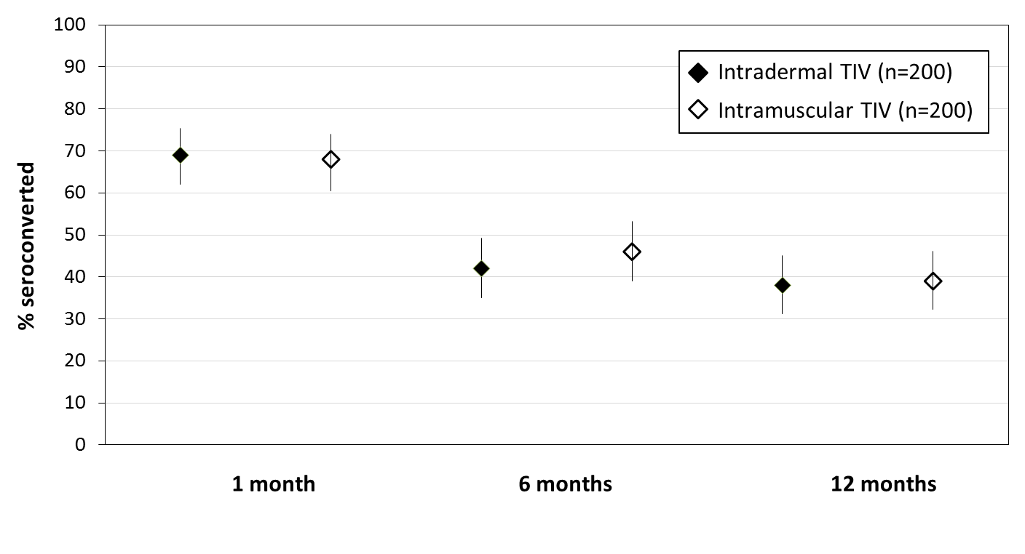

Supplemental Figure 2a. Geometric Mean Titer and 95% Confidence Interval of HIV-infected Participants to the A/H1N1 Vaccine Strain Prior to and 1, 6, and 12 months Post-Vaccination

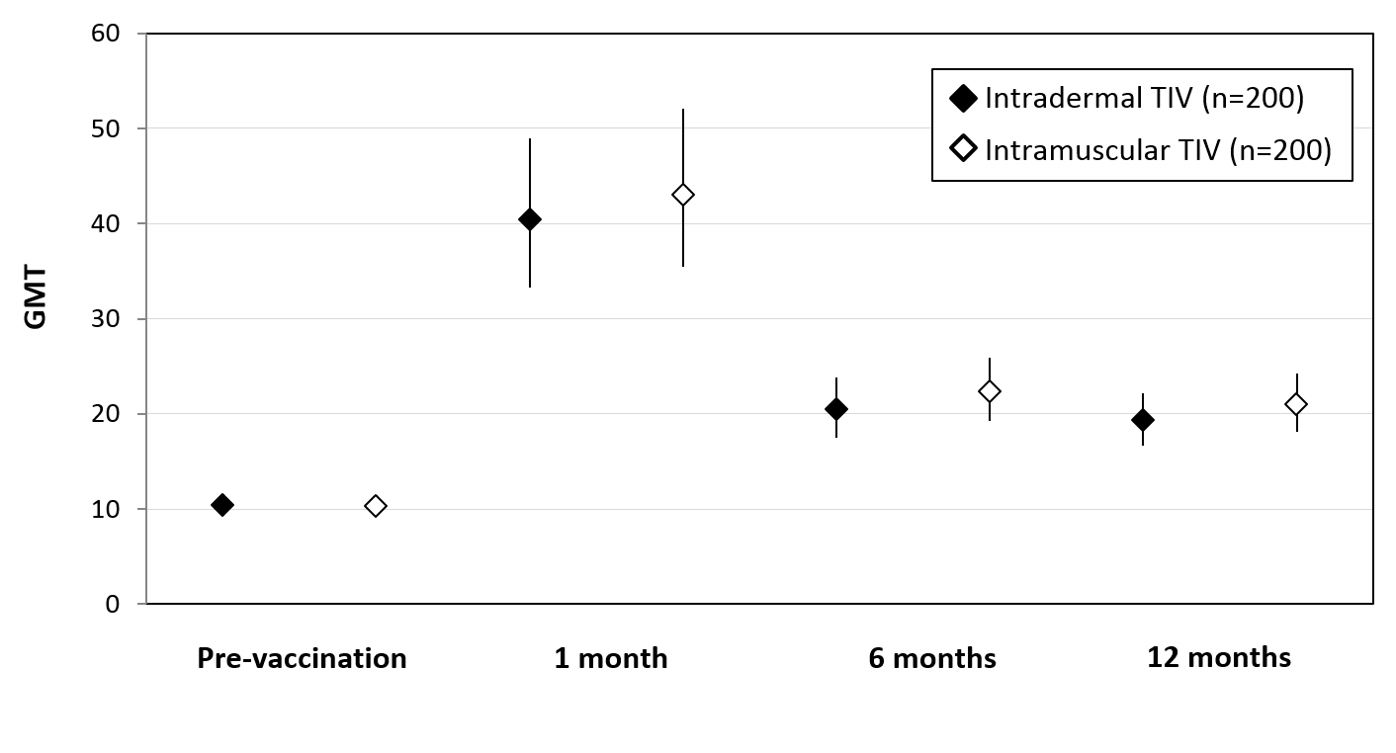

Supplemental Figure 2b. Geometric Mean Titer and 95% Confidence Interval of HIV-infected Participants to the A/H3N2 Vaccine Strain Prior to and 1, 6, and 12 months Post-Vaccination

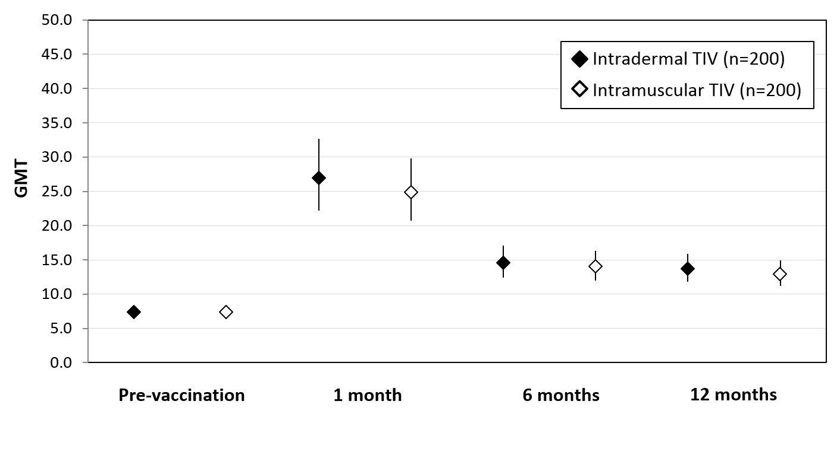
Supplemental Figure 2c. Geometric Mean Titer and 95% Confidence Interval of HIV-infected Participants to the B Vaccine Strain Prior to and 1, 6, and 12 months Post-Vaccination

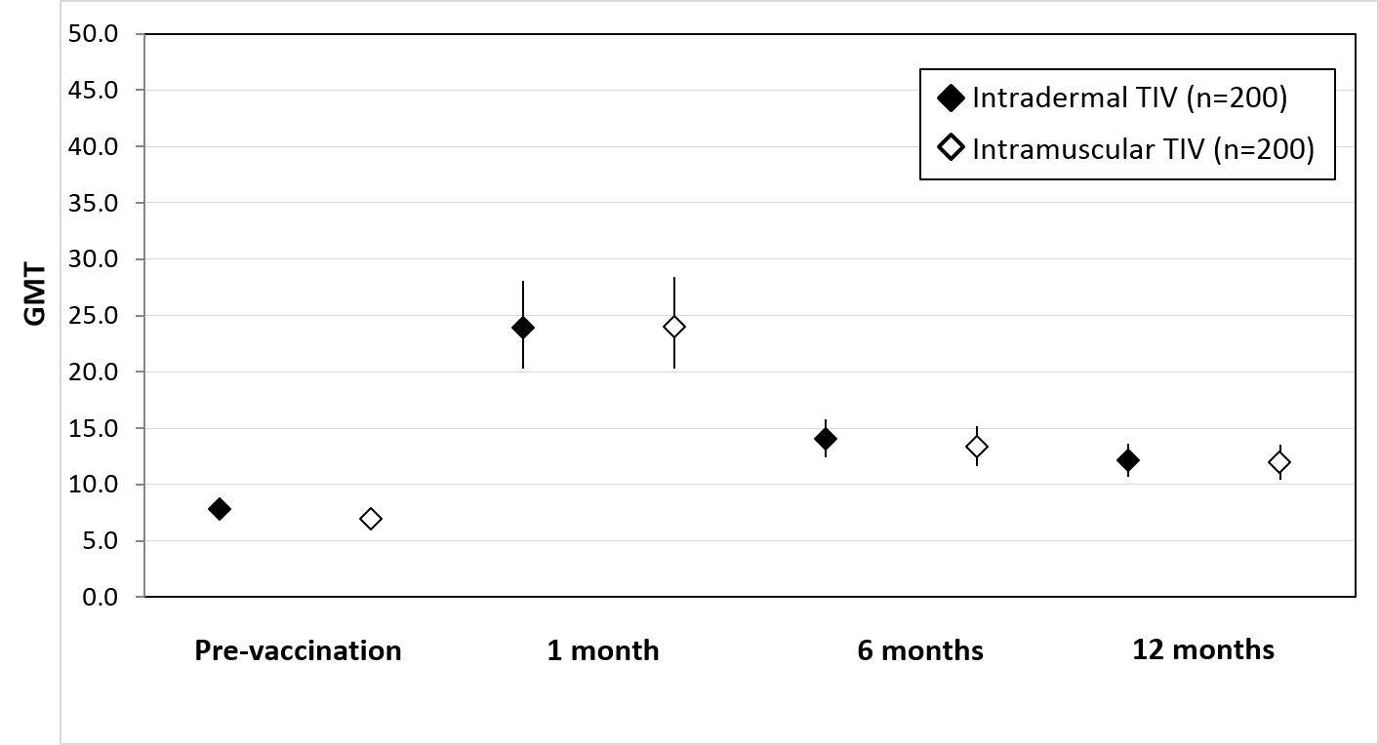

Supplemental Figure 3. Enrollment and follow-up HIV-uninfected study participant

Assessed for eligibility (n=83)

Enrolled (n=83)

Randomized (n=80)

Received intradermal vaccine** (n=40)
Received intramuscular vaccine*
(n=40)

Completed 6 month visit per protocol (n=33)

Completed 12 month visit per protocol (n=35

Completed all study visits per protocol (n=32)

Completed 1 month visit per protocol (n=39)

Completed 6 month visit per protocol (n=36)

Completed 12 month visit per protocol (n=35)

Completed 1 month visit per protocol (n=38)

Completed all study visits per protocol (n=32)

*For intramuscular vaccine: 2 persons did not complete the 1 month visit; 2 persons did not complete the 6 month visit and 5 completed it outside the acceptable window period; 1 person did not complete the 12 month visit and 4 completed it outside the acceptable window period
**For intradermal vaccine: 0 persons did not complete the 1 month visit and 1 completed it outside of the acceptable window period; 0 persons did not complete the 6 month visit and 4 completed it outside the acceptable window period; 0 persons did not complete the 12 month visit and 5 completed it outside the acceptable window period

Supplemental Table 1. Baseline demographic and clinical characteristics of HIV-uninfected participants
Characteristics | Intramuscular Vaccine  (n=40) | Intradermal Vaccine  (n=40)
Age in years; median (range) | 30 (19-48) | 29 (20-45)
BMCS Cohort Member; no. (%) | 23 (58) | 33 (83)
Employment status; no. (%)
Employed full time | 36 (90) | 33(83)
Unemployed | 0 | 0
Other | 4 (10) | 7 (18)
Education level; no. (%)
Less than high school | 1 (3) | 0
High school | 5 (13) | 4 (10)
Greater than high school | 34 (85) | 36 (90)
Income level; no. (%)
<10000 Baht | 10 (25) | 5 (13)
10001-15000 Baht | 5 (13) | 11 (28)
≥15001 Baht | 25 (63) | 24 (60)
Unknown | 0 | 0
Current tobacco use; no. (%) | 10 (25) | 6 (15)
Injection drug use¹; no. (%) | 0 | 0
Non-injection drug use¹; no. (%) | 7 (18) | 1 (3)
Medical conditions; no. (%)
Hepatitis B | 1 (3) | 0
Hepatitis C | 0 | 0
Tuberculosis | 0 | 0
Asthma | 1 (3) | 1 (3)
Diabetes | 0 | 0
Chronic lung diseases | 1 (3) | 2 (5)
Cardiovascular disease | 0 | 0
Hospitalized in month prior to vaccination; no. (%) | 0 | 0
¹Use in the 4 months prior to vaccination
² Non-injection drug use included: marijuana, cocaine, ecstasy, crystal methamphetamine, gamma-hydroxybutyric acid, ketamine, inhalants, or poppers
³At time of study enrollment

Supplemental Table 2. Solicited adverse events (AE) during the 7 days after receipt of vaccine by vaccine type and AE severity grade among HIV-uninfected participants
Adverse event | IM Vaccine (n=40)  n (%; 95% confidence interval) |  | ID Vaccine (n=40)  n (%; 95% confidence interval)
 | Grade 1–2 | Grade >3 | Grade 1–2 | Grade >3
Injection Site Reactions
Pain | 14 (35;21–52) | 0 | 5 (13; 4–27) | 0
Redness | 0 | 0 | 20 (50; 34–66) | 0
Swelling | 3 (8; 2–20) | 0 | 29 (73; 56–85) | 0
Tenderness | 17 (43; 27–59) | 0 | 23 (58; 41–73) | 0
Any injection-site reaction | 19 (48; 32–64) | 0 | 36 (90; 76–97) | 0
Systemic Reactions
Feverishness | 6 (15; 4–26) | 1 (3; 0–7) | 2 (5; 0–17) | 1 (3; 0–13)
Malaise | 14 (35; 21–52) | 0 | 6 (15; 6–30) | 1 (3; 0–13)
Myalgia | 21 (53; 37-68) | 0 | 7 (18; 7–33) | 1 (3; 0–13)
Headache | 13 (33; 19–49) | 0 | 7 (18; 7–33) | 1 (3; 0–13)
Nausea | 3 (8; 2–20) | 1 (3; 0-13) | 5 (13; 4–27) | 0
Itching | 2 (5; 0–17) | 0 | 1 (3; 0–13) | 0
Any systemic reaction | 26 (65; 48–79) | 2 (5; 1–17) | 17 (35; 21–52) | 1 (3; 0–13)
Any adverse event | 31 (78; 62–89) | 2 (5; 1–17) | 37 (93; 80–98) | 1 (3; 0–13)

Supplemental Table 3. Antibody responses at one month post-vaccination by vaccine type among HIV-uninfected vaccine recipients
Virus | IM Vaccine (N=40) | ID Vaccine (N=40)
Influenza A/H1N1
Seroprotection; no. (%; 95% CI) | 29 (73; 56-85) | 27 (68; 51–81)
Seroconversion; no. (%; 95% CI) | 24 (60; 43–75) | 21 (53; 36–68)
Geometric mean titer (range) | 68 (43–108) | 67 (43–106)
Geometric mean titer ratio (range) | 7 (4–10) | 6 (4–9)
Influenza A/H3N2
Seroprotection; no. (%; 95% CI) | 25 (63; 46–77) | 27 (68; 51–81)
Seroconversion; no. (%; 95% CI) | 23 (58; 41–73) | 22 (55; 38–71)
Geometric mean titer (range) | 47 (29–75) | 53 (34–82)
Geometric mean titer ratio (range) | 6 (4–9) | 5 (4–8)
Influenza B
Seroprotection; no. (%; 95% CI) | 28 (70; 53–83) | 26 (65; 48–79)
Seroconversion; no. (%; 95% CI) | 24 (60; 43–75) | 19 (48; 32–64)
Geometric mean titer (range) | 47 (32–68) | 48 (33–68)
Geometric mean titer ratio (range) | 6 (4–9) | 5 (3–8)
All 3 influenza virus strains
Seroprotection; no. (%;95% CI) | 16 (40; 25–57) | 12 (30; 17–47)
Seroconversion; no. (%;95% CI) | 12 (30; 17–47) | 6 (15; 6–30)
Any of the 3 virus strains
Seroprotection; no. (%;95% CI) | 37 (93; 80–98) | 38 (95; 83–99)
Seroconversion; no. (%;95% CI) | 34 (85; 70–94) | 36 (90; 76–97)

Supplemental Table 4. Antibody response at one month post vaccination among vaccine recipients by HIV status

Virus | HIV-Infected  (N=400) | HIV-Uninfected  (N=80)
Influenza A (H1N1)
Seroprotection; no. (%; 95% CI) | 233 (58; 53–63) | 56 (70; 59–80)
Seroconversion; no. (%; 95% CI) | 191 (48; 43–53) | 45 (56; 45–67)
Geometric mean titer (range) | 42 (36–48) | 68 (50–93)
Geometric mean titer ratio (range) | 4 (4–5) | 6 (5–8)
Influenza A (H3N2)
Seroprotection; no. (%; 95% CI) | 180 (45; 40–50) | 52 (65; 54–75)
Seroconversion; no. (%; 95% CI) | 151 (38; 33-43) | 45 (56; 45–67)
Geometric mean titer (range) | 26 (23–30) | 50 (36–68)
Geometric mean titer ratio (range) | 4 (3–4) | 6 (4–8)
Influenza B
Seroprotection; no. (%; 95% CI) | 172 (43; 38–48) | 54 (68; 56–78)
Seroconversion; no. (%; 95% CI) | 145 (36; 32–41) | 43 (54; 42–65)
Geometric mean titer (range) | 24 (21–27) | 47 (37–61)
Geometric mean titer ratio (range) | 3 (3–4) | 6 (4–7)
All 3 virus strains
Seroprotection; no. (%; 95% CI) | 82 (21; 17–25) | 28 (35; 25–46)
Seroconversion; no. (%; 95% CI) | 58 (15; 11–18) | 18 (23; 14–33)
Any of the 3 virus strains
Seroprotection; no. (%; 95% CI) | 301 (75; 71–79) | 75 (94; 86–98)
Seroconversion; no. (%; 95% CI) | 273 (68; 63–73) | 70 (88; 78–94)

Supplemental Table 5. Antibody responses by CD4 cell count at enrollment and at 1 month post vaccination among HIV-infected participants

Virus Strain | CD4 Count <200 (N=85) |  | CD4 Count ≥200 (N=315)
 | Day 0 | Day 30 | Day 0 | Day 30
Influenza A (H1N1)
Seroprotection; no. (%; 95% CI) | 7 (8; 3-16) | 26 (31, 21-42) | 38 (12; 9-16) | 207 (66%, 60-71)
Seroconversion; no. (%; 95% CI) | --- | 17 (20, 12-30) | --- | 174 (55%, 50-61)
Geometric mean titer (range) | 9 (8-11) | 18 (14-23) | 11 (10-12) | 53 (46-61)
Geometric mean titer ratio (range) | --- | 2 (2-2) | --- | 5 (4-6)
Influenza A (H3N2)
Seroprotection; no. (%;95% CI) | 3 (4;1-10) | 21 (25, 16-35) | 25 (8;5-12) | 159 (51%, 45-56)
Seroconversion; no. (%;95% CI) | --- | 19 (22, 14-33) | --- | 132 (42%, 36-48)
Geometric mean titer (range) | 7 (6-18) | 13 (10-17) | 7 (7-8) | 31 (27-36)
Geometric mean titer ratio (range) | --- | 2 (2-3) | --- | 4 (4-5)
Influenza B
Seroprotection; no. (%;95% CI) | 3 (4;1-10) | 16 (19, 11-29) | 11 (4;2-6) | 156 (50%, 44-55)
Seroconversion; no. (%;95% CI) | --- | 10 (12, 6-21) | --- | 135 (43%, 37-49)
Geometric mean titer (range) | 7 (6-8) | 12 (10-15) | 7 (7-8) | 29 (25-33)
Geometric mean titer ratio (range) | --- | 2(1-2) | --- | 4 (3-4)
All 3 influenza virus strains
Seroprotection; no. (%;95% CI) | 0 | 7 (8, 3-16) | 0 | 75 (24%, 19-29)
Seroconversion; no. (%;95% CI) | --- | 5 (6, 2-13) | --- | 53 (17%, 13-21)
Any of the 3 virus strains
Seroprotection; no. (%;95% CI) | 12 (14; 8-23) | 38 (45; 34-59) | 68 (22; 17-27) | 263 (83; 79-87)
Seroconversion; no. (%;95% CI) | --- | 30 (35; 25-46) | --- | 243 (77; 72-82)

