Supplement:
Table 1S. Estimated gradient of serum IgG increase against the age in healthy children
Antigen | Age (mo) | Gradient of serum IgG increase (Log2 IgG (ng/ml) / Age (mo)) |  |  | P
 |  | Estimated gradient | Standard error | 95% Confidence interval
OMP CD | 6 | 0.303 | 0.060 | 0.189 - 0.416 | < 0.001
 | 9 | 0.167 | 0.025 | 0.119 - 0.216
 | 12 | 0.105 | 0.012 | 0.081 - 0.129
 | 15 | 0.070 | 0.009 | 0.051 - 0.088
 | 18 | 0.048 | 0.010 | 0.028 - 0.069
 | 24 | 0.024 | 0.013 | -0.001 - 0.048
 | 30 | 0.012 | 0.013 | -0.014 - 0.038
OppA | 6 | 0.255 | 0.054 | 0.152 - 0.361 | < 0.001
 | 9 | 0.145 | 0.022 | 0.102 - 0.190
 | 12 | 0.094 | 0.010 | 0.075 - 0.113
 | 15 | 0.065 | 0.007 | 0.052 - 0.078
 | 18 | 0.047 | 0.008 | 0.033 - 0.063
 | 24 | 0.027 | 0.010 | 0.007 - 0.048
 | 30 | 0.016 | 0.011 | -0.005 - 0.038
Msp22NL | 6 | 0.264 | 0.055 | 0.162 - 0.374 | < 0.001
 | 9 | 0.134 | 0.021 | 0.094 - 0.177
 | 12 | 0.078 | 0.009 | 0.059 - 0.097
 | 15 | 0.048 | 0.007 | 0.034 - 0.062
 | 18 | 0.031 | 0.008 | 0.014 - 0.047
 | 24 | 0.012 | 0.010 | -0.009 - 0.031
 | 30 | 0.003 | 0.011 | -0.019 - 0.023
Hag5-9 | 6 | 0.216 | 0.039 | 0.141 - 0.292 | < 0.001
 | 9 | 0.135 | 0.018 | 0.101 - 0.173
 | 12 | 0.095 | 0.010 | 0.077 - 0.115
 | 15 | 0.071 | 0.008 | 0.056 - 0.086
 | 18 | 0.055 | 0.008 | 0.039 - 0.071
 | 24 | 0.035 | 0.011 | 0.016 - 0.056
 | 30 | 0.024 | 0.012 | 0.002 - 0.048
PilA2 | 6 | 0.098 | 0.057 | -0.002 - 0.213 | < 0.001
 | 9 | 0.084 | 0.022 | 0.042 - 0.129
 | 12 | 0.073 | 0.011 | 0.053 - 0.095
 | 15 | 0.066 | 0.009 | 0.047 - 0.083
 | 18 | 0.059 | 0.010 | 0.037 - 0.079
 | 24 | 0.051 | 0.013 | 0.024 - 0.074
 | 30 | 0.044 | 0.014 | 0.016 - 0.071
Serum anti-Mcat protein specific IgG antibody concentrations (ng/ml) were determined with a quantitative ELISA and then power transformed using the Box-Cox method. Linear models including transformed antibody concentrations (Log2 IgG (ng/ml)) as response and age number (mo) as predictors were used for analyzing the slope of age-dependent change of serum IgG concentrations. Age numbers were log-transformed and nonlinear relationships were captured by including a quadratic age term. In order to control for subject-level dependence induced by repeated measures, a bootstrap procedure was used to estimate statistical significance, using subject-level resampling. The P-values correspond to the regression coefficient (beta not equal to 0) associated with the age factor. The numbers of sera analyzed at age 6, 9, 12, 15, 18, 24, 30 mo were 56, 67, 76, 75, 71, 73, 58, respectively. P < 0.05 was considered significant.

Table 2S. Comparison of serum IgG antibody to Mcat proteins OMP CD, OppA, Msp22NL, Hag5-9 and PilA2 in the acute and convalescence stage of Mcat AOM
Antigen | N | Acute |  | Convalescence
 |  | Mean (ng/ml) | 95% Confidence interval (ng/ml) | Mean (ng/ml) | 95% Confidence interval (ng/ml)
OMP CD | 34 | 2446 | 1597 - 3295 | 2712* | 1818 - 3607
OppA | 34 | 2434 | 1751 - 3117 | 2318 | 1723 - 2913
Msp22NL | 34 | 2808 | 2038 - 3577 | 2610 | 1990 - 3229
Hag5-9 | 32 | 1565 | 909 - 2221 | 1494 | 765 - 2222
PilA2 | 35 | 1441 | 931 - 1952 | 1433 | 784 - 2081
The data are represented as mean concentration with lower and upper 95% confidence intervals. A non-parametric Wilcoxon matched-pairs test was employed to compare the difference of the means between acute and convalescence phases. *P < 0.05.

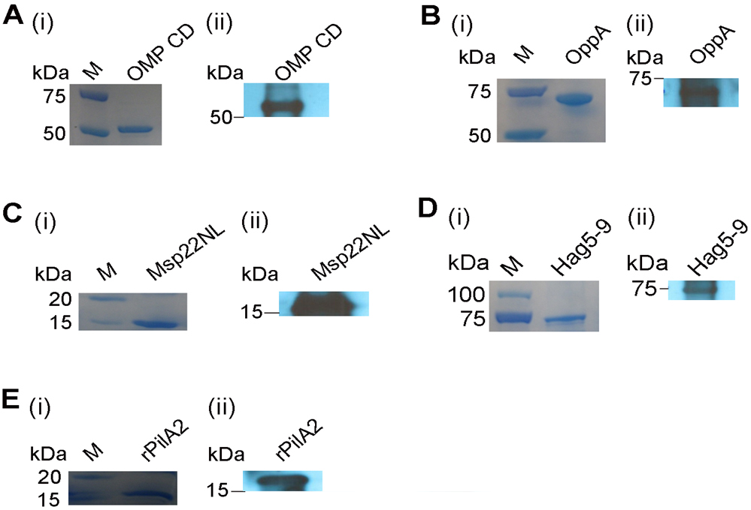

Figure 1S. Characterization of recombinant Mcat proteins with SDS-PAGE and Western blot. A. (i) Migration of OMP CD (calculated molecular weight (CMW) of 45 kDa) in SDS-PAGE. (ii) OMP CD detected with Western blot by using a rabbit anti-OMP CD polyclonal antibody provided by Dr. Timothy Murphy. B. (i) Migration of OppA (CMW of 74 kDa) in SDS-PAGE. (ii) OppA detected with Western blot by using a rabbit anti-OppA polyclonal antibody [1]. C. (i) Migration of Msp22NL (CMW of 16 kDa) in SDS-PAGE. (ii) Msp22NL detected with Western blot by using a rabbit anti-Msp22 polyclonal antibody [2]. D. (i) Migration of Hag5-9 (CMW of 79 kDa) in SDS-PAGE. (ii) Hag5-9 detected with Western blot by using a mouse anti-Hag polyclonal antibody [3]. E. (i) Migration of rPilA1a and rPilA2 (CMW of 17 kDa for both) in SDS-PAGE. (ii) rPilA1a and rPilA2 detected with Western blot by using a rabbit anti-rPilA polyclonal antibody [4]. M, Molecular mass standard.

References

1. Yang M, Johnson A, Murphy TF. Characterization and evaluation of the Moraxella catarrhalis oligopeptide permease A as a mucosal vaccine antigen. Infect Immun 2011; 79:846-57
2. Ruckdeschel EA, Brauer AL, Johnson A, et al. Characterization of proteins Msp22 and Msp75 as vaccine antigens of Moraxella catarrhalis. Vaccine 2009; 27:7065-72
3. Bullard B, Lipski S, Lafontaine ER. Regions important for the adhesin activity of Moraxella catarrhalis Hag. BMC Microbiol 2007; 7:65
4. Luke-Marshall NR, Sauberan SL, Campagnari AA. Comparative analyses of the Moraxella catarrhalis type-IV pilus structural subunit PilA. Gene 2011; 477:19-23

