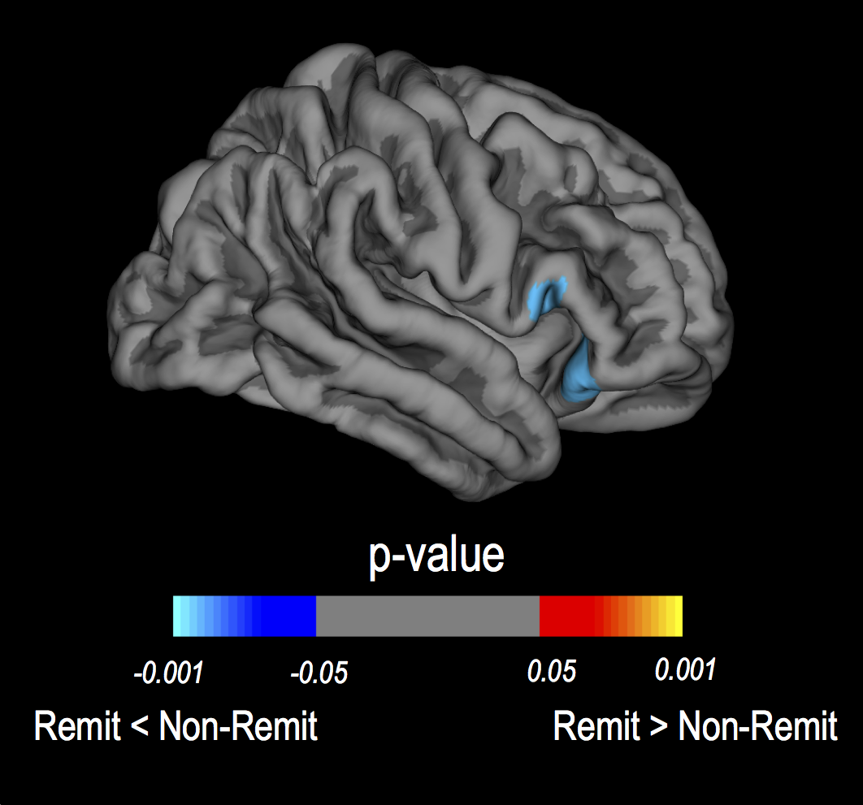
figure S1 Prospective change in cortical thickness between remitted and non-remitted BECTS. A region of more cortical thinning in remitted BECTS than in non-remitted BECTS was identified by whole brain vertex-wise analysis in the right hemisphere. No significant differences were found in the left hemisphere. The color of the scale bar indicates the statistical significance of the cluster. Cluster-wise corrected for multiple comparisons at p<0.05. Corrected for baseline differences in cortical thickness, age and gender.

table S1: Putamen volume at baseline and two-year follow-up
Baseline | Anatomical region | BECTS group (mean ± SE) (mm³) | Control group (mean ± SE) (mm³)
 | Left putamen | 6687 ± 142 | 6246 ± 106
 | Right putamen | 6499 ± 146 | 6121 ± 109
Two-year Follow-up | Anatomical region | BECTS group (mean ± SE) (mm³) | Control group (mean ± SE) (mm³)
 | Left putamen | 6690 ± 132 | 6203 ± 98
 | Right putamen | 6521 ± 131 | 6040 ± 98
SE=standard error.

