**SUPPLEMENTAL INFORMATION**

**Measurement of Mercury Species in Human Blood using Triple Spike Isotope Dilution with SPME-GC-ICP-DRC-MS**

Yuliya L. Sommer1,2,4, Carl P. Verdon1, Mark R. Fresquez1,2, Cynthia D. Ward1, Elliott B. Wood1,3, Yi Pan1, Kathleen L. Caldwell1, and Robert L. Jones1

1Centers for Disease Control & Prevention, National Center for Environmental Health, Division of Analytical Sciences, Inorganic & Radiation Analytical Toxicology Branch, 4770 Buford Highway, Atlanta, GA 30341.

2Battelle Memorial Institute, 2987 Clairmont Road, Suite 450, Atlanta, GA 30329

3Oak Ridge Institute for Science and Education, Oak Ridge, TN 37831

4Corresponding Author: Yuliya L. Sommer   
 Centers for Disease Control and Prevention

4770 Buford Highway, N.E., MS F-50  
 Atlanta, GA 30341   
 Phone: 770-488-7364  
 Fax: 770-488-0509

Email: [YSommer@cdc.gov](mailto:YSommer@cdc.gov)

**Table of contents:**

1. Reagents and standards
2. Preparation of quality control material
3. Sample preparation
4. Instrumentation
5. Software and data processing
6. Derivatization/volatilization
7. Extraction time and temperature
8. Desorption/injection conditions
9. GC-ICP-MS interface
10. Sample solubilization
11. Freeze-thaw stability
12. Room temperature stability
13. Sample recovery
14. Spike solution stability
15. Bland – Altman Plots
16. Analytical figures of merit
17. **Reagents and standards**

We used deionized (DI) water (≥18 MΩ .cm resistivity, Aqua Solutions, Jasper, GA, USA) in the preparation of all aqueous solutions. We prepared 0.1 M sodium acetate buffer solution using sodium acetate anhydrous (Sigma-Aldrich, Milwaukee, WI, USA) and adjusted to a pH of 4.75 with glacial acetic acid (GFS Chemicals, Powell, OH, USA). We purchased tetramethylammonium hydroxide (TMAH), 25% w/w in methanol from Alfa Aesar (Ward Hill, MA, USA). We prepared aqueous solutions (2% w/v) of sodium tetra(n-propyl)borate (NaBPr4) (ABCR, Germany) in 250 mL UV-resistant glass volumetric flasks (Fisher Scientific, Pittsburg, PA, USA) under nitrogen gas (Airgas, Atlanta, GA, USA) in a plastic tent (Erlab, North Andover, MA, USA) to exclude oxygen. We acquired standard solutions of naturally abundant HgCl2 in 1% (v/v) nitric acid, CH3HgCl in 1% (v/v) sodium thiosulfate, and C2H5HgCl in 1% (v/v) sodium thiosulfate from Applied Isotope Technologies (AIT), Inc. (Sunnyvale, CA, USA), which were used for quality control (QC) pool preparations and for identification of retention times of the mercury species. Additionally, we purchased standard solutions of isotope-enriched 199HgCl2 in 1% (v/v) nitric acid, CH3200HgCl in 1% (v/v) sodium thiosulfate, and C2H5201HgCl in 1% (v/v) sodium thiosulfate from AIT for preparation of spiking material for the TSID technique. We obtained SRM NIST 955c Caprine Blood Level 3 from the National Institute of Standards and Technology (NIST, Gaithersburg, MD, USA) and proficiency testing (PT) samples from the Centre de Toxicologie du Québec (CTQ, Québec, Canada).

1. **Preparation of quality control material**

The Inorganic and Radiation Analytical Toxicology Branch uses the method described in this protocol for environmental and occupational health screening studies. The analyst inserts bench QC specimens two times in each analytical run (a set of consecutive assays performed without interruption) so that judgments may be made on the day of analysis. Taking these samples through the complete analytical process assesses all levels of the analyte concentrations. The data from these materials are then used to estimate methodological imprecision and to assess the magnitude of any time-associated trends. The bench QC pools used in this method comprise two levels of concentration spanning the "low" and "high" ranges for each mercury species. Both of these pools are analyzed before any patient samples are analyzed to ensure that all systems are functioning properly. These bench QCs should be analyzed again at the end of the run.

We prepared QC samples using donated human whole blood purchased from Tennessee Blood Services (Memphis, TN, USA). After the completion of endogenous total mercury measurements, we spiked two separate pools of characterized blood with non-enriched (IUPAC natural abundances) aqueous standard solutions of iHg, MeHg and EtHg, which resulted in a “low”, and a "high" QC pool (herein referred to as LB QC and HB QC) that contained concentrations of 0.8, 0.7, 0.6 and 2.2, 3.7, 1.2 μg/L, respectively, of each mercury species (see **Table S1** for exact concentrations of each mercury species). We aliquotted two levels of spiked blood quality control materials –- into 2.0 mL cryogenic tubes (Thermo Fisher Scientific, Pittsburg, PA, USA) and stored them at –70 °C prior to being characterized by mercury speciation analysis.

|  |  |  |  |  |  |  |  |
| --- | --- | --- | --- | --- | --- | --- | --- |
| **Table S1**: Bench Quality Control material limits. | | | | | | | |
| **Analyte** | **QC** | **MEANc** | **STDc** | **2SD (low)** | **2SD (high)** | **3SD (low)** | **3SD (high)** |
| iHg | LB | 0.827 | 0.081 | 0.665 | 0.988 | 0.585 | 1.07 |
| MeHg | LB | 0.733 | 0.053 | 0.628 | 0.838 | 0.576 | 0.891 |
| EtHg | LB | 0.596 | 0.066 | 0.464 | 0.728 | 0.397 | 0.795 |
| iHg | HB | 2.19 | 0.169 | 1.85 | 2.52 | 1.68 | 2.69 |
| MeHg | HB | 3.73 | 0.169 | 3.39 | 4.07 | 3.22 | 4.23 |
| EtHg | HB | 1.20 | 0.107 | 0.987 | 1.41 | 0.880 | 1.52 |

The homogeneity of the pools is assessed after the pools are aliquotted into individual vials. Vials are randomly chosen and randomly analyzed, and the first and last vials dispensed are always included in the homogeneity study. Unlike the characterization of the QC, the homogeneity study can be completed in a single analytical run. Once analysis is complete, the data is evaluated in terms of QC recovery to determine whether or not trends exist in QC during the dispensing of the pool. If the pool does not vary from beginning to end or problem vials can be identified and eliminated, the characterization of the QC is the next step. If problems do exist, the source(s) of the problem has to be identified and the pool has to be re-made and dispensed again.

To complete the characterization that will allow us to assess limits for each QC pool, we analyzed sixty samples of each pool (low and high) on 30 different days, on two different instruments and by two analysts. During the 30 characterization runs, samples from previously characterized QCs or pools with target values assigned by outside laboratories to evaluate each run's QC were analyzed. Once analysis is complete, the mean and standard deviation for each pool were calculated. These values will be used to establish the limits for each pool (**Table S1**).

QC rules are as follows**:**

* If both the low-and the high-QC results are within the 2s limits, accept the run.

##### If one of two QC results is outside the 2s limits, apply the rules below and reject the run if any condition is met.

###### **13s** - Average of both low QCs OR average of both high QCs is outside of a 3s limit.

* **22s** - Average of both low QCs AND average of both high QCs is outside of 2s limit on the same side of the mean.
* **R4s sequential** - Average of both low QCs AND average of both high QCs is outside of 2s limit on opposite sides of the mean.
* **10x sequential** - The previous nine average QCs results (for the previous nine runs) were on the same side of the mean for either the low OR high QC.

If the run is declared "out of control," the analysis results for all patient samples analyzed during that run are invalid for reporting.

1. **Sample preparation**

Mercury speciation analysis for each blood sample began with the addition of 100 µL of aqueous spike solution (containing enriched 199HgCl2, CH3200HgCl and C2H5201HgCl isotopes) to 100 µL of blood sample in a 2 mL polypropylene micro-centrifuge tube (Eppendorf, Westbury, NY, USA). If patient samples are frozen, first they are thawed for approximately 30 minutes then vortexed for 5 seconds prior beginning sample preparation procedure. We prepared the spike solution fresh on the day of sample analysis by weighing each isotopically-enriched, chemically-pure mercury species standard (we rely on the purity data of AIT certificate of analysis) to an exact amount prior to dilution with deionized water using an analytical balance (Mettler Toledo, delta range XP205). The isotopically enriched mercury species concentrations in the working spike solution were within a range of 0.9 –1.2 µg/L. Following addition of spike solution, we vortexed the capped tube for 10-20 seconds to ensure complete mixing of sample with enriched mercury isotopes. Next, we added 500 µL of TMAH. The tubes were recapped and vortexed for 5 seconds, and then placed in an 80 °C convection oven (FREAS Model 605, Thermo Fisher Scientific, USA) for alkaline digestion for 24 - 26 hours. After digestion, we transferred 200 µL of the digested sample to a 20 mL glass SPME analysis vial (Microliter Analytical Supplies, Inc., Suwanee, GA, USA) followed by addition of 7.7 mL of 0.1 M sodium acetate buffer (NaOAc) achieving a final pH of approximately 5 (~5-6). In the final sample preparation step, we added 250 µL of 0.2% w/v NaBPr4 to the 20 mL glass SPME analysis vial. We manually mixed the capped glass vial by repeated inversions for approximately 5 seconds while derivatization of mercury species occurred at room temperature. **Figure S1** shows anabbreviated representation of all sample preparation steps and the subsequent mercury species analysis**.**

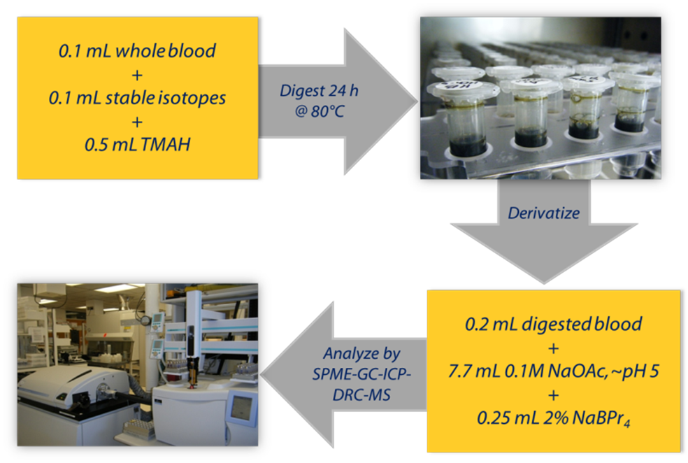

**Figure S1**: The sample preparation steps and the subsequent mercury species analysis: 1) aqueous spike solution is added to the blood sample followed by addition of TMAH, 2) the sample is placed in a convection oven, 3) the digested sample is added to a 20 mL glass SPME vial followed by addition of buffer and derivatizing reagent, 4) glass vial is capped and ready for SPME-GC-ICP-DRC-MS analysis.

1. **Instrumentation**

We measured mercury analytes with an ELAN® DRC II ICP-MS (PerkinElmer Life Sciences, Shelton, CT, USA) equipped with the ELAN® instrument control and data handling software, version 3.4. We used platinum sampler and skimmer cones (PerkinElmer Life Sciences, Shelton, CT, USA) instead of standard nickel cones because they are more chemically resistant and require less cleaning and maintenance. Sample analysis was performed in DRC™ mode using argon gas (Ar) (Airgas, Atlanta, GA, USA) at 0.3 mL/min to enhance the mercury signal intensity by collisional focusing [1].

Our laboratory used a PerkinElmer® Clarus 500™ gas chromatograph (PerkinElmer Life Sciences, Shelton, CT, USA) equipped with a GC capillary column (Perkin Elmer® Elite-5 30m, 0.25mm ID, 0.25µm of 5% diphenyl, 95% polydimethylsiloxane, Shelton, CT, USA) connected via a vespel v-union (Restek, Bellefonte, PA) to a non-coated capillary column (Perkin Elmer® Fused Silica Tubing 5m, 0.25mmID, Shelton, CT, USA). We conditioned the column before initial use per the manufacturer’s recommendations. We maintained a GC injector at 220-280 °C in the splitless mode with analytical grade Helium (He) (Airgas, Atlanta, GA, USA) as a carrier gas at constant flow rate of 2 mL/min. We used temperatures programming for the GC injector. We maintained a GC injector at 220°C for 1 minute then ramped-temperature to 280 °C and held at that temperature till the end of sample run. We increased the column temperature at a rate of 45 °C/min from an initial temperature of 75 °C to the final temperature of 250 °C. The GC was coupled to a quadrupole ICP-MS with a heated GC transfer line (REDshift®, Italy, acquired through PerkinElmer Life Sciences, Shelton, CT) constantly held at 250 °C.

A CombiPAL® robotic sample processing workstation (CTC Analytics, Zwinger, Switzerland) performed SPME extractions and injections into the GC [2]. This system has two independently controlled SPME fiber injection heads that run along a dual rail system. Each free-running SPME head encloses a fused-silica SPME fiber coated with a 100 µm film of polydimethylsiloxane (PDMS) (Supelco, Bellefonte, PA, USA).

1. **Software and data processing**

We programmed the CombiPAL® autosampler using Chronos™ software (LEAP Technologies Inc., Carrboro, NC, USA) which controls the timings for SPME fiber exposure to the sample (adsorption) and fiber injection into the GC (desorption). Our laboratory used ELAN® software (PerkinElmer Life Sciences, Shelton, CT, USA) to process ICP-MS intensity signals of three mercury species (inorganic, methyl, and ethyl) measured at m/z 198, 199, 200, 201 and 202(**Figure S2**).

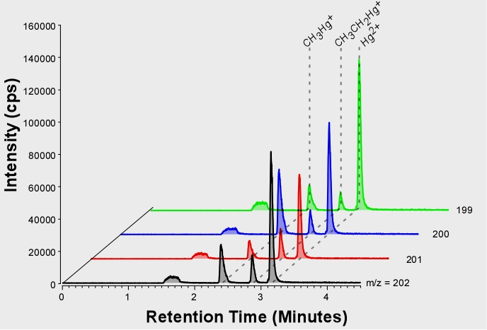

**Figure S2:** A GC chromatogram presenting four measured Hg isotopes (m/z 199, 200, 201, 202) in HB QC sample (approximate concentrations: iHg – 4.3 μg/L, MeHg – 4 μg/L, and EtHg – 5.5 μg/L) along with retention times for each mercury species produced by the SPME-GC-ICP-DRC-MS method.

TotalChrom™ version 6.3 (PerkinElmer Life Sciences, Shelton, CT, USA) handled chromatography data manipulations. The ChromLink™ feature of TotalChrom™ interfaces ICP-MS and GC data. Using an in-house written macro, we imported the integrated peak areas for iHg, MeHg and EtHg from TotalChromTM into a Microsoft Excel spreadsheet where the 198Hg/202Hg, 199Hg/202Hg, 200Hg/202Hg, and 201Hg/202Hg ratios were calculated and exported into a second spreadsheet containing multiple spiking species-specific isotope dilution mathematical equations developed by Ouerdene and colleagues [3-5].

1. **Derivatization/volatilization**

Usage of a SPME-GC analysis technique requires the conversion of ionic mercury species into their more volatile, non-polar dialkyl derivatives [6]. Most common derivatization methods for mercury speciation analysis include ethylation, propylation, and phenylation by appropriate sodium tetraorganoborate solutions [7]. We selected NaBPr4 as the derivatization agent to permit analysis of ethyl mercury [6,8-12]. Yang et al., evaluated the influence of NaBPr4 concentration on SPME response and detected no significant effect in the concentration range from 0.2% to 2% (w/v) [13]. In this method, we selected a concentration of 2% (w/v) NaBPr4 to ensure complete propylation of analytes in the blood sample matrix. To reach maximum derivatization efficiency with minimal species transformations we adjusted the sample pH to a range between 5 - 6 using sodium acetate buffer [14,15,11,13,6].

1. **Extraction time and temperature**

One of the most important parameters influencing SPME extraction is equilibration time (the time required for the analyte extracted to reach a steady state). At equilibrium, variations in the extraction time will have a minimal effect on the amount of analyte extracted by the fiber thus providing the best measurement precision [13,16]. We investigated the effect of extraction time on the peak areas of mercury species in the range of 2–10 minutes (**Figure S3a**). We found that an 8 minute extraction time is required to achieve an equilibrium distribution of derivatized mercury species between the matrix and the PDMS fiber [14,13]. **Figure S3a** presents equilibrium time for the m/z 201mercury isotope. The other measured isotopes followed the same trend. This method’s goal is to analyze clinical human whole blood specimens, and according to NHANES survey summary, the geometric mean for the U.S. population (years 2009-2010) is 0.863 μg/L [17]. Therefore, it is important to ensure the extraction time (equilibrium time) was not a limiting factor in our ability to accurately quantify patient samples with low levels of mercury species present. Consequently, we selected a 20 minute extraction time to ensure complete equilibrium in all cases.

The overall mercury species extraction yield depends on the temperature of the sample solution during the liquid and gas phase equilibration [8,11,18]. When using a CombiPAL® dual-arm autosampler, the equilibration and extraction temperatures are the same. Various researchers have optimized the SPME equilibration temperature of derivatized mercury species between ambient (room temperature) and 80 °C. Most often scientists selected a temperature between 30 °C and 65 °C [8,14]. In this work, we varied the sample solution temperature from room temperature, to 30 °C, 40 °C, 50 °C, and 60 °C while monitoring the sensitivity of all three mercury species (**Figure S3b**). **Figure S3b** shows that an ambient temperature (~23 °C) allowed for maximum sensitivity of all three mercury species; therefore, we selected this temperature for this method.

1. **Desorption/injection conditions**

The optimal temperature for the GC injector port is one that will strike a balance between efficient sample desorption (higher port temperatures lead to faster desorption and peaks with sharper resolution) and thermal decomposition of the sample/accelerated degradation of the SPME fiber polymer coating (when the temperature is too high) [7]. We monitored peak areas of mercury species while varying GC injector temperatures from 75 °C to 300 °C (**Figure S3c**) which falls within the operating temperature range for the 100 µm PDMS (SPME) fibers [7]. **Figure S3c** shows that 220 °C for one minute provided maximum sensitivity for iHg, MeHg and EtHg species. The area of a peak with a retention time of approximately 1.7 minutes (**Figure S2**) was also monitored throughout the GC injector temperature changes. We believe that this peak is elemental mercury (Hg0) resulting from thermal decomposition of other mercury species in the heated GC injector, as reported by others [11,19,7,20,21]. The possible appearance of Hg0 does represent a loss of analyte but does not affect the accuracy of our measurements because a constant mass fraction of the derivatized species decomposes which leads to the same loss of response from both isotopically enriched mercury standards and endogenous mercury species [19]. Therefore, we selected a higher injection port temperature of 220 °C despite possible formation of the Hg0 peak. After desorption of mercury species is complete (220 °C for 1min) we ramp the GC injector temperature to 280°C to clean the SPME fiber.

In the literature, scientists have previously reported possible memory effects associated with the SPME analytical technique [20]. Thus, we found it important to demonstrate that over the reportable range in our method there is no carryover from sample to sample which would interfere with obtaining acceptable recoveries of the mercury species. To demonstrate this, we analyzed three sample concentrations - LB QC, HB QC, and NIST SRM 955c Level 3 (10 replicates) - each followed by a blank. The chromatographic results in **Figure S4**reveal that blank chromatograms do not have any mercury peaks present. This data confirms that there is no carryover from sample to sample during our routine analytical measurements.

1. **GC-ICP-MS interface**

We achieved optimum separation of propylated mercury species with the use of NaBPr4 using an initial oven temperature of 75 °C, ramped at 45 °C/min to a final temperature of 250 °C, **Figure S2**. Mercury species eluted from the column in order of increasing molecular weight [19,22]. The peaks in order of elution are MeHg, EtHg, and iHg (in propylated forms) with retention times of approximately 2.4, 2.8, and 3.2 minutes, respectively. We verified the peak identity by the comparison of retention times of naturally abundant mercury standards. The chromatographic run time is approximately 6 minutes, which is the time from the injection of the SPME fiber into the GC inlet to the withdrawal of the fiber. We optimized the GC parameters for maximum sensitivity and optimal resolution of mercury species. Further, we optimized both plasma and mass spectrometer parameters of the ICP-MS by monitoring the sensitivity response for isotope 126Xe (0.01% (v/v) xenon (Xe) in argon (Ar) and isotopic abundance 0.096%) in the bulk mode (steady state signal) [20,23-25,12]. Xenon was chosen because it has similar ionization energy to mercury and therefore allowed us to optimize the instrument without disconnection of the chromatographic interface. We set plasma andICP-MS parameters for optimum sensitivity and lowest background signal of 126Xe. We performed dead time correction (60 ns) using a standard liquid sample introduction system [26].

We coupled the GC to the ICP-MS by way of a heated GC transfer line operated at 250 °C to prevent condensation of sample constituents in the transfer line’s capillary tubing [27,11]. This setup works under dry plasma conditions which means that the spray chamber was removed and the GC transfer line, equipped with an inner deactivated capillary column, was coupled to the base of the injector support. The transfer line was introduced into the central channel of the quartz torch and injector [28]. The advantage of this simple arrangement (compared to one utilizing a spray chamber placed between the transfer line and the injector) is that it reduces dilution and turbulence effects which can potentially cause peaks to widen and increase signal noise. At the same time, the absence of a spray chamber removes the option to introduce liquid standards with the transfer line intact. For this reason, a carrier gas containing xenon is used for optimizing the instrument system with an intact transfer line. Also, for this reason we switched to using internal mass bias correction over external mass bias correction methods which proved inadequate for producing meaningful mass bias data. The temperature of the GC transfer line, which is composed of a Silcosteel® tube surrounding an inert silica capillary, is controlled by the GC oven. To achieve sufficient flow to sweep mercury analytes into the plasma, the Ar makeup gas was introduced through the GC transfer line. Its flow rate is controlled from the ICP-MS nebulizer control and is heated as it enters the GC transfer line.

Additionally, the position of the inner deactivated capillary column in the GC transfer line was optimized with respect to the tip of the sample injector. The capillary position was varied by moving the column between 0 - 10 cm back from the tip of sample injector (away from plasma). The optimum response for the Xe signal was found to be at approximately 0.5-1 cm from the tip of the injector.

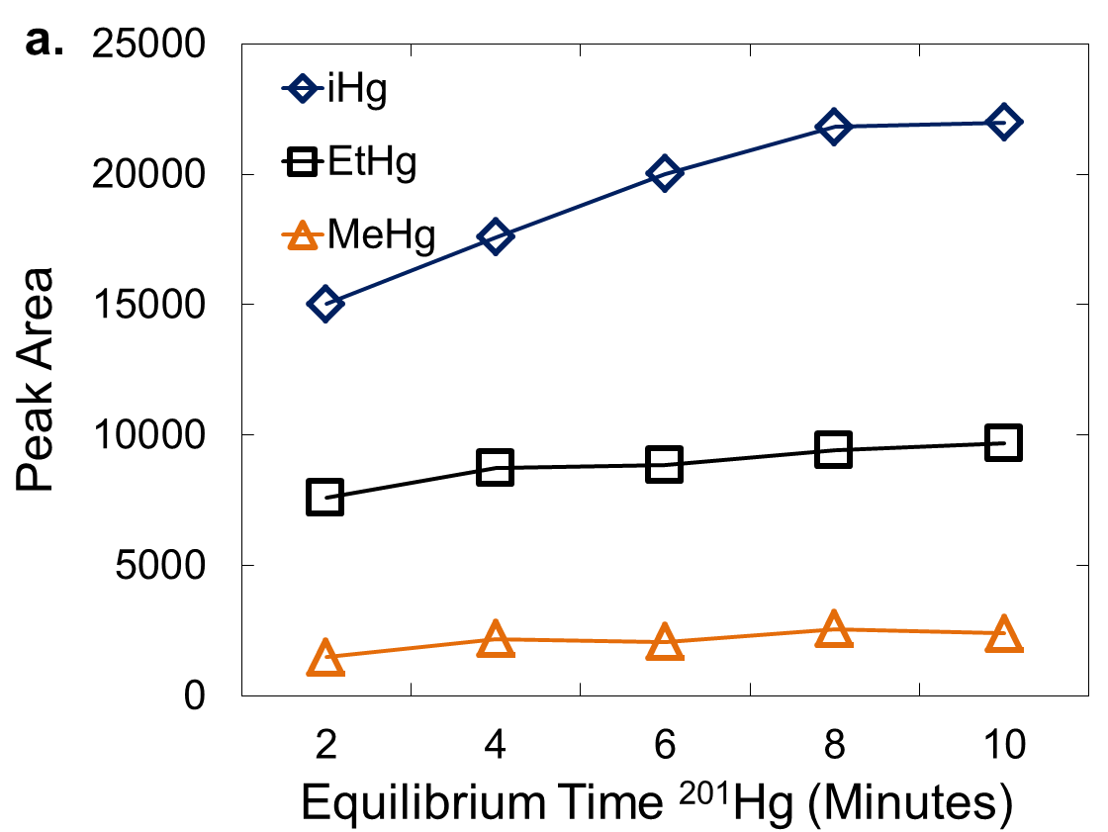

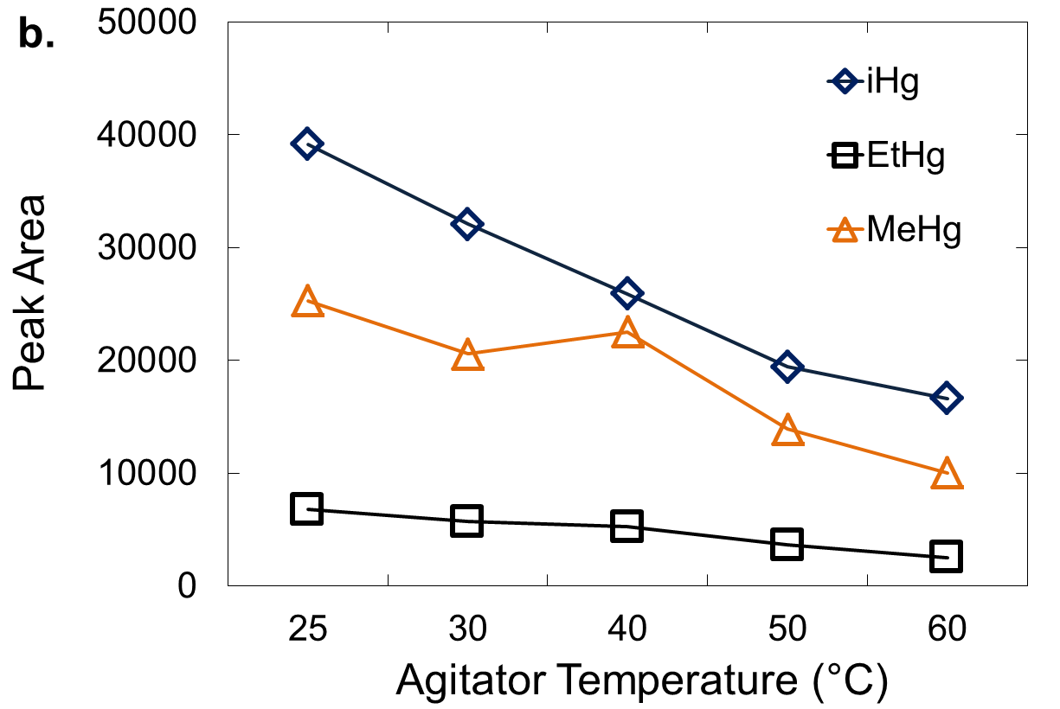

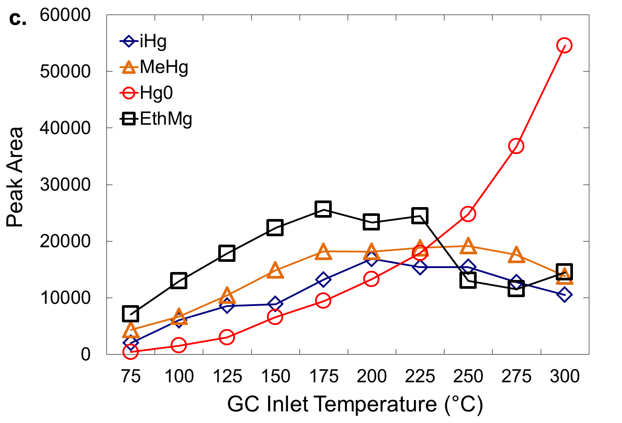

**Figure S3:** Optimization of SPME-GC-ICP-DRC-MS method. Monitoring peak areas of iHg, EtHg, MeHg, in HB QC (approximate concentrations: iHg – 4.3 μg/L, MeHg – 4 μg/L, and EtHg – 5.5 μg/L) as a function of changing (a) the equilibrium time, (b) Agitator temperature (c) GC sample injection port temperatures.

 

 

 

**Figure S4:** Overlaid chromatographs illustrating signal intensity of 202Hg isotope in (a.) LB QC and Blank, (c.) HB QC and Blank, and (e.) NIST and Blank. Graphs (b.), (d.), (f.) are enlarged areas of baseline of graphs (a.), (c.), and (e.), respectively.

1. **Sample solubilization**

After TMAH addition, the LB QC samples were left at room temperature and analyzed periodically. At 72 hours the mercury peaks were well visible and quantifiable by our method with ethyl to inorganic mercury conversion of 63 ± 9 % (N=12). To decrease the solubilization time, the blood samples were subjected to thermal treatment (“convection oven”) at 40°, 60°, 80°, 100° C for 24 hours. At 40° C, mercury peaks were visible but not quantifiable. At 60°, 80°, 100° C, mercury species were correctly quantifiable with EtHg to iHg conversion at 59 ± 6, 59 ± 4, 67 ± 3%, respectively (N=12 for each temperature setting). We found that at 80° and 100° C mercury species displayed the highest peak intensities. At 100° C, the mercury peak intensities were similar to 80° C and occasionally higher; however, the centrifuge plastic vials become pliable and spontaneously uncapped in the oven. To prevent loss of sample, we chose a solubilization temperature of 80° instead of 100° C.

To determine the level of degradation of mercury species in the blood samples (specifically the EtHg to iHg conversion percentage) during the solubilization step we measured the conversion percentage of the species during the other steps in the sample preparation procedure and analysis (derivatization and SPME injection into the heated GC injector) and subtracted these values from the final conversion percentages. Base blood samples are ones which have been prescreened for mercury content and found to have minimal amounts of mercury species present. For sample solubilization, TMAH was added to a number of the base blood samples and the samples were placed in the convection oven at 80° C for 24 hours. After this solubilization step, the base blood samples were spiked with approximately 1 µg/L of EtHg, MeHg, iHg (natural abundances). Standard sample preparation and analysis procedures followed. The EtHg to iHg conversion percentage was 23 ± 6% (this does not include conversion percentages during solubilization step, since no mercury species were present at that point). LB and HB QCs were also analyzed in this analytical run. For the LB and HB QCs, the EtHg to iHg final conversion percentage was 43 ± 4 % (including conversion percentages during solubilization step). From this experiment we concluded that approximately half of the ethyl to inorganic species conversion takes place during the solubilization step and the other half during the rest of sample preparation and analysis (derivatization and SPME injection into the heated GC injector).

1. **Freeze-thaw stability**

The stability of mercury species in blood after five freeze-thaw cycles was analyzed. (**Figure S5, Table S1**). Furthermore, in this experiment we used p-value to evaluate if there is statistically significant difference between five freeze-thaw cycles (**Table S2**). The concentration means for the 5th freeze-thaw cycle were found to be statistically significantly different for MeHg in LB QC pool (p=0.01) thus step-down tests were conducted. Adjusting for multiple comparisons with Bonferroni correction, our new significance level was 0.05/10=0.005. We found the concentration mean for 5th cycle was significantly lower than that for 1st cycle (0.697 vs. 0.808, p=0.0009). Also, we found statistical significance in EtHg in LB QC pool (p=0.003). We found the mean under 2nd cycle was significantly higher than that under 4th cycle (0.621 µg L-1 vs 0.502 µg L-1, p=0.003), and 4th cycle was significantly lower than that for 5th cycle (0.502 µg L-1 vs. 0.639 µg L-1, p=0.0008).

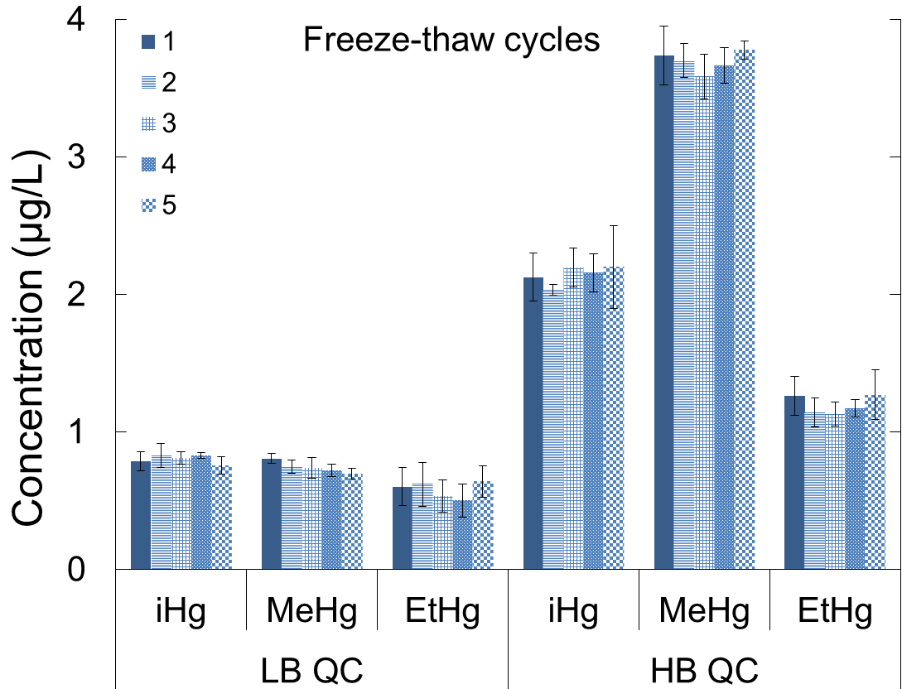

**Figure S5:** Five freeze-thaw cycles (error bars represent standard deviation).

1. **Room temperature stability**

The stability at room temperature of the analytes (iHg, MeHg and EtHg) in its matrix (blood) was tested for the time period of 24 hours prior to addition of spike (enriched mercury isotopes), digestion, buffer, and derivatizing reagent (**Figure S6, Table S1**). Furthermore, in this experiment we used p-test to evaluate if there is statistically significant difference between 0, 4, 8, 16, 20 and 24 hours (**Tables S2**). We observed significance for iHg in HB QC pool and for EtHg LB QC pool (p=0.03 and p=0.001, respectively). In the step-down tests, adjusting for multiple comparisons with Bonferroni correction, our new significance level was 0.05/15=0.0033. We found for iHg (HB QC), the mean under hour 0 was significantly higher than that under hour 20 (2.27 µg L-1 vs. 2.03 µg L-1, p=0.002). Similarly, for EtHg (LB QC), the mean under hour 4 was marginally lower than that under baseline (hour 0) (0.534 µg L-1 vs 0.614 µg L-1, p=0.0025). Furthermore, hour 16 was significantly lower than baseline (0.529 µg L-1 vs 0.614 µg L-1, p=0.0015) and hour 20 was significantly lower than baseline (0.494 µg L-1 vs. 0.614 µg L-1, p<0.0001).

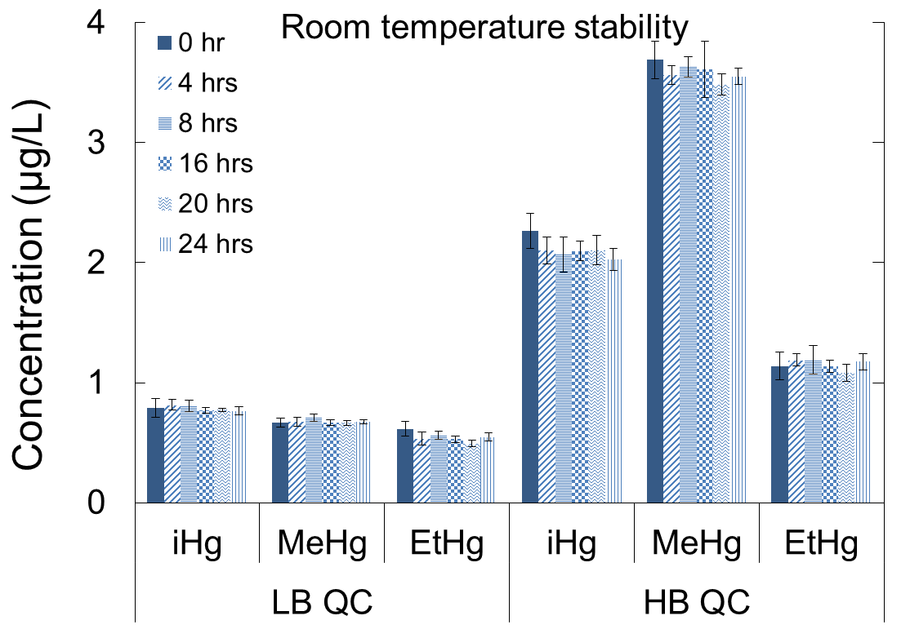

**Figure S6:** Room temperature stability (error bars represent standard deviation).

1. **Sample recovery**

We performed repeated extraction cycles (five) by the SPME fiber out of the same sample vial for four samples LB QC, HB QC, LB QC diluted ten times with base blood (10X, concentration ≤ LOD for the method) and NIST SRM 955c Level 3 (experiment repeated six times). Extractions occurred in approximately 20 minute intervals, which provided enough time for full re-equilibration. For all five repuncturing trials, we measured sample concentrations for three mercury species that were within our expected recovery limits. There was a difference in the response achieved for the three species when using the same PDMS SPME fiber. Peak area of all three mercury species decreased after each puncture (**Figure S7** in SI). The peak areas (for natural 202 isotope) for iHg, EtHg and MeHg species for the last (5th) injection decreased 83 ± 5%, 63 ± 10%, and 26 ± 9% from the peak areas of the first SPME injection, respectively. It is projected that each PDMS SPME fiber will have slightly different percentages, corresponding to the length of time the fiber has been in use for sample analysis. During sample preparation, approximately 50% of EtHg transforms to iHg, which is typical of this method. This partially contributes to EtHg having the lowest peak areas and iHg having the highest peak areas. Additionally, the peak areas for EtHg are usually lower than iHg and MeHg after derivatization due to poorer derivatization efficiencies [15,29]. The peak area of iHg (first injection) is the highest and this may be due to iHg having a higher extraction yield with PDMS in comparison to propylated forms of MeHg and EtHg [30,18]. Further decreased recovery of iHg may arise for several reasons: decreased concentration of propylated inorganic volatile species in the headspace due to lower volatility than propylated methyl species and/or competitive saturation of uptake sites on the fiber [11]. Overall, there is a loss of analyte sensitivity through reanalysis of the same vial; however, concentrations are still accurately measureable on the fifth injection.

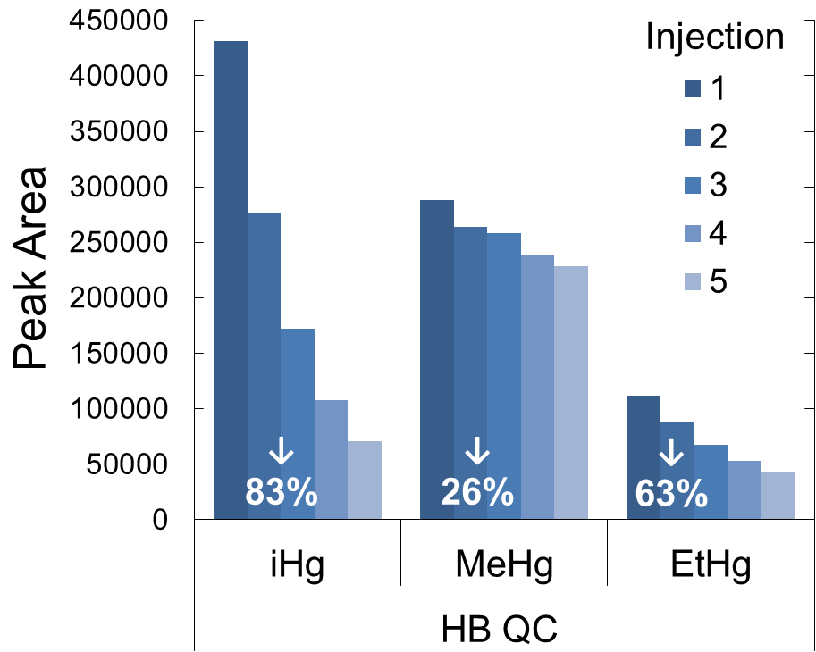

**Figure S7:** Repeated SPME extraction cycles out of the same HB QC (approximate concentrations: iHg – 4.3 μg/L, MeHg – 4 μg/L, and EtHg – 5.5 μg/L) sample vial. Changes in peak area for iHg, MeHg and EtHg in HB QC sample after each of five SPME injections. Percentages represent by how much peak area of each mercury specie decreased from the first to the fifth injection.

1. **Spike solution stability**

We gravimetrically prepared a single spike solution having a precisely determined concentration of each isotopically enriched mercury standard. We kept these concentrations as close as possible to 1 μg/L to give isotope ratios (199Hg/202Hg, 200Hg/202Hg, and 201Hg/202Hg) between one and three for HB QC (**Table S2**).

We tested the stability of the spike solution over the period of 1 month (29 days) by observing changes in LB and HB QC concentrations prepared using the same spike solution (**Figure S8**). Furthermore, we used p-value to evaluate if there is statistically significant difference in mercury species concentration levels between Day 1, 8, 15, 22, and 29 (**Table S3**). For solution 1, iHg (LB QC) showed significance (p=0.007). In the step-down tests, our new significance level was 0.05/10=0.005. We found for iHg (LB QC) the mean concentration for day 29 was significantly higher than that mean for day 1 (0.96 µg L-1 vs. 0.79 µg L-1, p=0.0015). Also, the concentrations mean for day 29 was significantly higher than that for day 8 (0.96 vs. 0.78, p=0.0009). Similarly, EtHg (LB QC) also showed significance (p=0.02). The mean for day 15 was significantly lower than that for day 1 (0.52 µg L-1 vs. 0.63 µg L-1, p=0.004). For solution 2, only EtHg (HB QC) showed significance (p=0.02). The concentration mean for day 22 was significantly lower than that for day 15 (1.11 µg L-1 vs. 1.28 µg L-1, p=0.0025). For solution 3, iHg (LB QC) showed significance (p=0.006). The concentrations mean for day 22 was significantly higher than that for day 15 (0.92 µg L-1 vs. 0.75 µg L-1, p=0.0017) and the mean for day 29 was significantly higher than that for day 8 (0.92 µg L-1 vs. 0.75 µg L-1, p=0.0018). Furthermore, the high pool of iHg (p=0.03) and high pool of EtHg (p=0.04) also showed significance. No statistical significance was detected for solution 4.

|  |  |  |  |  |  |  |
| --- | --- | --- | --- | --- | --- | --- |
| **Table S2:** Isotope ratios (Rm values*) for LB and HB Quality control samples. | | | | | | |
| **Spike** | **LB QC** | | | **HB QC** | | |
| Conc. (μg/L) | iHg (199/202) | MeHg (200/202) | EtHg (201/202) | iHg (199/202) | MeHg (200/202) | EtHg (201/202) |
| 0.5 | 2.4 | 2.9 | 3.1 | 1.3 | 1.2 | 1.8 |
| 1.0 | 4.2 | 4.9 | 5.6 | 1.9 | 1.6 | 3.1 |
| 2.5 | 9.3 | 10.7 | 12 | 4 | 2.9 | 6.7 |
| 5.0 | 16.5 | 18.9 | 21 | 7.4 | 4.9 | 12.1 |
| 10.0 | 29 | 31.7 | 33.4 | 13.5 | 8.7 | 20.8 |
| \**Rm values (measured isotope ratio in mixture) calculated using single spike equations [**21**].* | | | | | | |

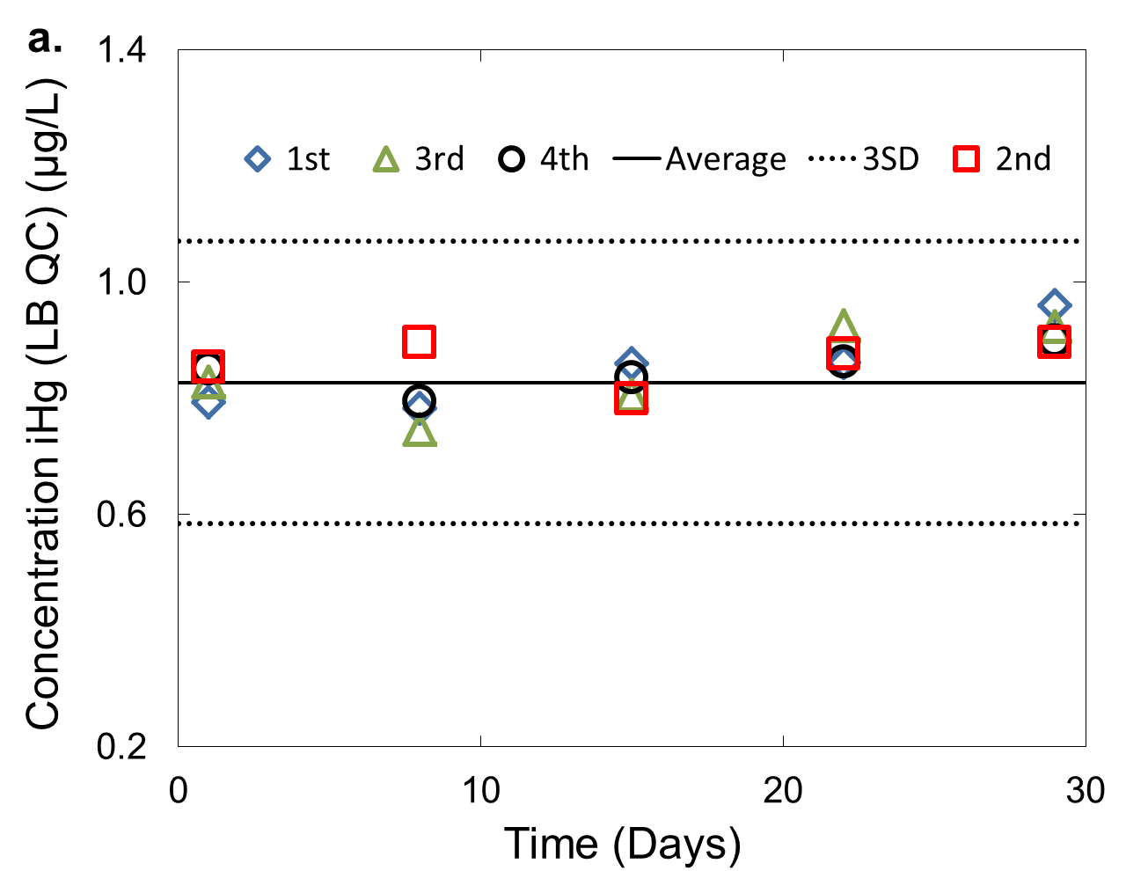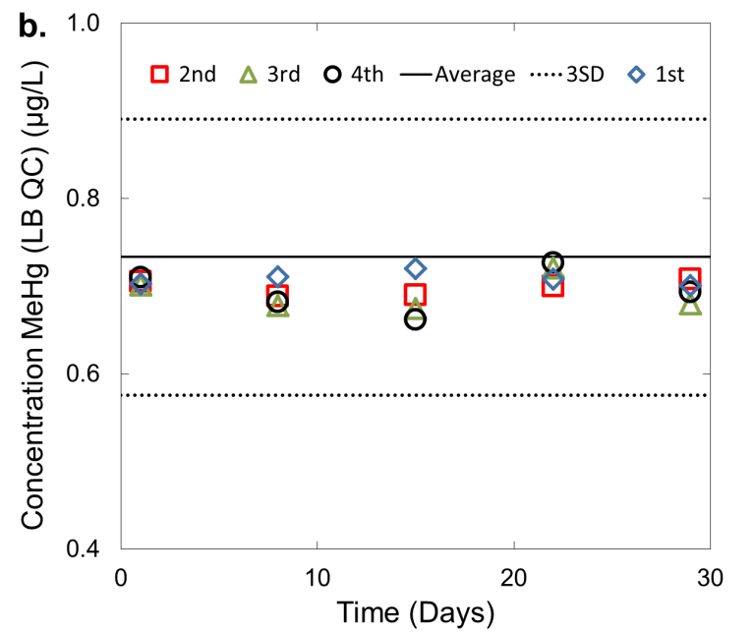

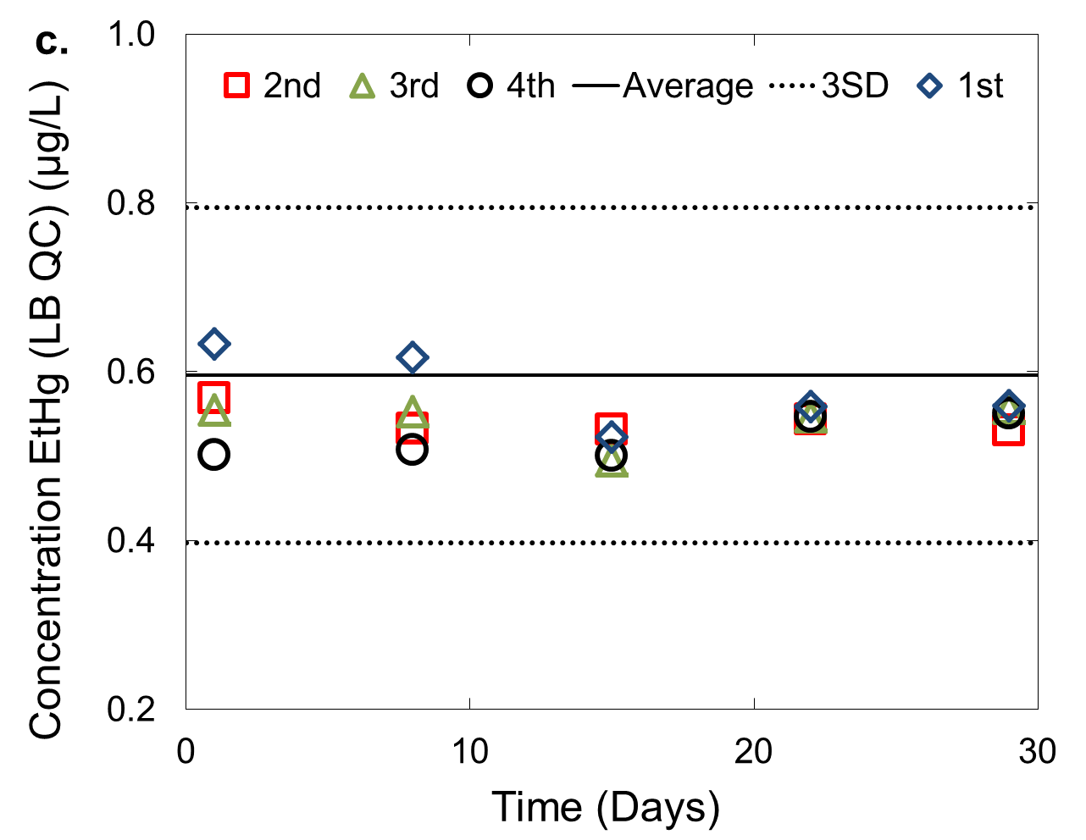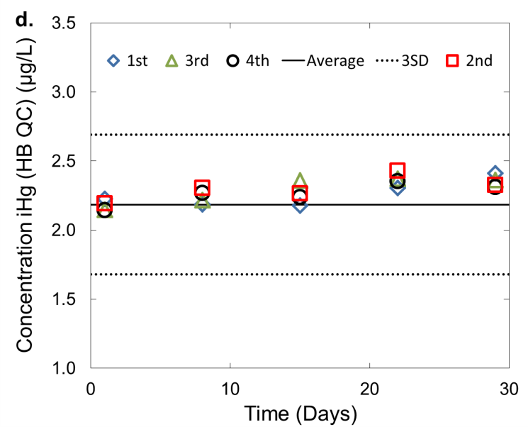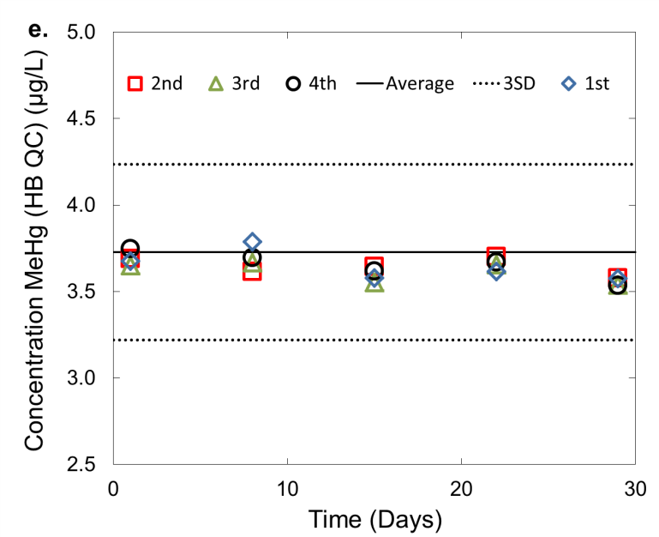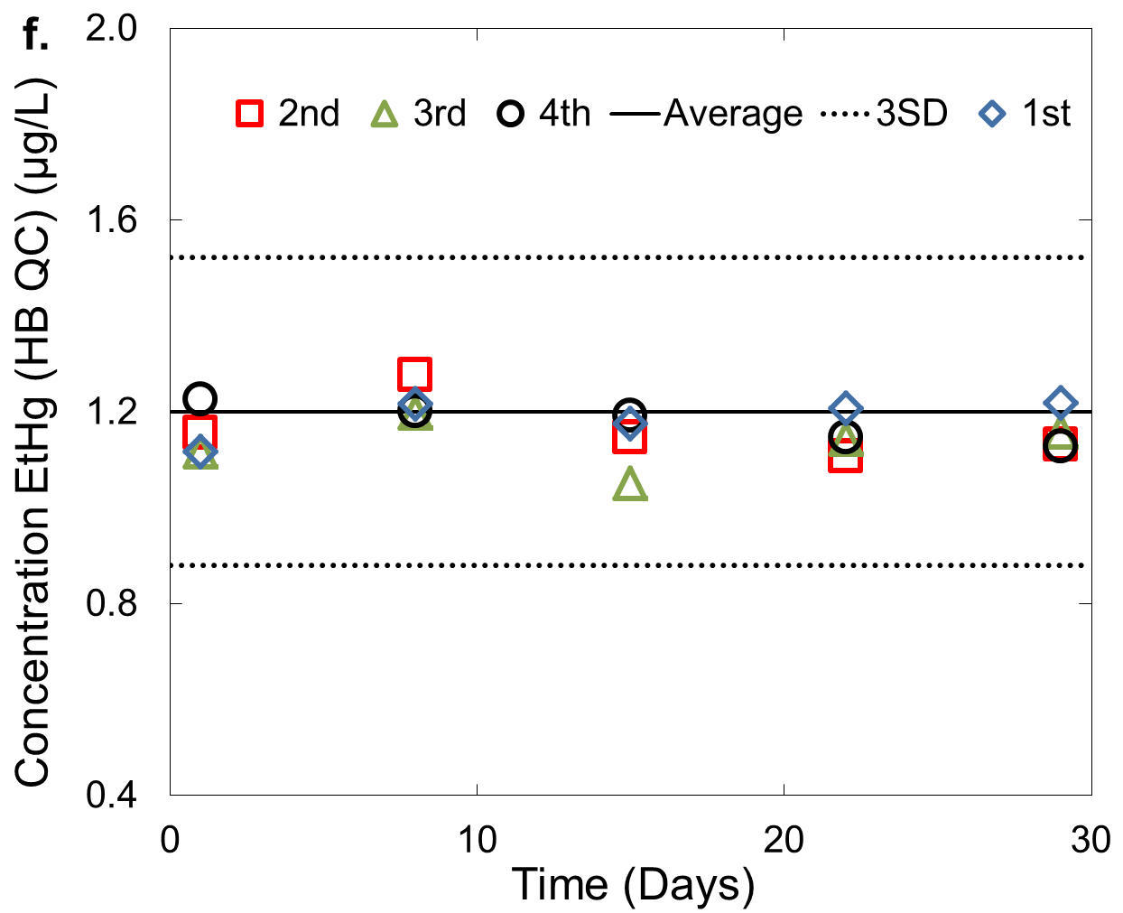

**Figure S8:** Reflection of spike solution stability in concentration changes of iHg, MeHg and EtHg in (a), (b), (c) LB QC and (d), (e), (f) HB QC as a function of time.

**Table S3**:One-way ANOVA statistical data analysis.

|  |  |  |  |
| --- | --- | --- | --- |
| **Study** | **Outcome** | **Pool** | **p values** |
| Freeze-thaw | iHg | LB | 0.2 |
| HB | 0.3 |
| MeHg | LB | 0.01 |
| HB | 0.3 |
| EtHg | LB | 0.003 |
| HB | 0.2 |
| Bench-top | iHg | LB | 0.3 |
| HB | 0.03 |
| MeHg | LB | 0.08 |
| HB | 0.1 |
| EtHg | LB | 0.001 |
| HB | 0.2 |
| Spike concentration | iHg | LB | 0.4 |
| HB | 0.8 |
| MeHg | LB | 0.04 |
| HB | 0.2 |
| EtHg | LB | 0.3 |
| HB | 0.08 |
| Solubilization time | iHg | LB | 0.6 |
| HB | 0.5 |
| MeHg | LB | 0.1 |
| HB | 0.9 |
| EtHg | LB | 0.02 |
| HB | 0.5 |
| Spike solution 1 | iHg | LB | 0.007 |
| HB | 0.3 |
| MeHg | LB | 1.0 |
| HB | 0.2 |
| EtHg | LB | 0.02 |
| HB | 0.6 |
| Spike solution 2 | iHg | LB | 0.1 |
| HB | 0.4 |
| MeHg | LB | 0.7 |
| HB | 0.9 |
| EtHg | LB | 0.7 |
| HB | 0.02 |
| Spike solution 3 | iHg | LB | 0.006 |
| HB | 0.03 |
| MeHg | LB | 0.2 |
| HB | 0.4 |
| EtHg | LB | 0.2 |
| HB | 0.04 |
| Spike solution 4 | iHg | LB | 0.07 |
| HB | 0.2 |
| MeHg | LB | 0.08 |
| HB | 0.1 |
| EtHg | LB | 0.1 |
| HB | 0.6 |

|  |  |  |  |  |  |  |  |
| --- | --- | --- | --- | --- | --- | --- | --- |
| **Table S4*:** BenchQuality Control material limits (previous QC pool). | | | | | | | |
| **Analyte** | **QC** | **MEANc** | **STDc** | **2SD (low)** | **2SD (high)** | **3SD (low)** | **3SD (high)** |
| iHg | LB | 1.11 | 0.048 | 1.01 | 1.20 | 0.966 | 1.25 |
| MeHg | LB | 1.08 | 0.039 | 1.00 | 1.16 | 0.963 | 1.19 |
| EtHg | LB | 1.49 | 0.082 | 1.33 | 1.65 | 1.24 | 1.73 |
| iHg | HB | 4.34 | 0.269 | 3.80 | 4.88 | 3.53 | 5.15 |
| MeHg | HB | 3.99 | 0.154 | 3.68 | 4.30 | 3.53 | 4.45 |
| EtHg | HB | 5.45 | 0.231 | 4.99 | 5.91 | 4.76 | 6.14 |

*\* A different QC pool was used for certain experiments. This pool was used in our mercury speciation method prior to characterization of the new QC pool (****Table S1****).*

1. **Bland – Altman Plots**

A Bland–Altman (B-A) difference plot comparing results from diluted and non-diluted samples displayed no clear bias (**Figure S9a**). B–A difference plot comparing certified CTQ values to the results from this methodshows no clear bias, **Figure S9b**.

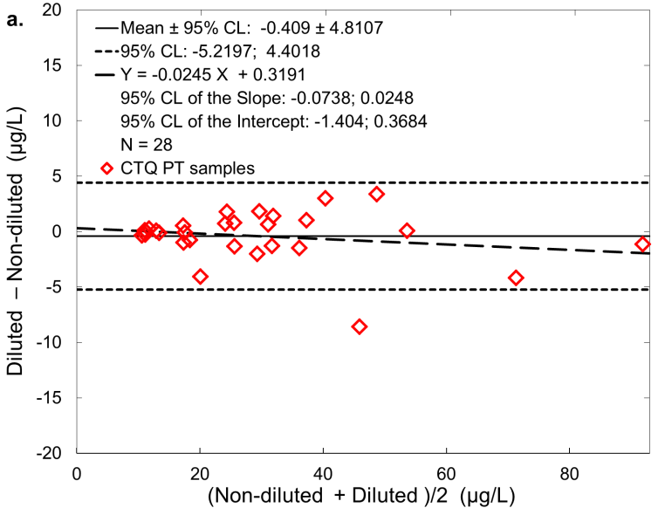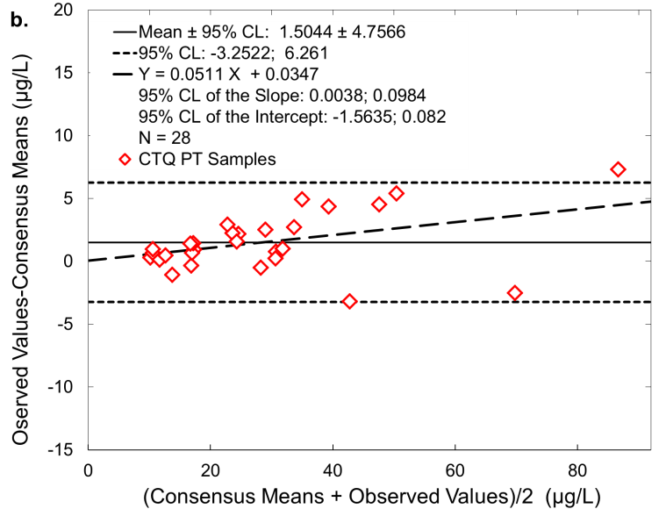

**Figure S9:** Bland-Altman plot for (b) diluted vs. non-diluted CTQ PT samples, (b) observed values vs. consensus means for CTQ PT.

*\* Non-diluted samples were not reported to CTQ.*

|  |  |  |  |  |  |  |
| --- | --- | --- | --- | --- | --- | --- |
| **Table S5**: Results for CTQ proficiency testing samples (inorganic - iHg, organic -MeHg). | | | | | | |
| **Sample** | **CDC Results (Diluted)** | **CDC Results\***  **(Non-diluted)** | **Assigned Target Value** | **Acceptable Range** | **Units** | **Species** |
| pc-b-m0802 | 10.3 | 10.7 | 10.03 | 7.0 - 13.0 | µg/L | Organic |
| pc-b-m0901 | 17.8 | 18.6 | 16.87 | 12.5 - 21.0 | µg/L | Inorganic |
| pc-b-m0902 | 28.0 | 30.0 | 28.48 | 21.9 - 35.1 | µg/L | Inorganic |
| pc-b-m0911 | 37.4 | 36.4 | 32.50 | 25.1 - 39.9 | µg/L | Organic |
| pc-b-m0916 | 68.5 | 72.7 | 71.01 | 55.8 - 86.3 | µg/L | Inorganic |
| pc-b-m0918 | 10.9 | 11.2 | 10.19 | 7.1 - 13.2 | µg/L | Organic |
| pc-b-m1004 | 16.7 | 17.7 | 16.99 | 12.6 - 21.5 | µg/L | Inorganic |
| pc-b-m1005 | 41.5 | 38.5 | 37.11 | 28.7 - 45.5 | µg/L | Inorganic |
| pc-b-m1007 | 31.1 | 30.4 | 30.29 | 23.3 - 37.3 | µg/L | Organic |
| pc-b-m1009 | 41.1 | 49.7 | 44.33 | 34.5 - 54.2 | µg/L | Organic |
| pc-b-m1010 | 17.3 | 17.4 | 16.65 | 12.3 - 21.1 | µg/L | Inorganic |
| pc-b-m1016 | 30.7 | 32.1 | 30.49 | 23.5 - 37.5 | µg/L | Organic |
| pc-b-m1017 | 11.8 | 11.5 | 11.61 | 8.3 - 14.9 | µg/L | Inorganic |
| pc-b-p1102 | 32.3 | 30.9 | 31.30 | 23.5 - 39.1 | µg/L | Inorganic |
| pc-b-m1103 | 25.7 | 24.9 | 23.47 | 17.6 - 29.3 | µg/L | Organic |
| pc-b-m1105 | 17.9 | 21.9 | 16.43 | 12.3 - 20.7 | µg/L | Organic |
| pc-b-m1106 | 12.8 | 12.8 | 12.38 | 9.3 - 15.5 | µg/L | Inorganic |
| pc-b-m1107 | 35.0 | 36.5 | 32.29 | 24.3 - 40.3 | µg/L | Inorganic |
| pc-b-m1109 | 11.0 | 10.9 | 10.05 | 7.5 - 12.6 | µg/L | Organic |
| pc-b-m1113 | 24.7 | 26.1 | 22.47 | 16.8 - 28.1 | µg/L | Inorganic |
| pc-b-p1113 | 90.3 | 91.5 | 83.00 | 62.6 - 103 | µg/L | Inorganic |
| pc-b-m1117 | 49.9 | 46.5 | 45.33 | 34.1 - 56.6 | µg/L | Organic |
| pc-b-m1118 | 25.1 | 23.3 | 23.47 | 17.6 - 29.3 | µg/L | Inorganic |
| PC-B-M1204 | 17.4 | 16.9 | 16.00 | 12.0 - 19.9 | µg/L | Organic |
| PC-B-M1205 | 13.2 | 13.3 | 14.30 | 10.7 - 17.9 | µg/L | Inorganic |
| PC-B-M1207 | 53.1 | 53.0 | 47.70 | 35.9 - 59.6 | µg/L | Organic |
| PC-B-M1208 | 30.2 | 28.4 | 27.70 | 20.9 - 34.5 | µg/L | Inorganic |
| PC-B-M1209 | 24.2 | 23.5 | 21.30 | 15.9 - 26.5 | µg/L | Organic |

1. **Analytical figures of merit**

We calculated the limit of detection (LOD) for each mercury species using guidelines established in the CDC’s Division of Laboratory Science’s Policies and Procedures Manual. We based the LOD calculation on variance of results from within matrix analyses [31]. By analyzing four samples with different concentration levels of mercury species (60 different runs for each level) plus base blood with undetectable mercury concentrations, we were able to determine the standard deviations (SDs) of the results and subsequently apply the SDs in a linear fit equation to obtain the LODs. The equation used allowed us to obtain LOD estimations that took both Type I and Type II errors into consideration while consistently characterizing the relationship between standard deviation of our analytical measurements and the low level analyte concentrations examined. The calculated LODs for iHg, MeHg and EtHg were determined to be 0.27, 0.12, 0.16 μg/L, respectively. We evaluated short-term within run analytical precision for this method by replicate analyses (n=8) of LB and HB QC samples for iHg, MeHg and EtHg species. The average RSD was approximately 3% (**Figure S10**).

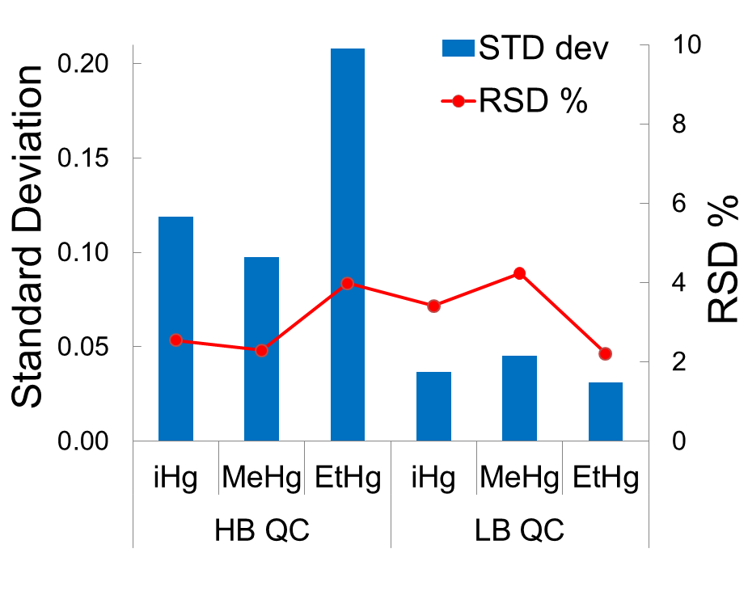

**Figure S10:** Short-term analytical precision for TSID-SPME-GC-DRC-ICP-MS method. Standard deviation and RSD values for inorganic, methyl, and ethyl mercury species were determined by analysis of eight LB and eight HB QC samples. The average RSD value for LB and HB QC is 3%.

**References**

1. Tanner SD, Baranov VI, Vollkopf U (2000) Journal of Analytical Atomic Spectrometry 15:1261-1269

2. Parkinson D-R, Bruheim I, Christ I, Pawliszyn J (2004) Journal of Chromatography A 1025:77-84

3. Ouerdane L, Mester Z, Meija J (2009) Analytical Chemistry 81:5075-5079

4. Meija J, Yang L, Caruso JA, Mester Z (2006) Journal of Analytical Atomic Spectrometry 21:1294-1297

5. Ouerdane L, Meija J, Mester Z (2013) US 13129479 Patent

6. Rodrigues JL, Alvarez CR, Farinas NR, Nevado JJB, Barbosa F, Martin-Doimeadios RCR (2011) Journal of Analytical Atomic Spectrometry 26:436-442

7. Davis WC, Vander Pol SS, Schantz MM, Long SE, Day RD, Christopher SJ (2004) J Anal At Spectrom 19:1546-1551

8. Geerdink RB, Breidenbach R, Epema OJ (2007) Journal of Chromatography A 1174:7-12

9. Huang JH (2005) Analytica Chimica Acta 532:113-120

10. Gibicar D, Logar M, Horvat N, Marn-Pernat A, Ponikvar R, Horvat M (2007) Analytical and Bioanalytical Chemistry 388:329-340

11. Grinberg P, Campos RC, Mester Z, Sturgeon RE (2003) Journal of Analytical Atomic Spectrometry 18:902-909

12. Wuilloud JCA, Wuilloud RG, Vonderheide AP, Caruso JA (2004) Spectrochimica Acta Part B-Atomic Spectroscopy 59:755-792

13. Yang L, Mester Z, Sturgeon RE (2003) Journal of Analytical Atomic Spectrometry 18:431-436

14. Bravo-Sanchez LR, Encinar JR, Martinez JIF, Sanz-Medel A (2004) Spectrochimica Acta Part B-Atomic Spectroscopy 59:59-66

15. Fernandez RG, Bayon MM, Alonso JIG, Sanz-Medel A (2000) Journal of Mass Spectrometry 35:639-646

16. Arthur CL, Pawliszyn J (1990) Analytical Chemistry 62:2145-2148

17. NHANES (2009) Fourth National Report on Human Exposure to Environmental Chemicals. Department of Health and Human Services Centers for Disease Control and Prevention, <http://www.cdc.gov/exposurereport/pdf/FourthReport.pdf>, accessed on 2/10/2014

18. Diez S, Bayona JM (2008) Talanta 77:21-27

19. Grinberg P, Campos RC, Mester Z, Sturgeon RE (2003) Spectrochimica Acta Part B-Atomic Spectroscopy 58:427-441

20. Jitaru P, Adams FC (2004) Journal of Chromatography A 1055:197-207

21. Rodriguez-Gonzalez P, Marchante-Gayon JM, Alonso JIG, Sanz-Medel A (2005) Spectrochimica Acta Part B-Atomic Spectroscopy 60:151-207

22. Krupp EA, Donard OFX (2005) International Journal of Mass Spectrometry 242:233-242

23. Jitaru P, Infante HG, Adams FC (2003) Analytica Chimica Acta 489:45-57

24. Moens L, DeSmaele T, Dams R, VandenBroeck P, Sandra P (1997) Analytical Chemistry 69:1604-1611

25. Jackson B, Taylor V, Baker RA, Miller E (2009) Environmental Science & Technology 43:2463-2469

26. Vanhaecke F, de Wannemacker G, Moens L, Dams R, Latkoczy C, Prohaska T, Stingeder G (1998) Journal of Analytical Atomic Spectrometry 13:567-571

27. Cai Y, Monsalud S, Jaffe R, Jones RD (2000) Journal of Chromatography A 876:147-155

28. Castro J, Tessier E, Donard O, Neubauer K (2012) Mercury Speciation in Biological Tissue and Sediments by GC/ICP-MS Using the NexION 300D/350D, <http://www.perkinelmer.com/CMSResources/Images/44-136196APP_NexION_300D_Hg_Speciation_in_Bio_Tissues_Sediments_GC_ICP_MS.pdf>, acessed on 2/10/2014

29. Mao YX, Liu GL, Meichel G, Cai Y, Jiang GB (2008) Analytical Chemistry 80:7163-7168

30. Jitaru P, Infante HG, Adams FC (2004) Journal of Analytical Atomic Spectrometry 19:867-875

31. Glaser JA, Foerst DL, McKee GD, Quave SA, Budde WL (1981) Environmental Science & Technology 15:1426-1435