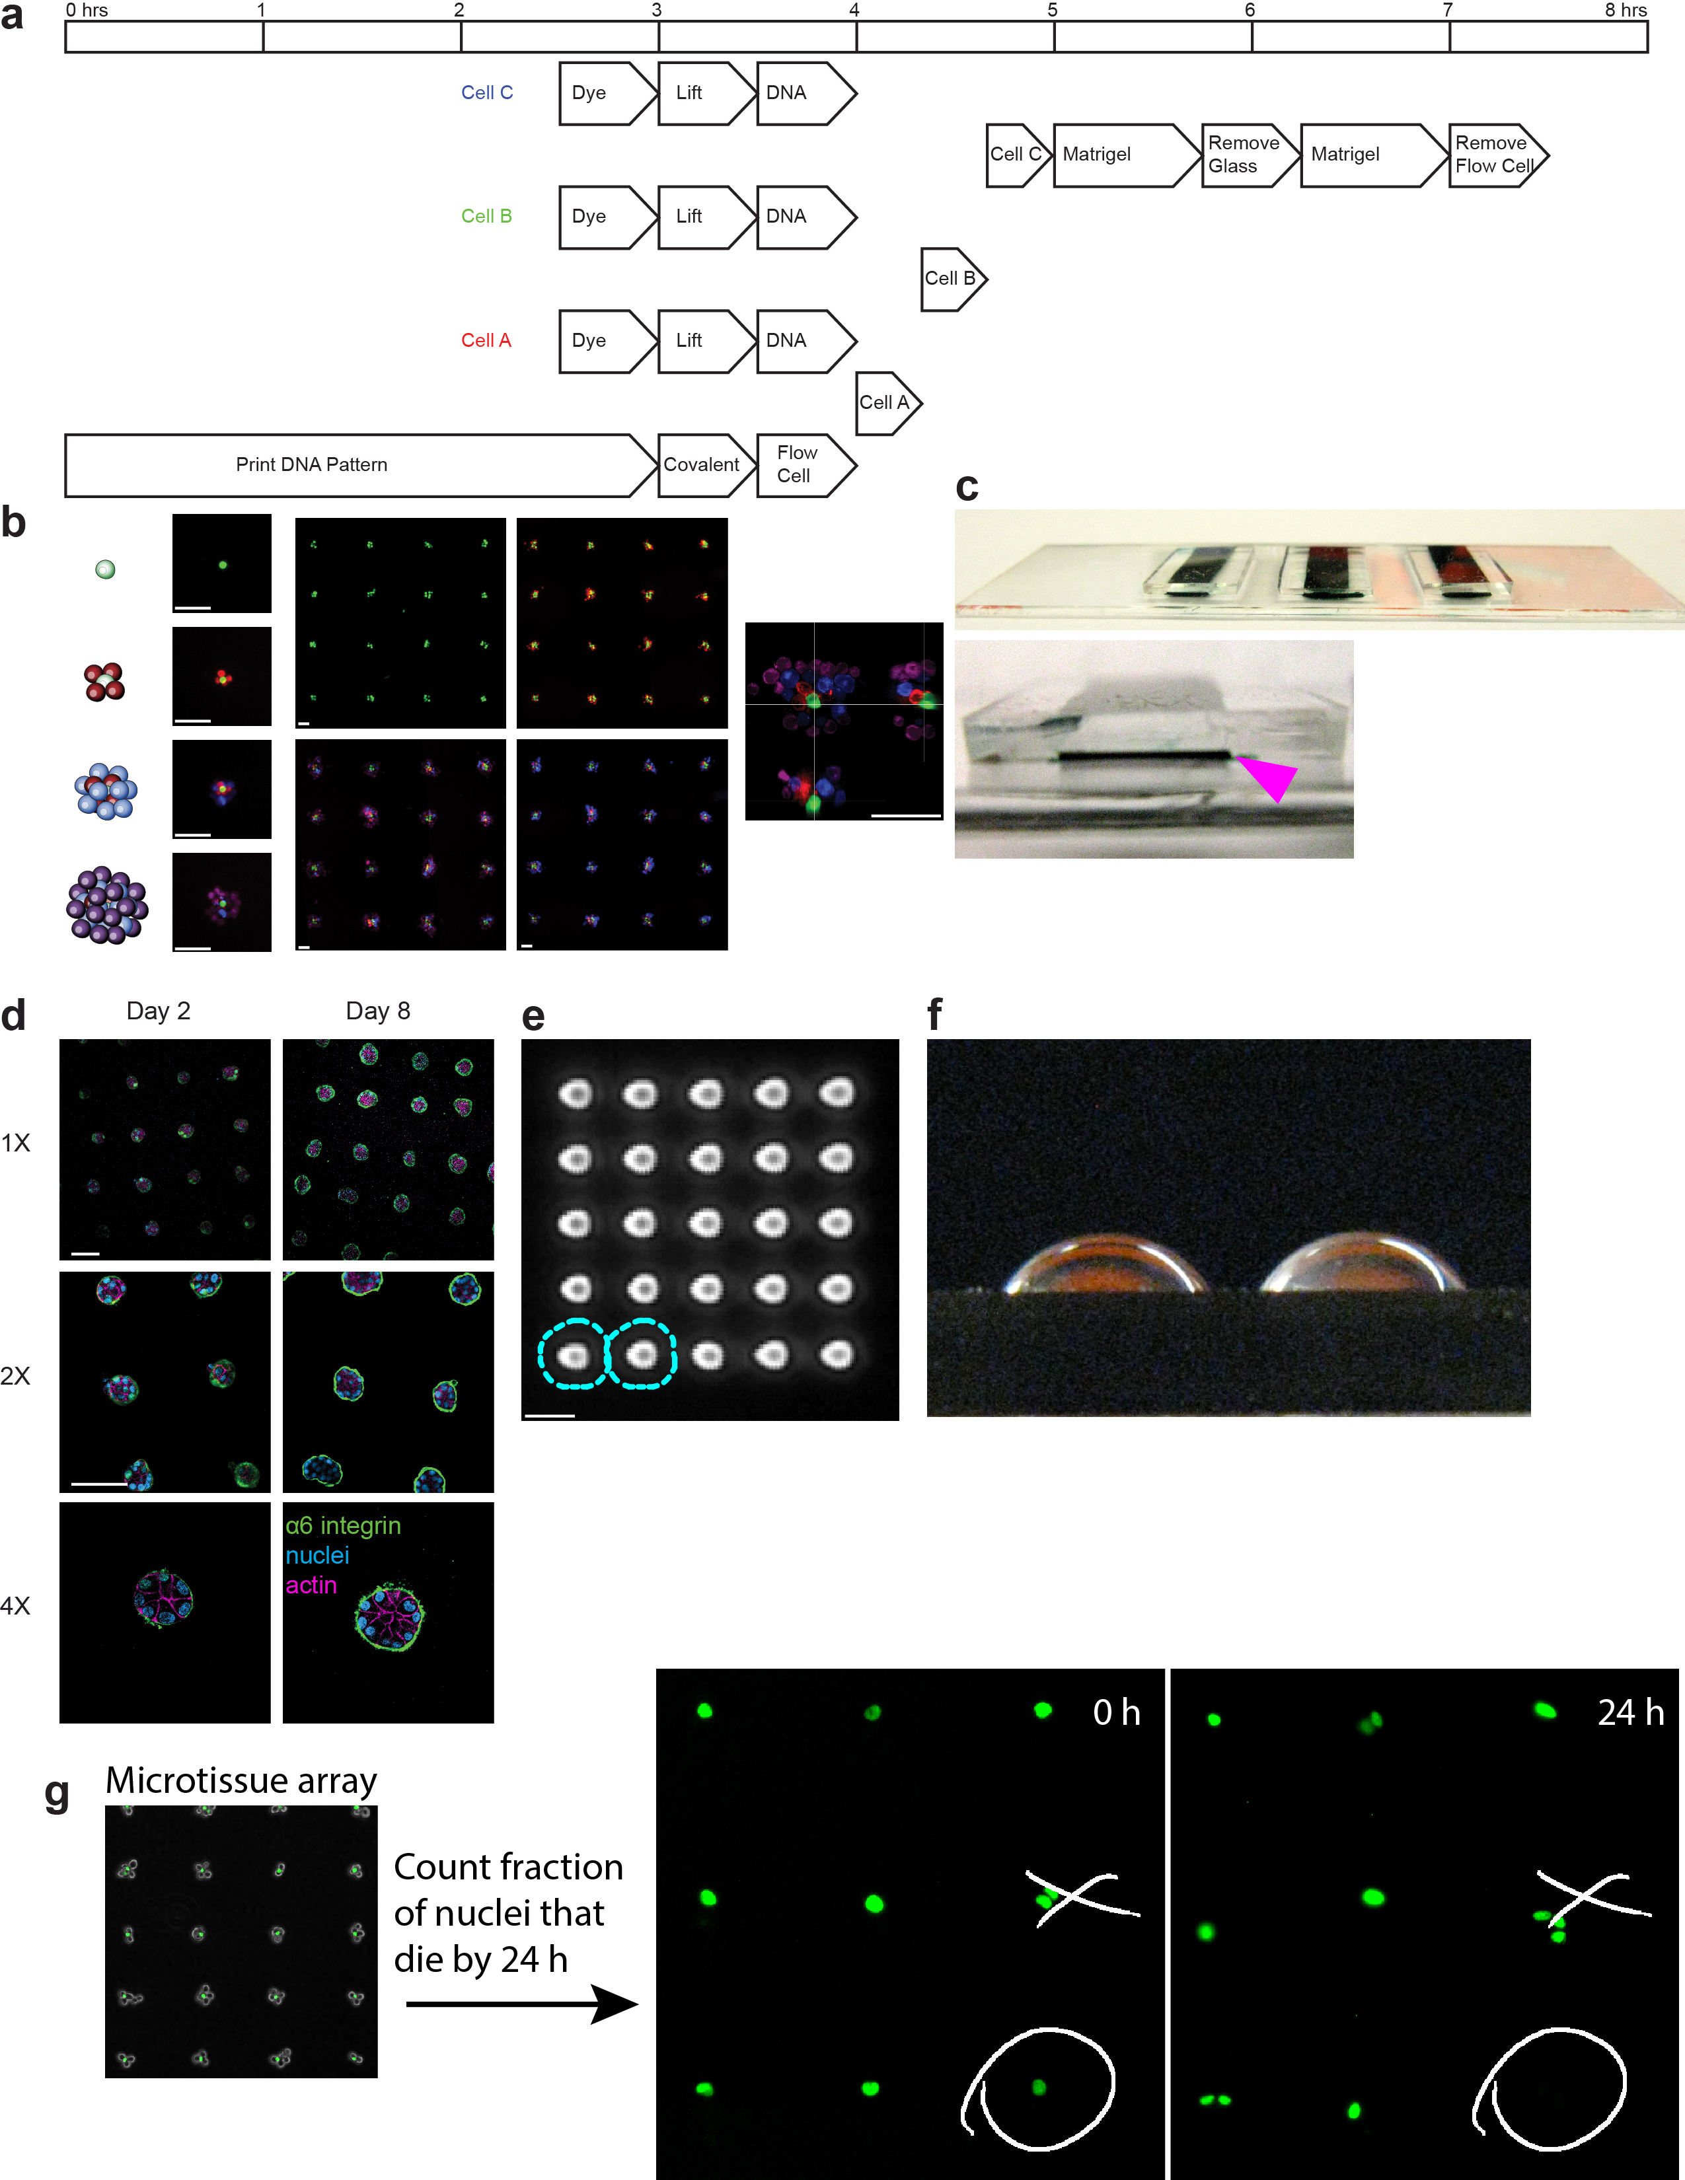
Supplementary Figure 1
Supplement: programming the reconstitution of fully ECM-embedded 3D microtissues by DNA-programmed assembly (DPAC).
(a) Timeline for a three-component tissue synthesis by DPAC. The process proceeds through a series of steps taking less than eight hours. (b) An array of microtissues assembled above single cells through four synthetic steps. Detail and orthogonal views of a representative aggregate is shown to the right. (c) Photographs of three PDMS flow cells on a 75 mm glass slide. Arrowhead indicates cross-section of flow cell. (d) MCF10A microtissue arrays stained for polarity and cytoskeletal markers at two time points. (e) Phase contrast microscopy image of a grid of 7 µm-wide DNA droplets at 14 µm pitch. These droplets are sufficiently dense that hybridized epithelial cells (~16 µm diameter dotted blue lines) come into contact with one another. (f) Photograph of aqueous DNA droplets on an aldehyde-glass slide, showing the contact angle of the liquid on the silanized glass surface. (g) Schematic illustrating scoring for cell viability. A circle denotes a cell that has died after 24 hrs, an “x” denotes a microtissue that was ignored due to having more than one green cell at time zero. In (e), scale bars are 10 µm. All other scale bars are 100 µm.
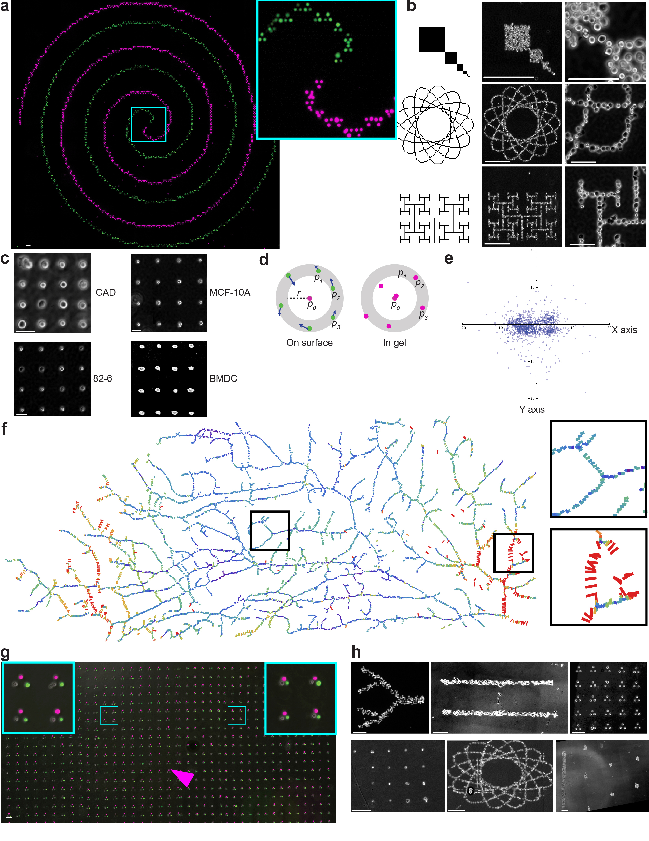
Supplementary Figure 2
Supplement: cell position is preserved upon transfer of cell patterns from their template to ECM for fully embedded 3D culture.
(a) Fluorescence microscopy images of a two-component DPAC pattern comprising a millimeter-scale spiral composed of micro-scale green and red cell triangles. Inset at right shows detail. (b) Bitmap images (left column) and phase-contrast microscopy (center and right columns) of dense, curved, and fractal patterns assembled via a single round of DNA-mediated cell-surface adhesion. (c) Phase-contrast microscopy images of cell arrays in 3D gels. Clockwise from top-left: neurons, epithelial cells, leukocytes, and fibroblasts. (d) Schematic illustrating the analytical method used for determining errors in cell position after transfer from templating pattern to 3D gel. For each cell in the pattern: (i) align p₀ to p_{n}. (ii) Define a ring of inner radius r_{i} and outer radius r₀, with origin p₀. (iii) Measure the set {|p₀ - p₁|, |p₀ - p₂|, ..., |p₀ - p_{n}| }. (iv) Repeat this process for every p_{n} in the microtissue. (v) Take the median of values within each ring to give the “error” for a given distance range. (e) Component analysis of error vectors, dividing each error into its perpendicular x and y components. The x axis corresponds to the direction of fluid flow through the flow cell during DPAC and gel transfer steps. (f) Vectors representing displacements from expected positions of all cells (and detail) in the mammary fat pad pattern. Vectors are colored according to the magnitude of displacement (g) Fluorescence/phase-contrast microscopy image showing the full-field of a microtissue array constructed from three cell-type triangles. Arrowhead indicates computational stitching error introduced during image composition. (h) Phase-contrast microscopy of microtissues fully embedded in a variety of hydrogels. Clockwise from top-left: cells in agarose, Matrigel/collagen I mixture, Matrigel, collagen I, QGel, and fibrin. All scale bars are 100 µm.
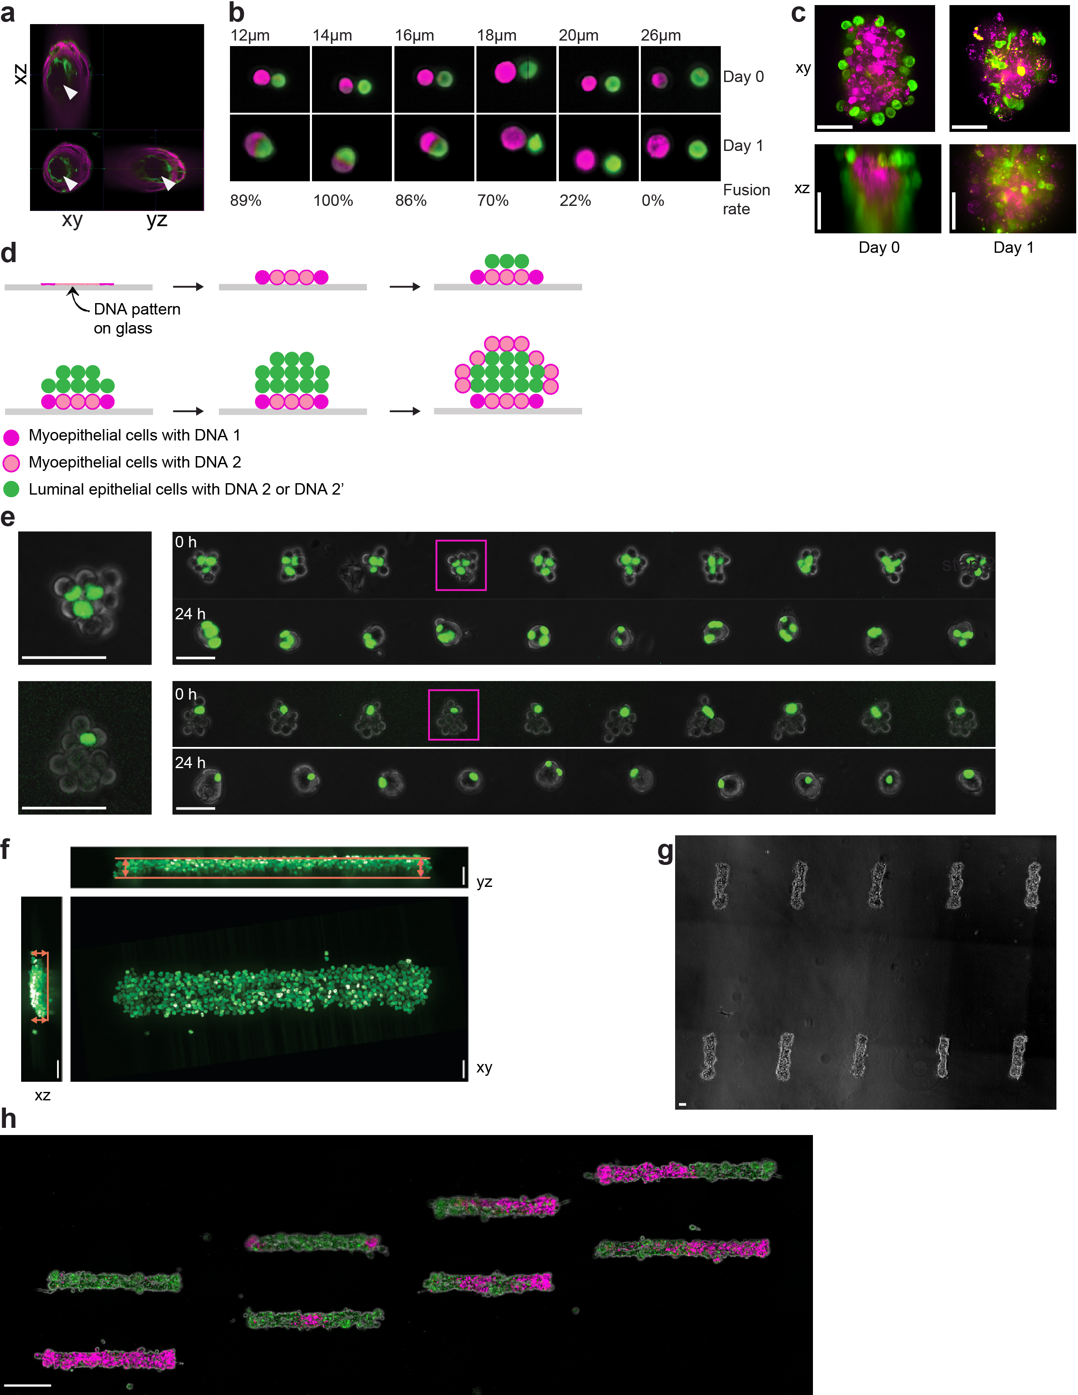
Supplementary Figure 3
Supplement: reconstituting epithelial microtissues with programmed size, shape, composition, spatial heterogeneity, and embedding ECM.
(a) Confocal fluorescence microscopy image with orthogonal views, showing LEP/MEP bilayer organization and lumenization for an HMEC organoid reconstituted via DPAC. (b) Fluorescence/phase-contrast microscopy images showing detail from a microtissue array incorporating cell pairs with nominal spacing between 12 and 26 µm in two micron increments. The frequency at which cell pairs coalesced into a single tissue is indicated below the images. (c) Confocal fluorescence microscopy images of MCF10As (green) and Chinese hamster ovary cells (red) assembled into a core-shell topology analogous to that shown in Fig. 3f. These microtissues do not retain their topology after 24 hr culture. (d) Cross-sectional view of the scheme used to synthesize the microtissues in Fig. 3f and S3a. (e) Fluorescence/phase-contrast microcopy images showing (left) detail of microtissues having similar total size but dissimilar minority cell composition. Rows (right) from microtissue arrays showing microtissues before and after 24 hr culture. (f) Maximum-intensity projection with orthogonal views of confocal fluorescence microscopy images illustrating a filled MCF10A tube. Arrows mark the 47 µm height of the tube. (g) Representative images of MCF10A cells assembled into cylindrical microtissues, shorter than those in Fig. 3h, and transferred to Matrigel/collagen mixtures. (h) Fluorescence/phase-contrast microscopy images showing MCF10A tubes having different patterns of spatial heterogeneity. In (c), scale bars are 30 µm. In (e), scale bars are 50 µm. All other scale bars are 100 µm.
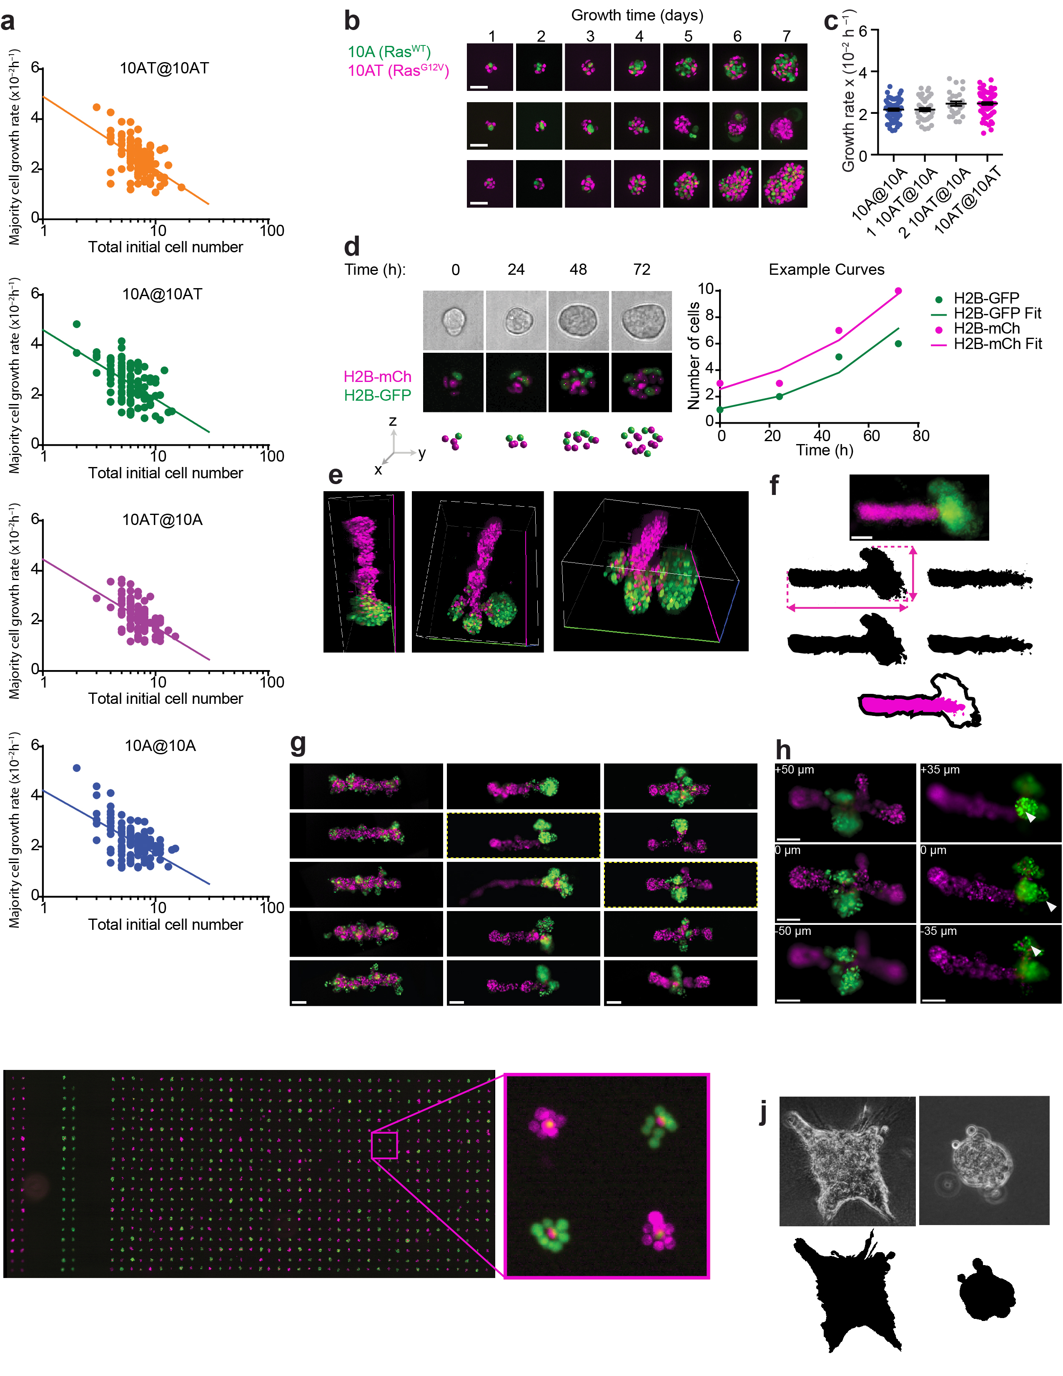
Supplementary Figure 4
Supplement: measuring the impact of microtissue size, shape, composition, spatial heterogeneity, and embedding ECM on collective cell behaviors.
(a) Plots of calculated growth rate compared to initial cell number for human mammary epithelial microtissues having four compositions of 10A and 10AT cells. (b) Time lapse microscopy showing growth trajectories for four representative microtissues. (c) Growth rate versus number of minority cells for heterotypic microtissues of the indicated composition (n = 66, 44, 27, 71). (d) Schematic illustrating analysis pipeline for extracting nuclei cell counts and positions, and reconstruction of growth trajectories for individual microtissues. (e) 3D reconstructions of heterotypic branching microtissues that have been cleared using CLARITY and imaged with confocal microscopy. Images from three viewing angles are shown. (f) Schematic illustrating analysis pipeline for the data presented in figure 4h. Fluorescence images are thresholded at 90 % intensity contours for (left) the sum of both channels, and (right) the red channel alone. The heights and widths of the total fluorescence 90% intensity contour was measured as indicated. (g) Representative fluorescence images showing MCF10A filled tubes incorporating MCF10ATs randomly, at their edges, or at their centers after 72 hr in culture. (h) Fluorescence microscopy showing three views of a microtissue at 50 micron z-intervals. Wedges indicate in-focus regions of the branching microtissues in each plane. (i) Full-field fluorescence image (and detail) showing a 3D microtissue array comprising MCF10A/MCF10AT microtissues having four different programmed compositions. Homotypic controls occupy leftmost columns. (j) Schematic illustrating the method used for measuring organoid circularity in figure 4b. Phase contrast images are thresholded, binned, and traced. All scale bars are 100 µm
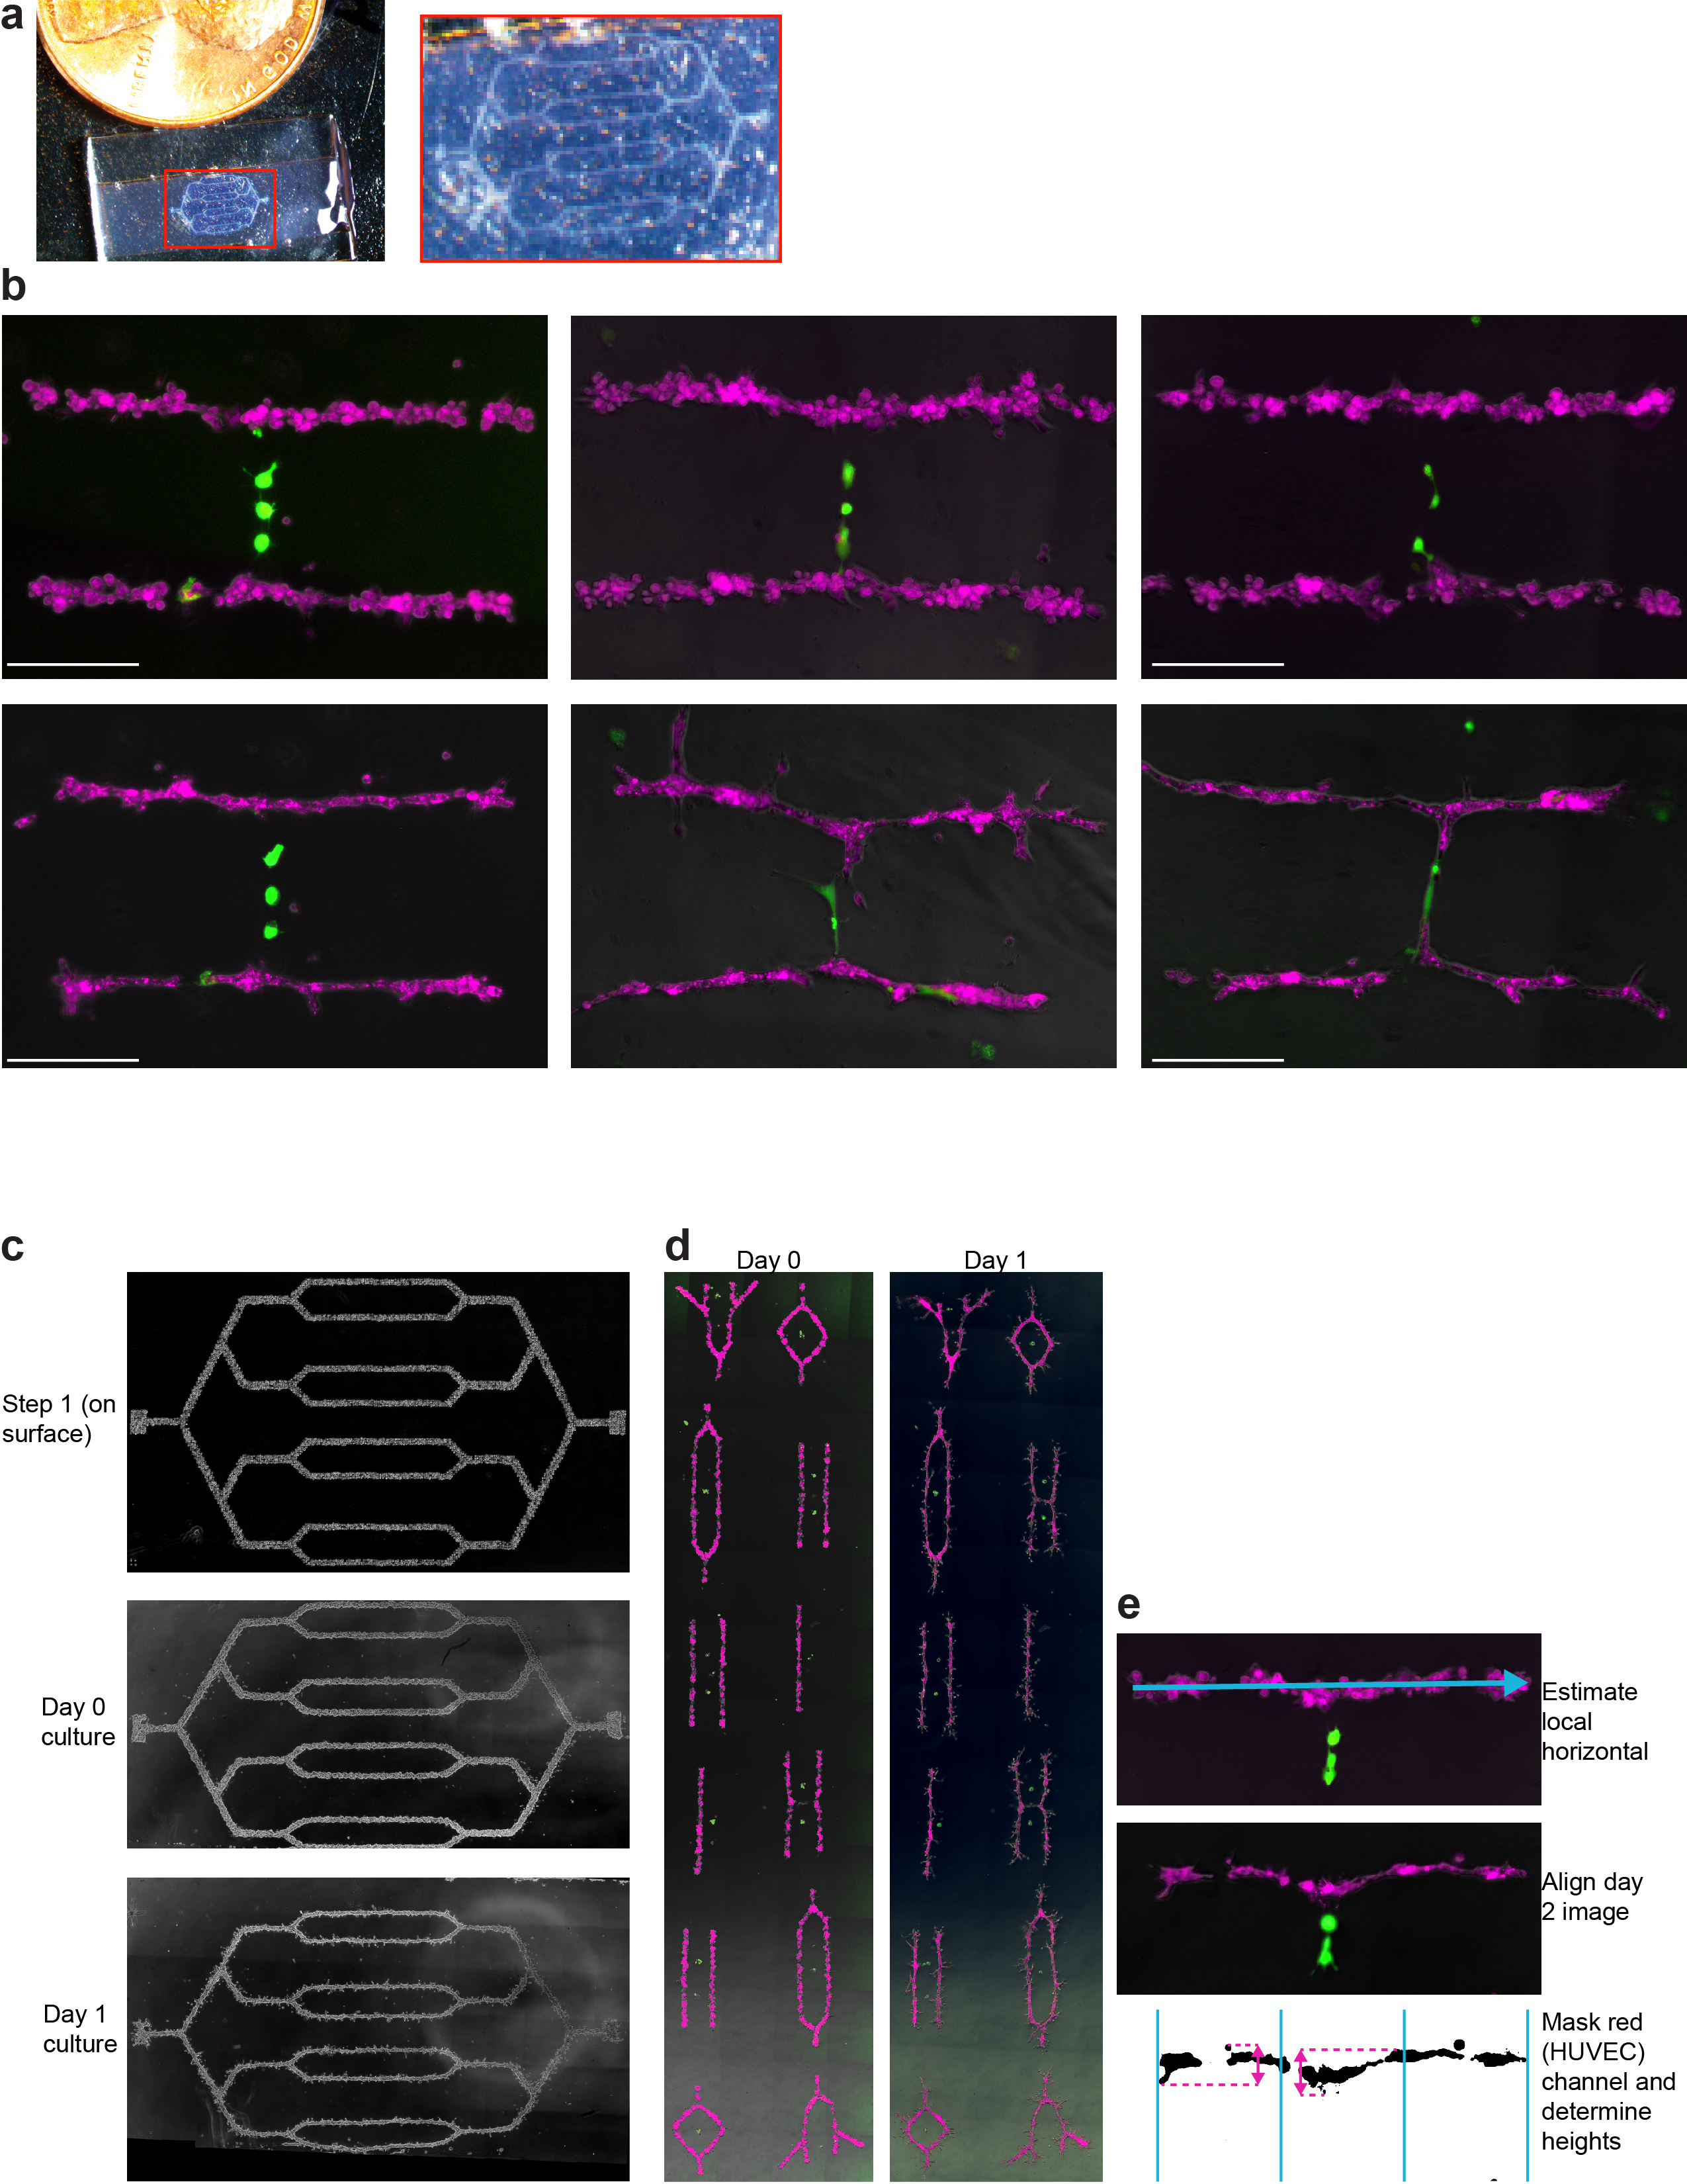
Supplementary Figure 5
Supplement: DPAC control of stromal architecture.
(a) Photograph showing HUVEC endothelial network embedded in a Matrigel/collagen mixcture. A penny is placed alongside the pattern for scale. (b) Fluorescence/phase-contrast microscopy images showing three representative microtissues showing three distinct behaviors: unchanged HUVEC networks, bending HUVEC networks, and branching HUVEC networks are shown at left, center, and right, respectively. Uncultured and cultured (24 hr) images are shown at the top and bottom, respectively. (c) Full-field phase contrast microscopy images of HUVEC networks at the indicated stage of DPAC and culture. (d) Full-field fluorescence/phase-contrast microscopy images showing three-compartment and multi-component microtissue arrays. (e) Schematic of the method used for measuring HUVEC extension. The 24 hr culture image is aligned with the initial cell pattern. The 24 hr culture image is divided into thirds, and the height of the central third (medial) and left third (lateral) are determined and compared to the same regions in the uncultured image. All scale bars are 100 µm.
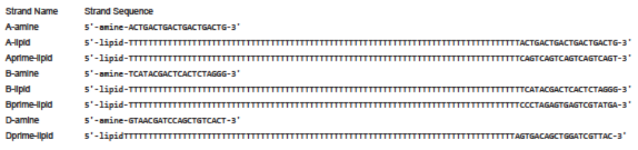.
Supplementary Table
List of DNA Sequences
These DNA sequences, with appropriate 5-prime chemical modifications, were used in this study.

